**1)**

class main {

public static void main(String args[]) {

char c[] = {'h', 'e', 'l', 'l','o'};

String s=new String("hello world");

String s1 = new String(s);

String s2 = new String(c);

System.out.println(s);

System.out.println(s1);

System.out.println(s2); }

}

Output

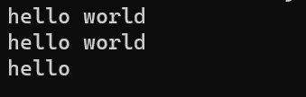

**2)**

public class main

{

public static void main(String args[])

{

char c[]={'a','b','c'};

String s=new String(c);

System.out.println(s.length());//length

String s1="abc";//string literal

System.out.println(s1.length());

int age=19;

System.out.println("i am "+ age+ "years old");//string concat

}

}

Output

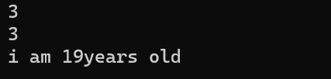

**3)**

class Box {

double width;

double height;

double depth;

Box(double width, double height, double depth) {

this.width = width;

this.height = height;

this.depth = depth;

}

public String toString() {

return "Dimensions are " + width + " by " +depth + " by " + height + ".";

}

}

class toStringDemoMain

{

public static void main(String args[])

{

Box b = new Box(10, 12, 14);

String s = "Box b: " + b; // concatenate Box object

System.out.println(b); // convert Box to string

System.out.println(s);

}

}

Output

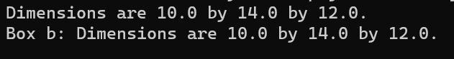

**4 and 5**

public class main

{

public static void main (String[] a)

{

String s="welcome to bmsce college";

char word[]=new char[6];

char[] w=s.toCharArray();//tochararray

s.getChars(11,16,word,0);//getchars

System.out.println(word);

System.out.println(w);

String s1="ABC";

byte[] b=s1.getBytes();//getbytes

for(int i=0;i<b.length;i++)

{

System.out.println(b[i]);

}

}

}

output

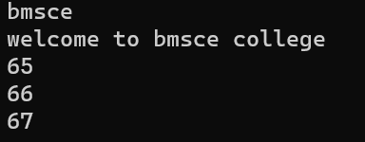

**6)**

class demo

{

public static void main(String args[])

{

String s1="Bmsce";

String s2="Bmsce";

String s3="College";

String s4="BMSCE";

System.out.println(s1 + " equals " + s2 + " -> " +s1.equals(s2));

System.out.println(s1 + " equals " + s3 + " -> " +s1.equals(s3));

System.out.println(s1 + " equals " + s4 + " -> " +s1.equals(s4));

System.out.println(s1 + " equalsIgnoreCase " + s4 + " -> " +s1.equalsIgnoreCase(s4));

}

}

Output

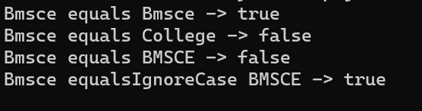

**7)**

class region

{

public static void main(String args[])

{

String s1="Bmsce College";

String s2="Welcome to Bmsce College of engineering";

Boolean isMatch=s2.regionMatches(11,s1,0,4);

if(isMatch)

System.out.println("substring is matched");

else

System.out.println("substring is not matched");

}

}

Output



**8 and 9**

class demo

{

public static void main(String args[])

{

String s1="welcome to bmsce college";

System.out.println(s1.startsWith("wel"));//startswith

System.out.println(s1.startsWith("bms"));

System.out.println(s1.endsWith("ege"));//endwith

System.out.println(s1.endsWith("ce"));

}

}

Output

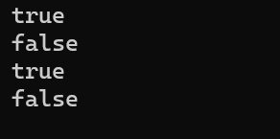

**10)**

class equal

{

public static void main(String args[])

{

String s="Hello";

String s1=new String(s);

System.out.println(s);

System.out.println(s1);

System.out.println(s + " equals " + s1 + " -> " +s.equals(s1));

System.out.println(s + " == " + s1 + " -> " + (s == s1));

}

}

Output

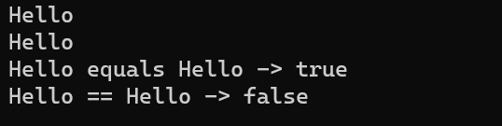

**11)**

class SortString {

static String arr[] = {"van", "watch","ball", "cat","xmas","yatch","zee","apple","ice","jug","kite","lift","man","net","orange","dog","ent","free","gun","hen","parrot","queen","ring","star","tree","umbrella" };

public static void main(String args[])

{

for(int j = 0; j < arr.length; j++)

{

for(int i = j + 1; i < arr.length; i++)

{

if(arr[i].compareTo(arr[j]) < 0)

{

String t = arr[j];

arr[j] = arr[i];

arr[i] = t;

}

}

System.out.println(arr[j]);

}

}

}

Output

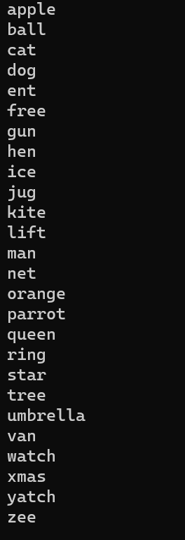

**12)**

import java.util.Arrays;

public class NumberSorting {

public static void main(String[] args) {

// Create an array of numbers from 10 to 1

Integer[] numbers = {10, 9, 8, 7, 6, 5, 4, 3, 2, 1};

Arrays.sort(numbers, (a, b) -> a.compareTo(b));

System.out.println("Sorted Numbers (Ascending Order):");

for (int number : numbers) {

System.out.print(number + " ");

}

}

}

Output

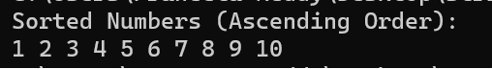

**13)**

class StringReplace

{

public static void main(String args[]) {

String org = "This is a test. This is, too.";

String search = "is";

String sub = "was";

String result = "";

int i;

do {

i = org.indexOf(search);

if(i != -1) {

result = org.substring(0, i);

result = result + sub;

result = result + org.substring(i + search.length());

org = result;

}

} while(i != -1);

System.out.println(org);

}

}

Output



**14)**

class cc

{

public static void main(String args[])

{

String s1= "hello ";

String s2 = "world";

String s3=s1.concat(s2);

System.out.println(s3);

}

}

Output



**15)**

class replace

{

public static void main(String args[])

{

String myStr = "College";

System.out.println(myStr.replace('l', 'm'));

}

}

Output



**16)**

class trim

{

public static void main(String args[])

{

String myStr = " hello friends ";

System.out.println(myStr);

System.out.println(myStr.trim());

}

}

Output

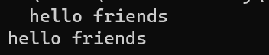

17)

import java.util.Arrays;

import java.util.Scanner;

class student {

int regno;

String name;

short sem;

float cgpa;

student() {

sem = 3;

}

student(String name, int regno, float cgpa) {

this.name = name;

this.regno = regno;

this.cgpa = cgpa;

this.sem=3;

}

public String toString() {

return "name:" + name + " regno:" + regno + " sem:" + sem + " cgpa:" + cgpa;

}

}

class studMain {

public static void main(String args[]) {

Scanner s = new Scanner(System.in);

System.out.println("enter the no of students:");

int n = s.nextInt();

student[] stud;

stud = new student[n];

for (int i = 0; i < n; i++) {

System.out.println("enter the name:");

String name = s.next();

System.out.println("enter the regno:");

int regno = s.nextInt();

System.out.println("enter the cgpa:");

float cgpa = s.nextFloat();

stud[i] = new student(name, regno, cgpa);

}

// Sorting based on cgpa

Arrays.sort(stud, (a, b) -> Float.compare(a.cgpa, b.cgpa));

System.out.println("Sorted by cgpa:");

for (int i=0;i<n;i++) {

System.out.println(stud[i]);

}

// Sorting based on name

Arrays.sort(stud, (a, b) -> a.name.compareTo(b.name));

System.out.println("Sorted by name:");

for (int i=0;i<n;i++) {

System.out.println(stud[i]);

}

}

}

Output

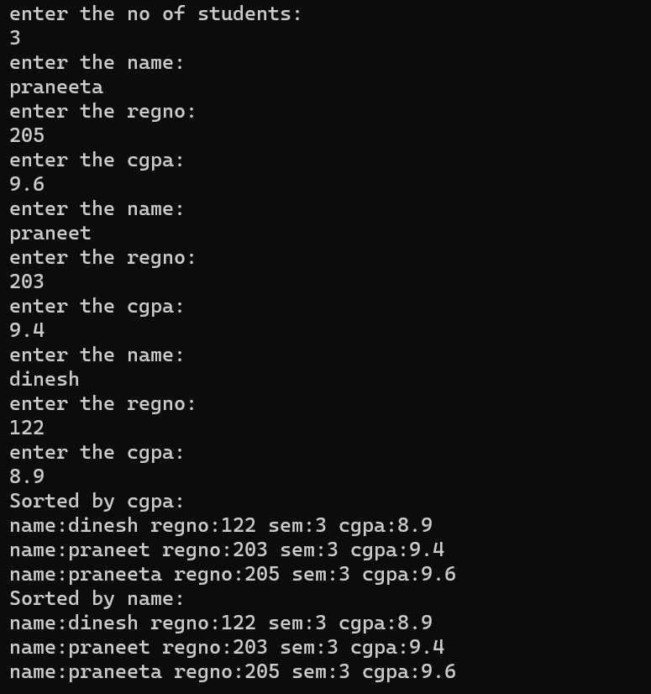

**18)**

class StringBufferDemo {

public static void main(String[] args) {

// Creating a StringBuffer

StringBuffer stringBuffer = new StringBuffer("Hello World");

// Set length of the buffer

stringBuffer.setLength(5);

System.out.println("Set Length: " + stringBuffer);

// charAt()

char charAtIndex = stringBuffer.charAt(1);

System.out.println("Char at index 1: " + charAtIndex);

// setCharAt()

stringBuffer.setCharAt(1, 'i');

System.out.println("After setCharAt: " + stringBuffer);

// getChars()

char[] charArray = new char[4];

stringBuffer.getChars(0, 4, charArray, 0);

System.out.print("getChars: ");

System.out.println(charArray);

// append()

stringBuffer.append(" How are you?");

System.out.println("After append: " + stringBuffer);

// insert()

stringBuffer.insert(5, "Awesome ");

System.out.println("After insert: " + stringBuffer);

// delete()

stringBuffer.delete(5, 13);

System.out.println("After delete: " + stringBuffer);

// deleteCharAt()

stringBuffer.deleteCharAt(0);

System.out.println("After deleteCharAt: " + stringBuffer);

// replace()

stringBuffer.replace(0, 4, "Hola");

System.out.println("After replace: " + stringBuffer);

// substring()

String substring = stringBuffer.substring(0, 4);

System.out.println("Substring: " + substring);

// reverse()

stringBuffer.reverse();

System.out.println("After reverse: " + stringBuffer);

}

}

Output

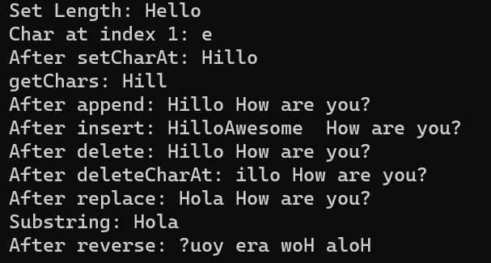

**19)**

abstract class bird {

public abstract void fly();

public abstract void makeSound();

}

class eagle extends bird {

public void fly() {

System.out.println("Eagle is flying high in the sky.");

}

public void makeSound() {

System.out.println("eagle makes Screech! Screech! sound");

}

}

class hawk extends bird {

public void fly() {

System.out.println("Hawk is soaring through the air.");

}

public void makeSound() {

System.out.println("Hawk makes Caw! Caw! sound");

}

}

class birdMain {

public static void main(String[] args) {

bird Eagle = new eagle();

bird Hawk = new hawk();

Eagle.fly();

Eagle.makeSound();

Hawk.fly();

Hawk.makeSound();

}

}

Output

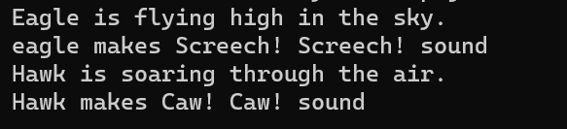

**20)**

abstract class shape

{

double s1,s2,s3,radius;

shape(double s1,double s2,double s3)

{

this.s1=s1;

this.s2=s2;

this.s3=s3;

}

shape(double radius)

{

this.radius=radius;

}

abstract void calarea();

abstract void calperimeter();

}

class circle extends shape{

circle(double radius)

{

super(radius);

}

void calarea()

{

System.out.println("area of circle:"+(3.14*radius*radius));

}

void calperimeter()

{

System.out.println("perimeter of circle:"+(2*3.14*radius));

}

}

class triangle extends shape{

triangle(double s1,double s2,double s3)

{

super(s1,s2,s3);

}

void calperimeter()

{

System.out.println("perimeter of triangle:"+(s1+s2+s3));

}

void calarea()

{

double s = (s1 + s2 + s3) / 2;

System.out.println("perimeter of triangle:"+Math.sqrt(s * (s - s1) * (s - s2) * (s - s3)));

}

}

class shapesMain

{

public static void main(String[] a)

{

circle c= new circle(5.0);

c.calarea();

c.calperimeter();

triangle t=new triangle(3.0, 4.0, 5.0);

t.calarea();

t.calperimeter();

}

}

Output

