Issue & Complaint Management
  - ServiceNow Governance, Risk & Compliance (GRC) Project Documentation

Executive summary
This sample project defines a controlled process to intake complaints and compliance findings, assess exposure, assign accountable owners, implement corrective actions, collect evidence, validate effectiveness, and approve closure. It is intentionally industry-neutral and suitable for portfolio, training, and implementation-planning use.
Scope note: “Complaint” is an intake source in this design, not an assertion that ServiceNow ships an identical out-of-the-box complaint module. Portal forms, integrations, states, approvals, and dashboards are configurable and may require licensed GRC capabilities.

Objectives & scope
- Create a single record of truth for issues originating from employees, audits, control tests, risk assessments, or monitoring.
- Apply consistent ownership, severity, prioritization, due dates, follow-up and escalation.
- Associate findings with applicable policies, risks, controls, entities, and obligations.
- Ensure remediation is supported by testable evidence and independent validation.
- Maintain an audit trail of decisions, exceptions, approvals and final dispositions.

End-to-end workflow
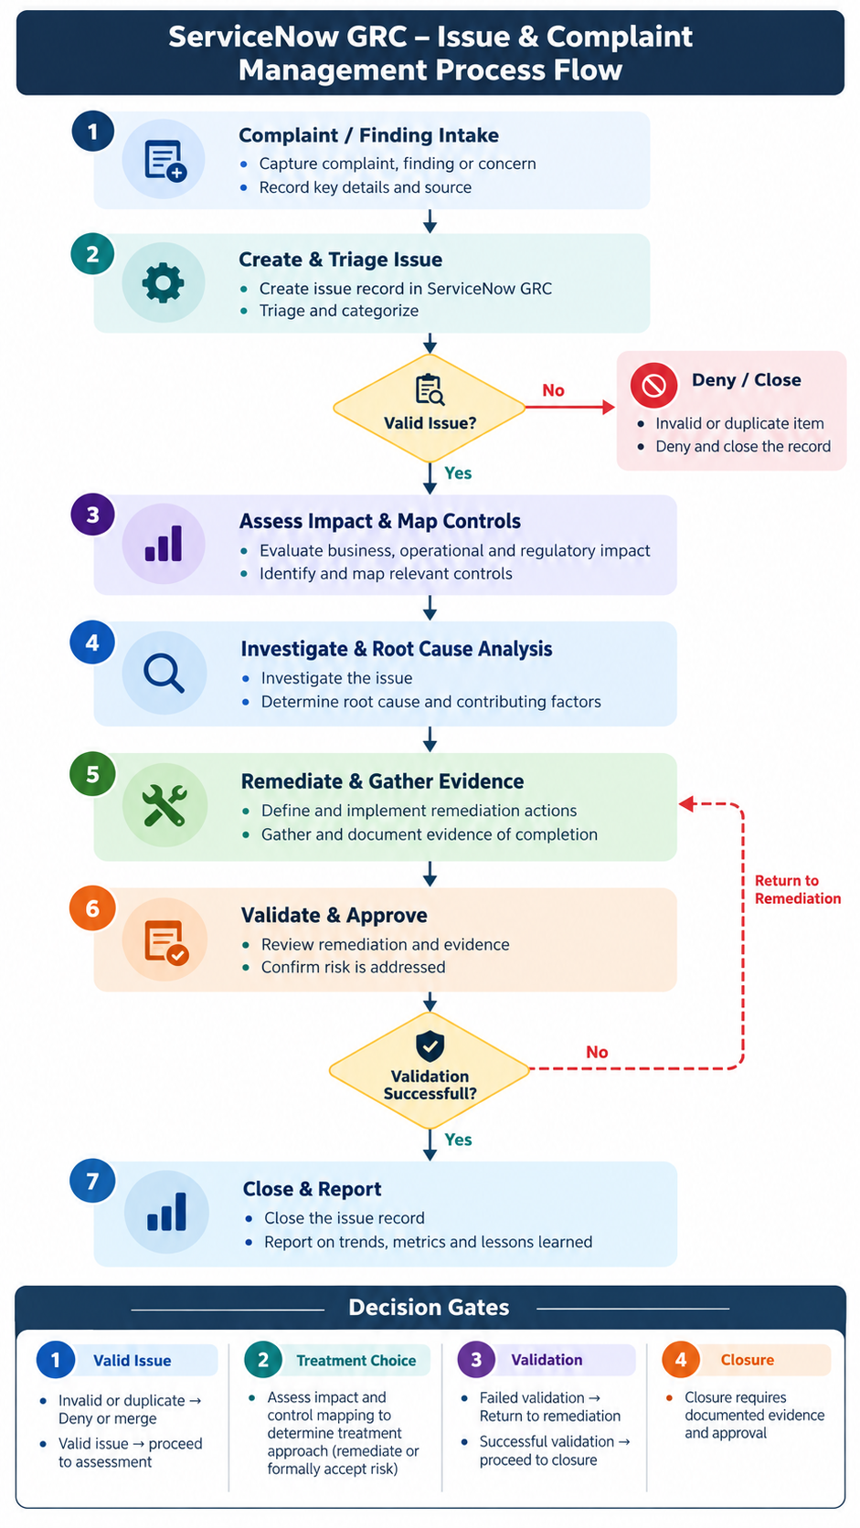

Workflow steps & deliverables
Stage | Accountable role | Key activity | Output
1. Intake | Reporter / employee | Complaint, audit finding or control alert | Submission ID and source
2. Triage | GRC analyst | Validate, deduplicate, assign owner | Accepted issue or documented disposition
3. Risk assessment | Risk / issue owner | Assess likelihood, impact, urgency | Rating, priority, due date
4. Mapping | Compliance / control owner | Link obligations, controls, risks and business entities | Traceability to related records
5. Investigation / RCA | Issue owner + SMEs | Evidence review, 5 Whys / cause analysis | RCA and causal factors
6. Remediation | Action owners | Corrective plan, tasks, dates, dependencies | Completed actions and artifacts
7. Validation | Independent tester | Sample-based retesting; evaluate effectiveness | Pass/fail validation report
8. Approval / closure | Issue manager / approver | Check closure criteria and sign-off | Approved disposition and audit trail

Proposed ownership & access model
Reporter: raise a complaint and receive status updates under agreed visibility rules. GRC analyst: triage and classify. Issue manager: manage lifecycle, rating and escalation. Control / risk owner: assess linked exposure. Remediation owner: perform corrective action. Validator: verify efficacy independent of implementation. Approver: authorize closure or documented exception. Administrator: configure roles, ACLs, flows and reports.
Security design: apply least privilege, record-level access controls, confidentiality where appropriate, and separate remediation from validation and approval duties.

Data model / important fields
- Issue: ID, title, description, source, issue type, classification, priority/rating, impacted entity, owner, due date, state, RCA, treatment decision.
- Relationships: policy statement, control, risk, audit observation, compliance requirement, business process and linked issue(s).
- Remediation task: parent issue, owner/group, action, priority, planned/actual dates, state, evidence and work notes.
- Validation: test plan, sample, criteria, test outcomes, residual risk, reviewer, timestamps and final approval.

Screenshots / proposed UI touchpoints
All images below are purpose-built illustrative mockups, not screenshots from a live ServiceNow tenant. Replace with screenshots from your own licensed instance after implementation, and redact personal/confidential data.
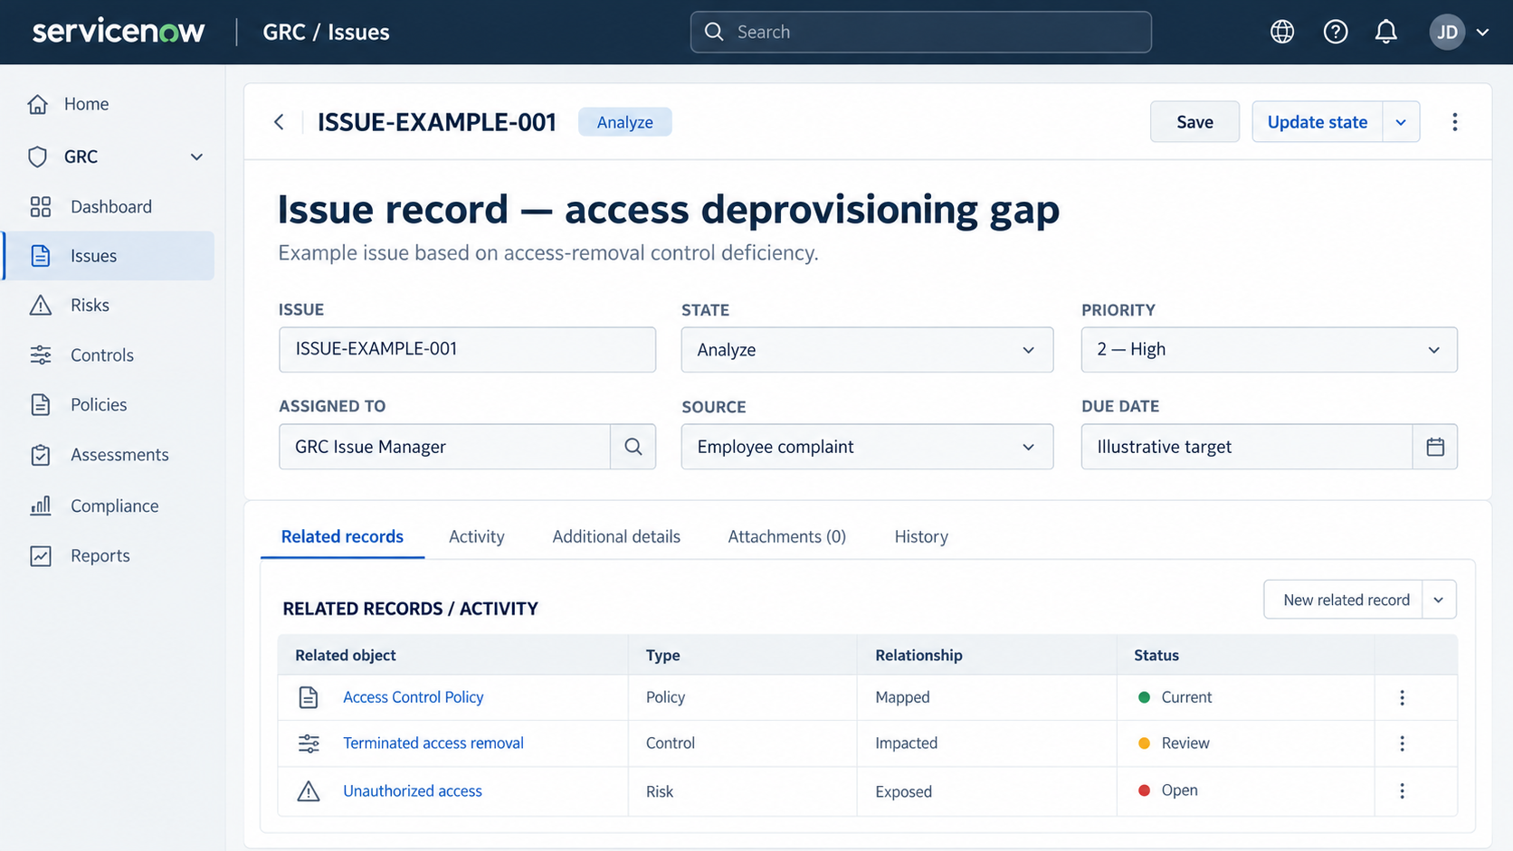

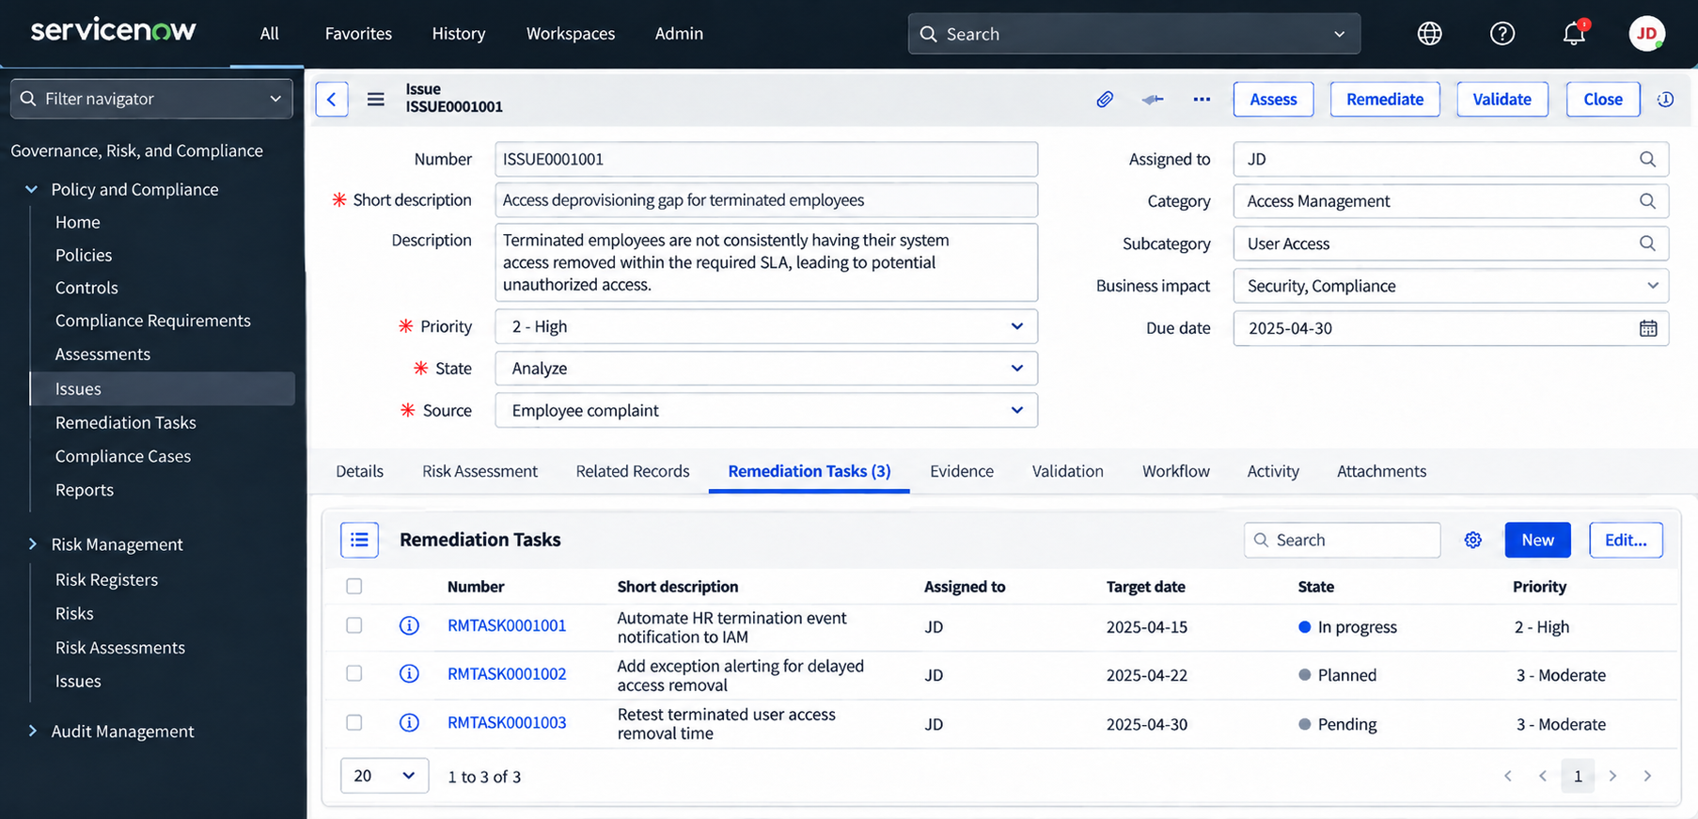

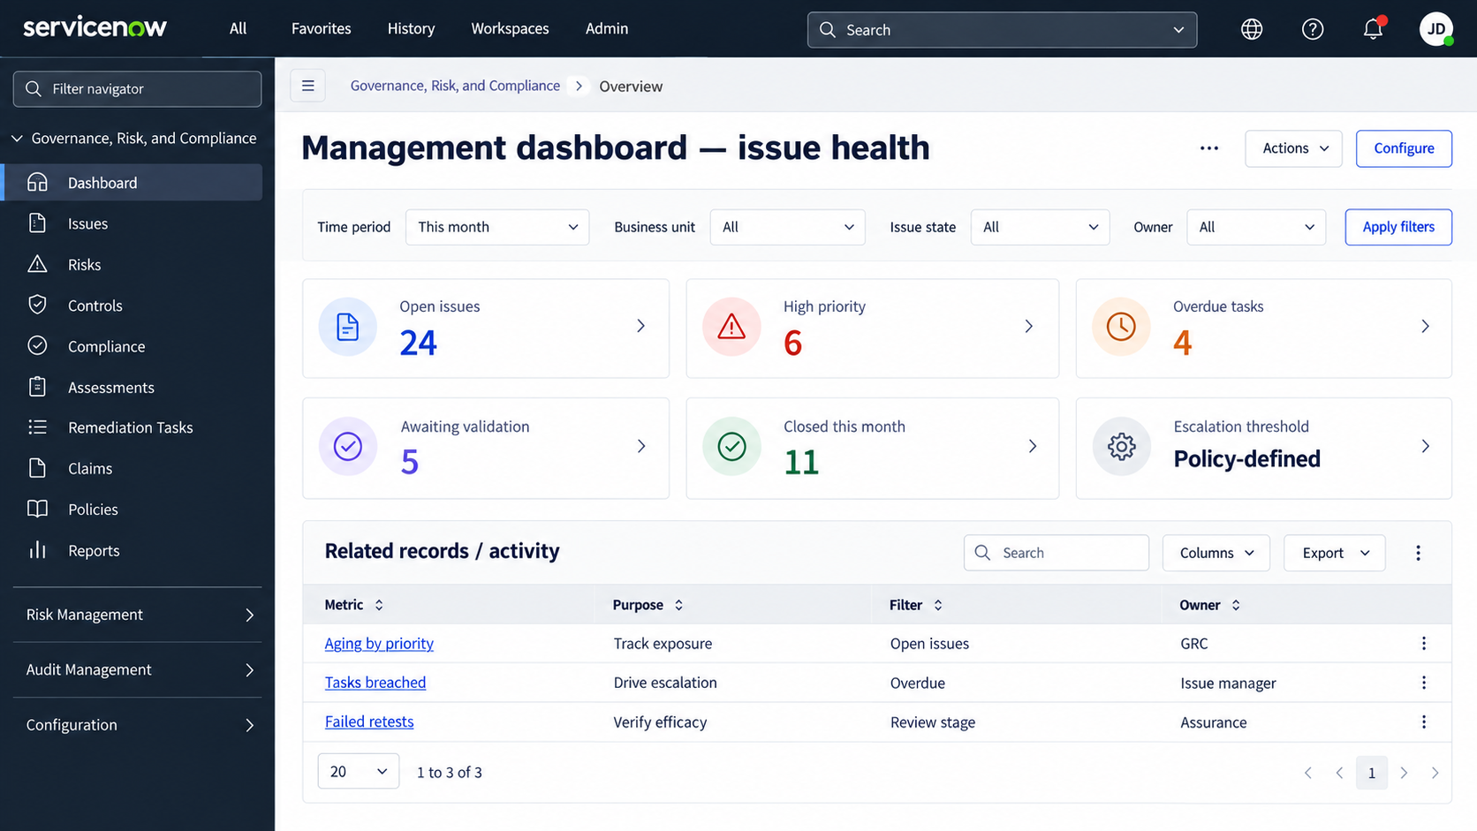

Automation requirements (illustrative)
- On valid intake: create or route an issue to a triage queue; assign unique record identifier.
- On classification / rating: calculate target date and notify assigned owner according to configured rules.
- On overdue task: notify task owner, escalate to issue manager, and flag dashboard.
- Before closure: require all mandatory actions, evidence, validation result and approval.
- On failed retest: reopen remediation, record discrepancy and reschedule validation.
- On exception / risk acceptance: route to authorized risk approver, record rationale and review expiry.

Sample case terminated user access
Scenario: an employee reports that access for a terminated colleague remained active after the required deprovisioning window. Triage confirms a potentially valid control failure; the issue manager rates it High based on exposed systems and duration.
- Related policy: Identity & Access Management / Access Control Policy.
- Risk: Unauthorized access from delayed deprovisioning.
- Control objective: Disable terminated user access within the defined organizational SLA
- Root cause: HR termination event was not reliably propagated to IAM, no exception alerting.
- Remediation: Automate HR→IAM notification, add alerts, establish fallback ownership.
- Evidence: Event logs, workflow configuration, ticket history, alert samples, test results.
- Validation: Compare termination effective times with access removal timestamps on a defined sample
- Closure decision: Close only if acceptance criteria pass and delegated approver signs off

Acceptance & closure criteria
- Issue classification, owner, linked records and RCA are complete.
- All required remediation tasks are completed with traceable evidence.
- Control tester documents sampling method and effectiveness result.
- Residual exposure is within tolerance or an authorized exception is approved.
- Closure approval, dates, work notes and attachments are retained.

Reporting KPIs
Suggested widgets: new issues by intake source; open issues by severity and business unit; average days to triage; issue aging buckets; due-date/SLA breach rate; remediation tasks overdue; repeat findings; pass/fail retest rate; accepted risks approaching expiry; mean time to closure. Segment by owner, process and impacted control.

Functional test scenarios
- TC01 — Valid complaint intake creates or routes an issue with reporter reference.
- TC02 — Duplicate finding is linked/merged without losing audit history.
- TC03 — High impact / urgent issue receives defined escalation and due date.
- TC04 — Unauthorized user cannot see confidential issue or evidence.
- TC05 — Closed remediation cannot bypass required validation evidence.
- TC06 — Failed validation sends case back for corrective action.
- TC07 — Approval by an unauthorized role is blocked.
- TC08 — Dashboard filters reconcile to underlying issue / task counts.

Implementation checklist
Confirm licensed products and workspace; define intake channels; finalize taxonomy and assessment scales; configure role/ACL matrix; build routing and notifications; define SLA policy; enable relationships and task templates; configure validation gate and exception path; create reports; execute UAT; capture actual instance screenshots; publish SOP and train owners.

Assumptions & limitations
This is a solution blueprint, not evidence of a deployed implementation. Exact form labels, state model, navigational paths, entitlements, automatic SLA notifications, and integration capabilities depend on release and installed applications. Risk acceptance is a distinct documented outcome and should not be represented as successful remediation.

