LAB -- 7: MINIMUM SPANNING TREE ALGORITHMS
Design and Analysis of Algorithms
Name | Baratam Praneeth Gupta
Admission Number | AP25110010120
Subject Code | CSE 204
Git Repository | https://github.com/Praneeth0910/DAA-CSE204

This report contains the two minimum spanning tree (MST) algorithms used for LAB-7, their time-complexity derivations, source code implementations, and the corresponding sample output screenshots.

Complexity Summary
Algorithm | Time Complexity | Reason | Auxiliary Space
Kruskal's (Greedy + DSU) | O(E log E) | Sorting edges dominates | O(V + E)
Prim's (Greedy + MinHeap) | O(E + V log V) | Min-key extraction dominates | O(V + E)

1. Kruskal's Algorithm
Kruskal's algorithm constructs a minimum spanning tree by greedily selecting edges in sorted order of weight. It uses a Disjoint Set Union (DSU) data structure to efficiently detect and avoid cycles.

Time Complexity Derivation
Sorting all E edges takes O(E log E) time. The union-find operations (find with path compression and union by rank) execute nearly O(E α(V)) where α is the inverse Ackermann function (effectively constant). Therefore, T(n) = O(E log E) + O(E α(V)) = O(E log E).
Time Complexity: O(E log E)
Auxiliary Space Complexity: O(V + E)

Source Code
#include <bits/stdc++.h>
using namespace std;
class DSU {
vector<int> parent, rank;
public:
DSU(int n) {
parent.resize(n);
rank.resize(n);
for (int i = 0; i < n; i++) {
parent[i] = i;
rank[i] = 1;
}
}
int find(int i) {
return (parent[i] == i) ? i : (parent[i] = find(parent[i]));
}
void unite(int x, int y) {
int s1 = find(x), s2 = find(y);
if (s1 != s2) {
if (rank[s1] < rank[s2]) parent[s1] = s2;
else if (rank[s1] > rank[s2]) parent[s2] = s1;
else parent[s2] = s1, rank[s1]++;
}
}
};
bool comparator(vector<int> &a, vector<int> &b){
return a[2] < b[2];
}
int kruskalsMST(int V, vector<vector<int>> &edges) {
sort(edges.begin(), edges.end(), comparator);
DSU dsu(V);
int cost = 0, count = 0;
for (auto &e : edges) {
int x = e[0], y = e[1], w = e[2];
if (dsu.find(x) != dsu.find(y)) {
dsu.unite(x, y);
cost += w;
if (++count == V - 1) break;
}
}
return cost;
}
int main() {
vector<vector<int>> edges = {
{0, 1, 10}, {1, 3, 15}, {2, 3, 4}, {2, 0, 6}, {0, 3, 5}
};
cout << kruskalsMST(4, edges);
return 0;
}

Output Screenshot
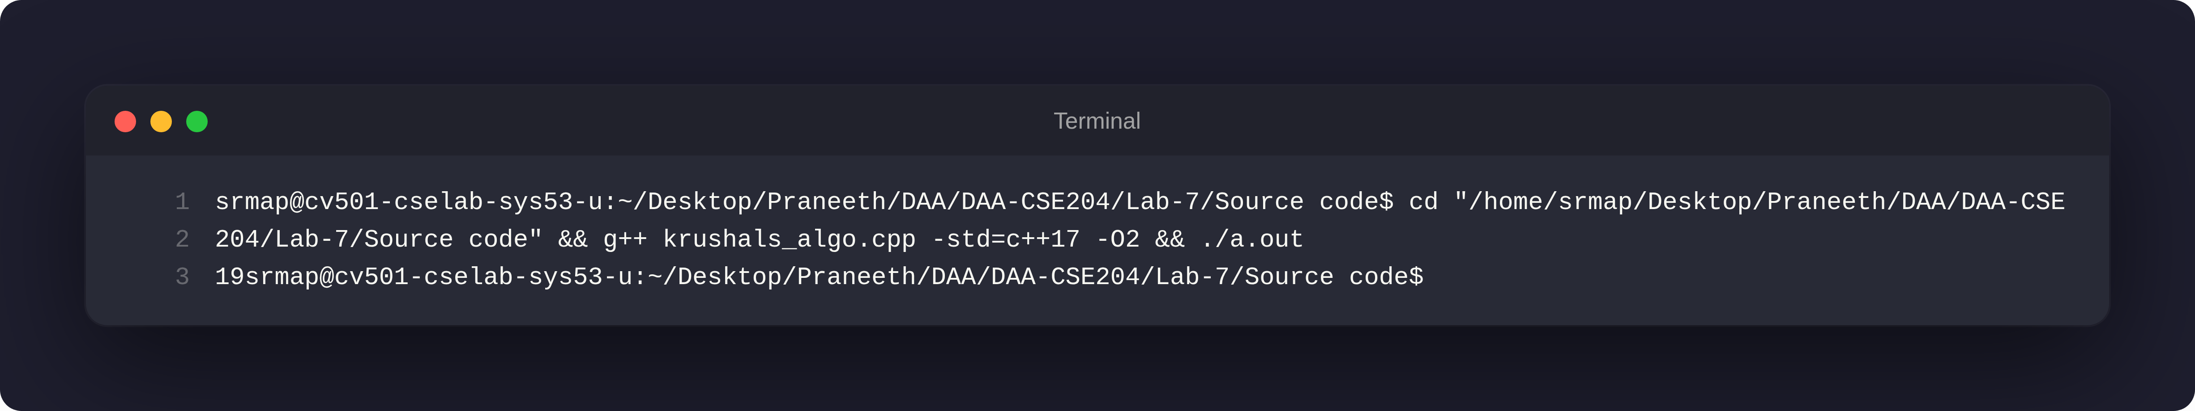

2. Prim's Algorithm
Prim's algorithm builds the minimum spanning tree incrementally by always extending the current tree with the minimum-weight edge to an unvisited vertex. It maintains a key array tracking the minimum cost to connect each vertex to the growing MST.

Time Complexity Derivation
With an adjacency matrix, finding the minimum key vertex requires O(V) time per iteration, and this occurs V times. Edge relaxation takes O(V²) in the worst case. Total: O(V²). With a min-heap, finding the minimum takes O(log V) per extraction, and we perform O(E) edge updates, giving O(E + V log V).
Time Complexity: O(V²) with adjacency matrix; O(E + V log V) with min-heap
Auxiliary Space Complexity: O(V²) for adjacency matrix; O(V + E) with adjacency list

Source Code
#include <climits>
#include <iostream>
#include <vector>
using namespace std;
int minKey(vector<int> &key, vector<bool> &mstSet) {
int min = INT_MAX;
int min_index = -1;
for (size_t v = 0; v < mstSet.size(); v++)
if (mstSet[v] == false && key[v] < min)
min = key[v], min_index = static_cast<int>(v);
return min_index;
}
void printMST(vector<int> &parent, vector<vector<int>> &graph) {
cout << "Edge \tWeight\n";
for (size_t i = 1; i < graph.size(); i++)
cout << parent[i] << " - " << i << " \t"
<< graph[parent[i]][i] << " \n";
}
void primMST(vector<vector<int>> &graph) {
int V = graph.size();
vector<int> parent(V);
vector<int> key(V);
vector<bool> mstSet(V);
for (int i = 0; i < V; i++)
key[i] = INT_MAX, mstSet[i] = false;
key[0] = 0;
parent[0] = -1;
for (int count = 0; count < V - 1; count++) {
int u = minKey(key, mstSet);
mstSet[u] = true;
for (int v = 0; v < V; v++)
if (graph[u][v] && mstSet[v] == false
&& graph[u][v] < key[v])
parent[v] = u, key[v] = graph[u][v];
}
printMST(parent, graph);
}
int main() {
vector<vector<int>> graph = { { 0, 2, 0, 6, 0 },
{ 2, 0, 3, 8, 5 },
{ 0, 3, 0, 0, 7 },
{ 6, 8, 0, 0, 9 },
{ 0, 5, 7, 9, 0 } };
primMST(graph);
return 0;
}

Output Screenshot
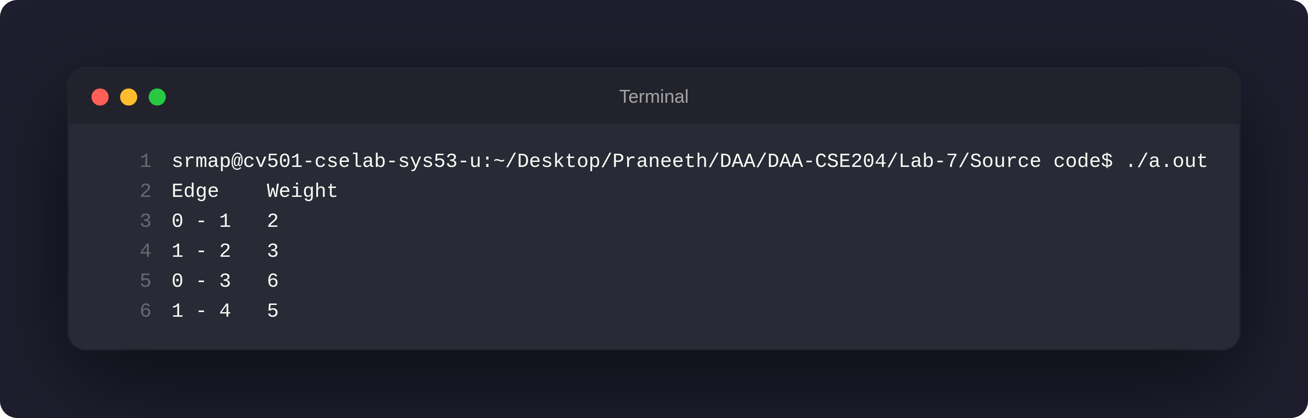

Algorithm Comparison
Aspect | Kruskal's | Prim's
Approach | Edge-centric: Sort edges, add greedily | Vertex-centric: Grow tree from start
Time Complexity | O(E log E) | O(V²) or O(E + V log V)
Best For | Sparse graphs (E ≪ V²) | Dense graphs (E ≈ V²)
Data Structure | Disjoint Set Union (DSU) | Priority Queue / Min-Heap
Graph Representation | Edge list | Adjacency matrix / list

