LAB – 5: SORTING TECHNIQUES
Design and Analysis of Algorithms

Name | Baratam Praneeth Gupta
Admission Number | AP25110010120
Subject Code | CSE 204
Git Repository | https://github.com/Praneeth0910/DAA-CSE204

This report contains the three sorting programs used for LAB-5, their time-complexity derivations, and the corresponding sample output screenshots.
Complexity Summary
Case | Time Complexity | Reason | Auxiliary Space
Merge Sort | O(n log n) | O(n log n) | O(n)
Bucket Sort | O(n) | O(n) under uniform distribution | O(n)
Quick Sort | O(n log n) | O(n log n) | O(n²)
Space notes: Merge Sort uses O(n) auxiliary space for the temporary merged array plus O(log n) recursion stack. Bucket Sort uses O(n) auxiliary space for the buckets. Quick Sort uses O(log n) recursion space for balanced partitions and O(n) in the worst recursion depth.
1. Merge Sort
Merge Sort follows the divide-and-conquer strategy. The array is divided into two halves, each half is sorted recursively, and the sorted halves are merged.
Time Complexity Derivation
Let T(n) be the running time for n elements.
Dividing the array takes O(1) time.
The two recursive calls contribute 2T(n/2).
Merging the two sorted halves scans all n elements and takes O(n) time.
Therefore, T(n) = 2T(n/2) + O(n).
There are log₂(n) levels, and each level performs O(n) total work.
Time complexity: Best case O(n log n), Average case O(n log n), Worst case O(n log n).
Auxiliary space complexity: O(n) for the temporary merged array and O(log n) recursion stack.
Source Code
#include <iostream>
#include <vector>

using namespace std;

void merge(vector<int>& values, int left, int middle, int right) {
vector<int> merged;
int first = left;
int second = middle + 1;

while (first <= middle && second <= right) {
if (values[first] <= values[second]) {
merged.push_back(values[first++]);
} else {
merged.push_back(values[second++]);
}
}

while (first <= middle) {
merged.push_back(values[first++]);
}

while (second <= right) {
merged.push_back(values[second++]);
}

for (int index = 0; index < static_cast<int>(merged.size()); ++index) {
values[left + index] = merged[index];
}
}

void mergeSort(vector<int>& values, int left, int right) {
if (left >= right) {
return;
}

int middle = left + (right - left) / 2;
mergeSort(values, left, middle);
mergeSort(values, middle + 1, right);
merge(values, left, middle, right);
}

void display(const vector<int>& values) {
for (int value : values) {
cout << value << ' ';
}
cout << '\n';
}

int main() {
int size;

cout << "Enter number of elements: ";
cin >> size;
if (!cin || size < 0) {
cerr << "Number of elements must be non-negative.\n";
return 1;
}

vector<int> values(size);
cout << "Enter " << size << " array elements: ";
for (int& value : values) {
cin >> value;
if (!cin) {
cerr << "Invalid array element.\n";
return 1;
}
}

cout << "Array before sorting: ";
display(values);

if (!values.empty()) {
mergeSort(values, 0, size - 1);
}

cout << "Array after sorting: ";
display(values);

return 0;
}
Sample Output
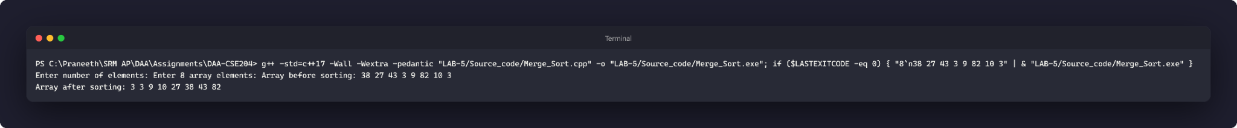
2. Bucket Sort
Bucket Sort distributes elements into buckets based on their values. Each bucket is sorted using std::sort, and the buckets are concatenated to form the final sorted array.
Time Complexity Derivation
Let n be the number of elements and k be the number of buckets. This implementation uses k = n buckets.
Finding the minimum and maximum values takes O(n) time.
Distributing all elements into buckets takes O(n) time.
Sorting bucket i with bᵢ elements takes O(bᵢ log bᵢ) using std::sort.
The total sorting cost is Σ O(bᵢ log bᵢ), where Σbᵢ = n.
For an even distribution, the expected cost is O(n), so the average time complexity is O(n).
If all elements fall into one bucket, the comparison sort costs O(n log n), giving the worst case O(n log n).
Best case for this implementation: O(n) when buckets contain at most one element; Average case: O(n) under uniform distribution; Worst case: O(n log n).
Auxiliary space complexity: O(n) for the buckets.
Source Code
#include <algorithm>
#include <iostream>
#include <vector>

using namespace std;

void bucketSort(vector<int>& values) {
if (values.size() < 2) {
return;
}

int minimum = values[0];
int maximum = values[0];
for (int value : values) {
minimum = min(minimum, value);
maximum = max(maximum, value);
}

long long range = static_cast<long long>(maximum) - minimum + 1;
int bucketCount = static_cast<int>(values.size());
vector<vector<int>> buckets(bucketCount);

for (int value : values) {
long long offset = static_cast<long long>(value) - minimum;
int bucketIndex = static_cast<int>(offset * bucketCount / range);
if (bucketIndex == bucketCount) {
bucketIndex--;
}
buckets[bucketIndex].push_back(value);
}

int index = 0;
for (vector<int>& bucket : buckets) {
sort(bucket.begin(), bucket.end());
for (int value : bucket) {
values[index++] = value;
}
}
}

void display(const vector<int>& values) {
for (int value : values) {
cout << value << ' ';
}
cout << '\n';
}

int main() {
int size;

cout << "Enter number of elements: ";
cin >> size;
if (!cin || size < 0) {
cerr << "Number of elements must be non-negative.\n";
return 1;
}

vector<int> values(size);
cout << "Enter " << size << " array elements: ";
for (int& value : values) {
cin >> value;
if (!cin) {
cerr << "Invalid array element.\n";
return 1;
}
}

cout << "Array before sorting: ";
display(values);

bucketSort(values);

cout << "Array after sorting: ";
display(values);

return 0;
}
Sample Output
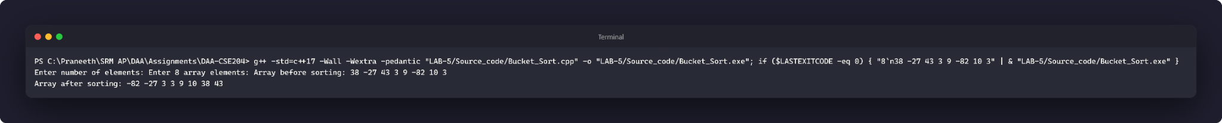
3. Quick Sort
Quick Sort selects the last element as the pivot, partitions the array around the pivot, and recursively sorts the two resulting subarrays.
Time Complexity Derivation
Let T(n) be the running time for n elements.
Partitioning scans the subarray once and takes O(n) time.
With a balanced pivot, T(n) = 2T(n/2) + O(n), which gives O(n log n).
With the last-element pivot, already sorted or reverse-sorted input can produce subarrays of sizes n − 1 and 0.
The unbalanced recurrence is T(n) = T(n − 1) + O(n) = O(n²).
Time complexity: Best case O(n log n), Average case O(n log n), Worst case O(n²).
Auxiliary space complexity: O(log n) on balanced recursion; O(n) in the worst recursion depth.
Source Code
#include <iostream>
#include <vector>

using namespace std;

int partition(vector<int>& values, int low, int high) {
int pivot = values[high];
int smaller = low;

for (int index = low; index < high; ++index) {
if (values[index] <= pivot) {
swap(values[smaller], values[index]);
++smaller;
}
}

swap(values[smaller], values[high]);
return smaller;
}

void quickSort(vector<int>& values, int low, int high) {
if (low >= high) {
return;
}

int pivotIndex = partition(values, low, high);
quickSort(values, low, pivotIndex - 1);
quickSort(values, pivotIndex + 1, high);
}

void display(const vector<int>& values) {
for (int value : values) {
cout << value << ' ';
}
cout << '\n';
}

int main() {
int size;

cout << "Enter number of elements: ";
cin >> size;
if (!cin || size < 0) {
cerr << "Number of elements must be non-negative.\n";
return 1;
}

vector<int> values(size);
cout << "Enter " << size << " array elements: ";
for (int& value : values) {
cin >> value;
if (!cin) {
cerr << "Invalid array element.\n";
return 1;
}
}

cout << "Array before sorting: ";
display(values);

if (!values.empty()) {
quickSort(values, 0, size - 1);
}

cout << "Array after sorting: ";
display(values);

return 0;
}
Sample Output
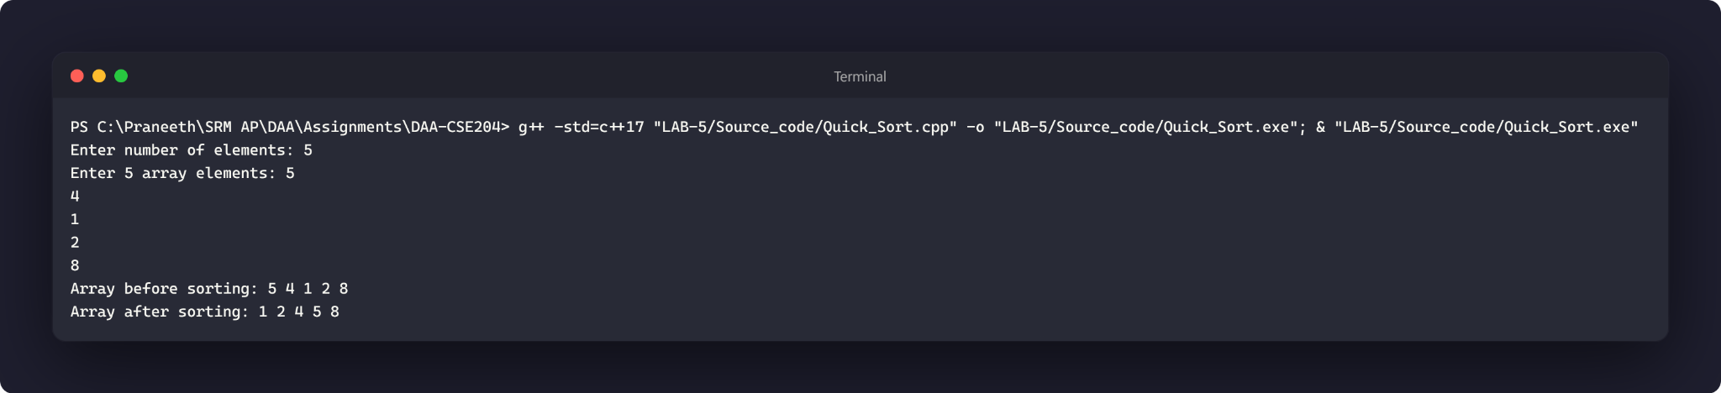
Conclusion
The three sorting techniques were implemented and tested using the supplied source files. Merge Sort provides O(n log n) time in all cases, Bucket Sort can achieve linear expected time under uniform distribution for this implementation, and Quick Sort has O(n log n) best/average performance but can degrade to O(n²) with unfavorable pivot partitions.

