LAB – 6: DIVIDE AND CONQUER AND GREEDY ALGORITHMS
Design and Analysis of Algorithms

Name | Baratam Praneeth Gupta
Admission Number | AP25110010120
Subject Code | CSE 204
Git Repository | https://github.com/Praneeth0910/DAA-CSE204

This report contains the four divide-and-conquer and greedy programs used for LAB-6, their time-complexity derivations, and the corresponding sample output screenshots.
Complexity Summary
Algorithm | Time Complexity | Reason | Auxiliary Space
Max-Min (D&C) | O(n) | T(n) = 2T(n/2) + O(1) | O(log n)
Maximum Subarray (D&C) | O(n log n) | T(n) = 2T(n/2) + O(n) | O(log n)
Strassen's Multiplication | O(n^2.807) | T(n) = 7T(n/2) + O(n²) | O(n²)
Fractional Knapsack (Greedy) | O(n log n) | Sorting dominates | O(n)
Space notes: Max-Min and Maximum Subarray use O(log n) recursion stack space in addition to the input array. Strassen’s algorithm uses O(n²) auxiliary space for temporary block matrices. Fractional Knapsack uses O(n) space for the item list, with sorting dominating the running time.
1. Maximum and Minimum Using Divide and Conquer
The array is divided into two halves recursively. Each half returns its minimum and maximum, and the two results are combined with two comparisons.
Time Complexity Derivation
Let T(n) be the running time for n elements.
Dividing the array takes O(1) time.
The two recursive calls contribute 2T(n/2).
Combining the two halves takes O(1) time using two comparisons.
Therefore, T(n) = 2T(n/2) + O(1).
By the Master theorem, this recurrence solves to O(n).
Time complexity: Best case O(n), Average case O(n), Worst case O(n).
Auxiliary space complexity: O(log n) recursion stack.
A traditional one-pass approach also takes O(n) time and O(1) extra space. Divide and conquer is not asymptotically faster here; its advantage is the clear recursive structure and the ability to process independent subarrays in parallel.
Source Code
#include <algorithm>
#include <iostream>
#include <vector>

using namespace std;

struct MinMax {
long long minimum;
long long maximum;
};

MinMax findMinMax(const vector<long long>& values, int left, int right) {
if (left == right) {
return {values[left], values[left]};
}

if (right == left + 1) {
if (values[left] < values[right]) {
return {values[left], values[right]};
}
return {values[right], values[left]};
}

int middle = left + (right - left) / 2;
MinMax firstHalf = findMinMax(values, left, middle);
MinMax secondHalf = findMinMax(values, middle + 1, right);

return {
min(firstHalf.minimum, secondHalf.minimum),
max(firstHalf.maximum, secondHalf.maximum)
};
}

int main() {
int size;

cout << "Enter number of elements: ";
cin >> size;
if (!cin || size <= 0) {
cerr << "Number of elements must be positive.\n";
return 1;
}

vector<long long> values(size);
cout << "Enter " << size << " array elements: ";
for (long long& value : values) {
cin >> value;
if (!cin) {
cerr << "Invalid array element.\n";
return 1;
}
}

MinMax result = findMinMax(values, 0, size - 1);
cout << "Minimum element: " << result.minimum << '\n';
cout << "Maximum element: " << result.maximum << '\n';

return 0;
}
Sample Output
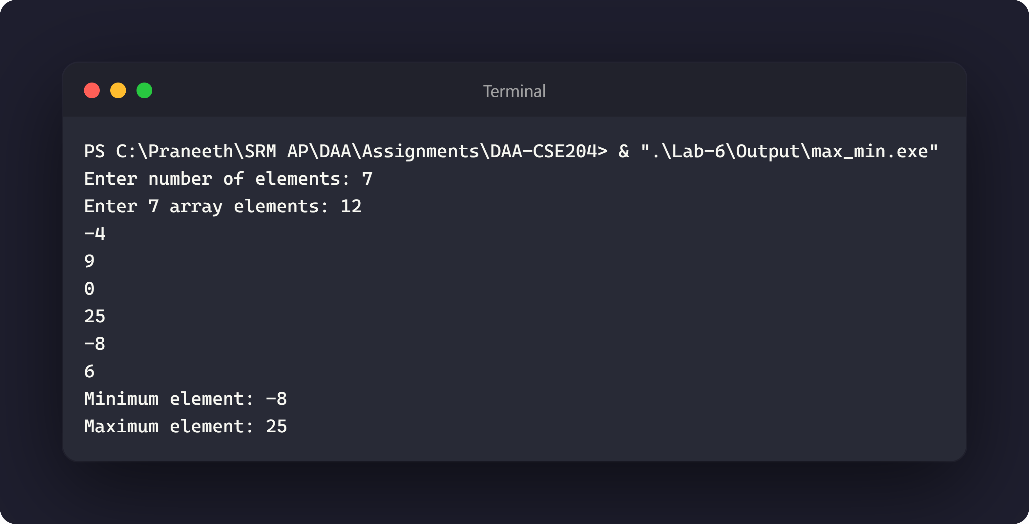
2. Maximum-Subarray Problem
The best subarray is either completely in the left half, completely in the right half, or crosses the midpoint. The crossing result is found by scanning outward from the midpoint.
Time Complexity Derivation
Let T(n) be the running time for n elements.
Solving the left and right halves recursively contributes 2T(n/2).
Finding the best crossing subarray scans all n elements and takes O(n) time.
Therefore, T(n) = 2T(n/2) + O(n).
There are log₂(n) levels, and each level performs O(n) total work, giving O(n log n).
Time complexity: Best case O(n log n), Average case O(n log n), Worst case O(n log n).
Auxiliary space complexity: O(log n) recursion stack.
The implementation also reports the sum and the 1-based start and end positions. Kadane’s algorithm solves the same problem in O(n) time and O(1) extra space, so the divide-and-conquer version is mainly useful for demonstrating the strategy and for extensions where subproblem results are combined.
Source Code
#include <iostream>
#include <limits>
#include <vector>

using namespace std;

struct SubarrayResult {
long long sum;
int left;
int right;
};

SubarrayResult bestCrossingSubarray(
const vector<long long>& values,
int left,
int middle,
int right
) {
long long leftSum = numeric_limits<long long>::lowest();
long long currentSum = 0;
int bestLeft = middle;

for (int index = middle; index >= left; --index) {
currentSum += values[index];
if (currentSum > leftSum) {
leftSum = currentSum;
bestLeft = index;
}
}

long long rightSum = numeric_limits<long long>::lowest();
currentSum = 0;
int bestRight = middle + 1;

for (int index = middle + 1; index <= right; ++index) {
currentSum += values[index];
if (currentSum > rightSum) {
rightSum = currentSum;
bestRight = index;
}
}

return {leftSum + rightSum, bestLeft, bestRight};
}

SubarrayResult maximumSubarray(
const vector<long long>& values,
int left,
int right
) {
if (left == right) {
return {values[left], left, right};
}

int middle = left + (right - left) / 2;
SubarrayResult leftResult = maximumSubarray(values, left, middle);
SubarrayResult rightResult = maximumSubarray(values, middle + 1, right);
SubarrayResult crossingResult = bestCrossingSubarray(values, left, middle, right);

if (leftResult.sum >= rightResult.sum && leftResult.sum >= crossingResult.sum) {
return leftResult;
}
if (rightResult.sum >= crossingResult.sum) {
return rightResult;
}
return crossingResult;
}

int main() {
int size;

cout << "Enter number of elements: ";
cin >> size;
if (!cin || size <= 0) {
cerr << "Number of elements must be positive.\n";
return 1;
}

vector<long long> values(size);
cout << "Enter " << size << " array elements: ";
for (long long& value : values) {
cin >> value;
if (!cin) {
cerr << "Invalid array element.\n";
return 1;
}
}

SubarrayResult result = maximumSubarray(values, 0, size - 1);
cout << "Maximum subarray sum: " << result.sum << '\n';
cout << "Subarray (1-based positions): ";
for (int index = result.left; index <= result.right; ++index) {
cout << values[index] << (index == result.right ? '\n' : ' ');
}
cout << "Starting position: " << result.left + 1 << '\n';
cout << "Ending position: " << result.right + 1 << '\n';

return 0;
}
Sample Output
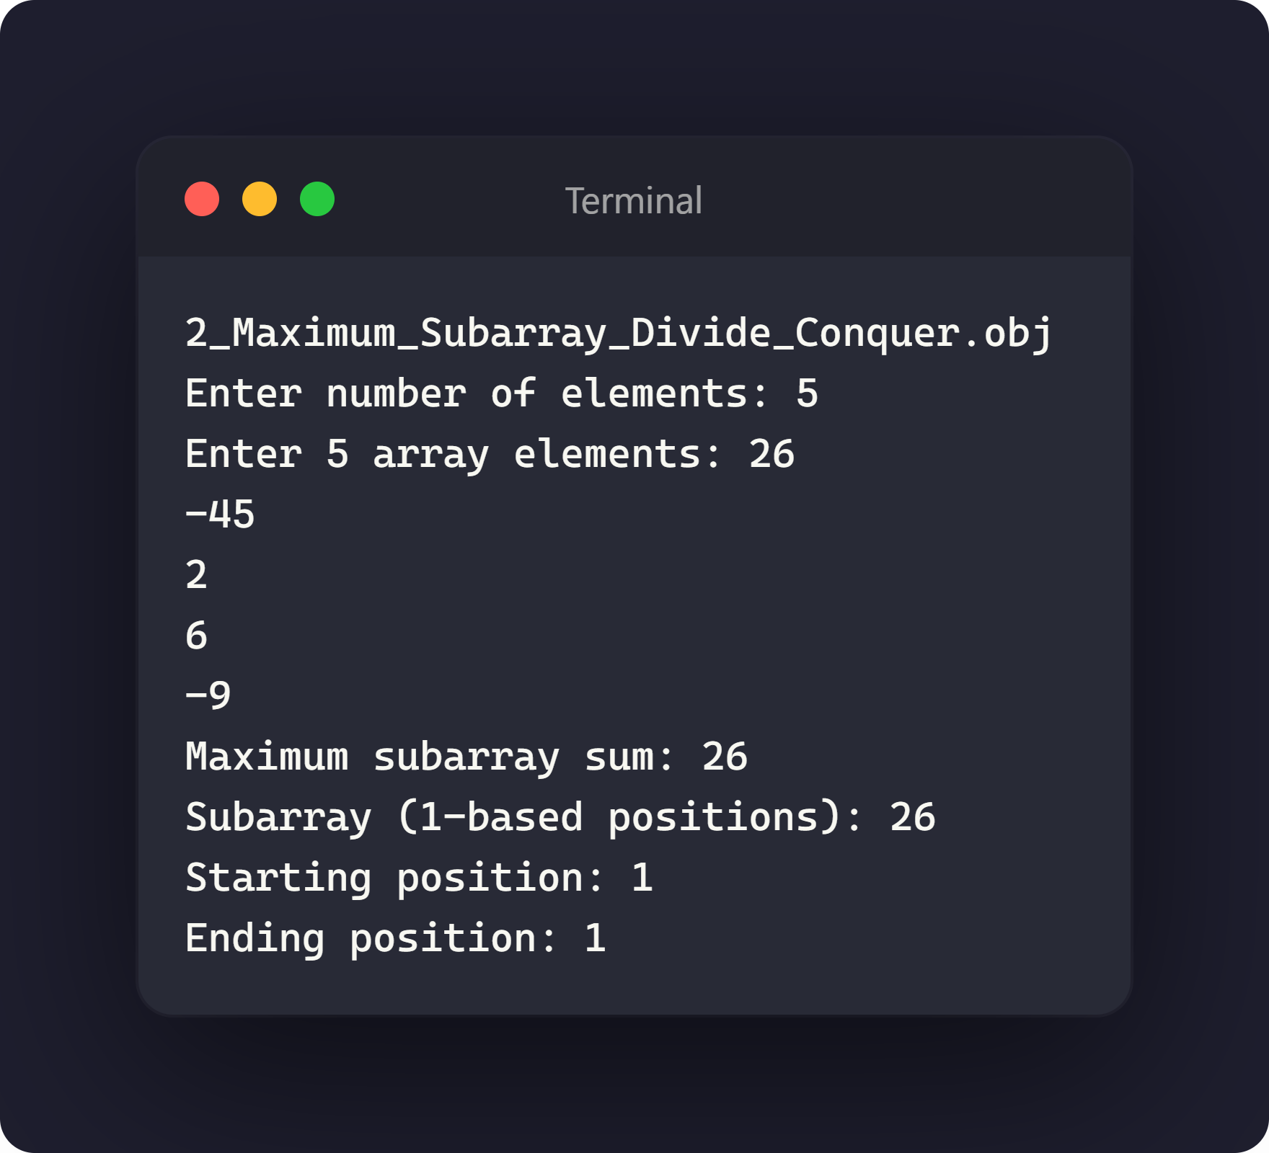
3. Strassen's Matrix Multiplication
Strassen’s method divides each matrix into four blocks. It computes seven recursive products instead of the eight products used by the direct block multiplication method, then combines them with additions and subtractions.
Time Complexity Derivation
Let T(n) be the running time for an n × n matrix multiplication.
Splitting each matrix into four (n/2) × (n/2) blocks takes O(1) time.
Seven recursive multiplications of (n/2) × (n/2) matrices contribute 7T(n/2).
Combining the seven products with additions and subtractions takes O(n²) time.
Therefore, T(n) = 7T(n/2) + O(n²).
By the Master theorem, this recurrence solves to O(n^log₂ 7) ≈ O(n^2.807).
Time complexity: Best case O(n^2.807), Average case O(n^2.807), Worst case O(n^2.807).
Auxiliary space complexity: O(n²) for the temporary block matrices at each recursion level.
Normal triple-loop multiplication takes O(n³) time, so Strassen’s algorithm has a better asymptotic running time for sufficiently large matrices. It performs extra additions, uses more temporary memory, and can have numerical or implementation overhead, so ordinary multiplication can still be faster for small matrices. The program pads a non-power-of-two order with zeros and displays only the requested portion of the product.
Source Code
#include <iostream>
#include <vector>

using namespace std;
using Matrix = vector<vector<long long>>;

Matrix add(const Matrix& first, const Matrix& second, int sign) {
int size = static_cast<int>(first.size());
Matrix result(size, vector<long long>(size));

for (int row = 0; row < size; ++row) {
for (int column = 0; column < size; ++column) {
result[row][column] = first[row][column] + sign * second[row][column];
}
}
return result;
}

Matrix strassenMultiply(const Matrix& first, const Matrix& second) {
int size = static_cast<int>(first.size());
Matrix result(size, vector<long long>(size, 0));

if (size == 1) {
result[0][0] = first[0][0] * second[0][0];
return result;
}

int half = size / 2;
Matrix first11(half, vector<long long>(half));
Matrix first12(half, vector<long long>(half));
Matrix first21(half, vector<long long>(half));
Matrix first22(half, vector<long long>(half));
Matrix second11(half, vector<long long>(half));
Matrix second12(half, vector<long long>(half));
Matrix second21(half, vector<long long>(half));
Matrix second22(half, vector<long long>(half));

for (int row = 0; row < half; ++row) {
for (int column = 0; column < half; ++column) {
first11[row][column] = first[row][column];
first12[row][column] = first[row][column + half];
first21[row][column] = first[row + half][column];
first22[row][column] = first[row + half][column + half];
second11[row][column] = second[row][column];
second12[row][column] = second[row][column + half];
second21[row][column] = second[row + half][column];
second22[row][column] = second[row + half][column + half];
}
}

Matrix product1 = strassenMultiply(add(first11, first22, 1), add(second11, second22, 1));
Matrix product2 = strassenMultiply(add(first21, first22, 1), second11);
Matrix product3 = strassenMultiply(first11, add(second12, second22, -1));
Matrix product4 = strassenMultiply(first22, add(second21, second11, -1));
Matrix product5 = strassenMultiply(add(first11, first12, 1), second22);
Matrix product6 = strassenMultiply(add(first21, first11, -1), add(second11, second12, 1));
Matrix product7 = strassenMultiply(add(first12, first22, -1), add(second21, second22, 1));

Matrix result11 = add(add(add(product1, product4, 1), product5, -1), product7, 1);
Matrix result12 = add(product3, product5, 1);
Matrix result21 = add(product2, product4, 1);
Matrix result22 = add(add(add(product1, product3, 1), product2, -1), product6, 1);

for (int row = 0; row < half; ++row) {
for (int column = 0; column < half; ++column) {
result[row][column] = result11[row][column];
result[row][column + half] = result12[row][column];
result[row + half][column] = result21[row][column];
result[row + half][column + half] = result22[row][column];
}
}
return result;
}

void printMatrix(const Matrix& matrix) {
for (const vector<long long>& row : matrix) {
for (long long value : row) {
cout << value << ' ';
}
cout << '\n';
}
}

int nextPowerOfTwo(int value) {
int power = 1;
while (power < value) {
power *= 2;
}
return power;
}

int main() {
int size;

cout << "Enter the order of square matrices: ";
cin >> size;
if (!cin || size <= 0) {
cerr << "Matrix order must be positive.\n";
return 1;
}

int paddedSize = nextPowerOfTwo(size);
Matrix first(paddedSize, vector<long long>(paddedSize, 0));
Matrix second(paddedSize, vector<long long>(paddedSize, 0));

cout << "Enter the first matrix:\n";
for (int row = 0; row < size; ++row) {
for (int column = 0; column < size; ++column) {
cin >> first[row][column];
if (!cin) {
cerr << "Invalid matrix element.\n";
return 1;
}
}
}

cout << "Enter the second matrix:\n";
for (int row = 0; row < size; ++row) {
for (int column = 0; column < size; ++column) {
cin >> second[row][column];
if (!cin) {
cerr << "Invalid matrix element.\n";
return 1;
}
}
}

Matrix product = strassenMultiply(first, second);
Matrix displayedProduct(size, vector<long long>(size));
for (int row = 0; row < size; ++row) {
for (int column = 0; column < size; ++column) {
displayedProduct[row][column] = product[row][column];
}
}

cout << "Product matrix using Strassen's algorithm:\n";
printMatrix(displayedProduct);

return 0;
}
Sample Output
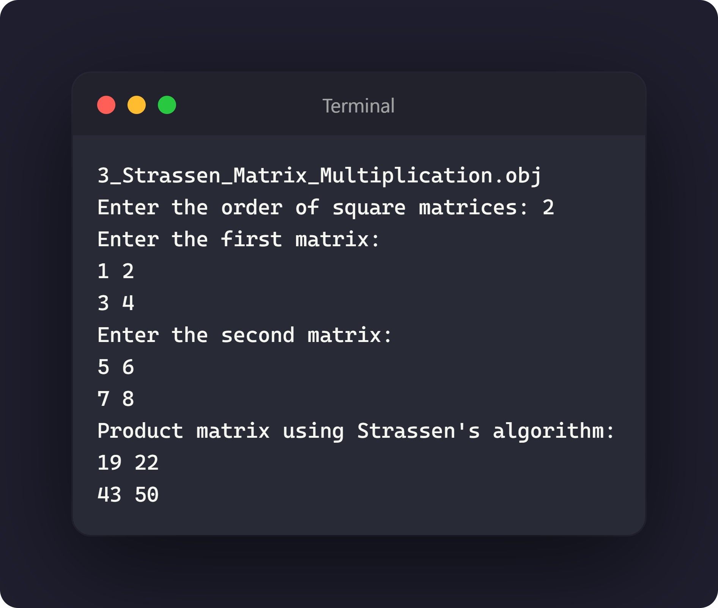
4. Fractional Knapsack Using a Greedy Approach
Each item is sorted by value-to-weight ratio in descending order. The algorithm takes as much as possible from the best remaining ratio, allowing the final item to be fractional.
Time Complexity Derivation
Let n be the number of items.
Sorting the items by value-to-weight ratio takes O(n log n) time.
Selecting items greedily and filling the capacity scans the sorted list once and takes O(n) time.
Therefore, total time = O(n log n) + O(n) = O(n log n).
Sorting dominates the running time.
Time complexity: Best case O(n log n), Average case O(n log n), Worst case O(n log n).
Auxiliary space complexity: O(n) for the item list.
This greedy choice is optimal because every unit of remaining capacity is assigned to the highest available value per unit weight. Unlike 0/1 knapsack, fractional knapsack permits splitting items; the same greedy strategy is not generally optimal when items must be taken whole.
Source Code
#include <algorithm>
#include <iomanip>
#include <iostream>
#include <vector>

using namespace std;

struct Item {
double value;
double weight;
};

bool compareByRatio(const Item& first, const Item& second) {
return first.value / first.weight > second.value / second.weight;
}

double fractionalKnapsack(vector<Item>& items, double capacity) {
sort(items.begin(), items.end(), compareByRatio);
double totalValue = 0.0;

for (const Item& item : items) {
if (capacity == 0.0) {
break;
}

double selectedWeight = min(item.weight, capacity);
totalValue += selectedWeight * item.value / item.weight;
capacity -= selectedWeight;
}

return totalValue;
}

int main() {
int numberOfItems;
double capacity;

cout << "Enter number of items: ";
cin >> numberOfItems;
if (!cin || numberOfItems < 0) {
cerr << "Number of items must be non-negative.\n";
return 1;
}

cout << "Enter knapsack capacity: ";
cin >> capacity;
if (!cin || capacity < 0.0) {
cerr << "Capacity must be non-negative.\n";
return 1;
}

vector<Item> items(numberOfItems);
cout << "Enter value and weight for each item:\n";
for (Item& item : items) {
cin >> item.value >> item.weight;
if (!cin || item.value < 0.0 || item.weight <= 0.0) {
cerr << "Each item must have a non-negative value and positive weight.\n";
return 1;
}
}

double maximumValue = fractionalKnapsack(items, capacity);
cout << fixed << setprecision(2);
cout << "Maximum value in the knapsack: " << maximumValue << '\n';

return 0;
}
Sample Output
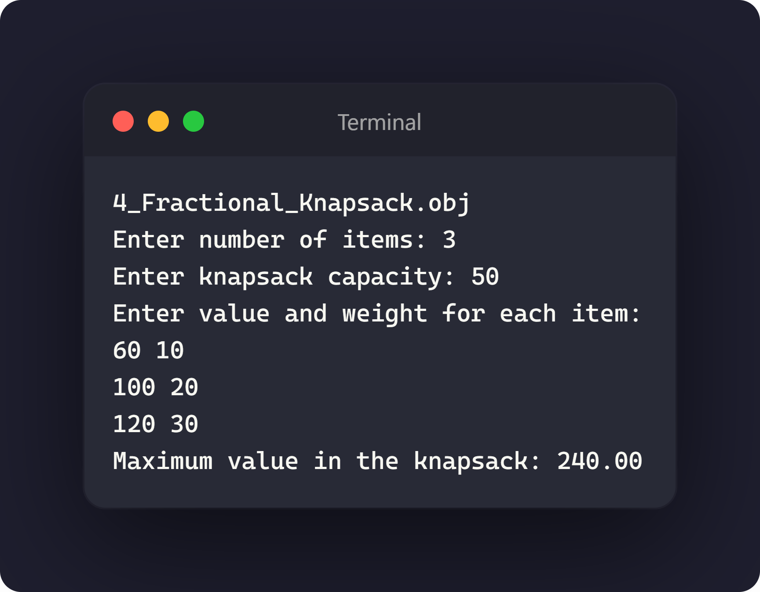
Conclusion
The four algorithms were implemented and tested using the supplied source files. Max-Min and Maximum Subarray illustrate the divide-and-conquer paradigm without necessarily improving on simpler linear or single-pass approaches, Strassen’s algorithm demonstrates how reducing the number of recursive multiplications yields a better asymptotic bound than standard O(n³) multiplication, and Fractional Knapsack shows a greedy strategy that is provably optimal whenever items can be split.

