**Kubernetes Environment Setup**

1. Setup Docker
   1. <https://www.digitalocean.com/community/tutorials/how-to-install-and-use-docker-on-ubuntu-20-04>
2. Install and setup Kubectl
   1. curl -LO<https://dl.k8s.io/release/v1.22.0/bin/linux/amd64/kubectl>
   2. sudo install -o root -g root -m 0755 kubectl /usr/local/bin/kubectl
   3. Validate the installation of kubectl
      1. Kubectl version
3. Install and setup Kind
   1. curl -Lo ./kind <https://kind.sigs.k8s.io/dl/v0.11.1/kind-linux-amd64>
   2. chmod +x ./kind
   3. sudo mv ./kind /usr/local/bin/kind
   4. Validate installation
      1. Kind version
4. Create a single node cluster with kind
   1. kind create cluster --name testcluster
5. Use the cluster by giving following command
   1. kubectl cluster-info --context kind-testcluster
      1. 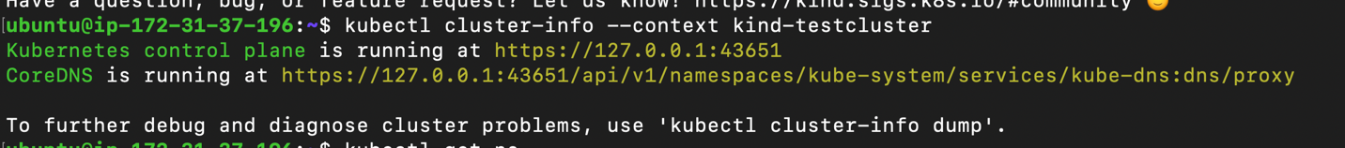
6. Validate by getting the namespaces
   1. Kubectl get ns
      1. Text

         Description automatically generated

Resources

<https://kodekloud.com/courses/kubernetes-for-the-absolute-beginners-hands-on/> BEGRES

<https://kodekloud.com/courses/certified-kubernetes-administrator-cka/> ADVRES

1. Introduction to Kubernetes
   1. BEGRES/Kubernetes Overview/Container Orchestration
   2. BEGRES/Kubernetes Overview/Kubernetes Architecture
   3. ADVRES/Core Concepts/Cluster Architecture
2. Working with Kubernetes Pods, Replica sets and Deployments
   1. BEGRES/Kubernetes concepts – Pods, Replica Sets, Deployments
3. Working with Kubernetes Environment Variables, Config maps, Secrets and volumes
   1. ADVRES/Application Life Cycle Management/Configure Environment Variables in Applications
   2. ADVRES/Application Life Cycle Management/Configure Config Map in Applications
   3. ADVRES/Application Life Cycle Management/secrets
   4. ADVRES/Storage/Volumes
   5. ADVRES/Storage/Persistent Volumes
   6. ADVRES/Persistent Volume Claims
   7. ADVRES/Using PVC in PODs
4. Kubernetes Networking, Services and Ingress
   1. BEGRES/Networking in Kubernetes
   2. BEGRES/Services
   3. ADVRES/Networking/Ingress
5. Helm Charts
   1. <https://www.youtube.com/watch?v=-ykwb1d0DXU>