#Install Minikube cluster on Windows through Command Line

winget install Kubernetes.minikube

#Start your cluster through docker

#Takes time as necessary images and dependcies are installed

minikube start --driver docker

minikube status

Kubectl get node

#Minikube runs either on container or virtual machine - so need to have either Docker runtime software or VM

#Minikube has docker preinstalled to run containers in cluser

#Therefore there are 2 layers of Dockers - 1. Minikube runs as docker container; 2. Docker inside Minikube to run our application container

#Kubectl to configure deployment while minikubectl is for creating/deleting clusters

**Project: Deploying MongoDB+WebApp in kubernetes**

#Create mongo-config.yaml file

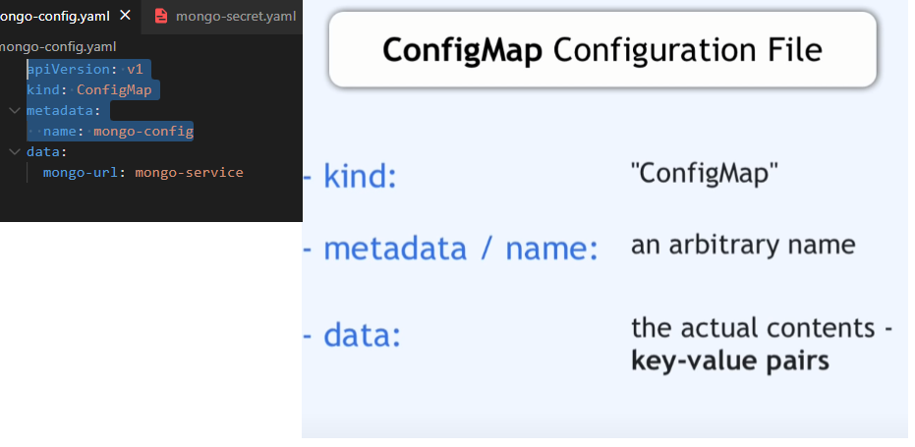

#Create mongo-secret.yaml file

#username & password should be baseencoded –

# echo -n mongouser | base64 –> bW9uZ291c2Vy

# echo -n mongopassword | base64 –> bW9uZ29wYXNzd29yZA==

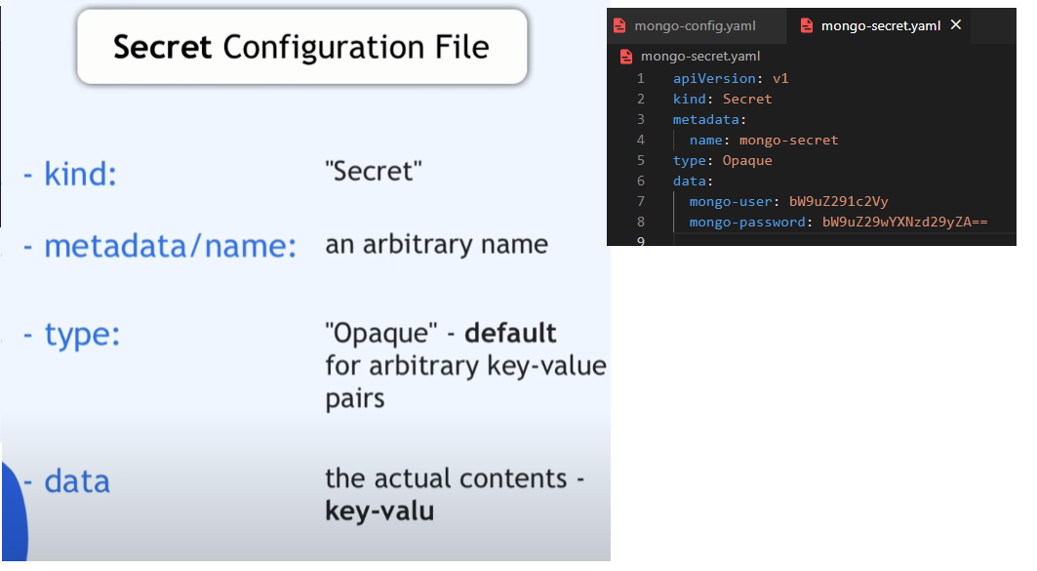

#Create mongo.yaml file for deployment

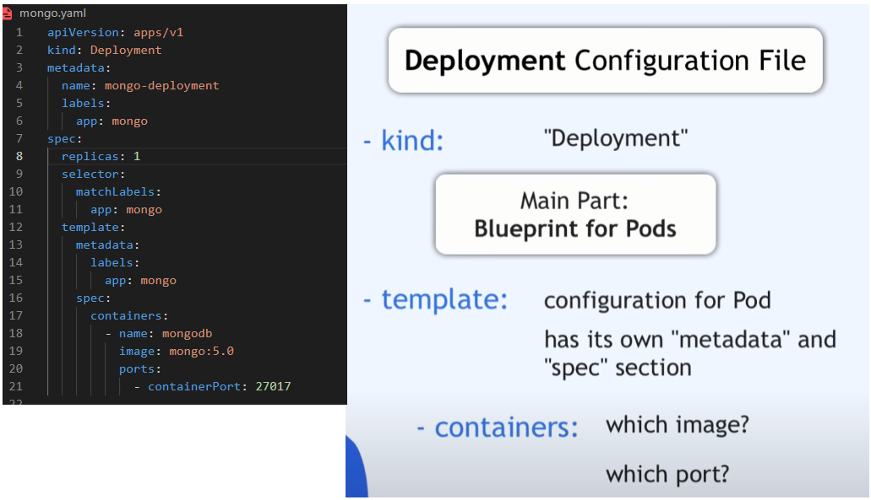

Secrets

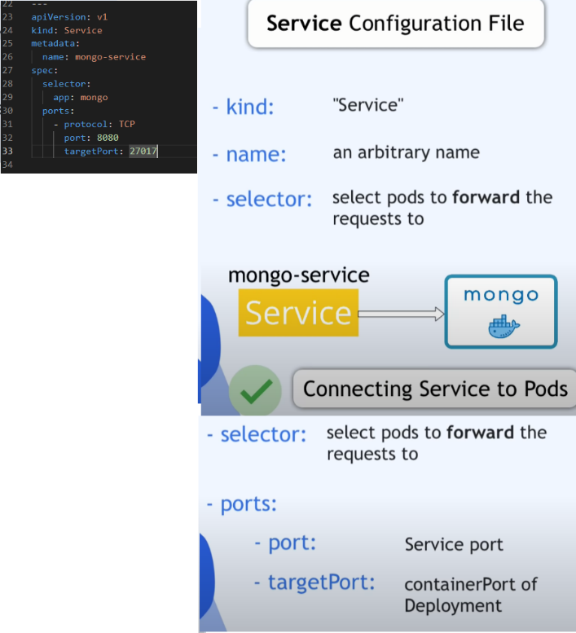

Create deployment for web app as well

Then configure environments to passdown info that the deployments will need (connecting to ConfigMap, Secrets)

Make it accessible to external using Nodeport type in Service (Ports should be bw 30000-32767)

#Now that everything is setup

#Open Terminal – sicne minkube is already running

#Config and Secrets need to be mapped before Deployment

kubectl apply -f mongo-config.yaml

kubectl apply -f mongo.yaml

kubectl apply -f webapp.yaml

#Check status by

kubectl get all

#Debug -> kubectl logs {pod_name}

#Access app through webbrowser

#Get port+url by kubectl get svc -> Ports (but whats the main url?)

#it runs on the machine it was created on -> minikube ip (or) kubectl get node -o wide (gives internalIP) -> 192.168.49.2