A
MAJOR PROJECT REPORT
ON
Secure Internal Chat (Slack Clone)
Submitted in the partial fulfilment of the requirement for the award of the degree of

BACHELOR OF TECHNOLOGY
IN
COMPUTER SCIENCE AND BUSINESS SYSTEM
By

P. Rahul 22P61A3246
D. Karthik 22P61A3218
C. Akshitha 22P61A3214
Under the esteemed guidance of
Mrs. P. Sree Lakshmi
Assistant Professor Dept.of CSBS

VIGNANA BHARATHI INSTITUTE OF TECHNOLOGY
(A UGC Autonomous Institution, Approved by AICTE, Affiliated to JNTUH,Accredited by NBA & NAAC) Aushapur (V), Ghatkesar (M), Medchal(dist.))
JANUARY – 2026


DEPARTMENT OF

COMPUTER SCIENCE AND BUSINESS SYSTEM

CERTIFICATE

This is to certify that the major project titled “Secure Internal Chat (Slack Clone)”submitted by P.Rahul (22P61A3246), D.Karthik (22P61A3218) C.Akshitha (22P61A3214) in B.Tech IV-II semester of Computer Science and Business System is a record of the bonafide work carried out by them.
The results embodied in this report have not been submitted to any other University for the award of any degree.

INTERNAL GUIDE THE
Mrs. P. Sree Lakshmi HEAD OF DEPARTMENT Dr. G Swamy

EXTERNAL EXAMINER

DECLARATION

We, P.Rahul ,D.Karthik, C.Akshitha bearing hall ticket numbers (22P61A3246, 22P61A3218, 22P61A3214) hereby declare that the major project report entitled “Secure Internal Chat (Slack Clone)” under the guidance of Mrs. P Sree Lakshmi, Assistant Professor, Department of Computer Science and Business System, Vignana Bharathi Institute of Technology, Hyderabad, have submitted to Jawaharlal Nehru Technological University Hyderabad, Kukatpally, in partial fulfillment of the requirements for the award of the degree of Bachelor of Technology in Computer Science and Business System.
This is a record of bonafide work carried out by us and the results embodied in this project have not been reproduced or copied from any source. The results embodied in this project report have not been submitted to any other university or institute for the award of any other degree or diploma.

C.Akshitha(22P61A3214)
D.Karthik (22P61A3218)
P.Rahul (22P61A3246)

ACKNOWLEDGEMENT

We are extremely thankful to our beloved Chairman, Dr. N. Goutham Rao and Secretary, Dr. G. Manohar Reddy who took keen interest to provide us the infrastructural facilities for carrying out the project work.
We would like to express our indebtedness to the project coordinator, Mrs. M. Malini, Assistant Professor, Department of Computer Science and Business System, for her valuable guidance during the course of project work.
We thank our Project Guide, Mrs. P Sree Lakshmi Assistant Professor, Department of Computer Science and Business System for providing us with an excellent project and guiding us in completing our major project successfully.
We would like to express our sincere thanks to all the staff of Computer Science and Business System, VBIT, for their kind cooperation and timely help during the course of our project. Finally, we would like to thank our parents and friends who have always stood by us whenever we were in need of them.

ABOUT CSBS DEPARTMENT
Computer Science and Business System (CSBS) was established in the year 2020 with the aim of providing inclusive technology education to students from all over India and the world and thereby creating responsible citizens who would contribute to the betterment of their families, society and nation. The vision of CSE department is to emerge as a world class technology department through education, innovation and collaborative research. The department has progressed with a vision and a strong commitment to developing competent programmers with uncompromising standard of excellence in the training, both class room sessions and hands on sessions, given to students. The department has well equipped computing laboratories and a rich repository of software covering a wide spectrum of applications.
DEPARTMENT VISION AND MISSON
VISION
To become a centre for excellence with a focused research, innovation and to stand as an exemplary institute for Computer Science and Business System by enabling students to develop enthralling industrial and management skills.
MISSION
DM-1: Provide a rigorous theoretical and practical framework across state-of-the-art infrastructure with an emphasis on software development.
DM-2: Impart the skills necessary to amplify the pedagogy to grow technically and to meet interdisciplinary needs with collaborations and innovative research abilities and societal needs.
DM-3: To develop globally competent engineers with excellent managerial skills to become leaders and entrepreneurs through quality pedagogy.
DM-4: To evolve as a center of excellence in the field of interdisciplinary engineering research and practice.

PROGRAM EDUCATIONAL OBJECTIVES (PEOs)
PEO 1. Domain Knowledge: Synthesize mathematics, science, engineering fundamentals, pragmatic programming concepts to formulate and solve engineering problems using prevalent and prominent software.
PEO 2. Professional Employment: Succeed at entry-level engineering positions in the software industries and government agencies.
PEO 3. Higher Degrees: Succeed in the pursuit of higher degrees in engineering or other by applying mathematics, science, and engineering Fundamentals.
PEO 4. Engineering Citizenship: Communicate and work effectively on team-based engineering projects and practices the ethics of the profession, consistent with a sense of social responsibility.
PEO 5. Lifelong Learning: Recognize the Significance of independent learning to become experts in chosen fields and broaden professional knowledge.
PROGRAM SPECIFIC OUTCOMES (PSOs)
PSO-1: Analyze various networking concepts and also aware of how security policies, standards and practices are used for trouble-shooting.
PSO-2: To incorporate ethical values and professional standards with soft-skills in computer science and business disciplines for enabling students to emerge as an entrepreneur in the society.
PSO-3: To Inculcate Proactive thinking to ensure effective performance in the dynamic, socioeconomic and business ecosystem.
PROGRAM OUTCOMES (POs)
Engineering graduates will be able to:
PO-01: Engineering Knowledge: Apply the knowledge of mathematics, science, engineering fundamentals, and an engineering specialization to the solution of complex engineering problems.
PO-02: Problem Analysis: Identify, formulate, review research literature, and analyze complex engineering problems reaching substantiated conclusions using first principles of mathematics, natural sciences, and engineering sciences.

PO-03: Design/development of solutions: Design solutions for complex engineering problems and design system components or processes that meet the specified needs with appropriate consideration for the public health and safety, and the cultural, and environmental considerations.
PO-04: Conduct investigations of complex problems: Use research-based knowledge and research methods including design of experiments, analysis and interpretation of data, and synthesis of the information to provide valid conclusions.
PO-05: Modern tool usage: Create, select, and apply appropriate techniques, resources, and modern engineering and IT tools including prediction and modelling to complex engineering activities with an understanding of the limitations.
PO-06: The engineer and society: Apply reasoning informed by the contextual knowledge to assess societal, health, safety, legal and cultural issues and the consequent responsibilities relevant to the professional engineering practice.
PO-07: Environment and sustainability: Understand the impact of the professional engineering solutions in societal and environmental contexts, and demonstrate the knowledge of, and need for sustainable development.
PO-08: Ethics: Apply ethical principles and commit to professional ethics and responsibilities and norms of the engineering practice.
PO-09: Individual and team work: Function effectively as an individual, and as a member or leader in diverse teams, and in multidisciplinary settings.
PO-10: Communication: Communicate effectively on complex engineering activities with the engineering community and with society at large, such as, being able to comprehend and write effective reports and design documentation, make effective Presentations, and give and receive clear instructions.
PO-11: Project management and finance: Demonstrate knowledge and understanding of the engineering and management principles and apply these to one’s own work, as a member and leader in a team, to manage projects and in multidisciplinary Environments.
PO-12: Life-long learning: Recognize the need for, and have the preparation and ability to engage in independent and life-long learning in the broadest context of technological change.
PROJECT MAPPING TABLES

- POMapping:

PO | PO  1 | PO  2 | PO  3 | PO4 | PO  5 | PO  6 | PO  7 | PO  8 | PO9 | PO10 | PO11 | PO12
Title | 2 | 3 | 3 | 2 | 3 | 3 | 1 | 2 | 3 | 2 | 3 | 3

- PSOMapping:

PSO | PSO1 | PSO2 | PSO3
Title | 1 | 3 | 3

ABSTRACT

This project presents the design and development of a Secure Internal chat (Slack Clone) inspired by modern enterprise communication tools such as Slack. The system enables real-time messaging, group communication, and file sharing within an organization while ensuring strong data security and privacy.
The platform integrates advanced security mechanisms such as encrypted communication, secure authentication using JWT, role-based access control, and safe web browsing through link scanning and isolated content preview. Unlike traditional messaging systems, this solution focuses on minimizing cybersecurity risks such as phishing attacks, malicious links, and unauthorized data access.
The system is implemented using modern web technologies including React.js, Node.js, Express.js, MongoDB, and Socket.IO for real-time communication. The proposed solution enhances collaboration while maintaining strict security standards, making it suitable for organizations requiring controlled and secure internal communication.

TABLE OF CONTENTS

CHAPTERS | PAGE NO
1. Introduction | 1
1.1 Introduction to the system | 2
1.2 Problem Statement | 3
1.3 Objectives | 4
1.4 Aim of the project | 5
2. Literature Survey | 6
2.1 Existing System | 7
2.2 Proposed System | 9
2.3 Scope of the project | 11
3. Analysis | 13
3.1 Feasibility Study | 14
3.1.1 Technical Feasibility | 15
3.1.2 Operational Feasibility | 18
3.1.3 Economical Feasibility | 20
4. Hardware and Software requirements | 21
4.1 Hardware requirements | 22
4.2 Software requirements | 24
5. System Design | 26
5.1 Architecture Diagram | 27
5.2 Use Case Diagram | 29
5.3 Class Diagram | 31
5.4 Sequence Diagram | 33
5.5 Activity Diagram | 35

- Methodology 37
  - System Methodology 38
  - Modules 40
  - Modules Overview 41
  - Introduction to Technologies used 41
  - Tools and Libraries Used 41
- Results and Performance Evaluation 44
- Conclusion 58
REFERENCE

LIST OF FIGURES

S.NO FIGURE NAME PAGE NO

5.1. Architecture diagram of Secure Internal 28
Chat (Slack Clone)
5.2.1 Use Case diagram of Secure Internal 30
Chat (Slack Clone)
5.2.2 Class diagram of Secure Internal 32
Chat (Slack Clone)
5.2.3 Sequence diagram of Secure Internal 34
Chat (Slack Clone)
5.2.4 Sequence diagram Secure Internal 36
Chat (Slack Clone)

CHAPTER – 1

    - INTRODUCTION

      - INTRODUCTION TO THE SYSTEM
Communication plays a fundamental role in the functioning and success of modern organizations. With the rapid advancement of digital technologies and the increasing adoption of remote and hybrid work environments, organizations are increasingly dependent on efficient, reliable, and secure communication systems to facilitate collaboration among employees.
Traditional communication methods such as emails and telephonic conversations are often insufficient in meeting the demands of real-time collaboration. These methods lack immediacy, structured communication channels, and efficient tracking mechanisms. Moreover, the use of third-party messaging applications for internal communication introduces significant concerns related to data privacy, security, and organizational control.
In recent years, real-time communication platforms such as Slack and Microsoft Teams have gained widespread adoption due to their ability to provide instant messaging, group collaboration, and integration with various enterprise tools. However, these platforms are often associated with limitations such as subscription costs, dependency on external servers, limited customization, and potential risks related to data ownership and privacy.
To address these challenges, the proposed system titled “Secure Internal chat (Slack Clone)” is designed and developed. The system aims to provide a private, scalable, and secure communication platform specifically tailored for internal organizational use. It enables users to communicate in real time through features such as one-to-one messaging, group channels, file sharing, typing indicators, and message delivery status.
The system is implemented using modern web technologies including React.js for the frontend interface and Node.js with Express.js for backend services. Real-time communication is achieved using Socket.IO, which enables bidirectional communication between clients and servers. MongoDB is used as the database for storing user data, messages, and system logs.
Security is a critical aspect of the system. The application incorporates multiple layers of security including encrypted communication using HTTPS protocols, secure authentication using JSON Web Tokens (JWT), password hashing using encrypt, and role-based access control (RBAC) to manage user permissions. These mechanisms ensure that sensitive organizational data remains protected from unauthorized access.

      - PROBLEM STATEMENT

Despite the availability of various communication tools, organizations continue to face several challenges in maintaining secure and efficient internal communication systems.
One of the major issues is the dependency on third-party messaging platforms, which often store data on external servers. This raises serious concerns regarding data privacy, confidentiality, and compliance with organizational policies. Sensitive company information shared through such platforms may be vulnerable to unauthorized access, data breaches, or misuse.
Another significant limitation is the lack of centralized control over communication systems. Organizations often struggle to manage user access, monitor communication activities, and enforce security policies effectively. Existing tools may not provide sufficient flexibility to customize features according to organizational requirements.
Traditional communication methods such as email are not suitable for real-time collaboration. They lack instant message delivery, structured communication channels, and interactive features, resulting in delays and reduced productivity. Furthermore, these methods do not provide efficient mechanisms for tracking conversations or managing team discussions.
Many existing communication platforms also emphasize functionality over security, leaving gaps in authentication, authorization, and data protection. In addition, some platforms involve high subscription costs, making them less feasible for small and medium-sized organizations.
Therefore, there is a need for a secure, customizable, and real-time communication system that enables efficient collaboration within organizations while ensuring data privacy, centralized control, and scalability.

      - OBJECTIVES

The objectives of the proposed system are defined to address the limitations of existing communication methods and to provide a comprehensive internal messaging solution.

Primary Objectives

        - To design and develop a secure internal communication platform for organizations.
        - To enable real-time messaging using WebSocket-based communication
        - To implement robust authentication and authorization mechanisms.
        - To ensure data privacy and secure message transmission and develop a scalable and efficient system architecture

Secondary Objectives

        - To improve replay ability through procedural generation of business events.
        - To provide one-to-one and group-based communication channels
        - To enable file and media sharing within the platform
        - To implement user presence indicators (online/offline status
        - To provide typing indicators and message delivery status
        - To implement role-based access control for users and administrators
        - To maintain audit logs for monitoring and compliance purposes.

      - AIM OF THE PROJECT

The aim of this project is to design and develop a secure and efficient internal communication system that facilitates real-time interaction among employees within an organization while ensuring data privacy and system reliability.
The project aims to create a platform that allows users to communicate seamlessly through instant messaging, group discussions, and file sharing in a controlled and secure environment. By leveraging modern web technologies and real-time communication protocols, the system aims to enhance collaboration and productivity within organizations.
A key objective of the project is to ensure the confidentiality and integrity of communication data. This is achieved through the implementation of secure authentication mechanisms, encrypted data transmission, and role-based access control. Unlike third-party platforms, the proposed system provides complete ownership and control over organizational data.
Another important aim is to provide real-time communication capabilities using technologies such as Socket.IO, enabling features like instant message delivery, typing indicators, and live updates. This ensures an interactive and responsive user experience.
The system is also designed with scalability and flexibility in mind, allowing it to support organizations of varying sizes. The modular architecture enables easy integration of additional features such as voice and video communication, AI-based assistants, and enterprise tool integrations in the future.
From an academic perspective, the project demonstrates the practical application of full-stack web development, real-time system design, and secure software engineering principles. It provides a comprehensive understanding of how modern technologies can be integrated to develop enterprise-level applications.
In conclusion, the project aims to provide a reliable, secure, and scalable communication solution that addresses the limitations of existing systems while supporting efficient and secure organizational collaboration.
systems.

CHAPTER – 2

- LITERATURE SURVEY
  - EXISTING SYSTEM

Communication systems have evolved significantly over the past decade, particularly with the rise of cloud computing and real-time web technologies. Modern organizations rely heavily on digital communication platforms to coordinate tasks, share information, and enable collaboration among distributed teams.

Traditional Communication Systems

Earlier communication methods such as emails, phone calls, and SMS were widely used for organizational communication. While these systems provided basic connectivity, they lacked real-time interaction and structured collaboration features. Email-based communication, in particular, suffers from delayed responses, cluttered message threads, and difficulty in tracking conversations across teams.
These limitations made traditional communication systems less suitable for dynamic work environments that require instant interaction and quick decision-making.

Modern Communication Platforms

With advancements in technology, several real-time communication platforms have been developed to address the shortcomings of traditional systems. Some widely used platforms include:
- Slack
- Microsoft Teams
- Discord
- WhatsApp (for business communication)
These platforms offer features such as:
- Instant messaging
- Group channels
- File sharing
- Notifications
- Integration with third-party applications
While these tools have significantly improved communication efficiency, they are not without limitations.

Limitations of Existing Systems

Despite their widespread usage, existing communication platforms exhibit several limitations:
• Data Privacy Concerns:
Sensitive organizational data is stored on third-party servers, increasing the risk of data breaches and unauthorized access.
• Lack of Customization:
Organizations have limited flexibility to modify features or adapt the system according to specific requirements.
• Subscription Costs:
Most enterprise-level communication tools require paid subscriptions, which may not be cost-effective for small and medium-sized organizations.
• Dependency on External Services:
Organizations rely on external infrastructure, which may lead to service disruptions or limited control over system performance.
• Limited Access Control:
Some platforms provide restricted capabilities for implementing fine-grained access control and internal monitoring.
• Security Limitations:
Although security features exist, they may not fully meet the strict compliance requirements of certain organizations.
These limitations highlight the need for a secure, customizable, and organization-controlled communication system.

  - PROPOSED SYSTEM

The proposed system, titled “Secure Internal chat (Slack Clone)”, is designed to overcome the limitations of existing communication platforms by providing a secure, real-time, and customizable internal communication solution.

Conceptual Overview

The system is a web-based real-time communication platform developed specifically for internal organizational use. It enables employees to communicate efficiently through instant messaging, group channels, and file sharing, while ensuring data privacy and security.
Unlike existing platforms, the proposed system can be deployed within the organization’s own infrastructure, allowing complete control over data storage, user management, and system configuration.

Core Functionalities

The system provides the following key features:
- One-to-one messaging between users
- Group-based communication through channels
- File and media sharing
- User presence indicators (online/offline status)
- Typing indicators for real-time interaction
- Message delivery and read status tracking
These features closely replicate the functionality of modern communication platforms while maintaining a secure internal environment.

Technology Integration
The proposed system utilizes modern web technologies to ensure efficiency and scalability:
• Frontend: React.js for dynamic user interface
• Backend: Node.js with Express.js for server-side logic
• Database: MongoDB for storing user data and messages
• Real-time Communication: Socket.IO for instant messaging
The use of Socket.IO enables bidirectional communication between client and server, ensuring low-latency message delivery and real-time updates.
Security and Access Control
Security is a primary focus of the proposed system. The application implements:
- JWT-based authentication to verify user identity
- Password encryption using bcrypt
- Role-Based Access Control (RBAC) to manage permissions
- Secure communication using HTTPS/TLS protocols
These measures ensure that only authorized users can access the system and that all communication remains protected.
System Workflow
The overall workflow of the system is as follows:
- User Registration and Authentication
- Secure login using JWT tokens
- Access to chat dashboard
- Real-time messaging using Socket.IO
- Storage of messages in database
- Continuous updates of user status and notifications

  - SCOPE OF THE PROJECT

The scope of the project defines the range of functionalities, applications, and future possibilities of the proposed system.
Functional Scope
The project focuses on developing a secure internal communication platform that supports:
- Real-time messaging
- Group communication through channels
- File sharing capabilities
- User authentication and access control
- Monitoring and logging of communication activities
The system is designed primarily for internal use within organizations and does not support external public communication.
Application Scope
The proposed system can be used in various domains, including:
- Corporate organizations for employee communication
- Educational institutions for student and faculty interaction
- Startup environments for team collaboration
- Small and medium enterprises requiring cost-effective solutions
- Research and development teams for secure communication
Technical Scope
From a technical perspective, the project involves:
- Full-stack web development
- Real-time communication using WebSockets
- Secure authentication and authorization mechanisms
- Database design and management
- API development and integration
The system demonstrates the practical implementation of modern web technologies in building scalable applications.
Limitations and Boundaries
- The system is designed as an internal communication tool and has certain limitations:
- It does not include video or voice communication in the current versionAdvanced AI-based
- features are not implemented
- The system is limited to organizational users only
- Performance depends on server configuration and network conditions
Future Scope
The system can be extended with additional features such as:
- Video and voice calling integration
- AI-based chat assistants
- Mobile application development
- Integration with enterprise tools (CRM, ERP)
- Advanced analytics and reporting dashboards

CHAPTER – 3

- ANALYSIS

  - FEASIBILITY STUDY
Feasibility analysis is an essential phase in the System Development Life Cycle (SDLC) that evaluates whether a proposed system is practical, implementable, and beneficial. It helps in determining whether the project can be successfully developed and deployed within the given constraints of technology, cost, and operational environment.
The proposed system, “Secure Internal chat (Slack Clone)”, is a real-time communication platform that integrates modern web technologies, secure authentication mechanisms, and scalable system architecture. Since the system involves real-time messaging, user management, and secure data handling, a detailed feasibility study is necessary to ensure its viability
This chapter presents a comprehensive feasibility study of the proposed system under three major categories:

- Technical Feasibility
- Operational Feasibility
- Economic Feasibility

    - Technical Feasibility
Technical feasibility evaluates whether the required technology, tools, and technical expertise are available to develop and implement the proposed system effectively..
Availability of Required Technology

The proposed system is developed using widely adopted and industry-standard technologies, which are readily available and well-supported.
Core Technologies Used

      - Frontend (React.js)
        - Provides a dynamic and responsive user interface
        - Enables component-based architecture
        - Supports efficient state management

      - Backend (Node.js with Express.js)
        - Handles server-side logic and API requests
        - Provides scalable and asynchronous processing
        - Manages user authentication and data handling

      - Real-Time Communication (Socket.IO)
        - Enables bidirectional communication between client and server
        - Supports instant messaging and live updates
        - Reduces latency in communication

      - Database (MongoDB)
        - Stores user information, messages, and logs
        - Provides flexible schema design
        - Supports scalability and high performance

      - Authentication Technologies
- JWT (JSON Web Token) for secure user sessions
- bcrypt for password encryption
All these technologies are open-source and widely used, ensuring reliability and ease of development.

- Real-Time Communication Feasibility

The core functionality of the system relies on real-time communication. This is achieved using Socket.IO, which is built on top of WebSocket protocol.

The system supports:
- Instant message delivery
- Typing indicators
- Online/offline user status
- Real-time notifications.
Since Socket.IO is lightweight and well-integrated with Node.js, it ensures efficient and reliable communication without requiring complex infrastructure.
- Hardware Compatibility

The system is designed to run on standard computing devices commonly available in academic and corporate environments.
Minimum Hardware Requirements

- Processor: Dual-core or higher
- RAM: 4 GB or above
- Storage: Minimum 20 GB
- Internet connection for real-time communication
The system does not require high-end hardware or specialized devices, making it easily deployable.

- Software Environment Compatibility

The system is compatible with major operating systems and development environments:
- Operating Systems: Windows, Linux, macOS
- Browsers: Chrome, Firefox, Edge
- Development Tools: Visual Studio Code, Git
The application is web-based, ensuring cross-platform accessibility without installation dependencies.

- System Architecture and Modularity
The system follows a modular architecture consisting of:
• Client Layer (Frontend Interface)
• Server Layer (Backend Logic)
• Database Layer (Data Storage)
• Communication Layer (Socket.IO)
Each module operates independently, which ensures:
• Easy debugging and testing
• Scalability
• Maintainability
• Future enhancements

- Security Implementation Feasibility
The system incorporates multiple security mechanisms:
• Encrypted password storage (bcrypt)
• Secure authentication using JWT
• Role-based access control (RBAC)
• HTTPS-based communication
These security measures can be implemented using existing libraries without requiring additional infrastructure.
Conclusion on Technical Feasibility
The proposed system is technically feasible as it utilizes widely available technologies, requires minimal hardware resources, and can be implemented using existing development tools. The modular design and use of open-source technologies further enhance its feasibility.

3.1.2 Operational Feasibility
Operational feasibility evaluates whether the system can be effectively used by its intended users and whether it integrates well within the organizational environment.

A. Ease of Use and User Interaction

The system is designed with a user-friendly interface that allows users to:
• Easily register and log in
• Access chat dashboard
• Send and receive messages
• Create and join channels
• Share files and media
The interface is intuitive and requires minimal training, making it suitable for users with basic computer knowledge.

B. Real-Time User Experience

The system provides an interactive experience through:
- Instant messaging
- Typing indicators
- Real-time notifications
- Online/offline user status
These features improve communication efficiency and enhance user engagement.
C. Organizational Integration
The system can be easily integrated into organizational workflows:
- Supports team-based communication
- Enables centralized communication system
- Provides controlled user access
- Maintains communication logs
It can be used in offices, educational institutions, and startup environments.
D. Reliability and Maintainability
The system ensures reliable performance through:
- Stable backend services
- Efficient database management
- Real-time communication protocols
Maintenance tasks such as adding users, updating roles, or modifying features can be performed easily due to modular architecture.
E. Security and User Acceptance
Since the system ensures secure communication and data privacy, it increases user trust and acceptance. Employees are more likely to adopt a system that protects sensitive information.
Conclusion on Operational Feasibility
The proposed system is operationally feasible as it is easy to use, integrates well with organizational workflows, and provides a reliable and secure communication platform.

    - Economical Feasibility

Economic feasibility evaluates whether the project can be developed and maintained within reasonable cost constraints.

- Development Cost

The development cost of the system is minimal because:
- Uses open-source technologies (React, Node.js, MongoDB)
- No licensing fees required
- Development can be done using existing hardware
Thus, the project does not require significant financial investment

- Operational Cost

The system incurs low operational costs:
- No subscription fees
- Minimal server maintenance cost
- No dependency on third-party platforms
If deployed on local servers, costs are further reduced.
- Cost-Benefit Consideration
Compared to commercial tools like Slack or Microsoft Teams, the proposed system offers:
- Cost savings (no subscription)
- Full data ownership
- Customizable features
- Secure internal communication
These benefits outweigh the development and maintenance costs.
- Long-Term Value
The system provides long-term value by:
- Improving communication efficiency
- Reducing dependency on external tools
- Enhancing data security
- Supporting scalability
Conclusion on Economic Feasibility

The proposed system is economically feasible as it requires low investment, minimal maintenance cost, and provides significant long-term benefits.

CHAPTER – 4

- HARDWARE AND SOFTWARE REQUIREMENTS

System requirements define the essential hardware and software components necessary for the successful design, development, deployment, and execution of the proposed system. Proper identification of these requirements ensures that the system operates efficiently, reliably, and within acceptable performance limits.
The project “Secure Internal chat (Slack Clone)” is a web-based real-time communication system that integrates frontend interfaces, backend services, real-time communication protocols, and secure data management. The system is designed to operate on standard computing platforms without requiring specialized infrastructure, making it suitable for both academic and organizational environments.
This chapter presents the hardware and software requirements required for the implementation and execution of the proposed system.

  - Hardware Requirements

Hardware requirements refer to the physical components necessary to support system development, execution, and user interaction. The proposed system is lightweight and does not involve computationally intensive processes such as heavy graphics rendering or machine learning models, making it compatible with standard computing devices.

Processor (CPU)

A standard multi-core processor is sufficient to handle the application’s frontend rendering, backend processing, and real-time communication tasks.
- Minimum: Dual-core processor (Intel i3 or equivalent)
- Recommended: Intel i5 or higher
The processor is responsible for executing server-side logic, handling API requests, and managing real-time communication through Socket.IO.
Memory (RAM)
Memory plays a crucial role in ensuring smooth execution of the application, especially when multiple users interact with the system simultaneously.
- Minimum: 4 GB RAM
- Recommended: 8 GB RAM or higher
Adequate RAM ensures efficient handling of:
- Concurrent user sessions
- Real-time message processing
- Database operations
- Browser-based frontend execution
Storage

The system requires storage space for application files, database storage, and log management.
- Minimum: 20 GB free space
- Recommended: 50 GB or more
Although the application itself is lightweight, additional storage is required for:
- Message data
- User profiles
- File uploads
- System logs
Solid State Drives (SSD) are preferred for faster data access and improved system performance.

Display and Input Devices

The system is accessed through a web browser and does not require specialized input/output devices.
- Standard monitor/display
- Keyboard and mouse
These devices are sufficient for interacting with the user interface and performing communication tasks.

Networking (Optional)

Internet connectivity is required for real-time communication and may be used for downloading updates, sharing results, or integrating with external learning platforms. The system does not require continuous network access for normal operation.
Hardware Summary
Since the system supports real-time communication, network connectivity is essential.
- Stable internet connection
- Local network (for internal deployment)
The system uses WebSocket-based communication, which requires consistent network .
  - Software Requirements
Software requirements define the development environment, programming tools, frameworks, and libraries necessary for building and running the system.
The proposed system is developed using modern, open-source technologies, ensuring flexibility, scalability, and cost-effectiveness
Operating System
The system is platform-independent and can run on major operating systems:
• Windows
• Linux
• macOS
The development and deployment are commonly performed on Windows or Linux environments.
Frontend Technologies
The frontend of the system is developed using:
• React.js
- Component-based UI development
- Efficient state management
- Responsive and dynamic user interface
• HTML5, CSS3, JavaScript
- Structure, styling, and interactivity
These technologies ensure a responsive and user-friendly interface.
Backend Technologies
The backend is responsible for handling server logic, authentication, and data processing.
• Node.js
- Asynchronous and event-driven architecture
- Efficient handling of multiple requests
• Express.js
- Simplifies API development
- Handles routing and middleware
These technologies enable scalable and efficient backend services.
Database
The system uses:
• MongoDB
- NoSQL database
- Flexible schema design
- High scalability and performance
MongoDB stores:
• User information
• Messages and chat history
• Channel data
• Logs and activity records

Real-Time Communication
The system implements real-time messaging using:
• Socket.IO
- Enables bidirectional communication
- Supports real-time updates
- Handles events such as messaging, typing indicators, and notifications
Authentication and Security
To ensure secure communication, the following technologies are used:
• JWT (JSON Web Token) – for authentication
• by crypt – for password hashing
• HTTPS/TLS – for secure data transmission
These technologies protect user data and ensure secure access control
Development Tools
The following tools are used for development and testing:
• Visual Studio Code – Code editor
• Git & GitHub – Version control and collaboration
• Postman – API testing
• MongoDB Compass – Database management
These tools improve development efficiency and debugging.
Software Summary
The system uses a full-stack development approach with:
• Frontend: React.js
• Backend: Node.js + Express.js
• Database: MongoDB

CHAPTER – 5

5.SYSTEM DESIGN
System design is the process of defining the architecture ,components , modules, interfaces, and data flow of the system. It acts as a blueprint for system implementation. The main objective of system design is to convert system requirements into a working system architecture.
In this project, system design focuses on building a secure, scalable, and real-time communication platform. The design ensures that the system supports real-time messaging, secure authentication, encrypted communication, and Zero Trust Security implementation.
The system is designed using modular architecture principles, which help in improving system scalability, maintainability, and performance.

ARCHITECTURE DIAGRAM
A Slack clone is essentially a real-time collaboration platform where users can communicate in channels or direct messages. At its core, the system follows a client-server architecture. The client side, typically a web or mobile application built using frameworks like React or React Native, provides a user interface for authentication, channel browsing, messaging, and notifications. The backend handles business logic, user management, message storage, and real-time updates.
For user authentication, the systemintegratesOAuth2orservices like Clerk to handle secure login and registration, ensuring only authorized users can access workspaces. Users are organized into workspaces, each containing multiple channels. Each message sent by a user is first validated and processed by the server, which then stores it in a database, commonly a NoSQL solution like MongoDB, allowing flexible storage of messages, channels, and user information.

To support real-time messaging, the backend uses WebSocket connections through a library like Socket.io. This ensures that when one user sends a message, all other users in the same channel receive it immediately. Channels, messages, and user presence (online/offline status) are all propagated via these WebSocket events, enabling live collaboration.

Additionally, the system includes REST APIs for non-real-time operations such as creating channels, fetching chat history, or managing user profiles. There is also a need for an audit log to track activities such as message edits, deletions, and user joins or leaves ,which helps in monitoring and debugging. For scalability, the architecture often separates services into modular components — authentication, messaging, and notifications can be independent microservices—while caching mechanisms like Redis are used to improve response times for frequently accessed data.
Finally, the front end continuously interacts with both the RESTAPI and Web Socket connections to maintain a seamless, reactive user experience, where messages appear instantly, channels are updated in real-time, and notifications alert users to new activity, closely mimicking the behavior of Slack.

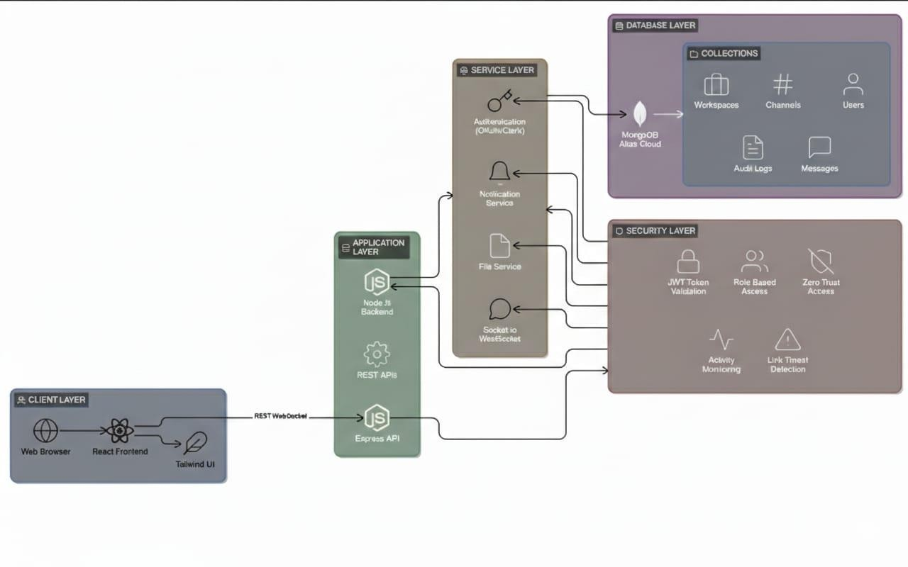
5.1 Architecture diagram

UML DIAGRAMS

5.2.1 USE CASE DIAGRAM

The primary use case of a Slack clone revolves around team communication and collaboration. Organizations or groups use the platform to centralize conversations, share files, and coordinate tasks in real-time. Users can join specific workspaces corresponding to their teams and participate in channels dedicated to particular topics or projects. Direct messaging allows private one-on-one conversations, while group channels facilitate discussions among multiple team members. The platform also supports notifications for mentions, replies, or important announcements, ensuring that critical messages are not missed. Additionally, users can search chat histories, pin important messages, and manage their profiles, creating an organized and efficient workspace environment. In essence, the use case addresses the need for remote collaboration, replacing traditional email threads or informal messaging apps with a structured, real-time communication tool.

Inconclusion, a Slack clone is more than just a messaging app; it is a robust plat form for seamless team collaboration. Its architecture combines a responsive frontend, a scalable backend, and real- time communication channels to deliver instant interactions and maintain organized workspaces. By integrating secure authentication, persistent message storage, and live notifications, it enables teams to work together efficiently regardless of location. The modular design and potential for microservices allow for future scaling and adding advanced features such as bots, file sharing, or analytics, making it a comprehensive solution for modern workplace communication.

.
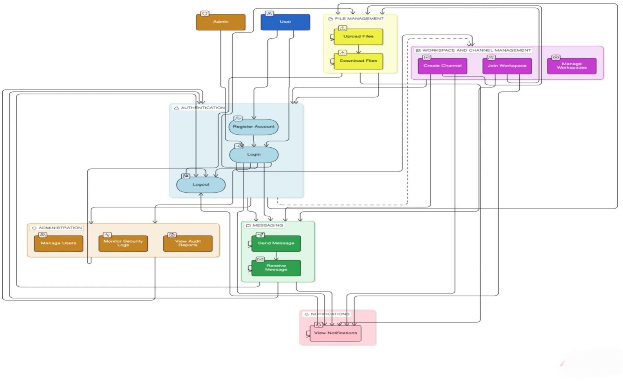

5.2.1 USE CASE DIAGRAM
5.2.2 CLASS DIAGRAM
The class diagram of a Slack clone represents the main entities in the system and the irrelationships. At the core is the User class, which holds details like user ID, name, email, password (or OAuth token), profile picture, and status (online/offline). Each user can belong to multiple Workspace instances. The Workspace class includes attributes such as workspace ID, name, description, list of users, and channels.

Within a workspace, communication happens in Channel objects, which can be either public or private. A Channel has an ID, name, type, list of members, and a collection of Message objects. Each Message object contains attributes like message ID, content, timestamp, sender (User), and optionally attachments or reactions. Messages can be edited or deleted, so version history or status fields may also be included.

For direct messaging, a Direct Message class can represent one-to-one or small group conversations. This class is similar to Channel but has restricted access between specific users. Additionally, a Reaction class may link to messages, allowing users to react with emojis, including the user who reacted and the type of reaction.
The system may also include auxiliary classes like File for attachments, with attributes like file ID, filename, URL, type, and uploader(User), and AuditLog fortracking actions such as messageedits, deletions, or user activity, which includes time stamp, user, and action description. Relationship between these classes are mostly associations : users belong to workspaces, workspaces contain channels, channels contain messages, and messages can have reactions and attachments.
Overall, the class diagram models the entities and their interactions, providing a blueprint for both database schema design and object-oriented backend implementation.
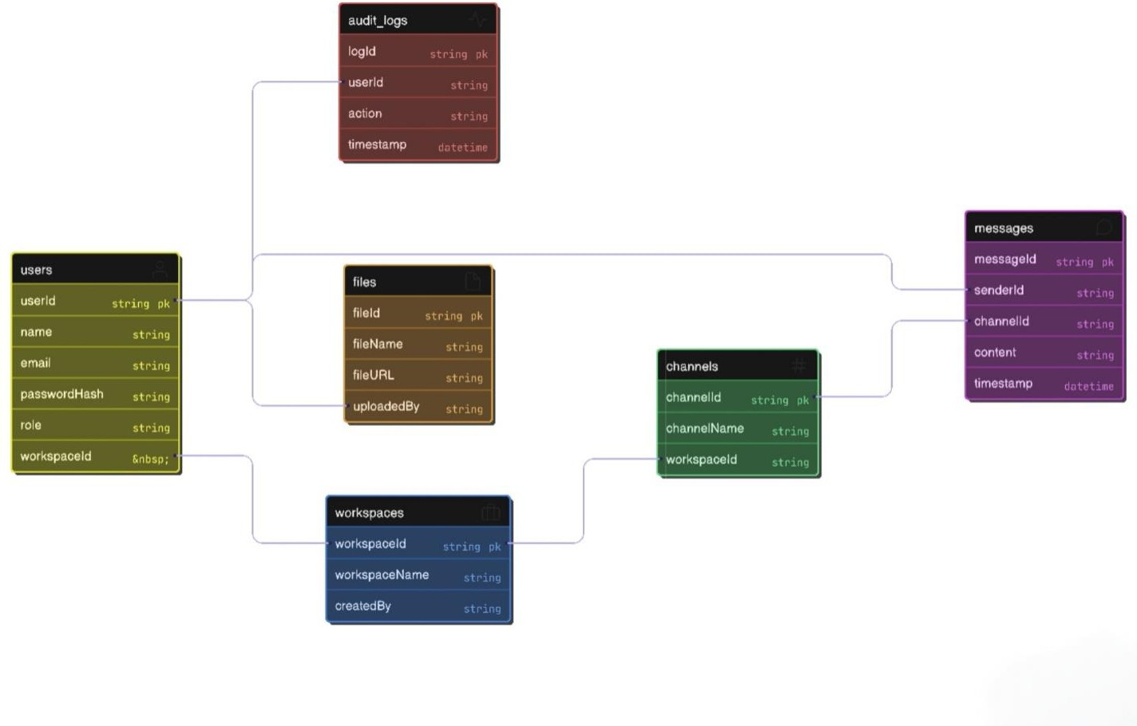
5.2.2 CLASS DIAGRAM

5.2.3 SEQUENCE DIAGRAM
In a sequence diagram for a Slack clone, the interaction starts with the User on the client side. When the user types a message and hits send, the Client Application (web or mobile) first validates the input and then sends it to the Backend Server via a WebSocket or REST API call.
The Backend Server receives the message and performs several actions. It first checks the user’s authentication and permissions to ensure the are allowed to post in that channel. Once validated, the servers as the message to the Database (e.g.,Mongo DB), creating a new message entry with the content, timestamp, sender ID, and channel ID. If the message includes attachments, the server stores the files and links them to the message.

After storing the message, the server triggers a real-time event through WebSocket/Socket.io, broadcasting the new message to all other connected clients subscribed to the same channel. Each client receives the event and updates its user interface, displaying the new message instantly. Optionally, the server may also update Notification Services for users who are offline or have muted the channel, so they get notified of the new message.

Finally, the user who sent the message receives a confirmation (acknowledgment) that the message has been successfully sent and stored .This flow ensures that all users in the channel see the message in real-time while maintaining data integrity and security.\

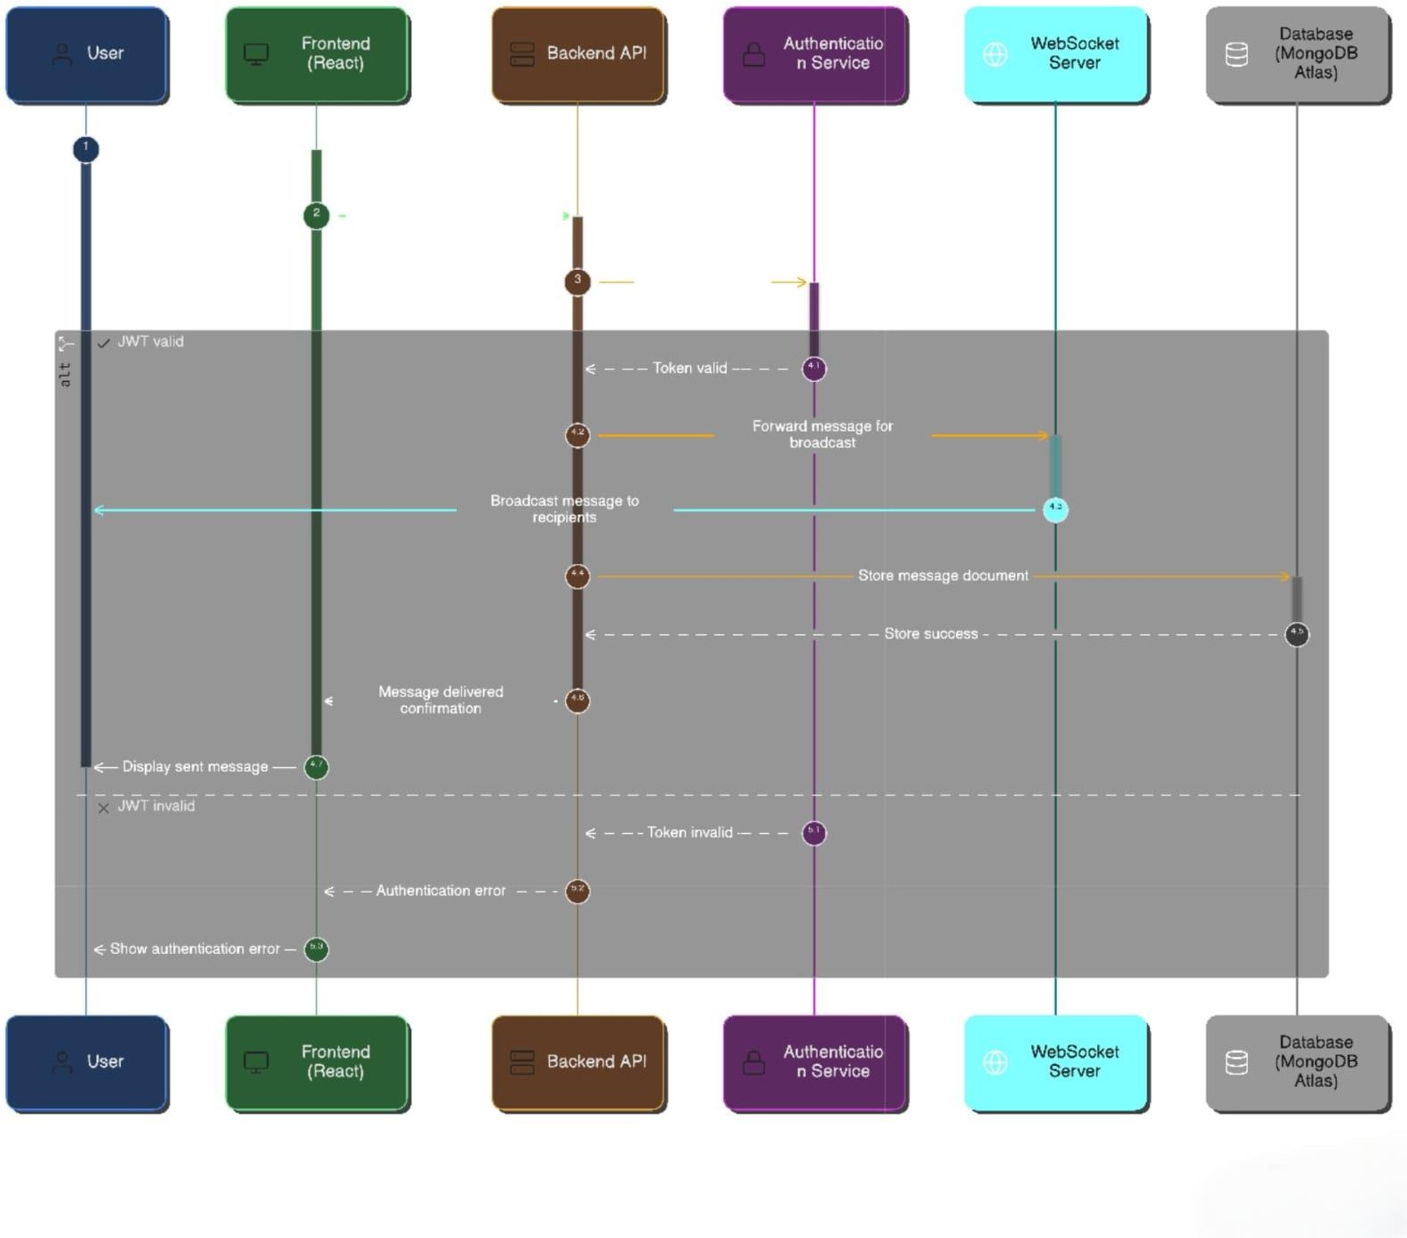
5.2.3 SEQUENCE DIAGRAM

ACTIVITY DIAGRAM
The activity diagram for a Slack clone illustrates the flow of actions when a user sends a message in a channel. The process begins with the user composing a message in the client application. Once the “send” button is clicked, the system performs message validation, checking that the content is not empty and meets length or format requirements. If validation fails, the user is prompted to correct the message, creating a loop until the message is valid.

After passing validation, the clients ends the message to the server through a Web Socket or REST API. The server first performs authentication and authorization, ensuring that the user is logged in and has permission to post in the selected channel. If this step fails, an error is returned to the client, and the activity terminates for that attempt.
Once authorized, the server stores the message in the database along with metadata such as timestamp, sender, channel ID, and any attachments. If attachments are included, the are saved in a file storage system and linked to the message. The server then broadcasts the message to all users subscribed to the channel using real-time WebSocket events. Each client updates the UI to display the new message immediately. Additionally, users who are offline or have notifications enabled receive alerts about the new message.

The activity concludes when the sender receives confirmation that the message was successfully sent and all subscribed users see the updated conversation in real-time. This ensures the communication loop is complete, consistent, and reliable.
Conclusion: The activity diagram highlights the step-by-step workflow of sending messages in a Slack clone, demonstrating how the system integrates validation, authentication, persistent storage, and real-time updates. It emphasizes the importance of user feedback, security checks, and instantaneous communication, which together create a seamless collaborative experience. The diagram provides a clear blueprint for developers to implement robust and efficient messaging functionality while ensuring data integrity and user satisfaction.

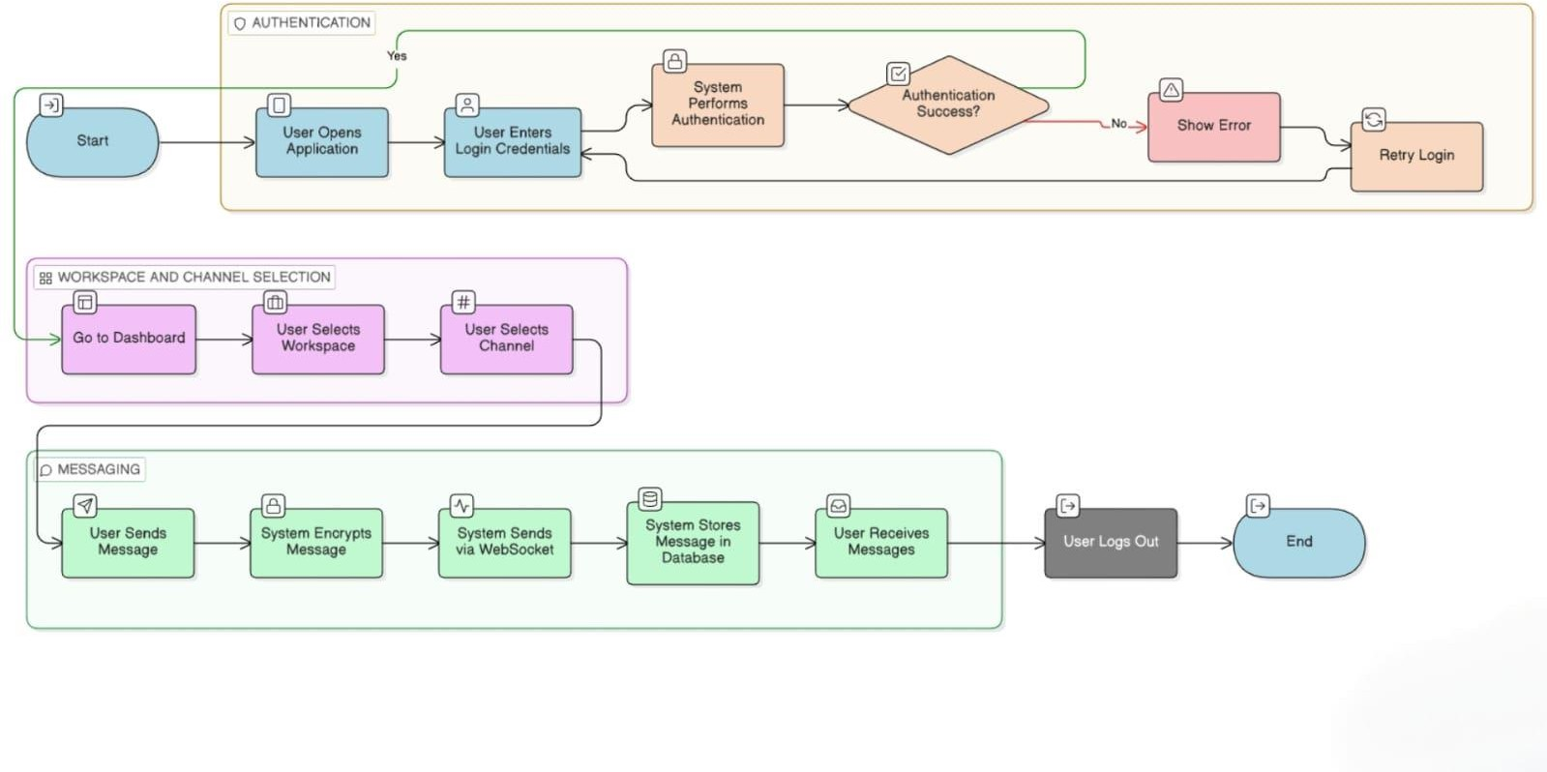

5.2.4 ACTIVITY DIAGRAM

CHAPTER – 6

6.METHODOLOGY

6.1 SYSTEM METHODOLOGY
The methodology adopted in this project follows a structured full-stack web application workflow consisting of requirement analysis, system design, frontend development, backend development, database integration, real-time communication implementation, testing, deployment, and result presentation. The system is designed to provide secure, real-time communication through a web browser.
Requirement Analysis
System requirements are collected based on organizational communication needs. The system supports user authentication, workspace creation, channel-based messaging, direct messaging, file sharing, and real-time notifications. Security requirements such as secure login, session management, and encrypted communication are also considered.

System Design
System design includes architecture planning, database schema design, and API structure definition. UML diagrams such as class diagrams, sequence diagrams, and activity diagrams are created to represent system behavior. The system follows a client-server architecture where the frontend communicates with backend services through REST APIs and Web Sockets.

Frontend Development
Front end development is performed using modern web technologies. The user interface is designed to provide responsive and interactive user experience. Login pages, workspace dashboards, chat interfaces, and notification panels are implemented. The frontend communicates with backend services to fetch and display real-time data.

BackendDevelopment
Backend development handles business logic, authentication, message processing, and channel management. Secure authentication is implemented using O Auth 2 or Clerk authentication. Backend services process client requests, validate user permissions, and manage real-time communication events.

Database Integration
Database integration is implemented using MongoDB or similar NoSQL database. The database stores user details, work space data, channel data ,message history, and audit logs. Database indexing and optimization techniques are used to improve performance.

Real-TimeCommunication Implementation
Real-time communication is implemented using WebSocket technologies such as Socket.io. This enables instant message delivery, typing indicators, and live user presence tracking.

Testing
Testing ensures system reliability and performance. Unit testing, integration testing, and system testing are performed. Security testing is conducted to verify authentication and data protection mechanisms.

Deployment
The application is deployed using cloud platforms such as AWS, Vercel, or Docker containers. Continuous Integration and Continuous Deployment (CI/CD) pipelines are used for automated deployment and updates.

MODULES
The system is divided into multiple functional modules. Each module is described below.
- Authentication Module
Handles user login, registration, session management, and secure token validation.

- Workspace Management Module
Manages work space creation, user invitations, and work space settings.

- Channel Management Module
Handles channel creation, member management and channel permissions.

- Messaging Module
Handles sending, receiving, editing, and deleting messages in real-time.

- File Sharing Module
Allows users to upload, store, and share files securely within chats.
- Notification Module
Sends real-time alerts for messages, mentions, and system updates.

- Graphical User Interface (GUI) Module
Provides an interactive interface for users to communicate and manage workspaces.

MODULES OVERVIEW

The modular architecture ensures separation of concerns and efficient work flow management. Each module operates independently while interacting with other modules. The authentication module validates users before granting access. Messaging and channel modules manage communication flow. The data base module ensures secure storage of all system data. The GUI module provides user interaction and displays real-time results.
This modular design improves scalability, allowing new features such as AI chatbots, analytics, or video conferencing to be added easily.

INTRODUCTION TO TECHNOLOGY USED
The system is developed ung JavaScript-based full-stack technologies. The frontend is developed using React or Next.js for building dynamic user interfaces. Back-end development is implemented using Node.js and Express.js .Real-time communication is implemented using Socket. Io .Mongo DB is used for database storage. Authentication is handled using Clerk or OAuth2.
6.5 TOOLS AND LIBRARIES USED

The following tools and libraries are used in the development of the Secure Internal Chat Platform:
• React.js – Used for developing the frontend user interface, enabling dynamic and responsive web pages through component-based architecture.
• Node.js – Serves as the backend runtime environment, allowing efficient handling of asynchronous operations and server-side logic.
• Express.js – Used as a backend framework to build RESTful APIs and manage routing, middleware, and server communication.
• MongoDB with Mongoose – Used for database management, where MongoDB stores application data and Mongoose provides schema-based modeling for structured data handling.
• Socket.IO – Enables real-time, bidirectional communication between client and server, supporting instant messaging and live updates.
• Clerk / OAuth2 – Provides secure authentication and authorization mechanisms, ensuring safe user login and session management.

• Axios / Fetch API – Used for client-server communication, enabling the frontend to send HTTP requests and receive responses from the backend.
• Tailwind CSS – A utility-first CSS framework used for designing responsive and visually consistent user interfaces.

CHAPTER – 7

7 .Results and Performance Evaluation

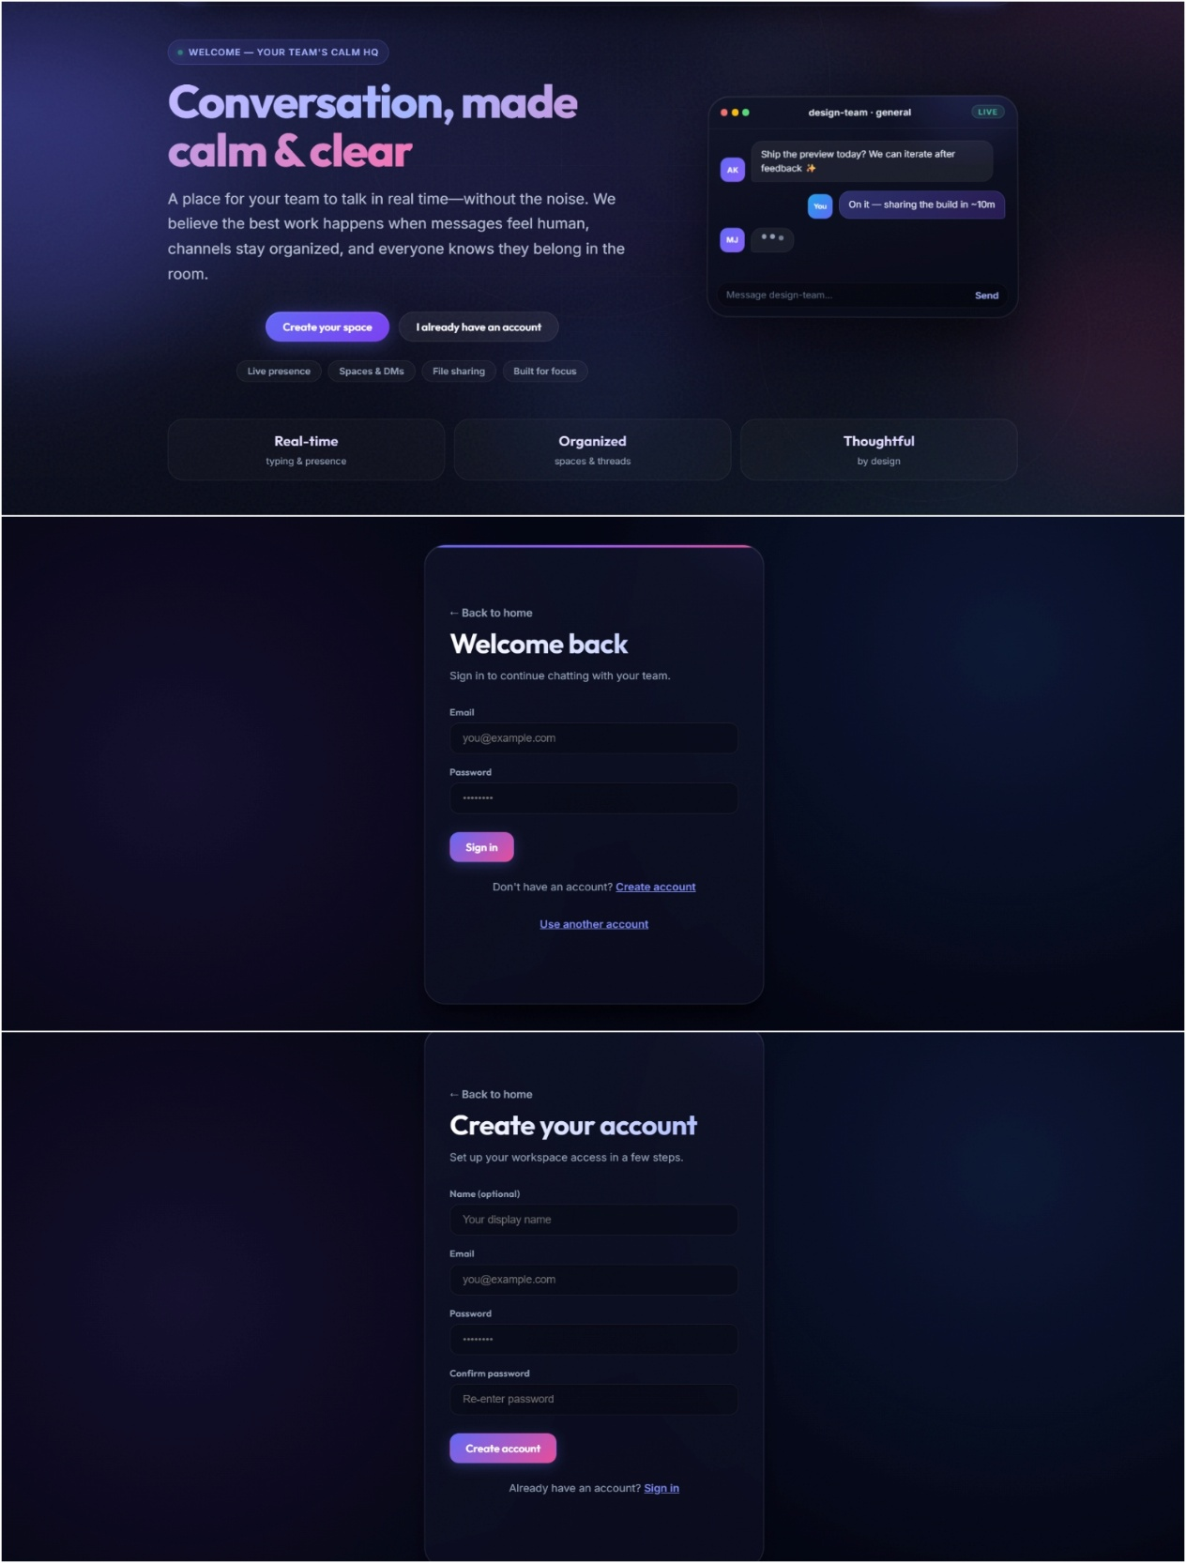

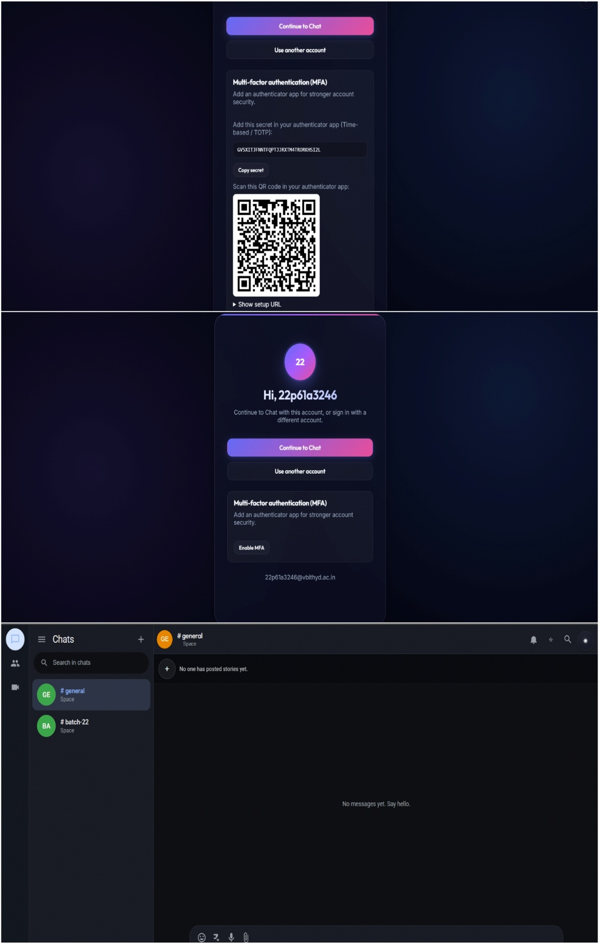

CHAPTER – 8

8.CONCLUSION

The project “Secure Internal chat (Slack Clone)” successfully demonstrates the development of a modern, web-based communication platform designed for real-time collaboration within organizations. The system integrates secure user authentication, workspace and channel management, real-time messaging, filesharing, and notifications to provide a complete and efficient communication environment. By combining WebSocket-based real-time updates with RESTful API interactions and a NoSQL database, the system ensures low-latency messaging, reliable data storage, and seamless user experience.

The modular architecture of the “Secure Internal chat (Slack Clone)” allows each component —such as authentication, messaging, channel management, notifications, and file sharing—to operate independently while interacting cohesively with other modules. This design enhances scalability, maintainability, and future extensibility. Front end technologies deliver responsive and interactive interface, while back-end services handle business logic, security, and persistent storage efficiently.

The system also emphasizes security and reliability, ensuring that only authorized users can access sensitive communication data. Cloud-based deployment options and optimized database management further support performance, availability, and scalability for enterprise-level use.
Overall, the “Secure Internal chat (Slack Clone)” achieves its objectives of providing a secure, scalable, and user-friendly communication platform. It enables teams and organizations to collaborate effectively in real-time, reducing dependency on traditional communication methods like email. The project lays a strong foundation for future enhancements, including AI-driven features, advanced analytics, and multimedia communication support, making it a robust solution for modern workplace collaboration.

REFERENCES
[1] Leonardi, P.M., Huysman, M., & Steinfield, C.(2015). What Will Become of Social Media? A Review of Research on the Technology That Changed How We Communicate and Collaborate. Academy of Management Annals, 9(1), 1349.
[2] NIST. (2020). Zero Trust Architecture (NIST Special Publication 800- 207). National Institute of Standards and Technology. Available at :https://doi.org/10.6028/NIST.SP.800- 2072
[3] Schneier, B. (1996). Applied Cryptography: Protocols, Algorithms, and Source Code in C(2nded.) John Wiley &Sons.
[4] Mishra, R., &Singh, R.K. (2019).AS2019(ICCA)
Survey on Browser isolation Techniques for Web Security. In 2019 International Conference on Computing, Communication, & Automation (ICCCA) (pp. 136). IEEE.
[5] Bhattacharyya, S., & Singh, P. K. (2018). Secure Communication in Social Networks using End-to-End Encryption. In 2018 International Conference on Computing, Power and Communication Technologies (ICCPCT) (pp. 1003104). IEEE.
[6] Zimmermann, K., &Krüger, T. (2018). Security and Privacy in Enterprise Social Networks: A Systematic Literature Review. Journal of Business & Information SystemsEngineering,60(5),4573477, Token (JWT), R FC 7519, IETF.
[7] Tilkov, S., & Vinoski, S. (2010). Node.js: Using Java Script to Build High-Performance Network Programs. IEEE Internet Computing, 14(6), 80–83.
[8] Fielding, R. T. (2000). Architectural Styles and the Design of Network-based Software Architectures. Doctoral Dissertation, University of California, Irvine.
[9] Grud in, J. (1994). Computer-Supported Cooperative Work: History and Focus IEEE Computer, 27(5),19–26.
[10] Nakamoto, S(2008) Bitcoin: A Peer-to-Peer
Electronic Cash System. Decentralized Systems Research), Pape.

