Download the project structure from the git repository by using bellow link

Link:

After downloading the project extract it and project structure is as fallows

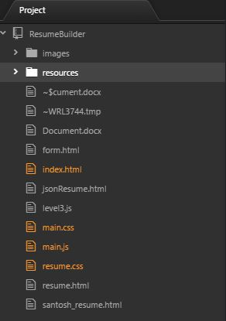

Before executing the project add the  **Web Server for Chrome** extensions for better experience.

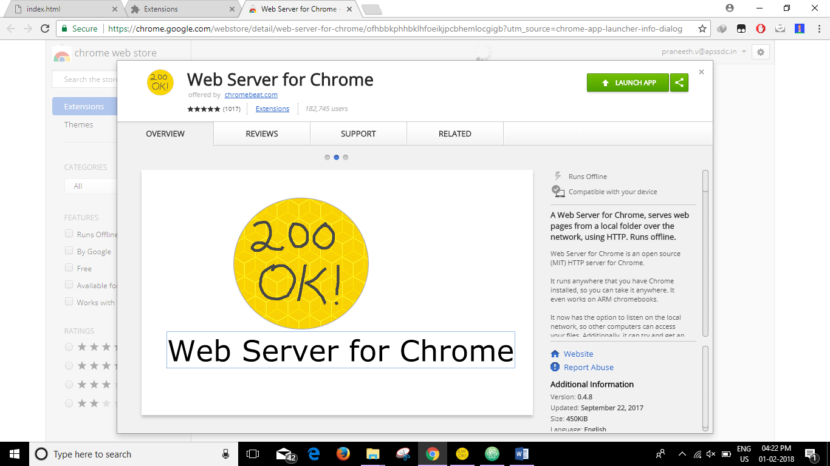

Start the 200 OK! WEB Server and select the folder where the project placed and click the link,

The shortcut of server will represent as fallows.

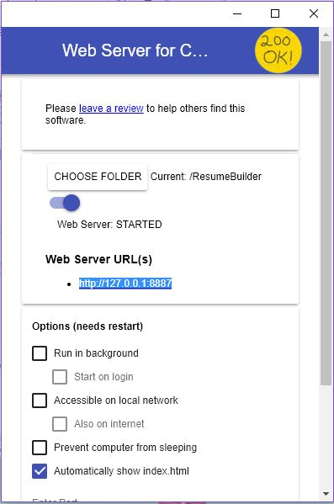

Start the execution of the project by default the **index.html** page will start, the execution of **index.html** page is as billow

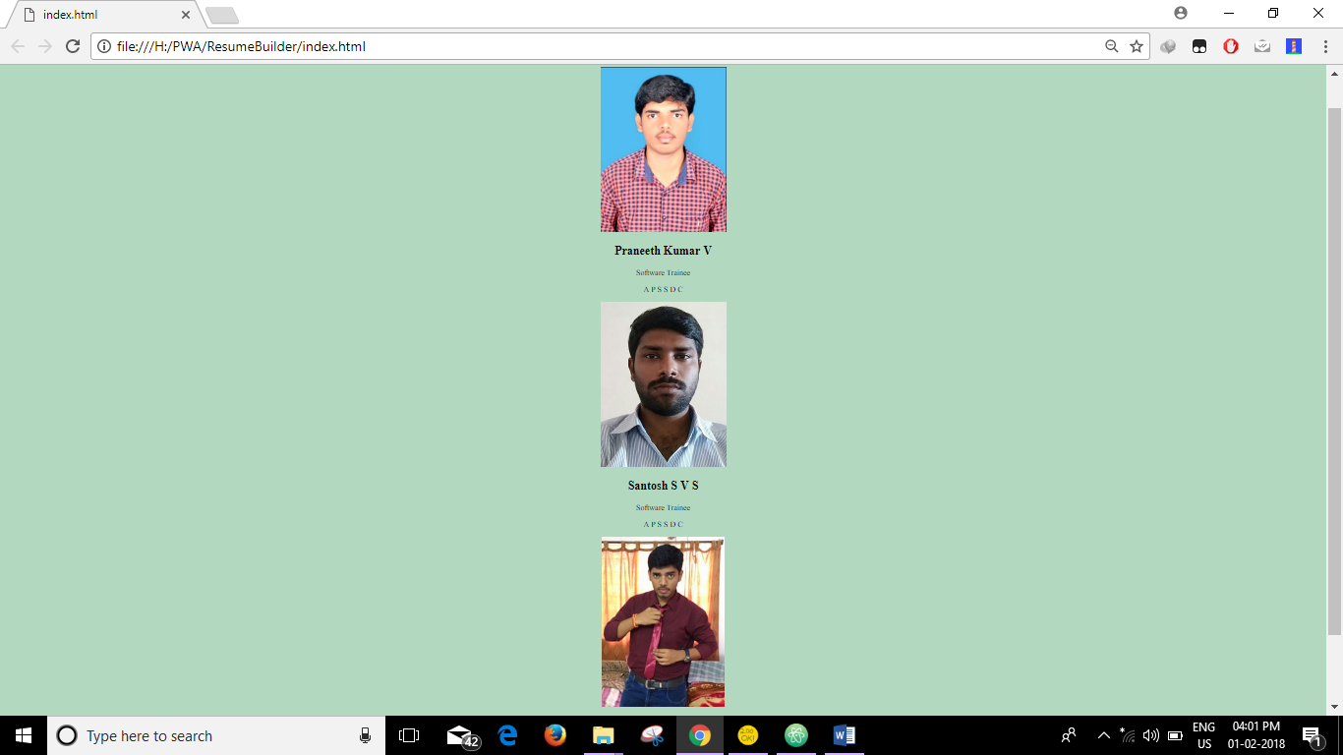

The above page is index.html page without CSS, so you should apply the CSS for better appearance

Fallow the bellow steps -🡪

1. In the index.html page **uncomment the CSS link in Line Number 6**.
2. Go to main.css that is empty page, past the bellow code.

|  |
| --- |
| .mainDiv {  background: #f2f2f2;  display: flex;  flex-wrap: wrap;  padding: 15px;  border-radius: 10px;  }  .childDiv{  margin: auto;  max-width: 20%;  min-width: 20%;  text-align: center;  font-family: arial;  border-radius: 5px;  box-shadow: 0 4px 8px 0 black;  padding-top:15px;  }  .childDiv:hover{  box-shadow: 0 8px 12px 0 black;  }  .image{  width: 85%;  border-radius: 10px;  }  button {  border: none;  outline: 1;  display: inline-block;  padding: 8px;  color: white;  background-color: #000;  text-align: center;  cursor: pointer;  width: 100%;  font-size: 18px;  border-radius: 5px;  }  button:hover, a:hover {  opacity:0.6;} |

1. After pasting the code save the index page and main.css page,
2. Now come to browser and refresh the page you can see the new look same as bellow

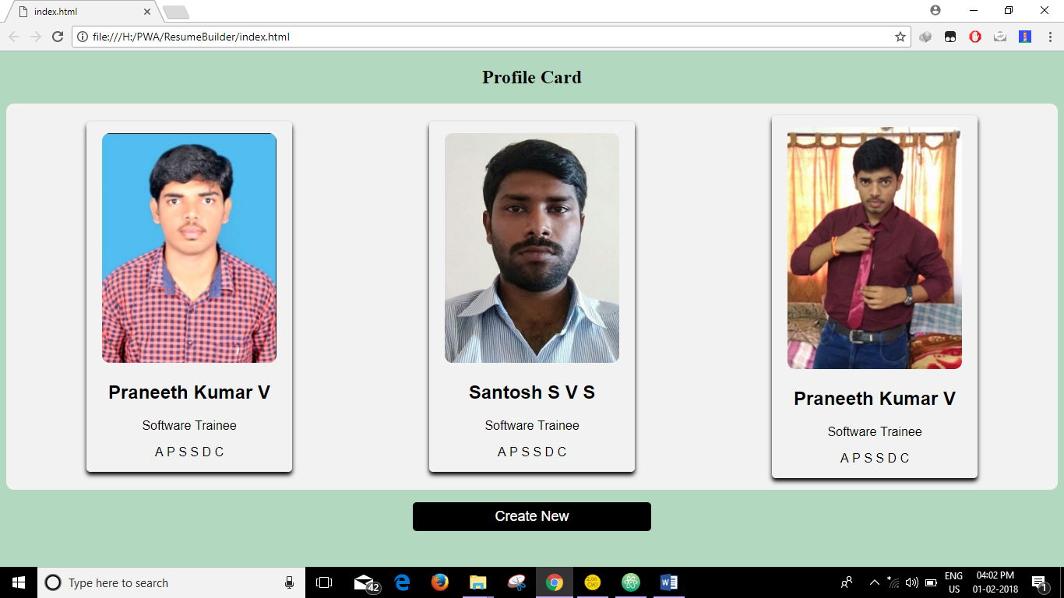

Congratulation you almost done

1. Up to now we have designed only for desktop view, our main moto is to designed desktop view at the same

time we have to design for mobile view fallows.

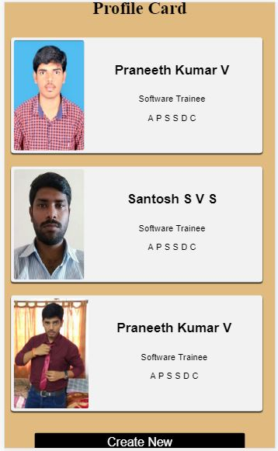

1. In the main.css past the fallowing code and see the difference by applying the toggle device toolbar by clicking **Ctrl+Shift+M** and compress the page to see the difference

|  |
| --- |
| @media only screen and (min-device-width : 320px) and (max-device-width : 600px) {  .indexBody{  background: #E0BA7F  }  .mainDiv{  background:#E0BA7F;  margin: 0;  display:flex;  flex-wrap: wrap;  flex-direction: column;  max-width: 57em;  }  .childDiv{  background: #f2f2f2;  display: flex;  margin:0;  max-width: 80em;  max-height: 25em;  min-height: 25em;  padding: 10px;  margin-bottom: 3em;  border-radius: 10px;  }  .image{  width: 17em;  border-radius: 10px;  }  .content{  width: 100%;  }  .content h2{  padding: 20px;  font-size: 3em;  }  .content p{  font-size: 2em;  }  button{  font-size: 2.8em;  }  #heading{  font-size: 4em;  }  }  input[type=text], select {  width: 100%;  padding: 12px 20px;  margin: 8px 0;  display: inline-block;  border: 1px solid #ccc;  border-radius: 4px;  box-sizing: border-box;  }  input[type=submit] {  width: 100%;  background-color: #4CAF50;  color: white;  padding: 14px 20px;  margin: 8px 0;  border: none;  border-radius: 4px;  cursor: pointer;  }  input[type=submit]:hover {  background-color: #45a049;  }  div {  border-radius: 5px;  background-color: #f2f2f2;  padding: 20px;  }  .formDiv{  margin: auto;  display: flex;  } |

Congratulation you have done index page with all css

1. Now to apply the onClick function **uncomment the javaScript link on line number 7**

In our resume builder we have 3 profile cards, and we have to design with 3 levels of coding

**Level1:**

1. Click on first profile card you are going to redirect to **resume.html** pagewhich looks as fallows

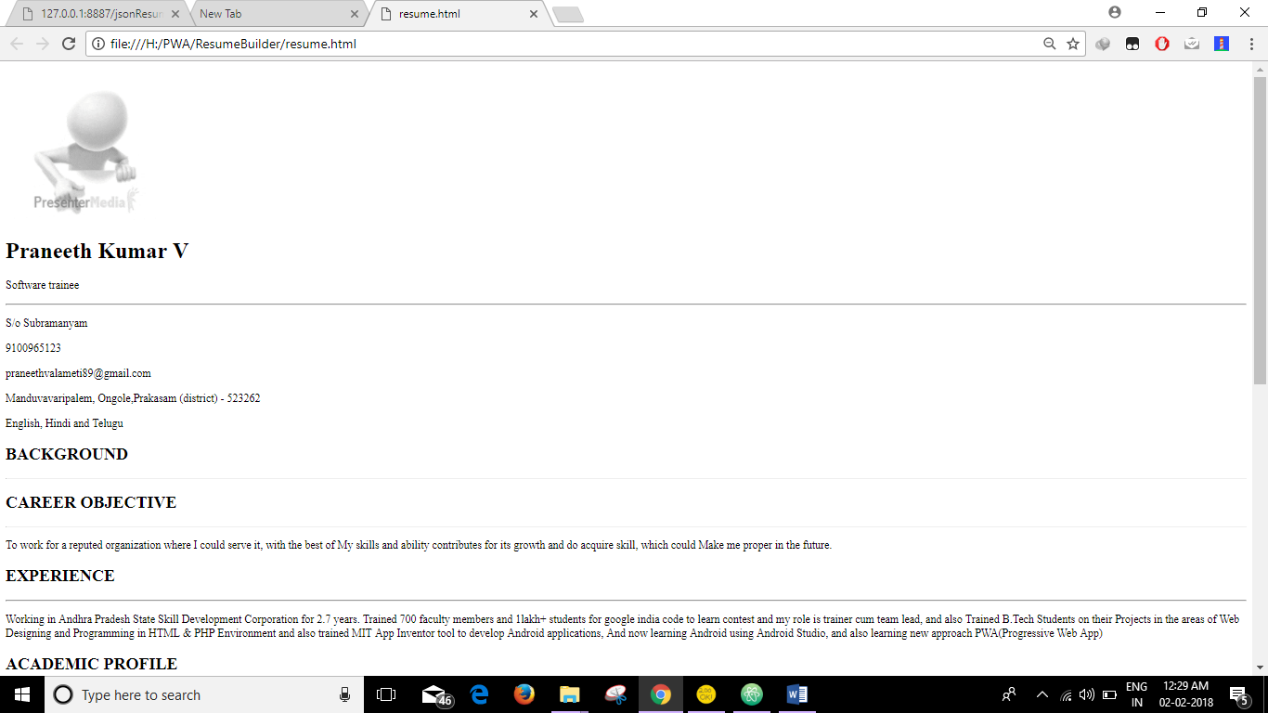

1. The above page is without CSS
2. Now open resume.html page and **uncomment the CSS kink and javaScript link on line number 5-6**
3. Now open **resume.css** and fallow the bellow instructions.
4. **Fallow the instructions which is given in line number 1**
5. **After completing u can check the changes done in the resume.html.**
6. **Similarly fallow the instructions given in the resume.css on line number 43,70 & 122**
7. **And same way check the modifications done**

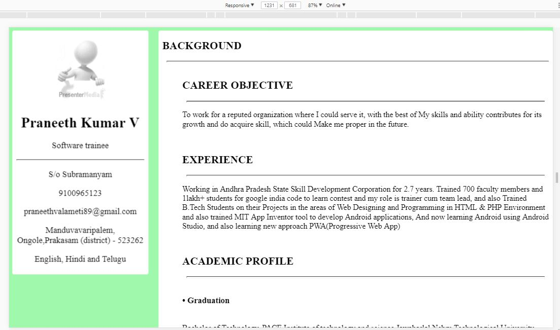

1. The above picture is for the desktop view i.e more than 1000px.

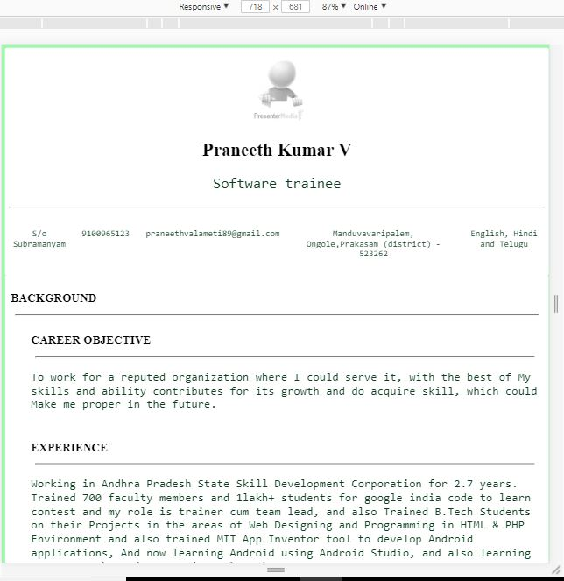

1. The above picture is for less than 1000px

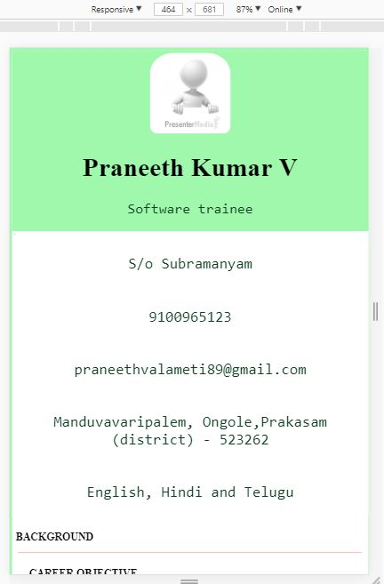

1. The above picture is for tab and mobile view i.e more than 320px & less than 600

**Congratulations Level 1 is completed**

**Level 2:**

**This is level 2 because in this we are not giving the resume data static, here we are getting the data from json using Ajax object by javaScript.**

1. Click on Second profile card you are going to redirect to **santosh_resume.html** page**.**
2. Open the **santosh_resume.html page and uncomment the line number 5 to link the css page** which we already designed
3. And in the same page uncomment the line number 78 to link the main.js
4. Our main moto is to get the data from the JSON page which Is present in the resources folder data.json page.
5. To get the data from json page we are using javaScript
6. Now open main.js and uncomment the following line numbers 19.
7. Now check the changes in the page in browser now the data is updated which is coming from data.json.