1.Customer_table:

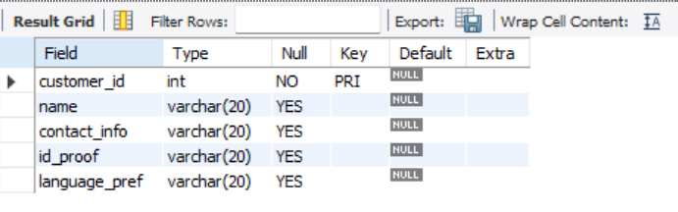

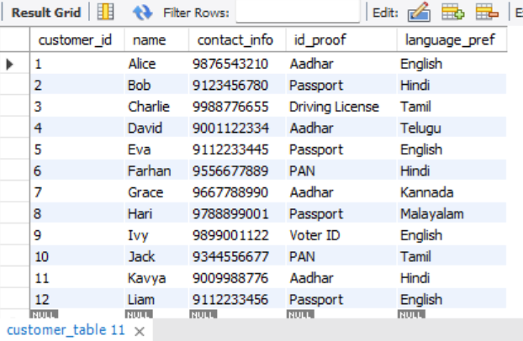

2.room_table  
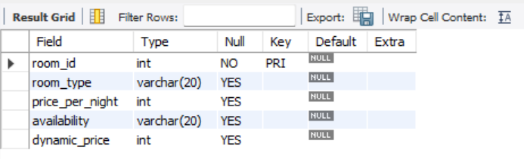

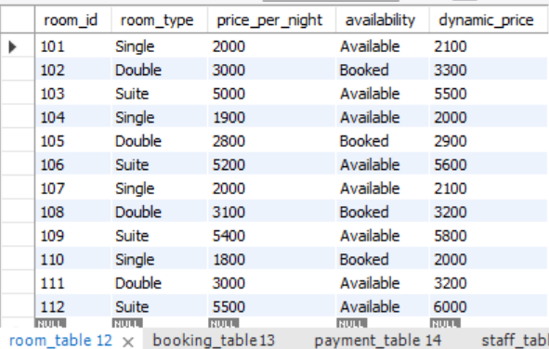

3.booking_table:

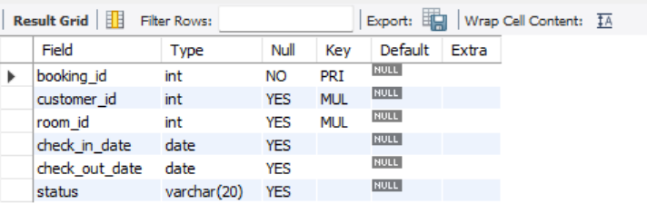

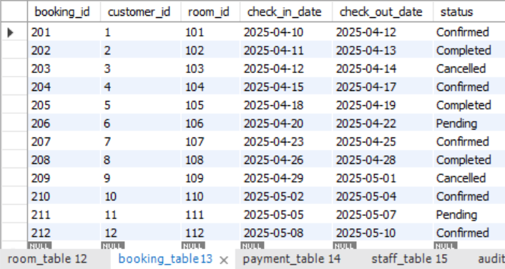

4.payment_table:

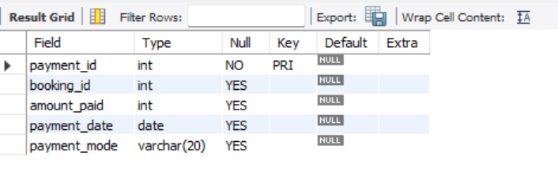

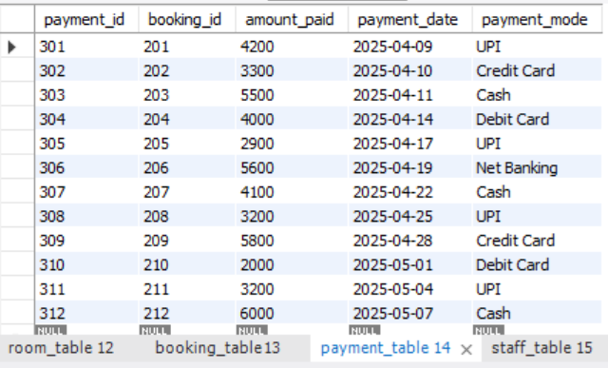

5.staff_table:

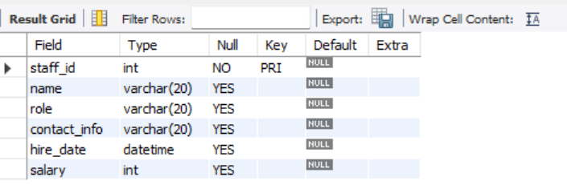

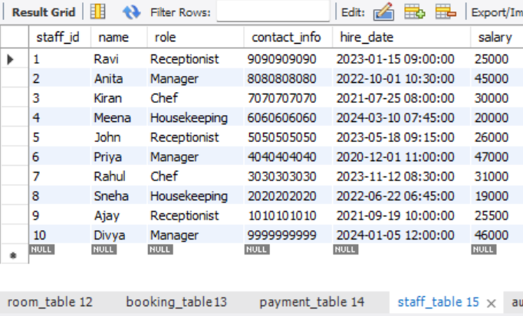

6.audit_table:

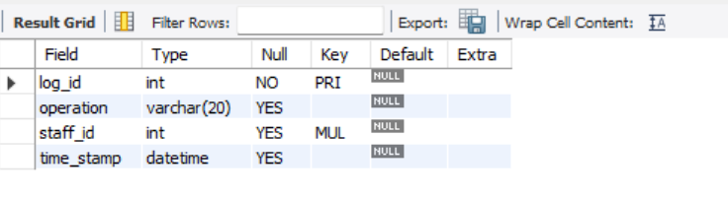

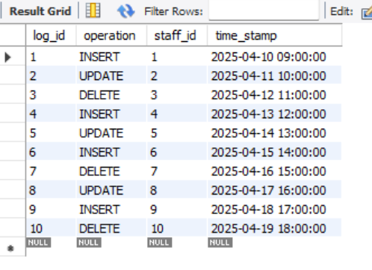

Operations  
1. select * from customer_table where id_proof="Aadhar";  
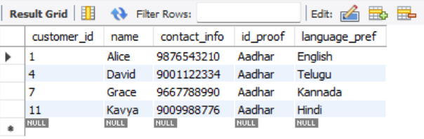  
2. select room_type,dynamic_price from room_table order by dynamic_price desc;  
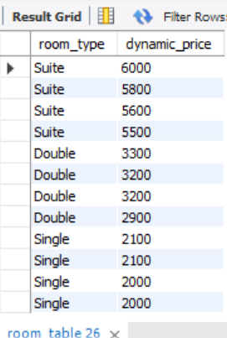

3. alter table payment_table modify column amount_paid DECIMAL(10,2);

select amount_paid from payment_table;  
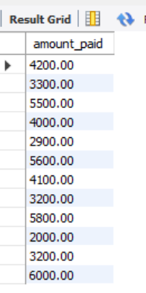

4. select (check_out_date - check_in_date)as no_of_days,customer_id,

(select name from customer_table where customer_table.customer_id=booking_table.customer_id) as name from booking_table;  
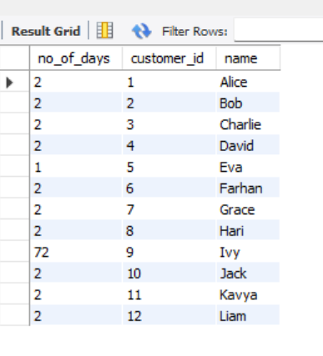

5. #adding column staff_id to room_table

alter table room_table add staff_id int;

#disabiling safe update mode

SET SQL_SAFE_UPDATES = 0;

#appoint staff with highest pay to suite room_type

update room_table set staff_id=(select staff_id from staff_table order by salary desc limit 1) where room_type="suite";

select * from room_table;  
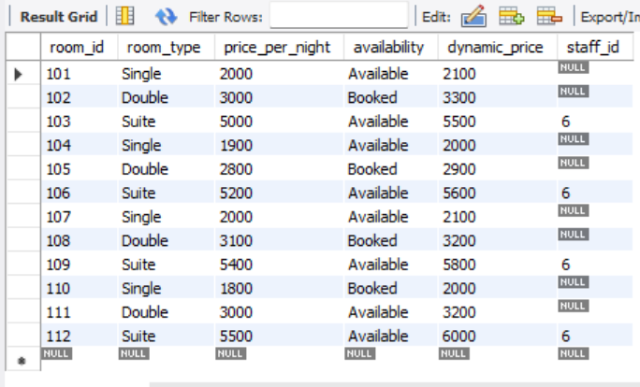

6. update room_table set dynamic_price=price_per_night*

case when month(current_date) in (12,4,8) then 1.2

when month(current_date) in (5,6,10) then 1.1

else 1.0

end;

select * from room_table;  
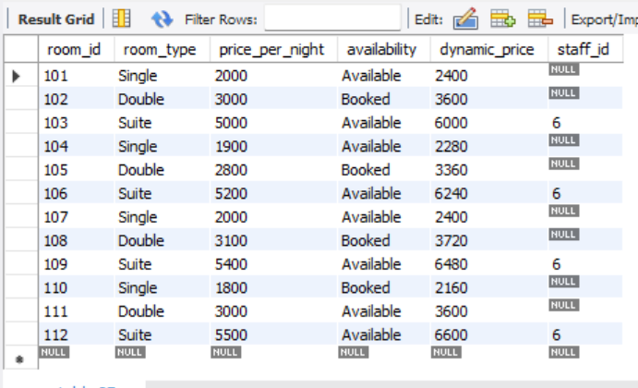

7. #displaying name of the staff a swell

SELECT

r.room_id,

r.room_type,

r.staff_id,

s.name AS staff_name

FROM room_table r

LEFT JOIN staff_table s ON r.staff_id = s.staff_id

WHERE r.room_type = 'suite';  
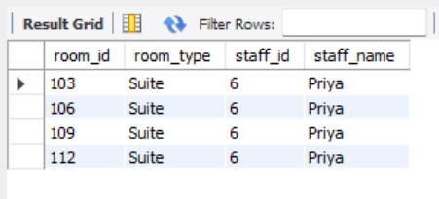

8.revenue report

select sum(amount_paid) as total_amount, month(payment_date) from payment_table

group by month(payment_date);

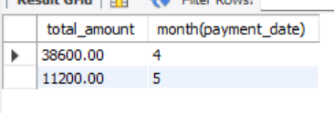

9. to find the customer details whose april month bookins are completed or confirmed

select * from customer_table where customer_id in

(select customer_id from booking_table where month(check_in_date)=4 and status='Confirmed' or status='Completed');

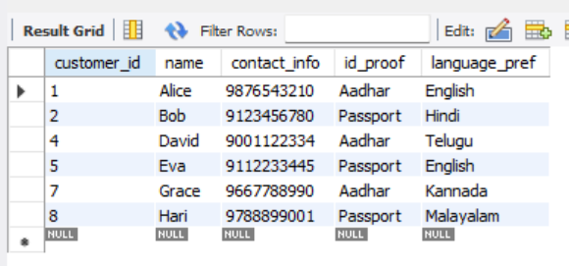

10.to assign staff for each room type along with their id and name in room_table

update room_table set staff_id=(select staff_id from staff_table order by hire_date asc limit 1) where room_type='Single';

update room_table set staff_id=(select staff_id from staff_table order by hire_date asc limit 1 offset 1) where room_type='Double';

UPDATE room_table r

JOIN staff_table s ON r.staff_id = s.staff_id

SET r.name = s.name

WHERE r.staff_id IS NOT NULL;

select *from room_table;

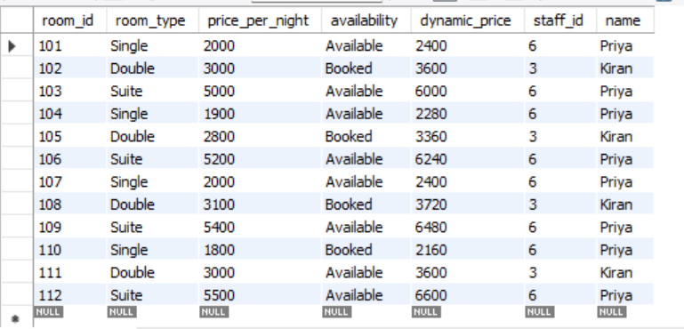

11.triggereing

DELIMITER //

CREATE TRIGGER log_staff_insert

AFTER INSERT ON staff_table

FOR EACH ROW

BEGIN

INSERT INTO audit_table(operation, staff_id, time_stamp)

VALUES('INSERT', NEW.staff_id, NOW());

END;

DELIMITER ;