Neural Networks & Deep Learning ICP-2

Sita Santoshi Praneetha. A

700772490

GitHub link: https://github.com/Praneetha65/Assignment-2

Video Link: https://drive.google.com/file/d/19uN2qqiGP7MlqrvnTLDJ1ItYKcUhR9FK/view?usp=sharing

**Question 1:**

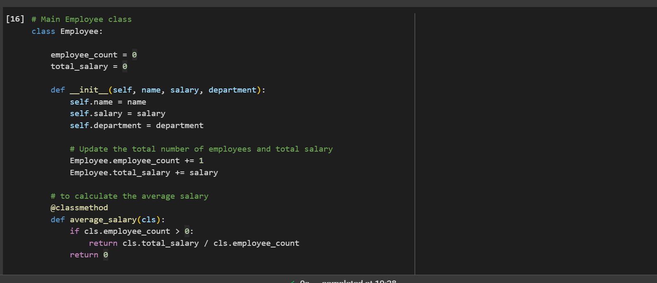

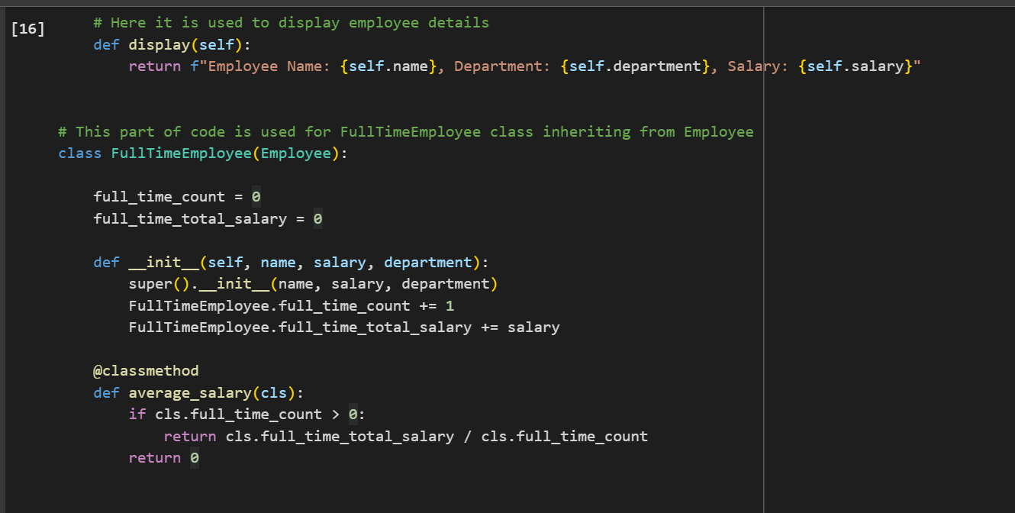

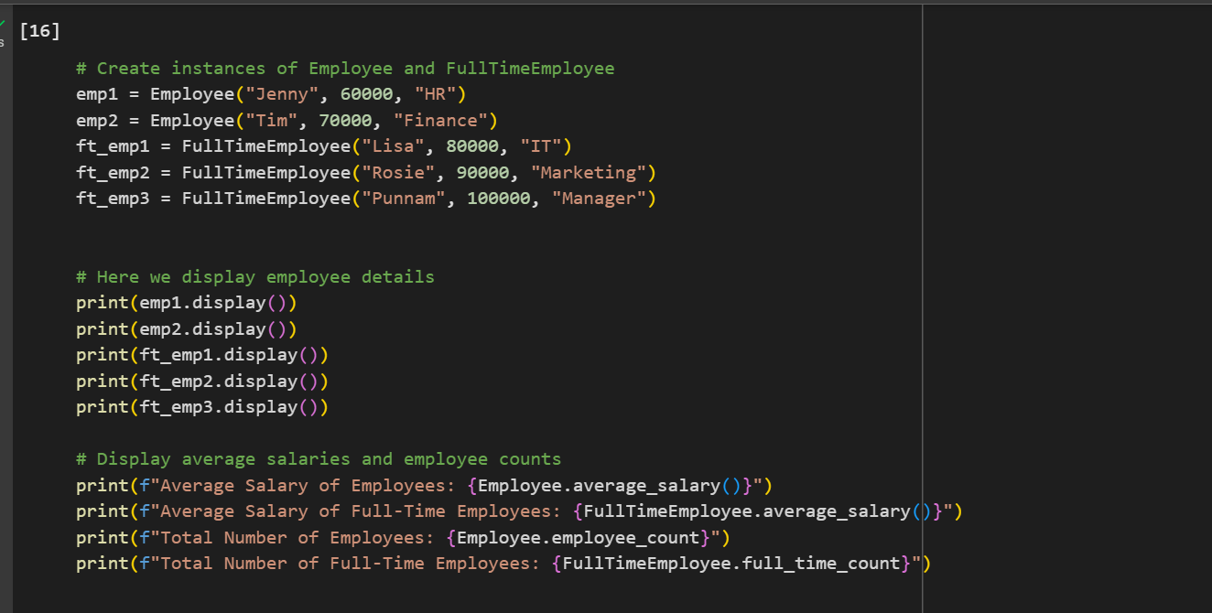

Explanation:

1. Employee Class:
   1. The Employee class stores the name, salary, and department of an employee.
   2. It also tracks the total number of employees (employee_count) and their combined salaries (total_salary).
   3. It has methods to display employee details and calculate the average salary of all employees.
2. FullTimeEmployee Class:
   1. The FullTimeEmployee class inherits from the Employee class.
   2. It keeps separate counts and total salaries for full-time employees using full_time_count and full_time_total_salary.
   3. It also has a method to calculate the average salary of full-time employees.
3. Creating and Using Objects:
   1. Two Employee objects are created: Jenny (HR) and Tim (Finance).
   2. Three FullTimeEmployee objects are created: Lisa (IT), Rosie (Marketing), and Punnam (Manager).
   3. The display method is used to print details of each employee.
   4. Displays the average salaries and total counts for both general and full-time employees after calculating.

OUTPUT:

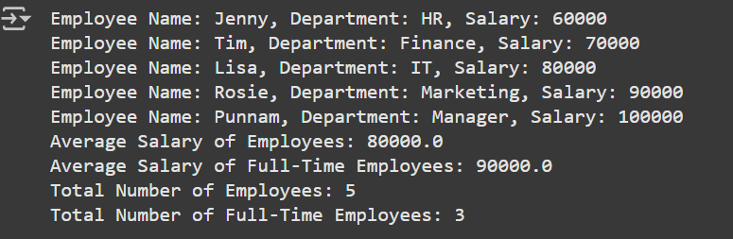

**Question 2:**

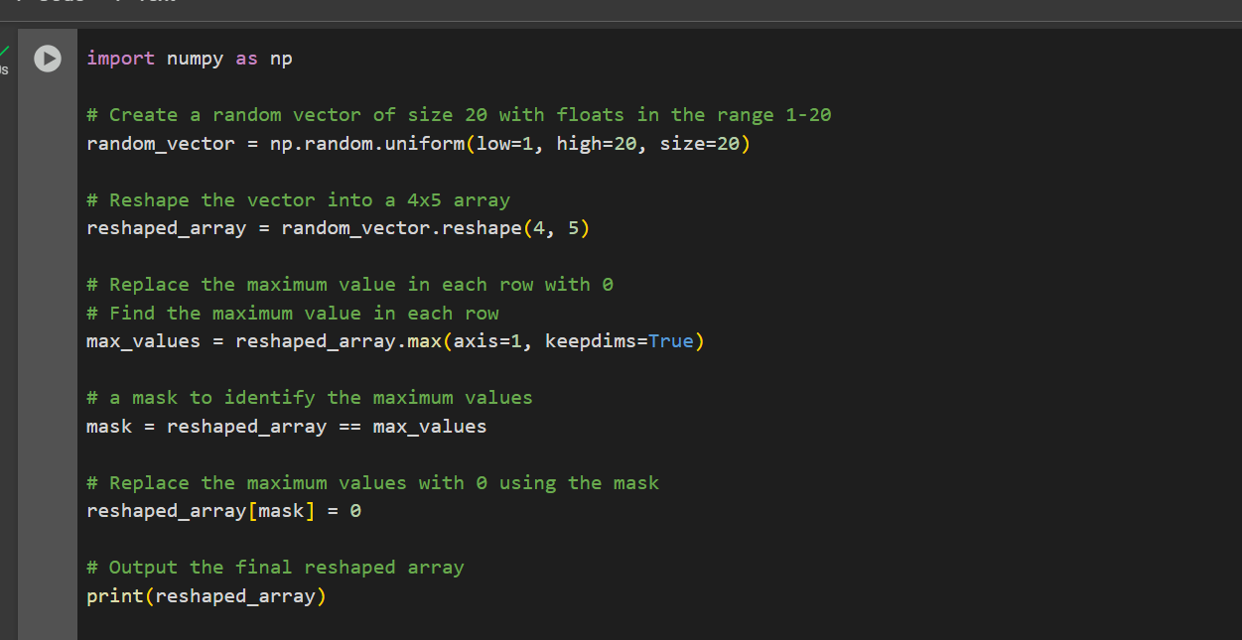

Explanation:

1. Creating a Random Vector:

* A random vector of size 20 is generated using NumPy, with floating-point numbers in the range 1 to 20.

1. Reshaping the Vector:

* The vector is reshaped into a 4x5 two-dimensional array.

1. Finding Maximum Values in Each Row:

* The maximum value in each row is identified using the max function with axis=1.

1. Replacing Maximum Values with 0:

* A mask is created to locate the positions of the maximum values in the array.
* The maximum values in each row are replaced with 0 using the mask and the final array with the maximum values replaced by 0 is printed.

OUTPUT:

