Neural Networks & Deep Learning ICP-3

Sita Santoshi Praneetha. A

700772490

GitHub link : <https://github.com/Praneetha65/Assignment-3/blob/main/ICP3.ipynb>

Video Link: <https://drive.google.com/file/d/1UT-71zulT33wrDWIRrzL0jFKhrjJ9YUB/view?usp=sharing>

**Question 1:**

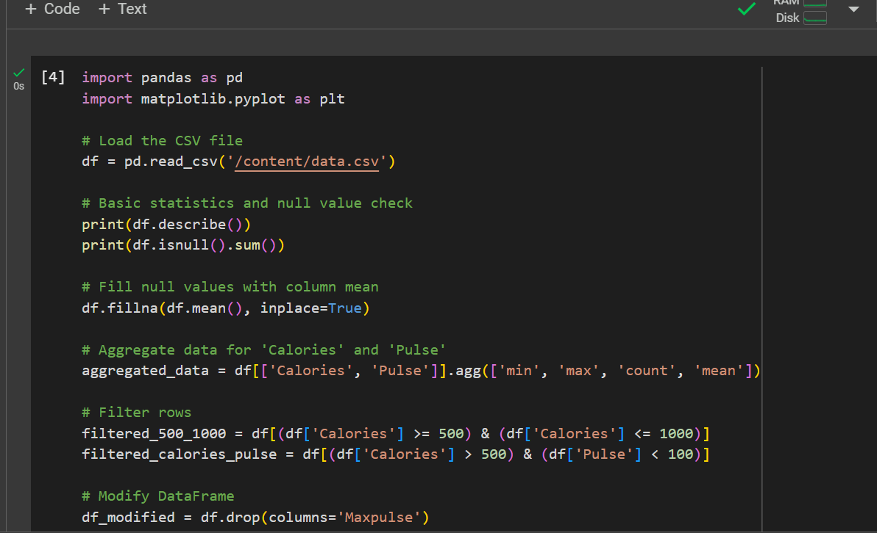

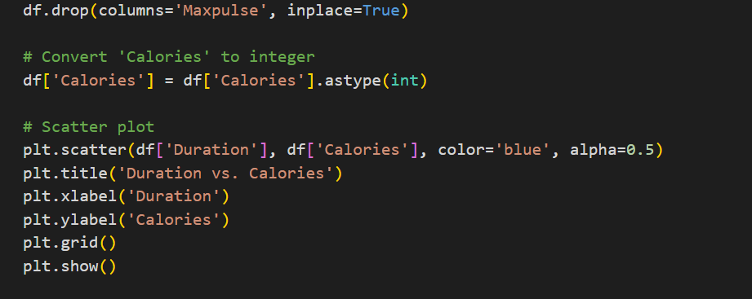

Explanation:

1. Dataset Loaded: Imported the data.csv file into a DataFrame for analysis.
2. Exploration: Checked basic statistics and identified missing values.
3. Data Cleaning: Filled missing values with column averages and removed the Maxpulse column.
4. Aggregation: Calculated key stats (min, max, mean, count) for Calories and Pulse.
5. Filtering: Selected rows based on specific conditions for Calories and Pulse.
6. Visualization: Created a scatter plot to show the relationship between Duration and Calories.

OUTPUT:

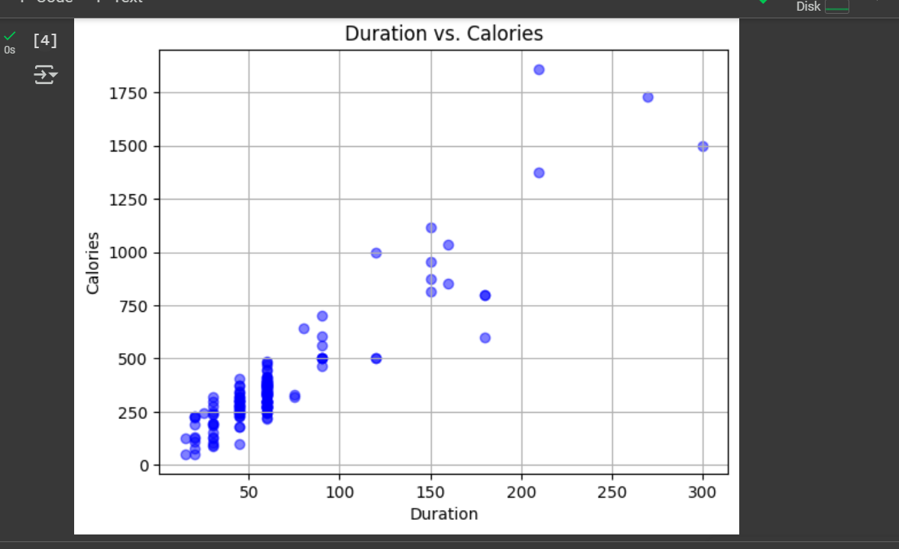

**Question 2:**

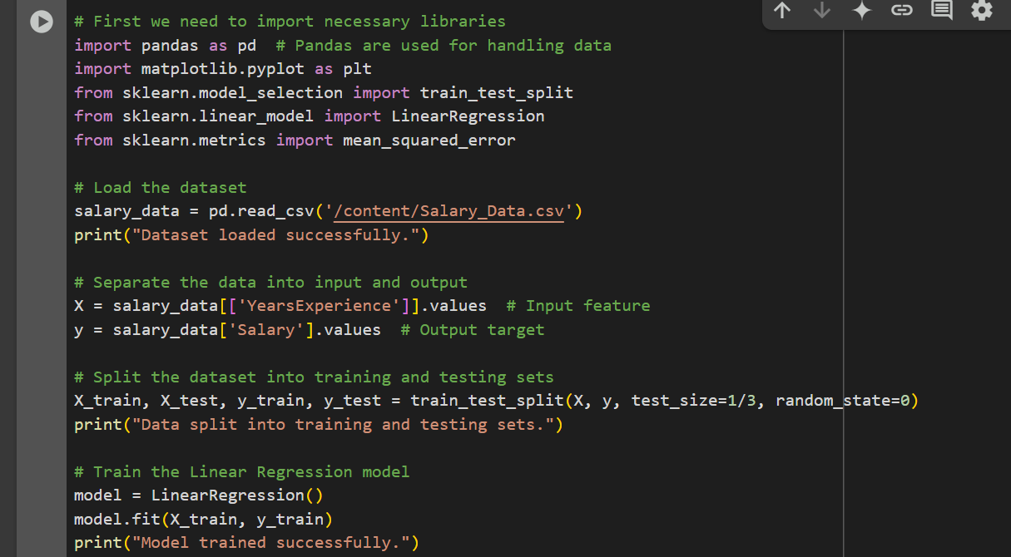

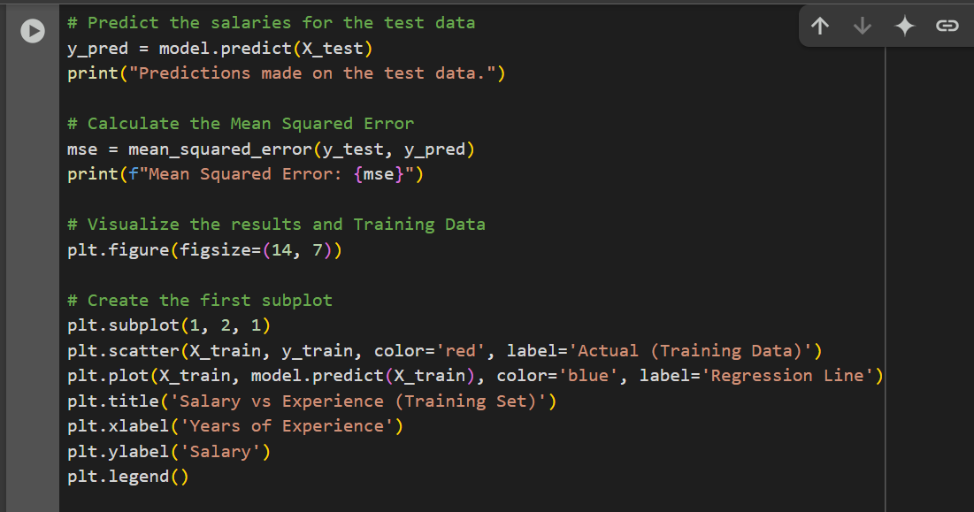

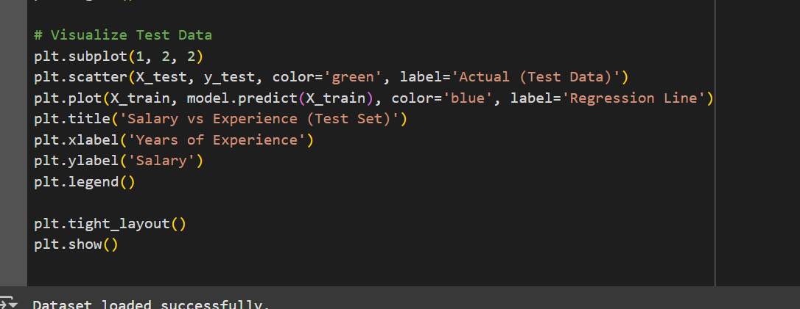

Explanation:

1. Dataset Loaded: Imported Salary_Data.csv and separated it into input and output.
2. Data Split: Divided the data into training and testing subsets using train_test_split.
3. Model Training: Built a Linear Regression model and trained it on the training data.
4. Prediction & Error Calculation: Predicted salaries for the test data and calculated the Mean Squared Error to evaluate the model's accuracy.
5. Visualization: Created scatter plots to compare actual and predicted salaries for both the training and testing datasets, along with the regression line.

OUTPUT:

