Neural Networks & Deep Learning ICP-1

Sita Santoshi Praneetha. A

700772490

GitHub link: <https://github.com/Praneetha65/neural1/upload/main>

Video Link:

<https://drive.google.com/file/d/1xIlA5XWaOzvEe94ZXnwDTM6e4yS3ZDRd/view?usp=sharing>

**Question 1:**

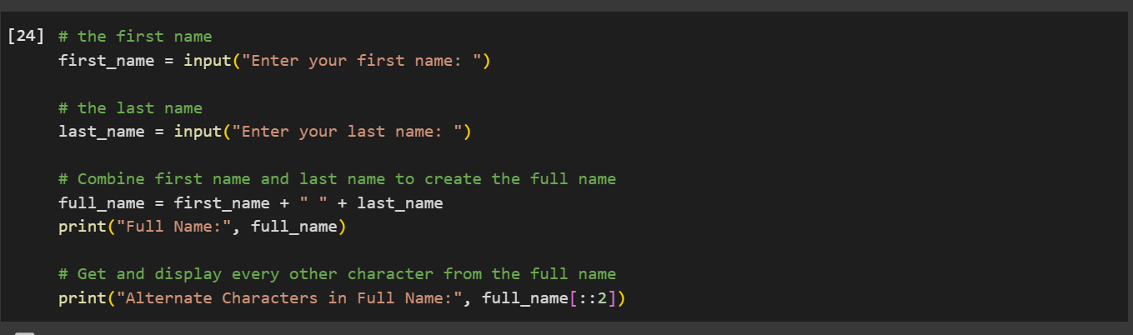

**Explanation:**

1. Input :

* Here we import first name (first_name) and last name (last_name) using the input() function.

2. Full Name Creation:

* Combines first_name and last_name with a space in between using string concatenation (+).
* Stores the resulting string in the variable full_name.

3. Output Full Name:

* Displays the full_name using the print() function.

4. Alternate Characters:

* Retrieves every other character from the full_name using string slicing (full_name[::2]).
* Displays the result as "Alternate Characters in Full Name."

**Output:**

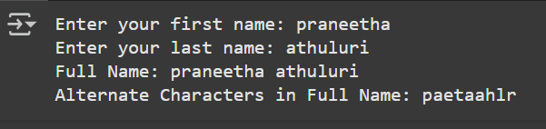

**Question 2:**

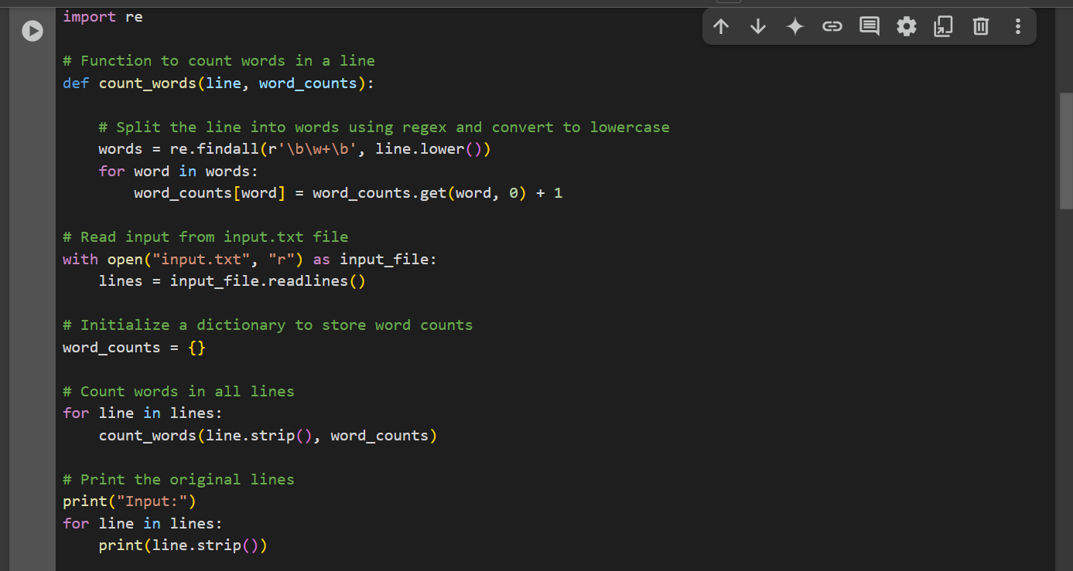

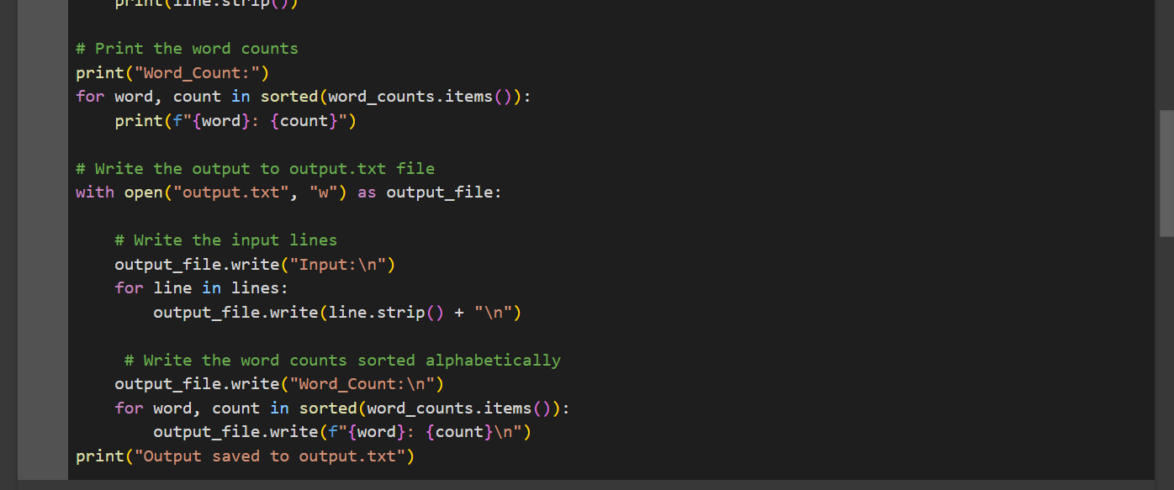

**Explanation:**

1.This script reads text from an input.txt file, counts the occurrences of each word , and writes both the original text and word counts to an output.txt file.

* The Word Counting Function:
  + The count_words() function takes a line of text and a dictionary (word_counts).
  + It uses a regular expression (re.findall()) to extract words, converts them to lowercase, and updates their count in the dictionary.
* Read Input File:
  + Opens input.txt in read mode and reads all lines into a lines.
* Count Words in All Lines:
  + Initializes an empty dictionary, word_counts, to store the word counts.
  + Iterates over each line, removes spaces, and processes the line using the count_words() function.
* Print the Input and Word Counts:
  + Displays the original lines from the file.
  + Displays the word counts sorted alphabetically.
* Write to Output File:
  + Opens output.txt in write mode.
  + Writes the original input lines under the "Input" section.
  + Writes the sorted word counts under the "Word_Count" section.
* Output:
  + Writes the original text and sorted word counts to output.txt.

**Output:**

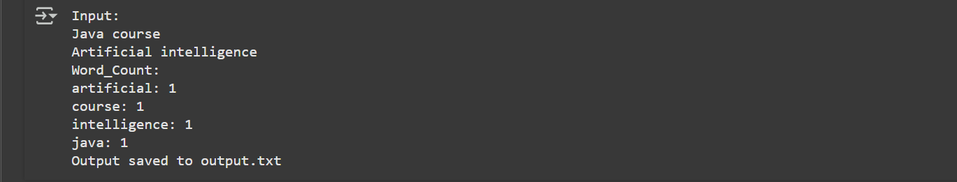

**Question 3:**

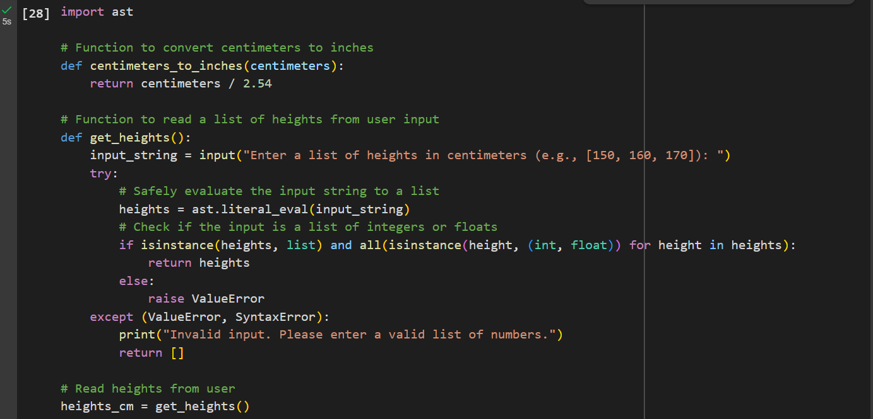

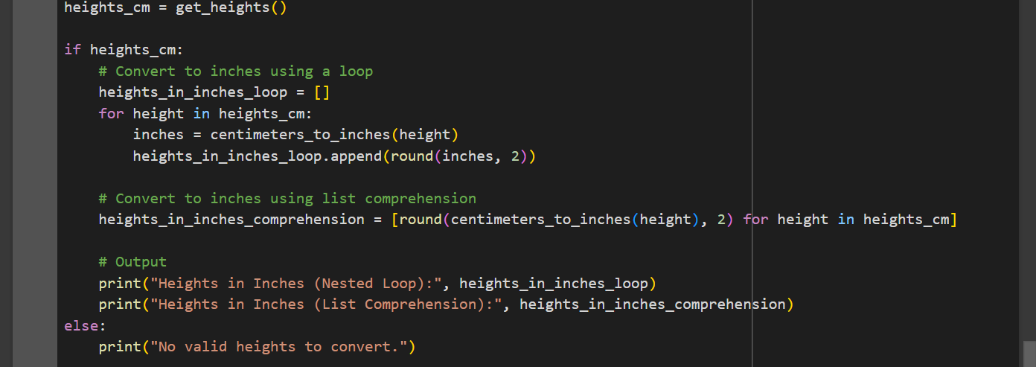

**Explanation:**

Here we are converting a list of heights from centimetres to inches. It does this in two ways: using a regular loop and using a more compact list comprehension:

1. Converting Centimetres to Inches:  
   There's a function called centimeters_to_inches() that takes a height in centimetres and divides it by 2.54 to convert it into inches.
2. Getting User Input:  
   The get_heights() function asks the user to enter a list of heights in centimetres (for example, [150, 160, 170]). The user needs to input this list in the correct format. The script then checks if the input is a valid list of numbers. If it's not, it will show an error and ask for a valid input.
3. Converting Heights: After getting the heights, the script converts each height from centimetres to inches in two ways:
   * Using a loop: It goes through each height, converts it to inches, and stores the results in a new list.
   * Using list comprehension: This is a shorter, more compact way to do the same thing in one line of code.
4. Displaying the Results:  
   Prints out the converted heights in inches for both methods .
5. Error Handling:  
   The script checks the user’s input to make sure it’s a list of numbers. If the user enters something wrong, it shows an error message and asks for the input again.

**Output:**

