PREDICTING DIABETES MELLITUS
A Industrial/Practical Training project report

Submitted to the Faculty of Engineering of
JAWAHARLAL NEHRU TECHNOLOGICAL UNIVERSITY KAKINADA,
KAKINADA

In partial fulfillment of the requirements for the award of the Degree of

BACHELOR OF TECHNOLOGY
In
COMPUTER SCIENCE AND ENGINEERING

By

M.PRANEETHA P.HARSHA VARDHAN
(16481A05C6) (16481A05H2)

P.AKHILA P.PHANI
(16481A05G4) (16481A05F7)

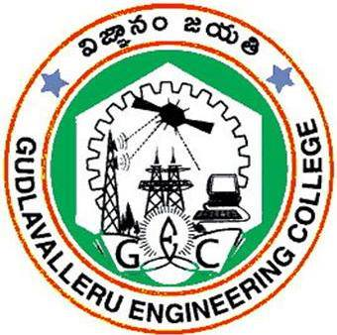

DEPARTMENT OF COMPUTER SCIENCE AND ENGINEERING

GUDLAVALLERUENGINEERINGCOLLEGE
(An Autonomous Institute with Permanent Affiliation to JNTUK, Kakinada)
SESHADRIRAOKNOWLEDGEVILLAGE
GUDLAVALLERU – 521356
ANDHRA PRADESH
2019-2020

GUDLAVALLERU ENGINEERING COLLEGE
(An Autonomous Institute with Permanent affiliation to JNTUK, Kakinada)

SESHADRIRAO KNOWLEDGE VILLAGE::GUDLAVALLERU

DEPARTMENT OF
COMPUTER SCIENCE AND ENGINEERING
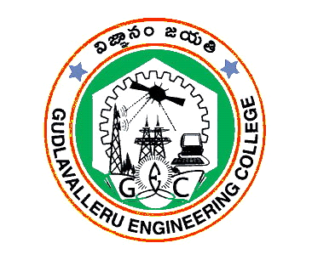

certificate

This is to certify that the Industrial/Practical Training project Report entitled “PREDICTING DIABETES MELLITUS” is a bonafide record of work carried out by M.PRANEETHA, P.HARSHA VARDHAN, P.AKHILA and P.PHANI in partial fulfillment of the requirements for the award of the degree of Bachelor of Technology in Computer Science and Engineering of Jawaharlal Nehru Technological University Kakinada, Kakinada during the academic year 2019-2020.

SK.SALMA BEGUM
(Industrial/Practical Training Coordinator)

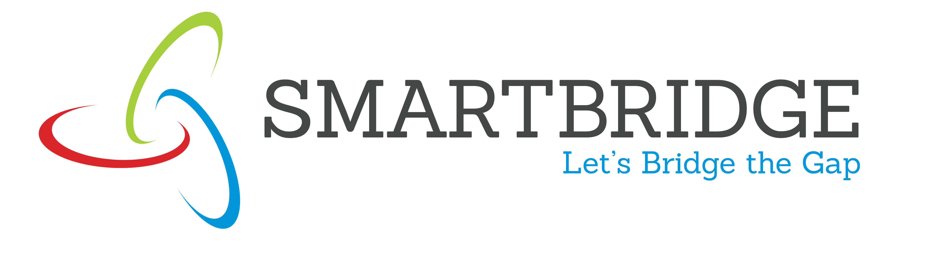
INTERNSHIP REPORT APPROVAL FORM

May 24, 2019

With immense pleasure, this is to approve that the students of Gudlavalleru Engineering College i.e,

Praneetha Marthi(16481A05C6),
Harsha vardha Perumalla(16481A05H2),
Akhila Parisi(16481A05G4) and
Phani Paladugu(16481A0557)

successfully completed their Project and Project Report on “Predicting Diabetes Mellitus” under our guidance.
We are highly impressed with the work that they have done and commend them on their quick grasping skills. They have shown good intent to learn and have put the knowledge gained into application in the from of this project. We appreciate the hard work and commitment shown by them.
We, hereby approve that this document is completely checked and accepted by SmartBridge Technical Team. Its been an absolute pleasure to educate and mentor these students. We hope that this document will also serve as a Letter of Recommendation, to whomsover applied.

We wish them success in all future endeavors and a great career ahead.

Mahankali Surya Tej
AI and IOT Developer

ACKNOWLEDGEMENT

The satisfaction that accompanies the successful completion of any task would be incomplete without the mention of people who made it possible and whose constant guidance and encouragements crown all the efforts with success.

We feel elated to express our floral gratitude and sincere thanks to Dr.S.Narayana, Head of the Department, Computer Science and Engineering for his encouragements all the way during analysis of the project. His annotations, insinuations and criticisms are the key behind the successful completion of the project work.

We would like to take this opportunity to thank our beloved principal Dr.P.Ravindra Babufor providing a great support for us in completing our project and giving us the opportunity for doing project.

We would like to take this opportunity to thank Smart Bridge Educational Services PVT Ltd. for providing this training program and support for us in completing our project.

Our Special thanks to the faculty of our department and programmers of our computer lab. Finally, we thank our family members, non-teaching staff, attendants and our friends, who had directly or indirectly helped and supported us in completing our project in time.

Team members
M.Praneetha (16481A05C6)
P.Harshavardhan (16481A05H2)
P.Akhila (16481A05G4)
P.Phani (16481A05F7)

ABSTRACT

Diabetes is considered as one of the deadliest and chronic diseases which causes an increase in blood sugar. Many complications occur if diabetes remains untreated and unidentified. The tedious identifying process results in visiting of a patient to a diagnostic center and consulting doctor. But the rise in machine learning approaches solves this critical problem. The motive of this study is to design a model which can prognosticate the likelihood of diabetes in patients with maximum accuracy. Therefore five machine learning classification algorithms namely Decision Tree, SVM , KNN , Random Forest, Logistic Regression are used in this experiment to detect diabetes at an early stage. Experiments are performed on Diabetes Database (PIDD) which is sourced from machine learning repository. The performances of all the three algorithms are evaluated on various measures like Accuracy, confusion matrix and AUC-ROC. Accuracy is measured over correctly and incorrectly classified instances. Results obtained show Random Forest outperforms with the highest accuracy of 75.00% comparatively other algorithms. These results are verified using Receiver Operating Characteristic (ROC) curves in a proper and systematic manner.

INDEX

TITLE PAGE NO

ABSTRACT

CHAPTER 1: TITLE OF THE PROJECT 1
1.1 INTRODUCTION 1
1.2. OBJECTIVES OF REASEARCH 1

1.3. PROBLEM STATEMENT 1

CHAPTER 2 : REVIEW OF LITERATURE 1

CHAPTER 3: DATA COLLECTION 2

CHAPTER 4: METHODOLOGY 2

4.1 : EXPLORATORY DATA ANALYSIS 3

4.1.1. FIGURES AND TABLES 3

4.2. STATISTICAL TECHNIQUES AND DATA 6 VISUALIZATION

4.3. DATA MODELING USING SUPERVISED ML 6 TECHNIQUES

CHAPTER 5 : FINDINGS AND SUGGESTIONS 7

CHAPTER 6 : CONCLUSION 8

