##### 

##### USECASE DIAGRAM

##### A Use case is a description of set of sequence of actions. Graphically it is rendered

##### as an ellipse with solid line including only its name. Use case diagram is a behavior

##### al diagram that shows a set of use cases and actors and their relationship. It is an

##### association between the use cases and actors. An actor represents a real- world ob

##### ject. Primary Actor – Sender, Secondary Actor Receiver.

The actors in this application are

* + 1. Admin
    2. Student/ User Use cases of admin are:

1. Manage exam
2. Manage student
3. View results

Use cases of student/ user are:

1. Registration
2. Login
3. Select exam
4. Give exam
5. Get result

Student has to register in order to write the exam. He can login using his details after registration. Later he can select the exam and attend it. After the exam is finished, he can view the result whereas admin can manage the list of students and all the exams that has to be performed.

**­­­­­**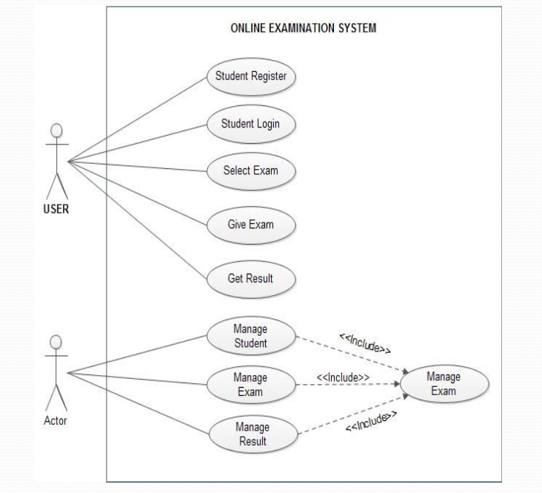

**Class ­­­­Diagram**

Class is nothing but a structure that contains both variables and methods. The Class Diagram shows a set of classes, interfaces, and collaborations and their relationships. There is most common diagram in modeling the object oriented systems and are used to give the static view of a system. It shows the dependency between the classes that can be used in our system.

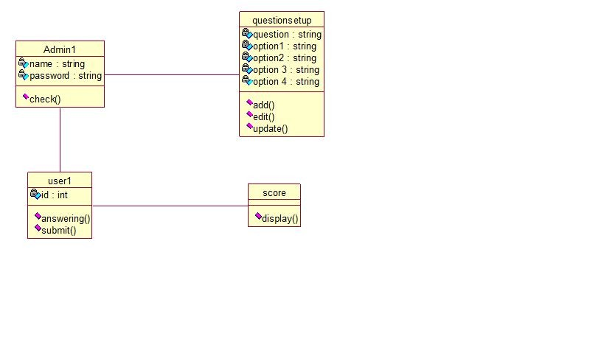The interactions between the modules or classes of our projects are shown below. Each block contains Class name, Variables and Methods.

**SEQUENCE DIAGRAM**

Sequence diagram and collaboration diagram are called INTERACTION DIAGRAMS. An interaction diagram shows an interaction, consisting of set of objects and their relationship including the messages that may be dispatched among them.

A sequence diagram is an introduction that empathizes the time ordering of messages. Graphically a sequence diagram is a table that shows objects arranged along the X-axis and messages ordered in increasing time

along the Y-axis.

In this application student visits the main page and registers into it. Then he uses his credentials for login. Application server database will check whether the credentials of the user are valid or not and sends appropriate message to the user. If he is able to login, he will be taken to the test page and he can write the test of his interest. After completing the test, he will get the result through the server database.

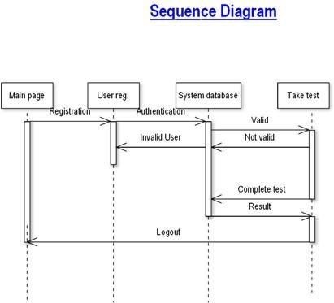

FIG2: Sequence Diagram