Project 1 – Data Cleaning & Preparation
Final submission package prepared from the uploaded project brief and dataset.

1. Objective
The goal of Project 1 is to clean a raw dataset by identifying missing/null values, removing duplicates, and correcting data formats such as dates, numbers, and text.

2. Project Requirement Mapping
The uploaded brief requires the following for Project 1:
- Identify missing or null values
- Remove duplicates
- Correct data formats (dates, numbers, text)
- Verify zero duplicate IDs and zero incorrectly formatted dates before completion

3. Dataset Overview
Rows before cleaning: 1200
Columns: 14
Columns: OrderID, Date, CustomerID, Product, Quantity, UnitPrice, ShippingAddress, PaymentMethod, OrderStatus, TrackingNumber, ItemsInCart, CouponCode, ReferralSource, TotalPrice

4. Initial Data Quality Audit
Duplicate rows before cleaning: 0
Duplicate OrderID values before cleaning: 0
Missing values before cleaning:
- OrderID: 0
- Date: 0
- CustomerID: 0
- Product: 0
- Quantity: 0
- UnitPrice: 0
- ShippingAddress: 0
- PaymentMethod: 0
- OrderStatus: 0
- TrackingNumber: 0
- ItemsInCart: 0
- CouponCode: 309
- ReferralSource: 0
- TotalPrice: 0

5. Cleaning Actions Performed
- Converted blank strings to null values for proper missing-value detection.
- Trimmed leading/trailing whitespace in text fields.
- Standardized date columns using pandas datetime conversion.
- Removed exact duplicate rows.
- Validated and removed duplicate OrderID values where required.
- Imputed missing numeric values using median.
- Imputed missing categorical/text values using mode.
- Imputed missing date values using the most frequent valid date.
- Standardized text formatting for selected categorical columns.

6. Change Log
Change ID | Description | Impact | Status
CR002 | Standardized date format in Date | 1200 rows parsed; 0 invalid coerced to NaT | Resolved
CR003 | Removed exact duplicate rows | 0 duplicate rows removed | Resolved
CR004 | Checked duplicate OrderID values | 0 duplicate IDs found | Resolved
CR005 | Handled missing values | 1 columns imputed | Resolved

7. Missing Value Treatment Details
- CouponCode: filled 309 missing categorical/text values with mode (FREESHIP)

8. Final Validation Results
Rows after cleaning: 1200
Columns after cleaning: 14
Duplicate rows after cleaning: 0
Duplicate OrderID values after cleaning: 0
- Missing values after cleaning in OrderID: 0
- Missing values after cleaning in Date: 0
- Missing values after cleaning in CustomerID: 0
- Missing values after cleaning in Product: 0
- Missing values after cleaning in Quantity: 0
- Missing values after cleaning in UnitPrice: 0
- Missing values after cleaning in ShippingAddress: 0
- Missing values after cleaning in PaymentMethod: 0
- Missing values after cleaning in OrderStatus: 0
- Missing values after cleaning in TrackingNumber: 0
- Missing values after cleaning in ItemsInCart: 0
- Missing values after cleaning in CouponCode: 0
- Missing values after cleaning in ReferralSource: 0
- Missing values after cleaning in TotalPrice: 0
- Incorrect/blank date values after cleaning in Date: 0

9. Verification Against Project Gate
- Unique identifier check (OrderID): PASS
- Date format check (Date): PASS

10. Visual Audit
Figure 1: Missing Values Before vs After Cleaning
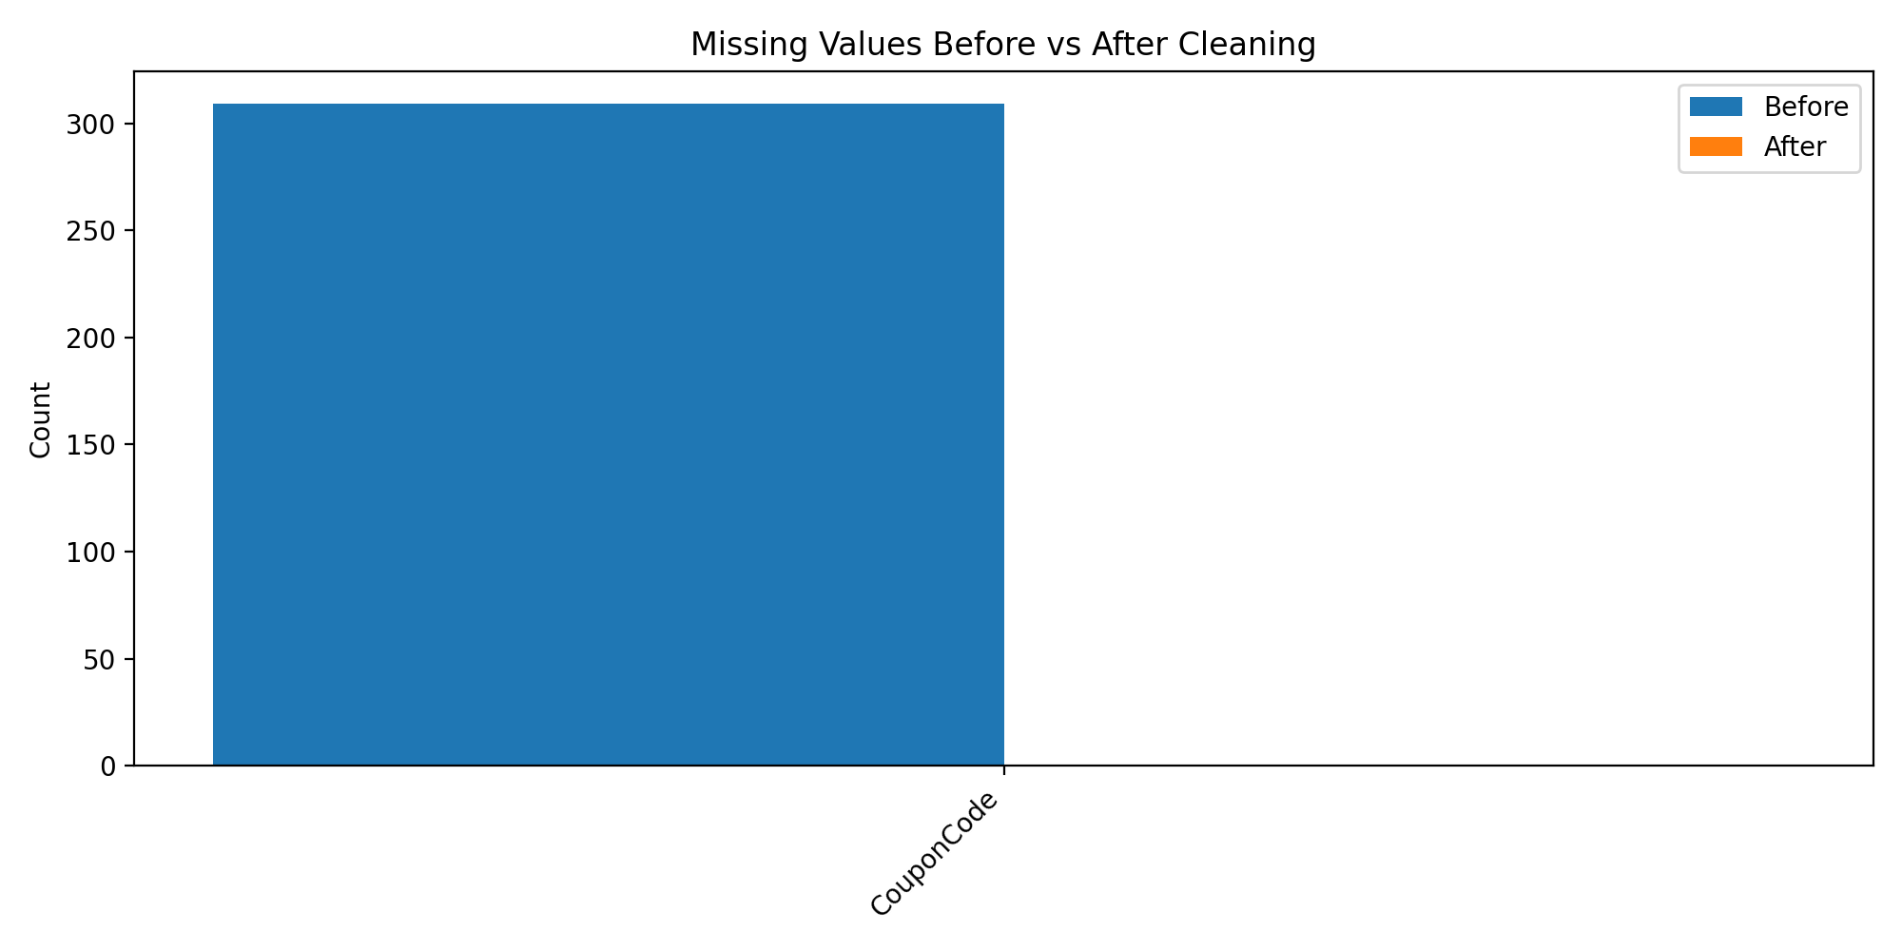
Figure 2: Duplicate Audit Summary
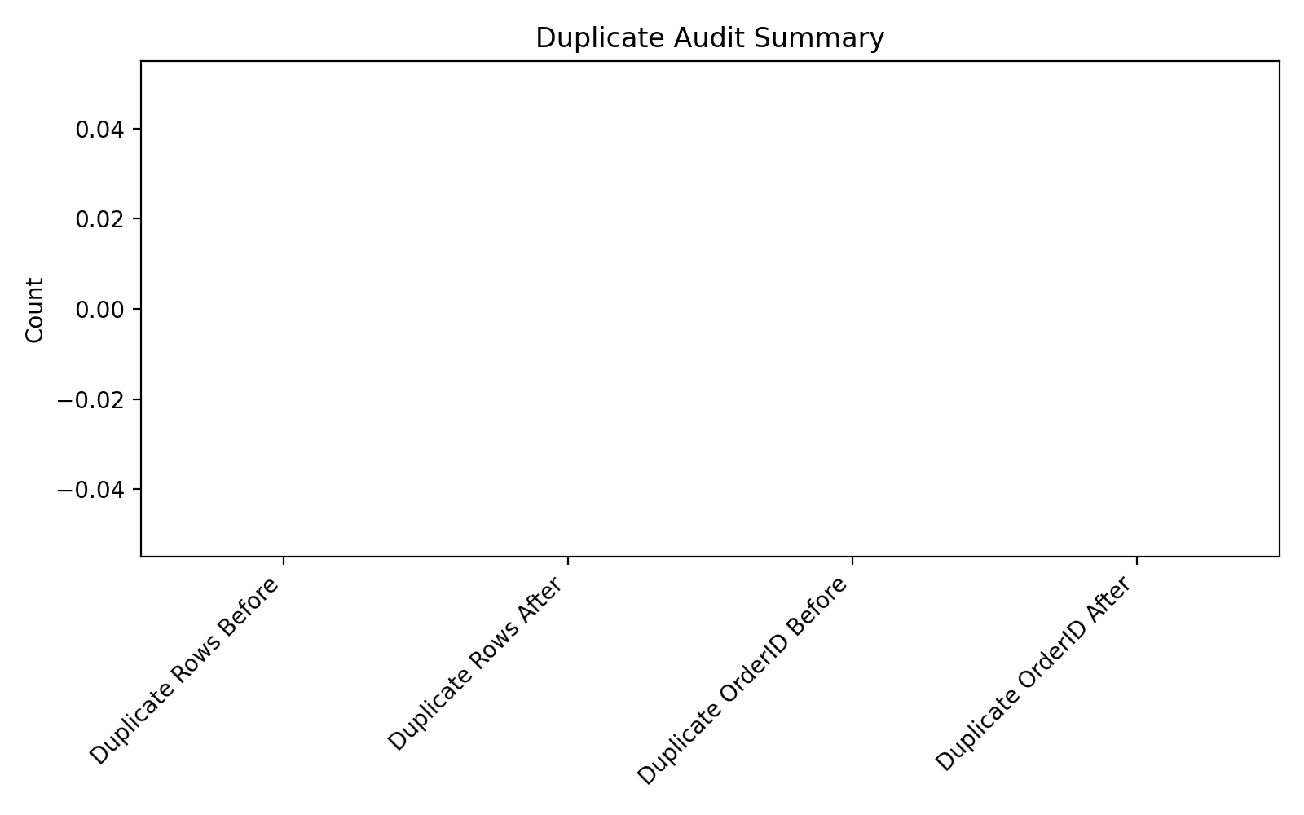

11. Conclusion
The dataset was successfully cleaned and standardized according to the Project 1 brief. Missing values were identified and treated, duplicate rows were removed, key text/date fields were standardized, and validation checks were run to confirm data integrity for the next stage of analysis.

