HematoVision – Project Report

## Introduction:

HematoVision is an advanced machine learning project focused on the automated classification of blood cells using deep learning and transfer learning techniques. The primary goal is to assist in medical diagnostics by accurately identifying different types of blood cells—such as lymphocytes, monocytes, eosinophils, and neutrophils—from microscopic images. By leveraging pre-trained convolutional neural networks (CNNs)

## Problem Statement:

Accurate and timely identification of blood cell types is crucial for diagnosing various diseases. Manual analysis is time-consuming and prone to human error. This project aims to automate the classification process using deep learning**.**

## Objectives:

* To use transfer learning (MobileNetV2) to classify blood cell images.
* To visualize and evaluate the performance of the model.
* To integrate the trained model into a Flask web application.
* To deploy a simple UI for users to upload blood cell images and get predictions.

## Tools and Technologies:

Python

TensorFlow / Keras

OpenCV

Flask

Jupyter Notebook

HTML/CSS (Milligram CSS)

Git & GitHub

## Dataset

Source: Kaggle Blood Cell Dataset

Classes: Eosinophil, Lymphocyte, Monocyte, Neutrophil

**HematoVision: Advanced Blood Cell Classification Using Transfer Learning**

Total Images: 12.500 augmented.

## Project Workflow:

**Step 1:** Data Preprocessing

- Images resized to (224x224)

-Normalized using MobileNetV2's preprocess input

**Step 2:** Model Building

- Used MobileNetV2 with frozen base layers

Added custom dense layers

**Step 3:** Model Evaluation

- Achieved -89% accuracy

Visualized training using loss and accuracy graphs

Evaluated with classification report and confusion matrix

**Step 4:** Saving the Model

Saved the model as Blood Cell.h5

**Step 5:** Web App using Flask

Created home.html for image upload

-Created result.html to show prediction

## Folder Structure

HematoVision/

app.py

Blood Cellh5

static/

[uploaded images)

templates/

**HematoVision: Advanced Blood Cell Classification Using Transfer Learning**

home.html

result.html

dataset/

[image folders]

report.pdf

demo_video.mp4

## 8. Results

- Achieved -89% classification accuracy

- Predicted all four blood cell types via web Ul

Users can upload images and view predictions instantly

## 9. Conclusion

HematoVision demonstrates how transfer leaming and Flask can be combined to build a real-time diagnostic tool. This helps reduce the burden on healthcare professionals by automating routine tasks.

## 10. Future Work

- Integrate additional cell types and datasets

Add cloud deployment features

Improve Ul and add batch prediction support

## 11. Showcase Screenshots

**HematoVision: Advanced Blood Cell Classification Using Transfer Learning**

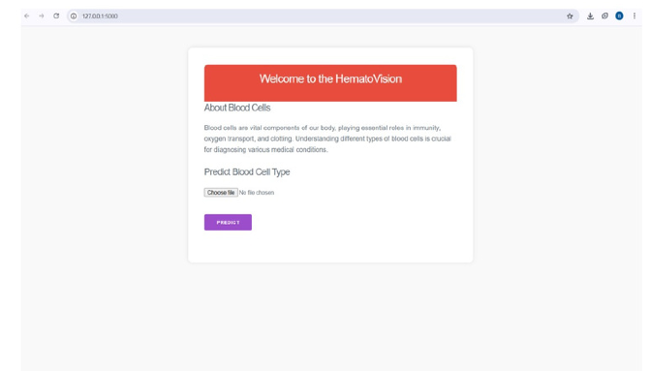

* Allows the user to upload microscopic blood cell images (JPEG/PNG).
* Ensures a user-friendly layout using Milligram CSS.
* Accepts files directly from local device storage.
* Prepares image for backend processing upon form submission.

**HematoVision: Advanced Blood Cell Classification Using Transfer Learning**

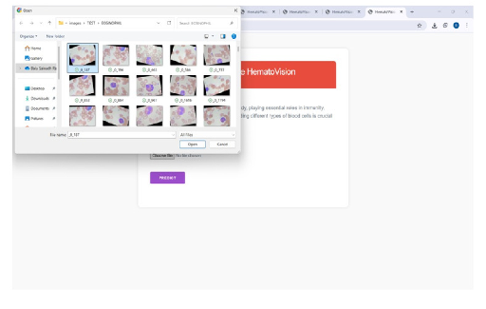

* Triggered when the user clicks the Predict button.
* Uploaded image is sent to Flask backend.
* The trained MobileNetV2 model processes and classifies the image.
* Prediction happens in real-time with fast response.