FINAL CODE
2. Data Cleaning and Feature Selection:
- Filtering the dataset to only include records from 2006 to 2013.
- Renaming the columns to make them more readable.
- Saved the cleaned dataset to an Excel file named Above_2005_Yield.xlsx.
- Manually added a Region column based on the countries in the Area column.
import pandas as pd
import numpy as np

# Load the dataset
df = pd.read_csv('Global Crop Yeild Analysis Dataset.csv')

# Step 1: Filter the dataset for years 2006 and later
df_above_2005 = df[df['year'] > 2005]

# Step 2: Rename columns to match the required names
df_above_2005.rename(columns={
'Area': 'Area',
'Item': 'Item',
'Year': 'Year',
'hg/ha_yield': 'Yield',
'average_rain_fall_mm_per_year': 'Average_Rain',
'pesticides_tonnes': 'Pesticide_Usage',
'avg_temp': 'Average_Temperature'
}, inplace=True)

# Step 3: Save the cleaned dataset to an Excel file
df_above_2005.to_excel('Above_2005_Yield.xlsx', index=False)

# Optional: Preview the first few rows of the modified dataset
df_above_2005.head()

Dataset Preview: Here is a preview of the cleaned and feature-engineered dataset:
Region | Area | Item | Year | Yield | Average_Rain | Pesticide_Usage | Average_Temperature
Europe | Albania | Maize | 2006 | 50111 | 1485 | 943.61 | 15.92
Europe | Albania | Potatoes | 2006 | 170745 | 1485 | 943.61 | 15.92
Europe | Albania | Soybeans | 2006 | 20000 | 1485 | 943.61 | 15.92
Europe | Albania | Wheat | 2006 | 30787 | 1485 | 943.61 | 15.92
Europe | Albania | Maize | 2007 | 46732 | 1485 | 1006.57 | 16.67

3.1 Trend Analysis Over Time
3.1.1 Average Yield Over Time with Temperature in R
# Group the data by 'Year' and calculate the average yield and temperature for each year
Yearly_Data <- Above_2005_Yield %>%
group_by(Year) %>%
summarise(
Avg_Yield = mean(Yield, na.rm = TRUE), # Calculate average yield, ignoring NA values
Avg_Temperature = mean(Average_Temperature, na.rm = TRUE) # Calculate average temperature, ignoring NA values
)
# Create a scatter plot of Average Yield over Time, with the size of the points representing Temperature
ggplot(Yearly_Data, aes(x = Year, y = Avg_Yield, size = Avg_Temperature)) +
geom_point(color = "darkblue") + # Add dark blue points for each year
scale_size_continuous(name = "Temperature (°C)", range = c(3, 8)) + # Set size scale for temperature with labels and range
labs(
title = "Average Yield Over Time with Temperature", # Set the plot title
x = "Year", # Label for the x-axis
y = "Average Yield" # Label for the y-axis
) +
theme_minimal() # Apply minimal theme to the plot
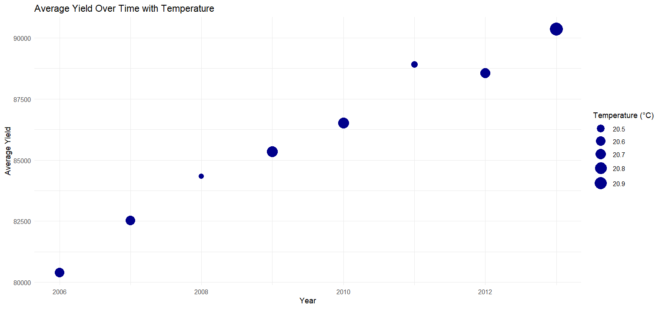
3.1.2 Trends in Yield and Pesticide Usage Over Time in R
# Load necessary libraries for data manipulation and visualization
library(ggplot2)
library(dplyr)
# Calculate the average Yield and Pesticide Usage per Year
average_data_table <- Above_2005_Yield %>%
group_by(Year) %>% # Group data by 'Year'
summarise(
Avg_Yield = mean(Yield, na.rm = TRUE), # Calculate the average yield, ignoring NA values
Avg_Pesticide_Usage = mean(Pesticide_Usage, na.rm = TRUE) # Calculate the average pesticide usage, ignoring NA values
)

# Convert the data from wide format to long format for easier plotting with ggplot
long_data <- average_data_table %>%
pivot_longer(cols = c(Avg_Yield, Avg_Pesticide_Usage), # Pivot the 'Avg_Yield' and 'Avg_Pesticide_Usage' columns
names_to = "Variable", # Convert the column names to a new 'Variable' column
values_to = "Value") # Convert the values to a new 'Value' column
# Plot the trends of Yield and Pesticide Usage over Time using a multi-line graph
ggplot(long_data, aes(x = Year, y = Value, color = Variable, group = Variable)) +
geom_line(size = 1.2) + # Draw lines for each variable with a thickness of 1.2
labs(
title = "Trends in Yield and Pesticide Usage Over Time", # Set the plot title
x = "Year", # Label for the x-axis
y = "Value", # Label for the y-axis
color = "Variable" # Label for the color legend
) +
scale_color_manual(values = c("Avg_Yield" = "darkblue", "Avg_Pesticide_Usage" = "red")) + # Set custom colors for the variables
theme_minimal() # Apply a minimal theme for the plot

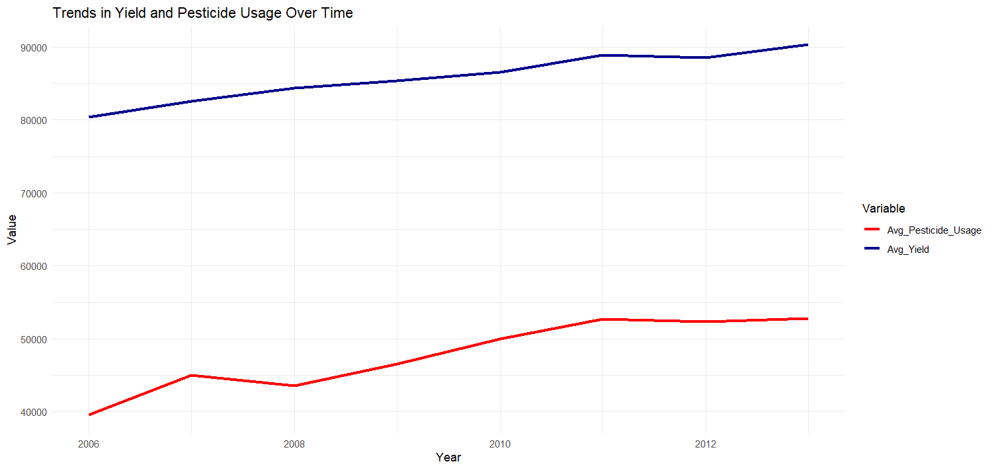
3.2 Geographical Trend Analysis
3.2.1 Comparison of Average Yield Across Regions in Python
import pandas as pd
import seaborn as sns
import matplotlib.pyplot as plt

# Assuming your data is in a pandas DataFrame called df (replace 'df' with your actual DataFrame variable)
df = pd.read_csv("Above_2005_Yield.csv") # Adjust this path to your actual data file

# Creating the bar plot for average yield
plt.figure(figsize=(10, 6)) # Adjust the figure size for better clarity
sns.barplot(x="Region", y="Yield", data=df, estimator="mean", ci=None, palette="viridis")

# Adding labels and title
plt.title("Regional Average Yield Comparison", fontsize=16)
plt.xlabel("Region", fontsize=14)
plt.ylabel("Average Yield", fontsize=14)

# Show the plot
plt.tight_layout()
plt.show()

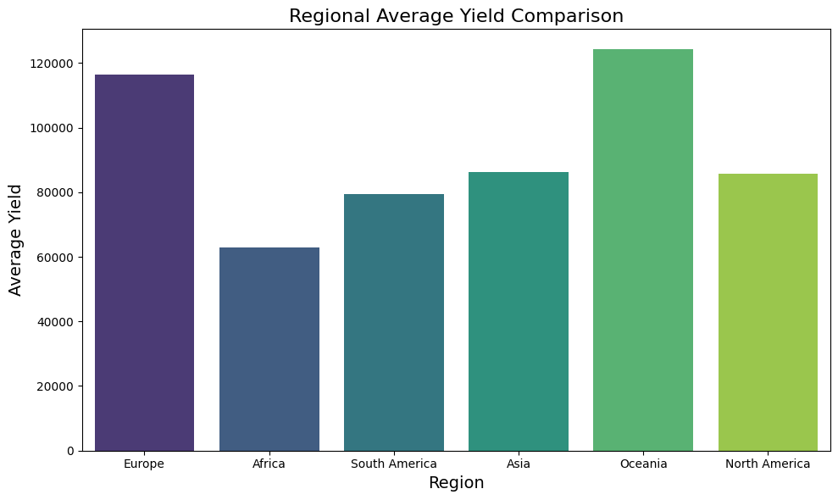
3.2.2 Average yield by Region with Rainfall as Bubble size in Tableau
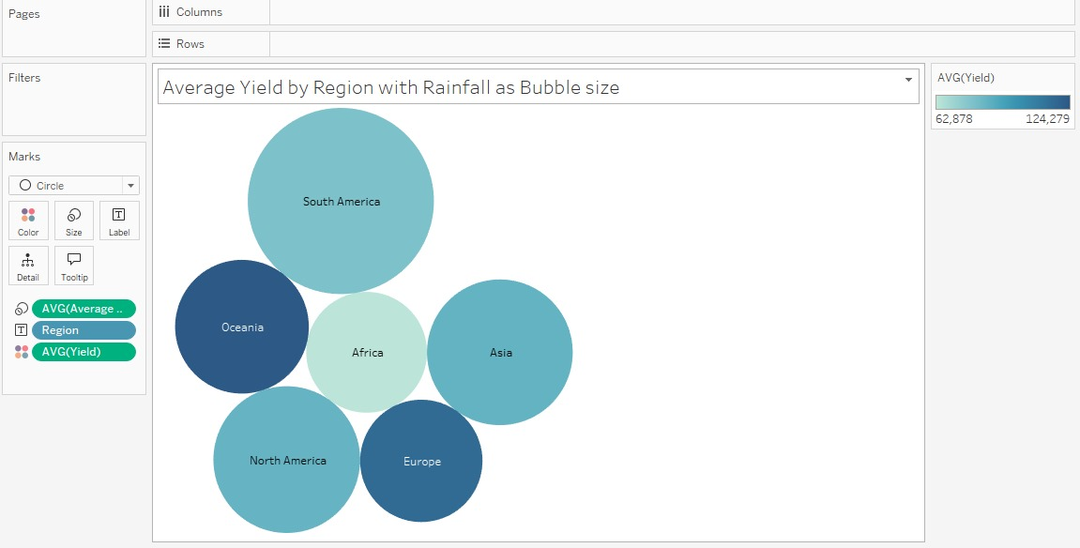

3.3 Crop Items Perspective
3.3.1 Grouped Bar Plot of Yield and Pesticide usage by Item in Python
# Import necessary libraries
import pandas as pd
import matplotlib.pyplot as plt
import seaborn as sns

# Assuming your data is in a DataFrame called df
# Example data structure: df = pd.read_csv("your_data.csv")

# Reshape the data to have 'Yield' and 'Pesticide Usage' as separate columns
df_melted = df.melt(id_vars=["Item"], value_vars=["Yield", "Pesticide_Usage"],
var_name="Measure", value_name="Value")

# Create a grouped bar plot
plt.figure(figsize=(10, 6))
sns.barplot(x="Item", y="Value", hue="Measure", data=df_melted, palette="Set2")

# Customize the plot
plt.title("Grouped Bar Plot of Yield and Pesticide Usage by Item")
plt.xlabel("Item")
plt.ylabel("Value")
plt.xticks(rotation=45, ha="right") # Rotate x-axis labels for better readability
plt.tight_layout() # Adjust the layout to prevent clipping

# Show the plot
plt.show()

