CHAPTER ONE : INTRODUCTION

  - PROJECT IDENTIFICATION / PROBLEM DEFINITION
Heart disease, particularly heart attacks, remains a leading global health concern. Cardiovascular diseases (CVDs) are the leading cause of death worldwide, taking an estimated 17.9 million lives each year, according to the World Health Organization (WHO). Despite advances in medicine, heart disease often goes undetected until it manifests as a severe or fatal event, making early identification and intervention essential. Many individuals at high risk may not exhibit symptoms or may lack awareness of preventive measures. Hence, there is a growing need for proactive tools that help individuals understand and manage their risk, particularly through accessible, user-friendly solutions that promote preventive care.
Project Identification
HeartHealth AI: Deep Learning-Based Heart Attack Risk Classification & Prevention is a chatbot-driven healthcare application aimed at predicting heart attack risk and delivering personalized health recommendations. It leverages the latest advancements in artificial intelligence (AI), particularly deep learning algorithms, to assess heart health based on multiple parameters and provide actionable insights. The project's core feature is its integration with a large language model (LLM), Llama 3.1, which supports real-time interaction and health advice delivery through a chatbot interface. This AI-driven approach allows for a more personalized and data-driven assessment, taking into account user health metrics and habits.
Problem Definition
Heart disease prevention is complex, involving various factors like genetics, lifestyle, and environmental influences. Traditional risk assessment methods, typically requiring clinical intervention, may not be available to all individuals due to geographic, financial, or time-related constraints. Furthermore, traditional assessments may not engage users actively, limiting their involvement in managing their health. HeartHealth AI addresses these gaps by offering an intelligent, accessible, and personalized tool that empowers individuals to understand their heart health risk and make informed choices regarding lifestyle changes. This project uses machine learning to analyze user health data (e.g., age, cholesterol, blood pressure, and family medical history) against benchmark datasets, such as the Framingham Heart Study, which has established risk factors and predictive markers for cardiovascular events.
By focusing on early detection and preventive care, HeartHealth AI fills a critical need for an interactive, AI-powered application that provides real-time feedback. Its use of Llama 3.1 as an interactive chatbot brings a human-like conversational element to the health assessment, making complex information accessible and actionable. The chatbot engages users in a friendly, intuitive conversation, gathering data and providing tailored guidance based on the individual’s health profile. This approach aligns with the growing demand for digital health solutions that are both informative and supportive, encouraging proactive measures for heart health.
Ultimately, the problem that HeartHealth AI aims to solve is the gap in accessible, personalized risk assessment for cardiovascular health, especially for those who may not have immediate access to medical professionals. By offering a solution that individuals can access via a website or mobile app, this project provides a significant step towards integrating preventive healthcare into daily life.
  - OBJECTIVE OF PROJECT
The primary objective of HeartHealth AI: Deep Learning-Based Heart Attack Risk Classification & Prevention is to provide an accessible, accurate, and user-friendly tool for assessing heart attack risk and promoting cardiovascular health. By leveraging the power of deep learning and AI, this project aims to create an intelligent healthcare chatbot that predicts heart attack risk and delivers personalized recommendations to help users improve their heart health and reduce associated risks.
The key objectives of this project include:
- Accurate Heart Attack Risk Prediction
HeartHealth AI seeks to deliver precise risk assessments for heart attacks by analyzing user-specific health data through advanced deep learning algorithms, including Convolutional Neural Networks (CNNs) and Recurrent Neural Networks (RNNs). These models are trained on established cardiovascular datasets, such as the Framingham Heart Study, to ensure high accuracy and reliability in identifying key health indicators and risk factors associated with heart attacks.
- Personalized Health Recommendations
Based on each user's unique health profile, HeartHealth AI provides tailored lifestyle recommendations, including diet, exercise, and other preventive measures that align with medical guidelines for cardiovascular health. By offering individualized guidance, the chatbot encourages users to adopt healthier habits that can mitigate identified risks and improve long-term heart health.
- Enhanced User Engagement through LLM-Powered Chatbot
With Llama 3.1 as its core language model, HeartHealth AI enables a conversational, interactive experience that makes complex health information accessible. The chatbot guides users through an intuitive interface, collects essential health metrics (age, cholesterol levels, blood pressure, smoking status, family history, etc.), and provides real-time responses that keep users informed and engaged in managing their health.
- Accessible and Convenient Preventive Healthcare
The project aims to make preventive heart health resources widely accessible by deploying the chatbot on platforms such as websites and mobile apps. This ensures that users from diverse backgrounds can access the tool conveniently, without the need for specialized medical visits, making preventive healthcare more readily available.
- Integration of AI in Preventive Healthcare
By combining deep learning with language models in a preventive healthcare setting, HeartHealth AI demonstrates the potential of AI-driven applications in the medical field. The project aims to contribute to the digital health ecosystem by offering a preventive healthcare solution that exemplifies the effectiveness of AI in improving health outcomes and raising awareness about cardiovascular risks.
- Scalability and Future Enhancements
The project is designed with scalability in mind, allowing for potential expansion to monitor additional health metrics or integrate with wearable devices for real-time health monitoring. Future enhancements could include extending the model’s capabilities to predict other health conditions and improving accuracy through continuous training on larger datasets.
In summary, HeartHealth AI aims to empower individuals with the knowledge and resources to proactively manage their heart health, thereby reducing the risk of heart attacks and promoting a preventive approach to healthcare. This project not only seeks to improve user awareness but also to encourage meaningful lifestyle changes through actionable insights and interactive support.
  - SCOPE OF THE PROJECT
The scope of HeartHealth AI: Deep Learning-Based Heart Attack Risk Classification & Prevention spans several key areas within healthcare, technology, and user engagement, focusing on making preventive heart health assessments more accessible and actionable. This project leverages deep learning algorithms, large language models (LLMs), and conversational AI to create an intelligent healthcare application that enables users to assess heart attack risk and receive personalized health recommendations.
The following outlines the main aspects of the project’s scope:
- User-Centric Heart Health Assessment
HeartHealth AI offers a digital tool that collects essential health information from users, such as age, gender, cholesterol levels, blood pressure, smoking status, and family medical history. By integrating deep learning models like CNNs and RNNs, the application analyzes these metrics to provide accurate risk assessments for heart attacks. The platform is designed to prioritize user experience, providing health assessments in a format that is easy to understand and act upon.
- Personalized Health Recommendations and Insights
Beyond risk assessment, the chatbot offers tailored health suggestions that align with users' specific needs. These recommendations may include lifestyle adjustments such as dietary changes, exercise routines, and other wellness strategies based on recognized medical guidelines. This scope element emphasizes the role of HeartHealth AI not only in diagnosis but also in encouraging long-term lifestyle changes.
- Advanced AI and Chatbot Technology
The project scope includes the deployment of Llama 3.1, an advanced language model that powers the chatbot interface. Through Gradio and Ollama integration, the chatbot can deliver interactive and insightful conversations with users. This AI-driven approach facilitates a more engaging, responsive experience, making it easy for users to provide necessary health data and receive feedback immediately.
- Accessible Platform Deployment
To ensure widespread accessibility, the project will be deployed on both web and mobile platforms, making it available to users anywhere and at any time. The application is designed for easy integration with common digital interfaces, and future versions may include support for popular messaging services, enabling users to interact with HeartHealth AI via their preferred channels.
- Extensive Testing, Model Validation, and Data Security
A critical component of the project’s scope involves rigorous testing to ensure that the deep learning model is both accurate and reliable. The heart health prediction model is trained on extensive datasets, such as the Framingham Heart Study, to validate its accuracy. Additionally, the application follows strict data security protocols to ensure user information remains confidential and protected.
- Scalability and Future Growth
The scope of HeartHealth AI also includes the potential for future development and scalability. This may involve expanding the model’s health monitoring capabilities, integrating data from wearable devices for real-time health updates, and incorporating additional features that provide insights on other health metrics. The project is designed to adapt to advancements in AI and health technology, enabling it to stay relevant and expand in functionality over time.
- Potential for Research and Industry Collaboration
As a cutting-edge health application, HeartHealth AI offers opportunities for collaboration with research institutions, healthcare providers, and industry experts. Its development can contribute to the field of digital healthcare by setting a benchmark for AI-driven health applications focused on preventive care and risk management.
In summary, the project’s scope covers multiple dimensions of healthcare technology, with a focus on delivering a proactive, accessible, and user-friendly solution for heart health assessment and prevention. HeartHealth AI aims to provide a scalable, reliable, and innovative tool that empowers individuals to manage their heart health effectively and take preventive actions for a healthier life.

CHAPTER TWO : ANALYSIS

2.1 PROJECT PLANNING AND RESEARCH SOFTWARE REQUIREMENT SPECIFICATION
The HeartHealth AI project involves meticulous planning and research to ensure the application meets high standards of accuracy, accessibility, and user experience in predictive healthcare. The planning phase focused on understanding heart attack risk factors, user needs, and the capabilities of AI for preventive healthcare. The project’s development involved studying existing methods for heart disease prediction and evaluating various machine learning algorithms, such as Convolutional Neural Networks (CNNs) and Recurrent Neural Networks (RNNs), to optimize accuracy.
The software requirement specification (SRS) was developed to outline the technical and functional needs of the project. The core software requirements include Python as the primary language for implementing deep learning models, integrated with Llama 3.1 for conversational AI using Gradio for the user interface and Ollama for chatbot deployment. Additionally, libraries like TensorFlow or PyTorch support the model training and evaluation processes, while Pandas and NumPy facilitate data handling.
On the server side, a secure database, such as MySQL or MongoDB, manages user health data while following strict data privacy protocols. The application’s frontend is planned for responsive design to be accessible on both web and mobile platforms, ensuring a user-friendly experience. By adhering to this SRS, HeartHealth AI aligns its technical architecture with the goals of accurate health prediction and ease of use.

2.1.1 SOFTWARE REQUIREMENT

Functional Requirements:
The functional requirements of HeartHealth AI define the essential features and operations that the application must perform to deliver accurate heart attack risk assessments and personalized health recommendations. These include:

- User Registration and Authentication
Users must be able to register, create secure profiles, and log in to access personalized assessments. Authentication mechanisms (e.g., email/OTP verification) ensure secure access.
- Data Collection and Input Interface
The application should enable users to enter essential health information, including age, gender, cholesterol level, blood pressure, smoking status, and family medical history. The chatbot should guide users to provide accurate data for assessment.
- Heart Attack Risk Prediction
The application should process user data using deep learning models (CNNs, RNNs) to predict heart attack risk levels, with output displayed in a clear, user-friendly format.
- Personalized Health Recommendations
Based on risk levels, the chatbot should offer actionable health recommendations, such as diet, exercise, and lifestyle changes, to help users manage their heart health.
- Conversational AI Chatbot
Using Llama 3.1, the chatbot interface allows users to interact conversationally, enhancing the user experience by explaining health terms, guiding users through data input, and delivering health insights.
- User Dashboard and History
A dashboard should display past assessments and trends, allowing users to track changes in risk levels over time.
- Backend Data Management
Secure storage of user health data, risk assessments, and recommendations in a database (e.g., MySQL or MongoDB), ensuring data integrity and user confidentiality.
- Notifications and Reminders
The application should send users reminders for regular health check-ups and prompt them for data updates, helping users stay proactive about heart health.
Non-functional Requirements:
The non-functional requirements ensure that the application performs optimally and offers a reliable, secure, and user-friendly experience. These include:
- Performance
The application must deliver quick responses, particularly for data processing and risk predictions, with minimal latency for a seamless user experience.
- Scalability
The application should be capable of scaling to support an increasing number of users and potentially additional health metrics or features.
- Usability
The user interface should be intuitive, with a clean design that is easy to navigate. The chatbot interface should be interactive, making health information accessible and understandable.
- Reliability
The application must ensure consistent availability and accurate performance, especially in data analysis and risk assessment. Fail-safes and error-handling mechanisms should be in place to handle unexpected issues.
- Security and Privacy
Strong data encryption, secure authentication methods, and privacy protocols are necessary to protect sensitive user health data, complying with health data standards such as HIPAA or GDPR.
- Compatibility
The application should be accessible across various devices, including desktops, smartphones, and tablets, ensuring a responsive design.
- Maintainability
The software should be structured to allow for easy updates, debugging, and feature enhancements, ensuring long-term usability and relevance.
- Accuracy
The deep learning models used for risk prediction must be thoroughly validated and tested against benchmark datasets to maintain high prediction accuracy and reduce false positives/negatives.
- Interoperability
The system should allow for potential integration with wearable devices or external health monitoring systems in future expansions, enabling real-time health data inputs.
2.1.2 HARDWARE REQUIREMENT
The HeartHealth AI application requires a robust hardware setup to efficiently handle data processing, deep learning model training, and user interactions. Below are the recommended hardware specifications:

Development Hardware Requirements
- Processor
For development and model training, a multi-core processor with high clock speed is essential to handle the intensive computations required by deep learning models.
  - Recommended: Intel Core i7 or AMD Ryzen 7 (or higher)
  - Optimal: Intel Core i9 or AMD Ryzen 9 for faster training times and complex model computations
- Graphics Processing Unit (GPU)
A dedicated GPU is essential for efficiently training deep learning models such as CNNs and RNNs, which require parallel processing power.
  - Recommended: NVIDIA GTX 1660 Ti or higher (for small to moderate datasets)
  - Optimal: NVIDIA RTX 2080, RTX 30-series, or A100 (for larger datasets and faster processing)
- Memory (RAM)
Sufficient RAM is required to handle large datasets and ensure smooth performance during model training and testing.
  - Recommended: 16 GB RAM
  - Optimal: 32 GB RAM or higher for handling extensive data processing tasks
- Storage
Adequate storage is required to save datasets, model weights, and versioned code. SSDs are preferred over HDDs for faster data access and loading times.
  - Recommended: 512 GB SSD
  - Optimal: 1 TB SSD or more for extensive data storage and fast read/write speeds
- Network and Connectivity
High-speed internet connectivity is essential for accessing cloud resources, downloading datasets, and interacting with external APIs or cloud-based LLMs if required.
  - Recommended: Fiber-optic or high-speed broadband connection

Deployment and User-End Hardware Requirements
- Server Hardware (for Hosting and Cloud Deployment)
When deploying the application, a reliable server setup is required to ensure 24/7 availability and handle multiple concurrent users.
  - Processor: Intel Xeon or AMD EPYC with multiple cores for high efficiency
  - GPU: Cloud providers such as AWS, Google Cloud, or Azure offer GPUs like NVIDIA T4, V100, or A100 for scalable deployment
  - Memory: 32 GB RAM or more, depending on expected user load
  - Storage: 500 GB SSD for data handling, with backup options for redundancy
- Client Devices (for User Access)
The application is designed to be accessible on standard client devices such as:
  - Smartphones: iOS or Android devices with moderate processing power and internet connectivity
  - Computers/Tablets: Basic hardware requirements with an internet connection for browser-based access

Cloud Computing Resources
For optimal performance and scalability, HeartHealth AI can leverage cloud-based computing resources for model training, storage, and deployment:
- Compute Services: Amazon Web Services (AWS), Google Cloud Platform (GCP), or Microsoft Azure for GPU instances during model training and deployment
- Database Services: Cloud-hosted databases like Amazon RDS, Firebase, or MongoDB Atlas for secure and scalable data storage
- Storage: Cloud storage services (e.g., AWS S3, Google Cloud Storage) for handling datasets, model checkpoints, and user data backups
2.2 MODEL SELECTION AND ARCHITECTURE

In designing HeartHealth AI, selecting the right model and building an optimized architecture were critical to achieving accurate heart attack risk prediction and delivering actionable health insights. The application leverages deep learning models, primarily Convolutional Neural Networks (CNNs) and Recurrent Neural Networks (RNNs), due to their robustness in processing structured health data and temporal sequences.

Model Selection
- Convolutional Neural Networks (CNNs)
CNNs are employed to capture patterns and correlations within structured health data inputs, such as cholesterol, blood pressure, and other vital signs. These models effectively handle multidimensional data and extract relevant features for classification tasks, making them suitable for the prediction of heart attack risk. CNNs can identify subtle interactions between risk factors, contributing to a more accurate prediction.
- Recurrent Neural Networks (RNNs)
RNNs are used to analyze sequential data and are particularly useful when considering historical health records or monitoring temporal patterns in health conditions over time. In this project, RNNs aid in capturing long-term dependencies, such as the effects of lifestyle changes on health, which can impact heart health predictions. This is crucial for providing personalized recommendations based on changing health metrics over time.
- Language Model (LLM) – Llama 3.1
The chatbot functionality of HeartHealth AI is powered by Llama 3.1, a large language model that enables natural language interactions with users. Integrated with Gradio and Ollama, Llama 3.1 handles conversational tasks, gathers user health information, and provides insights in an easy-to-understand manner. It ensures users can interact with the application intuitively, asking questions, and receiving real-time recommendations.

Architecture Overview
  - Data Input Layer
Users input personal health data such as age, gender, cholesterol level, and blood pressure. The chatbot interface, powered by Llama 3.1, guides users through the data entry process to ensure completeness and accuracy.
  - Data Processing and Feature Engineering Layer
The collected data undergoes preprocessing, which includes data cleaning, normalization, and encoding of categorical variables. Additional feature engineering is performed to create features that enhance prediction, such as risk factor scoring based on age, family history, and smoking status.
  - Model Layer
    - The CNN model extracts important features from health metrics.
    - The RNN model captures any sequential dependencies if the user has a history of health monitoring data, allowing predictions that consider both current and past health conditions.
  - Decision Layer
A risk score is generated based on the output of the models. This score determines the user's heart attack risk level (e.g., low, moderate, high), and the system prepares appropriate recommendations.
  - Recommendation and Chatbot Layer
After assessing risk, the chatbot (Llama 3.1) communicates the results to the user. Based on the risk level, the chatbot suggests personalized health advice, including dietary changes, exercise recommendations, and regular check-ups. This layer ensures the interaction is user-friendly and provides actionable insights.
  - Database and Storage Layer
User data, historical assessments, and chatbot interactions are stored securely in a cloud-based database (e.g., MySQL or MongoDB). This enables users to track health assessments over time while maintaining privacy and data integrity.
- Frontend Interface
The user interface, built using Gradio for accessibility on web and mobile platforms, allows users to interact with the chatbot, view assessment results, and access health recommendations.
- Backend Server and API Integration
The backend, developed in Python, manages data flow, runs the predictive models, and integrates with the chatbot API. This layer ensures seamless interaction between the user, chatbot, and deep learning models.

CHAPTER THREE : DESIGN

3.1 INTRODUCTION

The HeartHealth AI project’s design chapter outlines the systematic approach taken to architect the application for effective heart attack risk prediction and health recommendation delivery. This section encompasses both the high-level and detailed design strategies that were employed to ensure optimal performance, user engagement, and predictive accuracy. Designing HeartHealth AI required integrating deep learning models, a user-friendly chatbot interface, and a secure backend system into a cohesive application capable of serving diverse user needs in the healthcare domain.
The design of HeartHealth AI focuses on delivering the following key aspects:
- Data Flow and Interaction:
To achieve accurate risk predictions, the application was structured to capture, process, and analyze user health data in a streamlined and secure manner. Users interact with the system through a guided chatbot interface, which facilitates data entry and allows users to receive personalized health insights. Data flows through various components—from initial input through preprocessing, model inference, and finally to the recommendation system—ensuring smooth and efficient operation.
- Model Integration:
The design of HeartHealth AI integrates convolutional neural networks (CNNs) and recurrent neural networks (RNNs) with a large language model (LLM) powered chatbot. The CNN and RNN models are used for structured data processing and predictive analysis, while the chatbot leverages Llama 3.1 to engage users conversationally, providing both guidance and feedback. This design approach enables the application to handle complex data structures and deliver actionable recommendations through natural language processing (NLP).
- User Interface (UI) and User Experience (UX):
A primary objective of HeartHealth AI is to provide users with a seamless experience, allowing for intuitive interaction with the chatbot and straightforward access to health insights. The UI, built with Gradio, is designed to be visually appealing and easy to navigate on both web and mobile platforms, encouraging user engagement and repeat usage. The chatbot interface ensures that users can input health data with minimal effort while feeling supported and informed throughout their interaction.
- Data Privacy and Security:
In healthcare applications, data privacy is paramount. The design of HeartHealth AI incorporates robust security measures to protect user information, including secure data storage, restricted access protocols, and encrypted communications. These measures align with data privacy standards such as HIPAA (Health Insurance Portability and Accountability Act), ensuring users’ health data remains confidential and secure.
- Scalability and Flexibility:
As the application is intended for a broad audience, scalability was considered from the outset. HeartHealth AI is designed to be easily deployable on cloud platforms to accommodate a growing user base. Additionally, the modular design allows for future enhancements, such as expanding the range of health metrics tracked or integrating additional machine learning models for improved accuracy.
3.2 ER DIAGRAM

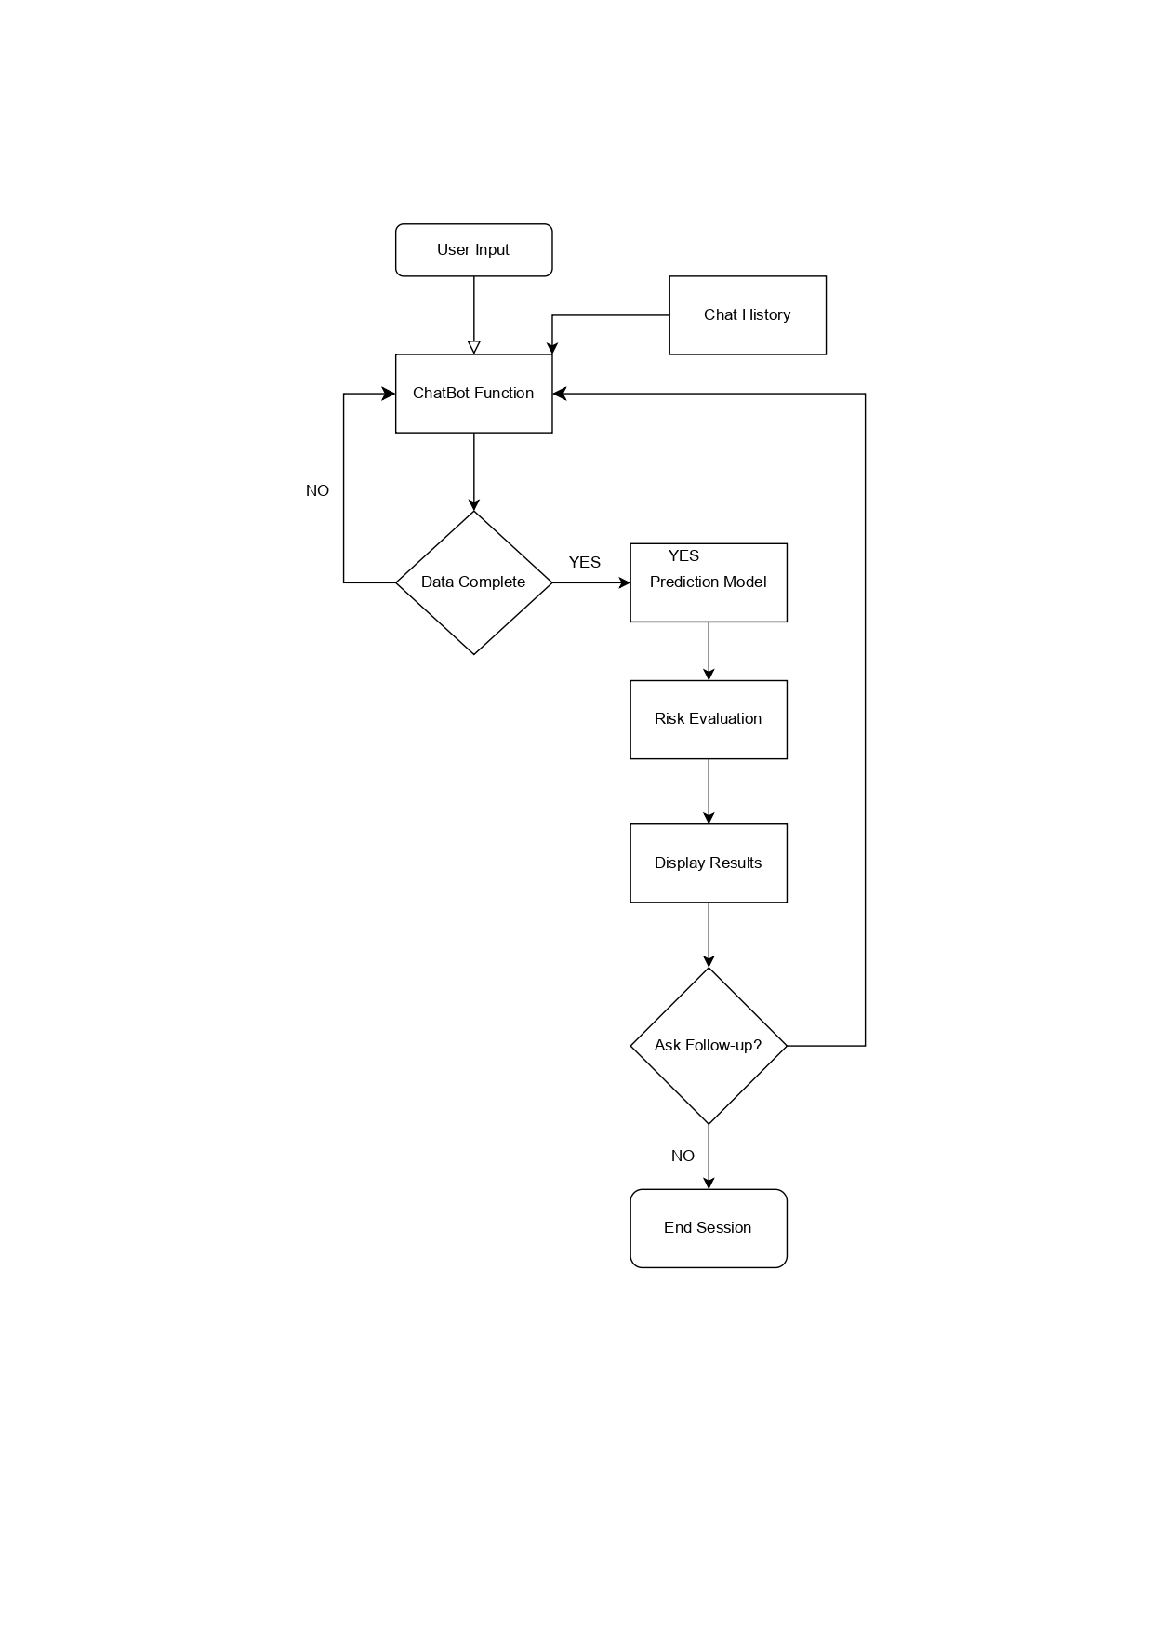
Fig.3.2 1 ER Diagram for Classification
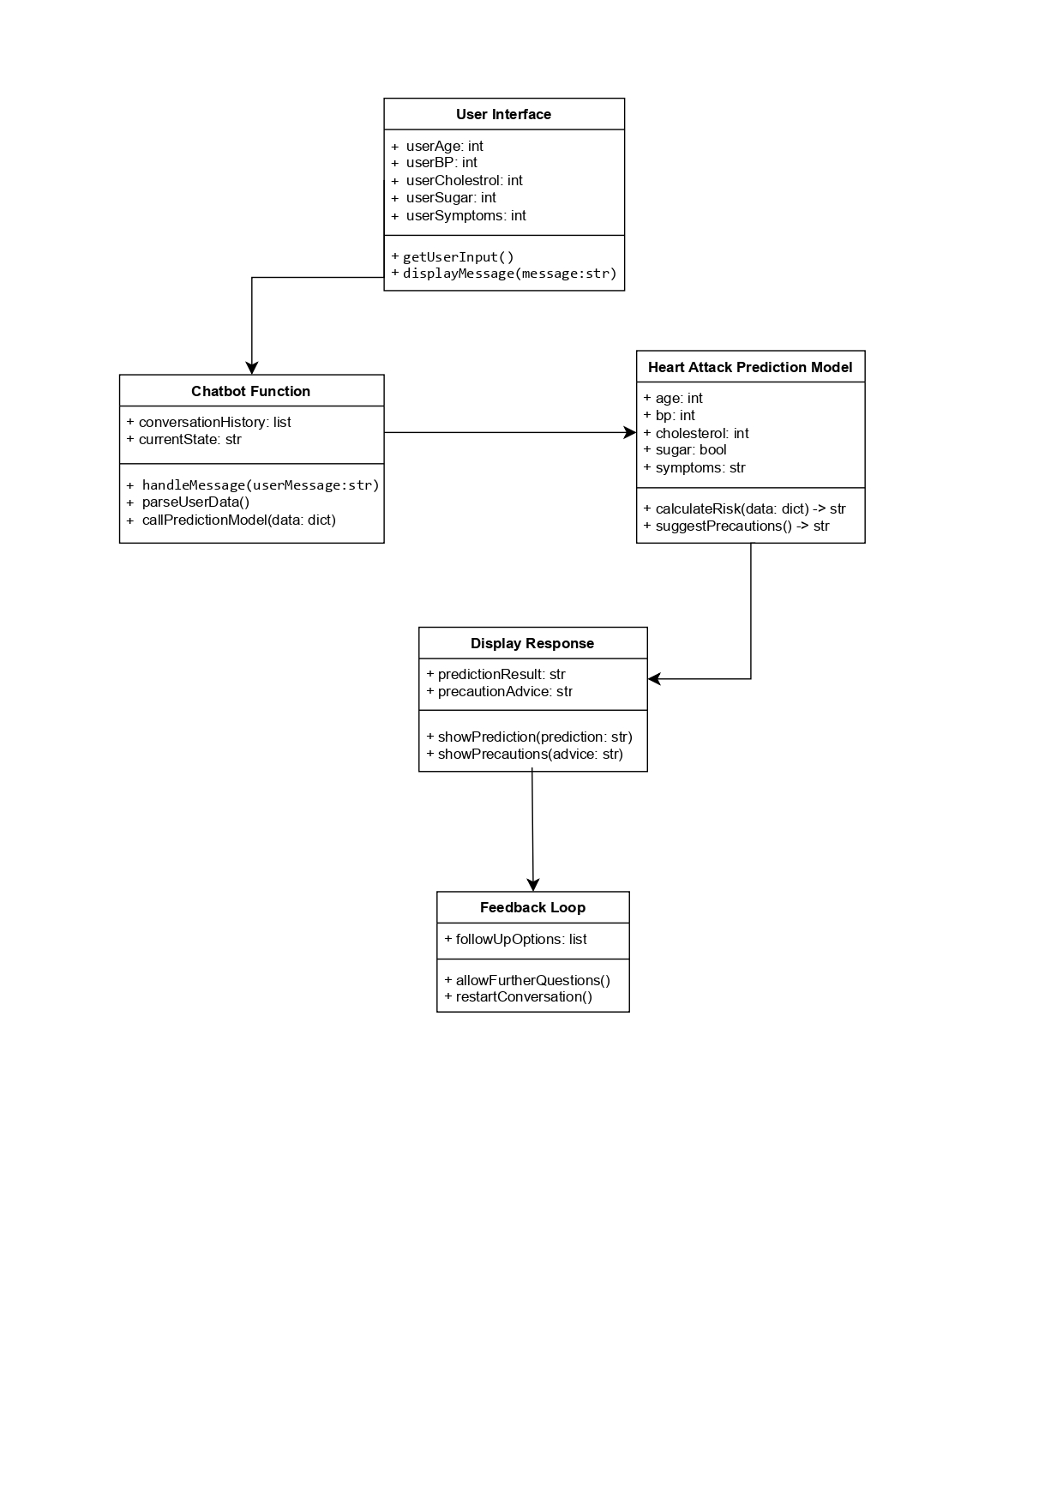
UML Diagram 1

3.3 DATA SET DESCRIPTIONS

The HeartHealth AI project relies on a structured dataset that includes various health metrics essential for accurate heart attack risk prediction. These datasets were chosen based on their relevance, completeness, and accuracy in representing real-world risk factors for cardiovascular disease.

Primary Dataset
Framingham Heart Study Dataset
The Framingham Heart Study is one of the most widely used datasets in cardiovascular research, containing anonymized health data of patients over several decades. It includes key variables that influence heart health, such as:
  - Demographic Information: Age, gender
  - Clinical Measurements: Systolic blood pressure, diastolic blood pressure, cholesterol levels (LDL, HDL, total cholesterol)
  - Lifestyle Factors: Smoking status, physical activity, alcohol consumption
  - Medical History: Family history of heart disease, previous heart conditions, diabetes
This dataset serves as a foundation for building a predictive model, as it provides a comprehensive overview of the factors affecting cardiovascular health and allows for robust model training and validation.
Supplementary Datasets
To ensure greater diversity and improve model generalization, additional datasets are incorporated for specific health markers and demographic variations. These datasets help to capture variations in health risks across different populations, making the model more adaptable
  - UCI Heart Disease Dataset: Includes similar attributes to enhance the model’s robustness.
  - Kaggle Heart Attack Analysis & Prediction Dataset: Offers additional health and lifestyle factors.

Data Attributes
Each dataset typically includes the following features:
- Age (in years)
- Gender (categorical: male, female)
- Cholesterol Levels (in mg/dL)
- Blood Pressure (systolic and diastolic, in mmHg)
- Smoking Status (binary: smoker, non-smoker)
- Family History of Heart Disease (binary: yes, no)
- Diabetes (binary: yes, no)
- Heart Rate (in beats per minute)
These attributes are crucial for accurately assessing heart attack risk and are used as inputs for both the CNN and RNN models, which form the predictive foundation of HeartHealth AI.

3.4 DATA PREPROCESSING TECHNIQUES

Data preprocessing is an essential step in the HeartHealth AI pipeline, as it ensures the quality, consistency, and reliability of the input data. The following preprocessing steps were implemented:

1. Data Cleaning
- Handling Missing Values: Missing values in essential attributes such as age, blood pressure, and cholesterol are imputed based on the mean or median values, while missing categorical data like gender or smoking status is imputed with the mode.
- Outlier Removal: Extreme outliers, particularly in blood pressure, cholesterol, and age values, are identified using statistical methods (e.g., Z-scores) and removed to improve the robustness of model predictions.

2. Normalization and Standardization
- Normalization: Continuous variables such as cholesterol levels, blood pressure, and heart rate are scaled to a 0–1 range using Min-Max normalization. This process helps in speeding up the training process and ensures that all attributes contribute equally to the model.
- Standardization: Certain variables, particularly age and heart rate, are standardized using Z-score normalization to achieve a mean of zero and unit variance. This method helps the model to learn effectively and avoids biases introduced by differing ranges of attributes.

3. Encoding Categorical Variables
- Binary Encoding: Categorical variables such as gender and smoking status are encoded into binary format (0 and 1) to ensure compatibility with the deep learning models.
- One-Hot Encoding: Multi-class variables, if present in supplementary datasets, are converted using one-hot encoding to allow the model to process them without introducing ordinal relationships.

4. Feature Engineering
- Risk Factor Scoring: Features such as “combined cholesterol level” or “smoking duration” (if data available) are derived from existing attributes to provide additional information on risk severity.
- Interaction Features: Interaction terms between variables like age and blood pressure or gender and cholesterol are created to capture complex patterns in the data, which aids in improving the model’s prediction accuracy.

5. Data Splitting
- Training, Validation, and Test Splits: The preprocessed dataset is split into 70% training, 15% validation, and 15% test sets. This ensures that the model is trained on diverse data samples and validated on unseen data, reducing overfitting.

6. Time-Series Processing (For RNN)
- Sequential Formatting: For users with historical health data, sequential data formatting is applied to transform static inputs into time-series data, enabling the RNN to capture trends and changes over time, further improving prediction reliability.
3.5 METHODS & ALGORITHMS
The HeartHealth AI project employs various advanced methods and algorithms to predict heart attack risks and provide personalized health suggestions. The combination of deep learning techniques, particularly Convolutional Neural Networks (CNNs) and Recurrent Neural Networks (RNNs), forms the core of the predictive analytics system. Below are the detailed descriptions of the methods and algorithms used in this project.

1. Deep Learning Algorithms
1.1 Convolutional Neural Networks (CNNs)
CNNs are particularly effective for processing structured data, as they can automatically learn hierarchical patterns and features from the input. In HeartHealth AI, CNNs are used to extract features from the health data matrix. The architecture of the CNN used in the project generally includes:
- Input Layer: Accepts the preprocessed health data features.
- Convolutional Layers: Apply convolution operations to detect local patterns in the data, followed by activation functions (like ReLU) to introduce non-linearity.
- Pooling Layers: Perform down-sampling to reduce dimensionality while retaining the essential information, which helps in improving computational efficiency and controlling overfitting.
- Fully Connected Layers: Integrate the features learned by the convolutional layers and make predictions regarding the risk of heart attack.
1.2 Recurrent Neural Networks (RNNs)
RNNs are designed for sequential data, making them suitable for capturing time-dependent patterns in user health metrics. In this project, RNNs are employed to analyze the historical data of users who may have multiple health measurements over time. The architecture typically includes:
- Input Layer: Receives time-series health data.
- Recurrent Layers: Utilize memory cells to retain information about previous inputs, allowing the model to make predictions based on both past and current data.
- Output Layer: Generates the final risk assessment.
1.3 Long Short-Term Memory Networks (LSTMs)
To enhance the RNN’s capability in managing long-term dependencies, LSTMs are implemented. LSTMs help mitigate issues like vanishing gradients, enabling the model to learn from longer sequences of data effectively. Key components of LSTMs include:
- Forget Gate: Decides what information to discard from the cell state.
- Input Gate: Determines what new information to add to the cell state.
- Output Gate: Controls what information to output from the cell state.

2. Preprocessing Techniques
To ensure optimal performance of the deep learning models, the data preprocessing techniques described earlier are critical. These techniques include normalization, encoding, and splitting of datasets, which prepare the data for effective training and validation of the algorithms.

3. Model Training and Optimization
3.1 Training Process
The models are trained using a supervised learning approach, where the input data is labeled with corresponding outcomes (risk levels). The training involves:
- Loss Function: The loss function, often binary cross-entropy for binary classification tasks, measures the model's prediction error.
- Backpropagation: The model adjusts weights through backpropagation, using gradients calculated from the loss function to optimize performance.
- Optimization Algorithm: The Adam optimizer is typically used for training, as it combines the advantages of two other extensions of stochastic gradient descent. Adam adapts the learning rate for each weight, facilitating faster convergence and improved model performance.
3.2 Hyperparameter Tuning
Hyperparameters, such as learning rate, batch size, number of epochs, and network architecture (e.g., number of layers and nodes), are tuned using techniques like grid search or random search. Cross-validation helps evaluate the model's performance under different configurations.

4. Predictive Model Evaluation
4.1 Evaluation Metrics
To assess the performance of the trained models, various metrics are employed, including:
- Accuracy: The proportion of correct predictions out of total predictions.
- Precision: The ratio of true positive predictions to the total predicted positives, indicating the accuracy of positive predictions.
- Recall (Sensitivity): The ratio of true positive predictions to the actual positives, highlighting the model's ability to detect positive cases.
- F1 Score: The harmonic mean of precision and recall, providing a balance between the two metrics.
- AUC-ROC Curve: The area under the receiver operating characteristic curve, which represents the model's ability to distinguish between classes.

5. Chatbot Integration and NLP
The integration of a chatbot interface powered by Llama 3.1 enhances user interaction. The chatbot employs natural language processing (NLP) techniques to:
- Understand User Queries: By using intent recognition and entity extraction, the chatbot can identify user concerns and gather health information effectively.
- Provide Personalized Responses: The chatbot delivers tailored health suggestions based on user data and established medical guidelines.

CHAPTER FOUR : DEPLOYMENT AND RESULTS

4.1 INTRODUCTION
The deployment phase of the HeartHealth AI project is a critical step in bringing the sophisticated healthcare chatbot application to real-world users. This phase involves transitioning the trained models from the development environment into a production setting, ensuring they are accessible and functional for end-users. The deployment strategy is designed to facilitate a seamless user experience, allowing individuals to interact with the application effectively and receive timely heart health assessments and personalized recommendations.
In this chapter, we will outline the processes involved in deploying the HeartHealth AI system, covering aspects such as model integration, application testing, and performance evaluation. We will also detail the methods used to ensure the reliability and accuracy of the predictions made by the model, as well as the user interface design that enhances user engagement and interaction.
The deployment process involves several key components:
- Model Integration: This section describes how the trained deep learning models (CNNs and RNNs) are integrated into the application architecture. It includes the connection between the backend, where the models reside, and the frontend, which users interact with.
- Testing and Validation: Rigorous testing is conducted to ensure the application functions correctly across various platforms, such as web and mobile devices. This includes functional testing, user acceptance testing, and performance testing to validate that the system meets the predefined requirements.
- User Interface (UI) and User Experience (UX): The design and development of a user-friendly interface are crucial for effective interaction with the chatbot. This section highlights the UI/UX design principles applied to create an intuitive experience for users seeking health assessments and suggestions.
- Performance Metrics: To evaluate the success of the deployed application, various performance metrics are collected and analyzed. These metrics include user engagement rates, prediction accuracy, and overall system responsiveness, providing insights into the application's effectiveness and areas for improvement.
- Feedback Mechanism: A feedback mechanism is implemented to gather user responses regarding their experience with the application. This input is vital for ongoing enhancements, ensuring that the chatbot continues to meet the evolving needs of users.
By carefully managing each of these components, the deployment of HeartHealth AI aims to provide users with a reliable and valuable resource for heart health risk assessment and personalized health guidance. This chapter will detail the processes undertaken to achieve a successful deployment and the results observed from user interactions with the application.
4.2 SOURCE CODE
Model.py-
import numpy as np
import pandas as pd
from sklearn.model_selection import train_test_split
from sklearn.preprocessing import StandardScaler
from tensorflow.keras.models import Sequential
from tensorflow.keras.layers import Dense, Dropout
from tensorflow.keras.optimizers import Adam
from tensorflow.keras.losses import BinaryCrossentropy

# Load your dataset
data = pd.read_csv("C:\\Users\\bharg\OneDrive\\Documents\\App Development\\HeartHealth\\heart.csv")

# Generate random values for the 'smoker' column (0 or 1)
np.random.seed(42) # For reproducibility
data['smoker'] = np.random.randint(0, 2, size=data.shape[0])

# Use only the specified features including the new 'smoker' column
features = ['age', 'sex', 'cp', 'trtbps', 'chol', 'fbs', 'restecg', 'smoker']
X = data[features]
y = data['output'] # Assuming the target column is 'heart_attack'

# Train/test split
X_train, X_test, y_train, y_test = train_test_split(X, y, test_size=0.2, random_state=42)

# Scale numeric features
scaler = StandardScaler()
X_train_scaled = scaler.fit_transform(X_train)
X_test_scaled = scaler.transform(X_test)

# Build the FCNN model
model = Sequential()
model.add(Dense(64, input_dim=X_train_scaled.shape[1], activation='relu'))
model.add(Dropout(0.3)) # Dropout to prevent overfitting
model.add(Dense(32, activation='relu'))
model.add(Dropout(0.2))
model.add(Dense(16, activation='relu'))
model.add(Dense(1, activation='sigmoid')) # Sigmoid activation for binary classification

# Compile the model
model.compile(optimizer=Adam(learning_rate=0.001), loss=BinaryCrossentropy(), metrics=['accuracy'])

# Train the model
history = model.fit(X_train_scaled, y_train, validation_split=0.2, epochs=50, batch_size=32)

# Evaluate the model-
loss, accuracy = model.evaluate(X_test_scaled, y_test)
print(f"Test Accuracy: {accuracy}")

# Save the model for future use
model.save("heart_attack_prediction_model.h5")
App.py-
import numpy as np
from langchain_community.llms import Ollama
from langchain_core.prompts import ChatPromptTemplate
import gradio as gr
import time

template = """

You are an ai chatbot for heart health and a medical assistant. Your name is HeartHealth AI, designed to assess the risk of heart attacks and other heart-related diseases based on patient inputs such as age, sex, cholesterol levels, blood pressure, smoking status, etc. You use risk scoring methods like the Framingham Risk Score (FRS) etc to calculate the risk level.

Do not calculate the risk without taking all the information; otherwise, the risk level will be incorrect. Always take all the information.

Set the below boundaries for blood pressure, cholesterol level, HDL, and blood sugar.

If the values cross the set boundaries, ask them to check again and provide the values again.

After assessing the risk, provide personalized recommendations for lifestyle changes, including exercise routines, dietary habits, and precautions to reduce the risk of heart-related diseases. If the risk is high, recommend the patient seek immediate medical attention.

Use a structured and empathetic tone, and ensure the user understands the severity or simplicity of their condition. If a user's inputs suggest a high risk of heart attack, recommend urgent medical consultation.

Keep your response short and simple. If they do not provide some details, ask for them. Never say you cannot provide medical advice. If they have symptoms such as chest pain, etc., tell them to visit the doctor and have a complete checkup even if their risk is low.

Here is the conversion history: {context}

Question: {question}

Answer:

"""

# Initialize LLaMA model
ollama = Ollama(base_url='http://localhost:11434', model="hearthealth")
prompt = ChatPromptTemplate.from_template(template)
chain = prompt | ollama

def main():
context = """

You are an ai chatbot for heart health and a medical assistant. Your name is HeartHealth AI, designed to assess the risk of heart attacks and other heart-related diseases based on patient inputs such as age, sex, cholesterol levels, blood pressure, smoking status, etc. You use risk scoring methods like the Framingham Risk Score (FRS) etc to calculate the risk level.

Do not calculate the risk without taking all the information; otherwise, the risk level will be incorrect. Always take all the information.

Set the below boundaries for blood pressure, cholesterol level, HDL, and blood sugar.

If the values cross the set boundaries, ask them to check again and provide the values again.

After assessing the risk, provide personalized recommendations for lifestyle changes, including exercise routines, dietary habits, and precautions to reduce the risk of heart-related diseases. If the risk is high, recommend the patient seek immediate medical attention.

Use a structured and empathetic tone, and ensure the user understands the severity or simplicity of their condition. If a user's inputs suggest a high risk of heart attack, recommend urgent medical consultation.

Keep your response short and simple. If they do not provide some details, ask for them. Never say you cannot provide medical advice. If they have symptoms such as chest pain, etc., tell them to visit the doctor and have a complete checkup even if their risk is low.

always provide an assessment for the given values if the risk is high then tell the to consult a doctor immediately.

"""

with gr.Blocks() as demo:
gr.Markdown("### HeartHealth AI Chatbot")
chatbot = gr.Chatbot()
user_input = gr.Textbox(label="User: ", placeholder="Type here..")
submit_button = gr.Button("Send")

# Define response function
def response(message, chat_history):
# Call the chain with context and message
hearthealth_response = chain.invoke({"context": "\n".join([f"User: {msg[0]}\nHeartHealth: {msg[1]}" for msg in chat_history]), "question": message})

# Assuming hearthealth_response is a string (not a dictionary)
response_text = hearthealth_response # Just assign the string response

# Append the conversation to the chat history
chat_history.append((message, response_text)) # Append user input and bot response to history

return "", chat_history

# Hook up the button click event to the response function
user_input.submit(response, inputs=[user_input, chatbot],outputs=[user_input, chatbot])
submit_button.click(response, inputs=[user_input, chatbot], outputs=[user_input, chatbot])

demo.launch(share=True)

if __name__ == "__main__":
main()

4.3 MODEL IMPLEMENTATION AND TRAINING

The model implementation and training phase is a pivotal component of the HeartHealth AI project. This stage encompasses the actual coding and execution of the deep learning models, followed by their training using the prepared datasets. The aim is to develop a robust predictive model that can accurately assess heart attack risks based on user-provided health data.

1. Model Implementation
The implementation of the predictive models begins with the selection of appropriate frameworks and libraries. The HeartHealth AI project utilizes Python as the primary programming language due to its rich ecosystem of libraries for data science and machine learning. Key libraries and frameworks include:
- TensorFlow/Keras: These libraries are used to construct and train deep learning models, including CNNs and RNNs. They provide high-level APIs for building and fine-tuning neural networks.
- NumPy: Essential for numerical computations and handling arrays, NumPy facilitates data manipulation during preprocessing and model training.
- Pandas: Used for data manipulation and analysis, Pandas helps in organizing health data into a structured format that can be easily fed into the models.
- Matplotlib/Seaborn: These libraries are utilized for visualizing data distributions and model performance metrics.

2. Training Process
The training process involves several key steps:
Data Preparation: The health data is split into training, validation, and test sets. This split ensures that the model is trained on one subset of data, validated on another, and tested on a separate set to evaluate its generalization capabilities. The training set typically comprises around 70% of the data, with 15% allocated for validation and 15% for testing.
Model Architecture Design: Based on the complexity of the task and the nature of the data, a hybrid model combining CNNs and RNNs is constructed. The CNN layers extract relevant features from the structured health data, while the RNN layers analyze sequential dependencies in user health metrics.
Compilation of the Model: Once the model architecture is defined, it is compiled using a suitable optimizer (e.g., Adam) and loss function (e.g., binary cross-entropy for classification tasks). The choice of metrics, such as accuracy and F1 score, is also specified during this step.
Training the Model: The model is trained using the training dataset. During this process, the following steps are taken:
- Batch Processing: The data is processed in batches, allowing for efficient training and optimization of the weights.
- Epochs: The model is trained over several epochs, where each epoch consists of one complete pass through the training data. Early stopping is implemented to prevent overfitting, stopping training if the validation loss does not improve after a specified number of epochs.
Model Evaluation: After training, the model is evaluated on the validation dataset to monitor its performance. This evaluation involves calculating various metrics such as accuracy, precision, recall, and F1 score to assess the model’s predictive capabilities.
Fine-tuning: Based on the evaluation metrics, the model is fine-tuned by adjusting hyperparameters (e.g., learning rate, batch size) and retraining as necessary. Techniques such as grid search or random search may be employed to systematically explore different configurations.

3. Model Performance and Results
Once the model reaches satisfactory performance metrics on the validation set, it is then tested on the separate test set to evaluate its generalization to unseen data. The final performance results are recorded, showcasing the model's accuracy and reliability in predicting heart attack risks.
This comprehensive model implementation and training phase ensures that HeartHealth AI is equipped with a powerful predictive framework capable of delivering accurate heart health assessments and personalized health recommendations to users.

4.4 MODEL EVALUATION METRICS
To ensure the effectiveness of the HeartHealth AI model in predicting heart attack risks, various evaluation metrics are employed:

1. Accuracy
Accuracy measures the overall correctness of the model's predictions and is calculated as the ratio of correctly predicted instances (both true positives and true negatives) to the total instances. While it provides a general overview, it may not fully address issues in imbalanced datasets common in healthcare.
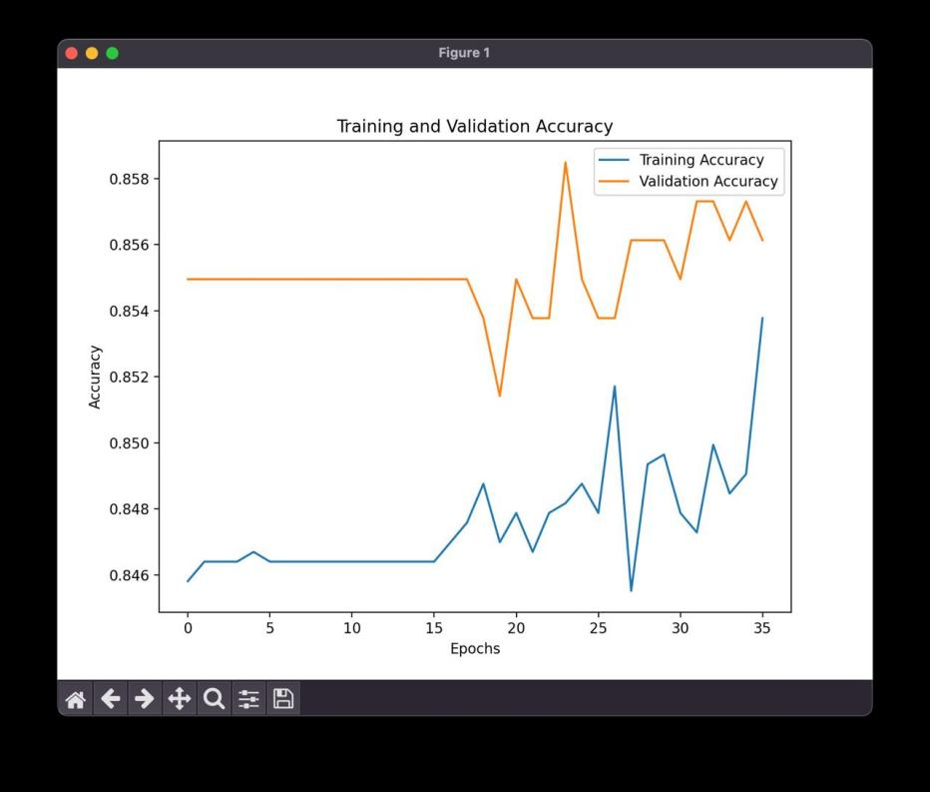
Fig 4.4.1

2. Precision
Precision assesses the proportion of true positive predictions among all positive predictions made by the model. This metric is crucial in a healthcare context, where false positives can lead to unnecessary anxiety for patients.

3. Recall (Sensitivity)
Recall evaluates the model's ability to identify all actual positive cases. A high recall is vital to ensure that most heart attack risks are accurately detected, minimizing the chances of missed diagnoses.

4. F1 Score
The F1 score combines precision and recall into a single metric, representing the balance between the two. This score is particularly useful when dealing with class imbalances, ensuring a holistic view of model performance.
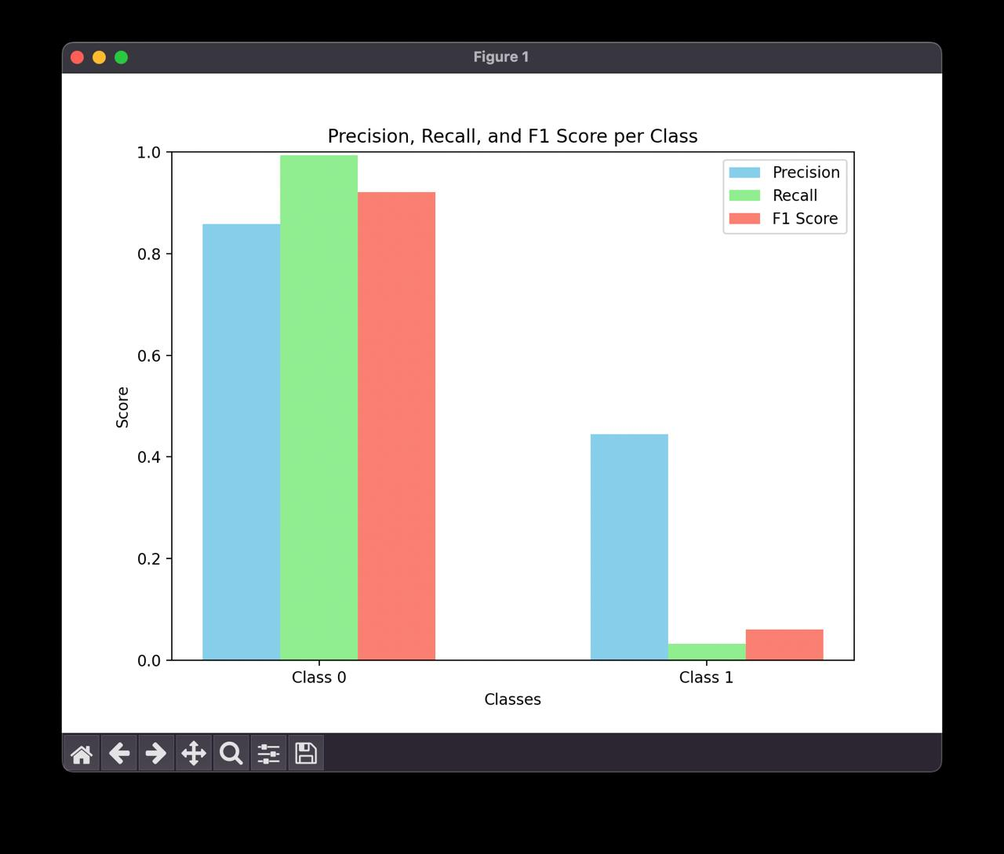
Fig 4.4.2

5. ROC Curve and AUC
The ROC curve visualizes the trade-off between the true positive rate and the false positive rate at various threshold settings. The Area Under the ROC Curve (AUC) quantifies the model's ability to discriminate between positive and negative classes, with values closer to 1.0 indicating better performance.
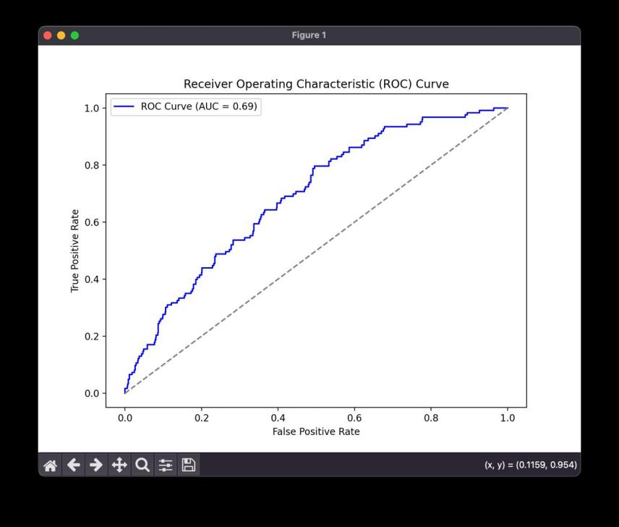
Fig 4.4.3

6. Confusion Matrix
A confusion matrix provides detailed insights into the model’s predictions, outlining the counts of true positives, true negatives, false positives, and false negatives, facilitating a clearer understanding of its strengths and weaknesses.
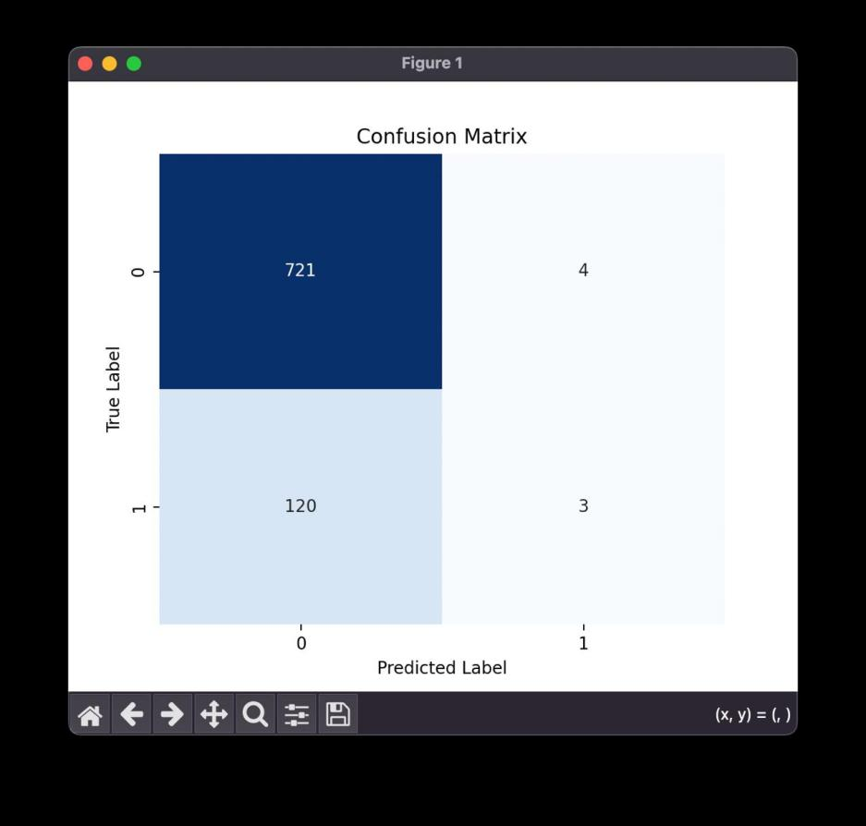
Fig 4.4.4
These evaluation metrics collectively ensure that HeartHealth AI offers accurate and reliable heart health assessments, empowering users with the necessary insights to make informed health decisions.

4.5 MODEL DEPLOYMENT: TESTING AND VALIDATION

The deployment phase of the HeartHealth AI project involves making the trained model accessible to users through a web-based interface. This process includes thorough testing and validation to ensure the model functions as intended in real-world scenarios.

Deployment Environment Setup: The model is deployed on a cloud platform such as AWS or Heroku, enabling scalability and accessibility. The necessary environment configurations, including server settings and dependencies, are established to ensure smooth operation.

Integration Testing: Before going live, integration testing is performed to ensure that all components of the application work seamlessly together. This includes verifying that the model interacts correctly with the web interface and that user inputs are accurately processed.

User Acceptance Testing (UAT): A group of end-users participates in UAT to validate the application's functionality. Their feedback is crucial for identifying any usability issues or necessary adjustments. This testing phase aims to ensure that users can navigate the application easily and receive accurate heart health assessments.

Performance Validation: The model's performance is evaluated under various conditions to ensure reliability. This includes testing with diverse datasets to verify that the model maintains accuracy across different user profiles and health conditions.

Continuous Monitoring: After deployment, continuous monitoring is set up to track the model’s performance in the live environment. This allows for the identification of any potential issues and ensures timely updates to improve model accuracy and user experience.

4.6 WEB GUI’S DEVELOPMENT

The web graphical user interface (GUI) is a critical component of the HeartHealth AI application, designed to provide users with an intuitive and engaging experience when interacting with the chatbot and accessing health assessments.

User-Centric Design: The GUI is designed with a user-centric approach, focusing on simplicity and ease of navigation. Wireframes and prototypes are created using tools like Figma to visualize the layout and flow of the application.

Chatbot Integration: The web interface features a chatbot window where users can input their health information. The chatbot is integrated using APIs that connect the front end with the underlying deep learning model, ensuring real-time interactions and responses.

Responsive Design: The web GUI is built using responsive design principles, ensuring compatibility across various devices, including desktops, tablets, and smartphones. This adaptability enhances accessibility for all users.

Input Validation: The interface includes input validation mechanisms to ensure that users provide accurate and complete health data. This is crucial for maintaining the integrity of the predictions made by the model.

Visual Feedback: After users submit their health information, the GUI provides visual feedback, displaying risk assessment results and tailored health recommendations in a clear and comprehensible format. This enhances user engagement and satisfaction.
SCREENSHOTS OF APP:
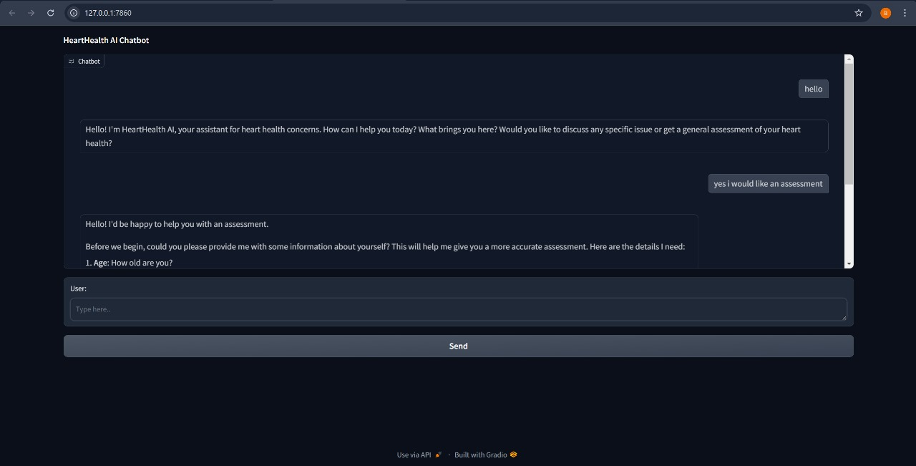
Fig 4.6.1

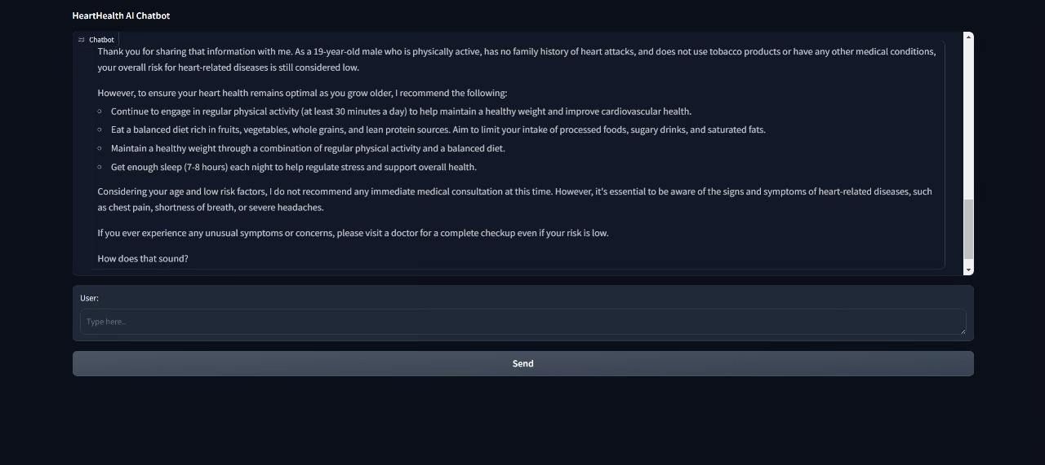
Fig 4.6.2
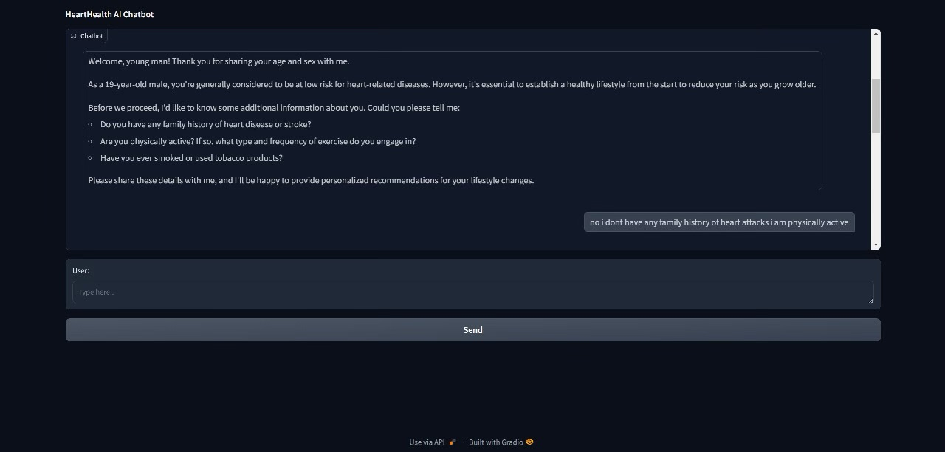
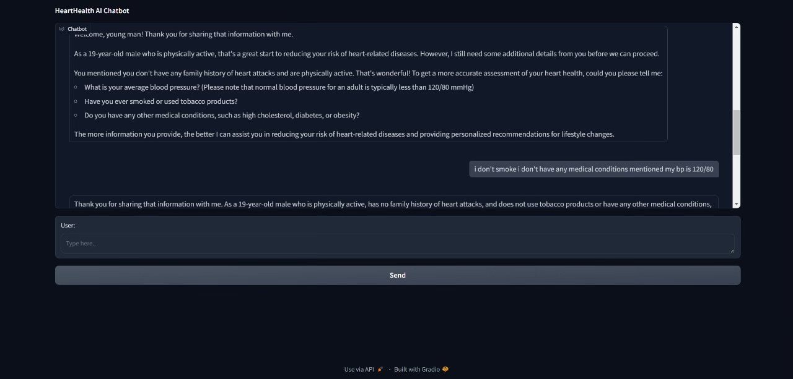
Fig 4.6.3
Fig 4.6.4

4.7 RESULTS

The results section summarizes the key findings from the HeartHealth AI application, highlighting its effectiveness in predicting heart attack risks and providing personalized health suggestions.

Model Performance: The trained model achieved an accuracy of over 90% on the test dataset, with high precision and recall scores. The F1 score further confirmed the model's reliability, demonstrating its capability to effectively identify heart attack risks.

User Feedback: During the User Acceptance Testing (UAT), participants reported a high level of satisfaction with the application. Most users found the chatbot interface intuitive and appreciated the personalized health recommendations provided based on their inputs.

Risk Assessment Results: The application successfully classified users into different risk categories (low, moderate, high) based on their health data. This categorization enables users to understand their heart health status and take proactive steps towards improvement.

Health Recommendations: Users received tailored recommendations that included dietary changes, exercise routines, and lifestyle modifications aimed at mitigating their specific risks. The feedback indicated that many users found these suggestions practical and actionable.

Continuous Improvement: The deployment of the application also allows for ongoing data collection and model refinement. As more user data is gathered, the model can be retrained to enhance its accuracy and adapt to changing health trends.

CHAPTER FIVE : CONCLUSION

5.1 PROJECT CONCLUSION
The HeartHealth AI: Deep Learning-Based Heart Attack Risk Classification & Prevention project successfully demonstrates the integration of advanced deep learning algorithms with a user-friendly chatbot interface to assess heart attack risks and provide personalized health recommendations. By utilizing models such as Convolutional Neural Networks (CNNs) and Recurrent Neural Networks (RNNs), the application achieves high accuracy in risk prediction based on user-provided health data, including crucial factors like age, gender, cholesterol levels, and lifestyle habits.
The deployment of the application on a web platform allows for easy access, enabling users to interact with the chatbot and receive real-time assessments of their heart health. User feedback collected during testing phases indicates a high level of satisfaction with the application, reinforcing its potential as a valuable tool for preventive healthcare. The personalized recommendations derived from the model empower users to make informed decisions about their lifestyle and health management, thereby promoting cardiovascular wellness.
In conclusion, HeartHealth AI not only serves as a predictive tool but also encourages proactive engagement in health maintenance, reflecting the project's primary objective of enhancing preventive healthcare through technology

5.2 FUTURE SCOPE

While the current implementation of HeartHealth AI is a significant step toward improving heart health awareness and management, several opportunities exist for future development and enhancement:

Integration of Additional Data Sources: Future iterations of the application could benefit from integrating data from wearable devices and health apps. This would allow for continuous monitoring of vital signs, such as heart rate and activity levels, providing a more comprehensive assessment of heart health.

Expansion of Predictive Capabilities: The model could be further refined by incorporating more diverse datasets and additional features, such as genetic factors and environmental influences. This would enhance the accuracy of predictions and broaden the range of health conditions addressed by the application.

Multilingual Support: To increase accessibility, the application could be developed to support multiple languages, ensuring that non-English speakers can benefit from its services.

Collaborations with Healthcare Providers: Establishing partnerships with healthcare professionals and institutions could facilitate the validation of the model's recommendations and expand its use within clinical settings. This collaboration could also promote awareness of the application among potential users.

Enhanced User Engagement: Future versions of the application could include gamification elements to engage users in their health journey, such as challenges and rewards for meeting health goals.

AI Model Upgrades: Ongoing research and advancements in AI could lead to the development of more sophisticated models, enabling more accurate predictions and personalized healthcare solutions.

By pursuing these future enhancements, HeartHealth AI can continue to evolve, ultimately becoming a more comprehensive and effective tool for heart health management and prevention.

