Header 0

# Header 1

## Header 2

### Header 3

#### Header 4

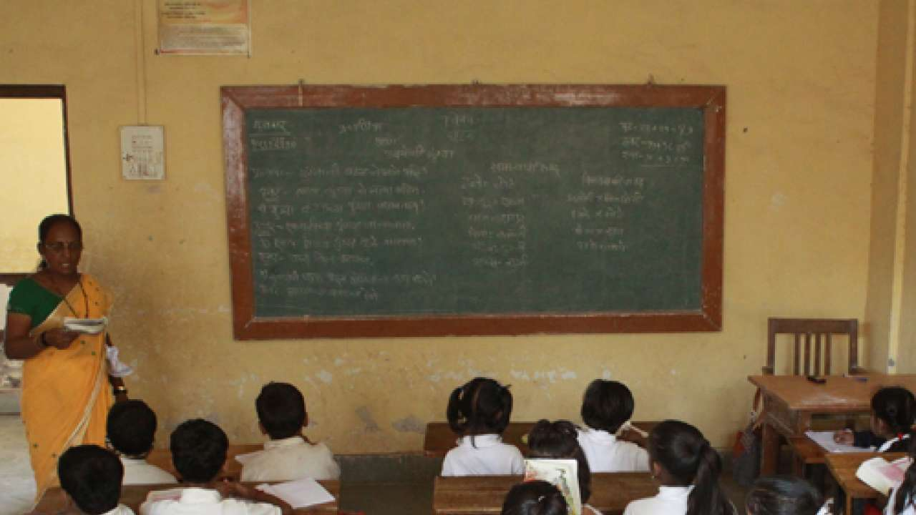

This creates a two-page Word document with This is on the first page! on the first page and This is  
on the second page! on the second. Even though there was still plenty of space on the first page after  
the text This is on the first page!, we forced the next paragraph to begin on a new page by inserting a  
page break after the first run of the first paragraph

This is on the second page!