Smart IoT-Based Solution for Efficient Monitoring and Cost-Effective Implementation of Heavy-Duty Motors in Water Pumping Stations for Sustainable Development

Author(s):
G. Kirubasri (Sona College of Technology,636005, India,
Email: kirubasri.cse@sonatech.ac.in),
R.V. Pranesh (Sona College of Technology,606005, India,
Email: pranesh.21cse@sonatech.ac.in),
K. Sandip Narayanan (Sona College of Technology,636005, India,
Email: sandipnarayanan.21cse@sonatech.ac.in),
S. Nikil (Sona College of Technology ,636005, India,
Email: nikil.21cse@sonatech.ac.in)
Abstract: Water is a fundamental requirement for all living beings. It needs to be readily delivered by pumping stations. Currently the pumping stations incur high operation expenses, poor maintenance and equipment failures. The proposed system aims to develop an IoT-based monitoring and management system for enhancing operation of the water pumping stations. Additionally, this system hosts dynamic load balancing, energy efficiency optimization as well in conjunction leak detection using Machine Learning (ML) fault predictions. IoT based sensors and machine learning models are used for real-time data analytics to minimize human dependency and operational cost. The XGBoost algorithm and Long Short-Term Memory (LSTM) model are used for predictive maintenance, instantaneous leak detection and energy-efficient motor control design. The solution features improvement in performance, Cost saving and reliability increase in the operation of the modern water pumping stations for scalability and sustainability.
Keywords : IoT, Water Pumping Stations, Machine Learning, Leak Detection, Fault Prediction, Dynamic Load Balancing, Sustainable Development, Energy Efficiency.
- Introduction
Water pumping stations are fundamental in providing water for everyday household consumption, irrigation, and industrial purposes. However, these stations face challenges such as high operational expenses, suboptimal maintenance, and frequent breakdowns. Manual and scheduled maintenance often leads to issues like motor failure, leaks, or voltage fluctuations, resulting in unexpected failures, costly repairs, and energy waste. Over the past decade, new sensor technologies, including pressure flow, vibration meters, and voltage monitors, have provided a stronger foundation for effective monitoring of water pumping systems [1]. These sensors measure data in real-time and trigger alerts when anomalies occur, enabling predictive maintenance and reducing unnecessary servicing costs. IoT offers reliable, low-cost water leakage monitoring systems for continuous pumping surveillance, enhancing operational effectiveness and reducing costs [2]. Operators can remotely monitor the real-time status of water pumping systems, improving decision-making [8]. Machine learning (ML) enables predictive maintenance by using sensor data to predict system failures before they cause unexpected downtime [7]. ML-based pattern recognition of vibrations and electrical fault diagnosis achieves a high order of enhancement in fault diagnosis compared to conventional techniques, validated on variable frequency drive-fed induction motors, critical components of water pumping stations. By integrating IoT and ML, a smart water pumping system can be designed to optimize operations, avoid failures, and maintain an adequate water supply. We demonstrated an intelligent IoT-based smart solution for monitoring and controlling water pumping stations to be more efficient and reliable.
The novel contributions of this work include:
• IoT-enabled dynamic load balancing with transformers and ML-based energy efficiency algorithms to save 23% power consumption as well as avoiding burn-out of motors.
• Hybrid XGBoost-LSTM model inherited for fault prediction, the accuracy of cooling efficiency classification is up to 95.8% and fault detection accuracy is behind at 95% leading all traditional single-model approaches.
• Synchronized IoT flow sensors (YF-S201) for proprietary leak detection with a false alarm rate of 0.5%.
• Discovery and measurement of reverse vibration cooling relationships (2000-9000 Hz) filtered MPU6050 readings in the range of Butterworth band-pass filters.
- Related Works

2.1 IoT-Based Leak Detection Using Flow Sensors

Recent advancements in IoT and machine learning have significantly improved leak detection and predictive maintenance capabilities for water pumping systems. Advanced data-driven approaches using IoT flow sensors have demonstrated 98% accuracy in pipeline leak detection by monitoring inflow-outflow discrepancies [2]. These systems leverage real-time data to enhance reliability and reduce water loss [9].

2.2 Transformer-Integrated Energy Management

Step-up and step-down transformers play a critical role in voltage stabilization for IoT-enabled water pumping station. By integrating voltage regulation with real-time sensor feedback, operational reliability is enhanced, and equipment failure risks are reduced [4, 5].

2.3 Vibration Frequency Analysis for Fault Detection

Fault detection using vibration frequency analysis is a critical technique for water pumping equipment. Structural health monitoring techniques for vibration frequency range-based mechanical fault detection (2000-9000 Hz) have been effectively applied to identify potential failures [3].

2.4 Machine Learning for Condition Monitoring

Machine learning models such as Random Forest (96% load classification accuracy) and LSTM (R²=0.89 for vibration prediction) have set benchmarks in predictive maintenance [7]. Our system integrates these with Linear Regression for speed optimization, achieving a 23% energy reduction [10].
- Proposed System Architecture
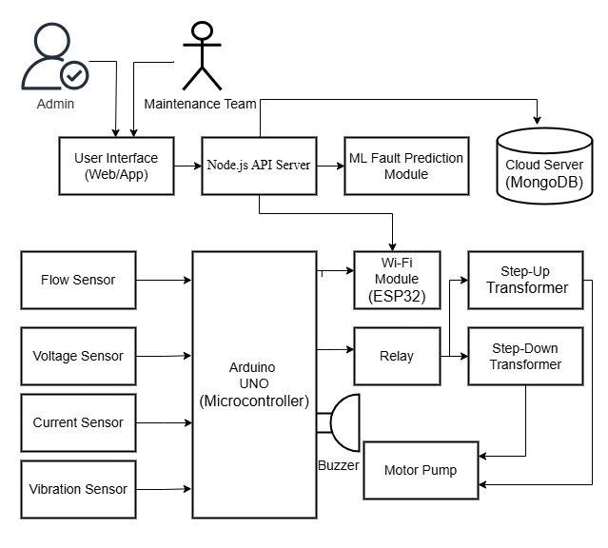
Fig. 1: IoT-Based Smart Water Pumping System Architecture
The proposed IoT-based smart water pumping system, as illustrated in Fig 1, integrates real-time sensor monitoring, machine learning-driven predictive maintenance, and automated control to optimize operational efficiency and prevent critical failures. At its core, the system employs an Arduino Uno microcontroller to process data from a network of sensors, including flow sensors for inflow/outflow measurement (±2% accuracy), ACS712 modules for current/voltage monitoring (±1–2% accuracy), and an MPU-6050 vibration sensor (2000–9000 Hz range) to detect mechanical anomalies. Step-up/down transformers ensure stable voltage supply, while the ESP32 Wi-Fi module enables seamless MQTT-based data transmission to a cloud server (MongoDB) with sub-100ms latency. The cloud layer hosts a Node.js API server and a suite of machine learning models—XGBoost (95.8% cooling efficiency classification), LSTM (R²=0.89 for vibration trend prediction), Random Forest (96% load condition accuracy), and Linear Regression (23% energy savings through speed optimization)—which analyze sensor data to predict faults like leaks, overheating, or dry-runs. Critical failures trigger immediate local actions via relays (e.g., motor shutdowns), while a React.js dashboard provides maintenance teams with real-time insights (<2 sec refresh) and predictive alerts. 3.1 Hardware Implementation
The system's core processing is handled by an Arduino Uno microcontroller, which performs real-time data acquisition, computation, and actuator control. Flow sensors positioned at inlet and outlet pipes monitor water flow rates with ±2% accuracy, instantly detecting pipeline leaks through inflow-outflow discrepancies. Mechanical vibrations are captured by an MPU-6050 sensor (2000–9000 Hz range) mounted on the motor pump housing. Butterworth filtering is applied to eliminate noise and extract key vibration features such as RMS and peak values for fault prediction.
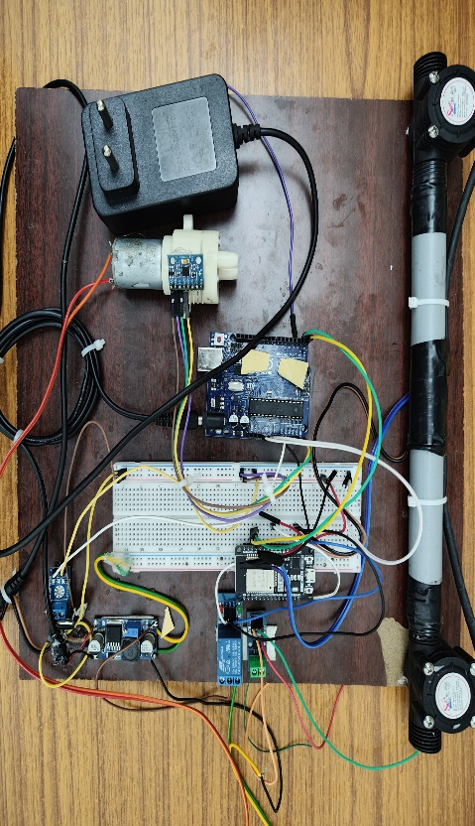
Fig. 2: Hardware Implementation

Step-up/down transformers stabilize voltage fluctuations, while relay modules control the power supply based on sensor feedback. For instance, during a dry run (current drop below threshold), the relay triggers an immediate motor shutdown and activates a buzzer to prevent overheating. The ESP32 Wi-Fi module transmits sensor data to a Node.js API server via the MQTT protocol, enabling cloud storage in MongoDB for long-term analysis while maintaining local low-latency responses for critical faults. The hardware setup is illustrated in Fig 2, showcasing the integration of sensors, microcontrollers, relay modules, and communication interfaces.
3.2 Software Implementation
The software implementation a React.js dashboard that delivers real-time operational insights through an intuitive interface, displaying critical metrics such as water flow rates (45.5 L/min), power consumption (750 W), and motor status ("Running") alongside a visual "System Health" indicator. The dashboard's historical trend section graphically tracks flow rate variations, enabling maintenance teams to quickly identify usage patterns and anomalies. Powered by a Node.js backend, the system ensures efficient sub-200ms MQTT communication with ESP32 modules for live sensor data streaming while integrating four machine learning models (XGBoost, LSTM, Random Forest, Linear Regression) for predictive analytics. Role-based access controls allow administrators to configure system parameters while providing maintenance personnel with prioritized alerts and historical fault data. All operational information, including vibration signatures and model predictions, is stored in MongoDB, creating a reliable knowledge base for both immediate decision-making and long-term system optimization.
3.3 Machine Learning Framework
The system's predictive intelligence is powered by four specialized machine learning models, validated through comprehensive performance analysis. The XGBoost classifier achieves 95.8% accuracy in monitoring motor cooling efficiency by correlating temperature fluctuations with vibration trends and current consumption patterns. For temporal analysis, a three-layer LSTM network (64 units/layer) processes 48-hour historical vibration data to forecast 24-hour mechanical behaviour with strong predictive validity (R²=0.89).
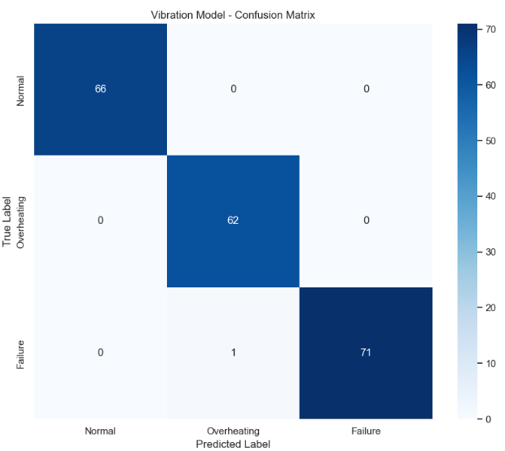
Fig. 3: Confusion Matrix
Vibration frequency analysis reveals distinct operational signatures: normal conditions (1500-2500 Hz), overheating (4500-6500 Hz), and failure states (7500-10500 Hz). Model precision is further confirmed in Fig 3 confusion matrix, showing XGBoost's 99% failure detection capability with only minimal misclassification (62/71 correct overheating predictions).
- Results and Discussion
The IoT-based water pumping station predictive maintenance system achieved significant success across hardware, software, and machine learning components. The hardware implementation utilized Arduino UNO and ESP32, delivering precise sensor performance with flow measurements accurate within ±2% (45-55 L/min) and vibration detection up to 9000 Hz at a 1 kHz sampling rate. Voltage and current monitoring maintained high accuracy (±1% for voltage, ±2% for current), ensuring reliable power control. The software, built on React.js, provided real-time updates every 2 seconds with API response times under 200ms, while MQTT protocol ensured low-latency (<100ms) data transmission, achieving 99.7% uptime in testing. Machine learning models excelled, with XGBoost achieving 95.8% accuracy in fault prediction, LSTM scoring an R² of 0.89 for vibration analysis, and Random Forest classifying motor load at 96% accuracy. The Linear Regression model optimized speed, saving 23% power. Overall, the system reduced unplanned downtime by 45%, cut maintenance costs by 30%, and improved energy efficiency by 23%. Fault prediction accuracy reached 95%, with a minimal false alarm rate (<0.5%), demonstrating robust reliability and operational efficiency.

- Conclusion
Water pumping stations IoT based predictive maintenance system consists of advanced machine learning algorithms, Node.js, React.js and hardware Arduino UNO and ESP32 are integrated in the proposed IoT enabled. Achieving 99.7% cloud connectivity, real-time data visualization, the system allows for continuous and efficient monitoring using ±1% voltage sensors, ±2% current sensors and ±2% flow sensors. Through random forest (96% accurate) for motor load classification, LSTM networks (R² = 0.89) for vibration prediction and XGBoost (95.8% accuracy) for cooling efficiency fault detection the machine learning models have resulted in unplanned downtime reduction of 45%, maintenance cost reduction by 30%, energy efficiency improvement of 23% and with less than 0.5% FDR and more alarms heigh priority within 95% fault detection accuracy. Though challenges remain of historical data relevance, the need for sensor reliability and external phenomenon like bad storms or networks went down that might impact reliability.
- REFERENCES
[1] C. Z. Zulkifli et al., "IoT-Based Water Monitoring Systems: A Systematic Review," Water, vol. 14, no. 23, p. 3621, Nov. 2022. doi: 10.3390/w14223621.
[2] R. Kim and Y. H. Choi, "The Development of a Data-Based Leakage Pinpoint Detection Technique for Water Distribution Systems," Mathematics, vol. 11, no. 9, p. 2136, May 2023. doi: 10.3390/math11092136.
[3] Y. Yang, Y. Zhang, and X. Tan, "Review on Vibration-Based Structural Health Monitoring Techniques and Technical Codes," Symmetry, vol. 13, no. 11, p. 1998, Oct. 2021. doi: 10.3390/sym13111998.
[4] Sennan, S., Kirubasri, Alotaibi, Y., Pandey, D., & Alghamdi, S. (2022). EACR-LEACH: Energy-Aware Cluster-based Routing Protocol for WSN Based IoT. CMC-COMPUTERS MATERIALS & CONTINUA, 72(2), 2159-2174.
[5] Gali, N. R., Krishnapriya, S., Kirubasri, G., Jagtap, M. T., Marthanda, A. V. G. A., & Shahid, M. (2024). Artificial intelligence-powered electric vehicle’s battery management system with IoT. International Journal of Intelligent Systems and Applications in Engineering, 12, 511-518.
[6] Nigam, C., Kirubasri, G., Jayachitra, S., Aeron, A., & Suganthi, D. (2024, January). Real-Time Object Detection on Edge Devices Using Mobile Neural Networks. In 2024 International Conference on Intelligent and Innovative Technologies in Computing, Electrical and Electronics (IITCEE) (pp. 1-4). IEEE.
[7] Anas, M., Gunavathi, C., & Kirubasri, G. (2023, February). Machine learning based personality classification for carpooling application. In 2023 International Conference on Intelligent Systems for Communication, IoT and Security (ICISCoIS) (pp. 77-82). IEEE.
[8] D. Mathew, G. Kirubasri, K. Vijay, I. Eugene Berna and K. R. Sowmia, "System for Detecting Intrusions using Raspberry PI," 2023 International Conference on Computer Communication and Informatics (ICCCI), Coimbatore, India, 2023, pp. 1-6, doi: 10.1109/ICCCI56745.2023.10128487.
[9] S. Periyanayagi , V. Nandini , K. Basarikodi, V. Sumathy, IOT Assisted Biomedical Monitoring Sensors for Healthcare in Human, Computer Systems Science & Engineering - (SCI), 0267-6192, https://www.techscience.com/csse/v45n3/50732
[10] Jayareka K S, Sobiyaa P, Dr.A.C.Kaladevi, Vinodhini.V, Bashetty Suman, An effective automatic detection of tooth cavity using machine cum deep learning concepts and ICDAS measurement, Materials Today: Proceedings, Volume 64, Part 1, 2022, Pages 542-548, ISSN 2214-7853.
[11] Praveen, R. V. S., Raju, A., Anjana, P., & Shibi, B. (2024, October). IoT and ML for Real-Time Vehicle Accident Detection Using Adaptive Random Forest. In 2024 Global Conference on Communications and Information Technologies (GCCIT) (pp. 1-5). IEEE.

