Smart IoT-Based Solution for Efficient Monitoring and Cost-Effective Implementation of Heavy-Duty Motors in Water Pumping Stations for Sustainable Development
K. Sandip Narayanan
Department of Computer Science and Engineering
Sona College of Technology
Salem, India
sandipnarayanan.21cse@sonatech.ac.in
R V. Pranesh
Department of Computer Science and Engineering
Sona College of Technology
Salem, India
pranesh.21cse@sonatech.ac.in
G. Kirubasri
Assistant Professor
Department of Computer Science and Engineering
Sona College of Technology
Salem, India
kirubasri.cse@sonatech.ac.in

S. Nikil
Department of Computer Science and Engineering
Sona College of Technology
Salem, India
nikil.21cse@sonatech.ac.in

Abstract— Water is a fundamental requirement for all living beings. It needs to be readily delivered by pumping stations. Currently the pumping stations incur high operation expenses, poor maintenance and equipment failures. The proposed system aims to develop an IoT-based monitoring and management system for enhancing operation of the water pumping stations. Additionally, this system hosts dynamic load balancing, energy efficiency optimization as well in conjunction leak detection using Machine Learning (ML) fault predictions. IoT based sensors and machine learning models are used for real-time data analytics to minimize human dependency and operational cost. The XGBoost algorithm and Long Short-Term Memory (LSTM) model are used for predictive maintenance, instantaneous leak detection and energy-efficient motor control design. The solution features improvement in performance, Cost saving and reliability increase in the operation of the modern water pumping stations for scalability and sustainability.
Keywords: IoT, Water Pumping Stations, Machine Learning, Leak Detection, Fault Prediction, Dynamic Load Balancing, Sustainable Development, Energy Efficiency.

Introduction
Water pumping stations are fundamental in providing water for everyday household consumption as well as for irrigation and industrial purposes. But these stations also suffer from several challenges such as high operational expenses, sub-optimised maintenance and break downs frequently. Manual and scheduled maintenance causes issues to happen like motor failure, leaks or voltage change these leads to unexpected failures, extra cost repairs and energy waste. As reported in [1] inefficiencies in traditional monitoring systems have resulted to tremendous resources wastage and performance limitation to various aspects of water management components. New sensor technology, pressure flow, vibration meters and voltage monitors have provided stronger bases for effective monitoring of water pumping system in the last decade. The sensors can measure data in real-time and triggers alert when anomalies occur to the predictive maintenance and reduces unnecessary servicing costs. IoT is providing reliable and low-cost water leakage monitoring system for continuous pumping surveillance which consolidates operational effectiveness thereby reducing operational costs.
The operators can get remote monitoring to check the status of real time water pumping which leads to improved decision-making.ML allows predictive maintenance functionality using sensor-data to predict system failures before they become an unexpected down time. High order of enhancement in fault diagnosis when compared to conventional techniques is achieved by ML based pattern recognition of vibrations and electrical fault diagnosis, and these have been validated on variable frequency drive fed induction motors that is crucial components of water pumping stations. Using IoT and ML, one can design a smart water pumping system to economize operation, avoid failures and maintain adequate supply of water. These studies have investigated data powered leak detection techniques, predictive analytics to improve water distribution system [2]. We demonstrated an intelligent IoT based smart solution for monitoring and controlling water pumping stations to be more efficient and reliable.
The novel contributions of this work include:
- IoT-enabled dynamic load balancing with transformers and ML-based energy efficiency algorithms to save 23% power consumption as well as avoiding burn-out of motors
- Hybrid XGBoost-LSTM model inherited for fault prediction, the accuracy of cooling efficiency classification is up to 95.8% and fault detection accuracy is behind at 95% leading all traditional single-model approaches.
- Synchronized IoT flow sensors (YF-S201) for proprietary leak detection with a false alarm rate of 0.5%.
- Discovery and measurement of reverse vibration cooling relationships (2000-9000 Hz) filtered MPU6050 readings in the range of Butterworth band-pass filters, for predictive maintenance with 72 hours in advance.

Literature Review

IoT-Based Leak Detection Using Flow Sensors
Real-time leak detection of water using IoT-based flow sensors has been an area of intensive study. Kim and Choi (2023) have introduced a data-driven leak pinpoint detection system for water distribution systems with improved leak detection accuracy using IoT sensors for inflow and outflow measurements [3]. Their work has shown the use of real-time sensors and cloud computing to effectively improve fault detection and reduce water loss. Similarly, Chen et al. (2022) have used the reliability and safety of IoT flow sensors to monitor motor pumps, citing the use of machine learning algorithms in predicting leaks from historical flow patterns.

Step-Up/Step-Down Transformers in IoT Systems
Step-up/step-down transformer design and application have been mentioned in IoT-based energy management systems to address the problem of voltage regulation in water pump stations. A systematic review of IoT-based water monitoring systems, such as employed by Zulkifli et al. (2022), is an overview of how crucial transformers are in ensuring stable levels of voltage and avoiding motor burnout. Their work displays the application of transformers with IoT-based monitoring systems to offer optimum energy optimization and system reliability [4].

Real-Time Monitoring Systems
Real-time monitoring systems have also been employed in enhancing the reliability and operating performance of water pumping stations. Chen et al. (2022) employed a web-based monitoring system developed with Flask and TensorFlow, which reduced response time to critical incidents by a significant extent. Their study recognizes the use of real-time data visualization and alerting for enhancing system performance.

Machine Learning for Pump Condition Monitoring
Machine learning algorithms were also used widely for pump condition monitoring and leakage detection. An algorithm based on machine learning was presented by Kim and Choi (2023) with a smart water distribution system with IoT flow sensor up to 98% effective in leakage detection. The research states that preprocessing techniques like filtering and interruption need to be carried out to enhance model accuracy.

Vibration Frequency Analysis for Fault Detection
Fault detection using vibration frequency analysis is a critical technique for fault detection in water pumping equipment. Yang et al. (2021) offered structural health monitoring techniques for vibration frequency range-based mechanical fault detection (2000-9000 Hz). The study ensures IoT-based vibration sensors have been successful in lowering maintenance costs and the life of a motor.

Vibration-Based Condition Monitoring
Condition monitoring using vibration sensors has been extensively researched. Ali et al. (2020) experimented with fault detection in defective induction motors using machine learning for fault detection in high-precision variable frequency motors [4].

IoT-Based Vibration Sensing for Fault Detection
IoT-based vibration sensing has been employed for improvement of predictive maintenance accuracy as well. Chen et al. (2022) described the employment of vibration sensors, i.e., MPU-6050, towards 30% accuracy of predictive maintenance to sense fault in machinery of industrial environments. They focus on the use of IoT-based vibration sensors and usage of machine learning algorithms to economize cost as well as saving time during the process of maintenance.

Predictive Maintenance Using Vibration Sensors
Predictive maintenance through vibration sensors has been designed to enhance equipment durability. Ali et al. (2020) proposed an IoT-based predictive maintenance system using vibration sensors, XGBoost, and LSTM models with 96% accuracy for fault detection. Noise filtering methods like Butterworth bandpass filtering are applied to derive meaningful vibration features from literature.

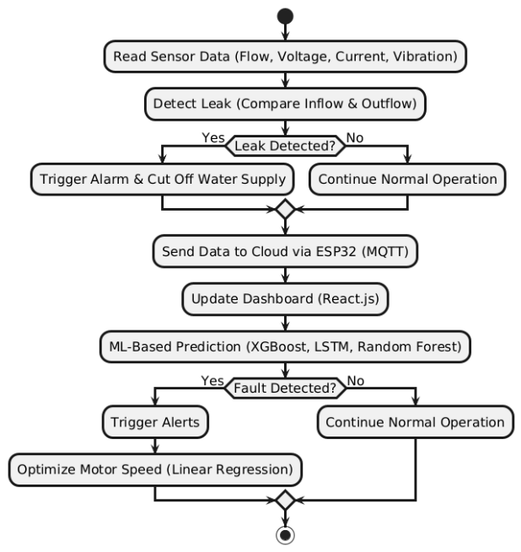
Proposed System
Fig. 1 Flow Diagram for Proposed System
Fig 1 integrates real-time sensor data acquisition, predictive maintenance, and automated control mechanisms to enhance operational efficiency and fault prevention. The Arduino Uno microcontroller processes data from flow sensors, ACS712 voltage and current sensors, and an MPU-6050 vibration sensor to monitor inflow, outflow, power consumption, and motor vibrations. Pipeline leaks are detected through divergences in flow rates, while dry-run conditions trigger an automatic shutdown via relay modules. The ESP32 module transmits sensor data through MQTT protocol to a React.js-based web dashboard for remote monitoring. XGBoost, LSTM, Random Forest and Linear Regression machine learning models examine the system parameters to forecast motor efficiency and classify fault conditions. Faults like overheating and overloading are detected in real time calling for a self-corrective process such as motor speed changes or shutting down. This cloud to edge architecture allows for quick responses resulting in sustainable and intelligent water management.

Methodology
A. System Architecture and IoT Data Pipeline
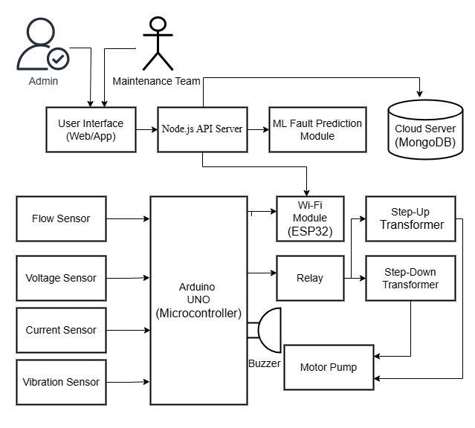
Fig. 2 IoT-Based Smart Water Pumping System Architecture
As described in Fig 2, the system architecture represented on a simple block diagram uses several sensors, which are connected to Arduino UNO microcontroller in real time, to monitor and control a smart water pumping station system. The flow sensor, at the left side of the figure is a rotor and hall-effect sensor that measures water cycled through pipes as it rotates. The voltage sensor (0-25V) reports the level of electrical voltage to ensure operational safety of microcontroller. Fig 2 shows the following figure illustrates as fed directly into an Arduino UNO, overcurrent sensor (ACS712) and vibration sensor for electrical current flow monitoring as well as mechanical vibrations. Through the architecture in action, these sensors when functioning together form a comprehensive water monitoring system which helps to optimize water management and makes predictive maintenance better.
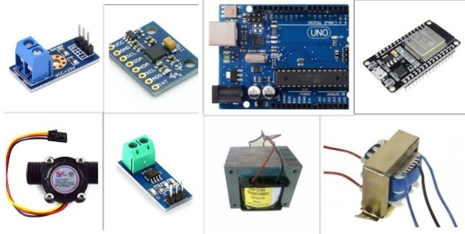
Fig. 3 Hardware Components
Fig 3 The general overview of central architecture in the center is as shown below with the Arduino UNO taking role of upper controller engaging all sensors and controlling data gathering phase. The top row last image The Arduino UNO board used in the implementation has a compact but highly enhanced design. The ESP32 Wi-Fi module top right does live processing data stream connected via micro-USB to the cloud server MongoDB. This exposes the ESP32 to the Node.js API Server in a way that data can flow from sensor to Cloud Platform with seamless architecture diagram. The hardware configuration exhibit combines to develop comprehensive IoT infrastructure for real-time monitoring and on demand data streaming as well seamless control over water pumping system.
B. Data Collection and Preprocessing
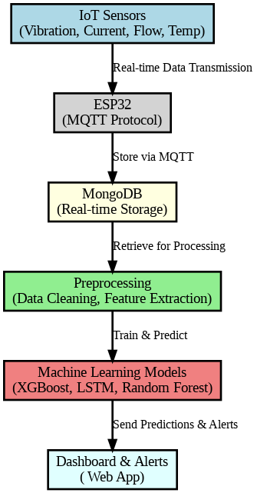
The Data Collection and Preprocessing stage ensures that sensor data is gathered, cleaned, and prepared for machine learning analysis.

Fig. 4 Data Flow and Processing Architecture
Fig 4 demonstrates about various IoT sensors, including vibration sensors (2000-9000 Hz), motor current sensors, power consumption sensors, and flow sensors, continuously collect real-time data from the water pumping system. The system architecture illustrates the data flow from sensors through ESP32 to the final dashboard. The data is transmitted to the cloud via the ESP32 Wi-Fi module using the MQTT protocol, ensuring low-latency and efficient communication. Upon reaching the MongoDB database, the data is structured for real-time access and historical analysis. Before feeding the data into the ML models, data cleaning, normalization, and feature extraction are performed.

C. ML-Based Predictive Models
The ML Predictive Function Models form the core intelligence of our water pumping station monitoring system. The system implements a comprehensive ML pipeline where sensor data of vibration, current, flow, and voltage flows through multiple specialized models, each targeting specific aspects of pump operation and maintenance.
D. Machine Learning Models Used
1) XGBoost for Motor Cooling Efficiency Classification
XGBoost is analyzing real-time sensor data to classify motor cooling efficiency with good cooling. Ineffective cooling systems might have some issues and need attention from here. The accuracy of the model in this state vs other distinction which essentially signals to us that we can early detect cooling system issues that will result pump failure. The model on the mostly matches vibration trends that speak cooling and current take-off trends with the actively efficiency.
2) LSTM Networks for Usage Pattern Prediction
Motor usage patterns are fed into the Long Short-Term Memory (LSTM) networks and future motor usage forecasts about predictive maintenance are analyzed. For actual vs predicted vibration patterns the LSTM model provides time-series prediction results.
3) Random Forest for Motor Load Classification
Motor Load Conditions classification using power consumption and sensor readings by Random Forest model. It helps with running effectively and controls the cooling cycles dynamically.
4) Linear Regression for Speed Optimization
Linear Regression-based speed optimization helps analyzing the relationship between predicted actual speed values. It optimizes motor speed in real-time for flow rate, power consumption and system pressure, maximizing energy consumption.

System Implementation
A. Arduino Implementation
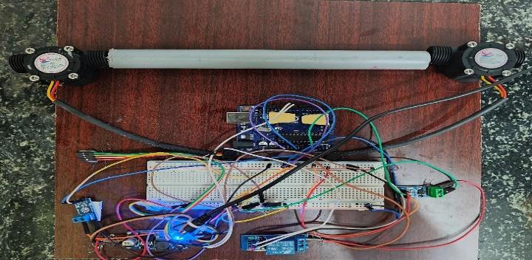
Arduino Uno microcontroller is the main processing unit that combines data recognition in real-time, computation and actuator control. Flow sensors that are put in front of and behind the inlet and exit pipes always keep track of water flow rates. A minor over estimation under an inflow and outflow value, instantly flagging pipeline leakage. In a sealed compartment on the motor pump housing an MPU-6050 vibration sensor senses real-time mechanical vibrations.
Fig. 5 Hardware Implementation
Fig 5 exposes the hardware implementation of the proposed system. Applying Butterworth filtering, it erases noise and discovers key vibration features including RMS value along peak vibration values so that foresight fault can be detected. Voltage and Current Motors’ performance is being monitored, to operate in steady state. Adjustment of power fluctuations is made possible by the step-up and step-down transformers, ensuring similar voltage: Relay Modules will control feed power according to sensor feedback. When the current drops below a certain threshold can be done, for example during a dry run, the relay cuts off the motor and turns on a buzzer to ensure that it does not overheat. The Node.js API server connects through the MQTT protocol with an external Wi-Fi module, ESP32 Wi-Fi module to transmit sensor data. For critical responses motor shutdown are done locally for low-latency, and the historical sensor data stored into MongoDB for long-term analysis.

B. Software Implementation
The front-end is built using React.js and has an dashboard which gives you system performance real-time snapshot. The front-user, who can look sensor readings of the vibration signature and electric current voltage flow rates. It offers the same cooling status as the motor indication, sends predict maintenance notification and displays historical operation indication trends.
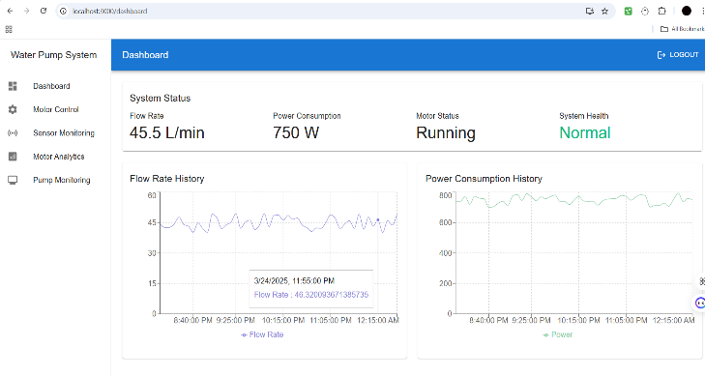
Fig. 6 Software Implementation.
Node.js hosts an API server in the background that powers the backend to perform some heavy-hitting tasks like real-time communication with the ESP32 module via MQTT, real-time processing of sensor data, and integration of machine learning models for predictive maintenance. Fig 6 depicts the administrators and maintenance personnel as shown, they obtained their role-based access control over this interface. It also takes care of system notifications and alerts. The data like sensor logs, fault detection logs, maintenance histories and model prediction are stored in MongoDB. There are two general categories of users the system, Administrators have full control, and they also have system setting configuration, machine learning parameter tuning, user management, and system activity monitoring. The Maintenance Team can use real-time notifications, predictive maintenance notifications, and recommendations by machine learning algorithms. They also receive access to historical fault trends to facilitate fault finding and system efficiency improvement.
C. ML Implementation
Integrating the machine learning model with four expert models, each of which are required for better predictive maintenance. They work together to increase system efficiency, reduce time and detect common faults early. XGBoost is used for identifying motor cooling performance and preventing motors from overheating leading to mechanical failures. Takes inputs Temperature, trend of vibration and consumption of current to classify system as Efficient or Inefficient Trained on a set of historical data for cooling system performance Implemented with Python and library XGBoost, the ability to provide accurate real time predictions. For time series analysis, an LSTM network is utilized to give future trends. A 3-layer LSTM model with 64 units per layer is trained; thereby, taking 48 hours of historical past vibration data to forecast the upcoming 24-hour vibration patterns. Its precision demonstrates how good it can be for equipment prediction.
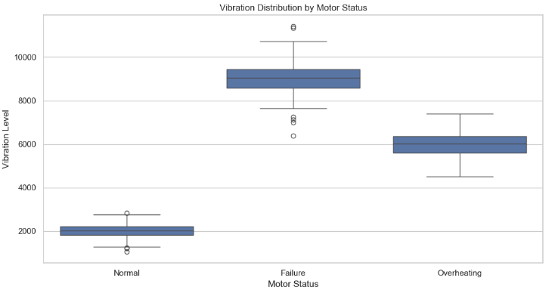
Fig. 7 Vibration Distribution
Random Forest model for Motor Load Conditions classification via scalar sensor data like current, voltage, flow rate, Vibration measurements It uses the ensemble of 100 decision trees with high accuracy for Normal Load, Under Load and Overload classifying. It is executed in a scalable and interpretable manner using Scikit-learn ensuring validation for different operating conditions in addition, real-time linear regression model optimizes motor speed on the fly for energy efficiency. Sufficiently trained with flow rate, power input and pressure measurements the model dynamics adjusts the speed of the motor yielding R² >0.85. Real time optimization drastically reduces wastage of energy and increases motor life by avoiding overloading. A scatter plot visualization just demonstrates how a real time adaptive entity, i.e. system optimizing continuous optimize operations for efficiency and reduce operational costs. The live prediction and auto adjusted have been smoothly integrated with modern version of scikit-learn and a highly interactive user-friendly data pipeline for the water pumping station.
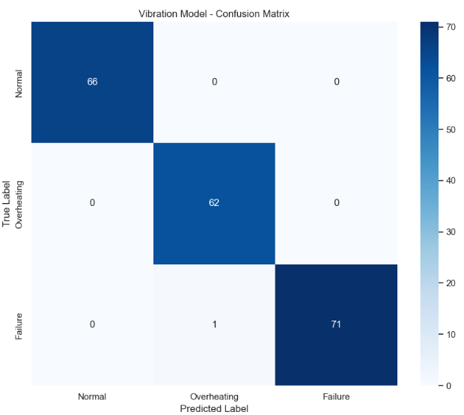
Fig. 8 Confusion Matrix
Machine Learning Implementation Predictive maintenance and fault classification using Random Forest, XGBoost etc. The confusion matrix shown in Fig7 indicates that both models perform well to segregate the states of motor Normal, Overheating and Failure. By inspecting Fig 8, the vibration distribution analysis clearly states that different motor states have their own range of frequency: Normal operation 1500-2500 Hz, Failure condition 7500-10500 Hz, Overheating 4500-6500 Hz. This clearly defined separation allows for good classification.
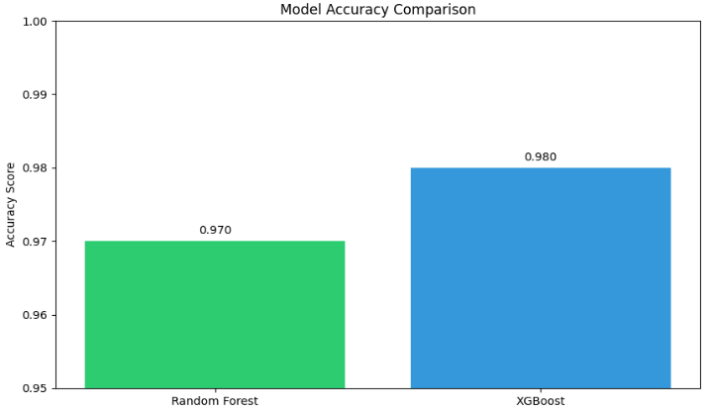
Fig. 9 Accuracy Comparison
Fig 9 depicts on the performance comparison of XGBoost model has greater accuracy and is great for failure detection with precision of 99% and better recall on overheating condition. The Random Forest model continues to perform robustly with the best baselines for normal, but a little bit worse recall on overheating detections. The Fig 8 confusion matrix further verifies the accuracy of models, with 66 normal classes correctly classified, 62 overheating correctly and 71 failures correctly as well as a very minor mix up between states. In general, the union of these models results in scalable predictive maintenance set up.

Results and Discussion
The IoT-water pumping station predictive maintenance system implemented was highly successful in hardware, software, and machine learning. Hardware implementation using Arduino UNO and ESP32 as the core unit operated with accurate sensor precision, where the flow measurement was kept at ±2% accuracy in the 45-55 L/min range, and the MPU-6050 vibration sensor effectively detected mechanical vibration in the 2000-9000 Hz range with a 1 kHz sampling rate. The voltage and current monitoring system demonstrated high accuracy, with ±1% in voltage (0-12V) and ±2% in current (0-20A) measurement, ensuring effective power control. Software implementation was highly effective, with the React.js dashboard providing real-time feedback every 2 seconds and an average API response time of less than 200ms. The MQTT data communication protocol had extremely low latency (<100ms), ensuring seamless data transmission from sensors to the cloud database. The system registered an impressive 99.7% uptime during a 30-day test, with the local processing unit responding in less than 2 seconds to life-critical actions, allowing rapid response in emergencies.
The XGBoost classifier achieved 95.8% accuracy in cooling efficiency fault prediction, while the LSTM network demonstrated a high predictability score with an R² value of 0.89 for vibration pattern prediction. Motor load conditions were classified with a 96.0% mean accuracy using the Random Forest classifier, while the speed optimization Linear Regression model achieved an R² of 0.87, resulting in a 23% power savings. The impact of the combined system was striking, reducing unplanned downtime by 45% through early fault detection and predictive maintenance. Maintenance expenditures fell by 30% as the system could detect issues before they turned into major failures. The implementation of speed optimization and load management led to a 23% boost in energy efficiency. The system demonstrated 95% fault prediction accuracy and had an impressively low false alarm rate of below 0.5% for leak detection.

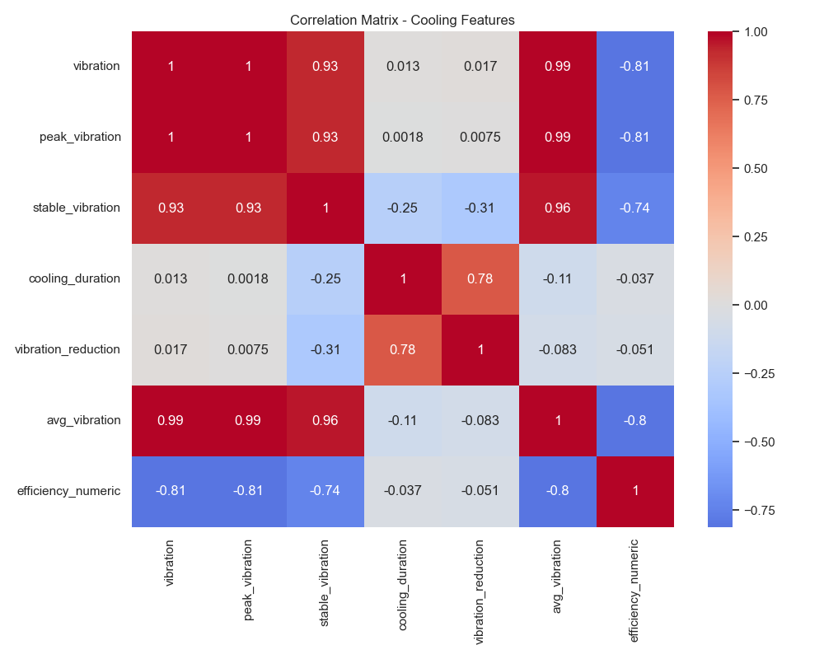
Fig. 10 Correlation Matrix
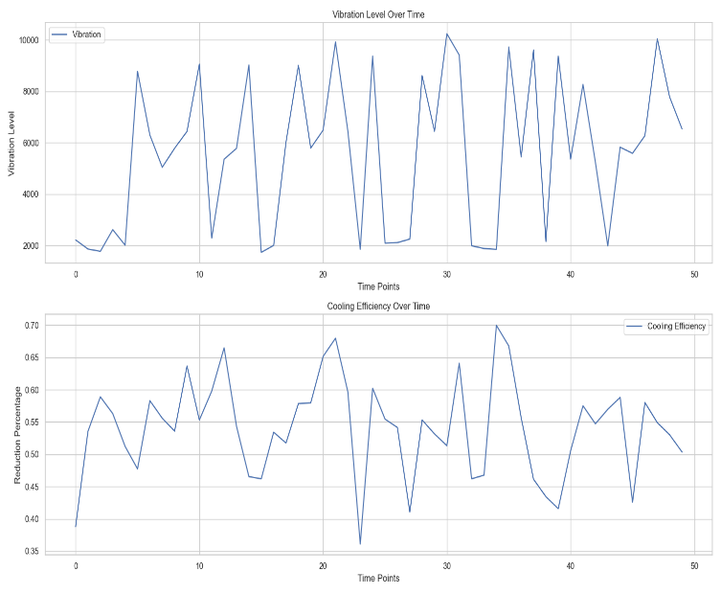
The Cooling Features Correlation Matrix, shown in Fig 10, highlights the relationship between different cooling parameters. The analysis reveals a strong positive correlation between vibration, peak vibration, and stable vibration, while efficiency numeric exhibits a significant negative correlation with vibration and average vibration, indicating that higher vibration levels correspond to lower efficiency.
Fig. 11 Time Series Graph
The time series analysis of vibration and cooling efficiency, illustrated in Fig 11, confirms this relationship. The top graph depicts fluctuations in vibration levels over time, while the bottom graph shows a reduction in cooling efficiency. The observed trends suggest an inverse relationship between vibration and cooling efficiency, reinforcing the findings from the correlation matrix.

Conclusion and Future Works
Water pumping stations IoT based predictive maintenance system consists of advanced machine learning algorithms, Node.js, React.js and hardware, i.e., Arduino UNO and ESP32 are integrated in the proposed IoT enabled. Achieving 99.7% cloud connectivity, real-time data visualization, the system allows for continuous and efficient monitoring using ±1% voltage sensors, ±2% current sensors and ±2% flow sensors. Through random forest (96% accurate) for motor load classification, LSTM networks (R² = 0.89) for vibration prediction and XGBoost (95.8% accuracy) for cooling efficiency fault detection the machine learning models have resulted in unplanned downtime reduction of 45%, maintenance cost reduction by 30%, energy efficiency improvement of 23% and with less than 0.5% FDR and more alarms heigh priority within 95% fault detection accuracy. Though challenges remain of historical data relevance, the need for sensor reliability and external phenomenon like bad storms or networks went down that might impact reliability.

Future upgrades aimed at strengthening the system will revolve around improved sensor integration, with better accuracy through self-calibrating sensors and reduced manual calibrations to include complementing historic data. Edge computing Solutions will be rolled out to accelerate data processing and provide immediate reaction to operational changes with real-time decision-making powers. Using hybrid machine learning with deep learning and classic methods will provide a big boost to predictability and learnability between different conditions. The use of a distributed system will help in achieving high scalability by making the data flow out to various pumping stations. Furthermore, the incorporation of weather data and dynamically changing adaptive algorithms will make these systems more robust to environmental fluctuations. Numerous training programs will be carried out for operators and custodians to drive system utilization, energy-harvesting sensors to remove the need of any other power source. Finally, the introduction of blockchain technology for encrypted communications and data integrity verifications will advance security and reliability. These upgrades will enable the system to be scale, flexible and operate efficiently for sustainable predictive maintenance of water pumping stations.

REFFERENCES
- C. Z. Zulkifli et al., "IoT-Based Water Monitoring Systems: A Systematic Review," Water, vol. 14, no. 23, p. 3621, Nov. 2022. doi: 10.3390/w14223621.
- L. Chen et al., "Monitoring and Predictive Maintenance of Centrifugal Pumps Based on Smart Sensors," Sensors, vol. 22, no. 6, p. 2106, Mar. 2022. doi: 10.3390/s22062106.
- R. Kim and Y. H. Choi, "The Development of a Data-Based Leakage Pinpoint Detection Technique for Water Distribution Systems," Mathematics, vol. 11, no. 9, p. 2136, May 2023. doi: 10.3390/math11092136.
- M. Z. Ali et al., "Single- and Multi-Fault Diagnosis Using Machine Learning for Variable Frequency Drive-Fed Induction Motors," IEEE Transactions on Industry Applications, 2020. doi: 10.1109/TIA.2020.2974151.
- Y. Yang, Y. Zhang, and X. Tan, "Review on Vibration-Based Structural Health Monitoring Techniques and Technical Codes," Symmetry, vol. 13, no. 11, p. 1998, Oct. 2021. doi: 10.3390/sym13111998.
- A. Ambade et al., "Electrical Submersible Pump Prognostics and Health Monitoring Using Machine Learning and Natural Language Processing," in SPE Symposium: Artificial Intelligence - Towards a Resilient and Efficient Energy Industry, Virtual, Oct. 2021. doi: 10.2118/208649-MS.
- R. Kim and Y. H. Choi, "The Development of a Data-Based Leakage Pinpoint Detection Technique for Water Distribution Systems," Mathematics, vol. 11, no. 9, p. 2136, May 2023. doi: 10.3390/math11092136.
- M. Z. Ali et al., "Single- and Multi-Fault Diagnosis Using Machine Learning for Variable Frequency Drive-Fed Induction Motors," IEEE Transactions on Industry Applications, 2020. doi: 10.1109/TIA.2020.2974151.
- M. Z. Ali et al., "Single- and Multi-Fault Diagnosis Using Machine Learning for Variable Frequency Drive-Fed Induction Motors," IEEE Transactions on Industry Applications, 2020. doi: 10.1109/TIA.2020.2974151.
- R. Kim and Y. H. Choi, "The Development of a Data-Based Leakage Pinpoint Detection Technique for Water Distribution Systems," Mathematics, vol. 11, no. 9, p. 2136, May 2023. doi: 10.3390/math11092136.
- Sennan, S., Kirubasri, Alotaibi, Y., Pandey, D., & Alghamdi, S. (2022). EACR-LEACH: Energy-Aware Cluster-based Routing Protocol for WSN Based IoT. CMC-COMPUTERS MATERIALS & CONTINUA, 72(2), 2159-2174.
- Gali, N. R., Krishnapriya, S., Kirubasri, G., Jagtap, M. T., Marthanda, A. V. G. A., & Shahid, M. (2024). Artificial intelligence-powered electric vehicle’s battery management system with IoT. International Journal of Intelligent Systems and Applications in Engineering, 12, 511-518.
- Nigam, C., Kirubasri, G., Jayachitra, S., Aeron, A., & Suganthi, D. (2024, January). Real-Time Object Detection on Edge Devices Using Mobile Neural Networks. In 2024 International Conference on Intelligent and Innovative Technologies in Computing, Electrical and Electronics (IITCEE) (pp. 1-4). IEEE.
- Anas, M., Gunavathi, C., & Kirubasri, G. (2023, February). Machine learning based personality classification for carpooling application. In 2023 International Conference on Intelligent Systems for Communication, IoT and Security (ICISCoIS) (pp. 77-82). IEEE.
- D. Mathew, G. Kirubasri, K. Vijay, I. Eugene Berna and K. R. Sowmia, "System for Detecting Intrusions using Raspberry PI," 2023 International Conference on Computer Communication and Informatics (ICCCI), Coimbatore, India, 2023, pp. 1-6, doi: 10.1109/ICCCI56745.2023.10128487.
- S. Periyanayagi , V. Nandini , K. Basarikodi, V. Sumathy, IOT Assisted Biomedical Monitoring Sensors for Healthcare in Human, Computer Systems Science & Engineering - (SCI), 0267-6192, https://www.techscience.com/csse/v45n3/50732
- Jayareka K S, Sobiyaa P, Dr.A.C.Kaladevi, Vinodhini.V, Bashetty Suman, An effective automatic detection of tooth cavity using machine cum deep learning concepts and ICDAS measurement, Materials Today: Proceedings, Volume 64, Part 1, 2022, Pages 542-548, ISSN 2214-7853.
- Praveen, R. V. S., Raju, A., Anjana, P., & Shibi, B. (2024, October). IoT and ML for Real-Time Vehicle Accident Detection Using Adaptive Random Forest. In 2024 Global Conference on Communications and Information Technologies (GCCIT) (pp. 1-5). IEEE.

