LAMP(Linux, Apache, Mysql, Php) project in AWS with VPC and EC2

Architecture:

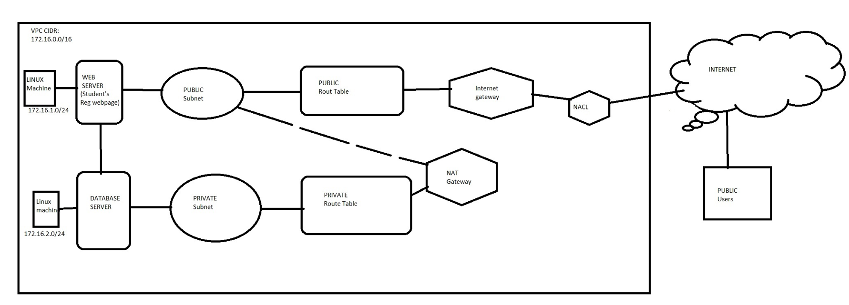

For the LAMP project we need to setup a infra of linux machine contains required package for HTTP, PHP and mysql(mariadb).

Through this infra we gonna create a database for student registration in private network and web page for registration and adding in public network.

Create VPC:

1. Creating VPC with CIDR block : 172.16.0.0/16 in one region.

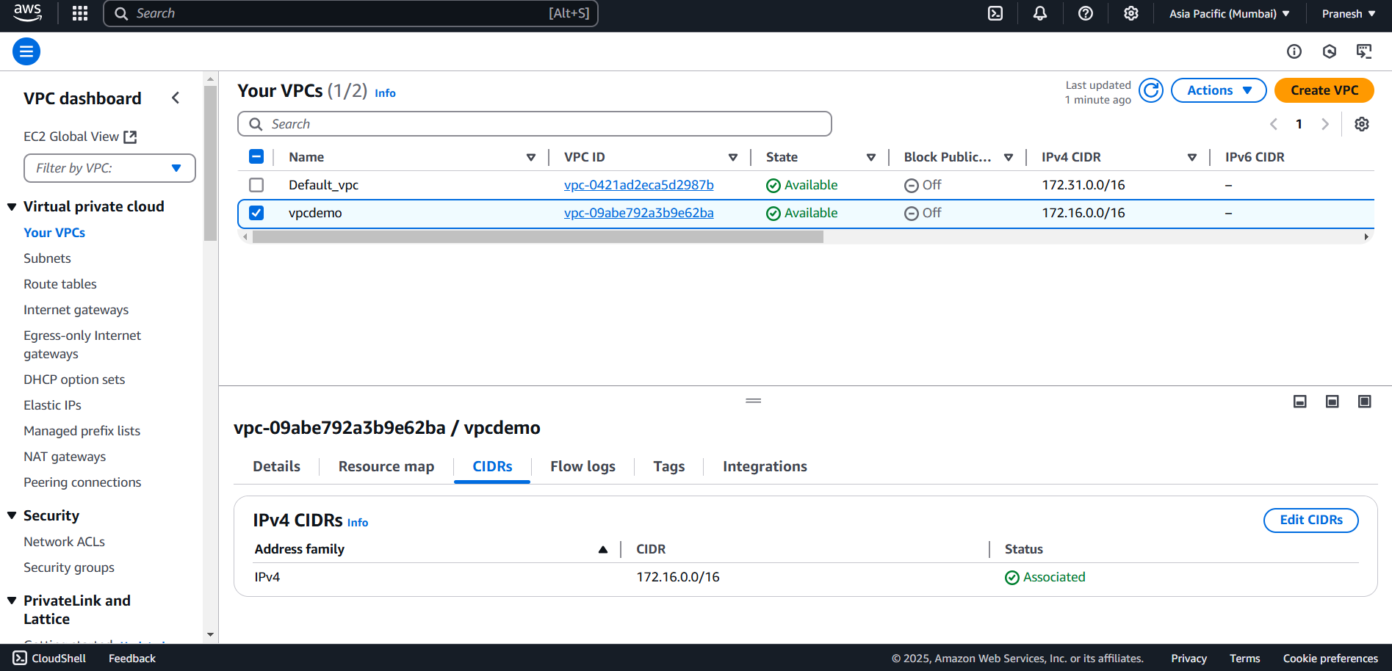

1. Create two subnet public and private under the VPC.

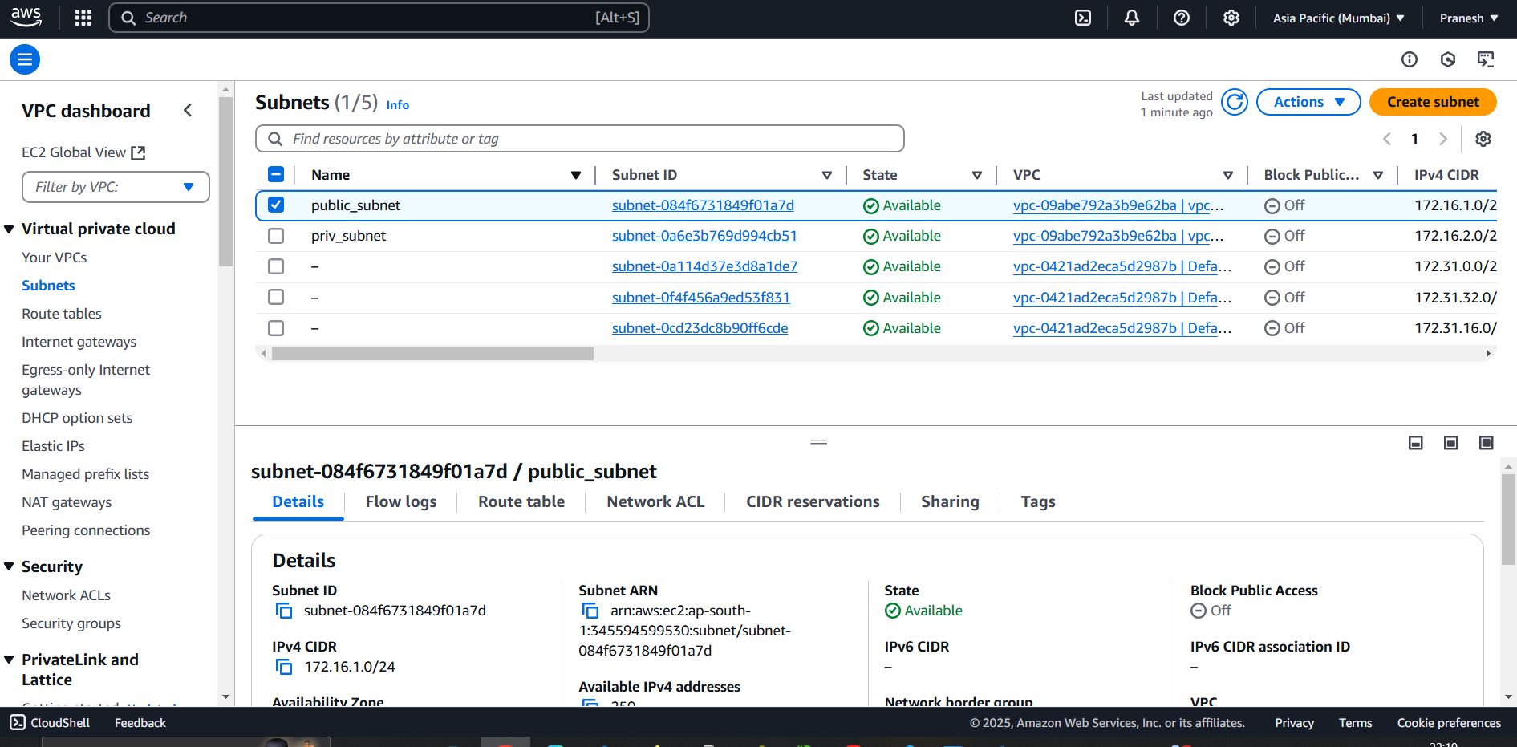

1. Create Internet gateway for the resources to communicate public internet and attach to the vpc.

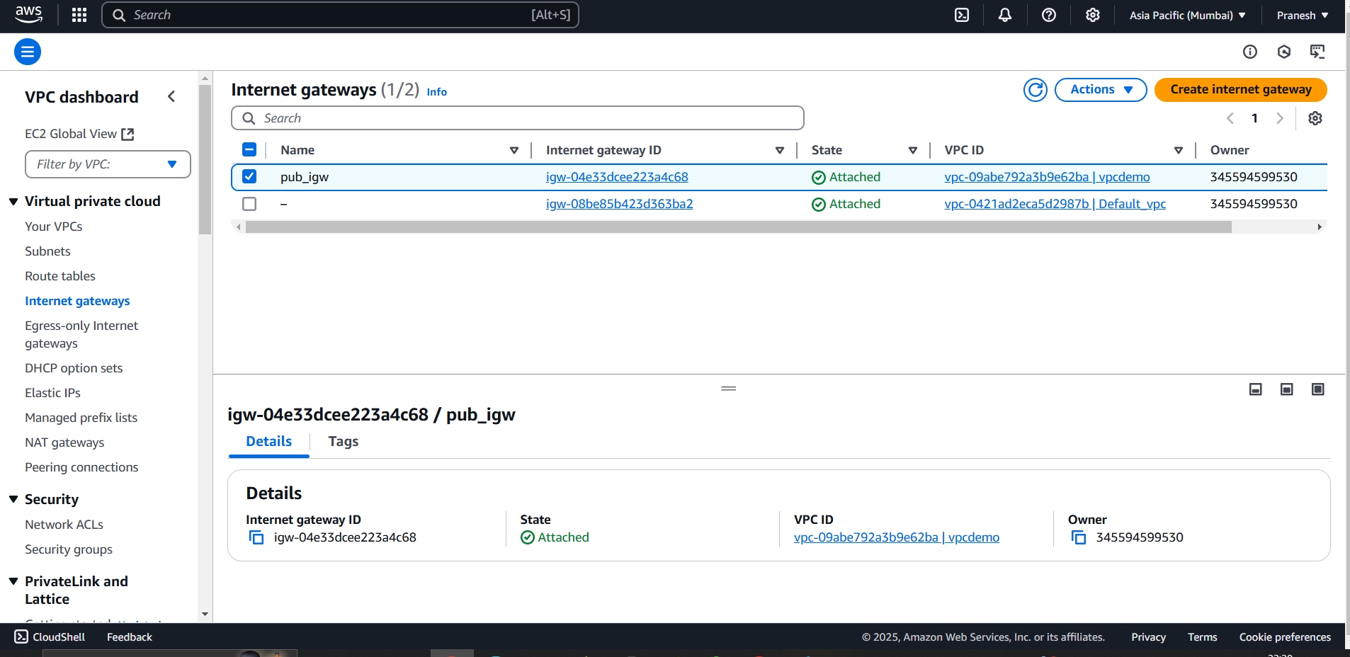

1. Create two route table public and private.
2. Associate route of IGW in public route table and associate public subnet in public RT.
3. Associate private subnet in private RT.

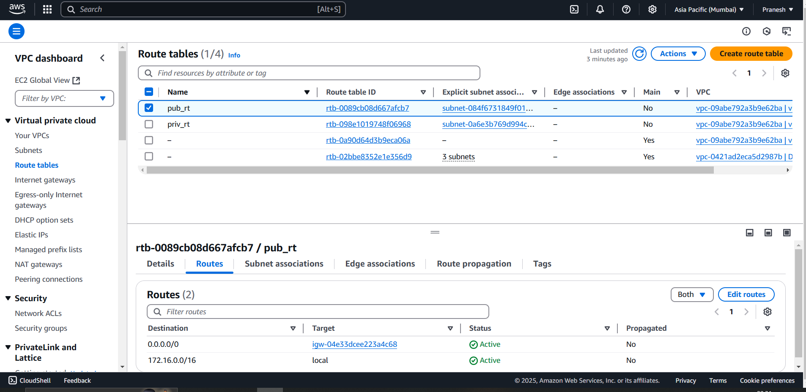

1. Create a security group(with inbound rules of SSH(22),HTTP(80)for public and sql(3306) for private(custom under public ip) under createdVPC.

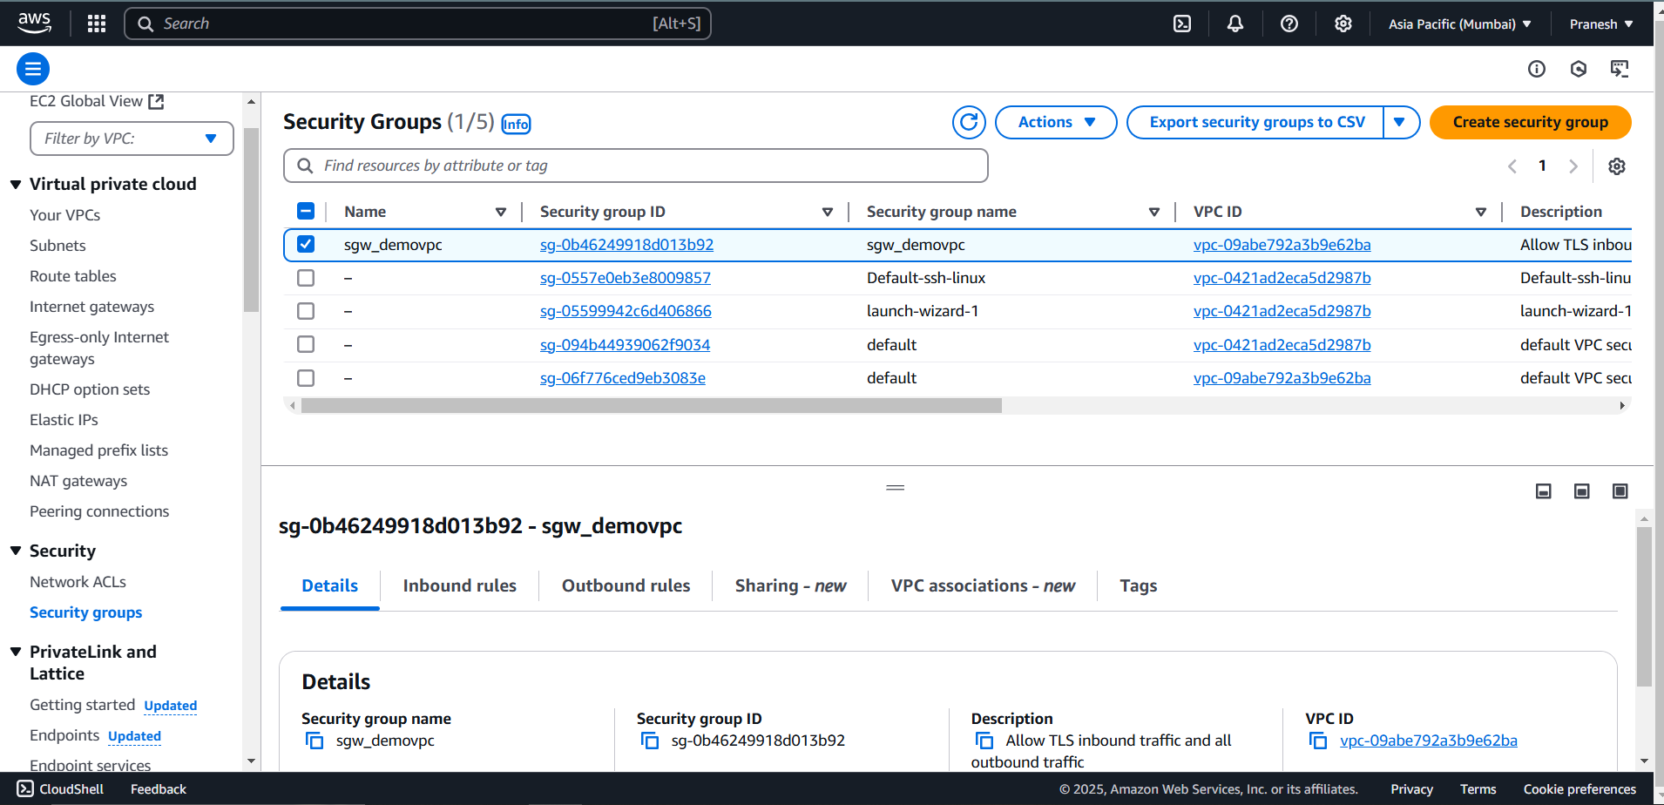

1. Now for the private server to get secured access to the internet (for package installation mariadb)configure NAT gateway.
2. NAT gateway: it establish secure access to the outbound internet for the VM deployed under private subnet.
3. Create NAT gateway connect to public subnet and define the route and private subnet assosciation to the NAT.

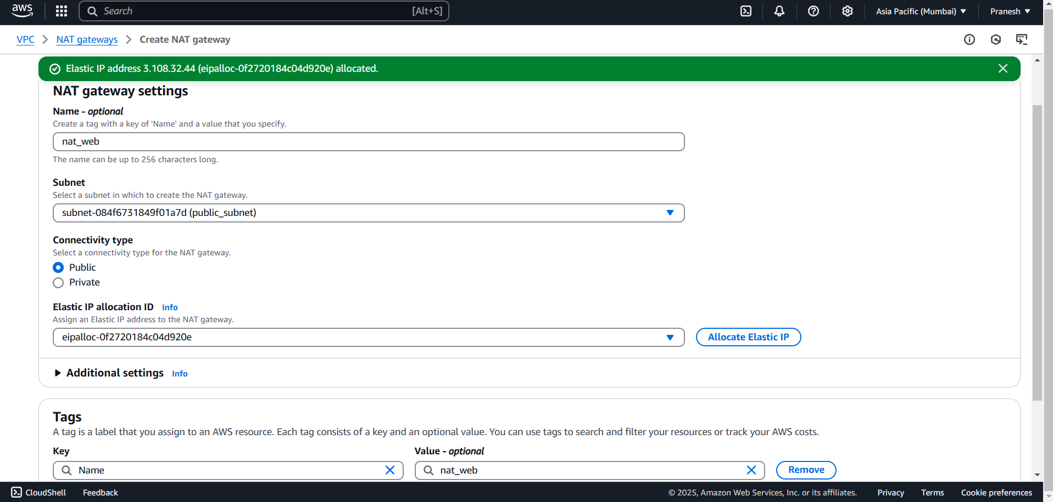

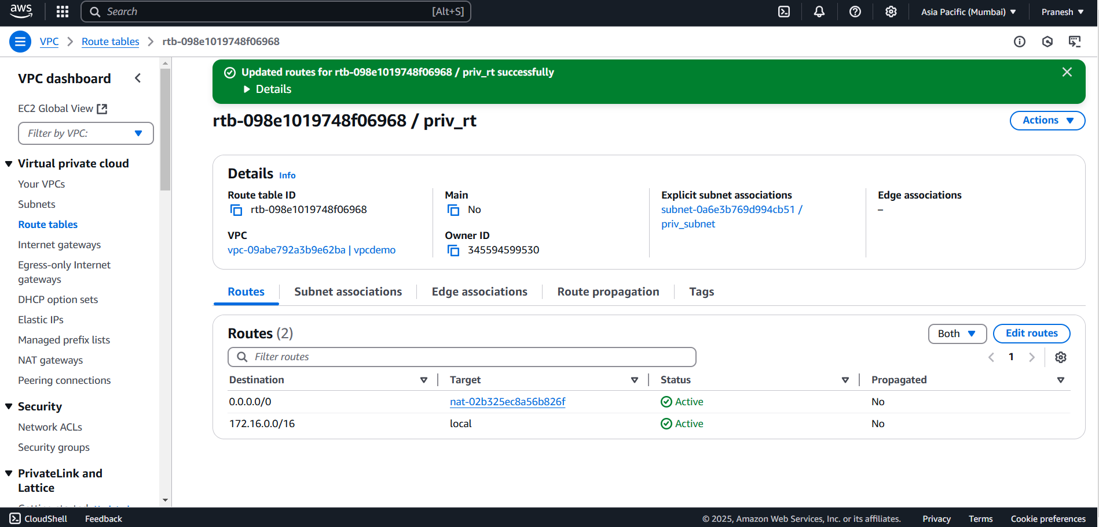

NOW create Two instance (Linux Machine):

One is under public subnet and another one is under Private subnet.

Instance for Public: (WEB)

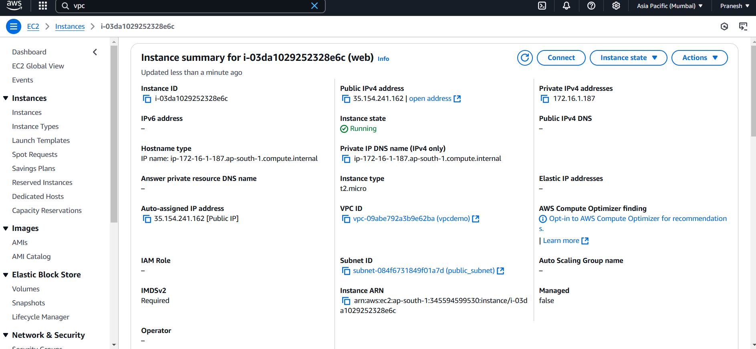

Instance for Private: (DATABASE)

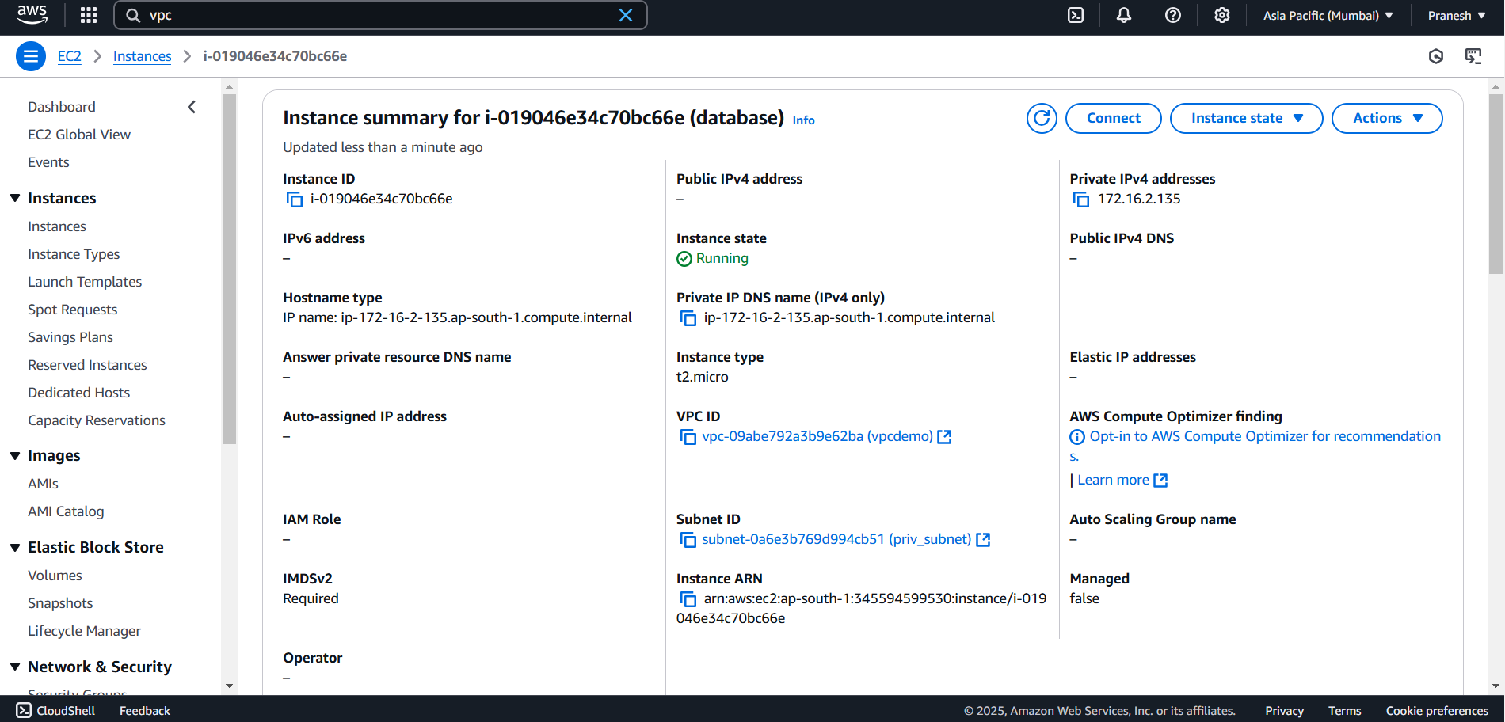

Now For the app deployment in Public instance :

Install the required package for web server and php server:

1. Yum install httpd
2. Yum install php
3. Yum install php-mysqlnd (to integrate with sql)
4. Start and enable http (systemctl start httpd)
5. Now path will be create /var/www/html

Now Create a database in Private Instance: login to private instance through public instance with shh and key pair.

1. Yum install mariadb105-server

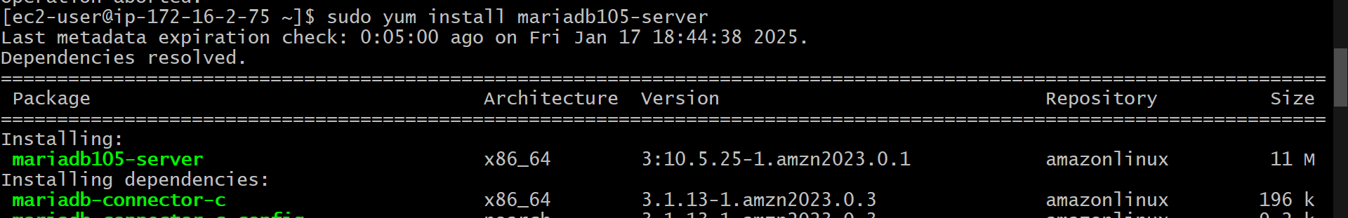

1. Start and enable sql (systemctl start mariadb)
2. mysql_secure_installation – to set password and install
3. create a database with student_db and create table into it with values reg no., name, age, student_id.

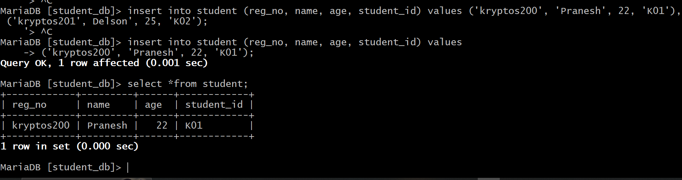

1. create a user with password in sql and grant all priviledge to the user for the database with private ip of public instance so that public instance can connect with sql, and save the changes by giving flush priviledge;
2. now to tighten the security vi /etc/my.cnf.d/mariadb-server.cnf and give private ip of private instance in BIND-ADDRESS so that sql access by only private instance.

Now database is created go to public machine and copy the php code in path /var/www/html/<file-name>

**Php code:**

**In the php code give server name: private ip of private instance give username and password that created in sql.**

<?php

$servername = "localhost";

$username = "root";

$password = "";  // MySQL root password (empty if not set)

$dbname = "student_db";

// Create connection

$conn = new mysqli($servername, $username, $password, $dbname);

// Check connection

if ($conn->connect_error) {

    die("Connection failed: " . $conn->connect_error);

}

$reg_no = "";

$name = "";

$age = "";

$student_id = "";

$message = "";

if ($_SERVER["REQUEST_METHOD"] == "POST") {

    if (isset($_POST['submit'])) {

        // Handle form submission to add a new student

        $reg_no = $_POST['reg_no'];

        $name = $_POST['name'];

        $age = $_POST['age'];

        $student_id = $_POST['student_id'];

        // Insert new student data into the database

        $sql = "INSERT INTO students (reg_no, name, age, student_id)

                VALUES ('$reg_no', '$name', $age, '$student_id')";

        if ($conn->query($sql) === TRUE) {

            $message = "New student added successfully!";

        } else {

            $message = "Error: " . $sql . "<br>" . $conn->error;

        }

    } else if (isset($_POST['fetch'])) {

        // Handle form submission to fetch student details based on reg_no

        $reg_no = $_POST['reg_no'];

        // Fetch student data based on reg_no

        $sql = "SELECT * FROM students WHERE reg_no = '$reg_no'";

        $result = $conn->query($sql);

        if ($result->num_rows > 0) {

            // Fetching the data

            $row = $result->fetch_assoc();

            $name = $row['name'];

            $age = $row['age'];

            $student_id = $row['student_id'];

        } else {

            $message = "No student found with this registration number!";

        }

    }

}

$conn->close();

?>

<!DOCTYPE html>

<html lang="en">

<head>

    <meta charset="UTF-8">

    <meta name="viewport" content="width=device-width, initial-scale=1.0">

    <title>Student Registration and Lookup</title>

    <link href="https://fonts.googleapis.com/css2?family=Poppins:wght@300;400;600&display=swap" rel="stylesheet">

    <style>

        /* Set office background image */

        body {

    background-image: url('office.jpg');

    background-size: cover;

    background-position: center;

    background-repeat: no-repeat;

    color: white;

    font-family: 'Poppins', sans-serif;

    margin: 0;

    padding: 0;

    height: 100vh;

    overflow-y: auto; /* Allow scrolling */

}

h1, h2, p {

    text-align: center;

    color: #ffcc00; /* Bright yellow color for titles */

    text-shadow: 2px 2px 4px rgba(0, 0, 0, 0.6);

}

form {

    max-width: 600px;

    margin: 20px auto;

    background-color: rgba(0, 0, 0, 0.6);

    padding: 20px;

    border-radius: 10px;

}

label, input {

    display: block;

    margin: 10px 0;

    width: 100%;

    padding: 10px;

    font-size: 1rem;

}

button {

    background-color: #4CAF50;

    color: white;

    padding: 10px 20px;

    border: none;

    border-radius: 5px;

    cursor: pointer;

    width: 100%;

    font-size: 1.2rem;

}

button:hover {

    background-color: #45a049;

}

/* Ensure student details section is scrollable */

.student-details {

    background-color: rgba(0, 0, 0, 0.6);

    color: #ffcc00;

    padding: 20px;

    margin-top: 20px;

    border-radius: 10px;

    font-size: 1.2rem;

    overflow-y: auto;  /* Make the student details section scrollable if content overflows */

}

.student-details p {

    font-weight: bold;

    margin: 10px 0;

}

        .message {

            font-size: 1.2rem;

            font-weight: 500;

            margin: 10px 0;

            color: #ffcc00;

        }

    </style>

</head>

<body>

    <h1>Student Registration and Lookup</h1>

    <!-- Form to Add a New Student -->

    <h2>Add New Student</h2>

    <form method="POST" action="">

        <label for="reg_no">Registration Number:</label>

        <input type="text" id="reg_no" name="reg_no" required>

        <label for="name">Name:</label>

        <input type="text" id="name" name="name" required>

        <label for="age">Age:</label>

        <input type="number" id="age" name="age" required>

        <label for="student_id">Student ID:</label>

        <input type="text" id="student_id" name="student_id" required>

        <button type="submit" name="submit">Add Student</button>

    </form>

    <!-- Form to Fetch Student Details by Registration Number -->

    <h2>Search for Student by Registration Number</h2>

    <form method="POST" action="">

        <label for="reg_no">Registration Number:</label>

        <input type="text" id="reg_no" name="reg_no" required>

        <button type="submit" name="fetch">Fetch Details</button>

    </form>

    <!-- Display message after form submission -->

    <?php if (!empty($message)) { ?>

        <div class="message"><?php echo $message; ?></div>

    <?php } ?>

    <!-- Display student details if found -->

    <?php if (!empty($name)) { ?>

        <div class="student-details">

            <h2>Student Details:</h2>

            <p><strong>Name:</strong> <?php echo $name; ?></p>

            <p><strong>Age:</strong> <?php echo $age; ?></p>

            <p><strong>Student ID:</strong> <?php echo $student_id; ?></p>

        </div>

    <?php } ?>

</body>

</html>

Now give the public ip of the public instance with the path to get the web page.

