Java Application CI/CD Pipeline

CI/CD Environment Overview

Build Agent

Continuous Integration (CI) Workload
- Git – source control and repository checkout
- Java Development Kit (JDK)
- Apache Maven – build and test automation
- Docker – container image creation
- Gitleaks – secret detection
- Trivy – container image vulnerability scanning
- SonarQube Scanner – code quality analysis

Ansible Agent

Continuous Deployment (CD) Workload
- Ansible – deployment automation
- community.docker Ansible collection
- SSH private-key access to the production server
- Ansible inventory.ini and deployment playbooks

Production Server
- Docker Engine
- Java application container
- Application listening port: 8080

CI/CD Execution Flow

Pipeline execution scenarios

Standard deployment – DEPLOY / v4
- Check out the application source code from GitHub.
- Scan the repository for accidentally committed secrets using Gitleaks.
- Build the Java application with Maven and execute JUnit tests.
- Generate the JaCoCo code-coverage report.
- Run SpotBugs static application analysis.
- Scan third-party dependencies using OWASP Dependency-Check.
- Run SonarQube analysis and evaluate the configured quality gate.
- Build the Docker image and scan it with Trivy.
- Push Docker image v4 to Docker Hub.
- Use Ansible to deploy v4 and run post-deployment smoke tests.

Manual rollback – ROLLBACK / v3
- Skip source checkout and the CI stages.
- Connect to the production server through Ansible.
- Deploy the existing Docker image v3.
- Run application health checks and smoke tests.

Automatic rollback
- Capture the Docker image currently running in production.
- Deploy the requested new image.
- Detect a failed health check or smoke test.
- Restore the previously captured production image.

Create and configure a Jenkins build agent
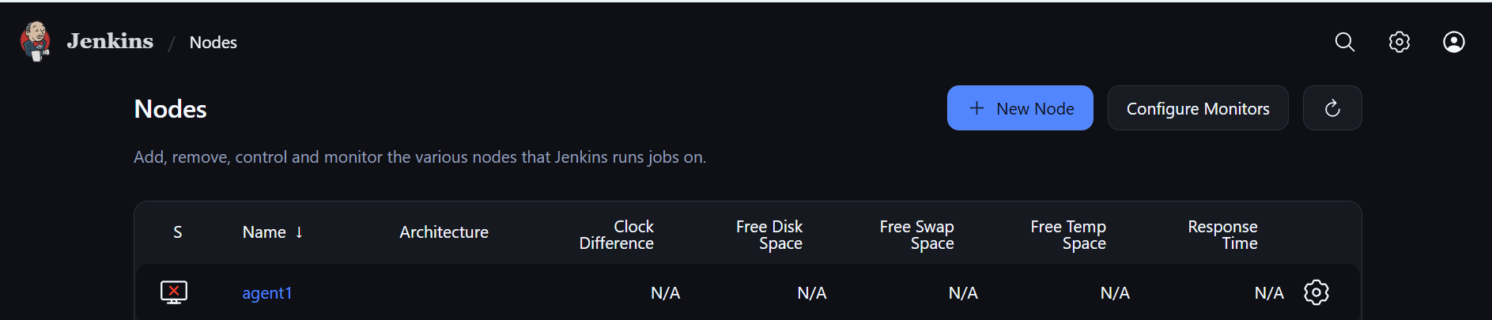

Run the Jenkins agent connection command on the agent machine.
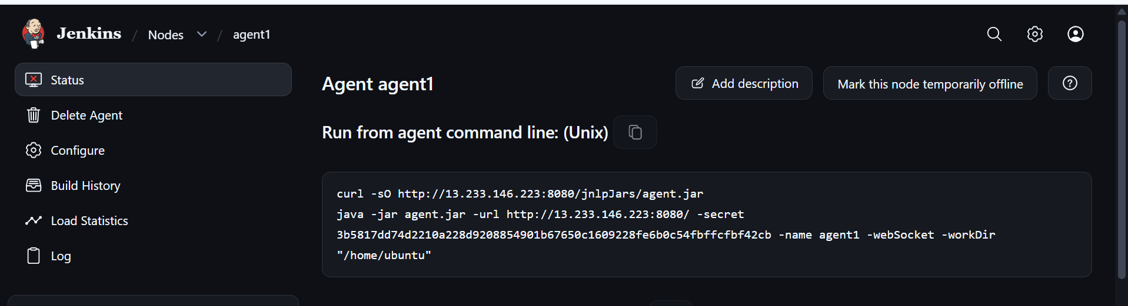

Install OpenJDK on the agent machine and start the agent.
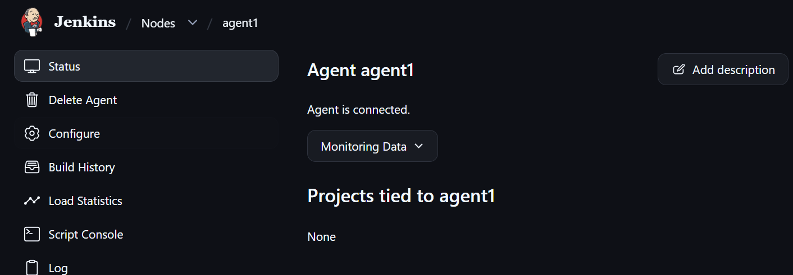

Configure pipeline stages to run in Docker agents

Install the required Jenkins plugins.
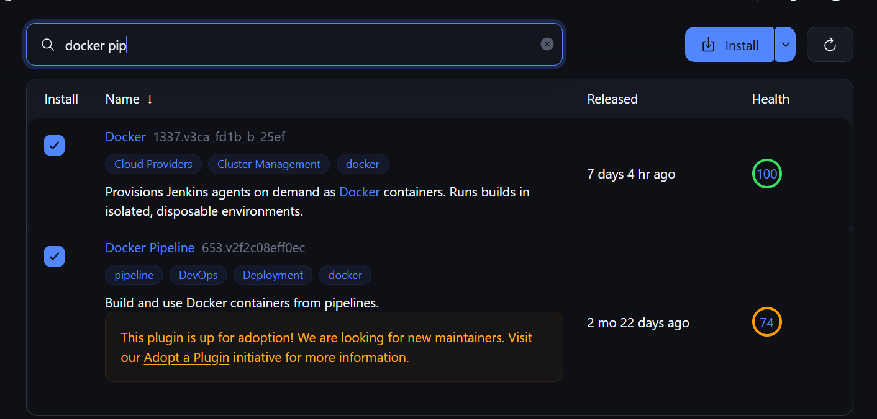

- Using containerized build tools keeps the build-agent virtual machine relatively clean.
- Component | - Where
- Docker Engine | - Build agent VM
- Maven + Java 17 | - Temporary Maven container
- Gitleaks | - Dedicated container
- SonarQube | - Separate server/container
- Trivy | - Dedicated container or agent CLI
- OWASP | - Maven container
- SpotBugs | - Maven container
- Playwright | - Dedicated browser container later

Static Analysis with SpotBugs

SpotBugs – Static Application Security Testing (SAST)

Run SpotBugs in the existing Maven container.
SpotBugs analyses compiled Java bytecode to identify potential programming defects and suspicious coding patterns.
The SpotBugs Maven plugin is configured in the project's pom.xml file:
<plugin>
<groupId>com.github.spotbugs</groupId>
<artifactId>spotbugs-maven-plugin</artifactId>
<version>4.9.3.0</version>
<configuration>
<effort>Max</effort>
<threshold>Low</threshold>
</configuration>
</plugin>

- mvn spotbugs:check

What happens during this stage?
- Maven compiles the Java application.
- SpotBugs analyses the compiled bytecode.
- The tool checks for potentially problematic coding patterns.
- The Maven goal fails when findings meet the configured severity threshold.

Dependency Vulnerability Scanning

OWASP Dependency-Check – Software Composition Analysis (SCA)

Run Dependency-Check in the existing Maven container.
- This stage checks third-party application dependencies for publicly known vulnerabilities.

For example, the application includes libraries such as:
- Spring Boot
- Spring Web
- Jackson
- Other Maven libraries
- Dependency-Check compares the resolved dependency versions with known vulnerability information.
- The OWASP Dependency-Check Maven plugin is configured in the project POM.
- Run the following Maven goal:
- mvn org.owasp:dependency-check-maven:check

Code Coverage

JaCoCo – Java Code Coverage

JaCoCo is already configured in the project POM.
- JaCoCo measures how much of the application's code is executed by the automated tests.

Example:
- Assume IncidentService.java contains 100 executable lines.
- If the tests execute 80 of those lines,
- 20 executable lines remain uncovered.
- The line coverage is therefore 80%.
- Because JaCoCo is already configured in pom.xml, no separate installation is required for the Maven report generation.

Generate the report with:
- mvn clean verify

The HTML report is generated at:
- target/site/jacoco/index.html

To display the report in Jenkins, install the HTML Publisher plugin.

Add the following stage to the Jenkins pipeline:
- stage('Publish JaCoCo Report') {
- steps {
- publishHTML(target: [
- reportDir: 'target/site/jacoco',
- reportFiles: 'index.html',
- reportName: 'JaCoCo Coverage Report',
- keepAll: true,
- alwaysLinkToLastBuild: true,
- allowMissing: false
- ])
- }
- }

SonarQube Setup and Jenkins Integration

Install Java 21 and PostgreSQL on the SonarQube server.

Connect to the SonarQube virtual machine over SSH:
sudo apt update

sudo apt install -y \
openjdk-21-jdk \
postgresql \
postgresql-contrib \
unzip \
wget

Configure PostgreSQL

Start and enable the PostgreSQL service:
sudo systemctl enable --now postgresql
- sudo -u postgres psql
- Open the PostgreSQL prompt and create the database user:
- CREATE USER sonar WITH ENCRYPTED PASSWORD 'ReplaceWithAStrongPassword';

- CREATE DATABASE sonarqube OWNER sonar;

- \q

Configure Linux kernel parameters
SonarQube uses Elasticsearch. Configure the required host kernel parameters before starting the service.
sudo tee /etc/sysctl.d/99-sonarqube.conf <<'EOF'
vm.max_map_count=524288
fs.file-max=131072
EOF

Apply the kernel parameter configuration:
- sudo sysctl --system

Verify the configured values:
- sysctl vm.max_map_count
- sysctl fs.file-max

Download the SonarQube archive.

Extract the downloaded archive:
sudo unzip sonarqube*.zip -d /opt/

Identify the extracted directory:
ls -d /opt/sonarqube*
The extracted directory will have a name similar to /opt/sonarqube-<version>.

Create a stable symbolic link, replacing the placeholder with the actual extracted directory name:
sudo ln -s /opt/sonarqube-<version> /opt/sonarqube

Create a dedicated Linux service account
Run SonarQube under a dedicated non-root account.
sudo useradd --system --create-home --shell /bin/bash sonar
Assign ownership of the installation directory:
sudo chown -R sonar:sonar /opt/sonarqube
Using a dedicated non-root account separates the SonarQube service from privileged system processes.

Configure the SonarQube database connection

Open the SonarQube configuration file:
sudo nano /opt/sonarqube/conf/sonar.properties

Set the database properties below. Replace the password placeholder with the password created in PostgreSQL:
sonar.jdbc.username=sonar
sonar.jdbc.password=ReplaceWithAStrongPassword
sonar.jdbc.url=jdbc:postgresql://127.0.0.1:5432/sonarqube

sonar.web.host=0.0.0.0
sonar.web.port=9000

Save the configuration file.

Reapply the installation directory ownership:
sudo chown -R sonar:sonar /opt/sonarqube

Configure SonarQube as a systemd service

Create the systemd unit file:
sudo nano /etc/systemd/system/sonarqube.service

Add the following service configuration:
[Unit]
Description=SonarQube Community Build
After=network.target postgresql.service
Requires=postgresql.service

[Service]
Type=forking
User=sonar
Group=sonar
WorkingDirectory=/home/ubuntu/sonarqube/sonarqube-26.10.0.133078/

ExecStart=/home/ubuntu/sonarqube/sonarqube-26.10.0.133078/bin/linux-x86-64/sonar.sh start
ExecStop=/home/ubuntu/sonarqube/sonarqube-26.10.0.133078/bin/linux-x86-64/sonar.sh stop

LimitNOFILE=131072
LimitNPROC=8192

Restart=on-failure
RestartSec=10

[Install]
WantedBy=multi-user.target

Reload the systemd configuration:
sudo systemctl daemon-reload

Enable and start the SonarQube service:
sudo systemctl enable sonarqube
sudo systemctl start sonarqube

Check the service status:
sudo systemctl status sonarqube

Once the service is running, access the SonarQube UI through the permitted network:
- http://<SONARQUBE-IP>:9000

Default initial login:
- Username: admin
- Password: admin
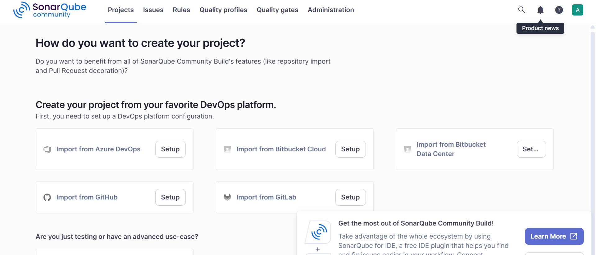

Create a SonarQube project
Enter a project name and create the project.

Generate a SonarQube analysis token

Select local analysis, provide a token name, and generate the token.

Configure SonarQube credentials in Jenkins
In Jenkins, add a credential under the global credentials configuration. Store the generated token as a secret and assign it a credential ID.

Configure the SonarQube server in Jenkins
Open Manage Jenkins → System. Under the SonarQube installations section, configure the server name, the credential ID, and the SonarQube URL using its private IP address.

Configure the Ansible Agent
Update the operating system packages.
Install pipx.
Install Ansible Core using pipx:
Install java

Configure the Ansible machine as a Jenkins agent.

Configure passwordless SSH access to the production server

ssh-copy-id -f "-o IdentityFile pathofpemofprod" prod@ip

Production Server Preparation
Keep the Jenkinsfile and the Ansible deployment and rollback playbooks (deploy.yml and rollback.yml) in the application repository.

Create a Jenkins Pipeline job

Use pipeline and add trigger of 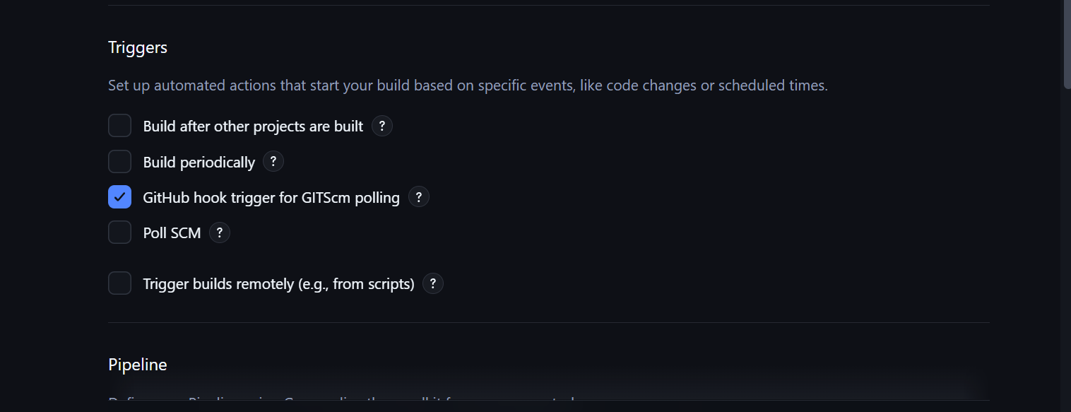

Add the Git SCM repository details and configure the pipeline script path.
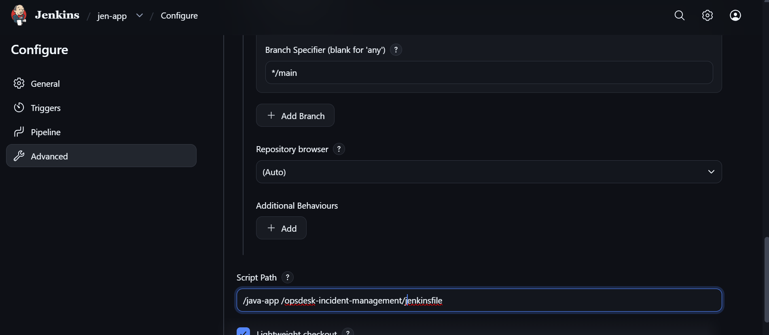

Create a GitHub webhook pointing to the Jenkins webhook endpoint.

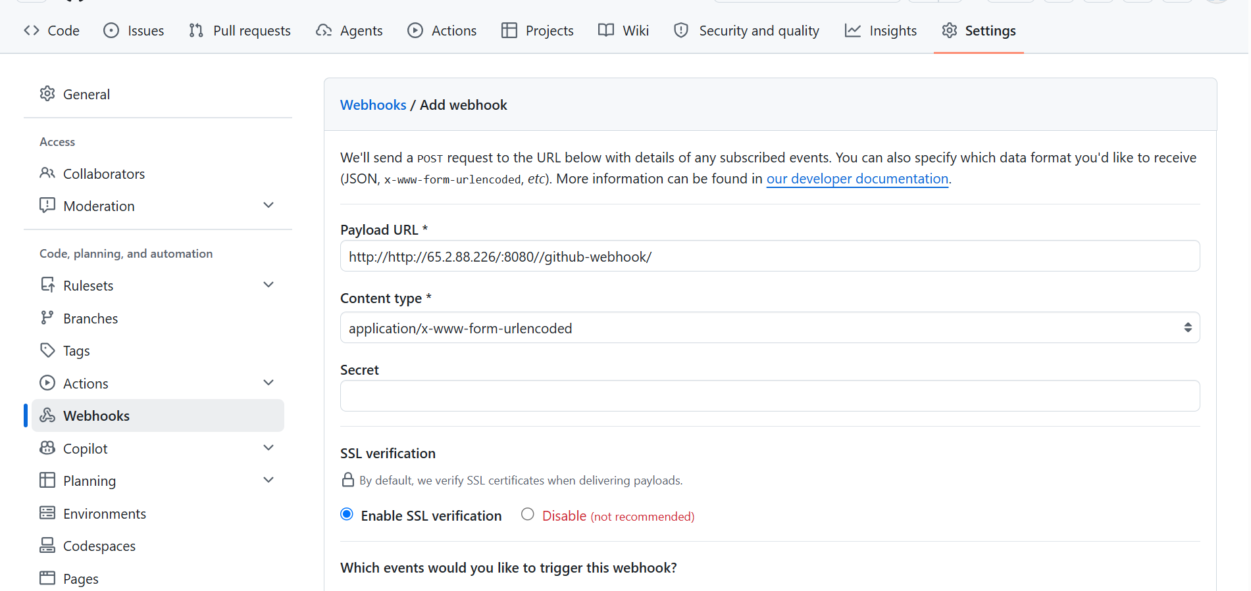

Git repository structure
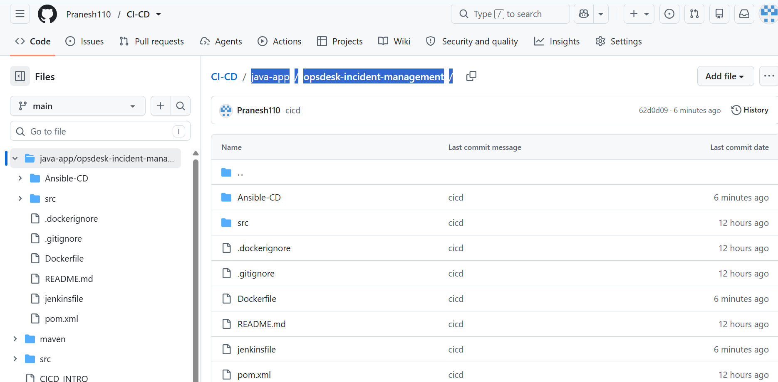

Run the pipeline manually, or allow the configured webhook to trigger it after a push event.
When the configured branch receives a push or a pull request is merged, the webhook triggers the pipeline automatically.
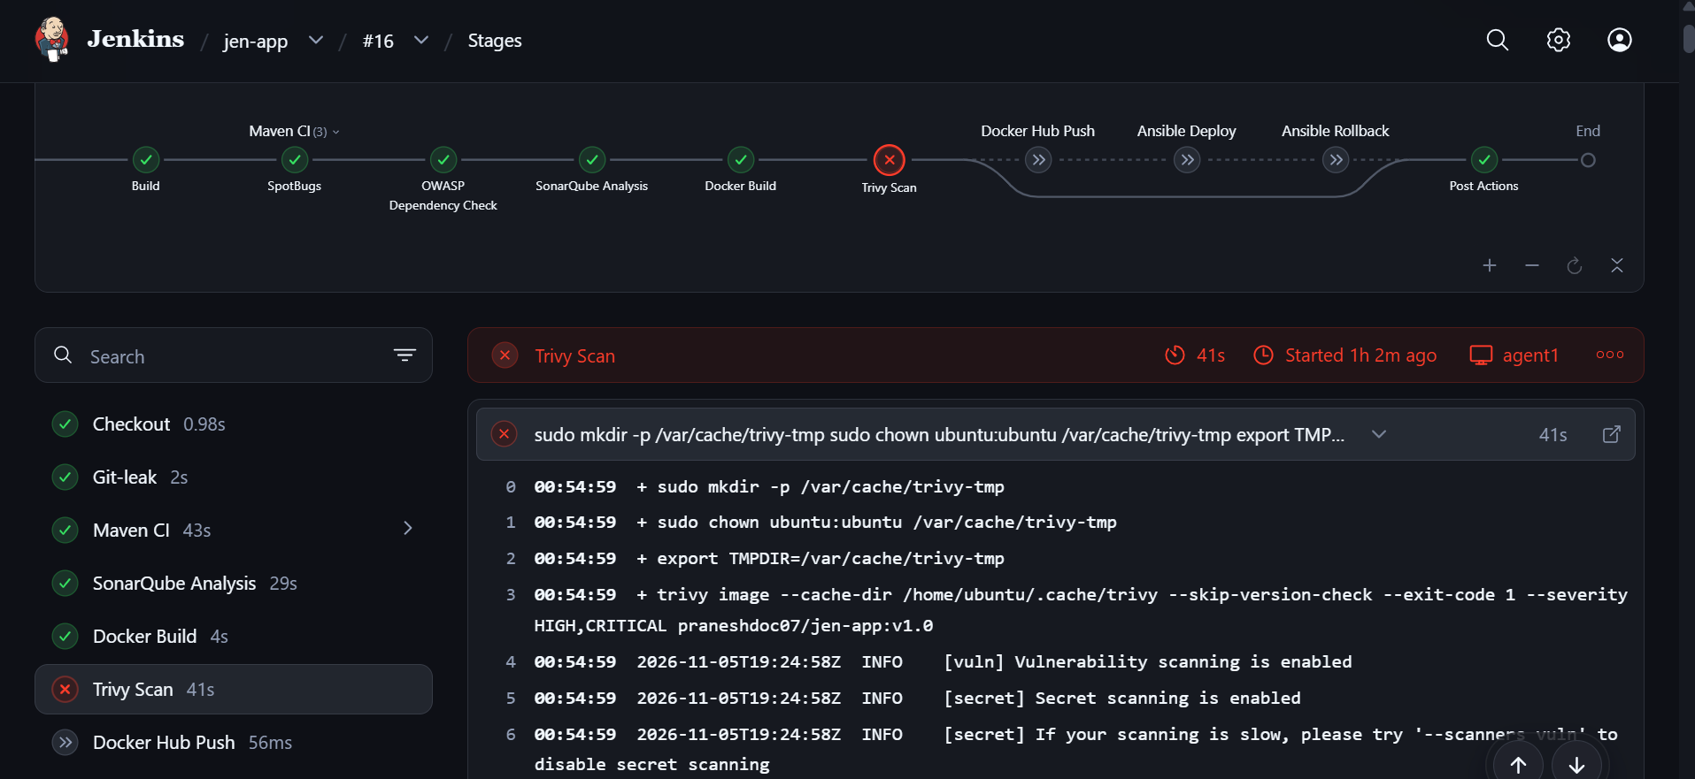

If a pipeline stage fails, Jenkins marks the build as failed and stops subsequent dependent stages.

When all required stages succeed, Ansible deploys the Java application image to the production server and starts the container.
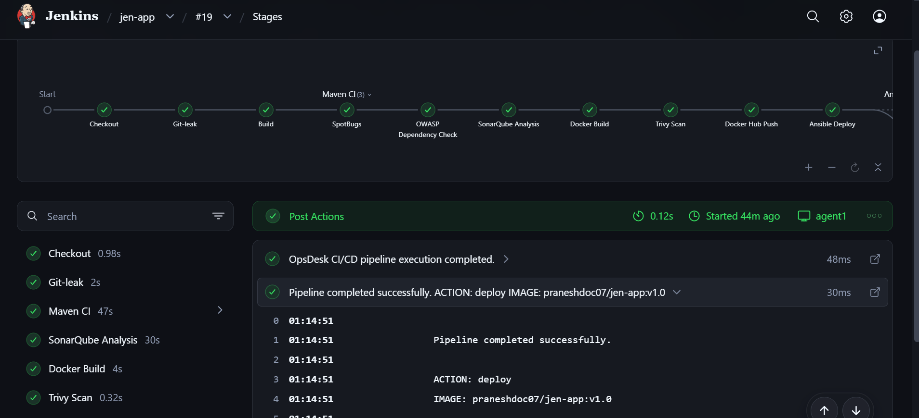

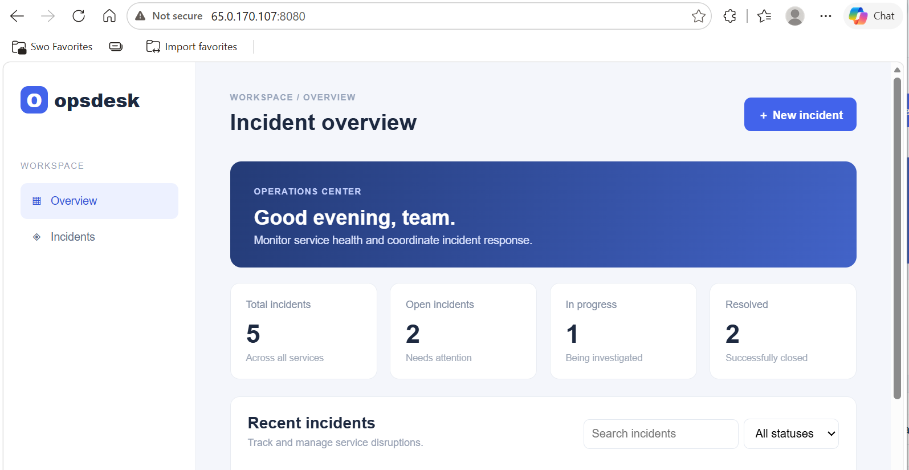

Deploying a new application version – v1.1
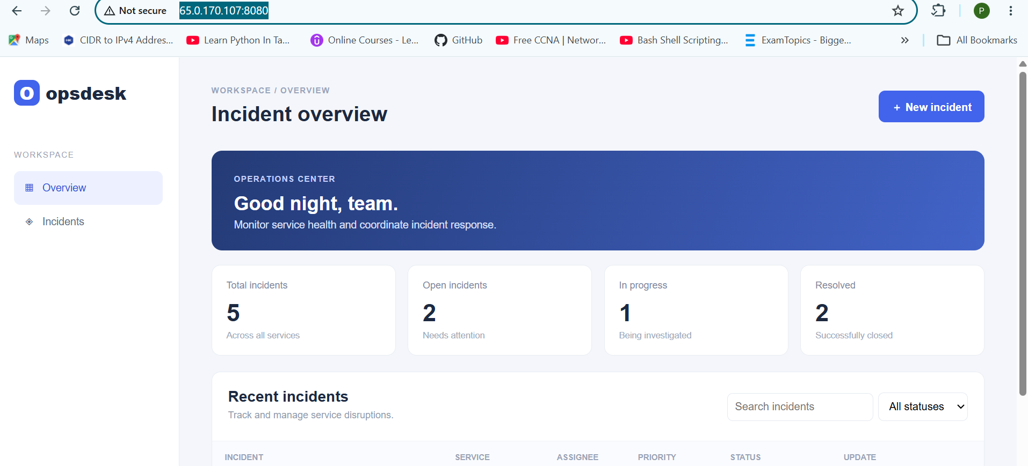
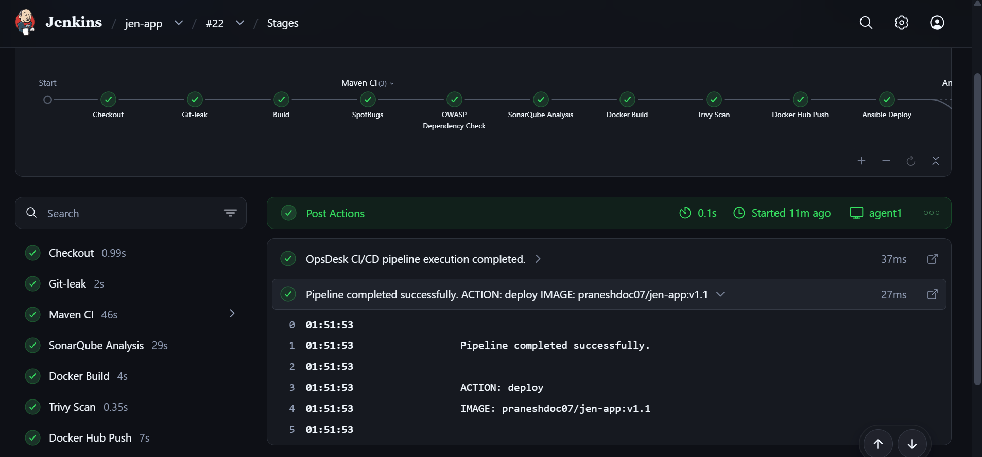

Automatic rollback scenario: if the v1.1 deployment fails its Ansible health check, the playbook restores the previously running application image.
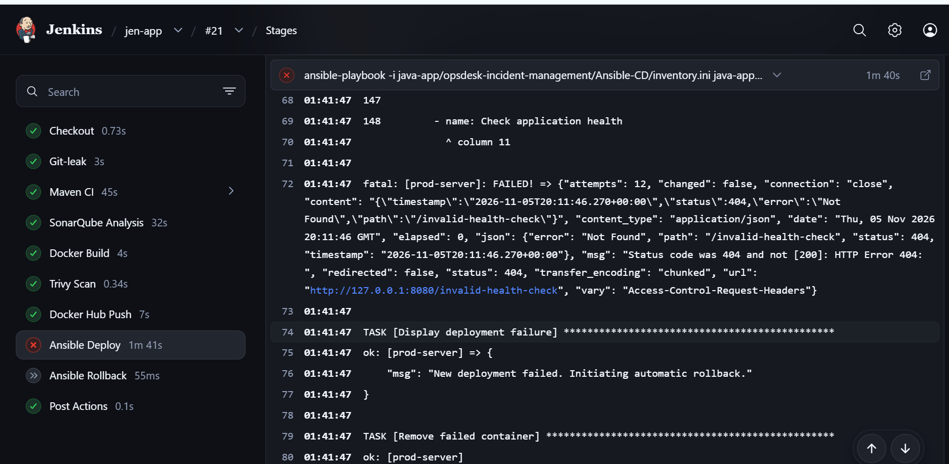
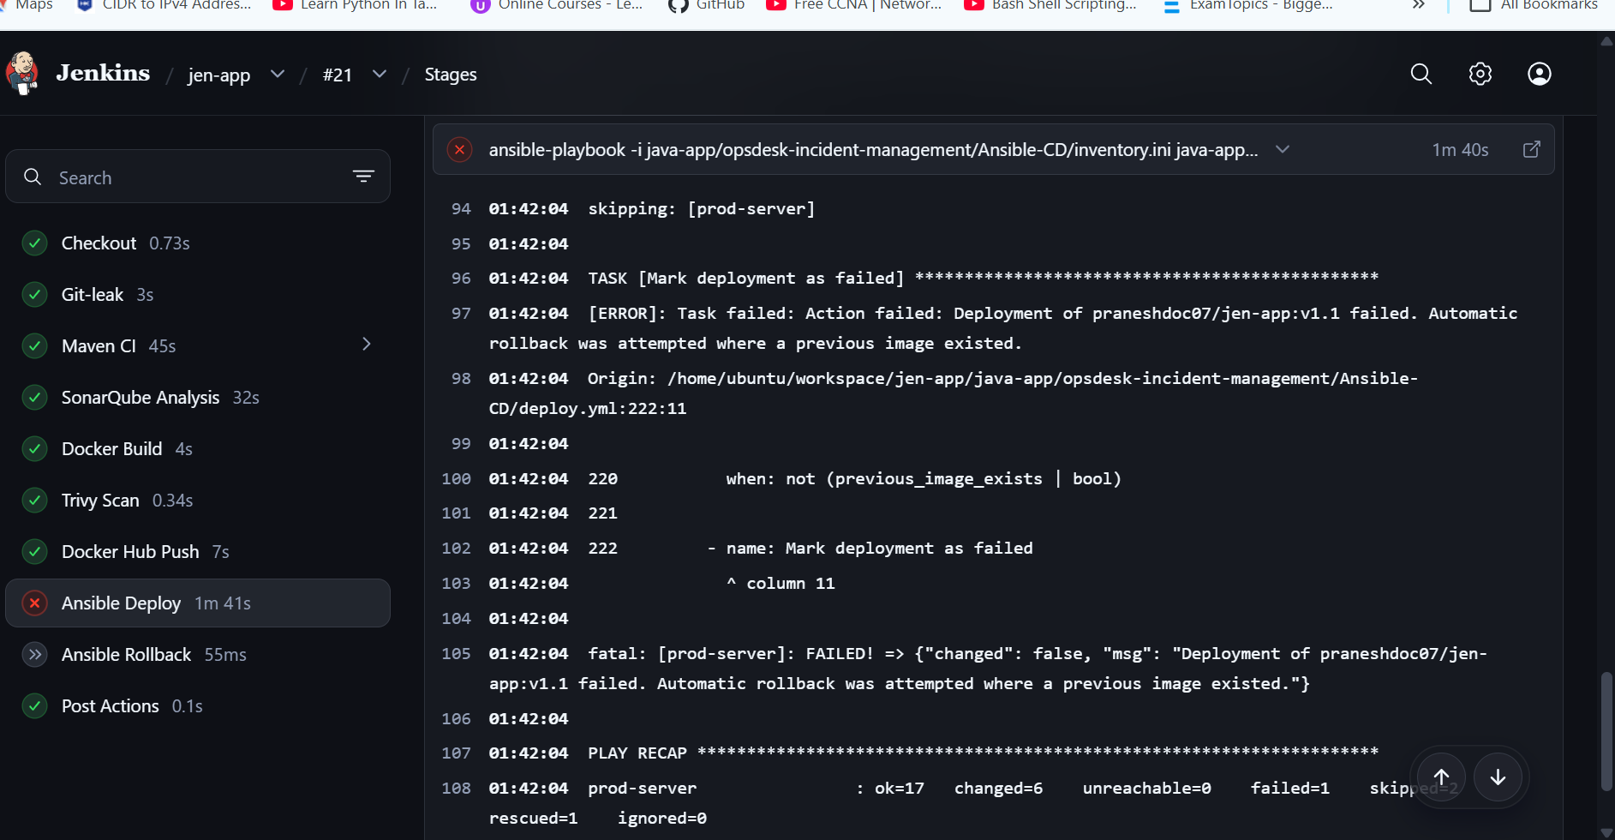

Manual rollback scenario: if a minor application or UI change causes an issue, select the rollback action and provide the required previous image version as a build parameter.
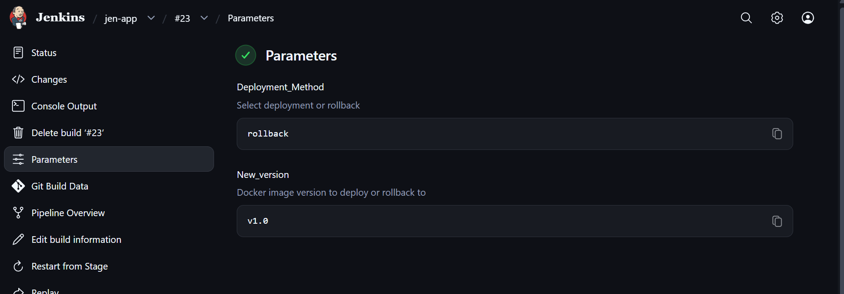

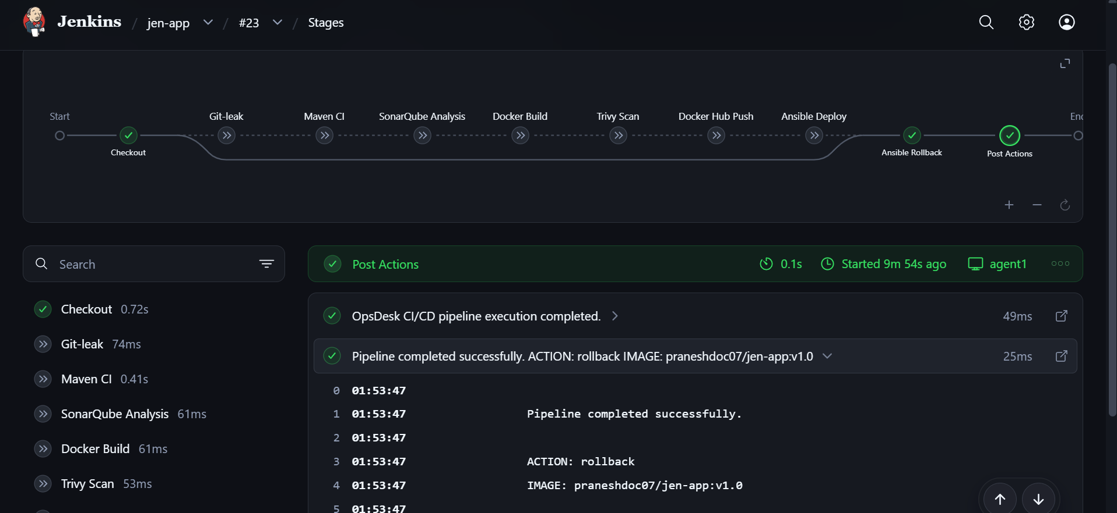

Docker images available on the build agent


