JENKINS
Installation:

Prereq:
JAVA needed:
sudo apt update
- sudo apt install fontconfig openjdk-21-jre
- java -version

Install;
sudo wget -O /etc/apt/keyrings/jenkins-keyring.asc \
- https://pkg.jenkins.io/debian-stable/jenkins.io-2026.key
- echo "deb [signed-by=/etc/apt/keyrings/jenkins-keyring.asc]" \
- https://pkg.jenkins.io/debian-stable binary/ | sudo tee \
- /etc/apt/sources.list.d/jenkins.list > /dev/null
- sudo apt update
- sudo apt install jenkins
- Start Jenkins
You can enable the Jenkins service to start at boot with the command:
sudo systemctl enable jenkins
You can start the Jenkins service with the command:
sudo systemctl start jenkins
You can check the status of the Jenkins service using the command:
sudo systemctl status jenkins

JENKINS RUN ON PORT 8080

Initial admin password will be in path /var/lib/jenkins/secrets/initialAdminPassword

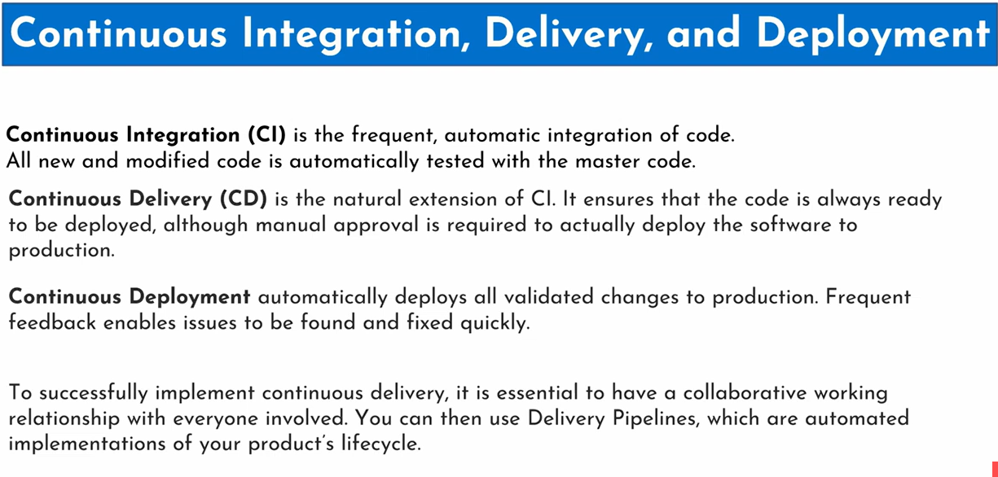

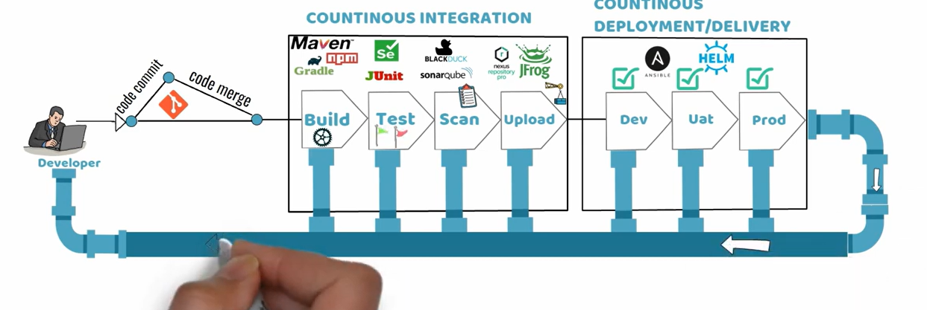

Run Jenkins in war file by diff port

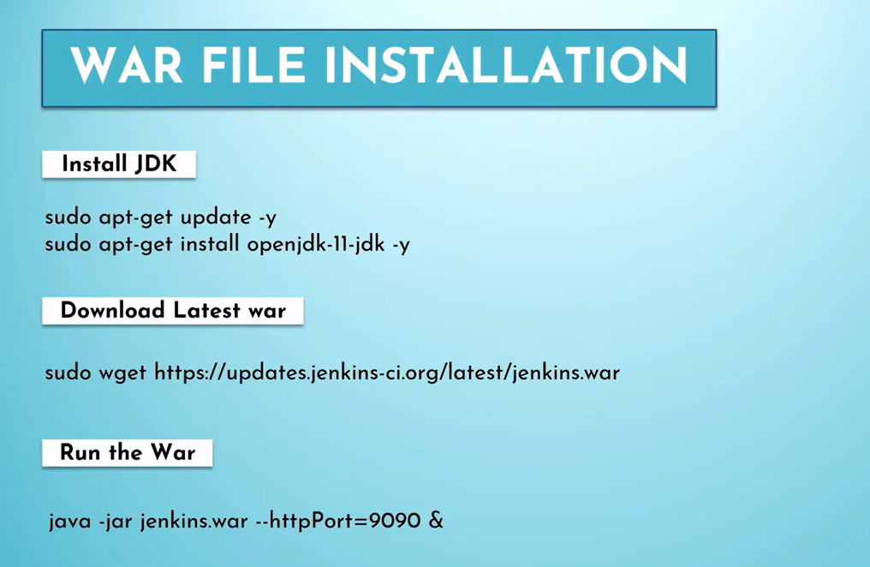

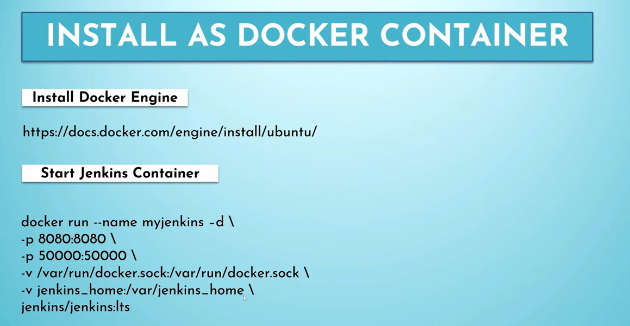

Workspace will recreate in Jenkins on path /var/lib/jenkins/workspace
GIT-MAVEN project
Pluggins:
GIT plugin
Maven integration plugin
Clonning a GIT hub repo into Jenkins through free style

Copy the http url of the repo in github and paste it in SRC git on Jenkins

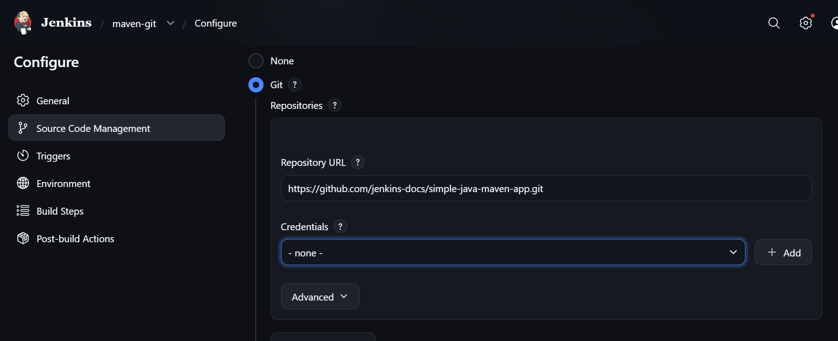

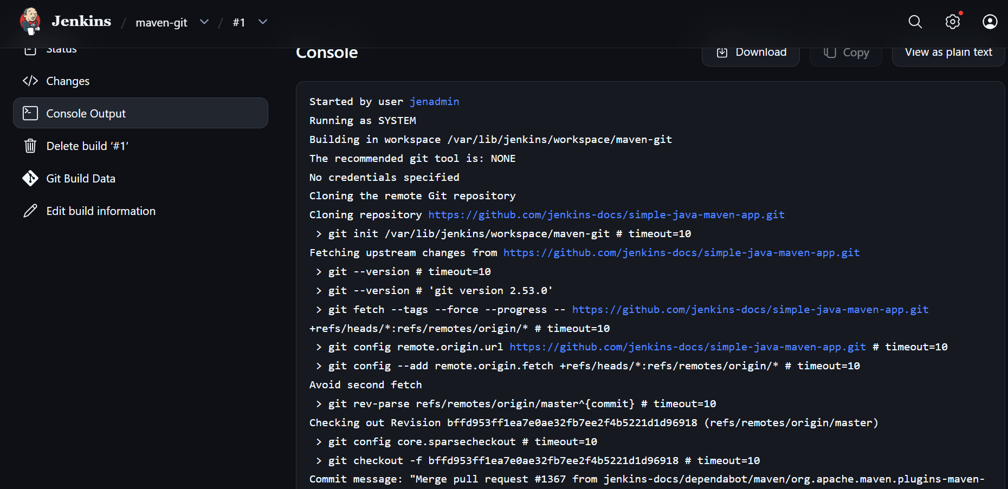

This was clone that project into the Jenkins workspace

Workspace is a temp folder where our all project and jobs, artifacts will be created

Now to configure mave:

Go to manage jenkin--> global tool under maven

- Selecte th req maven version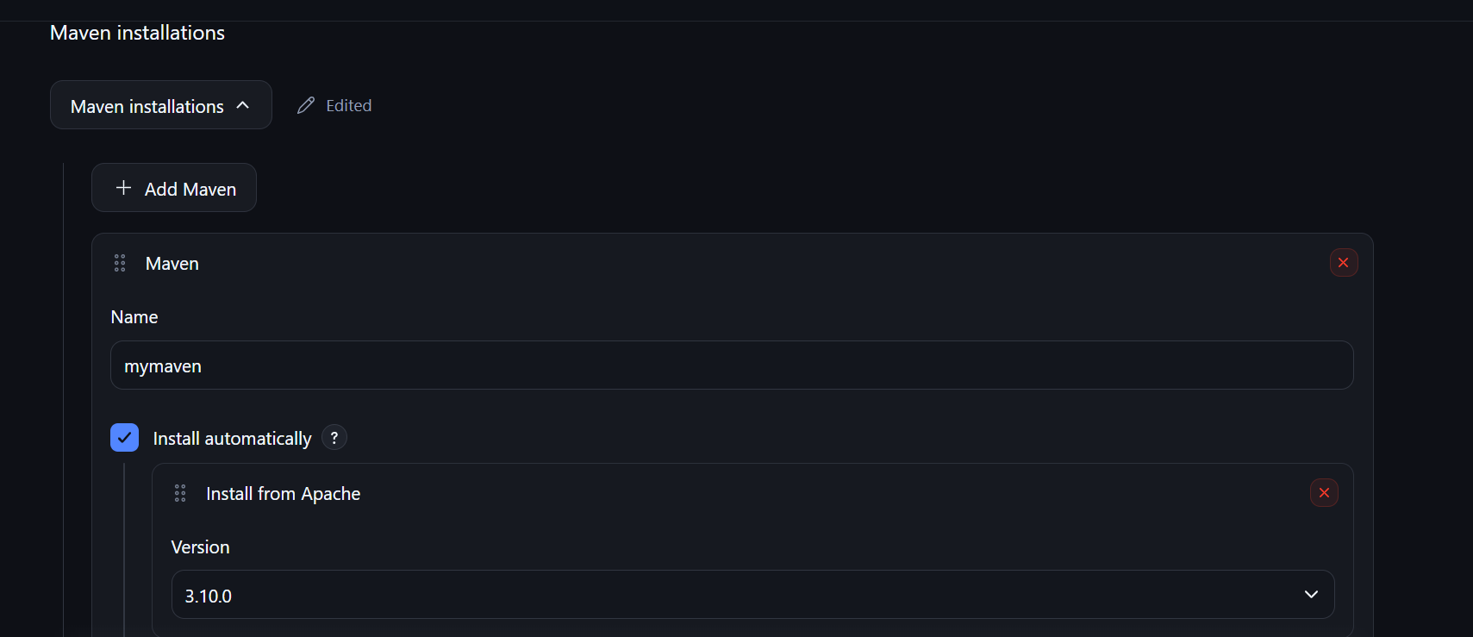

Maven uses the project's directory structure
- Maven follows a standard directory layout. In a typical Java Maven application:
- simple-java-maven-app/
- │
- ├── pom.xml
- │
- └── src/
- ├── main/
- │ └── java/
- │ └── ...
- │
- └── test/
- └── java/
- └── ...
- The two important locations are:
- Directory | - Purpose
- src/main/java | - Application source code
- src/test/java | - Test source cod

Now we do done a git clone from repo

Now to run this maven to package this src code as jar and run test

In the project add build with invoke maven
We can use mvn -B clean package (if test is needed when package itself)
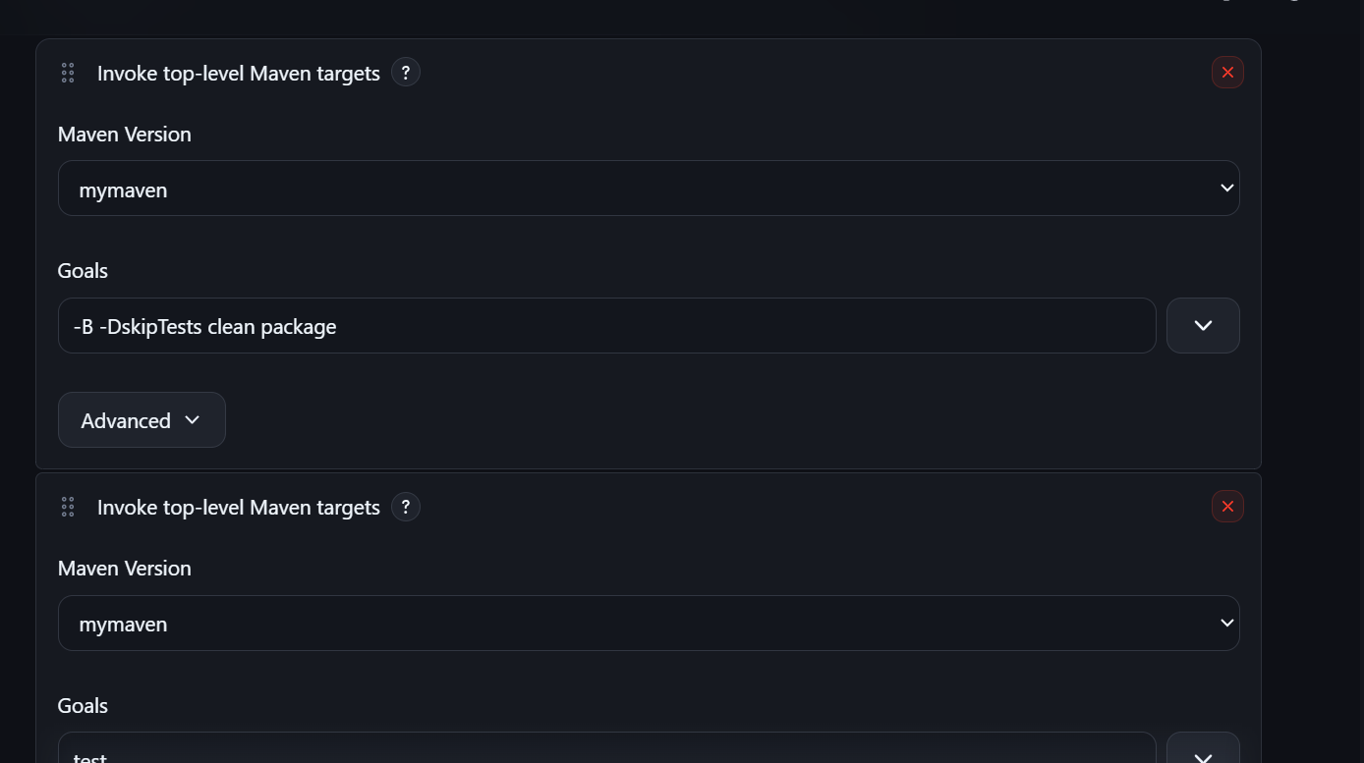

Now to deploy the jar and see the output

Every thing is now performing under /var/lib/Jenkins/workspace/maven-git/targets
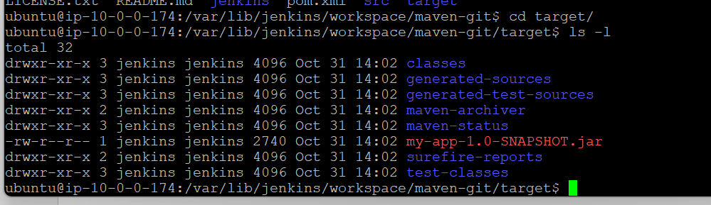

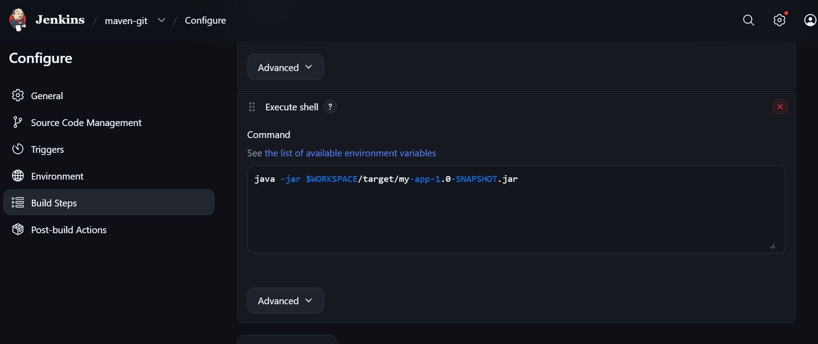

$workspace in the env-var where by deault the values is var/lib/Jenkins/workspace so instead of hardcode the path we can use it like this as best practice

CAN FOUND ENV_VAR IN THE FOLLOWING URL:
http://<ip of Jenkins controller>:8080/env-vars.html/

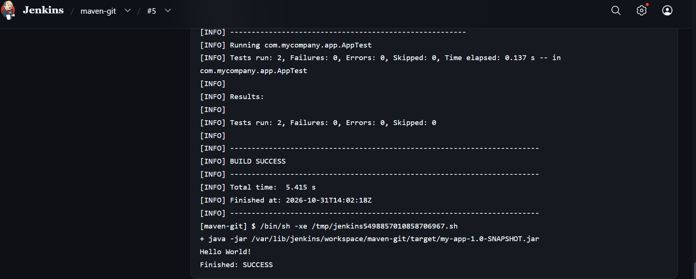

Now push the test reports(to visualize the build pass or not) by Post build action
Publish junit report ts
$ ls
TEST-com.mycompany.app.AppTest.xml com.mycompany.app.AppTest.txt
ubuntu@ip-10-0-0-174:/var/lib/jenkins/workspace/maven-git/target/surefire-reports$

this .xml is the test report

once it is add in post build acotion

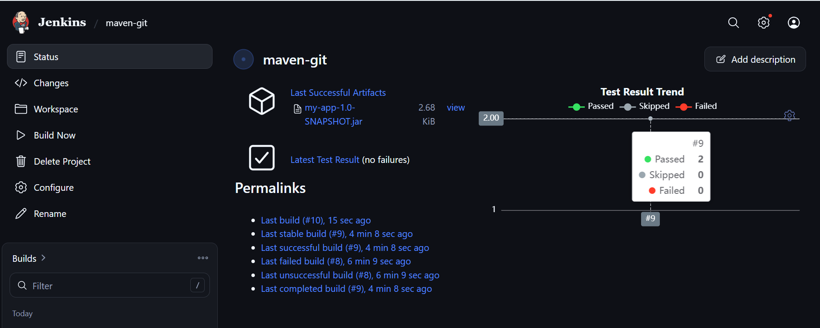
Also in post build we can store the artifacte for other users to see the successfully executed code or test file

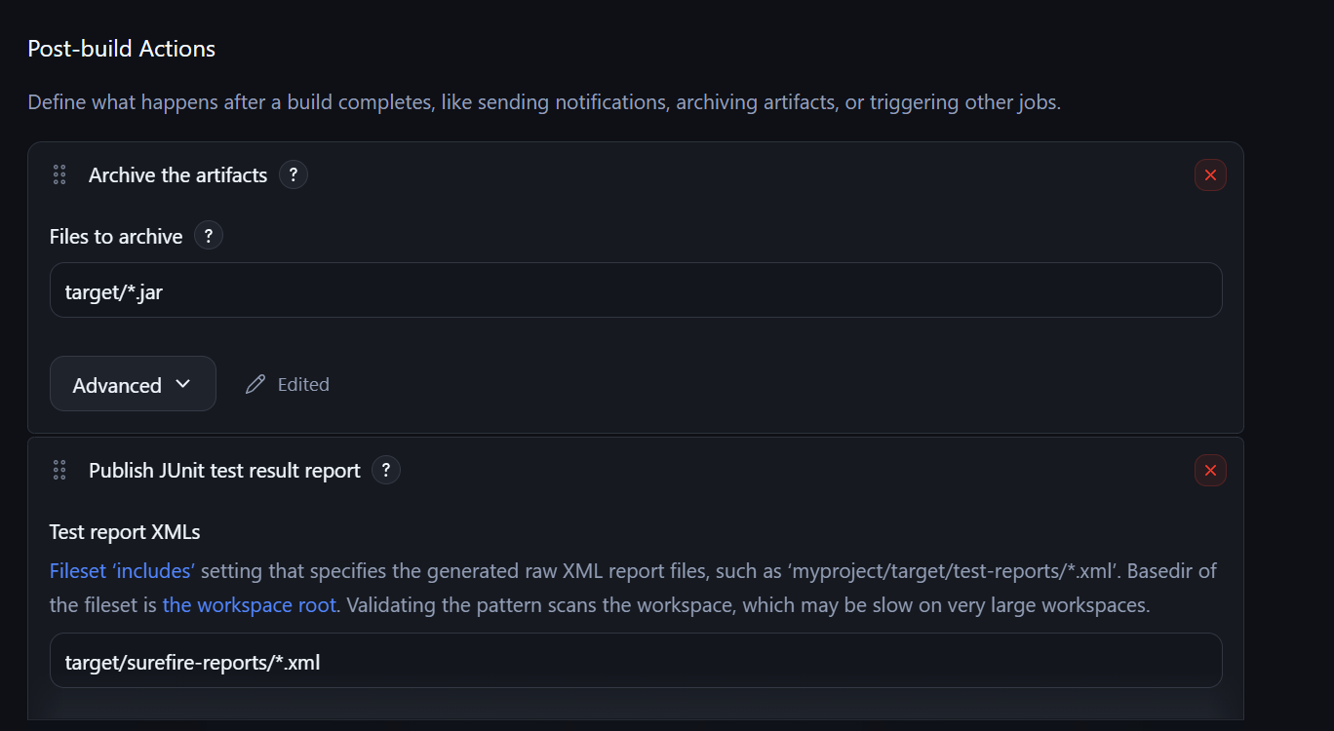

GIT HUB AUTH WITH JENKINS
For private repo:
Create a ssh-key-gen and add the public key to git hub
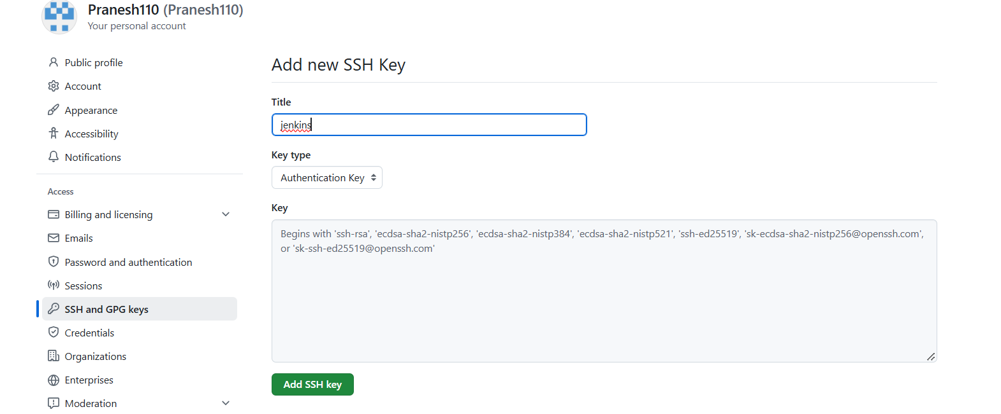

And in jenkis setting credential add a new system global credential and select ssh-and-username

And give the private key

In build add the ssh of the private repo and in credential use the created one
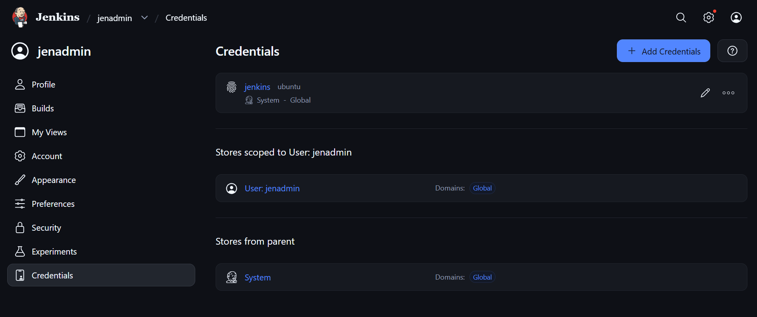

Build trigger:
Build periodically: can set a time as cron syntax to run the build

Github webhook trigger:
Whenever a user pushes a code to git repo or pull request delete merge what ever action we can select
Jenkins have a push event from git hub when something done and Jenkins done a scm pooling event that is it will check for any change of that repo
Go to github:
Setting--> webhook add the webbook like
Jenkinsurl/github-webhook/
http://13.233.146.223:8080//github-webhook/
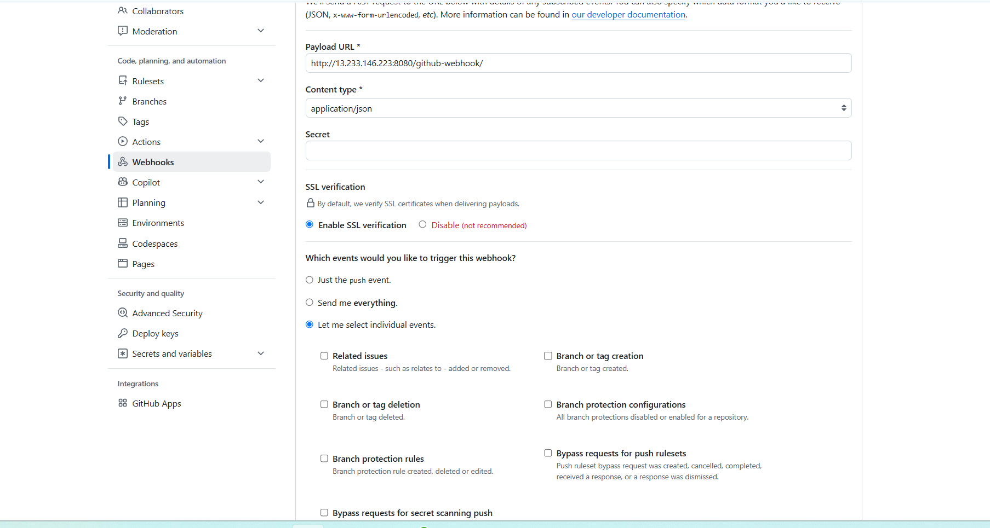
Select the event if that happen it will send the event push to Jenkins to trigger the build
Add build trigger as github scm pooling
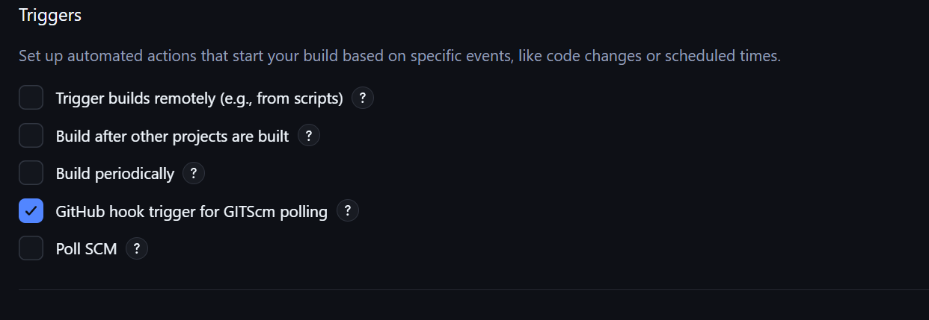

If any push happen this build will trggier

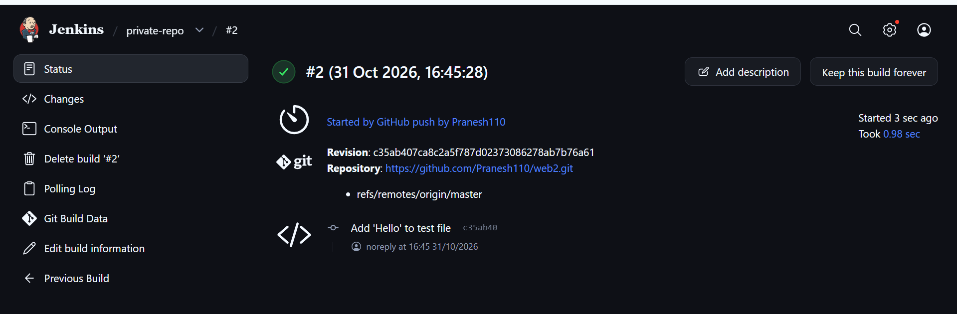

Pool scm;
Same like build periodically but it will check for Github hook wether any changes hppend and according to cron it will trigger

Jenkins master and slave:
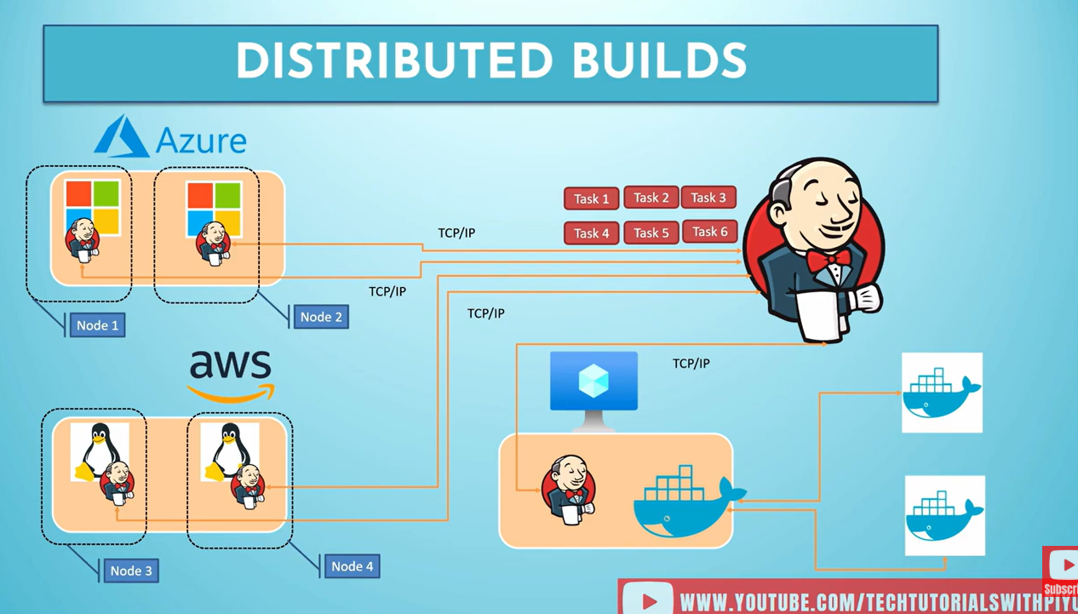

Instead of running the jobs by the Jenkins master itself it distribute the task over the connected nodes of another VMS
Or we can configure it with docker containers as a container wil spin up and do the task and got removed when the process is done.

By using dedicated VM as slave it will can incur addional task and it will remain ideal when there no task to run.
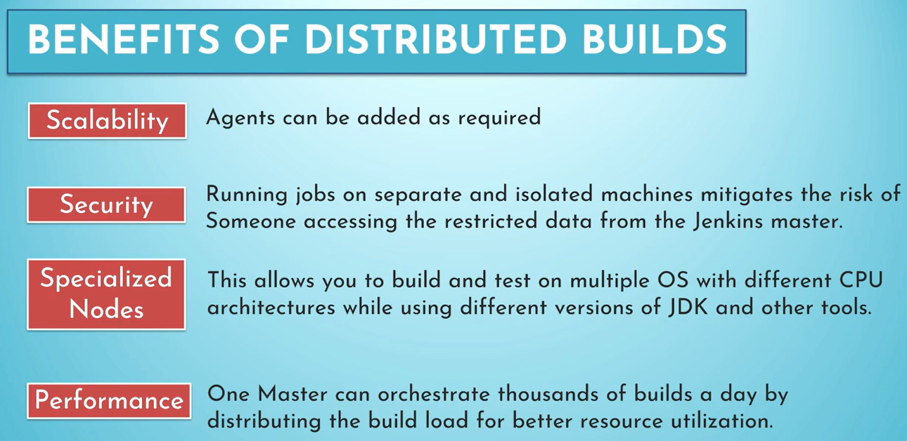

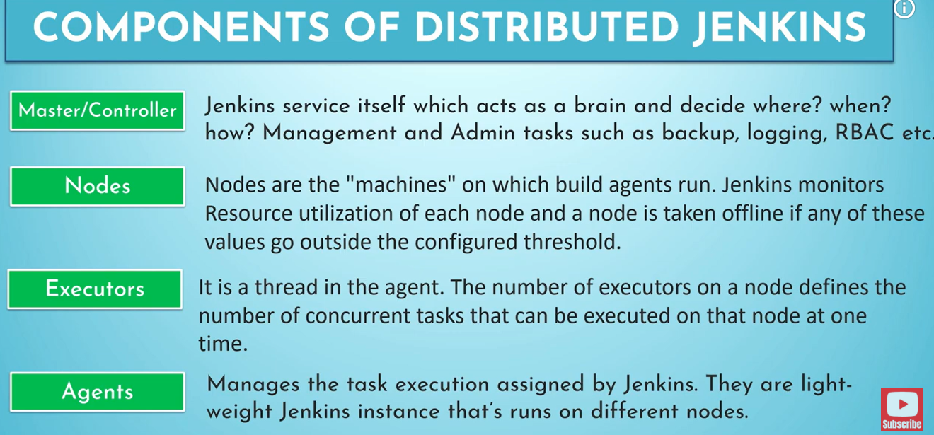

Precheck need to done for master and slave concept:
Configure Agent port on global confi and all that port on both slave and master

Number of executors need to be equal to number CPU core of a machine

To create a node:
Manage Jenkins new node

Give a name
And add label
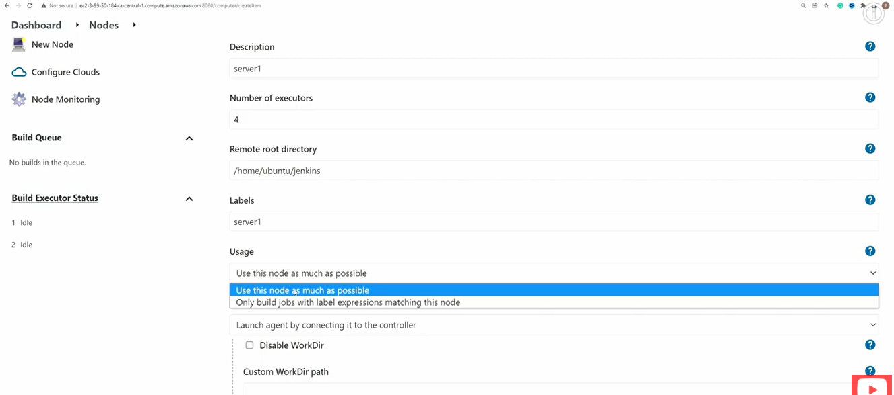

Usage
First one will be like any free node will be run for a build job
Second is like we neeed to specify the lable name in the build so that pipeline will be only run on this node.

Oncre created
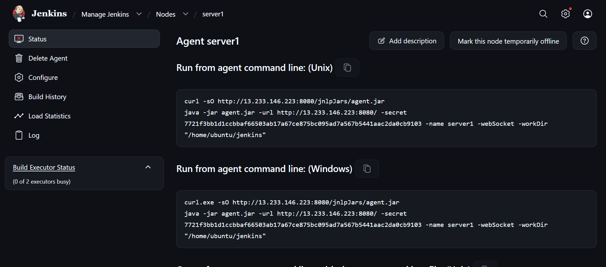

Run this command on slave server

Agent.jar need to download and be there in slave machine

Once done to explicitly run a build on specify node

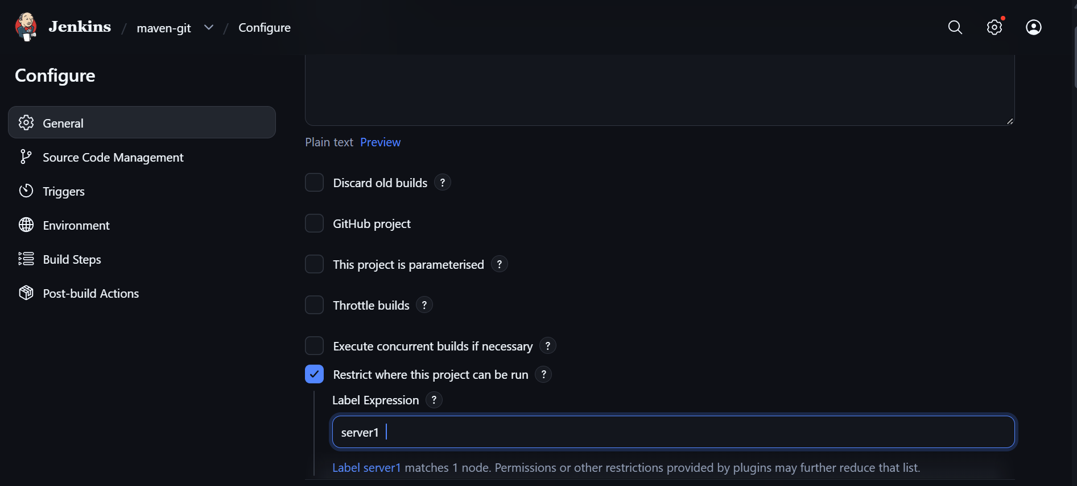

Give the label name of the node

Jenkins pipeline :
CICD flow as a code:

Declarative and syntax expression:
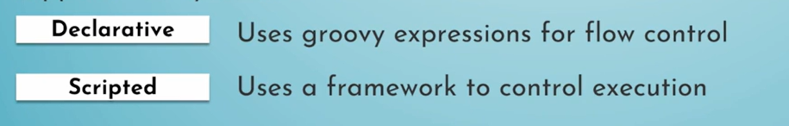

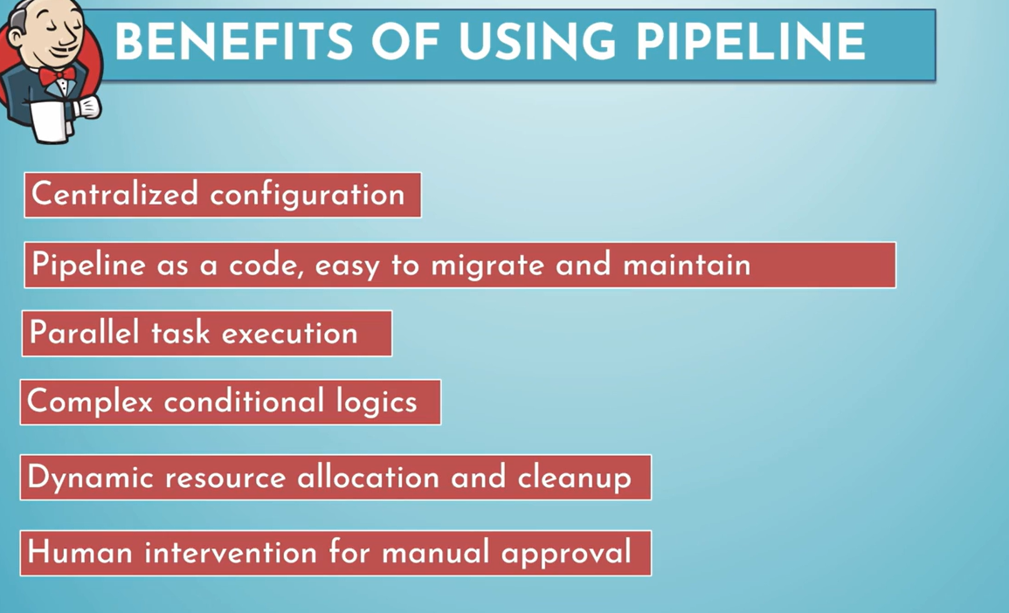

- Feature | - Declarative | - Scripted
- Syntax | - Structured and predefined | - Groovy-based and flexible
- Learning curve | - Easier for beginners | - More programming knowledge needed
- Structure | - Must follow pipeline {} syntax | - Uses node {} and Groovy logic
- Flexibility | - Structured, with supported extensions | - Greater flexibility
- Error handling | - Often simpler with post and options | - Can use Groovy try/catch/finally
- Best for | - Standard CI/CD pipelines | - Complex or dynamic workflows

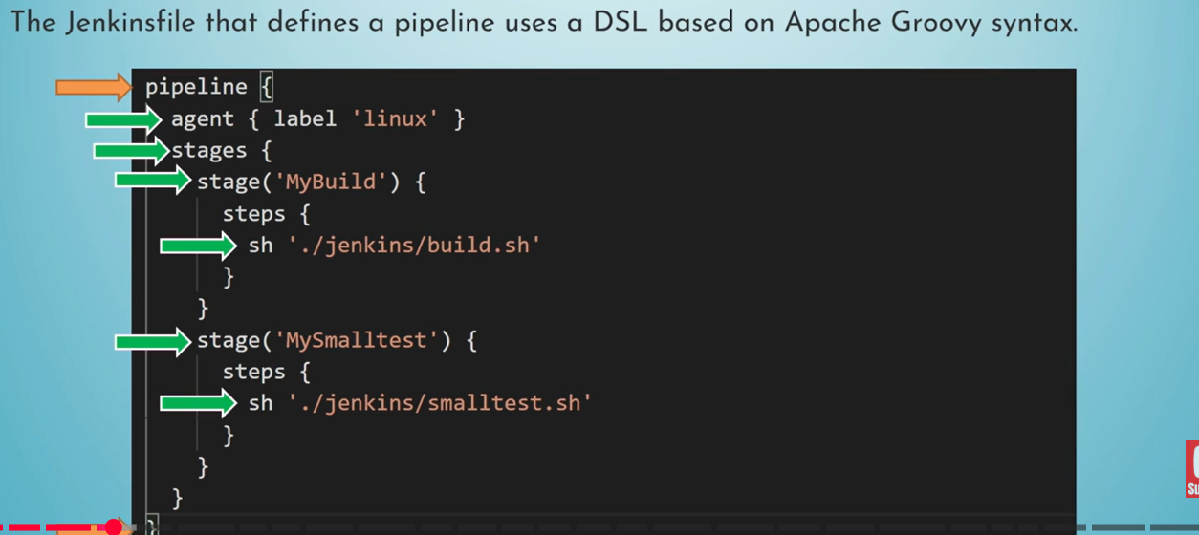

Declarative syntax:

All should put under pipeline {

}

Inside pipepline there could be multiple stages
Agent can be null any or specifiy by labels

Inside the stages there will stage a stage b
Inside stage a we have steps{
Sh ‘ inside sh we run the bash shell python commands to run on that machien‘
}

- Jenkinsfile syntax | - Where commands execute
- agent any | - Any available eligible Jenkins agent
- agent { label 'srv1' } | - Directly on the srv1 agent
- agent { docker { image '...' } } | - Inside a Docker container on an eligible agent
- agent { docker { image '...'; label 'srv1' } } | - Inside a Docker container launched on srv1
- agent none | - No global agent; stages define their own agents

First pipeline script:

pipeline {
agent any

stages {
stage('Build') {
steps {
echo "This is build stage"
}
}

stage('Test') {
steps {
echo "This is test stage"
}
}

stage('Deploy') {
steps {
echo "Deploy stage"
}
}
}
}

We can configure triggers as like in free style

Can get the Jenkins file from SCM also instead of hardcode it in Jenkins itself
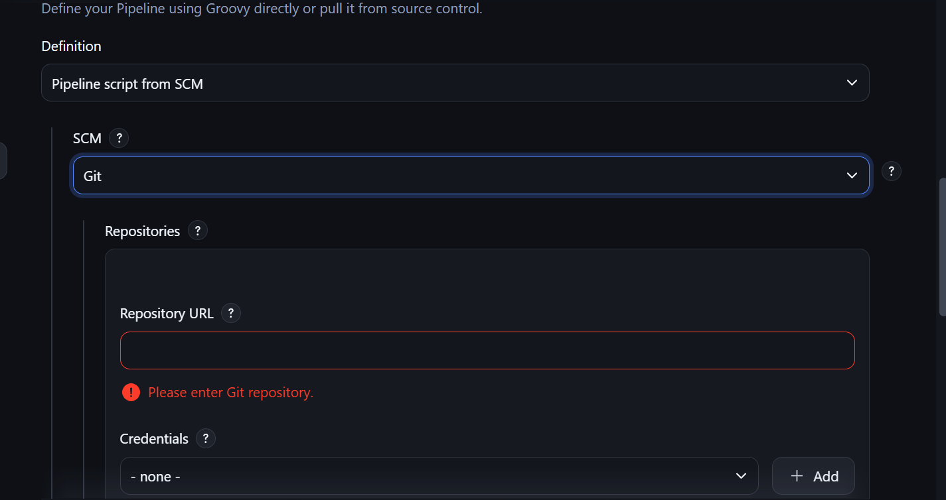

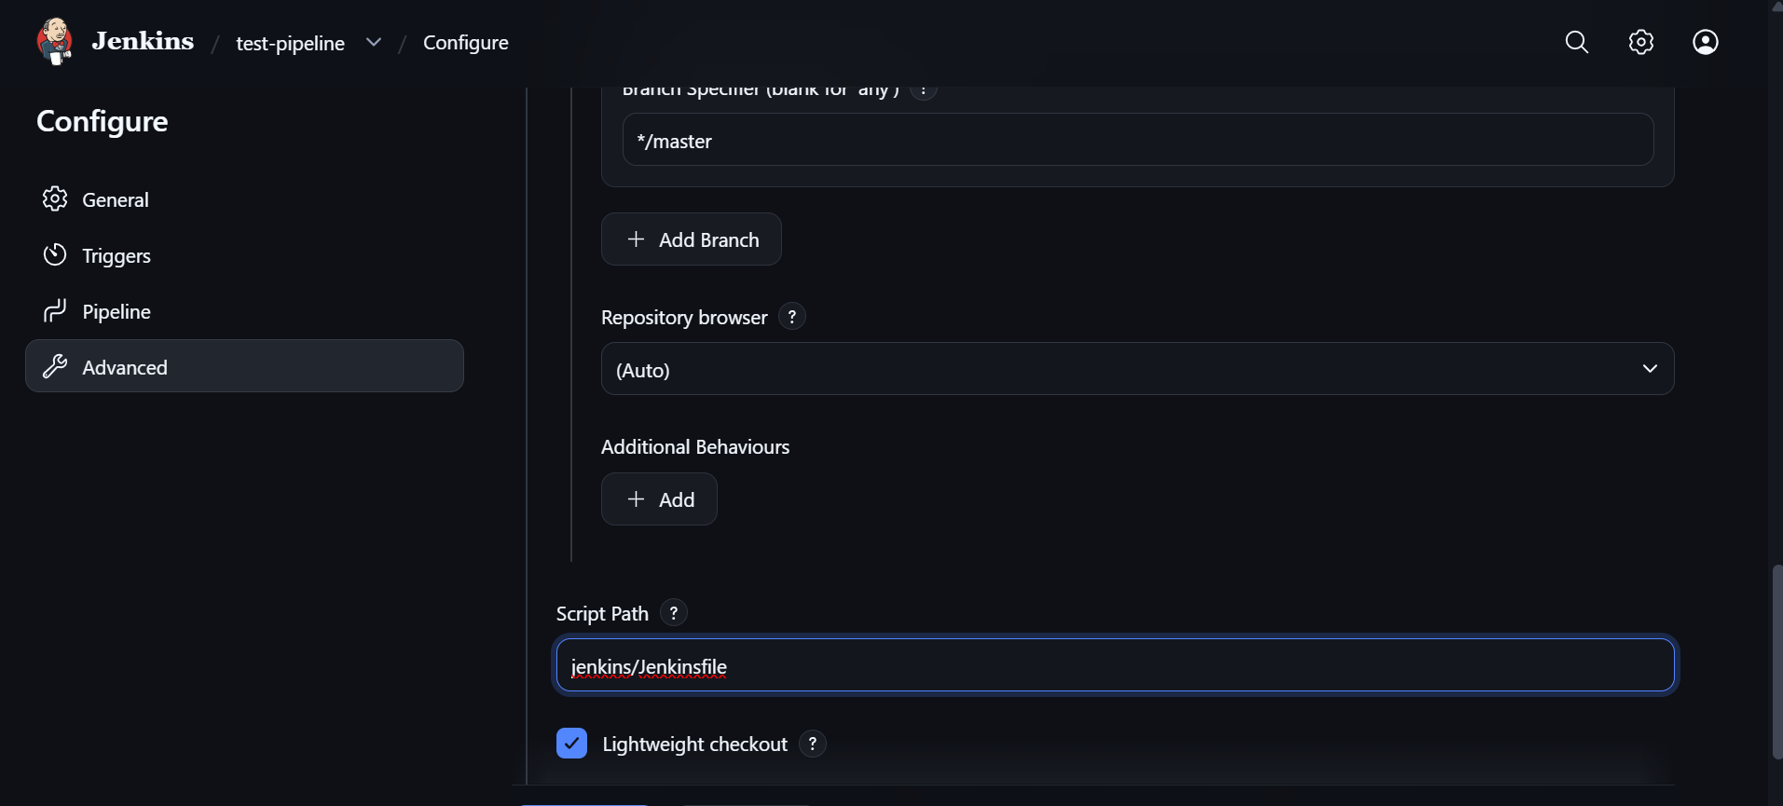

This will get the Jenkins file groovy script run has pipeline
Can check pipeline overview
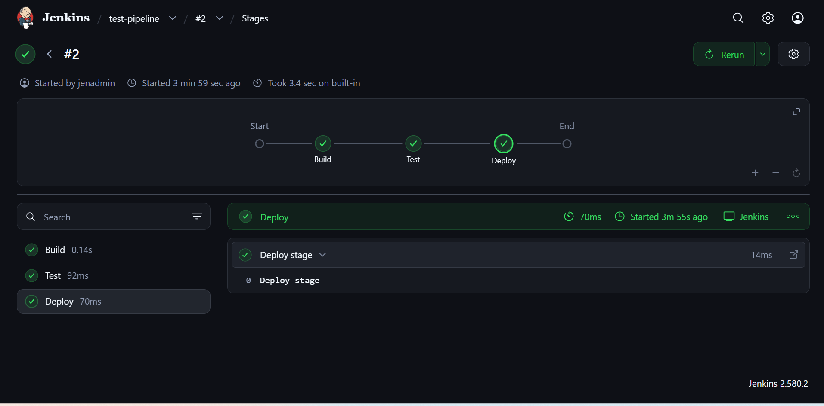

Now build a maven build and .jar:

pipeline {
agent any

tools {
maven 'mymaven'
}

stages {
stage('Build') {
steps {
sh 'mvn clean package'
}

post {
success {
archiveArtifacts artifacts: 'target/*.jar'
}
}
}

stage('Test') {
steps {
sh 'mvn test'
}
post {
always {
junit 'target/surefire-reports/*.xml'
}
}
}

}
}

Post—it do post build action
We used archieveArtifacte articats: path

TO have a junit report as we do in frees tyle we use
Post
Always{
Junit ‘path.xml’
}

To integrate maven pluging use
Tool syntax and add maven name

ENV Variables and parameter

Just like we have var and storing value and reuse it in code

environment{
name = “Pranesh”
}

Stages{
Stage(‘build’)
{

Step{
Mvn clean package
echo “$name”
}
}
}

- • Parameters: Values supplied by the user when starting a pipeline.
- • Environment variables: Values available to the pipeline during execution.

- Choice Parameters allow you to customize a pipeline when triggering it.
- For example, suppose you
- want to deploy your application to either Dev, Staging, or Production.
- pipeline {
- agent any

- parameters {
- choice(
- name: 'ENVIRONMENT',
- choices: ['dev', 'staging', 'prod'],
- description: 'Select deployment environment'
- )
- }

- stages {
- stage('Deploy') {
- steps {
- echo "Deploying to ${params.ENVIRONMENT}"
- }
- }
- }
- }
- When you click Build with Parameters in Jenkins, you will get a dropdown:
- ENVIRONMENT:
- dev
- staging
- prod
- If you select staging, Jenkins prints:
- Deploying to staging
- You access the parameter using:
- params.ENVIRONMENT
- Other parameter types include:
- string
- booleanParam
- choice
- password
- text
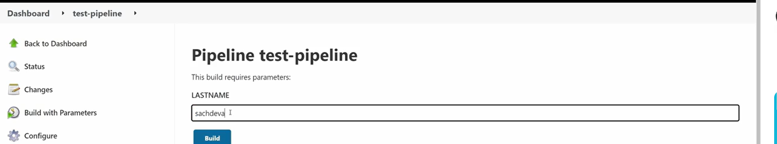
When we run it will ask to put value for the parameters

- 2. Jenkins Environment Variables
- Environment variables define values that the pipeline can use during execution.
- Example:
- pipeline {
- agent any

- environment {
- APP_NAME = 'flask-app'
- VERSION = '1.0.0'
- DOCKER_IMAGE = 'flask-app:1.0.0'
- }

- stages {
- stage('Build') {
- steps {
- echo "Building ${APP_NAME}"
- echo "Version: ${VERSION}"
- sh 'docker build -t $DOCKER_IMAGE .'
- }
- }
- }
- }
- Here:
- environment {
- APP_NAME = 'flask-app'
- }
- defines a variable that is available throughout the pipeline.
- You can access it in Groovy:

Parallel :

Say in stages under many stage will be there each run independently once above stage is finished.

To avoid and to make many stage run parallelly

Use stage(){
Parallel{
Stage{}
Stage{}
Stage{} this stage will run parallely don’t wait for any stage above
}
}
pipeline {
agent any

stages {
stage('Build') {
steps {
echo 'Building application...'
sh 'mvn clean package'
}
}

stage('Parallel Testing') {
parallel {
stage('Unit Tests') {
steps {
echo 'Running unit tests...'
sh 'mvn test'
}
}

stage('Code Scan') {
steps {
echo 'Running code quality scan...'
sh 'sonar-scanner'
}
}

stage('Security Scan') {
steps {
echo 'Running security scan...'
sh 'trivy fs .'
}
}
}
}

stage('Deploy') {
steps {
echo 'Deploying application...'
}
}
}
}

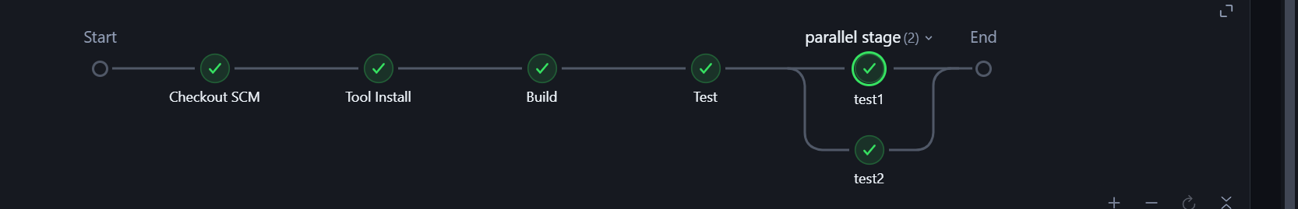

STASH AND UNSTASH:

In Jenkins, stash and unstash are used to transfer files between stages of a pipeline, especially when those stages run on different agents or in different workspaces.
- Think of it like this:
- stash → Save selected files temporarily.
- unstash → Retrieve those files in another stage.
- Imagine your pipeline has two stages:
- Build runs on Jenkins agent srv1.
- Deploy runs on Jenkins agent srv2.
- The Maven build generates a JAR file:
- srv1 workspace/
- └── my-java-app/
- └── target/
- └── my-app.jar
- But srv2 has a different workspace. The JAR file created on srv1 won't automatically appear on srv2.
- This is where stash and unstash help.

pipeline {
agent none

stages {
stage('Build') {
agent {
label 'srv1'
}

steps {
git 'https://github.com/example/my-java-app.git'

sh 'mvn clean package'

stash name: 'app-jar',
includes: 'target/*.jar'
}
}

stage('Deploy') {
agent {
label 'srv2'
}

steps {
unstash 'app-jar'

sh 'ls -l target/'
echo 'Deploying application...'
}
}
}
}

- stash name: 'app-jar',
- includes: 'target/*.jar'
- Jenkins collects the JAR files matching target/*.jar from the current workspace and stores them as a stash named app-jar.
- Deploy stage on srv2:
- unstash 'app-jar'
- Jenkins restores the stashed files into the current workspace.
- After unstash, the workspace on srv2 contains:
- workspace/
- └── target/
- └── my-app.jar
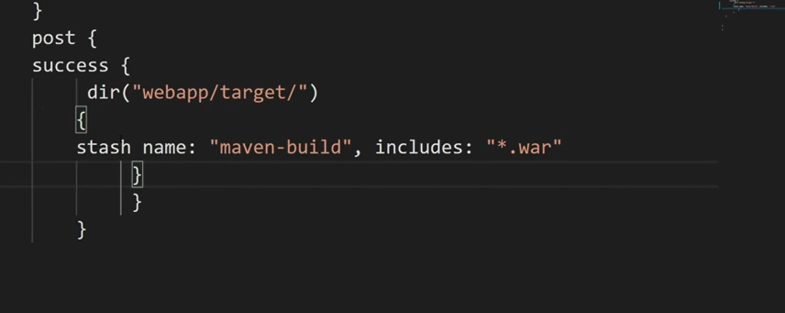

When expression is like making a condition to evaluate before run

beforeAgent true is to check the when condition first then look for the agent and unstash

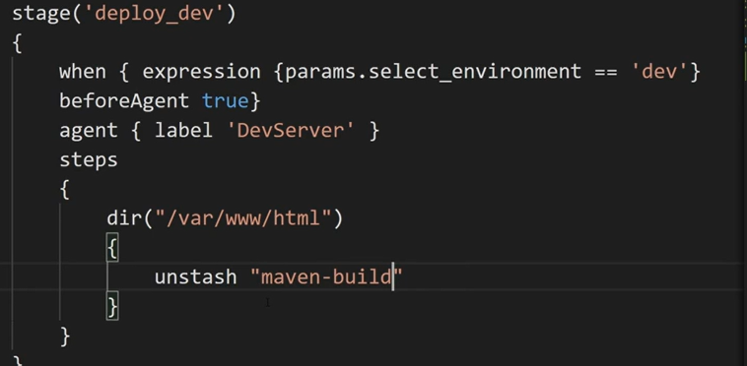

APPROVAL STAGE:
Like need manual approval to deploy it on prod
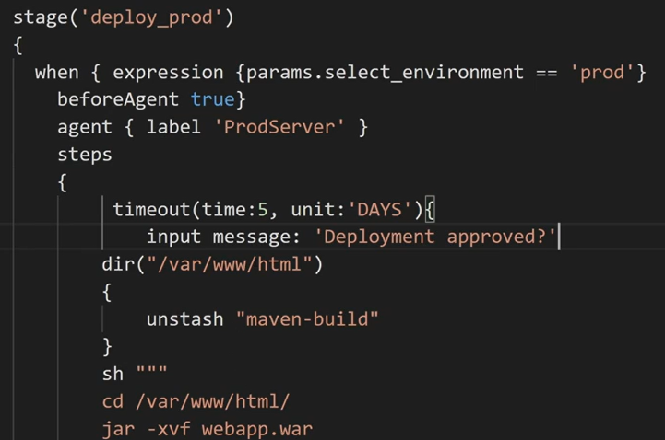

GIT SCM in script:

checkout([
$class: 'GitSCM',
branches: [[name: 'origin/main']],
doGenerateSubmoduleConfigurations: false,
extensions: [
[$class: 'CleanBeforeCheckout'], // Cleans workspace before cloning
[$class: 'CloneOption', depth: 1, shallow: true] // Shallow clone for speed
],
userRemoteConfigs: [[
url: 'https://github.com',
credentialsId: 'my-git-credentials-id'
]]
])

MULTI BRANCH pipeline:
Install the multibranch plugin

And add the repo which has multi branch

Now in Jenkins we can see the branches of the repo

In deploy stage have a condition to say when to deploy
When {branch ‘dev’}
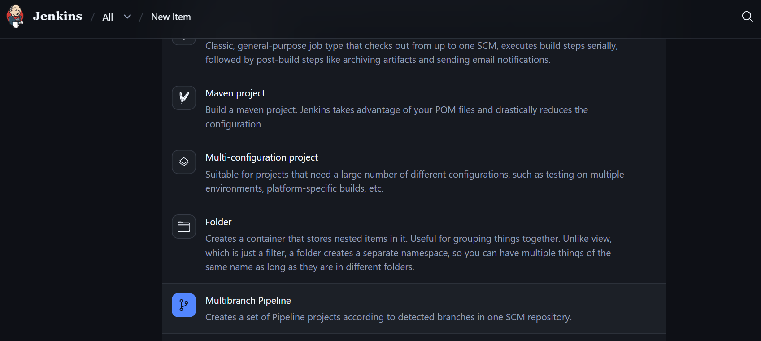

CONTINOUS DEPLOYMENT :

WAYS TO DEPLOY THE IMAGE OR FILE IN THE PROD OR DEV SERVERS

  - Using the ansible vm as agent with Jenkins and run the playbook to deploy the code or image to the servers
  - Can use the prod or dev server directly as agent with Jenkins and do stash unstash
  - Can use SSH agent plugin and give script to connect the VM and do SCP fro agent to server .

SSH
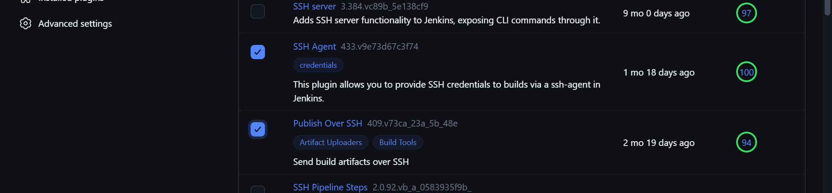
- I think you mean the Jenkins SSH Agent plugin and Publish Over SSH plugin. I'll show you how to install both, configure SSH access to your Dev/Prod server, and write the Jenkinsfile for deployment.
- There are two different plugins here:
- SSH Agent: Lets your Jenkins pipeline use an SSH private key with normal ssh and scp commands.
- Publish Over SSH: Lets Jenkins transfer files and execute remote commands through its own configured SSH server settings.
- They can both perform deployments, but their pipeline syntax is different.
Jenkins plugin+1
- 1. Install the plugins
- In Jenkins:
- Go to Manage Jenkins → Plugins.
- Open the Available plugins tab.
- Search for:
  - SSH Agent
  - Publish Over SSH
- Select both and click Install.
- Restart Jenkins if required.
- You can also use Manage Jenkins → Plugins → Installed plugins to verify that they are installed.
- Official plugin documentation:
- SSH Agent plugin
- Publish Over SSH plugin
- 2. Configure SSH access from Jenkins to the Dev/Prod server
- For example, assume:
- Component | - Value
- Jenkins build agent | - 10.0.1.10
- Dev server | - 10.0.2.20
- SSH user on Dev | - deployuser
- Application directory | - /opt/myapp
- SSH port | - 22
- Step A: Generate an SSH key
- On the Jenkins build agent:
ssh-keygen -t ed25519 -C "jenkins-deploy"
- This generates:
~/.ssh/id_ed25519
~/.ssh/id_ed25519.pub
- The private key is id_ed25519. The public key is id_ed25519.pub.
- Step B: Add the public key to the Dev server
- Copy the public key to the Dev server's authorized_keys:
ssh-copy-id deployuser@10.0.2.20
- Or manually append the contents of id_ed25519.pub to:
/home/deployuser/.ssh/authorized_keys
- Ensure that the permissions are correct:
chmod 700 ~/.ssh
chmod 600 ~/.ssh/authorized_keys
- Now test the connection from the Jenkins agent:
ssh deployuser@10.0.2.20
- The Jenkins agent must have network connectivity to the Dev server on TCP port 22.
- Step C: Add the private key to Jenkins Credentials
- In Jenkins:
- Go to Manage Jenkins → Credentials.
- Select the appropriate domain, usually Global.
- Click Add Credentials.
- Configure:
- Field | - Value
- Kind | - SSH Username with private key
- Username | - deployuser
- Private Key | - Enter directly
- ID | - dev-ssh-key
- Paste the private key contents into the private key field.
- Do not put the private key in the Jenkinsfile or Git repository.
- Option 1: SSH Agent plugin — Jenkinsfile using SSH and SCP
- This is the approach I recommend learning first because it uses normal Linux SSH/SCP commands.
- Example Jenkinsfile
- Suppose your Maven build generates:
target/myapp.jar
- The Jenkins pipeline:
- Builds the JAR.
- Uses the SSH Agent plugin to load the SSH key.
- Copies the JAR to the Dev server.
- Executes a remote command to restart the application.

pipeline {
agent { label 'build-agent' }

stages {
stage('Build') {
steps {
sh 'mvn clean package'
}
}

stage('Deploy to Dev') {
steps {
sshagent(credentials: ['dev-ssh-key']) {
sh '''
scp target/myapp.jar \
deployuser@10.0.2.20:/opt/myapp/app.jar

ssh deployuser@10.0.2.20 \
'sudo systemctl restart myapp'
'''
}
}
}
}
}
- What happens here?
sshagent(credentials: ['dev-ssh-key'])
- This loads the SSH private key from Jenkins Credentials into an SSH agent for the duration of the block.
- Then:
scp target/myapp.jar deployuser@10.0.2.20:/opt/myapp/app.jar
- Transfers the JAR file.
- And:
ssh deployuser@10.0.2.20 'sudo systemctl restart myapp'
- Connects to the Dev server and restarts the Java application.
- The SSH Agent plugin requires the ssh-agent executable to be available on the Jenkins agent.
Jenkins plugin+1
- Important: The target server must have Java installed, the myapp systemd service configured, and the deployment user must have permission to restart that service.
- Also, for production, configure SSH host-key verification instead of blindly trusting a host. The example above assumes the server's SSH host key is already trusted by the Jenkins agent.
- Option 2: Publish Over SSH plugin — Jenkinsfile
- This plugin works differently.
- Instead of writing separate scp and ssh commands, you configure the SSH server in Jenkins and then use the sshPublisher pipeline step.
- Step A: Configure the SSH server
- Go to:
- Manage Jenkins → System → Publish over SSH
- Add an SSH server:
- Field | - Example
- Name | - dev-server
- Hostname | - 10.0.2.20
- Username | - deployuser
- Remote Directory | - /opt/myapp
- Authentication | - SSH private key
- Configure the private key and test the connection.
- The server configuration defines the connection properties and base directory for the remote server.
Jenkins+1
- Step B: Jenkinsfile

pipeline {
agent { label 'build-agent' }

stages {
stage('Build') {
steps {
sh 'mvn clean package'
}
}

stage('Deploy to Dev') {
steps {
sshPublisher(
publishers: [
sshPublisherDesc(
configName: 'dev-server',
transfers: [
sshTransfer(
sourceFiles: 'target/myapp.jar',
removePrefix: 'target',
remoteDirectory: '',
execCommand: 'sudo systemctl restart myapp'
)
],
verbose: true
)
]
)
}
}
}
}
- How this works
configName: 'dev-server'
- Uses the SSH server configuration created in Jenkins.
sourceFiles: 'target/myapp.jar'
- Selects the JAR from the Jenkins workspace.
removePrefix: 'target'
- Removes the target/ part of the source path so that the file is transferred directly into the configured remote directory.
execCommand: 'sudo systemctl restart myapp'
- Executes the command on the remote server after the file transfer.
- Publish Over SSH supports transferring files and executing remote commands through the sshPublisher step.
Jenkins+1
- Which one should you use?
- Feature | - SSH Agent plugin | - Publish Over SSH plugin
- Transfer files | - scp command | - sshTransfer
- Execute remote commands | - ssh command | - execCommand
- SSH credentials | - Jenkins Credentials | - Jenkins SSH server configuration
- Pipeline flexibility | - Very flexible | - More plugin-specific
- Good for learning SSH | - Yes | - Useful to learn
- Recommended for your project | - Start here | - Learn afterward
- For your Jenkins learning project, I would first implement:
GitHub
↓
Jenkins Build Agent
↓
Maven Build
↓
myapp.jar
↓
SSH Agent plugin
↓
SCP to Dev Server
↓
SSH command: systemctl restart myapp
- Once this works, implement the same pipeline using Publish Over SSH. That will help you understand both the native SSH/SCP deployment method and Jenkins plugin-based deployment.

TO MAKE CHECKOUT OF PRIVATE REPO IN JENKINS(PAT)

USE HTTPS URL AND GET PAT (TOKEN) FORM git hub (developer setting)
and
IN JENKINS ADD CREDENTIAL USERNAME AND PASSWORD
Username: git account user name
Password: token

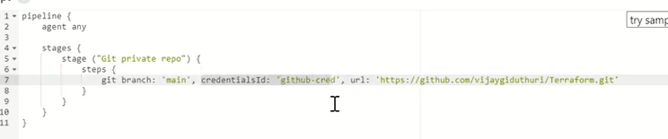

TO MAKE CHECKOUT OF PRIVATE REPO IN JENKINS(SSH)
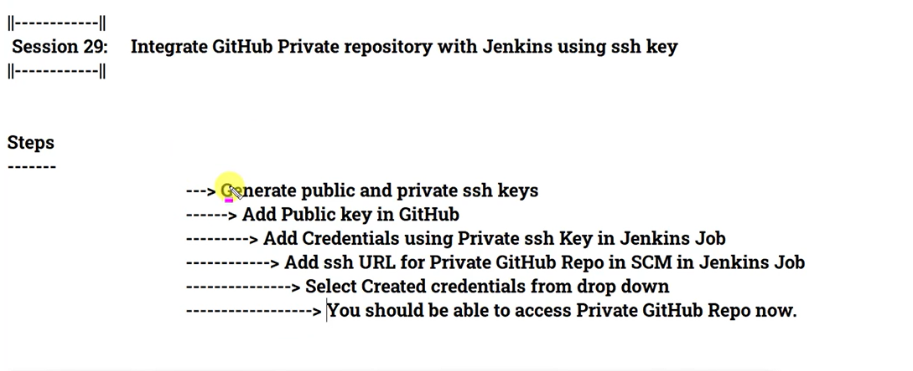

PIPELINE TOOLS AND PLUGINS:
Continous integration:
Build : MAVEN

Testing: unit testing(test file will be there in git)
Static coding testing( scanning for vulnerability by SONAR QUBE)
Notification: IF build failed notification can be triigred
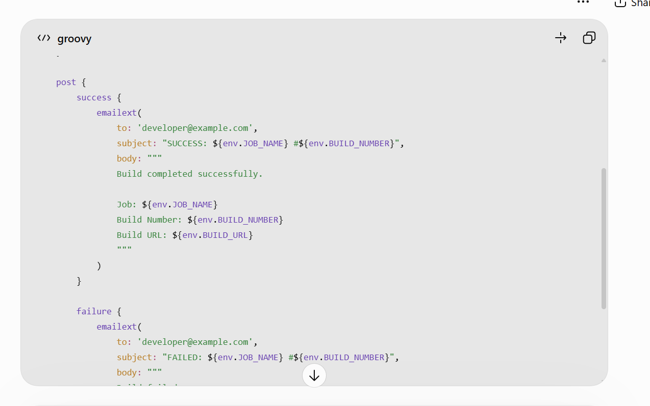

DOCKER AGENT:
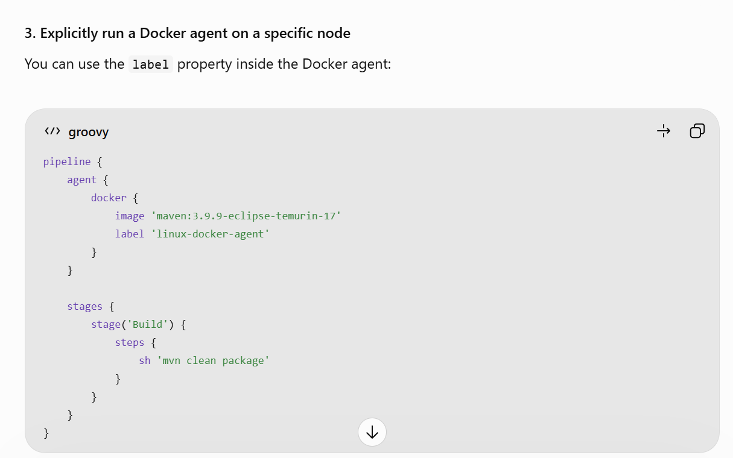

Push the image to REPO: docker hub or ecr
- Recommended tools for your project
Testing category | Tool
Unit testing | JUnit
SAST | SonarQube Community Build
DAST | OWASP ZAP
Dependency vulnerability scanning (SCA) | OWASP Dependency-Check
Container image scanning | Trivy

- • SAST (Static Application Security Testing): Scans application source code without running the application.
- • DAST (Dynamic Application Security Testing): Tests a running application by sending requests and analyzing its responses.
- SAST — Static Application Security Testing
SAST analyzes your source code to identify security vulnerabilities.
- SAST tools
- SAST scans source code, configuration, and sometimes compiled code to detect insecure coding patterns.
- For example, it can identify:
- SQL injection risks
- Hardcoded passwords or API keys
- Insecure cryptographic functions
- Unsafe input handling
- Potential command injection
- A DAST scanner sends HTTP requests to the application and analyzes the responses.
- It can test for:
- Cross-Site Scripting (XSS)
- SQL injection
- Insecure HTTP headers
- Authentication and session weaknesses
- Exposed application endpoints

Now continuous deployment:

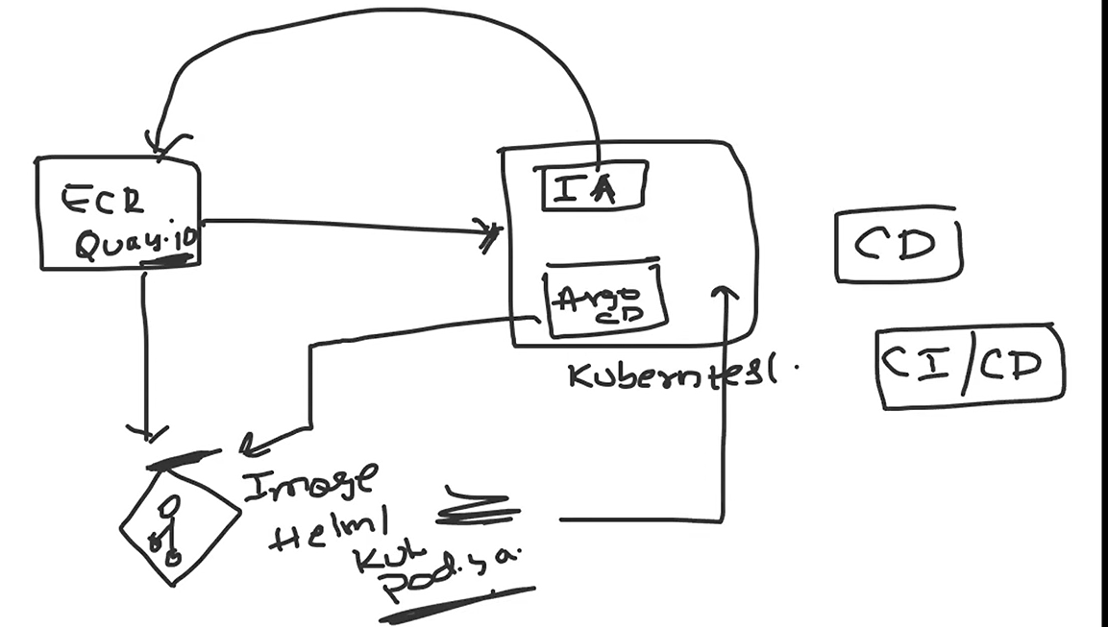
In kube we deploy Image updater and arco cd

The image updater will continuously see the ecr wheather any image is updated
Once it see a image is updated it wil fetch that and put it in another git
repo that contains the helm chart manifest file pod.yaml file

Now argo cd sees the changes and make the changes of Kube pod with updated image or changes.

