Kubernetes

Kube is an orchestrator of containers

Why we need kube to manage containers?

Containers are ephemeral in nature: the conatiner or short life(die and revive anytime)

Problem1:(single host problem)

Let say one host machine launching 50 conatiner and say one of the conatiner consumes lot of host resources

other one of the container is will not get enough resource becoz of that or down.
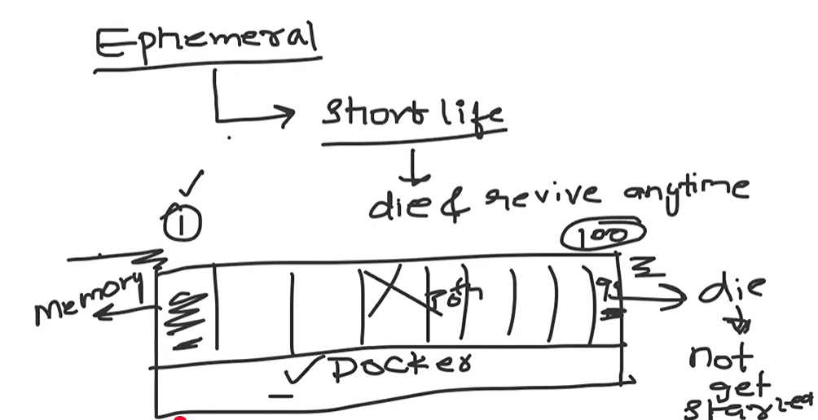

Problem2:(auto healing)
Say if anyone killed the container app wont be accessible

so some need to up the container.

AUTO HEALING: with out manual work it should come up
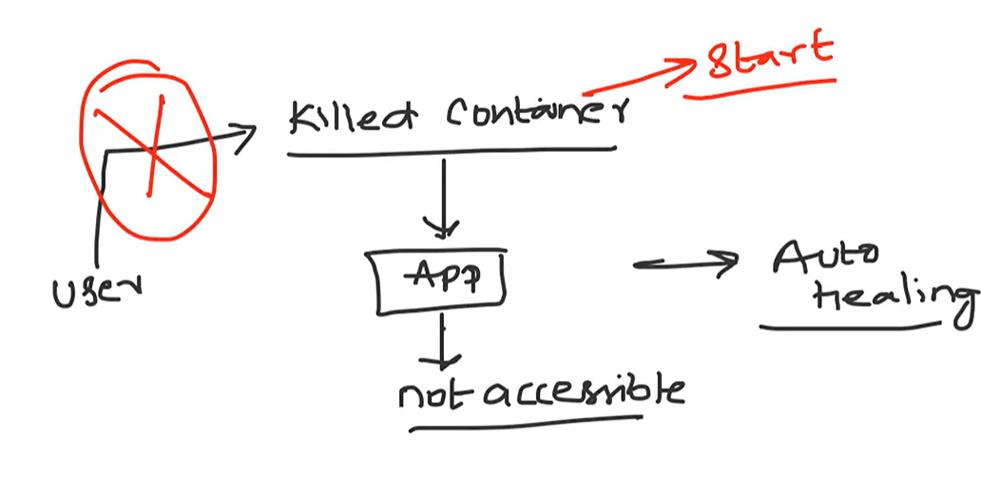

Problem 3(Auto scaling):
During high loads of traffic to act upon the load it should auto scale
Let say we have one container only one cannot afford more load so manually we will create a another container as same as first container. With docker it doesn’t do auto scaling.
Also we have to the load balancing

Problem4:
Any enterprise level support:
Docker is very simple platform that doestnt support enterprsie level support
Say we have enterprise applications that need:
Load balancer, firewall, autoscaling, api gateway.

These problems are managed and solve by USING KUBERNETES

BY DEFAULT KUBE IS A CLUSTER(grp of nodes)

Master node(kubernetes)
|
Worker nodes
|
POD’S(containers) in each nodes

Kube will be installed in master node and other work as worker node (as like Jenkins)
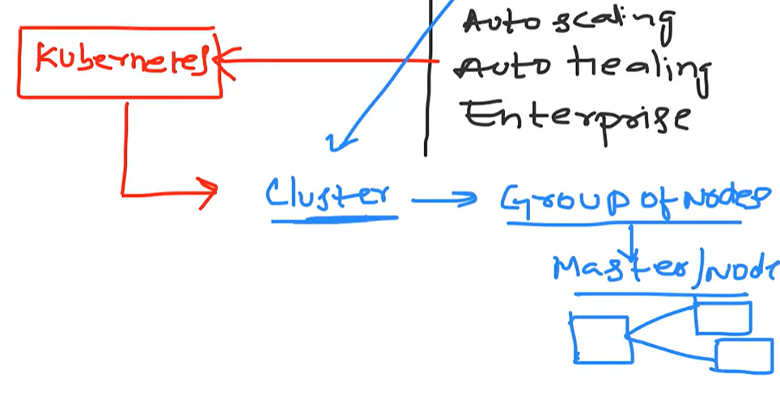

Single host problem:
We can use kube in only one node as master for dev environment

But production Kube will be in CLUSTER type

SAY we have a two node in one node 1-50 containers running if one node has resource limit reach and 50 th container goes down kube will move that container to second node.
This is cluster bheaviour.

Auto Scaling:
Kube will have replica set (replication controller)
Replica.yaml file where we define autoscale from one to 10 has load increase (which is manual way)
HPA:
Kube also support HPA(horizontal pod autoscale) which we will define whenever there is load(container reaching 80% threshold) keep increase.

AUTO HEALING:
When ever there is a damage kube will control the damage and fix it

Say a container is going down kube will start a new container.

How kube knows that by default kube will have a API server whenever the api server understand or receive a signal of any container(pods) going down it will create a new container even before the old one goes down.

Enterprise support capabilities:
Kubernets is propertery by google (where BORG part is kube) a open src orchestrator
So using kube we can set up an enterprise level needed arch like load balancing security and autoscaling.

But as 100% kube wont solve it
Integrating firewall load balancing and security is far easy on VM

Say Kube cannot do Advance level Lb(it use round robin)

For this we can have solution:
Ingress Controller: where we deploy F5 lb in Kubernetes and to advance lb to pods
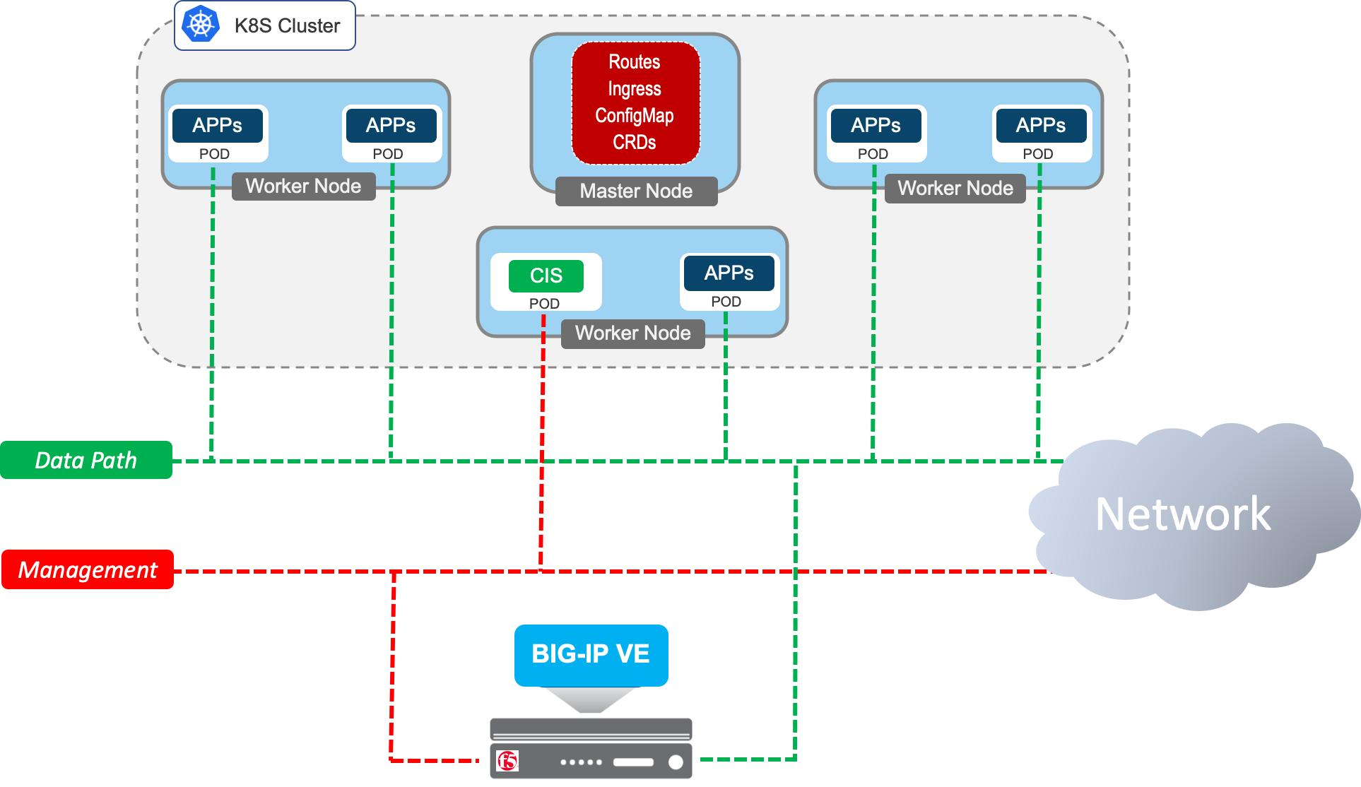

KUBERNETES ARCHITECTURE:
K8s has control plane and data plane
Each has many components

Lets compare kube and docker to understand:

To run docker containers, we will need docker engine so inside container to run app it needs container runtime

Same like in Kubernetes Control plane where user do POD (container) creation will come as request
And POD will be created on Worker nodes
DATA PLANE COMPONENTS:
Docker runtime:
Now this POD will be deployed and has runtime of docker shim(deprecated), containerd. Or CRI-O

These are the Docker runtime which will help to run container

KUBELET:
Kubelet is the one which will look after these POD’s which will ensure this pod is always running so that Auto healing will happen when POD is down.

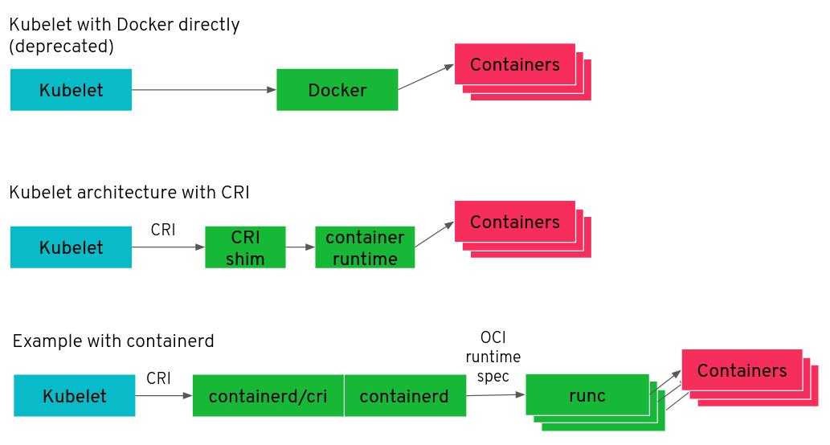

KUBE-PROXY:

As like Docker0(bridge network in docker) which is bridge and default network between host and docker

Here in k8’s Every POD creating it has to be allocated with IP address or LB capability
So kube proxy manage the networking and ip address and default lb capabilities

Control plane:

ETCD:
It will have the all Kubernetes information.
Backing up this is important
Api server:
This is component which will expose the Kubernetes to external world which is also decide to which node the task should be created and task request from external will be handled by api -server

Schedular:
It will schedule the task which comes from the api server, like say a pod need to create req from external comes to API -server which will decide which node to deploy the will schedule by the schedular

Controller manager:
- Controller is a component that continuously monitors the cluster and ensures that the actual state matches the desired state.
- Think of a controller as an automatic administrator that continuously checks whether Kubernetes is running according to your requirements.
- Suppose you deploy your application with three replicas.
- Your desired state is:
- replicas: 3
- Initially, Kubernetes has three running Pods.
- But imagine one Pod crashes.
- Without a controller, Kubernetes wouldn't automatically maintain the three-replica requirement.
- The Deployment Controller, through its ReplicaSet, ensures that a replacement Pod is created.
- Kubernetes has a component called kube-controller-manager, which runs several built-in controllers.
- These generally run on the Control Plane node.
- Some important controllers are:
Controller | Responsibility
Deployment Controller | Manages Deployments and their desired state
ReplicaSet Controller | Maintains the required number of Pods
Node Controller | Monitors node health
Job Controller | Manages Jobs and ensures completion
EndpointSlice Controller | Maintains backend endpoint information for Services
Namespace Controller | Handles namespace lifecycle and cleanup

CCM Cloud controller manager:
- Kubernetes Control Plane component that integrates Kubernetes with the underlying cloud provider, such as AWS, Azure or Google Cloud.
- In simple terms:
- Kubernetes Controller Manager manages Kubernetes resources.
- Cloud Controller Manager manages the integration between Kubernetes and cloud infrastructure.
- Suppose you deploy Kubernetes on AWS EC2 instances.
- Kubernetes needs to interact with AWS infrastructure to perform operations such as:
- Identifying cloud instances and their properties.
- Managing cloud load balancers.
- Configuring routes in supported cloud networking setups.
- Checking cloud instance information.
- Component | - Main responsibility
- kube-controller-manager | - Maintains Kubernetes resource desired state
- Cloud Controller Manager | - Integrates Kubernetes with cloud infrastructure
- kube-scheduler | - Assigns Pods to worker nodes
- kubelet | - Manages Pods on worker nodes
- kube-proxy | - Implements Service networking, when used
- Kubernetes distributions are different packaged versions of Kubernetes provided by different vendors or communities.
- The core Kubernetes technology is the same, but distributions may differ in installation methods, management tools, security, networking, storage integration, monitoring and enterprise support.
- Think of it like Linux distributions: Ubuntu, Debian and Red Hat use the Linux kernel, but provide different tools and management experiences.
- 1. Why do we have Kubernetes distributions?
- Installing and maintaining Kubernetes manually involves several components:
- API Server
- Scheduler
- Controller Manager
- etcd
- Kubelet
- Container runtime
- CNI networking
- CSI storage
- Ingress and load balancing
- Organizations may not want to configure and maintain every component themselves.
- Kubernetes distributions package these components and often provide additional enterprise features.
- 2. Popular Kubernetes distributions
Download Kubernetes Icon Logo Vector Online | Logowik
- 1. Kubernetes (upstream)
- The original open-source Kubernetes project.
- Install using kubeadm.
- Maximum flexibility.
- You manage networking, storage and other integrations.
- Suitable for learning and custom cluster deployments.
Red Hat Openshift Logo PNG Vector (SVG) Free Download
- 2. Red Hat OpenShift
- Enterprise Kubernetes platform.
- Built around Kubernetes.
- Integrated developer platform.
- Strong security and policy controls.
- Integrated monitoring, networking and deployment tooling.
- Used in enterprise environments.
Training — Securelinx
- 3. Rancher Kubernetes
- Kubernetes cluster management platform.
- Manage multiple Kubernetes clusters.
- Centralized cluster administration.
- Supports different Kubernetes environments.
- Useful for multi-cluster management.
K3s Original Wordmark PNG Logo — Download Free Transparent Logo
- 4. K3s
- Lightweight Kubernetes distribution.
- Low resource requirements.
- Simplified installation.
- Suitable for edge computing, IoT and small clusters.
[Microk8s] 쿠버네티스 기본 실습
- 5. MicroK8s
- Kubernetes distribution from Canonical.
- Easy installation.
- Supports single-node and multi-node clusters.
- Useful for development and testing.
Solutions - VMware
- 6. VMware Tanzu
- Enterprise Kubernetes platform and portfolio.
- Enterprise application platform capabilities.
- Integration with VMware infrastructure.
- Cluster lifecycle and workload management.
- Managed Kubernetes services vs distributions
This is an important distinction.
Cloud providers offer managed Kubernetes services. You don't need to manage the entire control plane yourself.
Platform | Provider | What it provides
Amazon EKS | AWS | Managed Kubernetes control plane
Azure Kubernetes Service (AKS) | Microsoft Azure | Managed Kubernetes service
Google Kubernetes Engine (GKE) | Google Cloud | Managed Kubernetes service
OpenShift | Red Hat | Enterprise Kubernetes platform
RKE2 | SUSE | Enterprise-focused Kubernetes distribution

