JIRA DATA CENTER PLUGIN
Manual Setup Guide — Complete Edition

React UI Setup • File-by-File Explanation • Jira SDK Integration • atlassian-plugin.xml Wiring
Atlassian Design System | Compiled CSS-in-JS | Webpack 5 | React 18 | Maven + atlas-create-jira-plugin

Version 3.0 | March 2026

1. Overview
This guide walks you through manually creating a Jira Data Center plugin UI from scratch. It covers: setting up the React project, understanding what every configuration file does, building the Hello World plugin page, and wiring the React UI into a real Jira plugin created by atlas-create-jira-plugin.

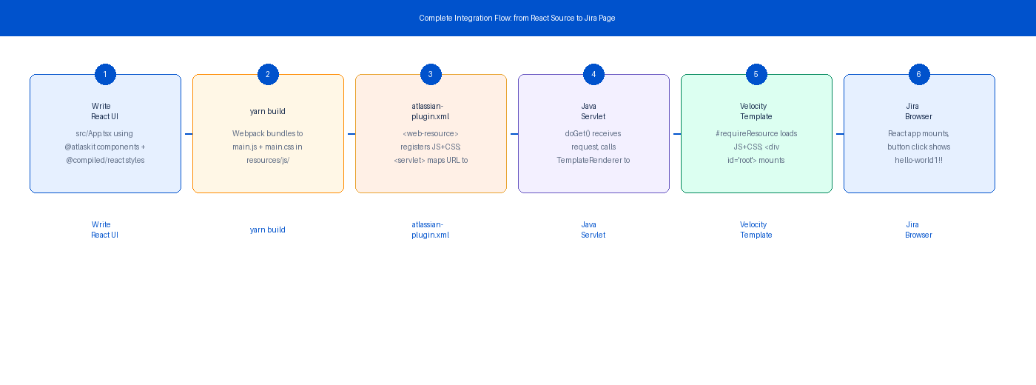
Figure 1 — Complete flow from writing React source to a working Jira plugin page

Technologies used in this guide:
- Atlassian Design System (ADS) — @atlaskit/* components and @atlaskit/tokens
- Compiled CSS-in-JS — @compiled/react for build-time style extraction
- Webpack 5 — bundler with @compiled/webpack-loader
- Babel 7 — transpiler with @compiled/babel-plugin
- React 18 + TypeScript 5
- Atlassian SDK (atlas-create-jira-plugin) — generates the Jira Data Center Maven plugin structure

Reference documents:
- https://atlassian.design/get-started/develop/atlassians — ADS developer setup guide
- https://compiledcssinjs.com/docs/installation#webpack — Compiled Webpack configuration
- https://atlassian.design/get-started/develop/composition — ADS composition patterns

2. Prerequisites
Install and verify the following tools before starting. The Atlassian SDK requires Java and Maven in addition to Node.

Tool | Minimum Version | How to verify | Required for
Node.js | 18 LTS+ | node –version | React build
npm / yarn | npm 9+ / yarn 1.22+ | npm –version | Package management
Atlassian SDK | 8.x+ | atlas-version | Jira plugin creation
Java JDK | 11+ | java -version | Atlassian SDK
Maven | 3.6+ | mvn –version | Atlassian SDK
Git | Any | git –version | Version control

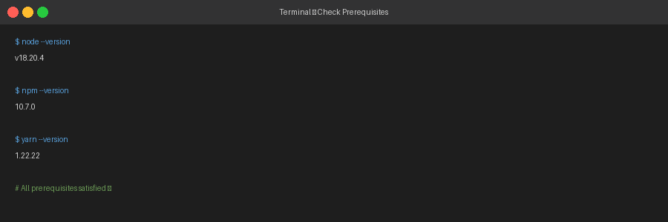
Figure 2 — Verify Node.js, npm, and yarn are installed and accessible

3. Step-by-Step Setup
This section walks through every step to build the plugin UI from scratch. Each step has a numbered badge, code to run, and an explanation of what the command does.

3.1 Create the Project Folder
1 | Create the project directory and initialise package.json

Open a terminal and run:

$ mkdir jira-dc-plugin-ui
$ cd jira-dc-plugin-ui
$ npm init -y

What each command does:
- mkdir jira-dc-plugin-ui — creates an empty folder for the project
- cd jira-dc-plugin-ui — moves your terminal into that folder
- npm init -y — generates a default package.json answering all prompts with 'yes'

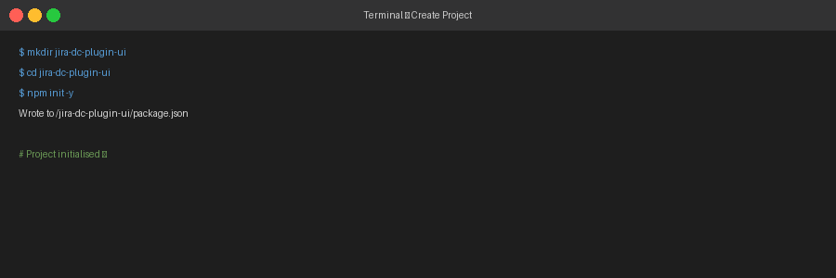
Figure 3 — Creating the project folder and package.json
Keep the folder name lowercase with hyphens. Webpack and Node work best without spaces or special characters in paths.

3.2 Install ADS Foundation Packages
2 | Install the CSS reset and design token packages

$ yarn add @atlaskit/css-reset @atlaskit/tokens

What is installed:
- @atlaskit/css-reset — Atlassian CSS normaliser. Removes browser-default margins and sets the Atlassian baseline styles.
- @atlaskit/tokens — Design token system. The included Babel plugin resolves token() calls at build time into CSS variables.

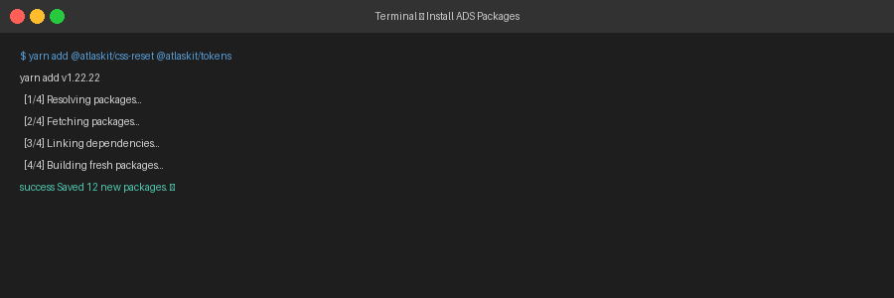
Figure 4 — Installing the ADS foundation packages
@atlaskit/css-reset must be the VERY FIRST import in src/index.tsx. If imported after any component CSS, it overrides component styles and breaks the visual output.

3.3 Install Compiled CSS-in-JS
3 | Install the Compiled runtime and build-time tools

$ yarn add @compiled/react
$ yarn add --dev @compiled/babel-plugin \
@compiled/babel-plugin-strip-runtime \
@compiled/webpack-loader

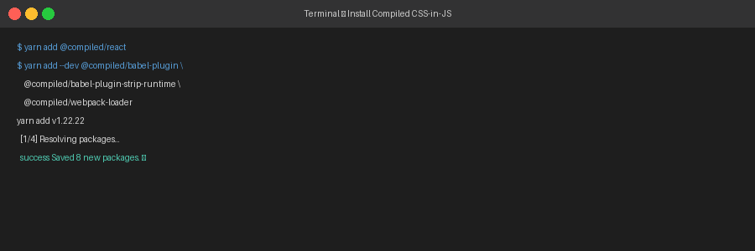
Figure 5 — Installing Compiled CSS-in-JS packages

3.4 Install Webpack, Babel and Loaders
4 | Install the bundler, transpiler, and all required loaders

$ yarn add --dev \
webpack webpack-cli webpack-dev-server \
babel-loader @babel/core @babel/preset-env \
@babel/preset-react @babel/preset-typescript \
css-loader style-loader mini-css-extract-plugin \
html-webpack-plugin typescript

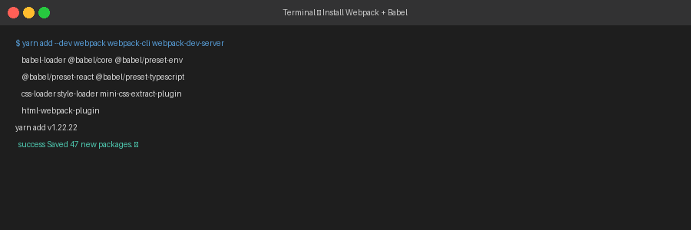
Figure 6 — Installing Webpack 5, Babel 7, and CSS loaders

3.5 Install Atlaskit UI Components
5 | Install the ADS React component packages

$ yarn add @atlaskit/button @atlaskit/primitives \
@atlaskit/page-header @atlaskit/flag @atlaskit/icon

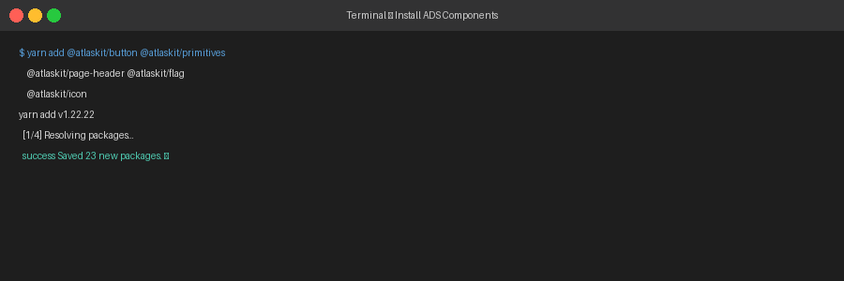
Figure 7 — Installing Atlaskit component packages

3.6 Create the Project File Structure
6 | Create all required folders and source files

Create the following folder structure. All source files go inside src/:

jira-dc-plugin-ui/
src/
index.html ← HTML shell for Webpack
index.tsx ← App entry point (imports css-reset first)
App.tsx ← Plugin page UI component
babel.config.js ← Babel presets and plugin order
webpack.config.js ← Webpack bundler configuration
tsconfig.json ← TypeScript compiler options
package.json ← Dependencies and npm scripts

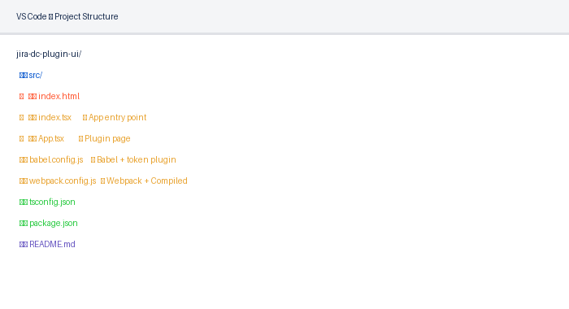
Figure 8 — Final project structure in VS Code

3.7 Configure Babel (babel.config.js)
7 | Create babel.config.js with the correct plugin order

Plugin order in Babel is critical. The @atlaskit/tokens/babel-plugin must come before @compiled/babel-plugin:

// babel.config.js
module.exports = {
presets: [
'@babel/preset-env',
['@babel/preset-react', { runtime: 'automatic' }],
'@babel/preset-typescript',
],
plugins: [
'@atlaskit/tokens/babel-plugin', // ← MUST be FIRST
['@compiled/babel-plugin', {
transformerBabelPlugins: ['@atlaskit/tokens/babel-plugin'],
}], // ← MUST be LAST
],
};

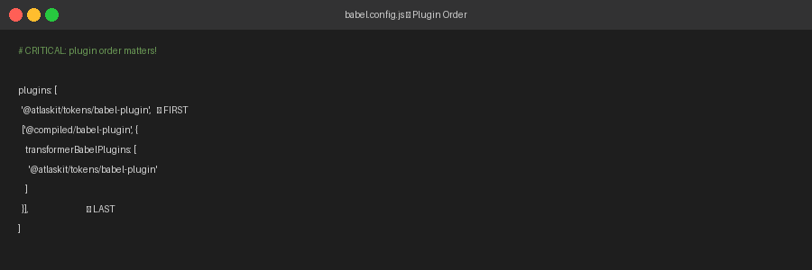
Figure 9 — Babel plugin order (tokens first, Compiled last)
Reversing the plugin order (Compiled before tokens) causes design token CSS variables to not resolve, producing wrong colours across the entire plugin UI.

3.8 Configure Webpack (webpack.config.js)
8 | Create webpack.config.js with two separate CSS loader rules

Webpack needs two distinct CSS rules: one for Compiled-extracted CSS (written to a file), and one for all other CSS (injected as inline style tags):

// webpack.config.js
const { CompiledExtractPlugin } = require('@compiled/webpack-loader');
const MiniCssExtractPlugin = require('mini-css-extract-plugin');
const HtmlWebpackPlugin = require('html-webpack-plugin');
const path = require('path');
module.exports = {
entry: './src/index.tsx',
output: {
path: path.resolve(__dirname, 'dist'),
filename: 'main.js',
clean: true,
},
resolve: { extensions: ['.tsx', '.ts', '.jsx', '.js'] },
module: {
rules: [
{
test: /\.(js|jsx|ts|tsx)$/,
exclude: /node_modules/,
use: [
{ loader: 'babel-loader' },
{
loader: '@compiled/webpack-loader', // ← LAST (runs FIRST)
options: {
transformerBabelPlugins: ['@atlaskit/tokens/babel-plugin'],
extract: true,
inlineCss: true,
},
},
],
},
// Rule 1: Compiled-generated CSS → separate file
{
test: /compiled(-css)?\.css$/i,
use: [MiniCssExtractPlugin.loader, 'css-loader'],
},
// Rule 2: All other CSS → inline style tags
{
test: /(?<!compiled-css)(?<!.compiled)\.css$/,
use: ['style-loader', 'css-loader'],
},
],
},
plugins: [
new HtmlWebpackPlugin({ template: './src/index.html' }),
new MiniCssExtractPlugin({ filename: 'main.css' }),
new CompiledExtractPlugin({ sortShorthand: true }),
],
devServer: { port: 3000, hot: true, open: true },
};

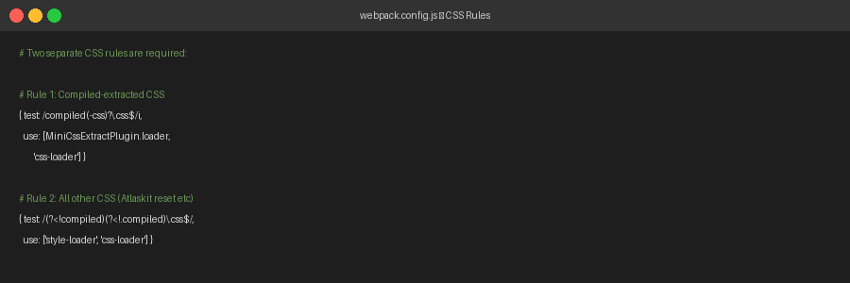
Figure 10 — Two separate CSS rules required by the Compiled setup
Loaders in Webpack run right-to-left within the 'use' array. '@compiled/webpack-loader' is listed last so it runs first — it must instrument the file before Babel transpiles it.

3.9 Create tsconfig.json
9 | TypeScript compiler configuration

{
"compilerOptions": {
"target": "ES2018",
"module": "ESNext",
"moduleResolution": "node",
"jsx": "react-jsx",
"strict": true,
"esModuleInterop": true,
"allowSyntheticDefaultImports": true,
"skipLibCheck": true
},
"include": ["src/**/*"],
"exclude": ["node_modules", "dist"]
}

3.10 Create src/index.html
10 | HTML shell — the page template Webpack injects bundles into

<!DOCTYPE html>
<html lang="en">
<head>
<meta charset="UTF-8" />
<meta name="viewport" content="width=device-width, initial-scale=1.0" />
<title>Jira DC Plugin</title>
</head>
<body>
<div id="root"></div>
</body>
</html>

The <div id='root'></div> is where React mounts. HtmlWebpackPlugin automatically injects <script src='main.js'> and <link href='main.css'> into this template.

3.11 Create src/index.tsx — App Entry Point
11 | Bootstrap React and import the global CSS reset

// src/index.tsx
// CRITICAL: @atlaskit/css-reset MUST be the very first import
import '@atlaskit/css-reset';
import React from 'react';
import { createRoot } from 'react-dom/client';
import App from './App';
const container = document.getElementById('root')!;
createRoot(container).render(
<React.StrictMode>
<App />
</React.StrictMode>
);

3.12 Create src/App.tsx — Plugin Page
12 | The main plugin page component using ADS composition primitives

// src/App.tsx
import React, { useState, useCallback } from 'react';
import { css } from '@compiled/react';
import { Box, Stack, Inline, Text, xcss } from '@atlaskit/primitives';
import Button from '@atlaskit/button/new';
import PageHeader from '@atlaskit/page-header';
import Flag, { FlagGroup } from '@atlaskit/flag';
import { token } from '@atlaskit/tokens';
const pageWrapperStyles = css({
minHeight: '100vh',
backgroundColor: token('color.background.neutral', '#F4F5F7'),
});
const cardStyles = xcss({
backgroundColor: 'elevation.surface',
borderRadius: 'border.radius.200',
padding: 'space.400',
boxShadow: 'elevation.shadow.raised',
});
const App: React.FC = () => {
const [show, setShow] = useState(false);
const [flagVisible, setFlagVisible] = useState(false);
const handleClick = useCallback(() => {
setShow(true);
setFlagVisible(true);
}, []);
return (
<>
<div css={pageWrapperStyles}>
<div style={{ maxWidth: 800, margin: '0 auto', padding: '32px 24px' }}>
<PageHeader>My Jira DC Plugin</PageHeader>
<Box xcss={cardStyles}>
<Stack space='space.300'>
<Text as='p' color='color.text.subtle'>
Click the button to display the message.
</Text>
<Inline space='space.100'>
<Button appearance='primary' onClick={handleClick}>
Click me to display hello-world!!
</Button>
</Inline>
{show && (
<Box xcss={xcss({
backgroundColor: 'color.background.success',
padding: 'space.300',
borderRadius: 'border.radius.100',
borderColor: 'color.border.success',
borderWidth: 'border.width',
borderStyle: 'solid',
})}>
<Text as='strong' color='color.text.success' size='large'>
hello-world1!!
</Text>
</Box>
)}
</Stack>
</Box>
</div>
</div>
<FlagGroup onDismissed={() => setFlagVisible(false)}>
{flagVisible && (
<Flag
id='hello-world-flag'
title='hello-world1!!'
description='Plugin action completed successfully.'
/>
)}
</FlagGroup>
</>
);
};
export default App;

3.13 Add npm Scripts to package.json
13 | Add the start and build commands

{
"scripts": {
"start": "webpack serve --mode development",
"build": "webpack --mode production"
}
}

3.14 Start the Development Server
14 | Run yarn start to launch the hot-reload dev server

$ yarn start
# Webpack compiles and opens http://localhost:3000

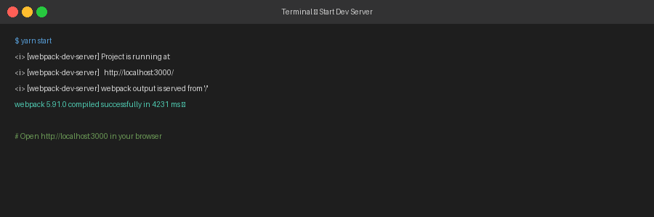
Figure 11 — Webpack dev server running successfully on port 3000

3.15 Test the Plugin UI
15 | Verify the button click shows hello-world1!!

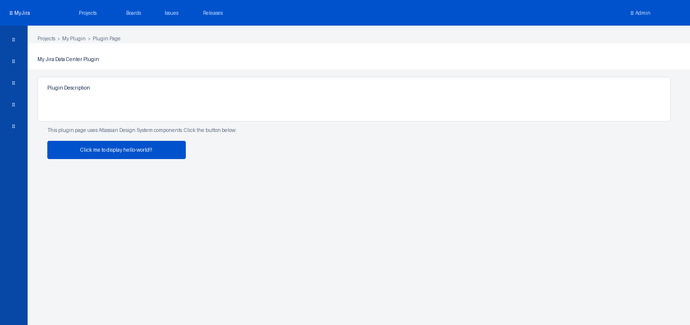
Figure 12 — Plugin page loads: Jira-styled UI with button ready to click
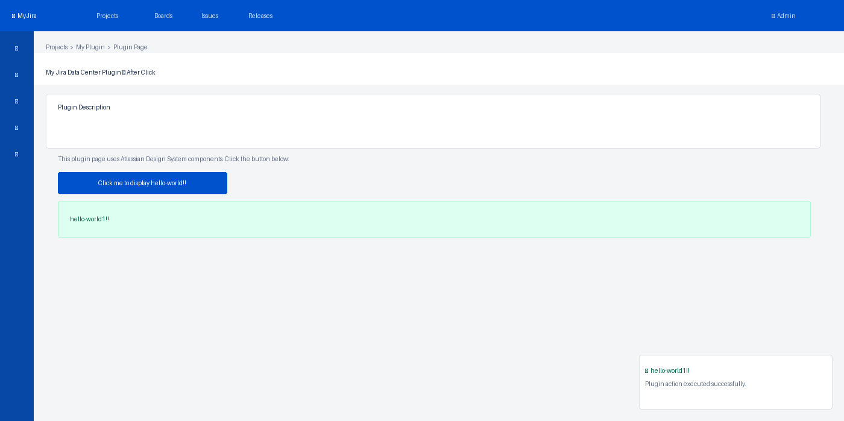
Figure 13 — After clicking: hello-world1!! appears with green success box and toast notification

3.16 Production Build
16 | Run yarn build to produce the deployable bundle

$ yarn build
# Output:
# dist/main.js ← minified JS bundle
# dist/main.css ← extracted Compiled CSS
# dist/index.html ← HTML with injected assets

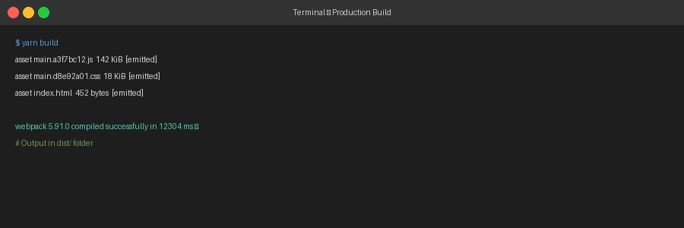
Figure 14 — Production build output in the dist/ folder

4. Plugin UI — Detailed Page Walkthrough
This section explains every element visible in the plugin page: what ADS component renders it, what props control its appearance, and what happens when the user interacts with it.

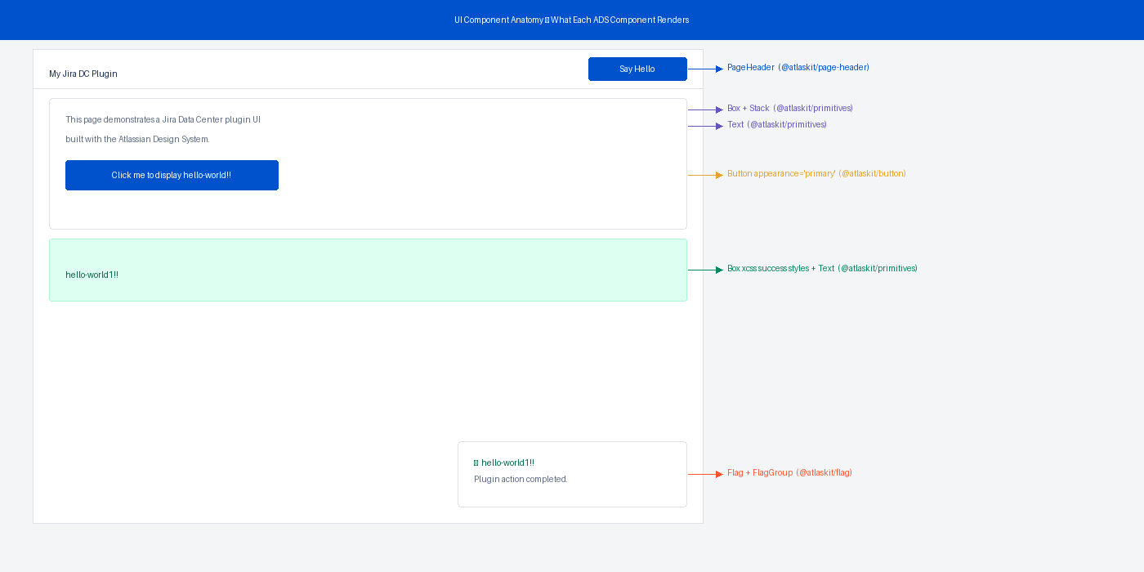
Figure 15 — UI anatomy: every element labelled with its ADS component

4.1 The Page Shell (Jira Background)
The outer page wrapper is a plain <div> styled with Compiled CSS using the ADS token 'color.background.neutral'. This renders the standard Jira page grey background (#F4F5F7 in light theme).

const pageWrapperStyles = css({
minHeight: '100vh',
backgroundColor: token('color.background.neutral', '#F4F5F7'),
});
// In JSX:
<div css={pageWrapperStyles}>

token() takes two arguments: the token name and a fallback value. If the CSS variable is not defined (e.g. during server-side render), the fallback is used instead.

4.2 PageHeader Component
The @atlaskit/page-header component renders the standard Jira page title bar. It accepts an 'actions' prop for buttons that appear on the right side.

import PageHeader from '@atlaskit/page-header';
// Basic usage — title only:
<PageHeader>My Jira DC Plugin</PageHeader>
// With action buttons on the right:
const actions = (
<Inline space='space.100'>
<Button appearance='subtle' onClick={handleReset}>Reset</Button>
<Button appearance='primary' onClick={handleClick}>Say Hello</Button>
</Inline>
);
<PageHeader actions={actions}>My Jira DC Plugin</PageHeader>

What it renders: a large bold page title with an optional right-aligned action area. This matches the native Jira page header pattern so your plugin looks like a native Jira screen.

4.3 Card Layout (Box + Shadow)
The white card that wraps the main content is a Box component with xcss() styles. xcss() enforces type-safe ADS tokens only — you cannot pass arbitrary CSS values.

const cardStyles = xcss({
backgroundColor: 'elevation.surface', // white card
borderRadius: 'border.radius.200', // 4px rounded corners
padding: 'space.400', // 24px internal padding
boxShadow: 'elevation.shadow.raised', // Jira card shadow
});
<Box xcss={cardStyles}>
<Stack space='space.300'> {/* 12px vertical gap between children */}
...
</Stack>
</Box>

ADS token values used in this card:
Token | Value in Light Theme | Purpose
elevation.surface | #FFFFFF | White card background
border.radius.200 | 4px | Rounded corners
space.400 | 24px | Card internal padding
elevation.shadow.raised | 0 1px 1px rgba(9,30,66,.25) | Jira-style card shadow
space.300 | 12px | Gap between Stack children

4.4 The Action Button
The Button component from @atlaskit/button renders the Jira-styled primary action button. The appearance prop controls visual style.

import Button from '@atlaskit/button/new'; // always import from /new
<Button
appearance='primary' // blue Atlassian button
onClick={handleClick} // triggers setState
testId='hello-world-btn' // for automated testing
>
Click me to display hello-world!!
</Button>

Available 'appearance' values:
appearance | Visual style | When to use
primary | Blue background (#0052CC) | Main call-to-action on the page
subtle | Transparent, text colour | Secondary or cancel actions
danger | Red background (#DE350B) | Destructive actions (delete, remove)
warning | Yellow (#FF991F) | Actions with caution (archive, disable)
link | Looks like a hyperlink | Navigation or non-prominent actions

Always import from '@atlaskit/button/new' — this is the latest API. Importing from '@atlaskit/button' uses a deprecated API that may be removed in a future release.

4.5 The Success Result Box
When the button is clicked, a success box appears conditionally. It uses a Box with xcss() styles using success colour tokens, plus a Text component with the success colour.

{show && (
<Box xcss={xcss({
backgroundColor: 'color.background.success', // light green
padding: 'space.300', // 12px
borderRadius: 'border.radius.100', // 3px
borderColor: 'color.border.success', // green border
borderWidth: 'border.width', // 1px
borderStyle: 'solid',
})}>
<Stack space='space.100'>
<Text as='strong' color='color.text.success' size='large'>
hello-world1!!
</Text>
<Text as='p' color='color.text.success' size='small'>
Plugin action executed successfully.
</Text>
</Stack>
</Box>
)}

The {show && (...)} pattern is standard React conditional rendering. The Box only appears in the DOM when the show state variable is true (after the button is clicked).

4.6 The Toast Notification (Flag)
Clicking the button also triggers a Flag notification — a toast that slides up from the bottom of the screen. This is the Jira standard feedback pattern for user actions.

import Flag, { FlagGroup } from '@atlaskit/flag';
import SuccessIcon from '@atlaskit/icon/glyph/check-circle';
import { token } from '@atlaskit/tokens';
<FlagGroup onDismissed={() => setFlagVisible(false)}>
{flagVisible && (
<Flag
id='hello-world-flag'
title='hello-world1!!'
description='Plugin action completed successfully.'
icon={
<SuccessIcon
label='Success'
primaryColor={token('color.icon.success', '#22A06B')}
/>
}
actions={[{
content: 'Dismiss',
onClick: () => setFlagVisible(false),
}]}
/>
)}
</FlagGroup>


Figure 16 — Full state after click: success box + toast flag + result text all visible

FlagGroup manages multiple flags and handles slide-in/out animations. Even if you only show one Flag at a time, it must be wrapped in FlagGroup for correct behaviour.

4.7 The Page Layout Structure
The complete page is composed using ADS layout primitives following the Atlassian composition guide. No raw CSS grid or flexbox — everything uses Box, Stack, and Inline:

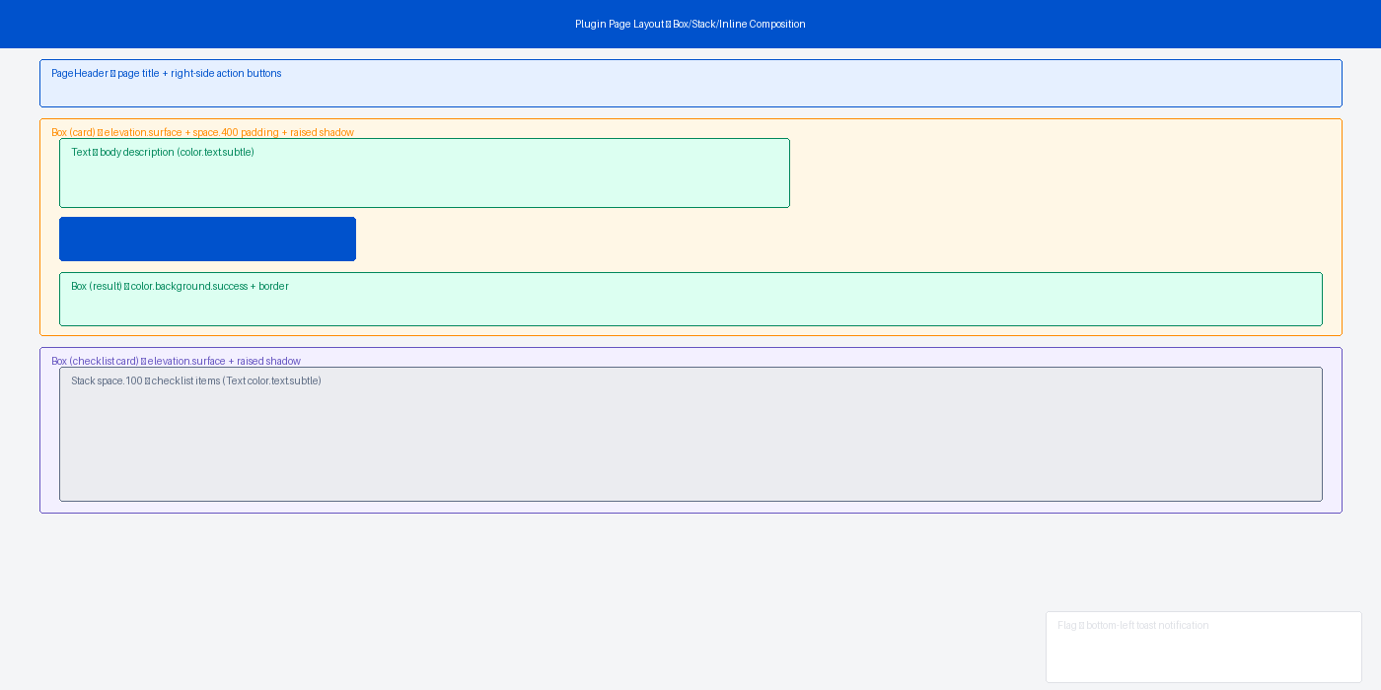
Figure 17 — Visual map of the page layout: every Box, Stack and Inline component shown

// Outer → Inner (composition tree):
<div css={pageWrapperStyles}> // page bg colour
<div style={{ maxWidth: 800 }}> // content width constraint
<PageHeader actions={...}> // title bar
<Box xcss={cardStyles}> // main card
<Stack space='space.300'> // vertical layout, 12px gaps
<Text>description</Text>
<Inline space='space.100'> // horizontal, 4px gap
<Button>...</Button>
</Inline>
{show && <Box xcss={result}/>} // conditional result
</Stack>
</Box>
<Box xcss={cardStyles}> // checklist card
<Stack space='space.200'> // 8px gaps
...
</Stack>
</Box>
</div>
</div>
<FlagGroup>...</FlagGroup> // toast at page level

5. How atlassian-plugin.xml Wires the React UI
This section explains exactly how the React bundle (main.js + main.css) gets connected to Jira. The atlassian-plugin.xml file is the central configuration file for every Jira Data Center plugin — it acts as the wiring diagram for all plugin modules.

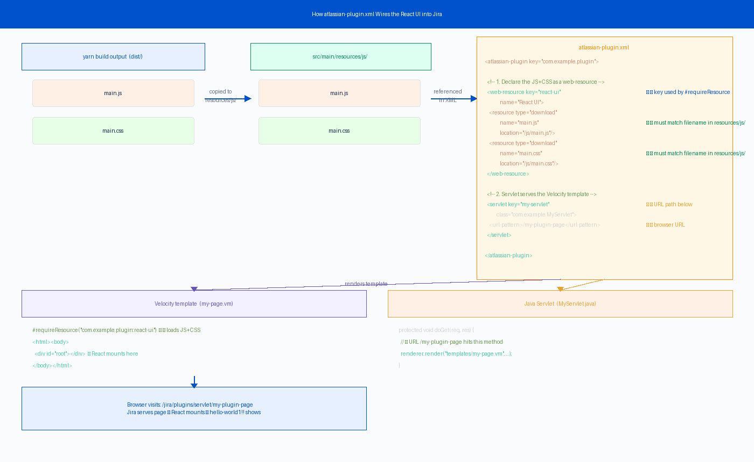
Figure 18 — Complete wiring diagram: from yarn build output to the Jira browser page

5.1 What atlassian-plugin.xml Controls
Every capability a Jira plugin provides must be declared in atlassian-plugin.xml. For a React UI plugin, you need two declarations:

XML Element | What it declares | In our plugin
<web-resource> | Registers static files (JS, CSS, images) that Jira serves | Registers main.js and main.css from resources/js/
<servlet> | Maps a URL path to a Java class that handles requests | Maps /my-plugin-page to MyServlet.java
<url-pattern> | The browser URL that activates the servlet | http://jira:2990/jira/plugins/servlet/my-plugin-page

5.2 The <web-resource> Element — Registering JS and CSS
The <web-resource> element tells Jira about the built React files and gives them a key that other parts of the plugin reference:

<!-- atlassian-plugin.xml -->
<atlassian-plugin key="com.example.my-jira-plugin"
name="My Jira Plugin">
<!-- Declare the React bundle as a web resource -->
<web-resource key="react-ui" <!-- ① internal key -->
name="React UI Bundle">
<!-- ② Each file must match the filename in resources/js/ -->
<resource type="download"
name="main.js" <!-- filename in resources/js/ -->
location="/js/main.js"/> <!-- path relative to resources/ -->
<resource type="download"
name="main.css"
location="/js/main.css"/>
<!-- ③ Optional: declare dependencies on other web resources -->
<dependency>com.atlassian.auiplugin:ajs</dependency>
</web-resource>

The three key attributes explained:
- key="react-ui" — the internal identifier used inside the plugin. This is what #requireResource references in the Velocity template. Must be unique within the plugin. Format: plugin-key:web-resource-key
- name="main.js" — the PUBLIC filename Jira exposes in the browser download URL. This is what the browser requests. Must match exactly what Webpack writes as output.filename.
- location="/js/main.js" — the PRIVATE path inside the plugin JAR where Jira reads the file from. Path is relative to the JAR root, which equals src/main/resources/ on disk.

The web-resource key used in atlassian-plugin.xml and the #requireResource call must match exactly: format is 'com.example.my-jira-plugin:react-ui' (plugin-key:web-resource-key).

5.3 How the File Path Flows from frontend/ to Jira
This is the most important concept to understand. The location= attribute in atlassian-plugin.xml does NOT point to your frontend/ folder directly. It points to a path INSIDE the compiled plugin JAR. Here is the full chain that connects them:

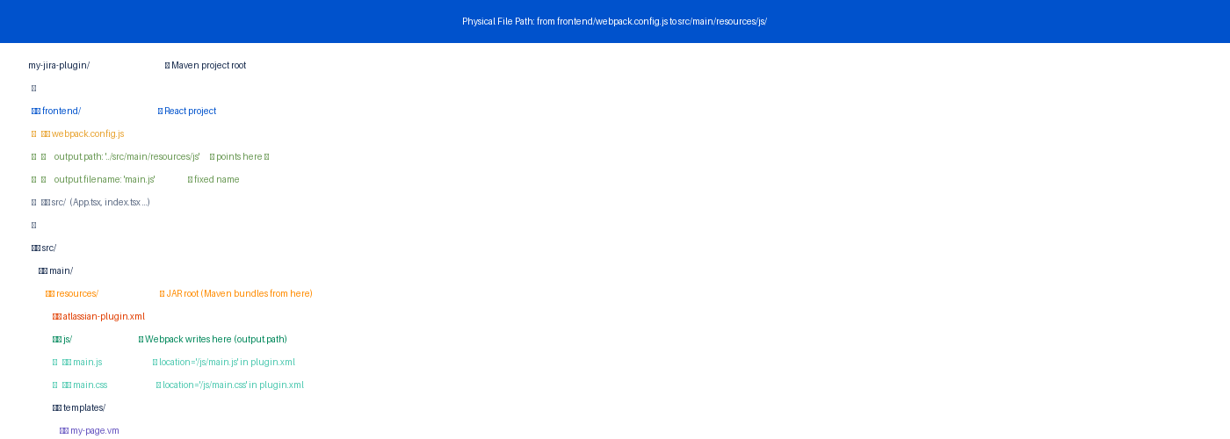
Figure 19 — Physical folder structure: how webpack output.path in frontend/ maps to src/main/resources/js/

Step 1 — Webpack writes the built files to resources/js/
The output.path in frontend/webpack.config.js is set to point two levels up into the Java project's resources folder:

// frontend/webpack.config.js
const path = require('path');
module.exports = {
output: {
// __dirname = the frontend/ folder
// '../src/main/resources/js' goes up one level then into resources/js/
path: path.resolve(__dirname, '../src/main/resources/js'),
filename: 'main.js', // fixed name — NOT main.[hash].js
clean: true,
},
};
// After 'yarn build' this creates:
// my-jira-plugin/src/main/resources/js/main.js
// my-jira-plugin/src/main/resources/js/main.css

Step 2 — Maven packages resources/ as the JAR root
When you run atlas-package, Maven compiles the Java code and bundles everything under src/main/resources/ into the root of the plugin JAR file. The resources/ folder itself disappears — its contents become the JAR root:

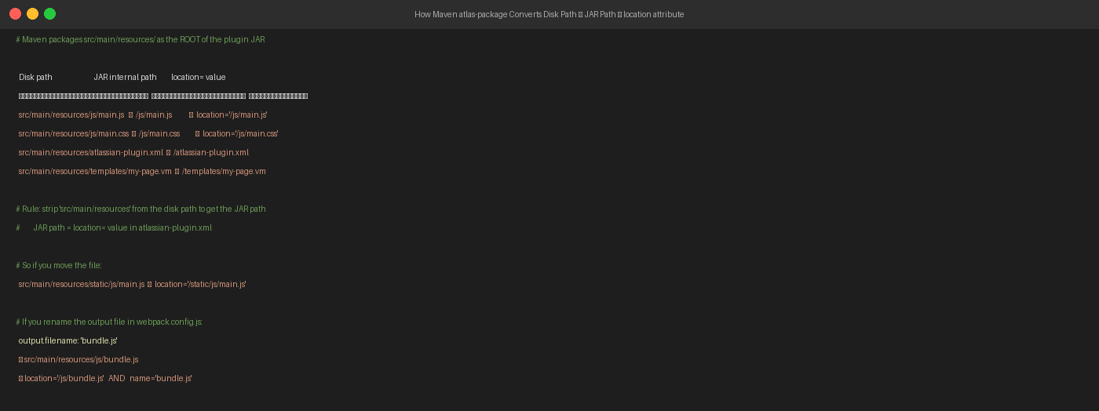
Figure 20 — Maven strips 'src/main/resources' to produce JAR paths: this is what location= must reference

# Disk path → JAR internal path
src/main/resources/js/main.js → /js/main.js
src/main/resources/js/main.css → /js/main.css
src/main/resources/atlassian-plugin.xml → /atlassian-plugin.xml
src/main/resources/templates/my-page.vm → /templates/my-page.vm
# Rule: remove 'src/main/resources' prefix to get the JAR path
# The JAR path IS the location= value in atlassian-plugin.xml

Step 3 — location= references the JAR path
Now the connection is clear. The location= attribute in atlassian-plugin.xml is the JAR-internal path (after Maven has stripped src/main/resources):

<!-- atlassian-plugin.xml -->
<resource type="download"
name="main.js"
location="/js/main.js"/> ← JAR path (= disk path minus src/main/resources)
<!-- Connects to: -->
<!-- src/main/resources/js/main.js (on disk) -->
<!-- /js/main.js (inside JAR) -->
<!-- frontend/webpack output (where it was written) -->

5.3a name= vs location= — Two Different Purposes
These two attributes are often confused because they look similar. They serve completely different purposes:

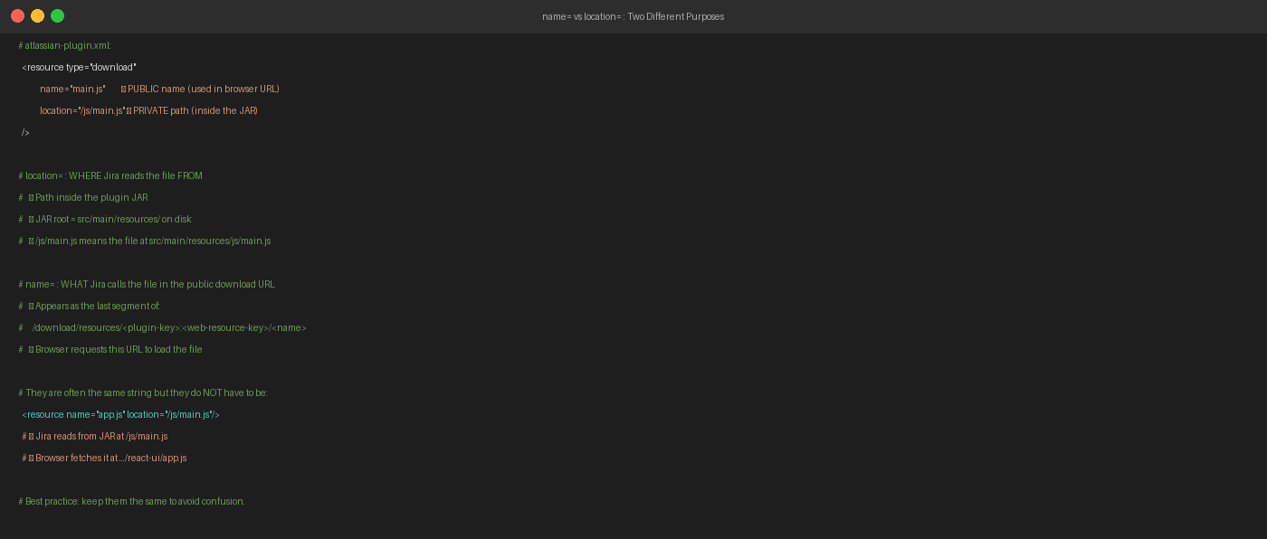
Figure 21 — name= is the public URL segment; location= is the private JAR path

Attribute | Direction | What it controls | Example
location= | INWARD (Jira reads file) | Path inside the plugin JAR where Jira finds the file. Derived from disk path by removing src/main/resources prefix. | /js/main.js
name= | OUTWARD (browser fetches file) | The filename that appears in the public browser download URL. This is what the browser requests. | "main.js"

They do not have to be the same string — but keeping them identical avoids confusion:

<!-- This is valid — different name and location: -->
<resource name="app.js" location="/js/main.js"/>
<!-- Jira reads from JAR: /js/main.js -->
<!-- Browser fetches: /download/resources/.../react-ui/app.js -->
<!-- This is what we use — same name and location (clearest): -->
<resource name="main.js" location="/js/main.js"/>
<!-- Jira reads from JAR: /js/main.js -->
<!-- Browser fetches: /download/resources/.../react-ui/main.js -->

5.3b The Complete End-to-End Path Chain
This diagram shows every hop the file takes from the time you write React code to the time the browser loads it in Jira:

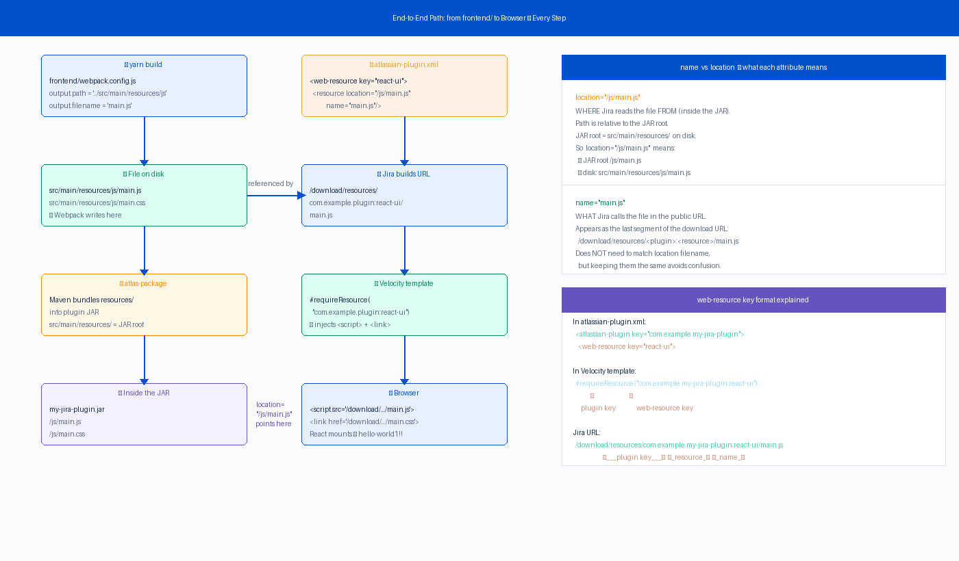
Figure 22 — Complete end-to-end chain: frontend/ source → webpack → disk → JAR → plugin.xml → URL → browser

Step | What happens | Key detail
① yarn build | Webpack compiles React and writes output files | output.path = '../src/main/resources/js' output.filename = 'main.js'
② File on disk | main.js lands at src/main/resources/js/main.js | This physical path is what you can verify with ls after building
③ atlas-package | Maven bundles src/main/resources/ into the JAR | src/main/resources/ becomes the JAR root — the prefix is stripped
④ Inside JAR | File is now at /js/main.js inside the JAR | This JAR path is what location= in plugin.xml must reference
⑤ plugin.xml | <resource location='/js/main.js' name='main.js'/> | location= reads from JAR; name= sets the public URL segment
⑥ Jira URL | Jira exposes the file at a download URL | Formula: /download/resources/<plugin-key>:<resource-key>/<name>
⑦ Velocity .vm | #requireResource injects <script> and <link> tags | Jira's web resource manager builds the full URL automatically
⑧ Browser | React app loads, mounts into <div id='root'> | createRoot() runs; button click shows hello-world1!!

5.3c What Breaks if the Path Is Wrong
Mistake | Symptom | Fix
output.path points to the wrong folder | main.js not in resources/js/ after yarn build | Set path.resolve(__dirname, '../src/main/resources/js') in webpack.config.js
output.filename uses content hash (main.abc.js) | location='/js/main.abc.js' never matches — changes every build | Set output.filename: 'main.js' (fixed name, no hash)
location='/js/main.js' but file is at resources/static/main.js | Jira cannot find the file in JAR — 404 on the asset URL | Either move the file to resources/js/ or change location to '/static/main.js'
name= does not match what browser expects | CSS or JS loads with wrong URL — network 404 | Keep name= identical to output.filename in webpack.config.js
Forgot to run yarn build before atlas-package | Old or missing main.js bundled into JAR | Add exec-plugin to pom.xml to auto-run yarn build (see section 6.3)

5.4 The URL Jira Builds for Your Assets
When Jira processes the <web-resource> declaration, it constructs a static asset URL for each resource file. Understanding this URL helps when debugging loading issues:

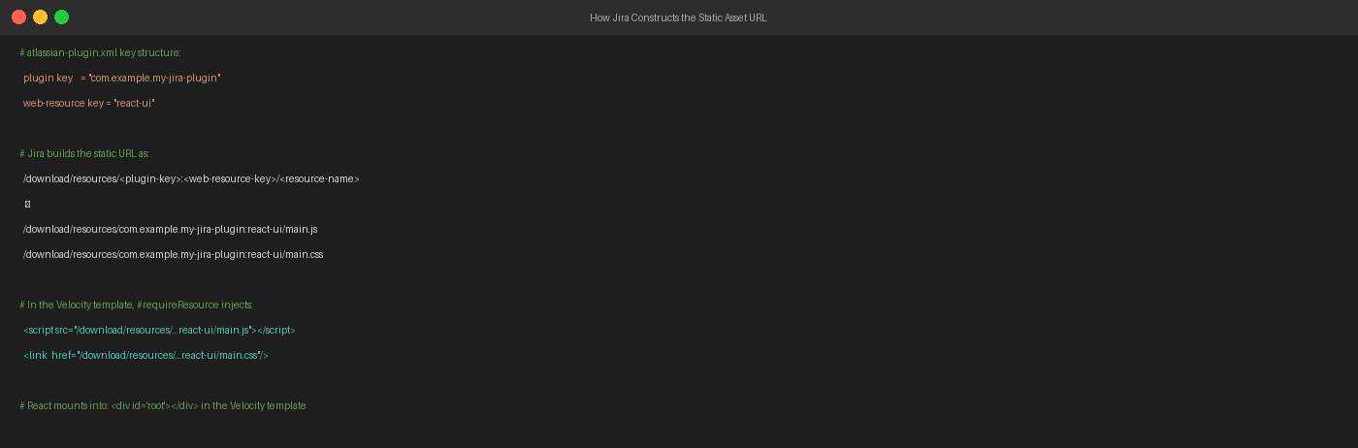
Figure 23 — How Jira constructs the static asset URL from plugin key + web-resource key + filename

# URL formula:
/download/resources/<plugin-key>:<web-resource-key>/<resource-name>
# For this plugin:
Plugin key: com.example.my-jira-plugin
Web-resource key: react-ui
Resource name: main.js
# Result URL:
/download/resources/com.example.my-jira-plugin:react-ui/main.js
/download/resources/com.example.my-jira-plugin:react-ui/main.css

You do not write these URLs manually. The #requireResource directive in the Velocity template tells Jira's web resource manager to inject the correct <script> and <link> tags automatically.

5.6 The <servlet> Element — Mapping a URL to Java
The <servlet> element tells Jira that a specific URL path should be handled by a Java class. When the user visits that URL, Jira calls your servlet's doGet() method:

<!-- Maps the URL /my-plugin-page to the MyServlet Java class -->
<servlet key="my-servlet"
name="My Plugin Servlet"
class="com.example.servlet.MyServlet">
<!-- The URL pattern appended after /jira/plugins/servlet/ -->
<url-pattern>/my-plugin-page</url-pattern>
</servlet>

The full browser URL for this servlet:
http://your-jira-host:2990/jira/plugins/servlet/my-plugin-page

5.7 The Velocity Template — Loading React in Jira
The Velocity template (.vm file) is rendered server-side by the Java servlet. It produces the HTML page that the browser receives. The template does two things: tells Jira to load the React bundle, and provides the <div id='root'> mount point.

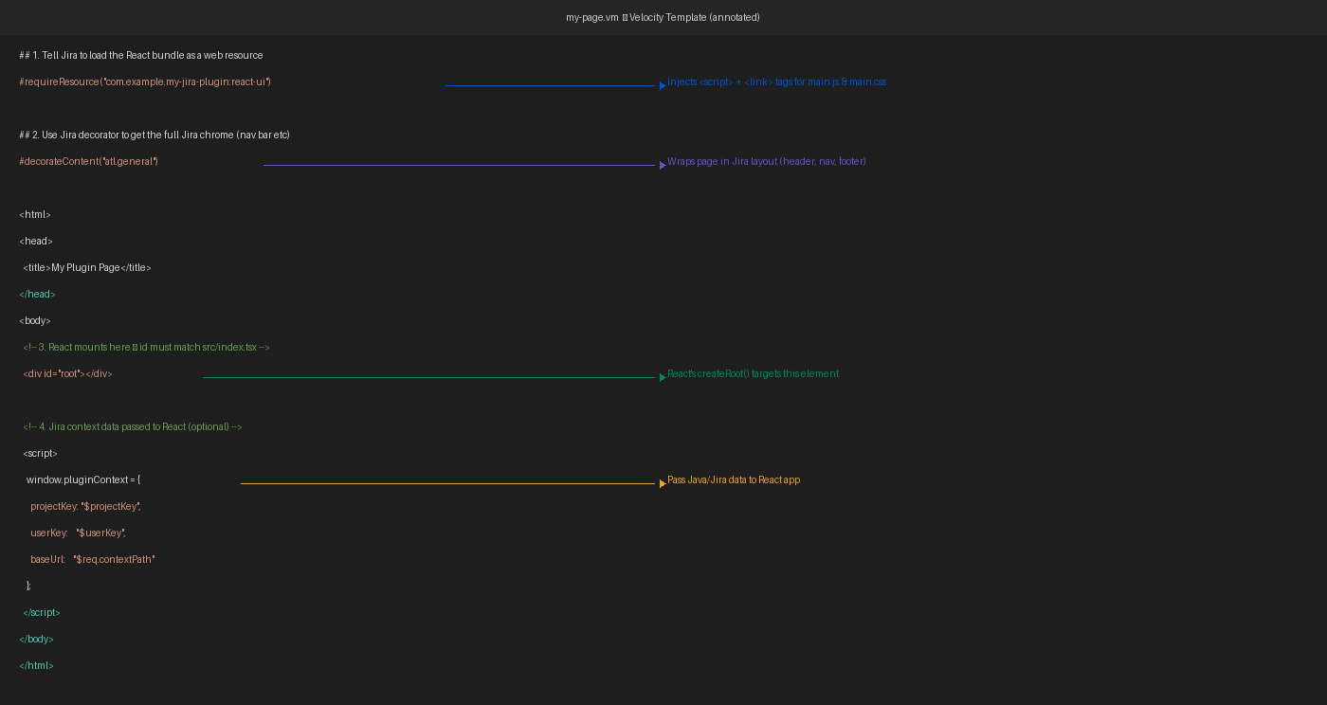
Figure 20 — Velocity template annotated: every line explained with its purpose

## File: src/main/resources/templates/my-page.vm
## ① Load the React JS+CSS bundle
#requireResource("com.example.my-jira-plugin:react-ui")
## ② Wrap in full Jira layout (top nav, sidebar, footer)
#decorateContent("atl.general")
<html>
<head><title>My Plugin Page</title></head>
<body>
<!-- ③ React mounts into this div -->
<!-- id='root' must match src/index.tsx: getElementById('root') -->
<div id="root"></div>
<!-- ④ Optional: pass server-side data to the React app -->
<script>
window.pluginContext = {
projectKey: '$projectKey', // Velocity variable from servlet
userKey: '$userKey',
baseUrl: '$req.contextPath'
};
</script>
</body>
</html>

Reading window.pluginContext in React:
// In src/App.tsx — access Jira context data passed from the servlet
const ctx = (window as any).pluginContext;
const projectKey = ctx?.projectKey ?? 'unknown';

#requireResource is the Velocity directive that triggers Jira's web resource manager to inject <script> and <link> tags. Without it, main.js and main.css never load and the page is blank.

5.8 The Java Servlet — Rendering the Template
The Java servlet receives the HTTP request and calls TemplateRenderer to process the Velocity template and write it to the response:

// src/main/java/com/example/servlet/MyServlet.java
package com.example.servlet;
import com.atlassian.templaterenderer.TemplateRenderer;
import javax.servlet.*;
import javax.servlet.http.*;
import java.io.IOException;
import java.util.HashMap;
import java.util.Map;
public class MyServlet extends HttpServlet {
private final TemplateRenderer templateRenderer;
// Injected by Atlassian's dependency injection framework
public MyServlet(TemplateRenderer templateRenderer) {
this.templateRenderer = templateRenderer;
}
@Override
protected void doGet(HttpServletRequest req, HttpServletResponse res)
throws ServletException, IOException {
res.setContentType("text/html;charset=UTF-8");
// Build context variables available in the Velocity template
Map<String, Object> context = new HashMap<>();
context.put("projectKey", req.getParameter("projectKey"));
context.put("userKey", req.getRemoteUser());
// Render the Velocity template with the context
templateRenderer.render("templates/my-page.vm", context, res.getWriter());
}
}

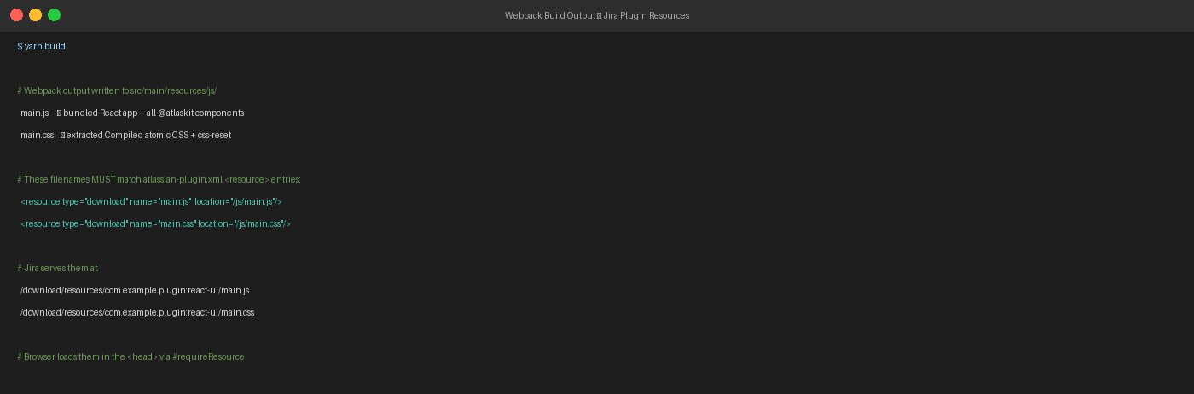
Figure 26 — How webpack output filenames must match the atlassian-plugin.xml resource declarations

5.9 End-to-End Request Flow
When a user navigates to the plugin page, this is the exact sequence of events:

Step | Who acts | What happens
1 | Browser | User visits /jira/plugins/servlet/my-plugin-page
2 | Jira | Matches URL pattern in atlassian-plugin.xml → routes to MyServlet.java
3 | MyServlet | doGet() runs; calls templateRenderer.render('templates/my-page.vm', ...)
4 | Velocity engine | Processes my-page.vm; #requireResource injects <script> and <link> tags
5 | Browser | Receives HTML with <div id='root'> and loads main.js + main.css
6 | React (main.js) | createRoot(document.getElementById('root')).render(<App/>)
7 | Atlaskit | ADS components render; Compiled CSS classes applied from main.css
8 | User | Sees the Jira-styled plugin page; clicks button → hello-world1!! Appears

5.10 Common Wiring Mistakes and Fixes
Symptom | Root Cause | Fix
Blank page — no React content | #requireResource key is wrong or missing from .vm | Check: plugin-key:web-resource-key exactly matches atlassian-plugin.xml
404 on main.js or main.css | Filename mismatch between Webpack output and <resource name=> | Ensure Webpack output filename = <resource name=> in plugin.xml
Styles not applied | main.css not declared as a <resource> in <web-resource> | Add the CSS <resource> entry alongside the JS entry
'root' element not found | <div id='root'> missing from the Velocity template | Add <div id='root'></div> to the .vm file body
Page works in dev but not Jira | Webpack uses hashed filenames (main.abc123.js) | Set output.filename: 'main.js' (fixed name) in webpack.config.js
Old bundle served after rebuild | Browser or Jira caching stale assets | Run atlas-package again; clear browser cache (Ctrl+Shift+R)

6. Integrating into a Jira DC Plugin (atlas-create-jira-plugin)

6.1 Create the Plugin with the SDK
Run this command to scaffold a new Jira Data Center plugin:

$ atlas-create-jira-plugin
Define value for groupId: com.example
Define value for artifactId: my-jira-plugin
Define value for version: 1.0.0-SNAPSHOT
Define value for package: com.example
[INFO] BUILD SUCCESS

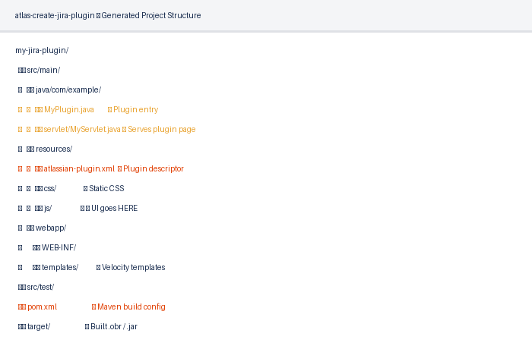
Figure 27 — Generated Maven project structure from atlas-create-jira-plugin

6.2 Add the frontend/ Folder
Create a frontend/ sub-folder inside the plugin project and copy the entire React project into it. Set the Webpack output path to write directly into the plugin's resources folder:

my-jira-plugin/
frontend/ ← React project lives here
src/
babel.config.js
webpack.config.js ← output path changed (see below)
package.json
src/main/
java/com/example/servlet/MyServlet.java
resources/
atlassian-plugin.xml
js/ ← Webpack writes here
templates/my-page.vm
pom.xml

Update webpack output in frontend/webpack.config.js:
output: {
// Write directly to the Jira plugin resources folder
path: path.resolve(__dirname, '../src/main/resources/js'),
filename: 'main.js', // fixed name — no hash
clean: true,
},

6.3 Auto-Build React with Maven exec-plugin
Add the Maven exec-plugin to pom.xml so that running atlas-package automatically builds the React UI first:

<!-- pom.xml inside <build><plugins> -->
<plugin>
<groupId>org.codehaus.mojo</groupId>
<artifactId>exec-maven-plugin</artifactId>
<executions>
<execution>
<id>yarn-install</id>
<phase>initialize</phase>
<goals><goal>exec</goal></goals>
<configuration>
<executable>yarn</executable>
<workingDirectory>frontend</workingDirectory>
<arguments><argument>install</argument></arguments>
</configuration>
</execution>
<execution>
<id>build-frontend</id>
<phase>generate-resources</phase>
<goals><goal>exec</goal></goals>
<configuration>
<executable>yarn</executable>
<workingDirectory>frontend</workingDirectory>
<arguments><argument>build</argument></arguments>
</configuration>
</execution>
</executions>
</plugin>

# Single command builds everything (React + Java plugin):
$ atlas-package
# Sequence:
# 1. yarn install (initialize phase)
# 2. yarn build (generate-resources phase) → writes to resources/js/
# 3. Maven compiles Java
# 4. Packages into .jar / .obr

Run 'atlas-run' for live development. The Jira server restarts automatically when you redeploy. For React-only changes, run 'yarn start' in the frontend/ folder for hot-reload on port 3000.

6.4 Full Integration Checklist
 | Area | Item
✅ | Webpack | output.filename is 'main.js' (fixed, no content hash)
✅ | Webpack | output.path points to ../src/main/resources/js/
✅ | yarn build | main.js and main.css exist in src/main/resources/js/
✅ | plugin.xml | <web-resource key='react-ui'> declared with both JS and CSS <resource> entries
✅ | plugin.xml | <resource name=> matches webpack output filename exactly
✅ | plugin.xml | <resource location=> starts with /js/ matching resources/js/ folder
✅ | plugin.xml | <servlet> declared with <url-pattern>/my-plugin-page</url-pattern>
✅ | Velocity .vm | #requireResource("com.example.my-jira-plugin:react-ui") present
✅ | Velocity .vm | <div id='root'></div> present in the body
✅ | Java Servlet | TemplateRenderer renders templates/my-page.vm on doGet()
✅ | pom.xml | exec-plugin runs yarn build in generate-resources phase
✅ | Test | atlas-package succeeds with no errors
✅ | Test | Browser visits /jira/plugins/servlet/my-plugin-page
✅ | Test | Button click shows hello-world1!!

7. Troubleshooting

Blank page after deploying to Jira
Open the browser developer tools (F12) → Network tab. If main.js or main.css return 404:
- Check the URL: /download/resources/<plugin-key>:<web-resource-key>/<filename>
- Verify the plugin key in atlassian-plugin.xml matches your pom.xml <groupId>.<artifactId>
- Verify <resource name='main.js' location='/js/main.js'/> matches the actual filename

hello-world1!! does not appear / React not mounting
Check the browser console (F12 → Console) for JavaScript errors:
- 'Target container is not a DOM element' → <div id='root'></div> is missing from the .vm template
- 'Cannot read properties of null' → same root cause as above
- 'Uncaught SyntaxError' → main.js failed to load (check Network 404)

Styles look wrong or tokens show fallback colours
This usually means @atlaskit/tokens/babel-plugin did not run before @compiled/babel-plugin. Check babel.config.js plugin order and confirm it matches step 3.7 of this guide.

atlas-package fails during frontend build step
Run 'yarn build' manually from inside the frontend/ folder and fix any errors before running atlas-package again. Common causes: missing node_modules (run yarn install), wrong Node.js version, or syntax errors in App.tsx.

Browser serves an old version of the React bundle
Use fixed filenames (main.js, not main.[hash].js) so the Jira resource URL is stable. After each rebuild, do a hard reload in the browser (Ctrl+Shift+R or Cmd+Shift+R) to bypass the cache.

