727721euit112

CIA-2

Pranesh SJ

1.CODE:

**package** cia2;

**import** org.openqa.selenium.By;

**import** org.openqa.selenium.WebDriver;

**import** org.openqa.selenium.WebElement;

**import** org.openqa.selenium.chrome.ChromeDriver;

**import** org.openqa.selenium.chrome.ChromeOptions;

**import** org.testng.AssertJUnit;

**import** org.testng.annotations.Test;

**import** io.github.bonigarcia.wdm.WebDriverManager;

**public** **class** Ques1 {

@Test

**public** **void** f()**throws** InterruptedException {

WebDriverManager.*chromedriver*().setup();

WebDriver driver;

ChromeOptions co = **new** ChromeOptions();

co.addArguments("--remote-allow-origins=*");

driver=**new** ChromeDriver(co);

driver.manage().window().maximize();

driver.get("https://www.trivago.in/");

Thread.*sleep*(2000);

String actualTitle="trivago.in - Compare hotel prices worldwide";

String extractedTitle=driver.getTitle();

AssertJUnit.*assertEquals*(actualTitle, extractedTitle);

System.***out***.println("Page title is Validated.");

Thread.*sleep*(2000);

WebElement location=driver.findElement(By.*xpath*("//*[@id=\"__next\"]/div[1]/div[1]/section/div[2]/div[3]/div/div[1]/div/form/div"));

location.click();

Thread.*sleep*(2000);

WebElement ben=driver.findElement(By.*xpath*("//*[@id=\"suggestion-list\"]/ul/li[1]/div/div"));

ben.click();

Thread.*sleep*(2000);

WebElement cin=driver.findElement(By.*xpath*("//*[@id=\"__next\"]/div[1]/div[1]/section/div[2]/div[3]/div/div[2]/div/div/div/div[2]/div/div[1]/div[2]/button[2]/time"));

cin.click();

Thread.*sleep*(2000);

WebElement cout=driver.findElement(By.*xpath*("//*[@id=\"__next\"]/div[1]/div[1]/section/div[2]/div[3]/div/div[2]/div/div/div/div[2]/div/div[1]/div[2]/button[7]/time"));

cout.click();

Thread.*sleep*(2000);

WebElement inc=driver.findElement(By.*xpath*("//*[@id=\"__next\"]/div[1]/div[1]/section/div[2]/div[3]/div/div[2]/div/div/div[1]/div/div[1]/div[1]/div/button[2]/span/span[1]"));

inc.click();

inc.click();

inc.click();

Thread.*sleep*(2000);

WebElement pet=driver.findElement(By.*id*("checkbox-13"));

pet.click();

Thread.*sleep*(3000);

WebElement apply=driver.findElement(By.*xpath*("//*[@id=\"__next\"]/div[1]/div[1]/section/div[2]/div[3]/div/div[2]/div/div/div[2]/div/button[2]"));

apply.click();

Thread.*sleep*(3000);

**if**(driver.getTitle().equals("Bengaluru (Pet friendly) Hotels | Find & compare great deals on trivago")) {

System.***out***.println("1.Verified that the user can enter the location of stay.");

System.***out***.println("2.Verified that the user can select the check-in and check-out date.");

System.***out***.println("3.Verified that the user can enter the no of rooms based on their preference.");

}

}

}

OUTPUT:

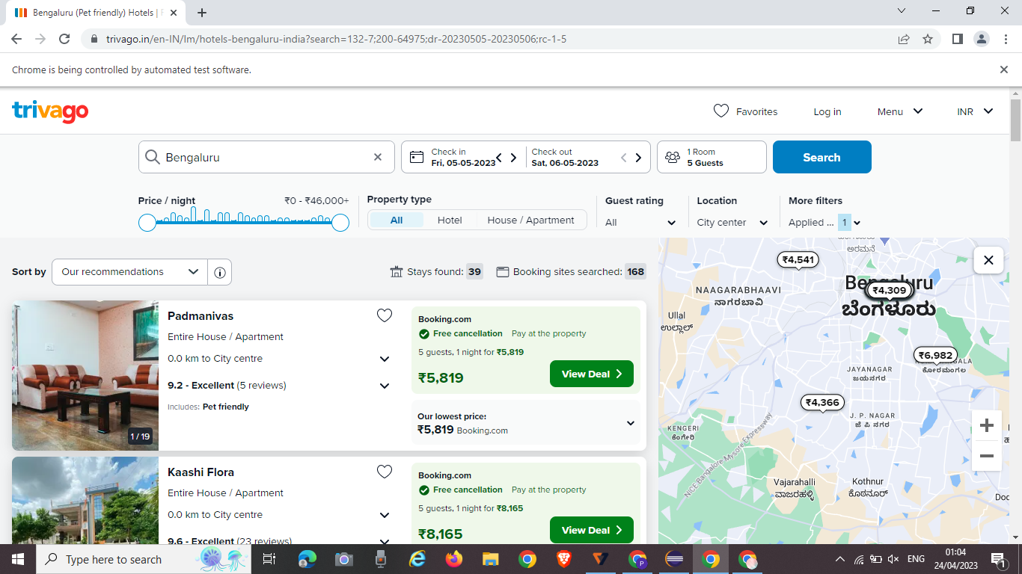

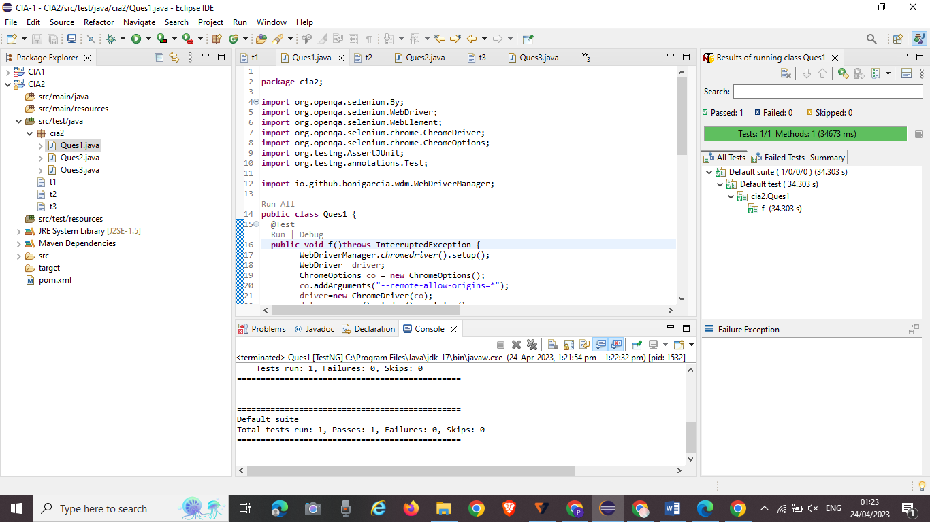

Code2:

**package Cia2;**

**import org.openqa.selenium.By;**

**import org.openqa.selenium.WebDriver;**

**import org.openqa.selenium.WebElement;**

**import org.openqa.selenium.chrome.ChromeDriver;**

**import org.openqa.selenium.chrome.ChromeOptions;**

**import org.testng.annotations.Test;**

**import io.github.bonigarcia.wdm.WebDriverManager;**

**public class Cia2_2 {**

**WebDriver driver;**

***@Test***

**public void f() throws InterruptedException{**

**ChromeOptions co=new ChromeOptions();**

**co.addArguments("--remote-allow-origins=*");**

**WebDriverManager.*chromedriver*().setup();**

**WebDriver driver=new ChromeDriver(co);**

**driver.get("https://www.trivago.in/");**

**driver.manage().window().maximize();**

**String currtitle=driver.getTitle();**

**System.*out*.println(currtitle);**

**driver.findElement(By.*xpath*("//*[@id=\"input-auto-complete\"]")).click();**

**Thread.*sleep*(3000);**

**driver.findElement(By.*xpath*("//*[@id=\"suggestion-list\"]/ul/li[1]/div/div")).click();**

**Thread.*sleep*(3000);**

**driver.findElement(By.*xpath*("//*[@id=\"__next\"]/div[1]/div[1]/section/div[2]/div[3]/div/div[2]/div/div/div/div[2]/div/div[1]/div[2]/button[24]/time")).click();**

**Thread.*sleep*(3000);**

**driver.findElement(By.*xpath*("//*[@id=\"__next\"]/div[1]/div[1]/section/div[2]/div[3]/div/div[2]/div/div/div/div[2]/div/div[1]/div[2]/button[26]/time")).click();**

**Thread.*sleep*(3000);**

**driver.findElement(By.*xpath*("//*[@id=\"__next\"]/div[1]/div[1]/section/div[2]/div[3]/div/div[2]/div/div/div[1]/div/div[1]/div[1]/div/button[2]")).click();**

**Thread.*sleep*(3000);**

**driver.findElement(By.*xpath*("//*[@id=\"__next\"]/div[1]/div[1]/section/div[2]/div[3]/div/div[2]/div/div/div[1]/div/div[1]/div[3]/div/button[2]")).click();**

**Thread.*sleep*(3000);**

**driver.findElement(By.*xpath*("/html/body/div[1]/div[1]/div[1]/section/div[2]/div[3]/div/div[2]/div/div/div[1]/div/div[2]/div[2]/input")).click();**

**Thread.*sleep*(3000);**

**driver.findElement(By.*xpath*("//*[@id=\"__next\"]/div[1]/div[1]/section/div[2]/div[3]/div/div[2]/div/div/div[2]/div/button[2]")).click();**

**Thread.*sleep*(40000);**

**driver.findElement(By.*xpath*("//*[@id=\"sorting-selector\"]")).click();**

**driver.findElement(By.*xpath*("//*[@id=\"sorting-selector\"]/option[4]")).click();**

**WebElement name=driver.findElement(By.*xpath*("//*[@id=\"__next\"]/div[1]/main/div[5]/section/div/div/ol/li[1]/div/article/div[2]/div[1]/section/h2/button/span"));**

**WebElement price=driver.findElement(By.*xpath*("//*[@id=\"__next\"]/div[1]/main/div[5]/section/div/div/ol/li[1]/div/article/div[2]/div[1]/section/h2/button/span"));**

**WebElement stays=driver.findElement(By.*xpath*("//*[@id=\"__next\"]/div[1]/main/div[5]/div[3]/div/div[2]/div[1]/div/div[2]/div[2]/div/div/div[1]/span[2]/strong"));**

**WebElement sites=driver.findElement(By.*xpath*("//*[@id=\"__next\"]/div[1]/main/div[5]/div[3]/div/div[2]/div[1]/div/div[2]/div[2]/div/div/div[2]/span[2]/strong"));**

**System.*out*.print("Hotel Name : "+name.getText());**

**System.*out*.print("Hotel Price : "+price.getText());**

**System.*out*.print("Stays Found : "+stays.getText());**

**System.*out*.print("Number of Booking sites Searched : "+sites.getText());**

**}**

**}**

Output:

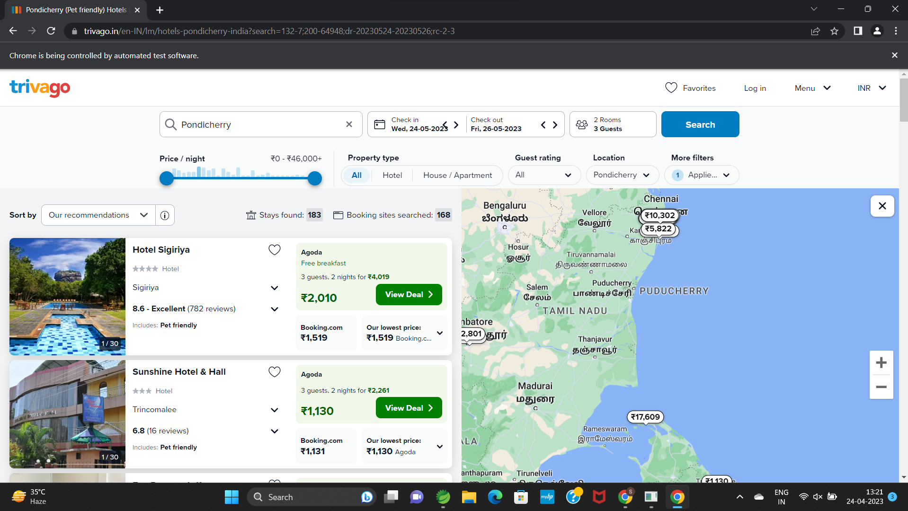

Code 3:

**package** cia2;

**import** java.util.List;

**import** org.openqa.selenium.By;

**import** org.openqa.selenium.WebDriver;

**import** org.openqa.selenium.WebElement;

**import** org.openqa.selenium.chrome.ChromeDriver;

**import** org.openqa.selenium.chrome.ChromeOptions;

**import** org.testng.annotations.Test;

**import** io.github.bonigarcia.wdm.WebDriverManager;

**public** **class** Ques3 {

@Test

**public** **void** qn3() **throws** InterruptedException {

WebDriverManager.*chromedriver*().setup();

WebDriver driver;

ChromeOptions co = **new** ChromeOptions();

co.addArguments("--remote-allow-origins=*");

driver = **new** ChromeDriver(co);

driver.manage().window().maximize();

driver.navigate().to("https://www.trivago.in/en-IN/srl/cheap-hotels-pondicherry-india?search=200-64948;dr-20230511-20230512;so-4");

String title=driver.getTitle();

System.***out***.println(title);

**if**(title.equals("Pondicherry Hotels | Find & compare great deals on trivago"))

System.***out***.println("Title validated");

**else**

System.***out***.println("Title not validated");

Thread.*sleep*(32000);

List<WebElement> sele = driver.findElements(By.*xpath*("//*[@id=\"__next\"]/div[1]/main/div[5]/section"));

System.***out***.println(sele.size());

**int** i=0;

**for** (WebElement webElement : sele) {

**if**(i==5)

**break**;

String name = webElement.getText();

System.***out***.println(name);

i++;

}

}

}

OUTPUT:

