Class exercise-1:

**package** Day5;

**import** io.github.bonigarcia.wdm.WebDriverManager;

**import** org.openqa.selenium.By;

**import** org.openqa.selenium.WebDriver;

**import** org.openqa.selenium.WebElement;

**import** org.openqa.selenium.chrome.ChromeDriver;

**import** org.openqa.selenium.chrome.ChromeOptions;

**import** org.openqa.selenium.interactions.Actions;

**public** **class** test1 {

**public** **static** **void** main(String[] args) {

WebDriverManager.*chromedriver*().setup();

ChromeOptions co=**new** ChromeOptions();

co.addArguments ("--remote-allow-origins=*");

WebDriver driver=**new** ChromeDriver(co);

driver.get ("https://demoqa.com/droppable/");

driver.manage().window().maximize() ;

WebElement drag=driver.findElement(By.*id*("draggable"));

WebElement drop=driver.findElement(By.*id*("droppable"));

Actions a = **new** Actions(driver);

a.dragAndDrop(drag, drop).build().perform();

}

}

Output:

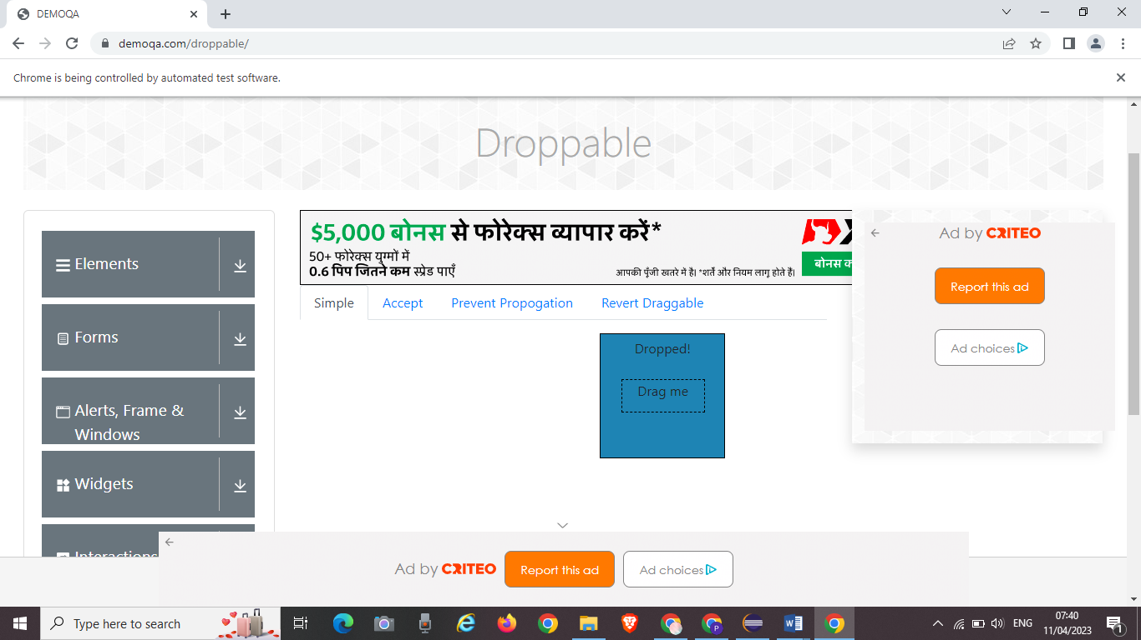

Class exercise-2:

**package** Day5;

**import** org.openqa.selenium.By;

**import** org.openqa.selenium.WebDriver;

**import** org.openqa.selenium.WebElement;

**import** org.openqa.selenium.chrome.ChromeDriver;

**import** org.openqa.selenium.interactions.Actions;

**import** io.github.bonigarcia.wdm.WebDriverManager;

**public** **class** test2 {

**public** **static** **void** main( String[] args ) **throws** InterruptedException

{

WebDriverManager.*chromedriver*().setup();

WebDriver driver = **new** ChromeDriver();

driver.manage().window().maximize();

driver.navigate().to("https://jqueryui.com/droppable/");

driver.manage().window().maximize();

driver.switchTo().frame(0);

WebElement drag = driver.findElement(By.*id*("draggable"));

WebElement drop = driver.findElement(By.*id*("droppable"));

Actions a = **new** Actions(driver);

a.dragAndDrop(drag, drop).build().perform();

}

}

Output:

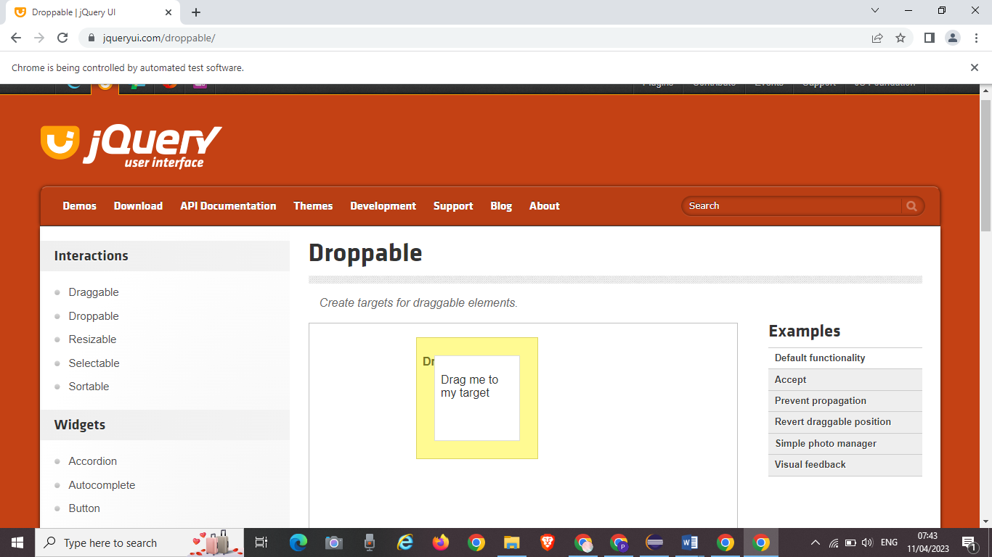

Class exercise-3:

**package** Day5;

**import** org.openqa.selenium.Alert;

**import** org.openqa.selenium.By;

**import** org.openqa.selenium.WebElement;

//public class test3 {

**import** org.openqa.selenium.WebDriver;

//import org.openqa.selenium.WebElement;

**import** org.openqa.selenium.chrome.ChromeDriver;

**import** org.openqa.selenium.chrome.ChromeOptions;

**import** io.github.bonigarcia.wdm.WebDriverManager;

**public** **class** test3 {

**public** **static** **void** main(String[] args) **throws** InterruptedException {

WebDriverManager.*chromedriver*().setup();

WebDriver driver;

ChromeOptions co=**new** ChromeOptions();

co.addArguments("--remote-allow-orgins=*");

driver=**new** ChromeDriver(co);

driver.get("https://demo.guru99.com/test/delete_customer.php");

WebElement cusid=driver.findElement(By.*name*("cusid"));

cusid.sendKeys("401");

WebElement submit=driver.findElement(By.*name*("submit"));

submit.click();

Thread.*sleep*(300);

driver.switchTo().alert().dismiss();

cusid.clear();

cusid.sendKeys("402");

submit.click();

Alert alert1=driver.switchTo().alert();

alert1.accept();

String str=alert1.getText();

System.***out***.print(str);

}

}

Output:

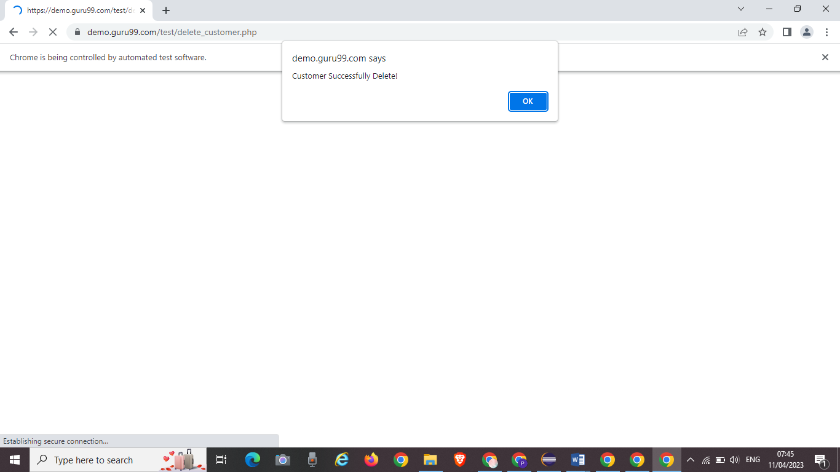

Class exercise-4:

package Day5;

import org.openqa.selenium.By;

import org.openqa.selenium.JavascriptExecutor;

import org.openqa.selenium.Keys;

import org.openqa.selenium.WebDriver;

import org.openqa.selenium.WebElement;

import org.openqa.selenium.chrome.ChromeDriver;

import org.openqa.selenium.chrome.ChromeOptions;

//import org.openqa.selenium.interactions.Actions;

import io.github.bonigarcia.wdm.WebDriverManager;

public class test4 {

public static void main(String[] args) {

WebDriverManager.chromedriver().setup();

WebDriver driver;

ChromeOptions co=new ChromeOptions();

co.addArguments("--remote-allow-origin=*");

driver=new ChromeDriver(co);

driver.get("https://www.abhibus.com/bus-ticket-booking?utm_source=google&utm_medium=cpc&utm_campaign=Sitelink&gclid=CjwKCAjwitShBhA6EiwAq3RqA1GHVvbJ-Z_Vequ0X8cZGe6kJsC2yFV7nkVML0Bn0MH6lPyM0_bOBhoCsqwQAvD_BwE");

WebElement from=driver.findElement(By.id("source"));

from.sendKeys(" Chennai");

WebElement to=driver.findElement(By.id("destination"));

to.sendKeys(" CBE"+Keys.ENTER);

WebElement date=driver.findElement(By.xpath("//*[@id=\"datepicker1\"]"));

JavascriptExecutor js=(JavascriptExecutor)driver;

js.executeScript("arguments[0].setAttribute('value','16/02/2020')",date);

}

}

Output:

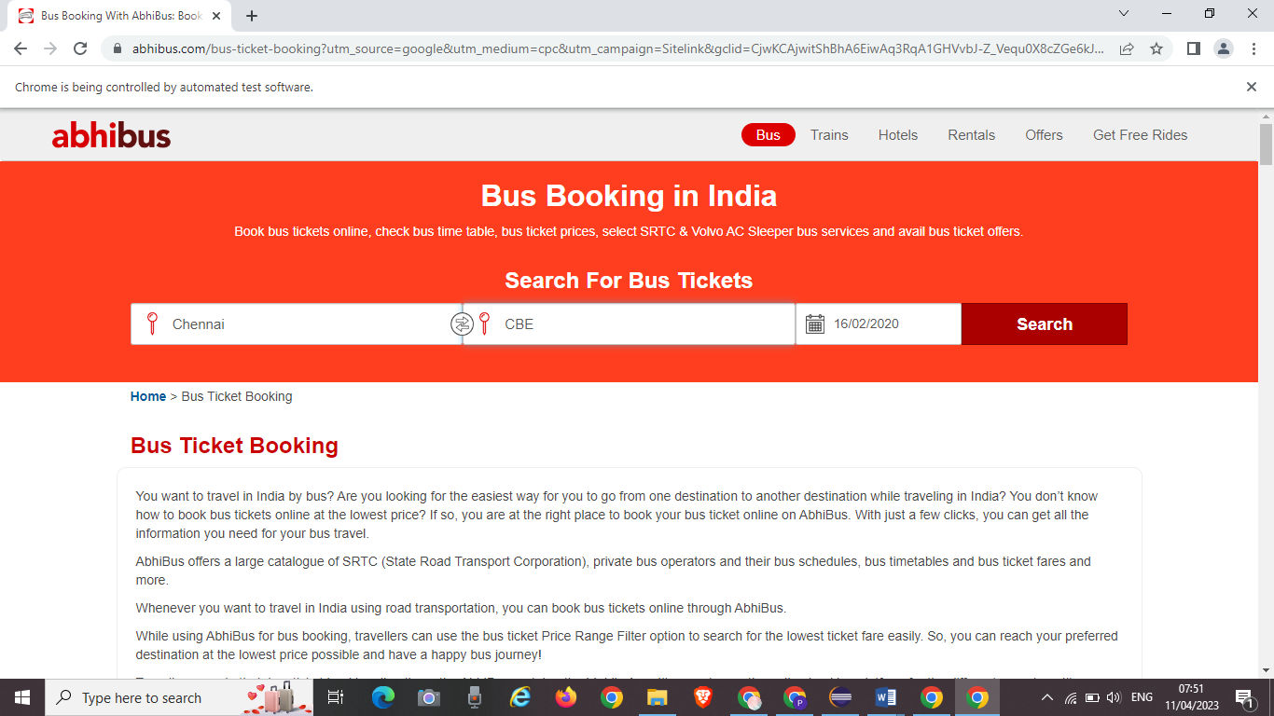

Class exercise-5

package Day5;

import java.util.Set;

import org.openqa.selenium.By;

import org.openqa.selenium.Keys;

import org.openqa.selenium.WebDriver;

import org.openqa.selenium.WindowType;

import org.openqa.selenium.chrome.ChromeDriver;

import org.openqa.selenium.chrome.ChromeOptions;

//import org.openqa.selenium.firefox.FirefoxDriver;

//import org.openqa.selenium.firefox.FirefoxOptions;

import io.github.bonigarcia.wdm.WebDriverManager;

public class test5 {

public static void main(String[] args) {

WebDriverManager.chromedriver().setup();

WebDriver driver;

ChromeOptions co = new ChromeOptions();

co.addArguments("--remote-allow-origins=*");

driver = new ChromeDriver(co);

driver.get("https://www.google.com/");

driver.manage().window().maximize();

driver.findElement(By.name("q")).sendKeys("Apple");

driver.findElement(By.name("q")).sendKeys(Keys.ENTER);

System.out.println(driver.getWindowHandle());

System.out.println(driver.getTitle());

driver.switchTo().newWindow(WindowType.TAB);

driver.get("https://www.google.com/");

driver.manage().window().maximize();

driver.findElement(By.name("q")).sendKeys("Selenium");

driver.findElement(By.name("q")).sendKeys(Keys.ENTER);

System.out.println(driver.getTitle());

System.out.println(driver.getWindowHandle());

driver.switchTo().newWindow(WindowType.TAB);

driver.get("https://www.google.com/");

driver.manage().window().maximize();

driver.findElement(By.name("q")).sendKeys("Cucumber");

driver.findElement(By.name("q")).sendKeys(Keys.ENTER);

System.out.println(driver.getTitle());

System.out.println(driver.getWindowHandle());

Set<String>s=driver.getWindowHandles();

System.out.println("Total Number of browsers "+s.size());

}

}

Output:

