🧬
VitaTwin Health Intelligence Assistant
- PRANET PAHWA
Machine Learning, Explainable AI & Digital Health Twin Prototype
Technical Evaluation Submission | HOPn Internship / VitaTwin AI Intelligence Track
700  Dataset  synthetic health records | RF  Final Model  Random Forest classifier | 90.71%  Accuracy  advanced model performance | 97.10%  ROC-AUC  risk separation quality

EXECUTIVE SUMMARY
The VitaTwin Health Intelligence Assistant is a compact healthcare intelligence prototype designed to transform routine health indicators into explainable, longitudinal, and actionable Digital Health Twin records. Instead of producing a one-time risk prediction, the system creates a complete health intelligence workflow: input health data, predict risk, explain why the prediction occurred, generate a human-readable insight, and save the result as a timeline event for future comparison.
The project demonstrates the core idea behind a Human Digital Health Twin: an evolving digital representation of a user’s health state. Each analysis becomes a snapshot that can later be compared against previous readings, allowing the dashboard to show whether health risk is improving, worsening, or remaining stable.

Design Philosophy
The prototype was built to show both technical capability and product thinking: ML quality, explainability, healthcare understanding, GenAI-style insight generation, Digital Twin storage, and dashboard visualization.

Prototype Snapshot
Layer | What it does | Implementation
Data Layer | Collects patient health indicators | Synthetic dataset + Streamlit input form
ML Layer | Predicts health risk category | Logistic Regression + Random Forest
Explainability Layer | Explains why risk was predicted | Feature importance + patient-specific factors
Insight Layer | Generates readable health summaries | Prompt-based health intelligence engine
Twin Layer | Stores each analysis as timeline event | JSON-based Digital Twin record

1. PROBLEM CONTEXT AND PRODUCT OPPORTUNITY
Healthcare data is often fragmented into isolated measurements: blood pressure readings, glucose values, BMI, sleep patterns, stress scores, and activity levels. Individually, these measurements are useful; together, they can become a powerful preventive intelligence layer. The challenge is not only to detect risk, but to explain the risk in a way that patients, doctors, and health platforms can use.
A Digital Health Twin improves this by maintaining an evolving record of a person’s health status. Instead of treating every measurement as a standalone event, the twin converts each reading into a continuous health timeline. This makes it possible to monitor trends, identify risk drivers, and support early intervention.

Healthcare Challenge | Why it matters | VitaTwin Prototype Response
Reactive care | Risks are often detected late | Predictive risk scoring
Black-box AI | Users may not trust unexplained predictions | Feature importance and patient-level reasoning
Fragmented data | Health signals are not connected over time | Digital Twin timeline storage
Low usability | Raw numbers are difficult to interpret | AI health insight generator
Poor monitoring | No simple trend view | Risk score trend dashboard

2. SYSTEM ARCHITECTURE
End-to-End Intelligence Flow
Patient Health Data → ML Prediction → Explainability → AI Health Insight → Digital Twin Timeline → Dashboard
The architecture was designed as a modular pipeline. Each layer has a clear role: data ingestion, prediction, explanation, insight generation, persistent storage, and visualization. This modularity makes the prototype easier to extend with real datasets, SHAP explanations, wearable data, or LLM-powered reasoning in future versions.

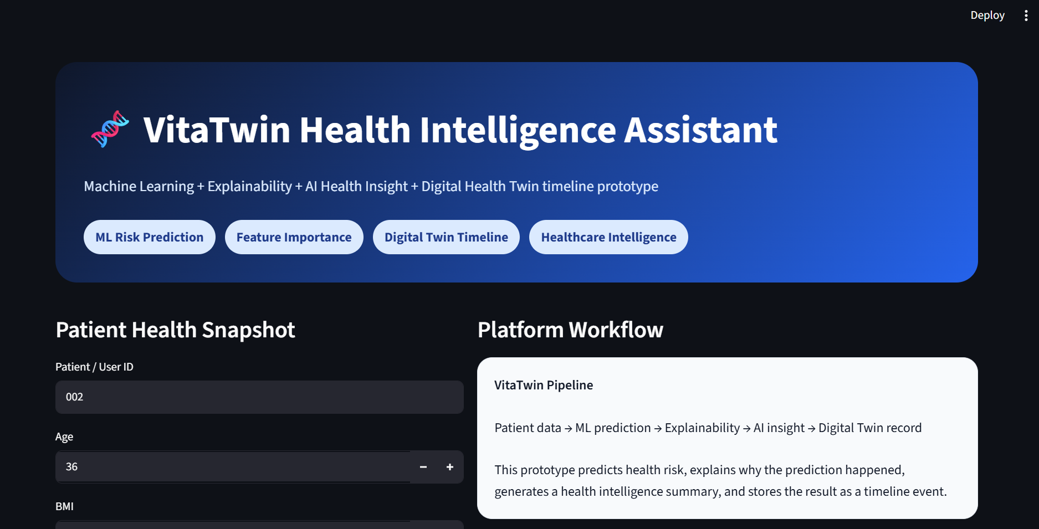

3. DATASET DEVELOPMENT
A synthetic healthcare dataset with 700 records was generated to match the evaluation requirement. The selected variables represent lifestyle, metabolic, and cardiovascular signals commonly associated with health risk. The target variable is a binary health risk category: Low Risk or High Risk.
Feature | Health Domain | Reason for Inclusion
Age | Cardiovascular | Risk tends to increase with age and long-term exposure to unhealthy patterns.
BMI | Metabolic | Indicates weight-related metabolic risk.
Blood Pressure | Cardiovascular | Strong indicator of cardiovascular strain and hypertension risk.
Glucose | Metabolic | Reflects diabetes and metabolic control signals.
Cholesterol | Cardio-Metabolic | Associated with lipid risk and heart health.
Activity Level | Lifestyle | Captures movement behavior and preventive health capacity.
Sleep Hours | Lifestyle | Represents recovery, routine, and health stability.
Stress Level | Behavioral | Adds behavioral and lifestyle risk context.

4. MACHINE LEARNING METHODOLOGY
Two models were trained to compare a simple interpretable baseline with a stronger ensemble-based model. Logistic Regression was used as the baseline due to its simplicity and common use in risk modeling. Random Forest was used as the advanced model because it can capture nonlinear relationships and interactions between health variables.

Metric | Logistic Regression | Random Forest | Interpretation
Accuracy | 73.57% | 90.71% | Random Forest predicted health risk more accurately.
Precision | 70.37% | 88.33% | Advanced model reduced false high-risk predictions.
Recall | 64.41% | 89.83% | Random Forest detected more actual high-risk cases.
F1 Score | 67.25% | 89.08% | Better balance between precision and recall.
ROC-AUC | 83.70% | 97.10% | Strong ability to distinguish low-risk and high-risk profiles.

Model Selection Decision
Random Forest was selected as the final prediction engine because it outperformed Logistic Regression across all evaluation metrics while also supporting feature importance for explainability.

5. EXPLAINABLE AI FRAMEWORK
In healthcare AI, a prediction without explanation has limited practical value. The prototype therefore includes a patient-specific explainability layer. Instead of only displaying a risk score, the system identifies the factors that contributed to the prediction for that particular patient.
Feature Importance was used as the explainability method. The dashboard shows the detected risk drivers, their patient values, and their model importance. This makes the output more transparent and supports trust in the model’s reasoning.
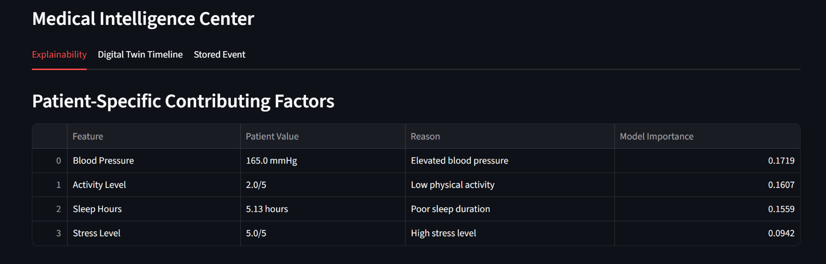

6. AI HEALTH INSIGHT GENERATOR
The insight generator converts numerical predictions into human-readable healthcare summaries. It transforms technical model outputs into patient-facing explanations, focus areas, and Digital Twin context. The current implementation uses a prompt-based system, which satisfies the requirement while keeping the prototype reliable and fast during demonstration.

Input to Insight Engine | Generated Output
Risk score and category | Overall health intelligence summary
Detected risk drivers | Main risk pattern explanation
Patient health values | Personalized focus areas
Timeline context | Digital Twin interpretation

Example Insight
The user is placed in a High Risk category because the health twin snapshot shows elevated blood pressure, poor sleep duration, and low physical activity. Future timeline events can show whether these drivers improve or worsen.

7. DIGITAL HEALTH TWIN INTEGRATION
Every analysis is stored as a Digital Health Twin timeline event. This is the difference between a normal prediction tool and a Digital Twin-oriented system. The platform does not simply return a result; it creates a persistent health event containing the user ID, timestamp, prediction, risk score, explanation, insight, and patient inputs.

8. DASHBOARD AND VISUALIZATION LAYER
The Streamlit dashboard was designed to separate patient-facing information from clinical/admin intelligence. The patient-facing view focuses on risk score, health domain status, priority focus areas, and AI health insight. The admin view provides explainability details, feature importance visualization, timeline history, and stored JSON records.
Dashboard Area | User Value | Evaluation Value
Digital Health Twin Overview | Quick understanding of current risk | Shows healthcare product thinking
Health Domains | Separates cardiovascular, metabolic, and lifestyle signals | Demonstrates healthcare understanding
Priority Focus Areas | Turns risk into action | Improves usability
Medical Intelligence Center | Provides model transparency | Supports explainability evaluation
Timeline Graph | Shows risk history | Demonstrates Digital Twin concept

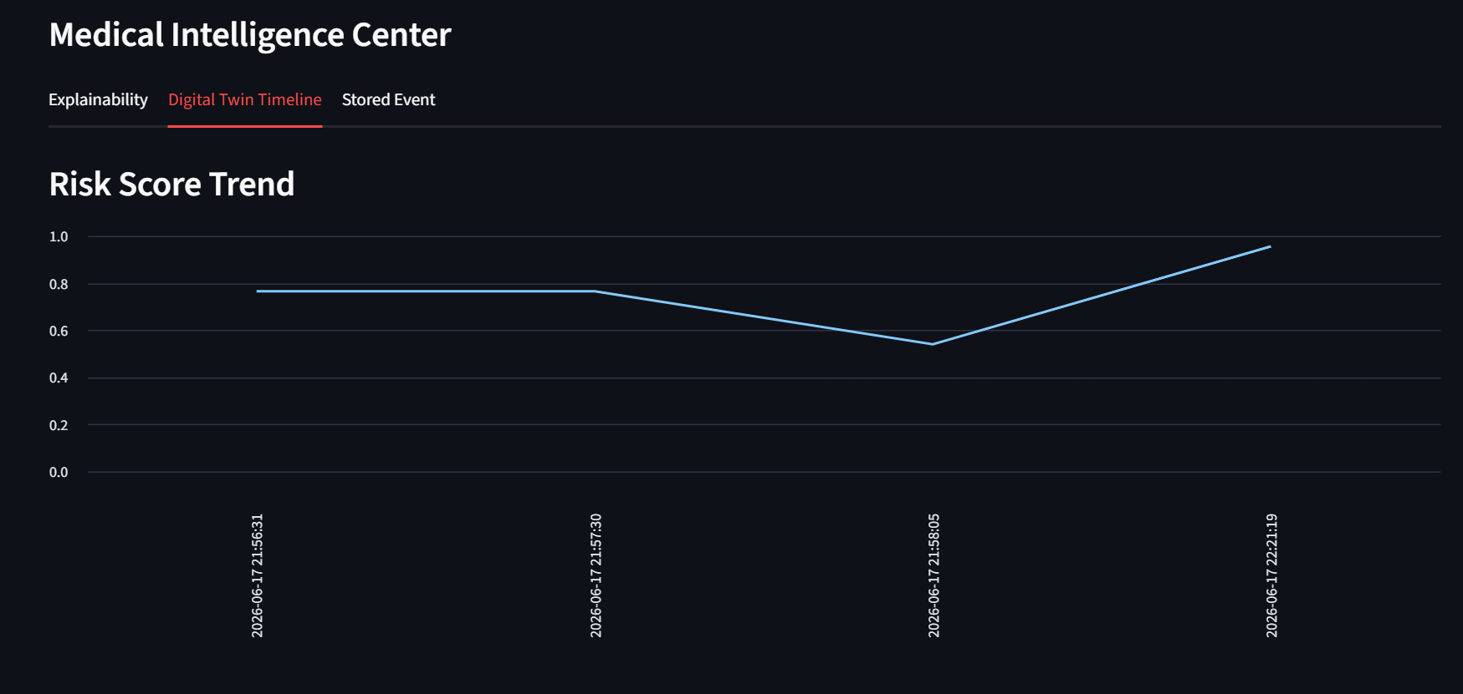
9. RESULTS AND EVALUATION MAPPING
The project meets the main evaluation criteria by combining strong machine learning performance with explainability, healthcare reasoning, dashboard visualization, and Digital Health Twin storage. The Random Forest model achieved 90.71% accuracy and 97.10% ROC-AUC, while the dashboard demonstrates how predictions can be converted into explainable and longitudinal healthcare intelligence.
Evaluation Criteria | How the Project Addresses It
ML Quality | Baseline and advanced models trained, evaluated, and compared.
Explainability | Feature Importance and patient-specific contributing factors.
Healthcare Understanding | Risk domains include lifestyle, metabolic, and cardiovascular signals.
GenAI Usage | Prompt-based AI health insight generation.
Product Thinking | Patient view, admin view, and Digital Twin timeline.
Visualization Quality | Risk scores, trends, domains, and explainability charts.

10. FUTURE VISION
- Integrate Ollama or Llama-based local LLMs for richer personalized health intelligence.
- Add SHAP explanations for deeper patient-specific model reasoning.
- Use validated healthcare datasets for clinical-grade model testing.
- Create multi-user Digital Twin profiles with separate timeline histories.
- Connect wearable devices for real-time sleep, heart rate, activity, and stress signals.
- Add CNN or transfer-learning based medical image classification as a computer vision module.
CONCLUSION
The VitaTwin Health Intelligence Assistant demonstrates how machine learning, explainability, AI-generated insight, and Digital Health Twin concepts can work together to create a preventive healthcare intelligence platform. The system moves beyond simple prediction by explaining risk, generating meaningful summaries, and preserving each analysis as part of an evolving health timeline. This prototype represents a practical foundation for future Digital Health Twin intelligence systems.

