SCI-INTEL: Acquisition-Aware Retrieval and Quality-Risk Curation of Scientific Microscopy Images
PRANET PALLATI (Primary & Corresponding Author)  24881A05B7  Department of Computer Science and Engineering  Vardhaman College of Engineering  Hyderabad, Telangana, India  24881A05B7@student.vardhaman.org | GOLLAKOTA CHARAN DEEP (Author)  24881A0586  Department of Computer Science and Engineering  Vardhaman College of Engineering  Hyderabad, Telangana, India  24881A0586@student.vardhaman.org
POOJA VUNNAM (Author)  24881A05B5  Department of Computer Science and Engineering  Vardhaman College of Engineering  Hyderabad, Telangana, India  24881A05B5@student.vardhaman.org | MS. C. BHAVANA (Faculty Guide & Supervisor, Author)  Assistant Professor  Department of Computer Science and Engineering  Vardhaman College of Engineering  Hyderabad, Telangana, India  bhavana1817@vardhaman.org

Abstract—Retrieval and quality control of scanning electron microscopy (SEM) archives are complicated because one specimen looks different under different instruments, detectors, and accelerating voltages. We present SCI-INTEL, a local platform that keeps two separate representations: a frozen DINOv2 ViT-S/14 for image-derived quality screening and an acquisition-aware supervised-contrastive adapter for same-specimen retrieval. The branches are combined by deterministic evidence retrieval, rule-based suggested actions, uncertainty-aware abstention, and curator review, not by learned fusion. On an instrument-held-out split of the HCCI collection (212 queries; three specimens shared across splits), the adapter reduced the observed acquisition-geometry similarity gap from 0.2016 to 0.0681 (66.23%; paired dz = 2.19, p = 5.03×10^-36, 210 queries) and raised Recall@5 from 0.9858 to 0.9921 under an unmasked-distractor protocol, but lowered 11-class synthetic-artifact macro-F1 from 0.6837 to 0.6323. Frozen DINOv2 reached binary AUROC 0.8582, and model-derived suspicious-region localization reached macro IoU 0.4454 (Dice 0.5103) on 500 synthetic masks. Selective prediction reached 99.08% accuracy at 29.73% coverage, with weak calibration (ECE 0.3333), and evidence was available for all 55 evaluated queries. Results rest on synthetic artifacts and limited specimen coverage; they do not establish physical-defect detection or unseen-specimen generalization.
Index Terms—scientific microscopy, image retrieval, acquisition robustness, quality assessment, human-in-the-loop curation
I. INTRODUCTION
Scanning electron microscopy (SEM) images depend strongly on how they are acquired. Accelerating voltage, detector (secondary or backscattered electrons), working distance, and focus change contrast and apparent texture, so one specimen can look more different across settings than different specimens do under identical settings. In shared archives, similarity search then returns same-acquisition neighbors instead of same-specimen evidence, and quality control is slow and subjective.
Four problems follow: (1) acquisition-induced visual variance; (2) the unverified benefit of acquisition metadata for ranking; (3) redundant re-scans, where aggressive deduplication could discard legitimate acquisitions; and (4) automated suggestions without a human decision point or traceable records. We treat the task as scientific-image retrieval and quality-risk curation. It is not diagnosis, and every indicator is image-derived and advisory.
Contributions. (C1) Acquisition-aware retrieval: a supervised-contrastive adapter on frozen DINOv2 features, trained with same-acquisition pairs masked and evaluated with unmasked distractors on an instrument-held-out split. (C2) A quantified specialization trade-off: adaptation helps retrieval but lowers artifact sensitivity, so screening stays on the frozen representation. (C3) Screening and evidence: image-derived quality risk, model-derived suspicious-region localization, evidence retrieval, and uncertainty-aware abstention, evaluated on controlled synthetic degradations. (C4) Engineering integration: a reproducible local platform that persists curator decisions, provenance events, and audit logs. C1 and C2 are the methodological findings; C4 is integration.
II. RELATED WORK
Micrograph retrieval. Handcrafted descriptors such as GLCM textures [1], SIFT [2], and visual-word signatures [3] were used for microstructure search; see [4] and the CBIR survey [5]. MicroNet pre-training improves micrograph segmentation [6]. Foundation features. Vision Transformers [7] trained by self-distillation [8], masked modeling [9], or at scale as DINOv2 [10] give general features; ResNet [11] is a common baseline. Acquisition shift. Contrastive [12] and supervised contrastive [13] objectives shape metric spaces, and domain-divergence theory [14] motivates treating instrument change as distribution shift. Indexing. FAISS [15] and HNSW [16] provide vector search. Quality and abstention. No-reference quality [17], structural similarity [18], anomaly benchmarks [19], selective classification [20, 21], and calibration [22] inform our screening and abstention. Curation. Perceptual hashing [23] and FAIR principles [24] inform deduplication and provenance.
III. SCI-INTEL ARCHITECTURE AND METHOD
A. Workflow and branches
Fig. 1 shows the workflow: upload, validation, storage, metadata, representation, quality screening, localization, retrieval, evidence retrieval, explanation, suggested action, uncertainty handling, review, curation, audit, and provenance. A FastAPI backend with JWT authentication, an SQLAlchemy database (SQLite by default), FAISS indices, and a React/TypeScript workbench implement it locally. Two representations stay separate: dinov2_base (frozen DINOv2 ViT-S/14) and phase4_adapted (an adapter head on DINOv2 features). They share no weights and are combined only by deterministic orchestration.
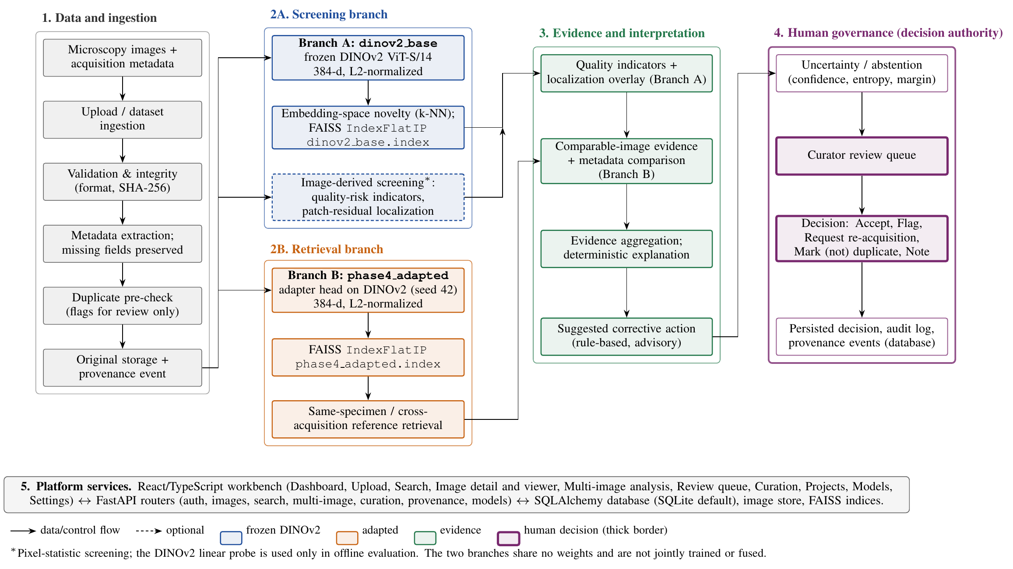
Fig. 1. SCI-INTEL architecture. The branches dinov2_base and phase4_adapted share no weights and are not jointly trained or fused; they are combined only by deterministic orchestration. Curators remain the decision authority.
B. Representation and retrieval
Images are resized, ImageNet-normalized, and encoded into 384-d vectors, then L2-normalized; similarity is cosine (inner product) in exact FAISS IndexFlatIP indices, one per representation:
ẑ = z / ‖z‖₂, s(q, x) = ẑ_qᵀ ẑ_x (1)
The adapter maps normalized features to a unit-norm 384-d embedding (seed 42: linear head; seeds 123 and 2024: Linear–LayerNorm–GELU–Linear). With specimen labels m and acquisition labels a, positives P(i) are same-specimen, different-acquisition pairs; same-specimen, same-acquisition pairs are excluded from the positives and from the comparison set V(i):
ℒ = −(1/|I|) ∑_{i∈I} (1/|P(i)|) ∑_{p∈P(i)} log[exp(s_ip / τ) / ∑_{a∈V(i)} exp(s_ia / τ)] (2)
with τ = 0.07. Training used AdamW [25] (learning rate 10⁻⁴, weight decay 10⁻⁴, batch 64, at most 40 epochs) on 427 images, and 135 validation images selected the checkpoint (best epoch 1 on a saturated validation set). The platform serves the seed-42 head after checkpoint-hash verification. The observed acquisition gap over same-specimen pairs is:
Δ = s̄_within − s̄_cross, R_Δ = (Δ_base − Δ_adapt) / Δ_base × 100% (3)
C. Screening, evidence, and review
Quality risk: the platform combines Laplacian variance, entropy, clipping ratio, and an FFT high-frequency ratio into a composite risk (flag at ≥ 0.50); offline evaluation adds a linear probe on frozen DINOv2 features for 11 synthetic categories, which is not part of the deployed engine. Localization thresholds a 16×16 patch-residual saliency map (|patch mean − image median|, min–max normalized, threshold 0.50) into boxes; it is not attention rollout and its output is a model-derived suspicious region, never a confirmed defect. Novelty is the mean cosine distance to the five nearest HCCI reference embeddings. Uncertainty uses confidence, normalized entropy, and top-two margin; the frozen configuration abstains at confidence < 0.40, entropy > 0.75, or margin < 0.10.
Evidence and action: a second retrieval returns comparable references (same specimen across acquisitions, cross-instrument, quality-compatible), and a rule catalog maps indicators to suggested corrective actions. Curators accept, flag, request re-acquisition, mark (not) duplicate, or add notes. The ingestion duplicate cascade declares exact duplicates by file or decoded-pixel SHA-256, and potential near-duplicates only when a perceptual-hash gate (threshold 10 on hash-string differences), DINOv2 and adapted cosine ≥ 0.985, and SSIM ≥ 0.95 all hold; the multi-image service applies its own rules (exact SHA-256; SSIM ≥ 0.95 with mean absolute error ≤ 5; cosine ≥ 0.75 for 'similar'). Results guide review and never delete images; no labeled benchmark supports their error rates. Decisions, provenance events, and audit logs are stored as database records; they are not hash-chained or tamper-evident.
IV. EXPERIMENTAL SETUP
Table I lists the 6,085 active micrographs. The HCCI split [27] (the record lists 777 micrographs; the deposited archive and our manifest contain 774) is instrument-disjoint (train: Helios; validation: VEGA3; test: Zeiss Gemini) with no image, hash, or near-duplicate overlap, but the same three steel specimens occur in every split. The task is acquisition-robust same-specimen retrieval, not unseen-specimen generalization. Carinthia [28] (100 images) serves a cross-domain novelty screen; BBBC021 [26] (fluorescence) is used only for ingestion and metadata profiling. Larger registered collections [29] were not evaluated.
Dataset | Images | Format | License | Role
HCCI (SEM, cast iron) | 774 | PNG | CC BY 4.0 | Retrieval; synthetic
Carinthia (SEM) | 4,591 | JPEG | CC BY 4.0 | Novelty screen
BBBC021 (bioimage) | 720 | TIFF (16-bit) | CC0 1.0 | Metadata profiling
Total active micrographs | 6,085 | Multi-format | – | Evaluated repository cohort
HCCI Train | 427 | PNG | CC BY 4.0 | Helios NanoLab, Helios G4 PFIB CXe
HCCI Validation | 135 | PNG | CC BY 4.0 | VEGA3 XMH
HCCI Test (queries) | 212 | PNG | CC BY 4.0 | Zeiss Gemini (211 candidates/query)

TABLE I: Datasets and HCCI Instrument-Disjoint Partition (3 Shared Steel Specimens).
Protocol U (unmasked distractors). Each of the 212 test images queries the other 211. A candidate is relevant if it shows the same specimen, a different acquisition, and a pHash distance above 3. Same-acquisition peers remain as non-relevant distractors, so R@1 is deliberately hard. In Protocol M, same-acquisition peers are masked; the two protocols use different candidate pools and are not comparable, and we report Protocol U only because Protocol M lacks a matching raw result file. Quality benchmark: 250 HCCI parent images are degraded into 2,750 images (11 balanced synthetic categories; 100/50/100 parents for train/validation/test, no parent overlap); the test set has 1,100 images (100 normal, 1,000 risk). Localization uses 500 synthetic masks. Gap statistics are paired over 210 test queries (Wilcoxon signed-rank; paired dz). Code, frozen results, and the table and figure scripts are in the project repository.
V. RESULTS
A. Acquisition gap and retrieval
The adapter shrank the observed acquisition-geometry gap from 0.2016 (within 0.7811, cross 0.5794) to 0.0681 (within 0.9085, cross 0.8404), a reduction of 66.23% (95% CI 65.72–67.19; query-level 66.40%), with p = 5.03×10⁻³⁶ and dz = 2.19 over 210 queries; per-seed reductions were 60.76%, 70.35%, and 67.57% (Fig. 2a). The adapted space is more compressed overall, so this is a reduction of the gap under the evaluated protocol, not acquisition invariance.
Under Protocol U (Table II, Fig. 2b) the 3-seed adapter reaches R@1 0.1447, R@5 0.9921, and MRR 0.5261, versus 0.1321, 0.9858, and 0.5200 for frozen DINOv2. The 95% confidence intervals overlap, so only the gap reduction is statistically strong. With three specimen classes R@5 is near ceiling for all deep models, and pHash attains the highest P@5 (0.6736), partly because the relevance rule itself uses a pHash threshold.
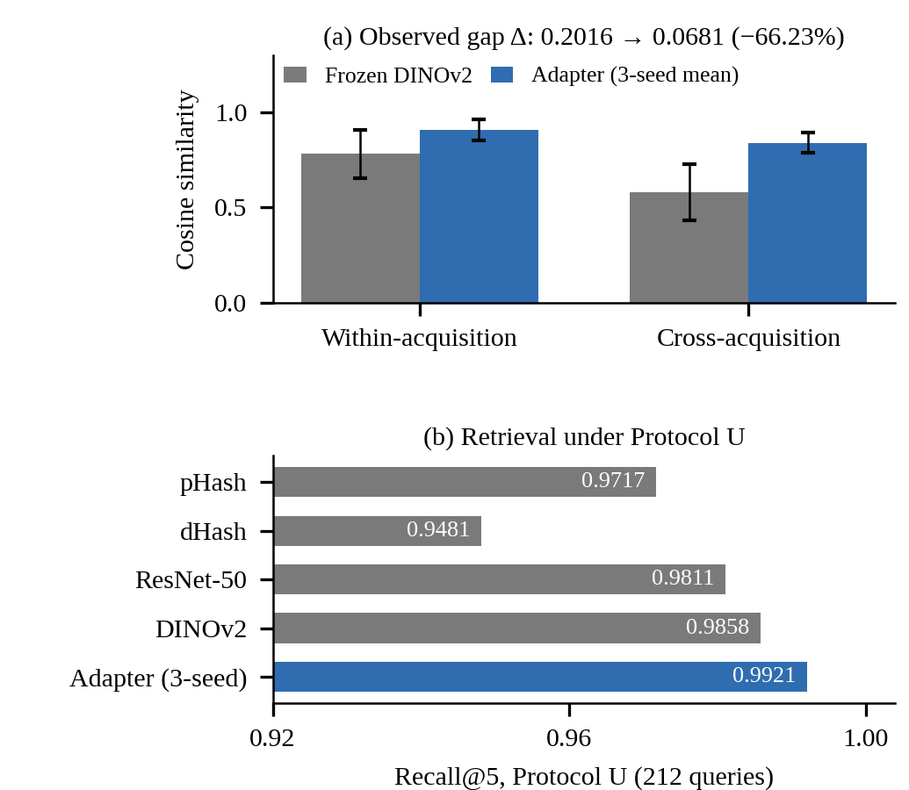
Fig. 2. (a) Within- and cross-acquisition cosine similarity (mean ± SD of pair similarities) for frozen DINOv2 and the 3-seed adapter mean; the observed gap shrinks from 0.2016 to 0.0681 over 210 paired test queries. (b) Recall@5 under Protocol U (212 queries, 211 candidates each).
Method | R@1 | R@5 | MRR | P@5
pHash-64 | 0.0991 | 0.9717 | 0.4894 | 0.6736
dHash-64 | 0.1085 | 0.9481 | 0.4995 | 0.6236
ResNet-50 | 0.0802 | 0.9811 | 0.4836 | 0.5726
DINOv2 ViT-S/14 | 0.1321 | 0.9858 | 0.5200 | 0.6160
Adapter, 3-seed mean | 0.1447 | 0.9921 | 0.5261 | 0.6327

TABLE II: Protocol U Retrieval Benchmarks (212 Queries, 211 Candidates Each).
B. Quality screening and trade-off
Threshold-free binary risk metrics (Table III) are AUROC/AUPRC 0.8281/0.9808 (handcrafted), 0.8582/0.9841 (frozen DINOv2), and 0.8230/0.9792 (adapted); the stored threshold-dependent binary table is internally inconsistent, so it is not reported. On the balanced 11-class task, macro-F1 equals weighted F1 and falls from 0.6837 (balanced accuracy 0.7036) to 0.6323 (0.6645) after adaptation. Adaptation therefore trades artifact sensitivity for retrieval, which motivates the two branches.
Metric | Handcrafted | Frozen DINOv2 | Adapted (3-seed)
Retrieval R@5 (Protocol U) | — | 0.9858 | 0.9921
Retrieval MRR (Protocol U) | — | 0.5200 | 0.5261
Acquisition gap Δ (lower better) | — | 0.2016 | 0.0681
Risk AUROC (binary) | 0.8281 | 0.8582 | 0.8230
Risk AUPRC (binary) | 0.9808 | 0.9841 | 0.9792
11-class macro-F1 | — | 0.6837 | 0.6323
11-class balanced accuracy | — | 0.7036 | 0.6645

TABLE III: Representation Specialization Trade-off Matrix.
C. Localization, uncertainty, evidence, and latency
Localization (Fig. 3b) reaches macro IoU 0.4454 and Dice 0.5103 (precision 0.5925, recall 0.4983) on 500 synthetic masks, strong for charging-like (0.7794 IoU) and exposure categories but weak for clipping (0.0762) and local illumination (0.2515). These are synthetic results.
Selective prediction (Fig. 3a) reaches 99.08% accuracy at 29.73% coverage (τ = 0.4) and 100% at 9.73% coverage (90.27% abstention at τ = 0.6). Calibration is poor (ECE 0.3333, Brier 0.4821), so confidence is a routing signal, not a calibrated probability. For the evaluated cohort of 55 queries (275 items; Table IV), every evidence check passed for 100.0% of queries, with no duplicate evidence and no missing provenance; this shows availability, not usefulness to experts. The k-NN novelty score reached AUROC 0.7404 (FPR@95 0.78) for DINOv2; a Carinthia cross-domain screen of 100 images was perfectly separable (AUROC 1.0), reflecting a large domain gap, not general open-set ability.
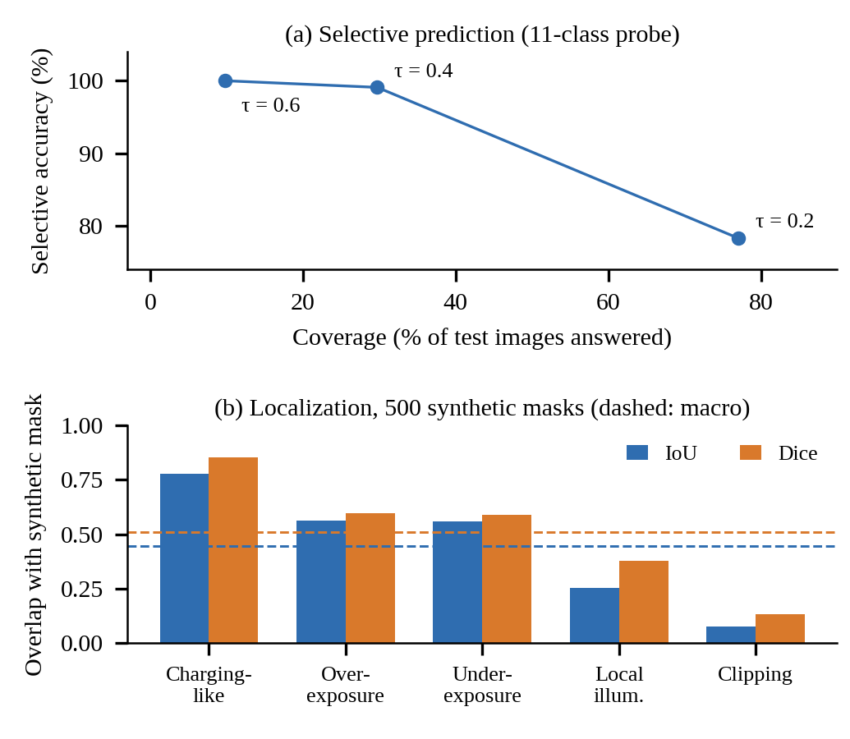
Fig. 3. (a) Coverage versus selective accuracy at the measured confidence thresholds τ = 0.2, 0.4, 0.6. (b) Per-category IoU and Dice of model-derived suspicious regions on 500 synthetic masks; dashed lines mark macro means (0.4454, 0.5103).
Evidence Cohort Parameter (N = 55 queries, 275 items) | Measurement Value
Valid evidence availability | 100.0%
Same-specimen cross-acquisition | 100.0%
Cross-instrument evidence | 100.0%
Quality-compatible evidence | 100.0%
Duplicate evidence items | 0.0%
Missing provenance | 0.0%
Deterministic ranking reproducibility | 100.0%
Mean evidence items / query | 5.0

TABLE IV: Grounded Evidence Cohort Verification (N = 55 Queries, 275 Evidence Items).
Orchestration latency. The sealed Phase-6 log (research/results/phase6/latency_results.csv) records 46.00 ms mean and 51.05 ms P95 per image on a local CPU (Python 3.11); stage means are preprocessing 1.27, representation step 0.04, quality screening 5.44, localization 12.20, retrieval 9.44, and evidence aggregation 17.61 ms. The script passes randomly generated 512×512 arrays and random feature vectors through the stages, so the timings exclude DINOv2 encoder inference, image decoding, database access, and network overhead; they are not end-to-end or production latency. An earlier report lists 23.40 ms (P95 28.30 ms); it does not match the sealed log and is not used. GPU and batched latency were not profiled.
VI. DISCUSSION AND LIMITATIONS
The evidence supports three statements: the adapter reduces the observed gap on a held-out instrument; adaptation costs artifact sensitivity; and abstention buys accuracy only at large coverage cost. Late score-level metadata fusion gave no gain: validation MRR was flat for every weight α ≥ 0.1, the tie-break chose α* = 1.0, and test ΔR@1 was 0.0000. This shows no benefit under a saturated validation set, not that metadata is useless; metadata remains essential for filtering and evidence constraints.
Limitations. All splits share three steel specimens and one instrument is held out, so we make no unseen-specimen claim. Quality and localization labels are synthetic, and charging-like artifacts only approximate real charging; image-derived indicators are not physical defects. Localization is a heuristic at 16-pixel resolution, calibration is weak, and the evidence cohort has 55 queries. No expert or prospective study was performed, suggested actions are untested on microscopes, and explanations are deterministic descriptions of model outputs, not causal accounts. Latency depends on the declared CPU environment, the platform serves one seed-42 adapter, validation was local, the duplicate cascade has no labeled benchmark and the HCCI archive holds 774 of the 777 micrographs listed in its record.
VII. CONCLUSION AND FUTURE WORK
SCI-INTEL reduced the observed acquisition-geometry similarity gap by 66.23% on a held-out instrument while the frozen backbone remained the better artifact screener, and it composes the two deterministically with uncertainty-aware human review. Held-out specimens, expert-labeled defects, cross-attention fusion, and user studies remain future work.
COMPLIANCE WITH ETHICAL STANDARDS
This study utilized publicly available scientific imaging datasets (HCCI bearing steel, Carinthia SEM, and BBBC021 bioimage benchmark) and controlled synthetic augmentations. The research did not involve human subjects, patient data, clinical interventions, or live animal experiments, and therefore did not require institutional review board (IRB) approval.
DISCLOSURES & CONFLICTS OF INTEREST
The authors declare that they have no financial or non-financial conflicts of interest. No external commercial funding was received for this study. The authors acknowledge the use of agentic software development assistants for code refactoring, test suite synthesis, and manuscript drafting assistance; final scientific responsibility for all findings, text, and data rests entirely with the authors.
REFERENCES
[1] R. M. Haralick, K. Shanmugam, and I. Dinstein, 'Textural features for image classification,' IEEE Trans. Syst., Man, Cybern., vol. SMC-3, no. 6, pp. 610–621, Nov. 1973.
[2] D. G. Lowe, 'Distinctive image features from scale-invariant keypoints,' Int. J. Comput. Vis., vol. 60, no. 2, pp. 91–110, 2004.
[3] B. L. DeCost and E. A. Holm, 'A computer vision approach for automated analysis and classification of microstructural image data,' Comput. Mater. Sci., vol. 110, pp. 126–133, 2015.
[4] E. A. Holm et al., 'Overview: Computer vision and machine learning for microstructural characterization and analysis,' Metall. Mater. Trans. A, vol. 51, no. 12, pp. 5985–5999, 2020.
[5] A. W. M. Smeulders, M. Worring, S. Santini, A. Gupta, and R. Jain, 'Content-based image retrieval at the end of the early years,' IEEE TPAMI, vol. 22, no. 12, pp. 1349–1380, Dec. 2000.
[6] J. Stuckner, B. Harder, and T. M. Smith, 'Microstructure segmentation with deep learning encoders pre-trained on a large microscopy dataset,' npj Comput. Mater., vol. 8, no. 1, pp. 1–12, 2022.
[7] A. Dosovitskiy et al., 'An image is worth 16x16 words: Transformers for image recognition at scale,' in Proc. ICLR, 2021.
[8] M. Caron et al., 'Emerging properties in self-supervised vision transformers,' in Proc. IEEE/CVF ICCV, 2021, pp. 9650–9660.
[9] K. He, X. Chen, S. Xie, Y. Li, P. Dollár, and R. Girshick, 'Masked autoencoders are scalable vision learners,' in Proc. IEEE/CVF CVPR, 2022, pp. 16000–16009.
[10] M. Oquab et al., 'DINOv2: Learning robust visual features without supervision,' Trans. Mach. Learn. Res., 2024.
[11] K. He, X. Zhang, S. Ren, and J. Sun, 'Deep residual learning for image recognition,' in Proc. IEEE CVPR, 2016, pp. 770–778.
[12] T. Chen, S. Kornblith, M. Norouzi, and G. Hinton, 'A simple framework for contrastive learning of visual representations,' in Proc. ICML, 2020, pp. 1597–1607.
[13] P. Khosla et al., 'Supervised contrastive learning,' in Adv. Neural Inf. Process. Syst. (NeurIPS), vol. 33, 2020, pp. 18661–18673.
[14] S. Ben-David et al., 'A theory of learning from different domains,' Mach. Learn., vol. 79, no. 1–2, pp. 151–175, 2010.
[15] J. Johnson, M. Douze, and H. Jégou, 'Billion-scale similarity search with GPUs,' IEEE Trans. Big Data, vol. 7, no. 3, pp. 535–547, Jul. 2021.
[16] Y. A. Malkov and D. A. Yashunin, 'Efficient and robust approximate nearest neighbor search using hierarchical navigable small world graphs,' IEEE TPAMI, vol. 42, no. 4, pp. 824–836, Apr. 2020.
[17] A. Mittal, A. K. Moorthy, and A. C. Bovik, 'No-reference image quality assessment in the spatial domain,' IEEE TIP, vol. 21, no. 12, pp. 4695–4708, Dec. 2012.
[18] Z. Wang, A. C. Bovik, H. R. Sheikh, and E. P. Simoncelli, 'Image quality assessment: From error visibility to structural similarity,' IEEE TIP, vol. 13, no. 4, pp. 600–612, Apr. 2004.
[19] P. Bergmann et al., 'MVTec AD—a comprehensive real-world dataset for unsupervised anomaly detection,' in Proc. IEEE/CVF CVPR, 2019, pp. 9592–9600.
[20] Y. Geifman and R. El-Yaniv, 'Selective classification for deep neural networks,' in Adv. Neural Inf. Process. Syst. (NIPS), vol. 30, 2017, pp. 4878–4887.
[21] D. Hendrycks and K. Gimpel, 'A baseline for detecting misclassified and out-of-distribution examples in neural networks,' in Proc. ICLR, 2017.
[22] C. Guo, G. Pleiss, Y. Sun, and K. Q. Weinberger, 'On calibration of modern neural networks,' in Proc. ICML, 2017, pp. 1321–1330.
[23] C. Zauner, 'Implementation and benchmarking of perceptual image hash functions,' Master's thesis, Upper Austria Univ. Appl. Sci., Hagenberg Campus, 2010.
[24] M. D. Wilkinson et al., 'The FAIR guiding principles for scientific data management and stewardship,' Sci. Data, vol. 3, p. 160018, 2016.
[25] I. Loshchilov and F. Hutter, 'Decoupled weight decay regularization,' in Proc. ICLR, 2019.
[26] V. Ljosa, K. L. Sokolnicki, and A. E. Carpenter, 'Annotated high-throughput microscopy image sets for validation,' Nat. Methods, vol. 9, no. 7, p. 637, 2012.
[27] B.-I. Bachmann, M. Stiefel, M. Müller, and F. T. Mücklich, 'A systematically designed open-access SEM dataset and robustness benchmark for machine learning-based microstructure segmentation: A high-chromium cast iron case study,' Zenodo, v1, Aug. 2026, doi: 10.5281/zenodo.21931379.
[28] C. Kofler, S. Strauß, A. Zernig, E. Lazaro Garcia, M. Boxleitner, B. Mayr, I. Dicillia-Kovatsch, and C. A. Dohr, 'Carinthia dataset,' Zenodo, v2, Feb. 2024, doi: 10.5281/zenodo.10715190.
[29] R. Aversa, M. H. Modarres, S. Cozzini, R. Ciancio, and A. Chiusole, 'The first annotated set of scanning electron microscopy images for nanoscience,' Sci. Data, vol. 5, p. 180172, 2018.

