

Group Member:

Krisha Jariwala (212022070)

Praneta Patel (212022067)

School: Information Technology

Program: BSC IT

Semester: 4

Subject: Deep Learning

Title: Mini project (assignment - 3)

Module Leader: Sunil Kumar

In several fields, like machine vision, banking, and postal services, recognition of individual letters is essential. Using the MNIST dataset, a well-known benchmark dataset in the field of machine learning, we hope to create a neural network model for digit recognition in this project. To correctly classify handwritten numbers from 0 to 9, the model will be trained.

The MNIST dataset consists of 60,000 training samples and 10,000 test samples, each containing grayscale images of handwritten digits with dimensions of 28x28 pixels. It serves as a fundamental dataset for evaluating machine learning algorithms, particularly in the domain of image classification.

Before feeding the data into the neural network model, preprocessing steps are applied, including scaling the pixel values to the range [0, 1]. Additionally, visualization of a sample image and its corresponding label helps in understanding the dataset.

The neural network architecture comprises a sequential model with three layers: an input layer (Flatten), two hidden layers (Dense), and an output layer (Dense). ReLU activation functions are used for the hidden layers, while a sigmoid activation function is employed for the output layer.

The model is compiled with the Adam optimizer and sparse categorical cross-entropy loss function. It is then trained for 10 epochs using the training dataset. Throughout the training process, the model learns to recognize patterns and features in the input images.

After training, the model's performance is evaluated on the test dataset to assess its accuracy in digit recognition. Performance metrics such as accuracy and a confusion matrix are used to analyse the model's effectiveness in classifying digits from 0 to 9.

**Model Architecture:** The model architecture consists of layers designed to effectively learn and classify handwritten digits. A summary of the model's layers and their parameters is provided.

**Training Process:** Plots of loss and accuracy curves over epochs showcase the model's learning progress. Observations regarding convergence and overfitting are discussed.

**Evaluation Results:** Screenshots of model accuracy and the confusion matrix illustrate the model's performance on the test dataset. Interpretation of the confusion matrix provides insights into the model's ability to classify digits accurately.

The trained model is used to predict digits on new images. Screenshots of new images along with their predicted labels demonstrate the model's generalization to unseen data. The model's ability to recognize handwritten digits is showcased through these predictions.



Using the MNIST dataset, the built neural network model shows encouraging results in digit recognition. The model demonstrates its promise for numerous applications needing digit recognition by properly identifying handwritten digits.

Model Accuracy:

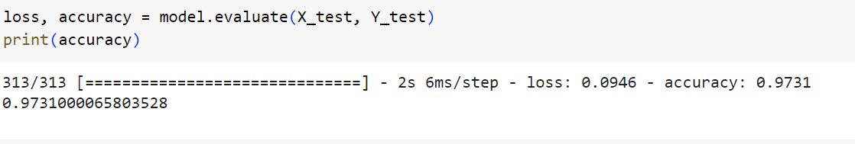

References:

* YouTube
* Kaggle
* GitHub
* Chat GPT