

COMPUTER NETWORKS LAB ASSIGNMENT-1(CS-613)

Name: Pranit De Roll No: 39/CSE/16161 Reg No: 0000152



The Modeled Network 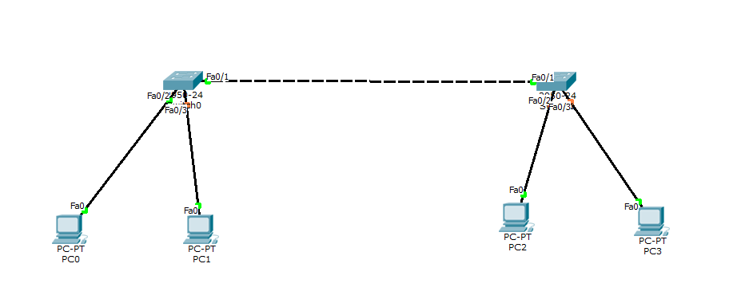

Packet Transfer (ARP table and MAC address table)

1. Initial ARP table for PC0

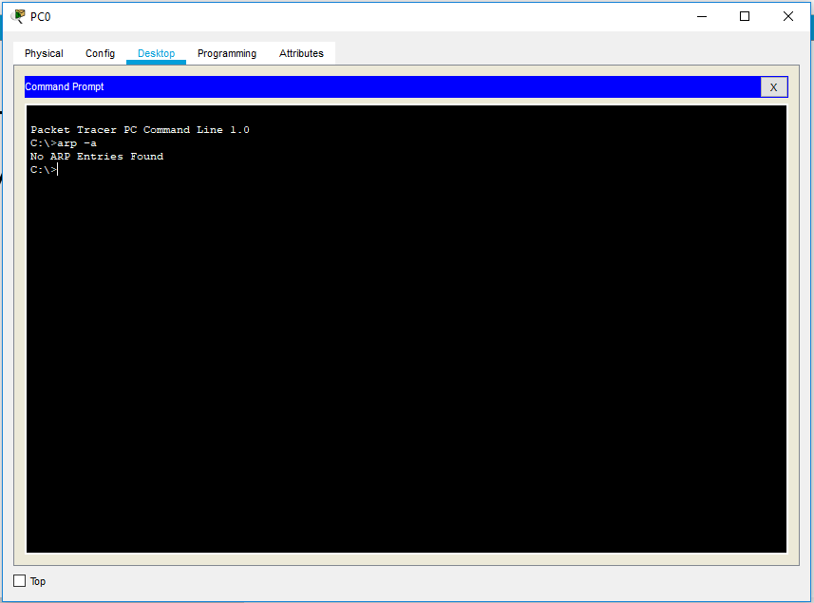

1. ARP table after sending packet from PC0 to PC4

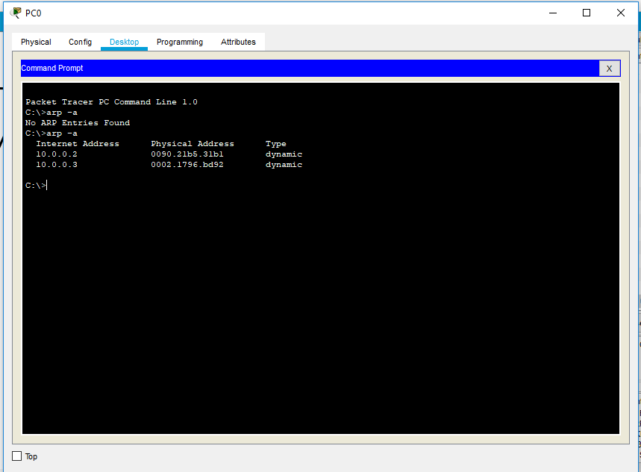

1. ARP table for PC4 after packet transfer

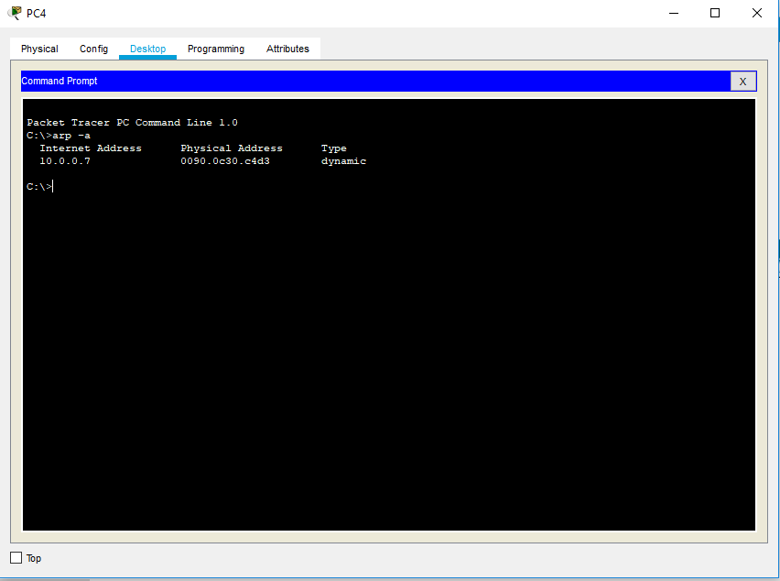

1. MAC address table for Switch2 before and after packet transfer

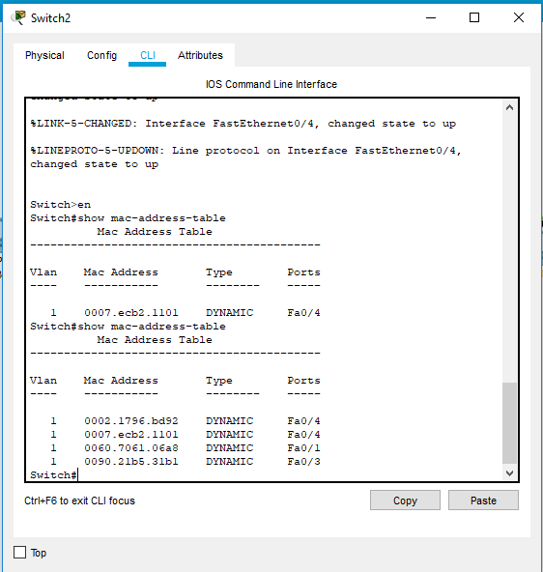

1. MAC address table for Switch3

