

COMPUTER NETWORKS LAB ASSIGNMENT-10(CS-613)

Name: Pranit De Roll No: 39/CSE/16161 Reg No: 0000152



Q1. Show the use of NAT and PAT.

*Network Topology*

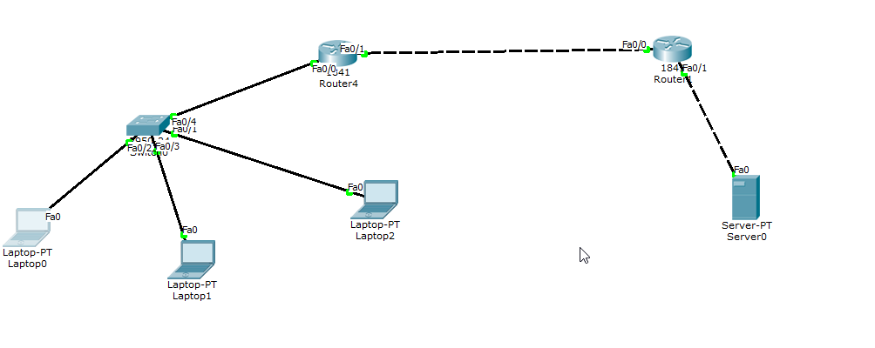

*Configurations:*

Laptop0- IP: 10.0.0.10

Default Gateway: 10.0.0.1

Subnet Mask: 255.0.0.0

Router0- IP: 10.0.0.1

Subnet Mask: 255.0.0.0

Router1: IP:100.0.0.2

Subnet Mask: 255.0.0.0

Server0: IP:192.168.1.10

Subnet Mask: 255.255.255.0

*NAT translations*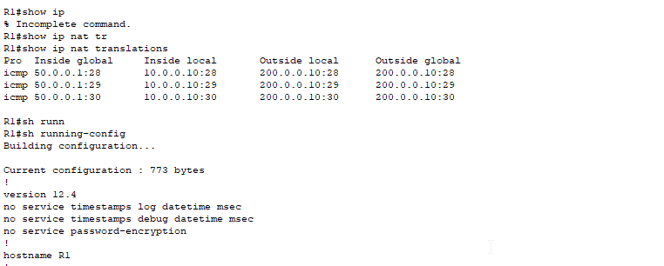

*Ping*

