

Computer Networks Lab ASsignment-2(CS-613)

Name: Pranit De Roll No: 39/CSE/16161 Reg No: 0000152



The Modeled Network

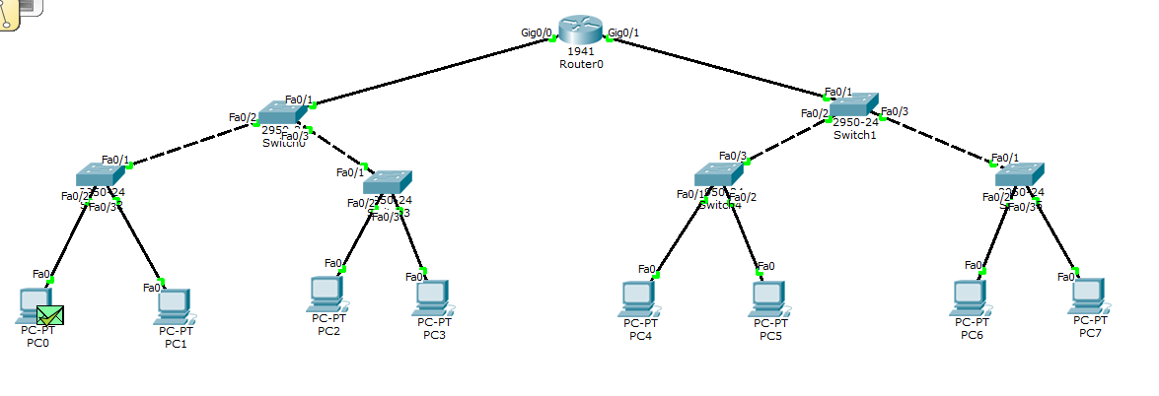

Packet Transfer (Inbound and Outbound)

1. From PC0 to Switch2

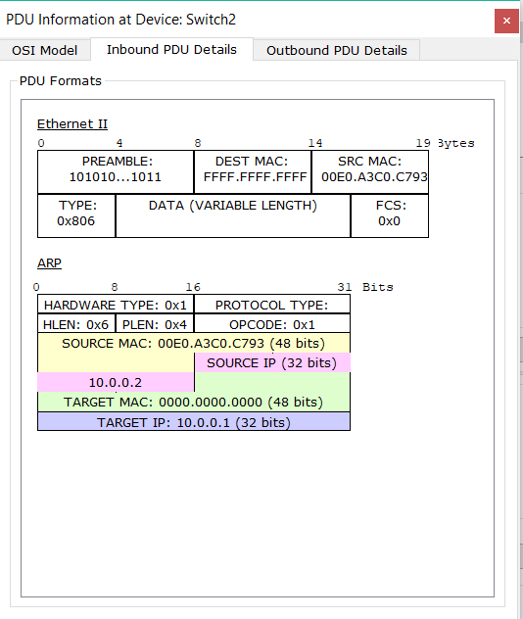

1. From Switch2 to Switch0

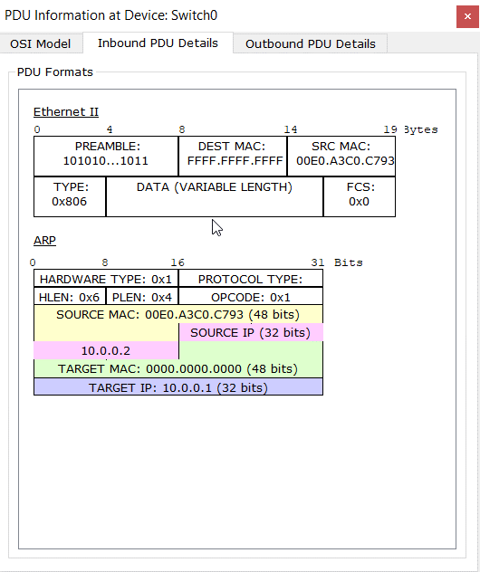

1. From Switch0 to Router

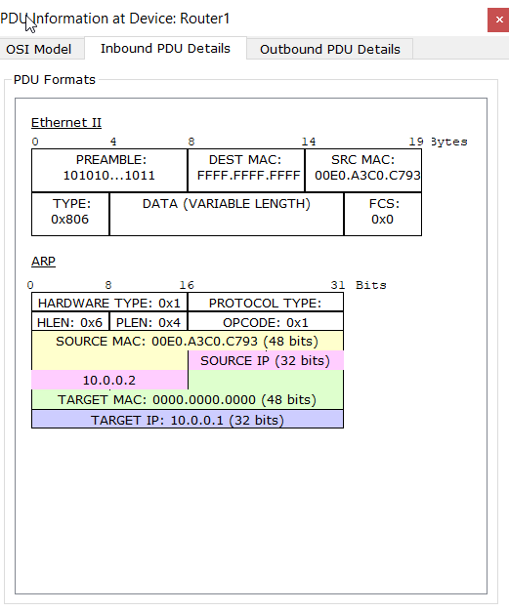

1. From Router1 to Switch1

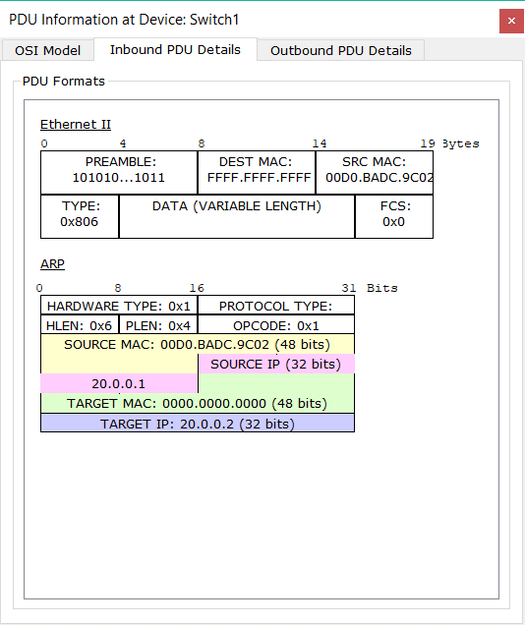

1. From Switch1 to Switch4

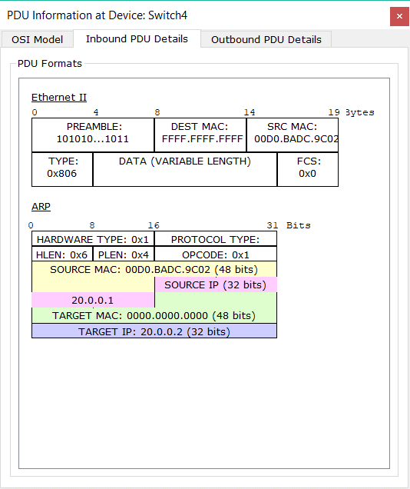

1. Switch4 to PC4

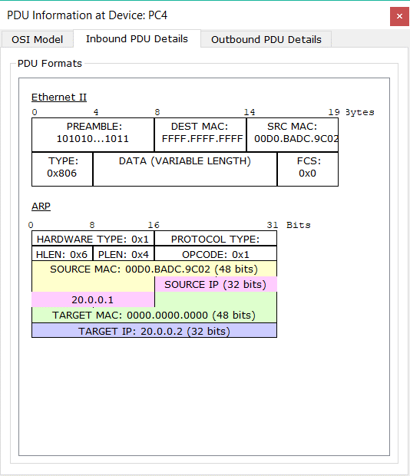

1. PC4 to Switch4

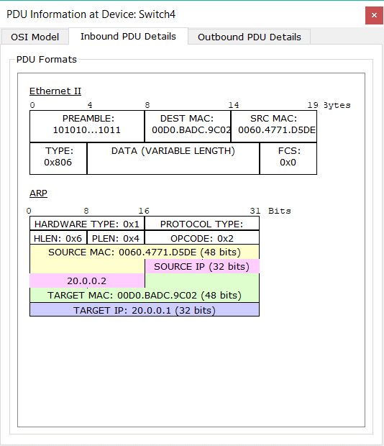

1. Switch4 to Switch1

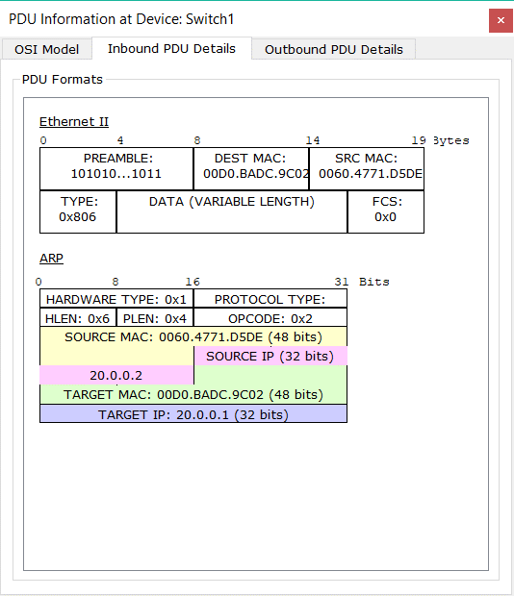

1. Switch1 to Router1

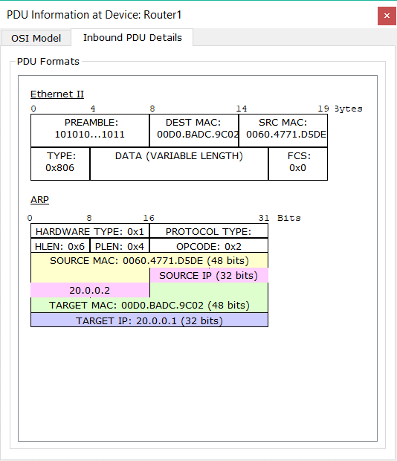

1. From Router to Switch0

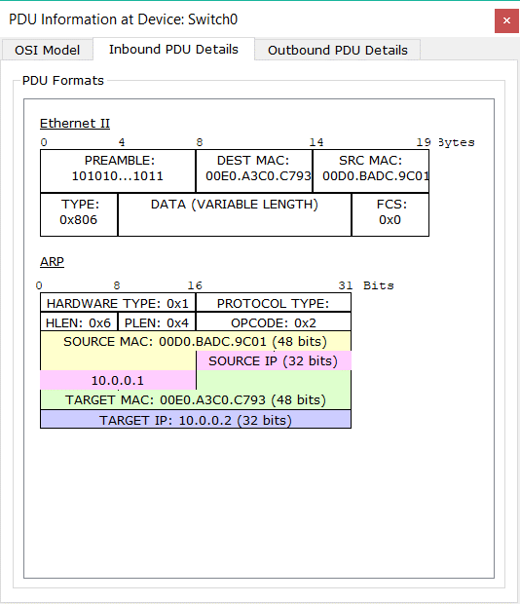

1. Switch0 to Switch2

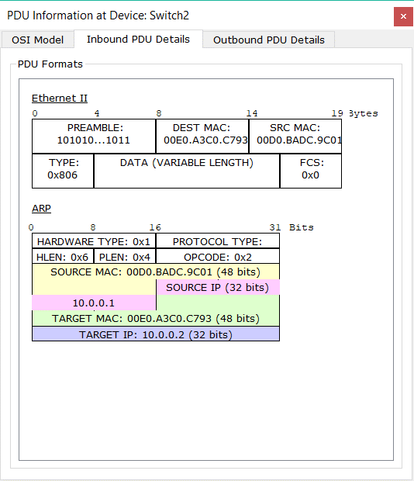

1. From Switch2 to PC0

