

COMPUTER NETWORKS LAB ASSIGNMENT-3(CS-613)

Name: Pranit De Roll No: 39/CSE/16161 Reg No: 0000152



Q. Create two virtual LAN (VLAN)one for student and another for Faculty and Student cannot access Faculty and Vice-Versa.

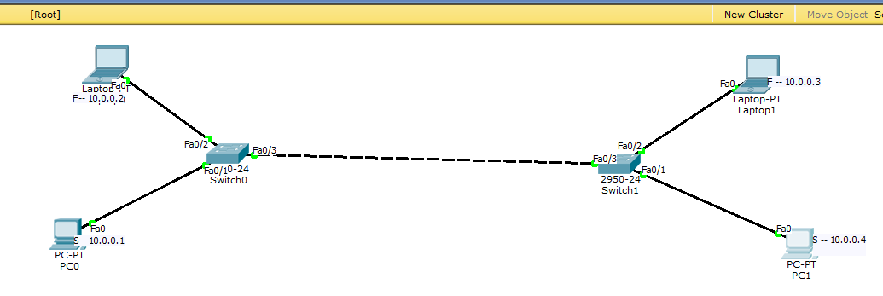

1. On transferring file from a student computer to faculty computer, then it fails.

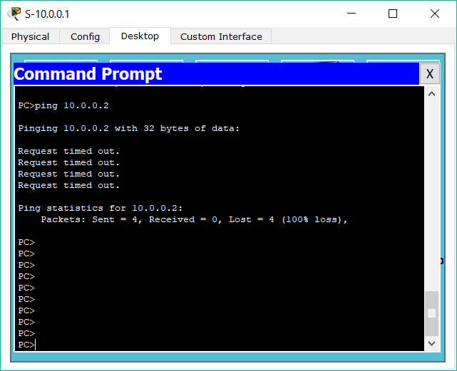

1. When we try to send file between two student terminals then it succeeds.

