

COMPUTER NETWORKS LAB ASSIGNMENT-5(CS-613)

Name: Pranit De Roll No: 39/CSE/16161 Reg No: 0000152



Q. Configure telnet in router1 and router5 to configure them from remote system. Check the change .

*Topology:*

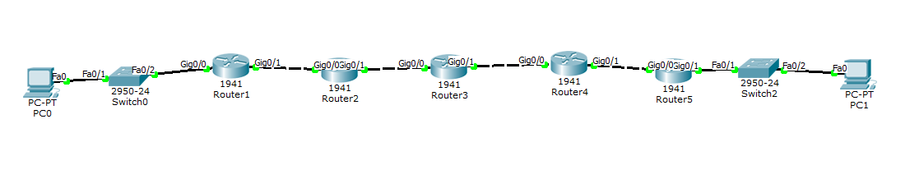

*At Switch2:*

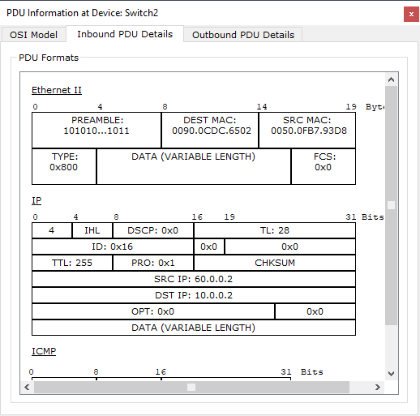

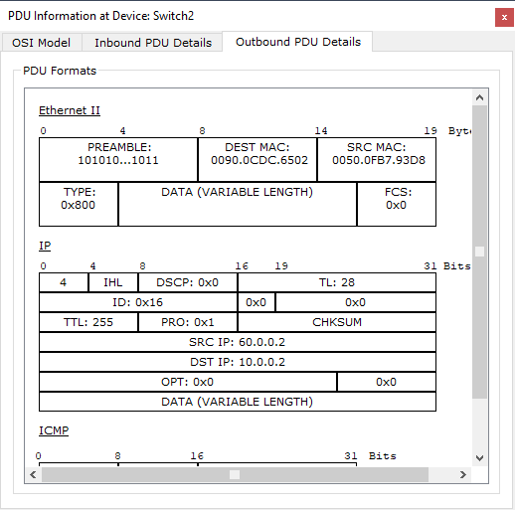

*At router5:*

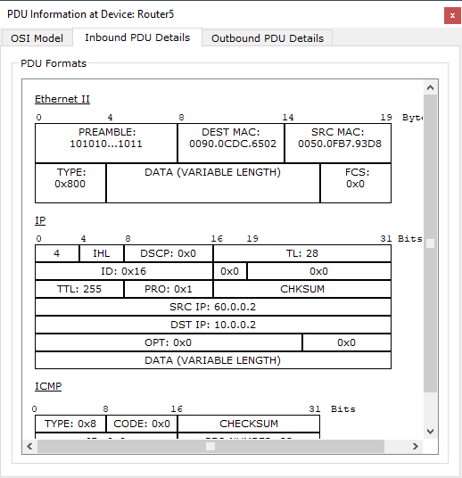

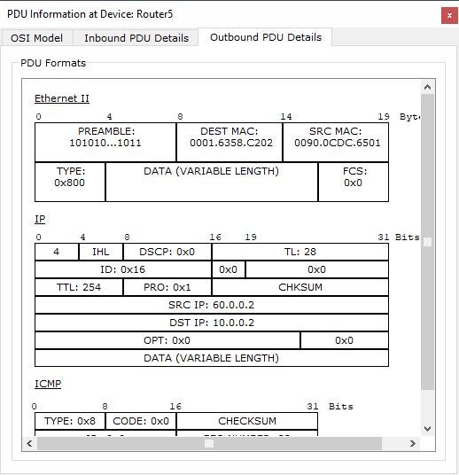

*At router4:*

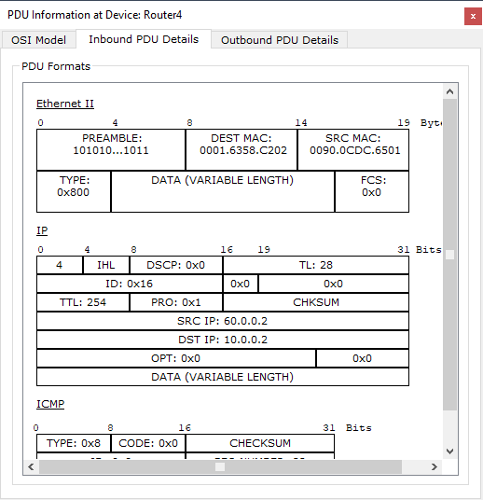

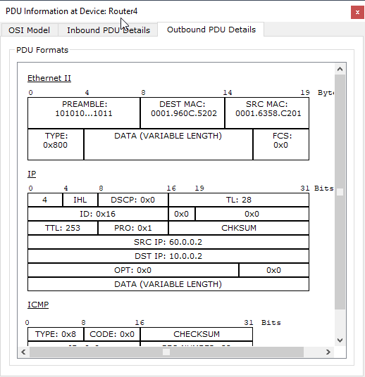

Q2. Perform the following tasks

1. Using mininet create a simple topology with two hosts.
2. Add user1 and user2 to h1 (host1)
3. Configure SSH in both host and login to h1(host1) from h2(host2) using either username.
4. Reconfigure SSH in host1 to block remote login using username ‘user2’ but remote login will be allowed using username user1.

ii. Commands to Add users

$ adduser user1

$ adduser user2

iii) installing openssh-server

$ sudo apt install openssh-server

$ sudo service ssh start

*On Client Machine:*

**For user 1:**

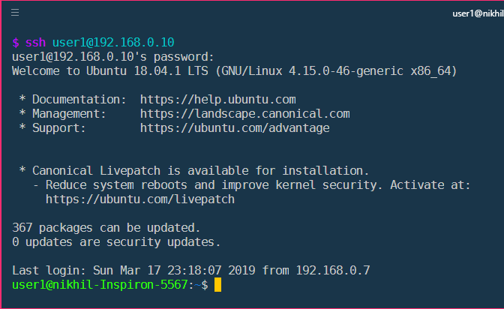

**For user 2:**

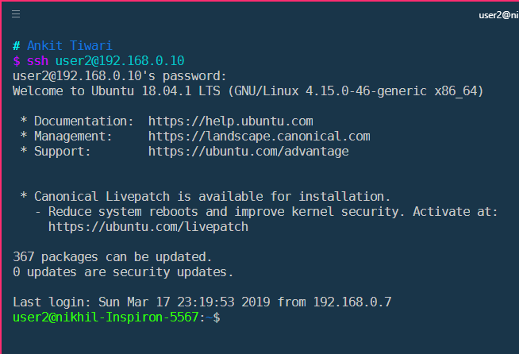

iv) Following changes are to be made in /etc/ssh/sshd_config

Deny Users user2

