

COMPUTER NETWORKS LAB ASSIGNMENT-7(CS-613)

Name: Pranit De Roll No: 39/CSE/16161 Reg No: 0000152



Ans1. Create a subnet from Network 192.168.1.0, Subnet 255.255.255.0 as follows:

Subnet 1: 128 hosts, Subnet 2: 64 hosts, Subnet 3: 64 hosts

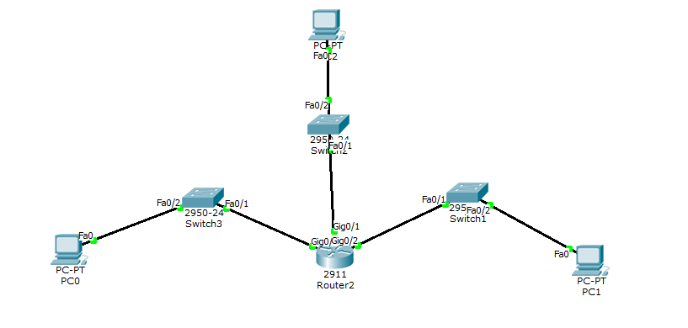

IpConfig Host 0: IpConfig Host 1:

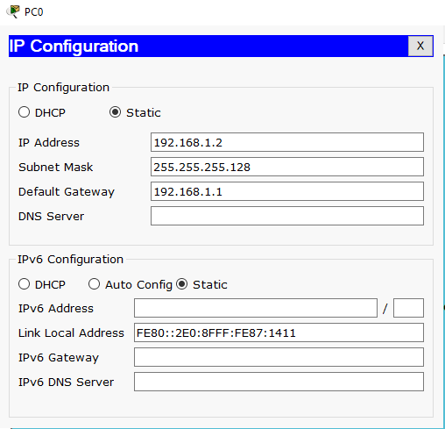 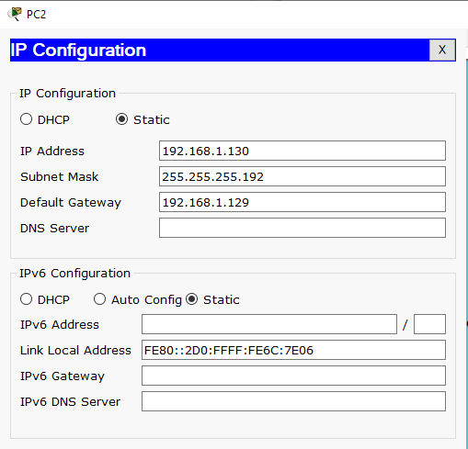

IpConfig Host 2:

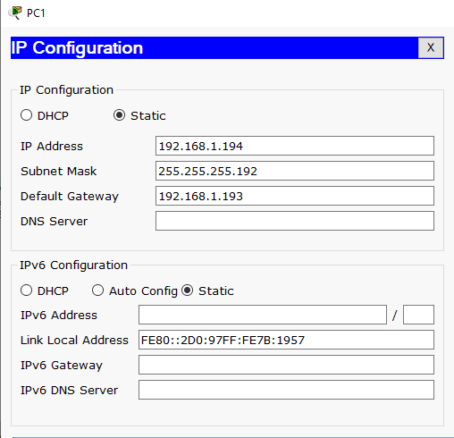

Ping from Host 0 to Host 2:

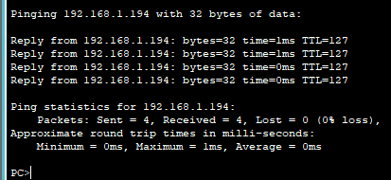

Ping from Host 2 to Host 0:

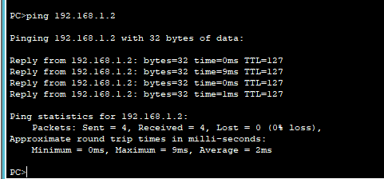

Interface 0:

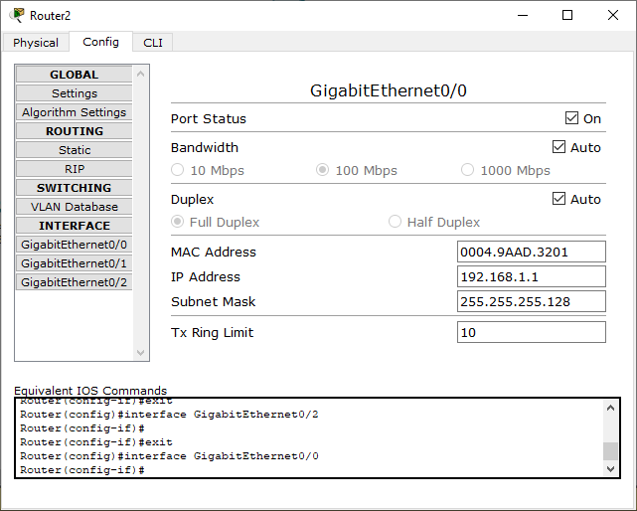

Interface 1

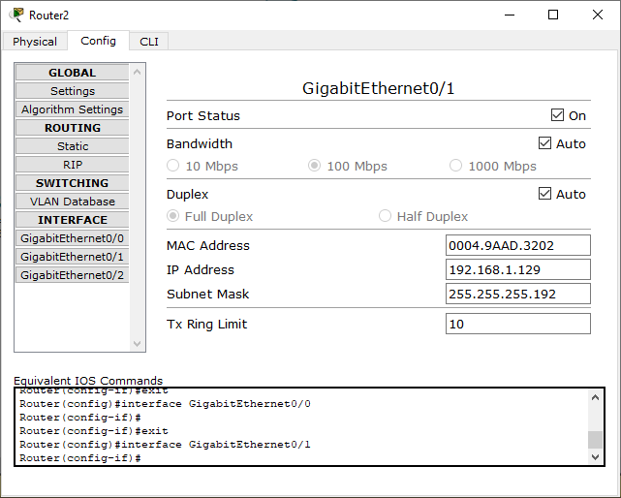

Interface 2

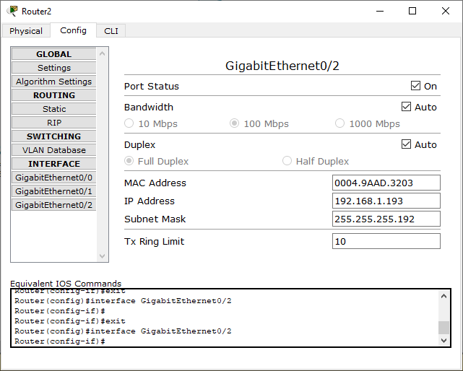

__________________________________________END____________________________________________