

DBMS LAB ASSIGNMENT-10 (CS-612)

Pranit De Roll no 39/CSE/16161 Reg no 0000152



**Input Data:**

Emp Table

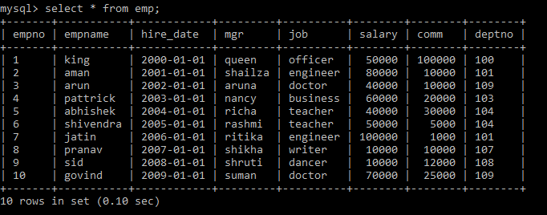

Dept

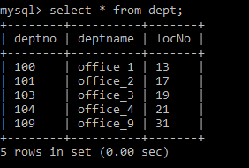

Location Salgrade

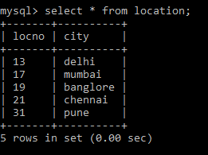 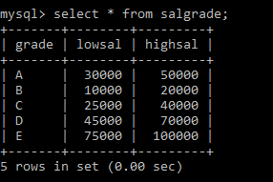

1. Write a query to display the last name, department number, and department name for all employees.

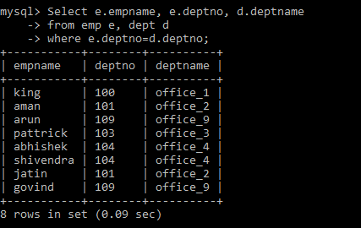

1. Create a unique listing of all jobs that are in department 109. Include the location of the department in the output.

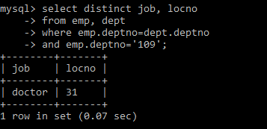

1. Write a query to display the employee last name, department name, location ID, and city of all employees who earn a commission.

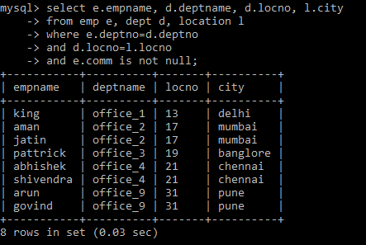

1. Display the employee last name and department name for all employees who have an a (lowercase) in their last names.

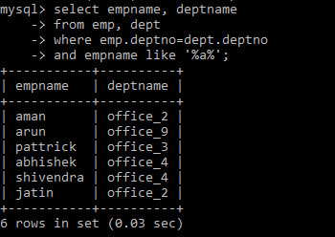

1. Write a query to display the last name, job, department number, and department name for all employees who work in Mumbai.

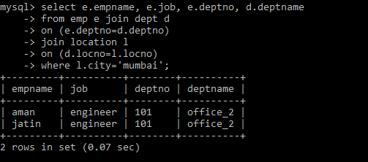

1. Display the employee last name and employee number along with their manager’s last name and manager number. Label the columns Employee, Emp#, Manager, Mgr#, respectively.

SELECT w.empname "Employee", w.empno "EMP#",

m.mgr "Manager", m.mgrno "Mgr#"

FROM emp w join emp m

ON (w.mgrno= m.empno);

7. Modify test6.sql to display all employees including King, who has no manager.

SELECT w.empname "Employee", w.empno "EMP#",

m.mgr "Manager", m.mgrno "Mgr#"

FROM emp w

LEFT OUTER JOIN emp m

ON (w.mgrno = m.emp_id);

8. Create a query that displays employee last names, department numbers, and all the employees who work in the same department as a given employee. Give each column an appropriate label.

SELECT e.deptno department, e.empname employee,

c.empname colleague

FROM emp e JOIN emp c

ON (e.deptno = c.deptno)

WHERE e.empno <> c.empno

ORDER BY e.deptno, e.empname, c.empname;

1. Show the structure of the JOB_GRADES table. Create a query that displays the name, job, department name, salary, and grade for all employees.

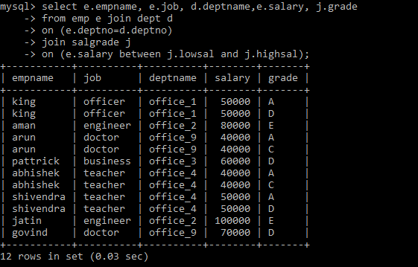

1. Create a query to display the name and hire date of any employee hired after employee Abhishek.

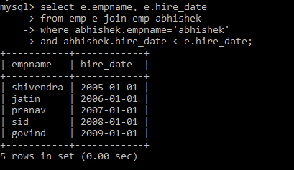

1. Display the names and hire dates for all employees who were hired before their managers, along with their manager’s names and hire dates. Label the columns Employee, Emp Hired, Manager, and Mgr. Hired, respectively.

SELECT w.empname, w.hire_date, m.mgr, m.hire_date

FROM emp w, emp m

WHERE w.mgrno = m.empno

AND w.hire_date < m.hire_date;