Name: Pranit de

roll no: 39/cse/16161

reg no: 0000152

DBMS LAB ASSIGNMENT 4

Ans 1 and Ans 2

Create(n:employees{empname:’suman’,address:’20 convent road’,empno:’a-101’,salary:20000,dob:’03/02/76’ ,doj:’05/05/03’});

n

"{empname:suman,address:20 convent road,empno:a-101,salary:20000,dob:03/02/76 ,doj:05/05/03}"

"{empname:sugoutam,address:new market cal-71,empno:a-105,salary:15000,dob:08/05/68,doj:03/07/02}"

"{empname:bobby,address:behala cal-34,empno:c-101,salary:14000,dob:07/05/70,doj:07/05/02}"

"{empname:shekhar,address:bidhannagarh kol-66,empno:b-101,salary:14000,dob:08/09/71 ,doj:07/07/02}"

"{empname:bobby,address:behala cal-34,empno:c-101,salary:5000,dob:07/05/70,doj:07/05/02}"

"{empname:bikas,address:p.p.colony,empno:a-104,salary:11000,dob:07/05/73,doj:07/05/02}"

"{empname:sumanta,address:p.p.colony,empno:a-109,salary:12000,dob:07/05/73,doj:07/05/02}"

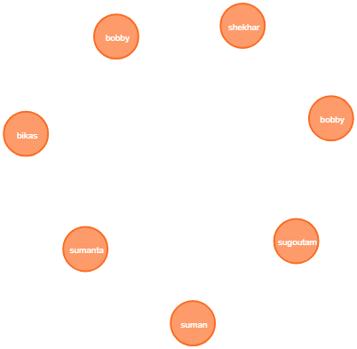

Ans 3:

match(n:Employee) where n.salary>12000 return n;

n

"{empname:suman,address:20 convent road,empno:a-101,salary:20000,dob:03/02/76 ,doj:05/05/03}"

"{empname:sugoutam,address:new market cal-71,empno:a-105,salary:15000,dob:08/05/68,doj:03/07/02}"

"{empname:bobby,address:behala cal-34,empno:c-101,salary:14000,dob:07/05/70,doj:07/05/02}"

"{empname:shekhar,address:bidhannagarh kol-66,empno:b-101,salary:14000,dob:08/09/71 ,doj:07/07/02}"

Ans 4:

match(n) return n;

n

"{empname:suman,address:20 convent road,empno:a-101,salary:20000,dob:03/02/76 ,doj:05/05/03}"

"{empname:sugoutam,address:new market cal-71,empno:a-105,salary:15000,dob:08/05/68,doj:03/07/02}"

"{empname:bobby,address:behala cal-34,empno:c-101,salary:14000,dob:07/05/70,doj:07/05/02}"

"{empname:shekhar,address:bidhannagarh kol-66,empno:b-101,salary:14000,dob:08/09/71 ,doj:07/07/02}"

"{empname:bobby,address:behala cal-34,empno:c-101,salary:5000,dob:07/05/70,doj:07/05/02}"

"{empname:bikas,address:p.p.colony,empno:a-104,salary:11000,dob:07/05/73,doj:07/05/02}"

"{empname:sumanta,address:p.p.colony,empno:a-109,salary:12000,dob:07/05/73,doj:07/05/02}"

Ans 5:

match(n:Employee) where n.empname='bobby' return n;

n

"{empname:bobby,address:behala cal-34,empno:c-101,salary:14000,dob:07/05/70,doj:07/05/02}"

"{empname:bobby,address:behala cal-34,empno:c-101,salary:5000,dob:07/05/70,doj:07/05/02}"

Ans 6:

match(n:Employee{empname:'bikas'}) SET n.salary = '15000' return n;

n

"{empname:bikas,address:p.p.colony,empno:a-104,salary:15000,dob:07/05/73,doj:07/05/02}"

Ans 7:

match(n:Employee{empno:'a-109'}) delete n;

n

"{empname:suman,address:20 convent road,empno:a-101,salary:20000,dob:03/02/76 ,doj:05/05/03}"

"{empname:sugoutam,address:new market cal-71,empno:a-105,salary:15000,dob:08/05/68,doj:03/07/02}"

"{empname:bobby,address:behala cal-34,empno:c-101,salary:14000,dob:07/05/70,doj:07/05/02}"

"{empname:shekhar,address:bidhannagarh kol-66,empno:b-101,salary:14000,dob:08/09/71 ,doj:07/07/02}"

"{empname:bobby,address:behala cal-34,empno:c-101,salary:5000,dob:07/05/70,doj:07/05/02}"

"{empname:bikas,address:p.p.colony,empno:a-104,salary:15000,dob:07/05/73,doj:07/05/02}"