1. Given Graph

Name: Pranit de

roll no: 39/cse/16161

reg no: 0000152

Assignment 5

DBMS LAB ASSIGNMENT 5

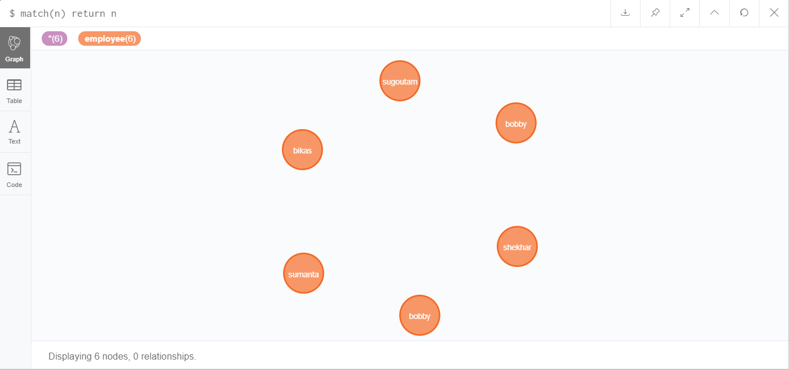

Ans1: Alter the nodes and add new property category

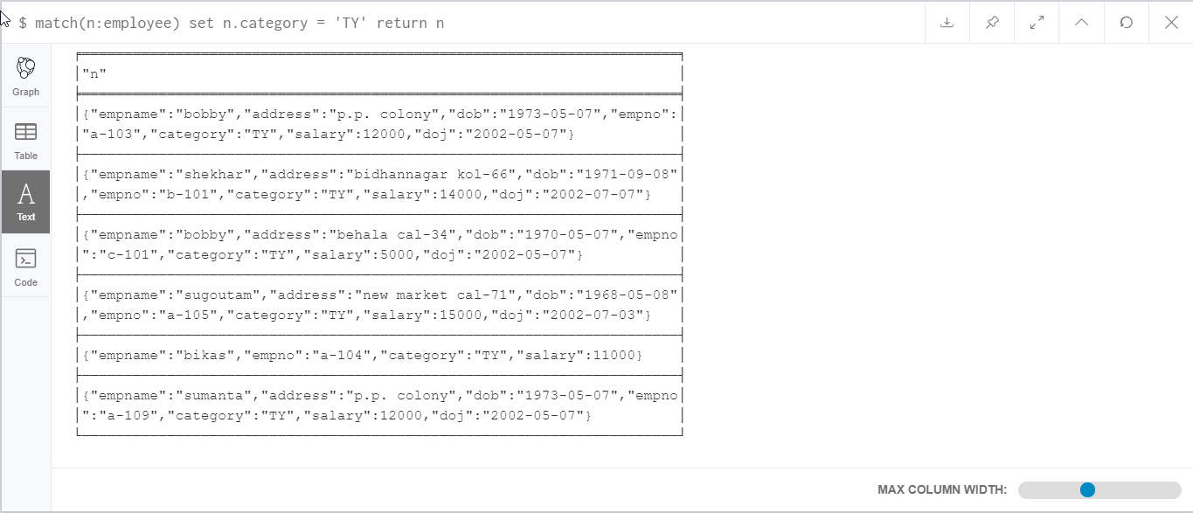

Ans2: Drop a Property from a node

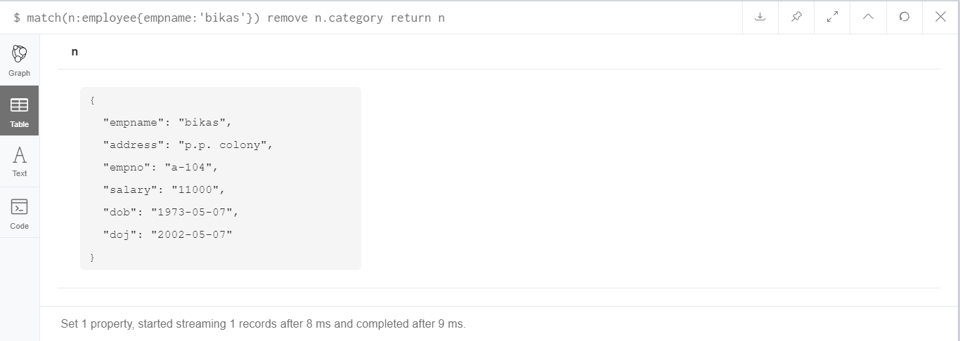

Ans3: Drop multiple properties.

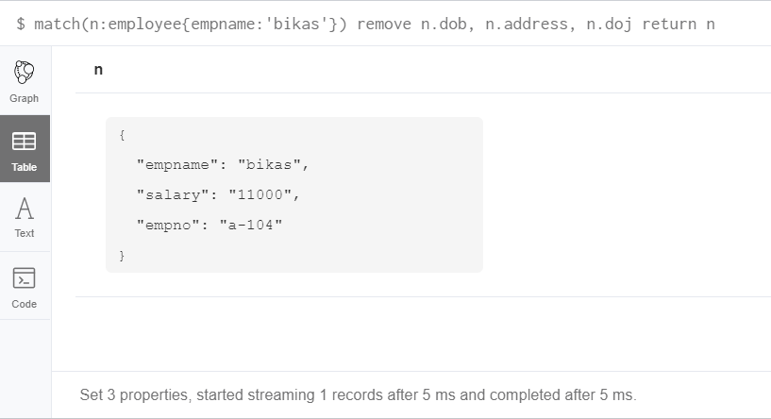

Ans4: Show empno, empname, address, salary.

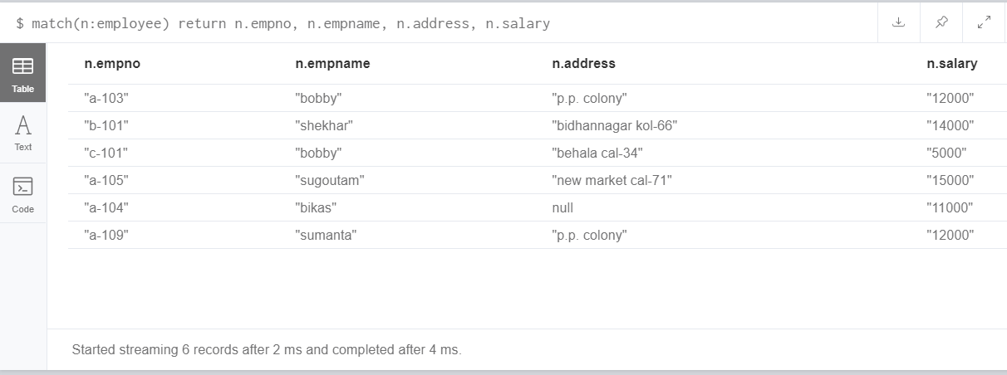

Ans5: Sort in ascending order by salary.

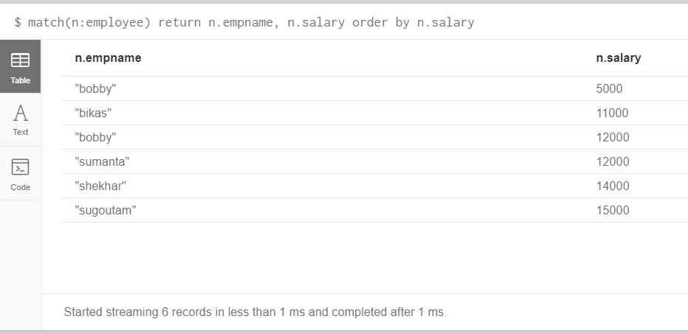

Ans6: Find the Average, Min and sum of salary.

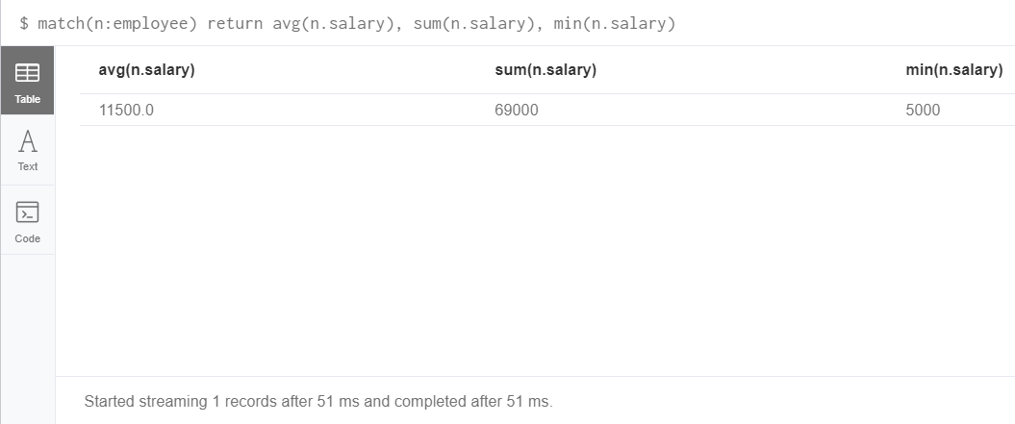

Ans7: Find maximum salary as Maximum Salary.

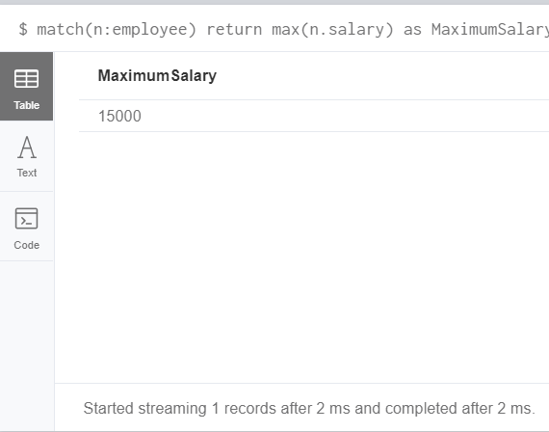

Ans8: Find Average salary.

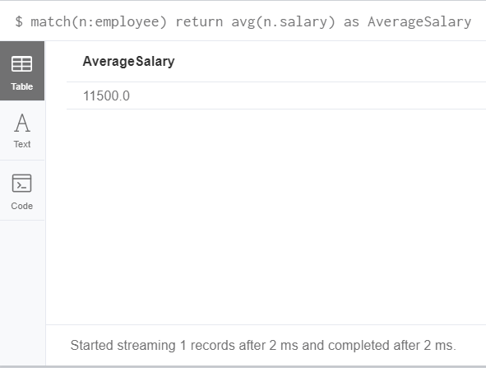

Ans9: Salary greater than average salary.

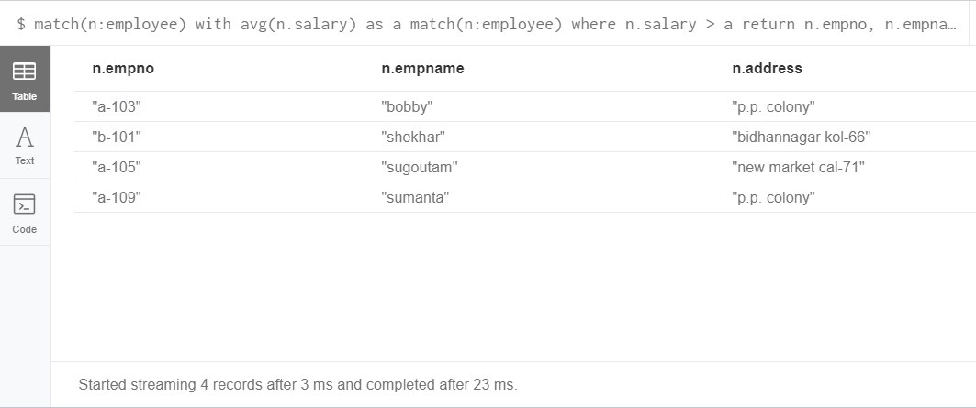

Ans10: Count employees with salary > 10000.

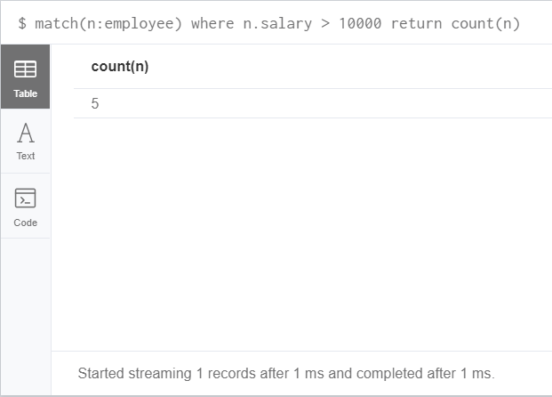

Ans11: Name start with ‘s’ or ends with ‘n’.

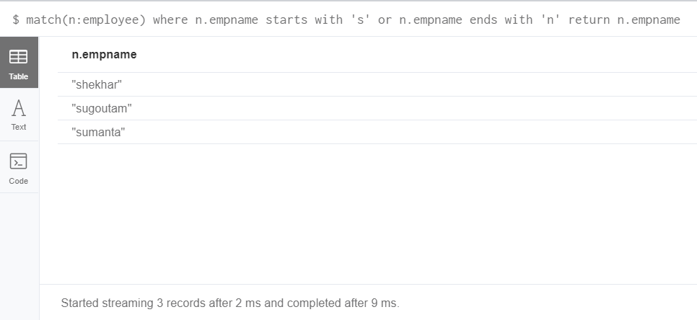

Ans12: find records with category ‘A’, ‘B’ and ‘C’

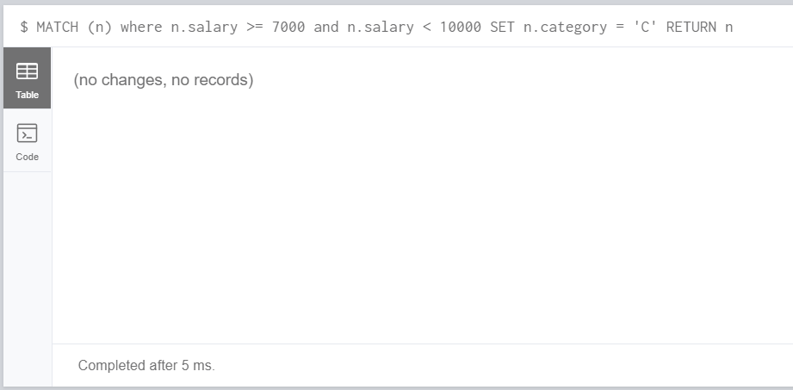

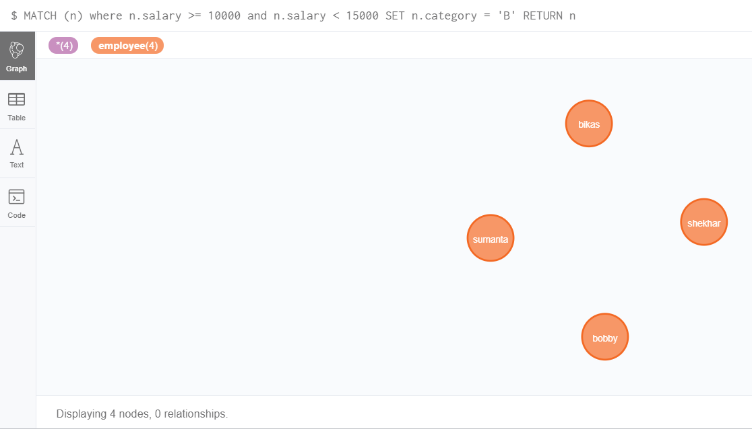



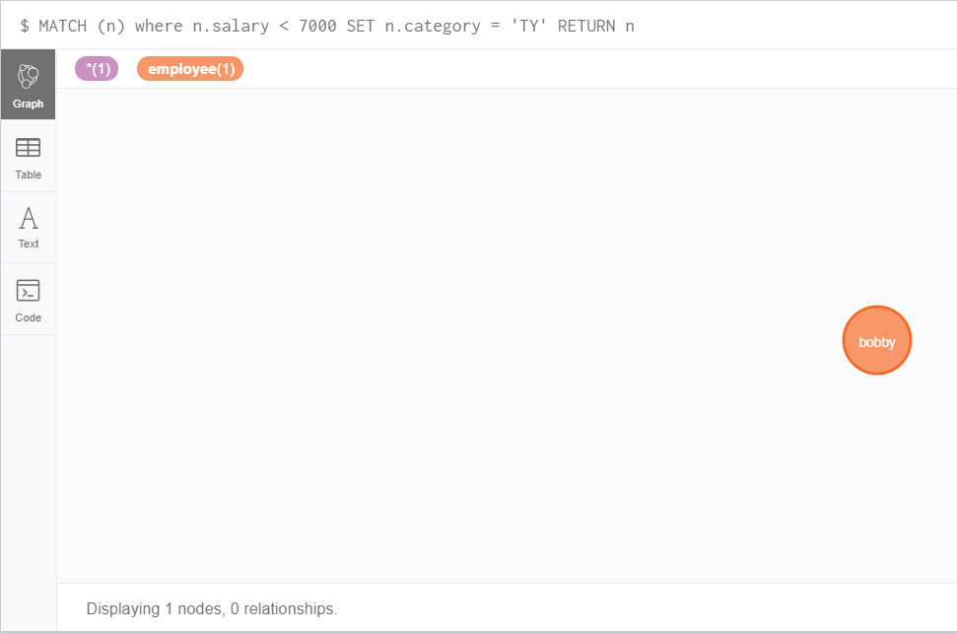

Ans13: Name with two consecutive ‘w’.

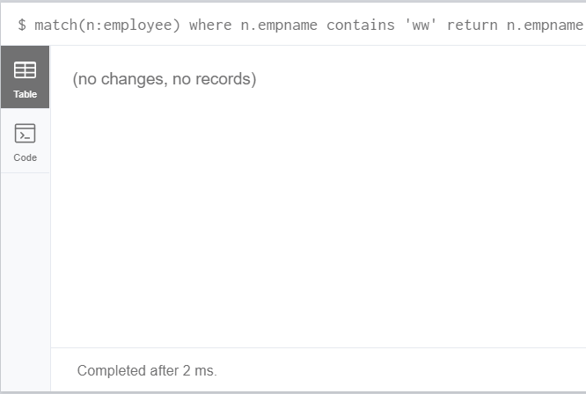

Ans14: Find Salary between 7000 and 15000.

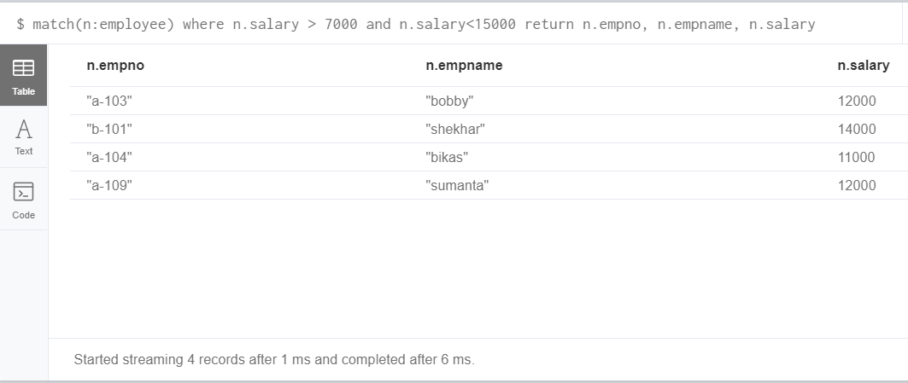

Ans15: Show employee whose category is A or B or C.

