

DBMS Lab assignment-7 (CS-612)

Pranit De Roll no 39/CSE/16161 Reg no 0000152



*Section A*

**Graph:**

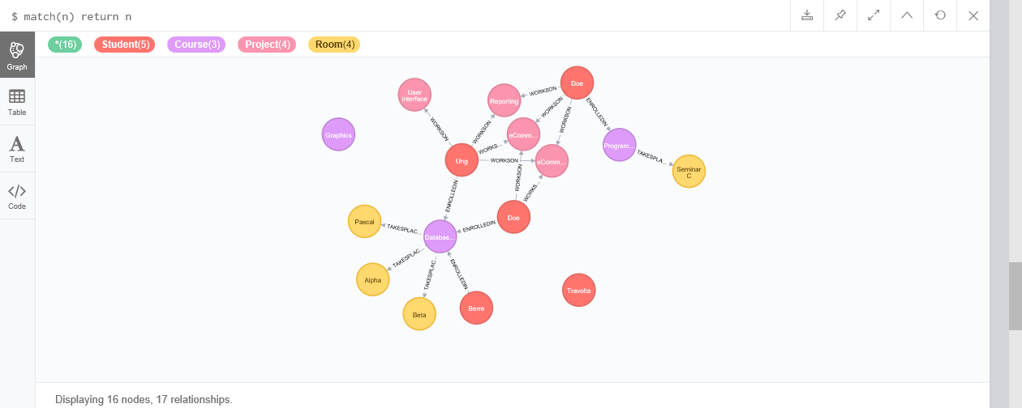

1. In which rooms does course with course number "1" take place in? Retrieve the course name and the names of the rooms in which the course takes place.

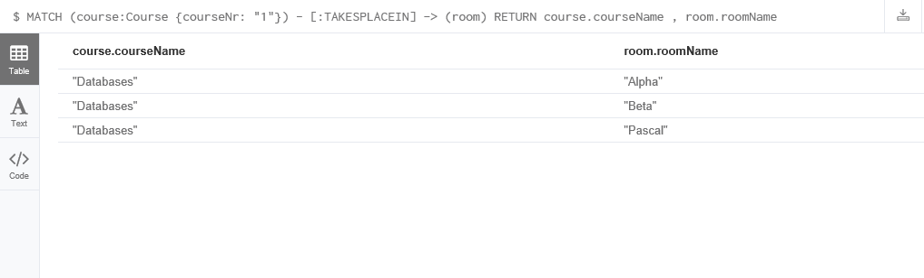

1. How many hours and in which projects does student with student number "1" works on? Retrieve the first name of the student, the project the student works on and the corresponding number of hours worked on the project.

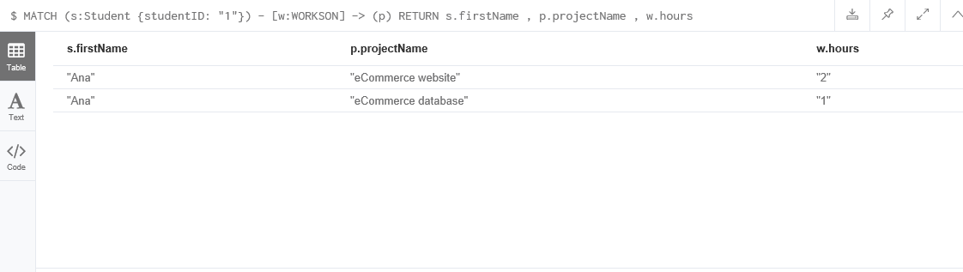

1. Which students and how many hours do they work on the project with project number "24"? Retrieve the project name, the last name of the student and the corresponding number of hours worked on the project.



1. Which students work in which projects and how many hours? Retrieve the last name of the students, the name of the projects they work on, and the corresponding number of hours. Order the results by the last name of the students. Limit the results to four.

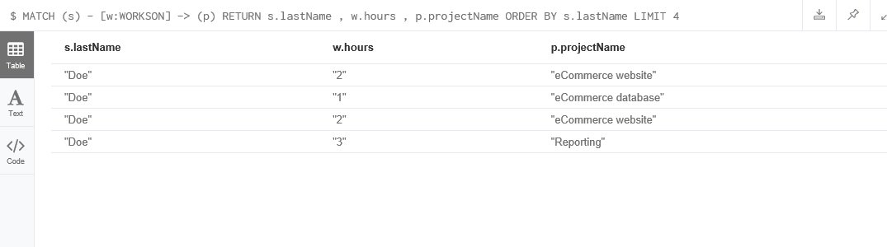

1. Which students work on more than two projects and on how many projects exactly? Retrieve the last name of the students and the corresponding number of projects. Order the results by the number of projects.



6.Which students have the same last name and work on the same projects? Retrieve the first name of the students and the name of projects they share.



*Section B*

Graph:

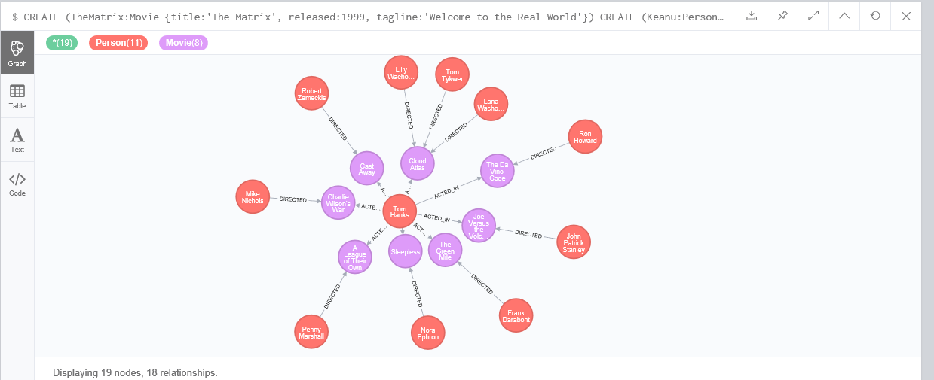

1. What is a shortest path (using any kind of relation) between Keanu Reeves and Tom Cruise? How long is it?

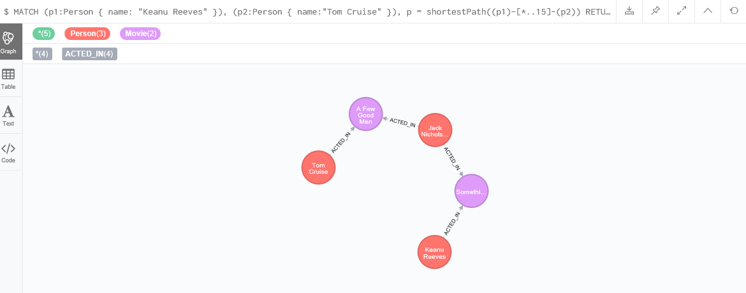

1. What are the shortest paths between people with first name Keanu and people with first name Tom? First, find one shortest path for each pair, then find all the possible shortest paths.

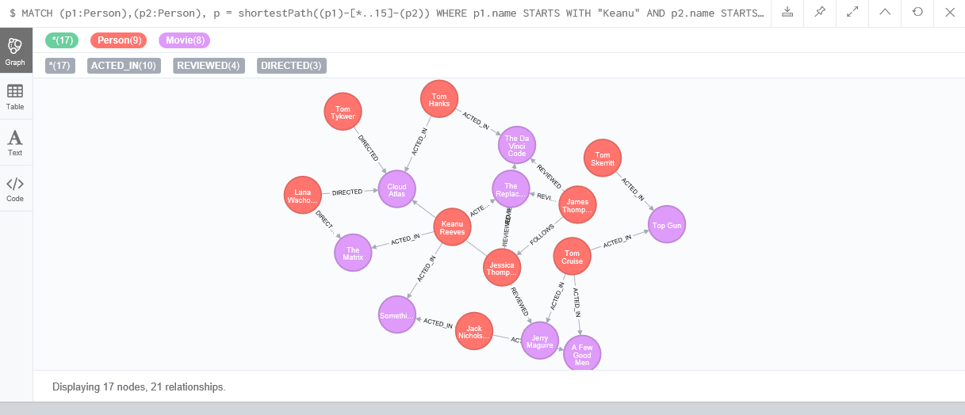

1. What is the largest distance of any person to Kevin Bacon (the distance between two persons being the length of a shortest path between them)?

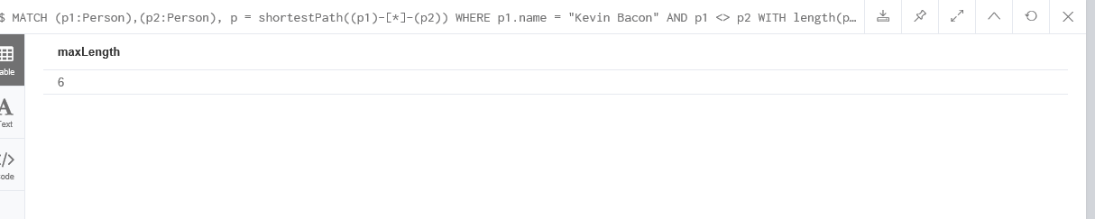

1. Which persons have maximal distance to Kevin Bacon?

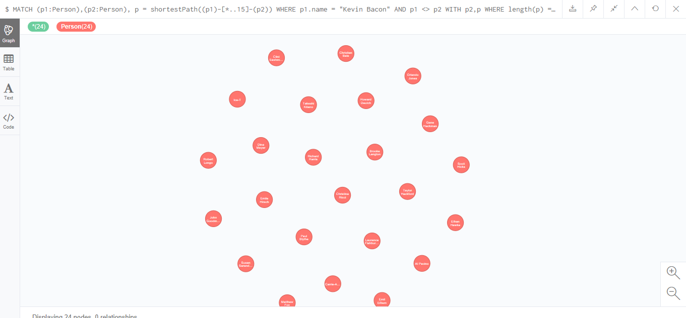

1. What is the average number of persons with distance 5 to any person?

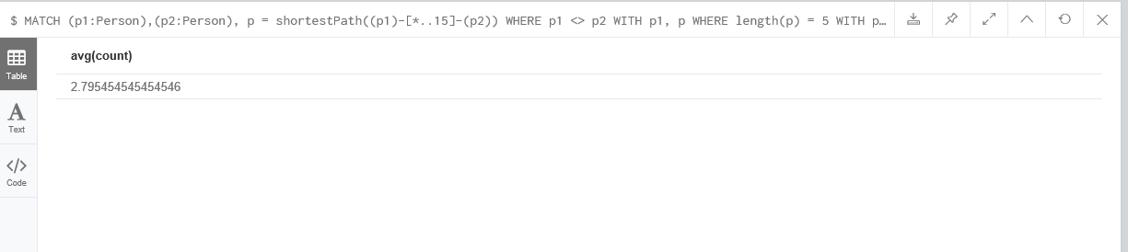

1. What is the largest shortest-path distance between any two persons?



1. What is the distribution of pairwise distances (i.e., for distance 1, 2, 3, ..., how many pairs of persons have that distance from each other)? Explain the shape of the distribution.



1. Find 10 name of people.

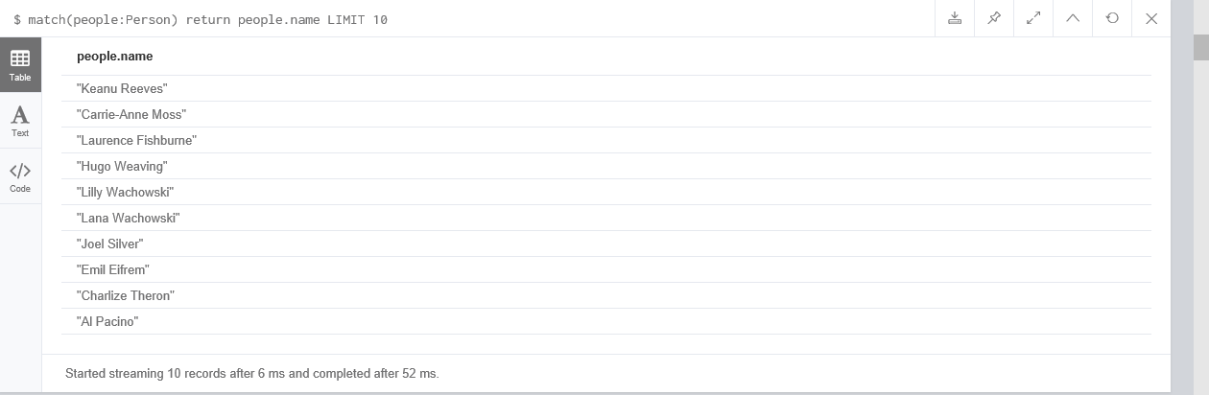

1. List of all tom hanks movies.



1. Who directed “Cloud Atlas”?



1. How people are related to “Cloud atlas”?

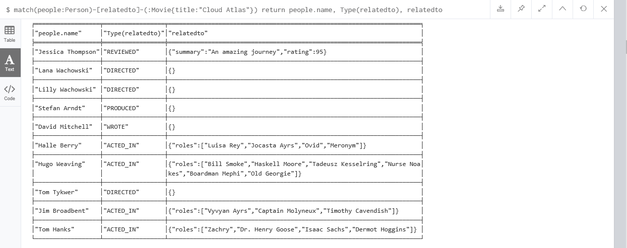

1. List movies and actors up to 4 hops away from kevin bacon?

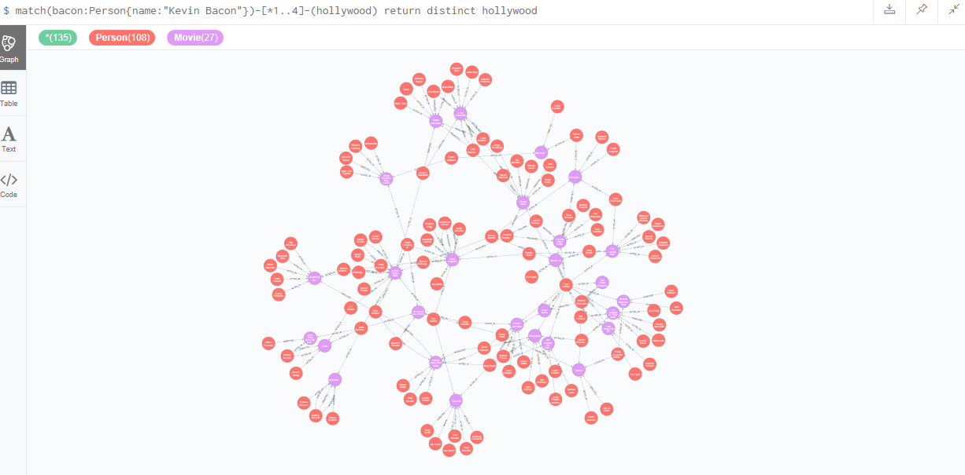

1. Find the shortest path of any relationships from kevin bacon to meg ryan?

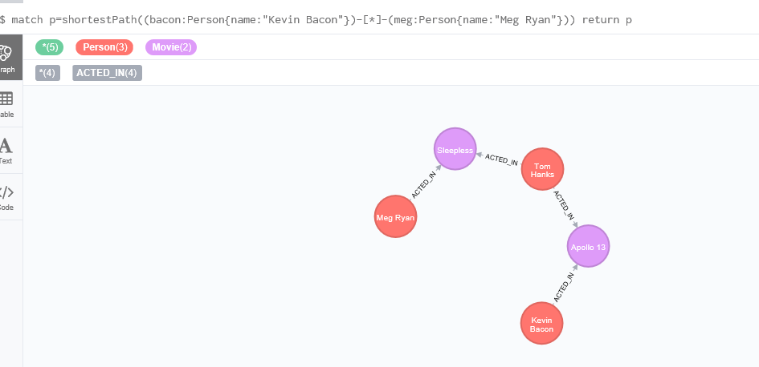

1. Find someone to introduce tom hanks to tom cruise.

