1. **Total_Revenue**

**Query :**

select sum(total_price) AS Total_Revenue from pizza_sales

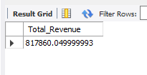

1. **Average Order Value**

**Query :**

select sum(total_price) / count(distinct order_id) as AVG_Value from pizza_sales

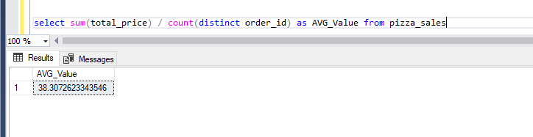

1. **Total Pizzas Sold**

**Query :**

select sum(quantity) As Total_Pizza_Sold from pizza_sales

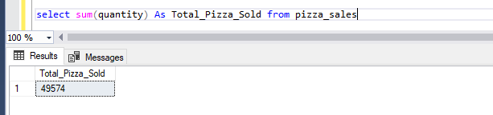

1. **Total Orders**

**Query :**

select count(distinct order_id) as Total_Orders from pizza_sales

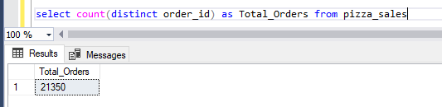

1. **Average Pizzas Per Order**

**Query**

select cast(cast(sum(quantity) as decimal(10,2)) / cast(count(distinct order_id) as decimal(10,2))

as decimal(10,2)) As AVG_PIZZA_PER_ORDER from pizza_sales

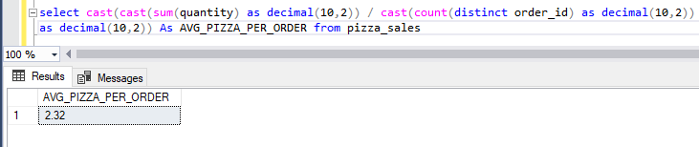

1. **Daily Trend for total orders**

**Query**

select DATENAME(DW, order_date) as order_day, count(distinct order_id) as Total_Orders from pizza_sales

group by DATENAME(DW, order_date)

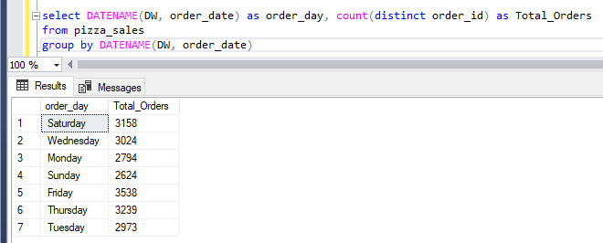

1. **Monthly Trend For Orders**

**Query**

select DATENAME(MONTH, order_date) as Month_Name, count(distinct order_id) as Total_Orders

from pizza_sales

group by DATENAME(MONTH, order_date)

order by Total_Orders desc

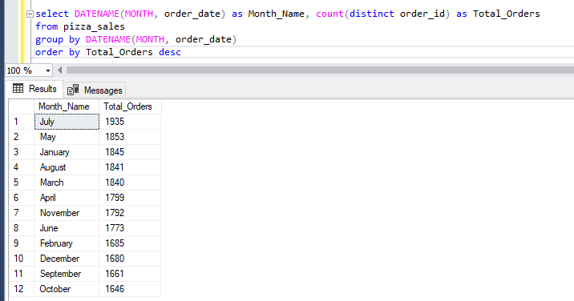

1. **% Of Sales By Pizza Category**

**Query**

select pizza_category,sum(total_price) as Total_Price,

sum(total_price) * 100 / (select sum(total_price) from pizza_sales where MONTH(order_date) = 1) as PCT

from pizza_sales

where MONTH(order_date) = 1

group by pizza_category

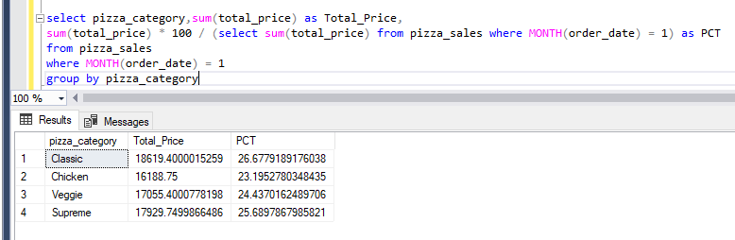

1. **% Of Sales By Pizza Size**

**Query**

select pizza_size,cast(sum(total_price) as decimal (10,2)) as Total_Price,

cast(sum(total_price) * 100 / (select sum(total_price) from pizza_sales where DATEPART(QUARTER, order_date) = 1) as decimal (10,2)) as PCT

from pizza_sales

where DATEPART(QUARTER, order_date) = 1

group by pizza_size

order by PCT desc

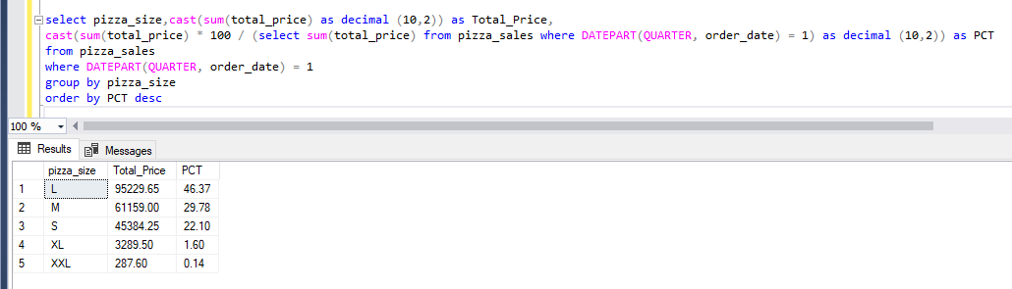

1. **Top 5 Pizzas By Revenue**

**Query**

select top 5 pizza_name, sum(total_price) as Total_Revenue

from pizza_sales

group by pizza_name

order by Total_Revenue desc

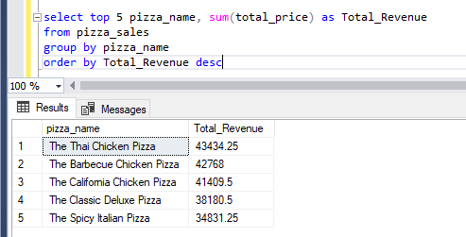

1. **Bottom 5 Pizzas By Revenue**

**Query**

select top 5 pizza_name, sum(total_price) as Total_Revenue

from pizza_sales

group by pizza_name

order by Total_Revenue

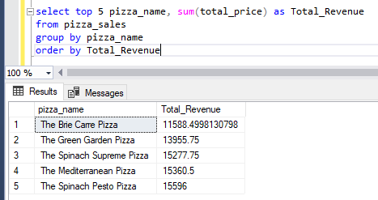

1. **Top 5 Pizzas By Quantity**

**Query**

select top 5 pizza_name, sum(quantity) as Total_Quantity

from pizza_sales

group by pizza_name

order by Total_Quantity desc

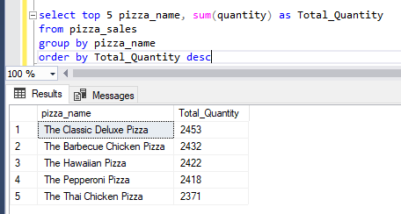

1. **Bottom 5 Pizzas By Quantity**

**Query**

select top 5 pizza_name, sum(quantity) as Total_Quantity

from pizza_sales

group by pizza_name

order by Total_Quantity

