Q.1. What are keywords in python? Using the keyword library, print all the python keywords.

**Answer:**

Keywords in Python are reserved words that have special meanings and are used to define the syntax and structure of the Python language.

**Code:**

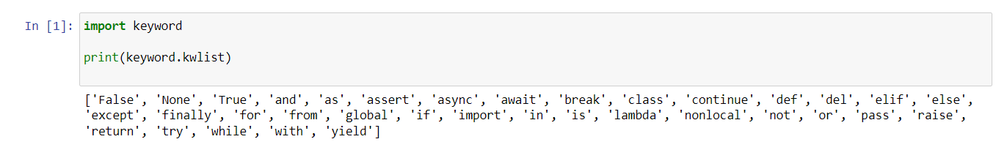

**=====================================================================**

Q.2. What are the rules to create variables in python?

**Answer:**

Following are the rules to create the variables in the python.

* Variable names must start with a letter or an underscore.
* Variable names can contain letters (a-z, A-Z), digits (0-9), and underscores (_).
* Variable names cannot be the same as Python keywords or reserved words
* Variable names are case-sensitive

**======================================================================**

Q.3. What are the standards and conventions followed for the nomenclature of variables in python to improve code readability and maintainability?

**Answer:**

* Use lowercase letters for variable names.
* Separate words with underscores to improve readability

Ex: my_name= ‘Pranit’

**======================================================================**

Q.4. What will happen if a keyword is used as a variable name?

**Answer:** if we use the keyword as the variable name the program will give the syntax error as we cannot use the keyword as the variable name.

**======================================================================**

Q.5. For what purpose def keyword is used?

**Answer**: the def keyword is use to define the function in the python. def define the start of the function definition.

**======================================================================**

Q.6. What is the operation of this special character ‘\’?

**Answer**:

The special character \ is known as the escape character. The \ character is followed by another character to create an escape sequence,

* \n: Represents a newline character.
* \t: Represents a tab character.
* \": Represents a double quote character.
* \': Represents a single quote character.
* \\: Represents a backslash character.

**======================================================================**

Q.7. Give an example of the following conditions:

(i) Homogeneous list

**Ans**: A homogeneous list contains elements of the same data type

List= [1,2,4,5,6,7,11]

(ii) Heterogeneous set

**Ans**: A heterogeneous set contains elements of different data types

Set = {1, ‘the’, 100,12.25}

(iii) Homogeneous tuple

**Ans**: A homogeneous tuple contains elements of the same data type

tuple= (1,2,4,5,6,7,11)

**======================================================================**

Q.8. Explain the mutable and immutable data types with proper explanation & examples

**Answer:**

**Mutable Data Types**

* Mutable data types allow us to modifications of it, meaning you can change the value of an object without creating a new object.
* Examples of mutable data types in Python include lists, dictionaries, and sets.

EX:

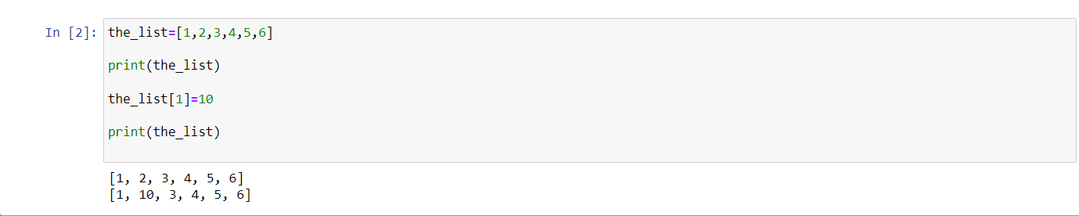

**Immutable Data Types:**

* Immutable data types, on the other hand, do not allow us the modifications. Once an object of an immutable data type is created, its value cannot be changed.
* Examples of immutable data types in Python include integers, floats, strings, tuples.

Ex: we can see in below example when we tried to modify the tuple, we got an error.

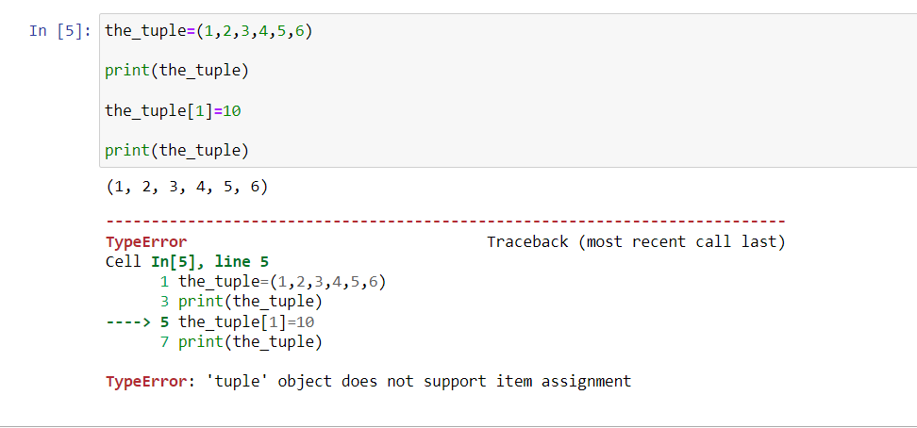

**======================================================================**

Q.9. Write a code to create the given structure using only for loop.

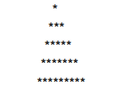

**Answer:**

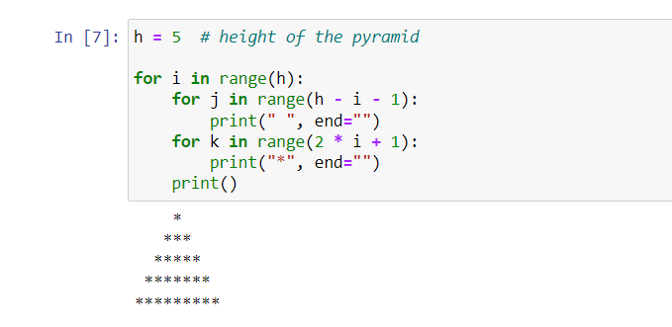

**======================================================================**

Q.10. Write a code to create the given structure using while loop.

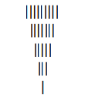

**Answer:**



