D.K.T.E. Society’s Textile and Engineering Institute, Ichalkaranji.

(An Autonomous Institute, Affiliated to Shivaji University, Kolhapur)

Department of Computer Science & Engineering

**2018-2019**



**Project Synopsis On**

A Practical Animal Detection to Avoid Collision using Machine Learning

**Under The Guidance Of**

Prof. Y. M. Kamble

**Submitted By:**

1. Pranita R. Giri 15CMPN08
2. Shraddha R. Karadge 15CMPN20
3. Priyanka A. Khot 15CMPN24
4. Shraddha S. Rhatole 15CMPN47
5. Jyoti A. Shinde 15CMPN51

Prof. Y.M.Kamble Dr.D.V.Kodavade

Project Guide Head of Department

**A Practical Animal Detection To Avoid Collision Using Machine Learning**

**INTRODUCTION**

Today’s automobile design primarily depends on safety measures, security tools and comfort mechanism. The safety of an automobile is the highest priority. A major percentage of these road crashes and accidents involved cars, other vehicles and animal collision. Recent study is done where human beings have to take the final call while driving whether they can control their car to prevent collision with a response time of 150ms or no. But there is issue that human eyes get exhausted quickly and need rest, So that this method is not that effective as much. Also there is a method applicable to moving backgrounds (e.g., due to camera motion) is presented in subsequent studies in which other moving objects apart from the object of interest may be falsely detected as an animal. So there is one approach to overcome this issue. Also there are some papers in which animals are detected using roadside system and for night vision and also for moose detection system.

The proposed system isto develop a practical animal detection system used to reduce the number of road accidents due to animal collision.This system will be applicable in real time for security purpose of wildlife and human being.

**RELATED WORK**

1. Sharma S, Shah D. 2013 proposed an Animal Detection for Highway Security: In this paper roadside system is installed at the road borders to detect animals.

2. David Forslund and Jon Bjarkefur 2014proposed aNight Vision Animal Detection: In this paper animal is detected up to 200 meters in potentially danger areas in night vision.

3. Mammeri A., Zhou D. 2014 proposed anEfficientAnimal Detection System for Smart Cars using Cascade Classifiers: In this moose animal detection system was explored through roadside cameras installed around areas of interest.

**PROBLEMSTATEMENT**

To design and developa system to find animals around the vehicle in motion using YOLO algorithm

**OBJECTIVES**

1.To get the features of the animal by using feature extraction technique.

2.To develop a low-cost automatic animal detection system.

3. To implement a system used to avoid the animal-vehicle collision by using object detection.

4. To enhance a security of animals as well as human being.

**METHODOLGY**

Architectural Diagram:

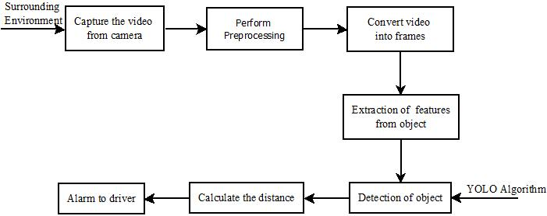

Figure: Architecture of a Practical Animal Detection Using Machine Learning

Description of each component:

Input: Any video captured by camera.

First of all, system will convert video into frames in short interval of time. Then we are doing preprocessing with the frames to enhance the image. Preprocessing will cover all the aspects of frames as sharpening, clearing image and removes variability without losing any essential information.

After getting frames extract the features from images by applying CNN then apply YOLO (You Only Look Once) algorithm which is generally used for real time object detection purpose. In this bounding box will be generated directly from CNN. In this one bounding box is responsible for detecting any object in given image or frame.

Image is divided into grid of cells. Each cell attempts to predict bounding box.

Each bounding box is multiplied by respective class probability and we get final object detection score. Once the object is detected we will find the distance of animal from vehicle. And finally alert to driver.

Note: The whole model is trained on **S*S*(B*5+C)** values per image.

Where S*S: S is the grid size (default value is 7). Each image is split into S*S cells.

B : Number of tested bounding box shapes at each cell.

The network predicts for 5 values which includes exact position (x, y), scale (height, width) as well as confidence score.

C: Number of classes in the dataset.

Output: Driver is getting alerted for the presence of animal.

**REFERENCES**

[1] Sharma S, Thaker J, Patel R. animal detection for highway security: IJSRD Vol 3, 2015; 2321-0613.

[2]David Forslund and Jon Bjarkefur Night vision animal detection: IEEE 2014.

[3]Mammeri A., Zhou D. Efficient animal detection system for smart cars using cascade classifiers:IEEE ICC 2014.