**24th October 2024**

**eFOREST_Test Report (Version 1.0)**

eFOREST Link -http://10.208.26.198:3001

**Revision History**

|  |  |  |  |
| --- | --- | --- | --- |
| **Sr. No.** | **Date** | **Test Report Version** | **Remarks** |
| 1. | 26/11/2024 | 1.0 | Test iteration 1 completed for eFOREST testing of below modules:-   1. Forest Protection Module  * Damage Report Form |

# System Access Details:

* Website/Web service Name: eFOREST
* Feature to test: Forest Protection Module
* URL: http://10.208.27.72:3001/
* Test Environment:
  + Windows 10 (64 Bit) + Google Chrome Version 129.0.6668.100 (Official Build)
  + Windows 10 (64 Bit) + Mozilla Firefox Version 91.0 (64 Bit)
  + Windows 11 (64 Bit) + Mozilla Firefox Version 131.0.3 (64 Bit)
  + Windows 10 (64 Bit) + Mozilla Firefox Version 131.0.3 (64 Bit)
  + Windows 10 (64 Bit) + Google Chrome Version 130.0.6723.58 (Official Build)
  + Windows 10 (64 Bit) + Google Chrome Version 131.0.6778.86 (Official Build)
* Testing Start date: 18th November 2024
* Test Completed on: 26th November 2024
* Scope: Functionality Testing

# Overview

The Forest Protection Module in the eForest application is designed to assist forest departments in monitoring, managing, and safeguarding forest ecosystems. This module focuses on illegal activities and violated environmental laws. The Forest Protection Module includes a Damage Report Form that allows users to record detailed information about any violations or offenses occurring within forest areas.

# Observations:

## Date Validations are not applied.

**Summary:** Date Validations are not applied.

**Steps to Generate Issue:**

1. Go to eFOREST link http://10.208.27.72:3001/.
2. Login as “Beat” with valid user credentials.
3. Click on “Forest Protection Module”, then click on “Forest Protection —>Damage Report Form.
4. Click on “Date of detection”.
5. You will see user can select any date of centuries back.

**Proof of Concept:**

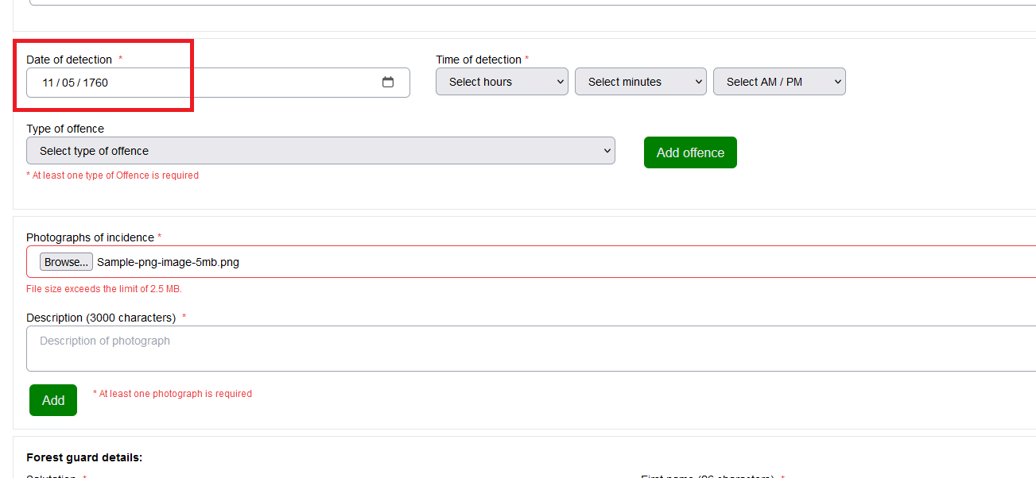

**Developers Remarks:**

## Though the offender doesn’t accept the offence, an OAR is generated.

**Summary:** Though the offender doesn’t accept the offence, an OAR is generated.

**Steps to Generate Issue:**

1. Go to eFOREST link http://10.208.27.72:3001/.
2. Login as “Beat” with valid user credentials.
3. Click on “Forest Protection Module”, then click on “Forest Protection —>Damage Report Form.
4. Fill out “Damage Report” form and select “No” radio button for if offender accept offence” & click on “Submit”.
5. Click on “Submit for approval” & then click on “OAR”.
6. You can see OAR getting downloaded.

**Developers Remarks:**

## Without uploading DR or OAR form getting approved.

**Summary:** Without uploading DR or OAR form getting approved.

**Steps to Generate Issue:**

1. Go to eFOREST link http://10.208.27.72:3001/.
2. Login as “Beat” with valid user credentials.
3. Click on “Forest Protection Module”, then click on “Forest Protection —>Damage Report Form.
4. Fill out “Damage Report” form and click on “Submit”.
5. Click on “Submit for approval”.
6. Now login as “RFO” with valid user credentials.
7. Click on “Further Action” for the form filled by Beat, Fill details and click on “Update”.
8. You can see form getting approved, although Beat don’t uploaded DR or OAR.

**Proof of Concept:**

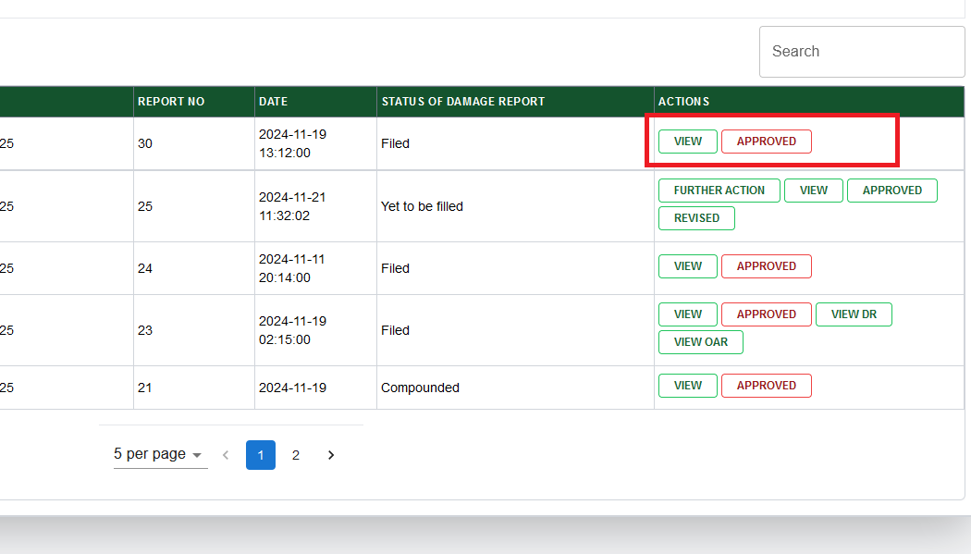

**Developers Remarks:**

## Beat can upload DR and OAR after approval from RFO.

**Summary:** Beat can upload DR and OAR after approval from RFO.

**Steps to Generate Issue:**

1. Go to eFOREST link http://10.208.27.72:3001/.
2. Login as “Beat” with valid user credentials.
3. Click on “Forest Protection Module”, then click on “Forest Protection —>Damage Report Form.
4. Fill out “Damage Report” form and click on “Submit”.
5. Click on “Submit for approval”.
6. Now login as “RFO” with valid user credentials.
7. Click on “Further Action” for the form filled by Beat, Fill details and click on “Update”.
8. Now login as “Beat” with valid user credentials.
9. Click on “DR” or “OAR”, and then click on “Upload DR” or “Upload OAR”.
10. You can see form is already approved from RFO still DR and OAR is getting uploaded.

**Proof of Concept:**

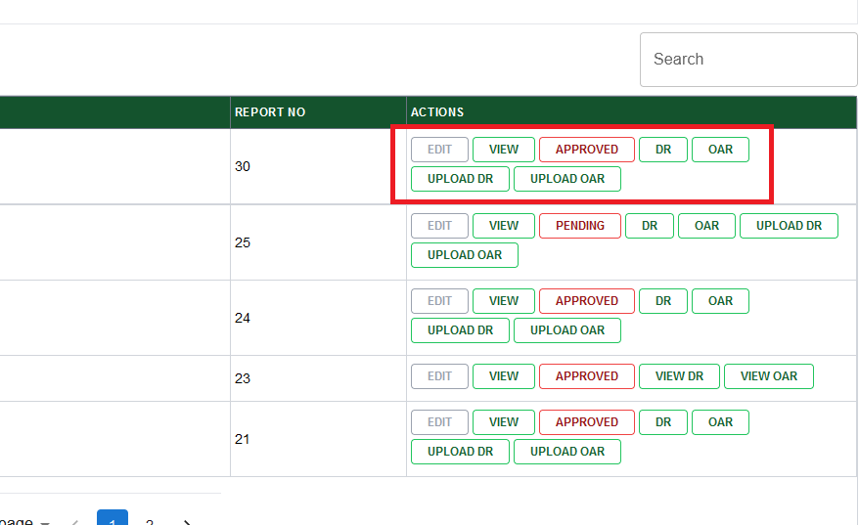

**Developers Remarks:**

## DR and OAR is not visible to RFO.

**Summary:** DR and OAR is not visible to RFO.

**Steps to Generate Issue:**

1. Go to eFOREST link http://10.208.27.72:3001/.
2. Login as “Beat” with valid user credentials.
3. Click on “Forest Protection Module”, then click on “Forest Protection —>Damage Report Form.
4. Fill out “Damage Report” form and click on “Submit”.
5. Click on “Submit for approval”.
6. Download and upload the DR and OAR.
7. Now login as “RFO” with valid user credentials.
8. You can see DR and OAR uploaded by Beat are not available at RFO login.
9. But when RFO approve the form then the DR and OAR uploaded by Beat is visible.

**Developers Remarks:**

## Only alphabet accepted as “Daily diary no”.

**Summary:** Only alphabet accepted as “Daily diary no”.

**Steps to Generate Issue:**

1. Go to eFOREST link http://10.208.27.72:3001/.
2. Login as “Beat” with valid user credentials.
3. Click on “Forest Protection Module”, then click on “Forest Protection —>Damage Report Form.
4. Fill out “Damage Report” form and click on “Submit”.
5. Now login as “RFO” with valid user credentials.
6. Click on “Further Action” for the form filled by Beat, select status of damage report.
7. Click on “No” radio button for “Is FIR filed”.
8. Enter Daily diary number only in alphabets and click on “Update”.
9. You can see form status getting updated.

**Proof of Concept:**

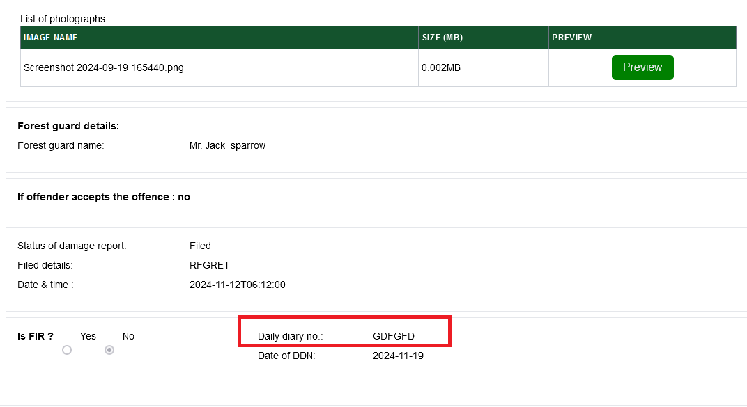

**Developers Remarks:**

## Date and time of detection is not visible properly after submitting damage report form.

**Summary:** Date and time of detection is not visible properly after submitting damage report form.

**Steps to Generate Issue:**

1. Go to eFOREST link http://10.208.27.72:3001/.
2. Login as “Beat” with valid user credentials.
3. Click on “Forest Protection Module”, then click on “Forest Protection —>Damage Report Form.
4. Fill out “Damage Report” form and click on “Submit”.
5. Now click on “View”.
6. You can see date and time of detection is not displayed properly.

**Proof of Concept:**

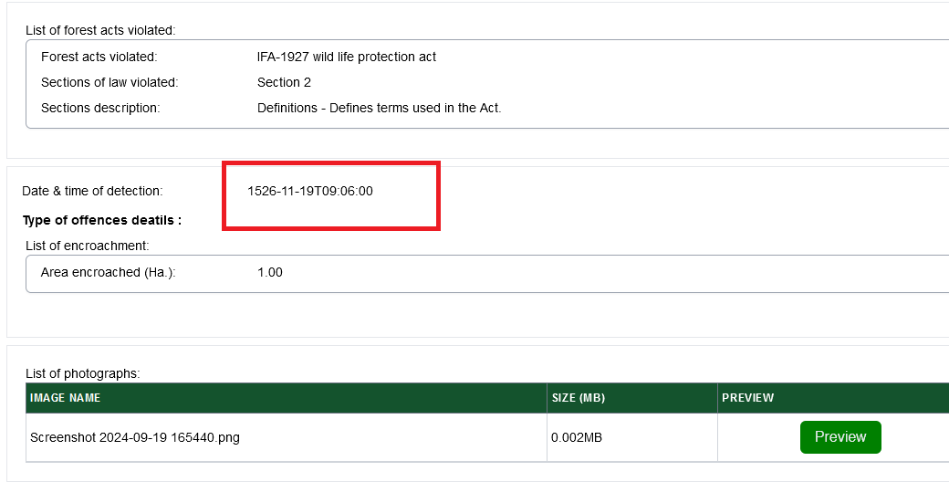

**Developers Remarks:**

## Sections are not populated for some acts.

**Summary:** Sections are not populated for some acts.

**Steps to Generate Issue:**

1. Go to eFOREST link http://10.208.27.72:3001/.
2. Login as “Beat” with valid user credentials.
3. Click on “Forest Protection Module”, then click on “Forest Protection —>Damage Report Form.
4. Click on “forest act violated”.
5. You can see for some acts like HP sale of timber act 1968 rule 1969 section list is not getting populated.

**Proof of Concept:**

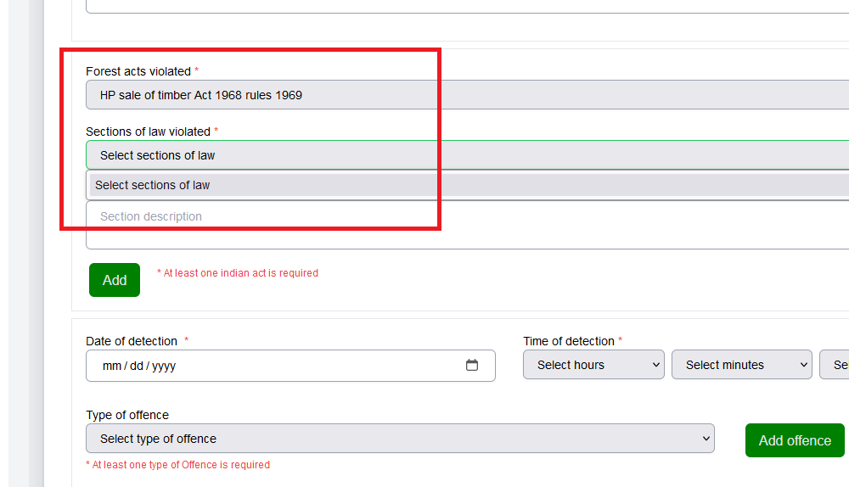

**Developers Remarks:**

## Section description is not editable in Damage report form.

**Summary:** Section description is not editable in Damage report form.

**Steps to Generate Issue:**

1. Go to eFOREST link http://10.208.27.72:3001/.
2. Login as “Beat” with valid user credentials.
3. Click on “Forest Protection Module”, then click on “Forest Protection —>Damage Report Form.
4. Section description of forest acts is not editable.

**Proof of Concept:**

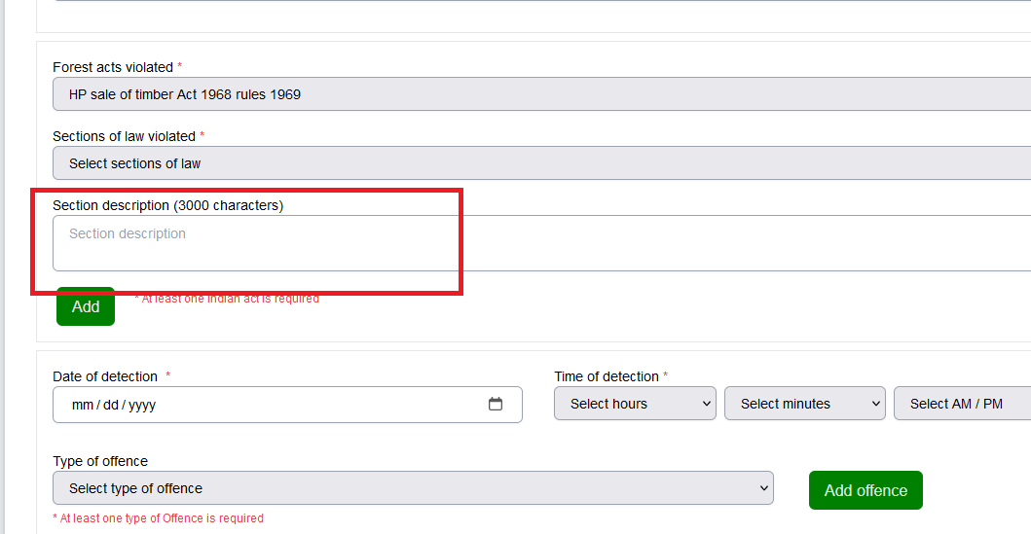

**Developers Remarks:**

## There is no signature of the offender on the Offence Acceptance Report (OAR).

**Summary:** There is no signature of the offender on the Offence Acceptance Report (OAR).

**Steps to Generate Issue:**

1. Go to eFOREST link http://10.208.27.72:3001/.
2. Login as “Beat” with valid user credentials.
3. Click on “Forest Protection Module”, then click on “Forest Protection —>Damage Report Form.
4. Fill out DR form and click on submit.
5. Click on submit for approval and download Offence acceptance report (OAR).
6. You can see there is no option for offender signature.

**Proof of Concept:**

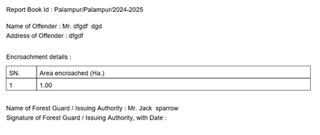

**Developers Remarks:**

## Name of the forest guard is editable in Damage Report form.

**Summary:** Name of the forest guard is editable in Damage Report form.

**Steps to Generate Issue:**

1. Go to eFOREST link http://10.208.27.72:3001/.
2. Login as “Beat” with valid user credentials.
3. Click on “Forest Protection Module” , then click on “Forest Protection —>Damage Report Form.
4. You can see the name of forest guard is editable.

**Proof of Concept:**

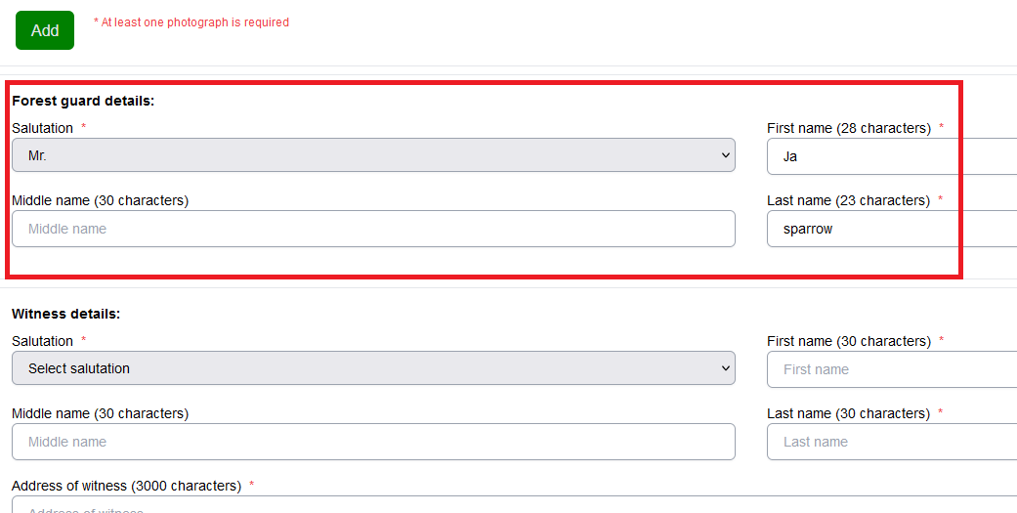

**Developers Remarks:**

## In “Illicit felling entry”, Number of trees is not editable.

**Summary:** In “Illicit felling entry”, Number of trees is not editable.

**Steps to Generate Issue:**

1. Go to eFOREST link http://10.208.27.72:3001/.
2. Login as “Beat” with valid user credentials.
3. Click on “Forest Protection Module” , then click on “Forest Protection —>Damage Report Form.
4. Select “Illicit felling” as type of offence and click on “Add offence”.
5. Enter “Id number” and you can see number of trees is always one and not editable.

**Proof of Concept:**

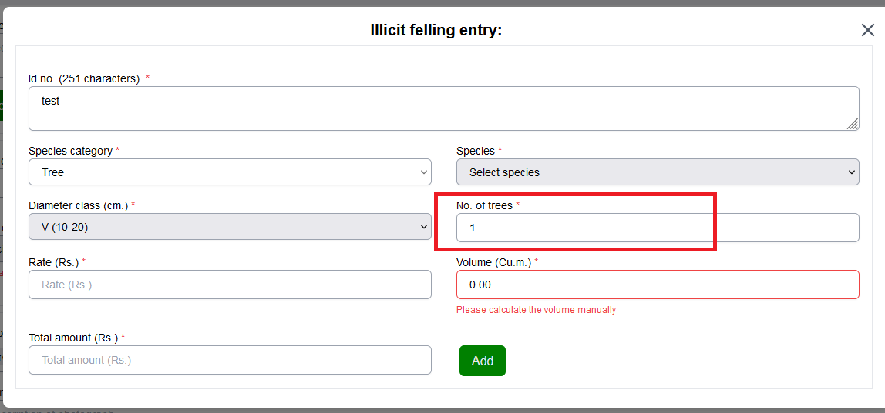

**Developers Remarks:**

## In “Illicit felling entry”, dropdown is not populated for species.

**Summary:** In “Illicit felling entry”, dropdown is not populated for species.

**Steps to Generate Issue:**

1. Go to eFOREST link http://10.208.27.72:3001/.
2. Login as “Beat” with valid user credentials.
3. Click on “Forest protection module” & Fill damage report form.
4. Fill all required details and type of offence & select illicit felling.
5. Click on add offence, here under species no values are shown .And if we proceed for add it will give error “Species Name is required.”

**Proof of Concept:**

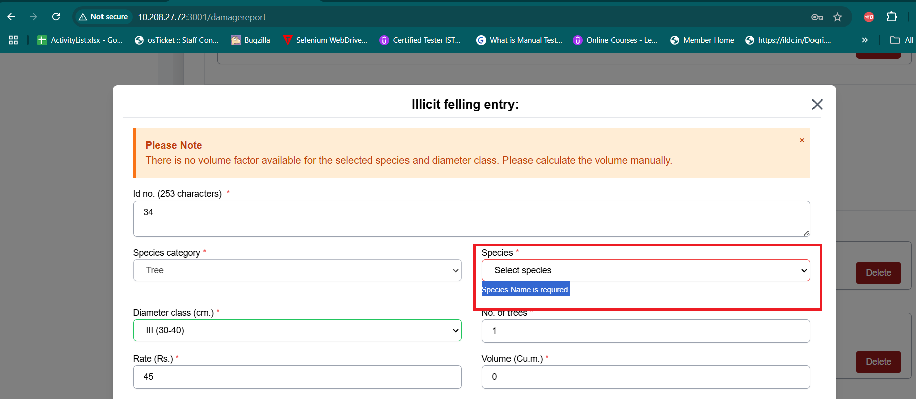

**Developers Remarks:**

## Vehicle registration Number field accepts all the character values.

**Summary:** The vehicle registration number field should accept only numeric values.

**Steps to Generate Issue:**

1. Go to eFOREST link http://10.208.27.72:3001/.
2. Login as “Beat” with valid user credentials.
3. Click on “Forest Protection Module”, then click on “Damage Report Form”—>Fill Form.
4. Fill all the required details and in type of offence select “Mock Dumping” from the dropdown.
5. In “Is Vehicle involved” click on Yes radio button.
6. Fill all the vehicle related details.
7. The registration number field allows the form to be submitted even when only character values are entered.

**Proof of Concept:**

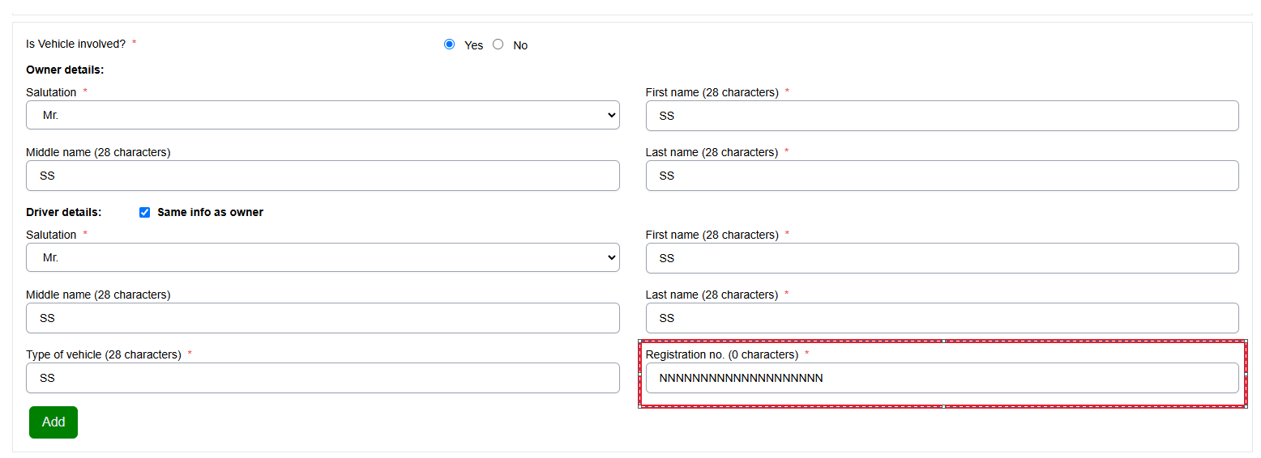

**Developers Remarks:**

## Photographs of incidence field is accepting pdf and word files.

**Summary:** The "Photographs of Incidence" field should accept only JPG, JPEG, and PNG files. However, it is also accepting Word and PDF files.

**Steps to Generate Issue:**

1. Go to eFOREST link http://10.208.27.72:3001/.
2. Login as “Beat” with valid user credentials.
3. Click on “Forest Protection Module”, then click on “Damage Report Form”—>Fill Form.
4. Fill all the required details.
5. The "Photographs of Incidence" field allows Word documents and PDF files to be uploaded, and the form is still being submitted.

**Proof of Concept:**

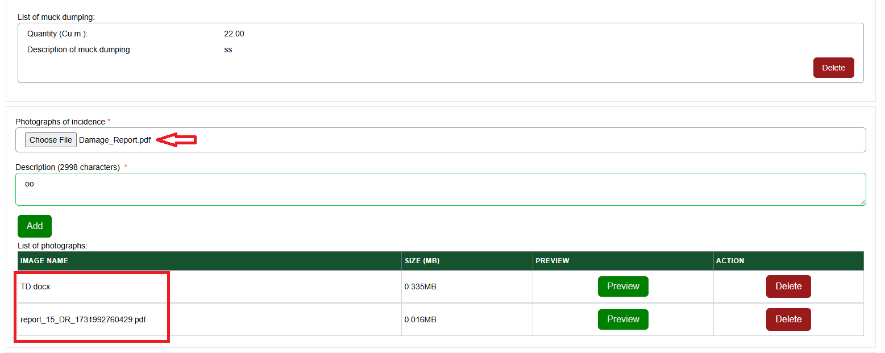

**Developers Remarks:**

## Keep Witness details blank and submit the form, it gets submitted.

**Summary:** The "Witness Details" field is marked as mandatory, yet the form can be submitted without providing any details.

**Steps to Generate Issue:**

1. Go to eFOREST link http://10.208.27.72:3001/.
2. Login as “Beat” with valid user credentials.
3. Click on “Forest Protection Module”, then click on “Damage Report Form”—>Fill Form.
4. Fill all the required details.
5. Keep the “Witness details” section empty and click on Submit Button.
6. The form should not be submitted if the "Witness Details" field is left blank, but it is currently allowing submission.

**Proof of Concept:**

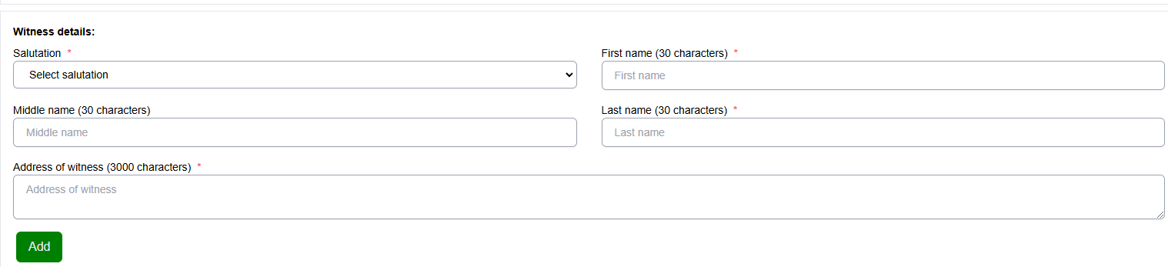

**Developers Remarks:**

## When beat selects any date of detection then range can select any date earlier date before detection while updating the status form .

**Summary:** When beat selects any date of detection then range can select any earlier date before detection while updating the status form.

**Steps to Generate Issue:**

1. Go to eFOREST link http://10.208.27.72:3001/.
2. Login as “Beat” with valid user credentials.
3. Click on “Forest Protection Module” , then click on “Damage Report Form”—>Fill Form.
4. Fill all the required details.
5. Select any Date of detection (e.g. 25/11/24) and after filling the remaining details click on Submit.
6. Then click on “Submit for Approval”
7. Now login as “Range” with valid user credentials.
8. Click on the further action for the form submitted by beat user.
9. Select the status of damage report from the dropdown and fill the details.
10. In date field we can enter the date (e.g. 25/11/22) before the date of detection which should not be allowed.

**Proof of Concept:**

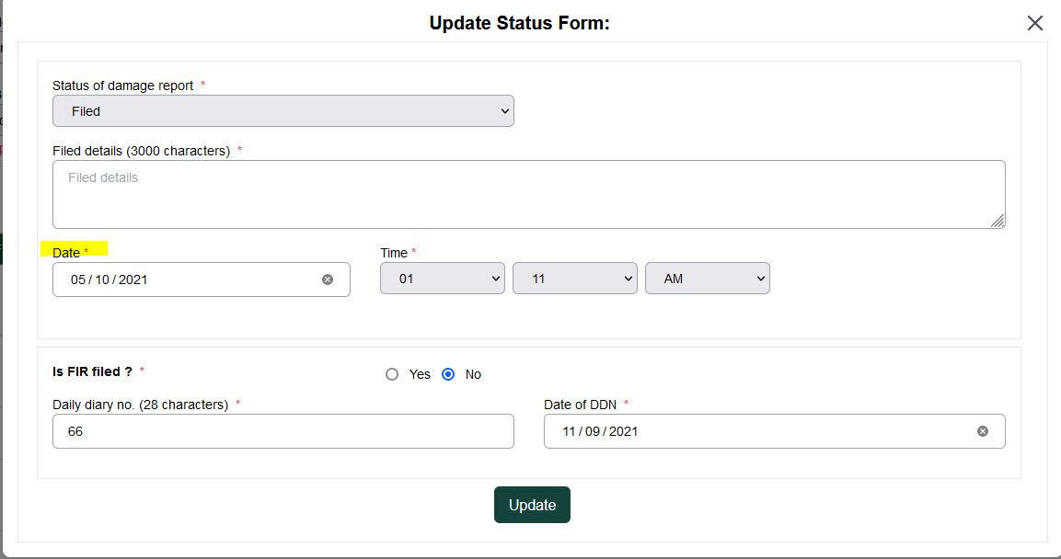

**Developers Remarks:**

## For some forest acts violated, the corresponding list of law sections violated is not being populated.

**Summary:** For some forest acts violated, the corresponding list of law sections violated is not being populated.

**Steps to Generate Issue:**

1. Go to eFOREST link http://10.208.27.72:3001/.
2. Login as “Beat” with valid user credentials.
3. Click on “Forest Protection Module”, then click on “Damage Report Form”—>Fill Form.
4. Fill all the required details.
5. In Forest acts violated select “HP sale of timber act 1968 rules 1969”, "Himachal Pradesh Public Premises and Land” (Eviction and Rent Recovery) Act, 1971, “Himachal Pradesh Forest Produce Transit Land Routes Amendment Rules 2021”.
6. The corresponding values in “sections of law violated” are not getting populated.
7. But once we click on add button it automatically takes values in lists of forests acts violated.

**Proof of Concept:**

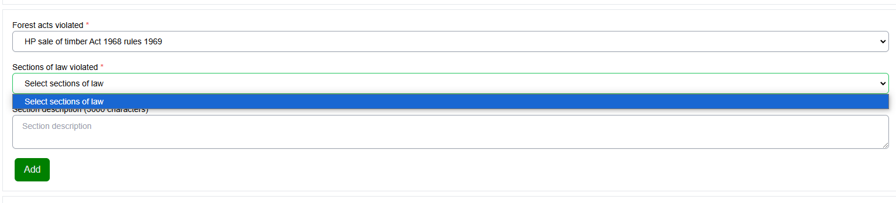

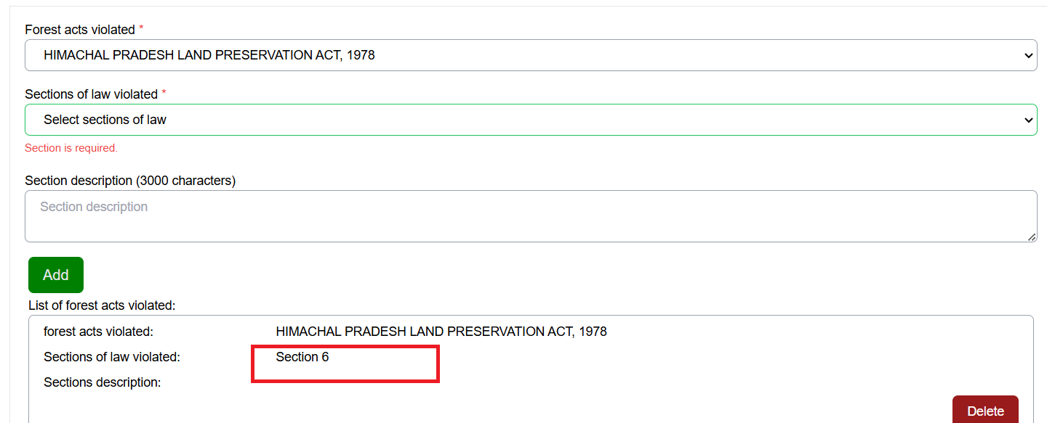

**Developers Remarks:**

## At Beat Login, if there are “No Notifications” it still shows combo box of “5 per page/ 10 per page/ 20 per page”.

**Summary:** At Beat login it shows combo box of “5 per page/ 10 per page/ 20 per page” even if there are “No Notifications.”

**Steps to Generate Issue:**

1. Go to eFOREST link http://10.208.27.72:3001/.
2. Login as “Beat” with valid user credentials.
3. Click on “Forest Protection Module” , then click on “Damage Report Form”.
4. In the Notification section we can see the combo box of “5 per page/ 10 per page/ 20 per page” even if there are “No Notifications.”

**Proof of Concept:**

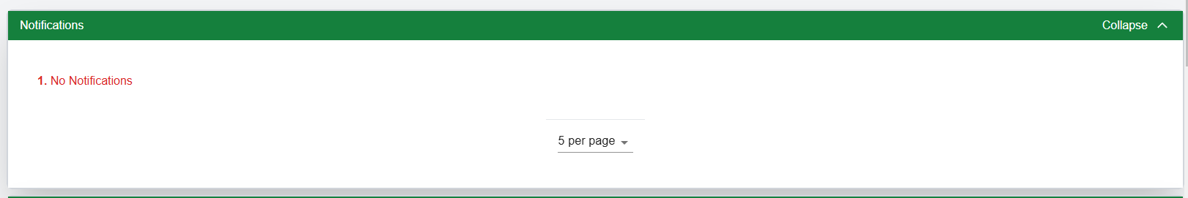

**Developers Remarks:**

## Once added “Type of offence” then the date and time fields are not getting cleared and if we try to add another offence we get alert message.

**Summary:** Once added “Type of offence” then the date and time fields are not getting cleared and if we try to add another offence we get alert message.

**Steps to Generate Issue:**

1. Go to eFOREST link http://10.208.27.72:3001/.
2. Login as “Beat” with valid user credentials.
3. Click on “Forest Protection Module” , then click on “Damage Report Form”—>Fill Form.
4. Fill all the required details.
5. Enter date of detection and time of detection.
6. In type of offence select mining and click on “Add offence”. Fill the details and click on Add.
7. After adding the offence the date and time field is not getting cleared.
8. Now again in “Type of offence” select “Encroachment” and click on add offence.
9. An alert message appears, prompting us to enter the area of the compartment.

**Proof of Concept:**

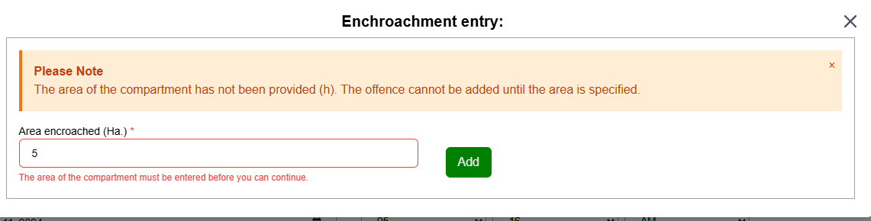

**Developers Remarks:**

## Date and Time of detection is not displayed on Damage report.

**Summary:** Date and Time of detection is not displayed on Damage report.

**Steps to Generate Issue:**

1. Go to eFOREST link http://10.208.27.72:3001/.
2. Login as “Beat” with valid user credentials.
3. Click on “Forest protection module” & Fill damage report form.
4. Fill all required details and submit.
5. Go to filled forms & click on DR , here we can’t see date & time of detection which we have filled in damage report.

**Developers Remarks:**

## At the RFO login, the date of file acceptance is earlier than the date of detection provided by the Beat in the DR form

**Summary:** At the RFO login, the date of file acceptance is earlier than the date of detection provided by the Beat in the DR form.

**Steps to Generate Issue:**

1. Go to eFOREST link http://10.208.27.72:3001/.
2. Login as “Beat” with valid user credentials.
3. Click on “Forest Protection Module” , then click on “Forest Protection —>Damage Report Form.
4. Fill out DR form and click on submit and then click on submit for approval.
5. Login as “RFO” with valid user credentials.
6. Click on Click on “Further Action” for the form filled by Beat,.
7. Select status of damage report as “Filed” and fill the date filling before the date of detection.
8. You can see the form getting approved despite date mismatch.

**Proof of Concept:**

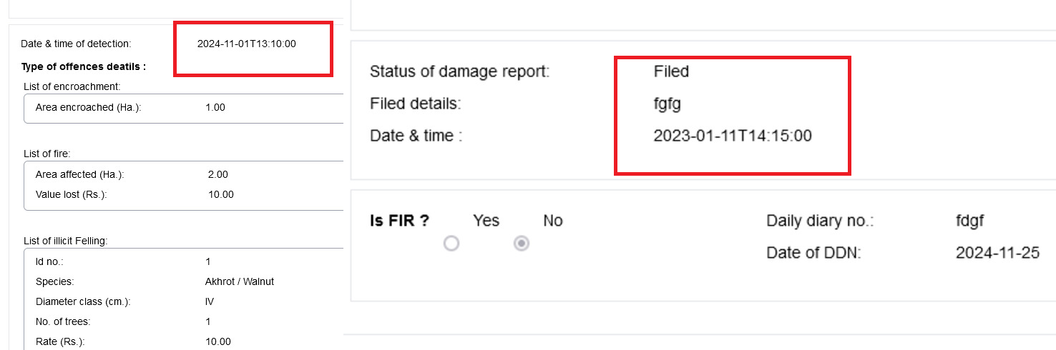

**Developers Remarks:**