

A Project Report on

“ Design and development of a system to measure and transmit vital body signs using MEMS sensor”

*Submitted in partial fulfillment of the requirement of*

*University of Mumbai for the Degree of*

**Bachelor of Engineering**

In

**Mechatronics Engineering**

Submitted By

**Madhura Parab TU6F1819005**

**Purva Bari TU6F1819019**

**Chinmay Warang TU6F1819008**

**Pranita Aloney TU6F1819007**

Under the Guidance of

**Prof. Kankath Govindan**

**Mechatronics Engineering Department**

**Terna Engineering College nerul**

**UNIVERSITY OF MUMBAI**

**Academic Year 2021 – 2022**



CERTIFICATE

This is to certify that the project entitled **“Design and development of a system to measure and transmit vital body signs using MEMS sensor”** is a bonafide work of

**Name Enrollment No.**

Madhura Parab TU6F1819005

Purva Bari TU6F1819019

Chinmay Warang TU6F1819008

Pranita Aloney TU6F1819007

`

submitted to the University of Mumbai in partial fulfillment of the requirement for the award of the degree of **“BE”** in **“Mechatronics Engineering”.**

**_____________________ _____________________**

**Project Guide Project Co-Guide**

**(Prof. Kankath Govindan) (Prof. D. B. Shinde )**

**_______________________ _____________________**

**Head of Department Principal**

**Prof. Vikram Vyawahare Dr. L. K. Ragha**

**Project Report Approval for B.E.**

This project report entitled ***“Design and development of a system to measure and transmit vital body signs using MEMS sensor” by***

***Madhura Parab TU6F1819005***

***Purva Bari TU6F1819019***

***Chinmay Warang TU6F1819008***

***Pranita Aloney TU6F1819007***

is approved for the degree of ***Bachelor in Engineering*** in ***Mechatronics Engineering***.

Examiners

1. _ _ _ _ _ _ _ _ _ _ _ _

2._ _ _ _ _ _ _ _ _ _ _ _

Co-ordinator

_ _ _ _ _ _ _ _ _ _ _ __

Date :

Place:

**Declaration**

We declare that this written submission represents our ideas in our own words and where others' ideas or words have been included, we have adequately cited and referenced the original sources. We also declare that we have adhered to all principles of academic honesty and integrity and have not misrepresented or fabricated or falsified any idea/data/fact/source in our submission. We understand that any violation of the above will be cause for disciplinary action by the Institute and can also evoke penal action from the sources which have thus not been properly cited or from whom proper permission has not been taken when needed.

Madhura Parab TU6F1819005 _ _ _ _ _ _ _ _ _ _ _ _ _

Purva Bari TU6F1819019 _ _ _ _ _ _ _ _ _ _ _ _ _

Chinmay Warang TU6F1819008 _ _ _ _ _ _ _ _ _ _ _ _ _

Pranita Aloney TU6F1819007 _ _ _ _ _ _ _ _ _ _ _ _ _

Date :

Place:

**Acknowledgement**

The project has attained completion through the efforts of many people. We would like to thank our internal guide **Prof. Kankath Govindan** for providing guidelines and giving timely suggestions and inputs to improve the project. He has been a driving force in this project. He has taken immense efforts to guide and explain the concepts behind this project. A special mention should be made about Terna Engineering College and the staff of Mechatronics Engineering department.

We also extend our humble appreciation towards our Project Coordinator, **Prof. D. B. Shinde**  our **H.O.D, Prof. Vikram Vyawahare**  for helping us with the best of their knowledge and for their unconditional and tireless support.

Madhura Parab TU6F1819005

Purva Bari TU6F1819019

Chinmay Warang TU6F1819008

Pranita Aloney TU6F1819007

**Table of Contents**

**Declaration …………………………………………………………………… 3**

**Acknowledgement ……………………………………………………………. 4**

**List of Figures ………………………………………………………………... 7**

**List of Tables …………………………………………………………………. 8**

**Abstract ………………………………………………………………………..**

**Chapter 1 ………………………………………………………….…. 1**

**Introduction ……………………………………………... 1**

* 1. Background …………………………………………………………………...1
  2. Motivation …………………………………………………………….………1

1.2 Problem Statement ……………………………………………………………2

1.3 Scope & Goal …………………………………………………………………2

1.4 Objectives …………………………………………………………………….3

1.5 Organization of the report ……………………………………………………3

**Chapter 2………………………………………………………………4**

**Literature Survey ……………………………………….4**

2.2Existing System ……………………………………………………………5

**Chapter 3 ……………………………………………………………7**

**Methodology ……………………………………………. 7**

3.1 System Overview ……………………………………………………………7

3.2 Controller ……………………………………………………………………8

3.3 Block Diagram of System …………………………………………………..9

3.4 Hardware Components………………………………………………………9

**Chapter 4 ………………………………………………………….14**

**Design and Implementation …………………………….14**

4.1 Overview of Implementation…..………………………………………...14

4.2 Code ……………………………………………………………………..…14

4.3 Mathematical Calculations/ Analysis ……………………………………...30

4.4 Simulation if any …………………………………………………………..31

4.5 Implementation ………………………………………………………...….34

**Chapter 5 …………………………………………………………….34**

**Results …………………………………………………… 34**

5.1 Snapshots ………………………………………………….…………………34

5.2 Application ……………………………………………………………………34

**Chapter 6 …………………………………………………………….35**

**Conclusion ………………………………………………..35**

6.1 Summary ………………………………………………………………………35

6.2 Future scope of the project ……………………………………………………35

**References ………………………………………………..36**

**List of Figures**

|  |  |  |
| --- | --- | --- |
| Figure 1.1 | Title of the figure | Page No |
| Fig 2.2.1 | **Apple Watch Series 7** | 5 |
| Fig 2.2.2 | **Fitbit** | 6 |
| Fig 3.1.1 | **Photoplethysmography** | 7 |
| Fig 3.3.1 | **Block Diagram** | 9 |
| Fig 3.4.1 | **MAX30102** | 10 |
| Fig 3.4.2 | **Arduino UNO R3** | 11 |
| Fig 3.4.3 | **LM35 Temperature Sensor** | 12 |
| Fig 3.4.4 | **SD CArd Module** | 12 |
| Fig 3.4.5 | **OLED Display** | 13 |
| Fig 4.4.1 | **LM35 Simulation at (30ºC)** | 31 |
| Fig 4.4.2 | **LM35 Simulation at (40ºC)** | 32 |
| Fig 4.5.1 | **Flowchart of system** | 33 |
| Fig 5.1.1 | **Working** | 34 |

**List of Tables**

|  |  |  |
| --- | --- | --- |
| Table | Title of the table | Page No |
| 3.1 | Parameters | 8 |

**CHAPTER 1**

**Introduction**

**1.1 BACKGROUND**

Our project is basically a remote health monitoring system where patient’s vital body state can be monitored remotely. Traditionally the detection systems were only found in hospitals and were characterized by huge and complex circuitry which required high power consumption.Initially, the goal of this study was to investigate the possible use of commercial off-the shelf products such as MEMS-based sensors which are very cheap and readily available. Measuring health outcomes allows us to make decisions about how to best care for our patients and outcome measures help us predict the patients who might benefit most from a particular intervention. It helps us identify any improvement after an intervention is provided.

Body temperature, heart rate, blood pressure, and respiratory rate are four basic parameters used to recognize a human's physiological condition. There have been a number of design proposals for measuring vital signs. A number of design techniques have been elaborated, either by invasive-based or noninvasive based systems. Today, emphasis is on the use of noninvasive diagnosis in health maintenance and emergency medicine. Noninvasive instruments and procedures are important due to minor side effects and minimum risk from infection or other complications. High speed and sensitive response of the system are necessary in measuring vital signs parameters. Key factors for the development of sensors in medical healthcare are the availability of low cost micro system sensor technologies as MEMS coupled, in many cases, with low cost, low power microcontrollers and efficient and reliable measuring modules.

**1.2 Motivation**

With the pandemic situation of Coronavirus Disease 2019 (COVID-19) currently happening globally, as of 28 April 2021, more than 146 million people have been infected resulting in the number of 3 million deaths.The most common symptom at the onset of critical COVID-19 patients are cough and fever , while patients with mild-COVID-19 usually have the symptoms of cough, and mostly without fever symptoms. Therefore, having a device that can measure the body temperature of confirmed COVID-19 cases integrated with intelligent health monitoring systems may reduce medical staff’ workload and risk of getting infected from a regular screening procedure for the initial symptoms of severe symptomatic patients from mild COVID-19 or asymptomatic patients in field hospitals resulting in higher efficiency of resources management in pandemic situations.In this fast moving life,people are busy doing their work and hence pay less attention to their personal health. Irregular exercise, imbalanced nutrition, and inadequate rest all contribute to bad health.The main motive for doing this project is that the  patients can keep required measurements within range, risks for serious and costly emergency situations would apparently decrease. Also it could reduce the burden on the healthcare system and better quality of care could be given. Overall, patients can be more satisfied, and doctors can care for their patients more efficiently.

**1.3 Problem Statement**

Health monitoring is difficult for  health enthusiasts or patients who are living in remote areas with hospital monitoring, because it would be difficult for such patients to regularly visit hospitals or go for checkups on regular basis.Wearable sensor, health monitoring can be done for health enthusiast or patient who is living in remote area because it would be difficult for patients to go for checkups on regular basis. So this system can reduce the risk of life of a person as it would be easy to detect any disease at early stage. No need of hospitalization as Real time monitoring would be done by device. Doctor’s can also view the previous records of the patient. As an expected output of this project some chronical diseases like chronic blood pressure, heart diseases can be treat in a better way with proper care which will improve patient’s health.

**1.4 Scope And Goals**

Our aim of the project is to detect vital signs with least error and based on data obtained our device is going to detect the  disease a patient may be suffering from..If detection of diseases which requires highly accurate vital signs data cannot be predicted using this system (not all diseases can be predicted by this system).

**1.5 Objectives**

1. Long-term, remote monitoring, miniature, wearable and low power consuming and long battery life of a designed device.

2. Displaying vital signs like temperature , blood pressure , SPO2 level on LCD.

3. Alerting wearer if vital signs are abnormal.

4. Assistance to the elderly and chronic patients and health enthusiasts . The device has minimal buttons and is easy to use.

**1.6 Organization Of The Project**

CHAPTER 1 includes the introduction of the report. It describes a basic of our system to measure vital body signs.

CHAPTER 2 It describes the full literature survey we have done for this project. It includes the important points we found in the papers and their advantages and disadvantages.It includes brief description of all the research and technical papers we have referred and well as some information about the existing system similar to ours.

CHAPTER 3 is Methodology. Here, we have included the basic principles and methods that would be useful to us to implement our project.

CHAPTER 4 is Design and Implementation. Here we have shown the block diagrams of our system and simulation snapshots.

CHAPTER 5 is the result. Here, we have listed various ways in which our system could be enhanced so that to achieve more functionality.

CHAPTER 6 is the conclusion. This includes the conclusion of the project and the future importance of it.

**CHAPTER 2**

**Literature Survey**

|  |  |  |  |
| --- | --- | --- | --- |
| Sr No | Paper | Authors | Summery |
| 1. | Title:-Measuring and Transmitting Vital Body Signs Using MEMS Sensors | Murat GULER, M.Sc. | measuring a vital body sign with MEMS accelerometer, transmitting the data by RF Transmission, signal processing and analysis with Labview in real-time have been realized. |
| 2. | Title:- FPGA-based system for countinous monitoring of three vital signs of human body | Aminuddin Rizal, Munawar A Riyadi | To design a low cost, low power, reliable, and easy to use biomedical instrumentation which can either monitoring or measuring three human body vital signs. |
| 3. | Title:-Mini Home-Based Vital Sign Monitor with Android Mobile Application | Mas Azalya Yusof 1, Yuan Wen Hau 2 | Vital signs such as blood oxygen saturation (SpO2), body temperature,  electrocardiogram (ECG), are home-based monitored using mobile application named my vital gear. |
| 4. | Title:-Adaptive threshold method for the peak detection of photoplethysmographic  waveform | Hang Sik Shin, Chungkeun Lee, Myoungho Lee | The aim of presented study is the development of improved  peak detection algorithm of PPG waveform. The study demonstrates a promising approach to overcome respiration effect and to detect PPG peak. |

2.2) Existing System

1). Apple Watch Series 7:

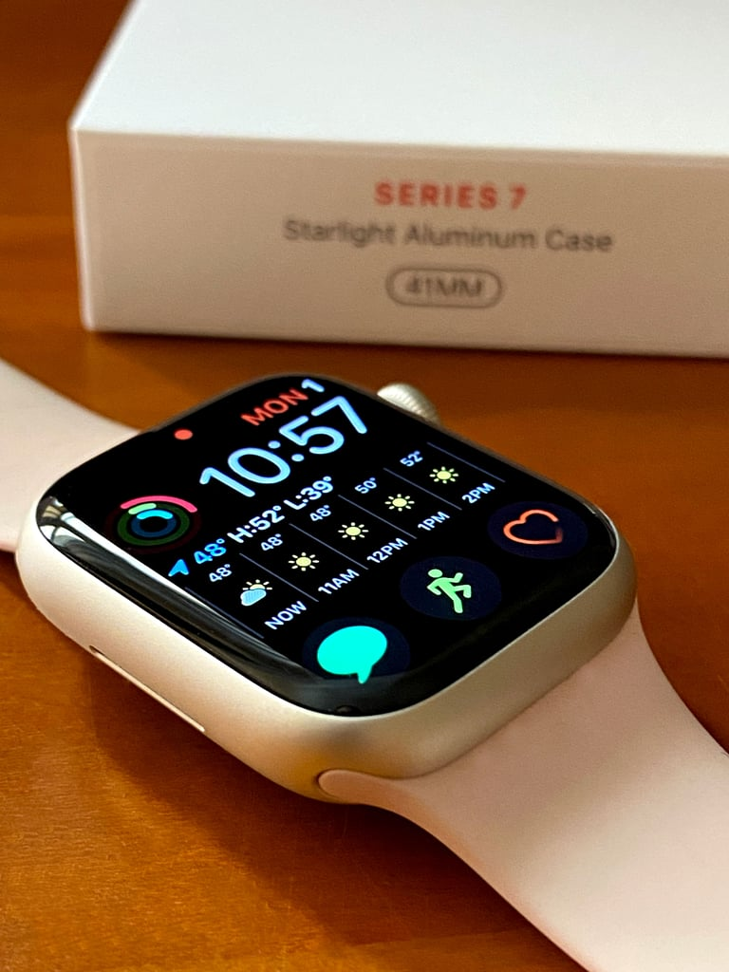

Fig.2.1 Apple Watch Series 7

Apple Watch is a line of [smartwatches](https://en.wikipedia.org/wiki/Smartwatch" \o "Smartwatch) produced by [Apple Inc.](https://en.wikipedia.org/wiki/Apple_Inc." \o "Apple Inc.) It incorporates [fitness tracking](https://en.wikipedia.org/wiki/Activity_tracker" \o "Activity tracker), [health-oriented capabilities](https://en.wikipedia.org/wiki/Health_(Apple)" \o "Health (Apple)), and [wireless telecommunication](https://en.wikipedia.org/wiki/Wireless_telecommunication" \o "Wireless telecommunication), and integrates with [iOS](https://en.wikipedia.org/wiki/IOS" \o "IOS) and other Apple products and services.The Apple Watch operates primarily in conjunction with the user's [iPhone](https://en.wikipedia.org/wiki/IPhone" \o "IPhone) for functions such as configuring the watch and syncing data with iPhone apps, but can separately connect to a [Wi-Fi network](https://en.wikipedia.org/wiki/Wi-Fi_network" \o "Wi-Fi network) for some data-reliant purposes, including basic communications and audio streaming. Models can connect to a [mobile network](https://en.wikipedia.org/wiki/Mobile_network" \o "Mobile network), including for calling, texting, and installed [mobile app](https://en.wikipedia.org/wiki/Mobile_app" \o "Mobile app) data use, substantially reducing the need for an iPhone after initial setup. Although the paired iPhone need not be near the watch, to make a call with the watch, the paired iPhone must still be powered on and connected to a cellular network.The oldest iPhone model that is compatible with any given Apple Watch depends on the version of [system software](https://en.wikipedia.org/wiki/System_software" \o "System software) installed on each device

2). Fitbit Versa 3:-

 Fitbit is an American consumer electronics and fitness company. It produces [wireless](https://en.wikipedia.org/wiki/Wireless" \o "Wireless) enabled [wearable technology](https://en.wikipedia.org/wiki/Wearable_technology" \o "Wearable technology), [physical fitness](https://en.wikipedia.org/wiki/Physical_fitness" \o "Physical fitness) monitors and [activity trackers](https://en.wikipedia.org/wiki/Activity_tracker" \o "Activity tracker) such as [smartwatches](https://en.wikipedia.org/wiki/Smartwatch" \o "Smartwatch), [pedometers](https://en.wikipedia.org/wiki/Pedometer" \o "Pedometer) and monitors for heart rate, quality of sleep and stairs climbed as well as related software.

Features:

* Heart Metrics and SpO2
* ECG monitoring
* Sleep Tracking
* 24/7 Heart Rate
* Voice Assistance

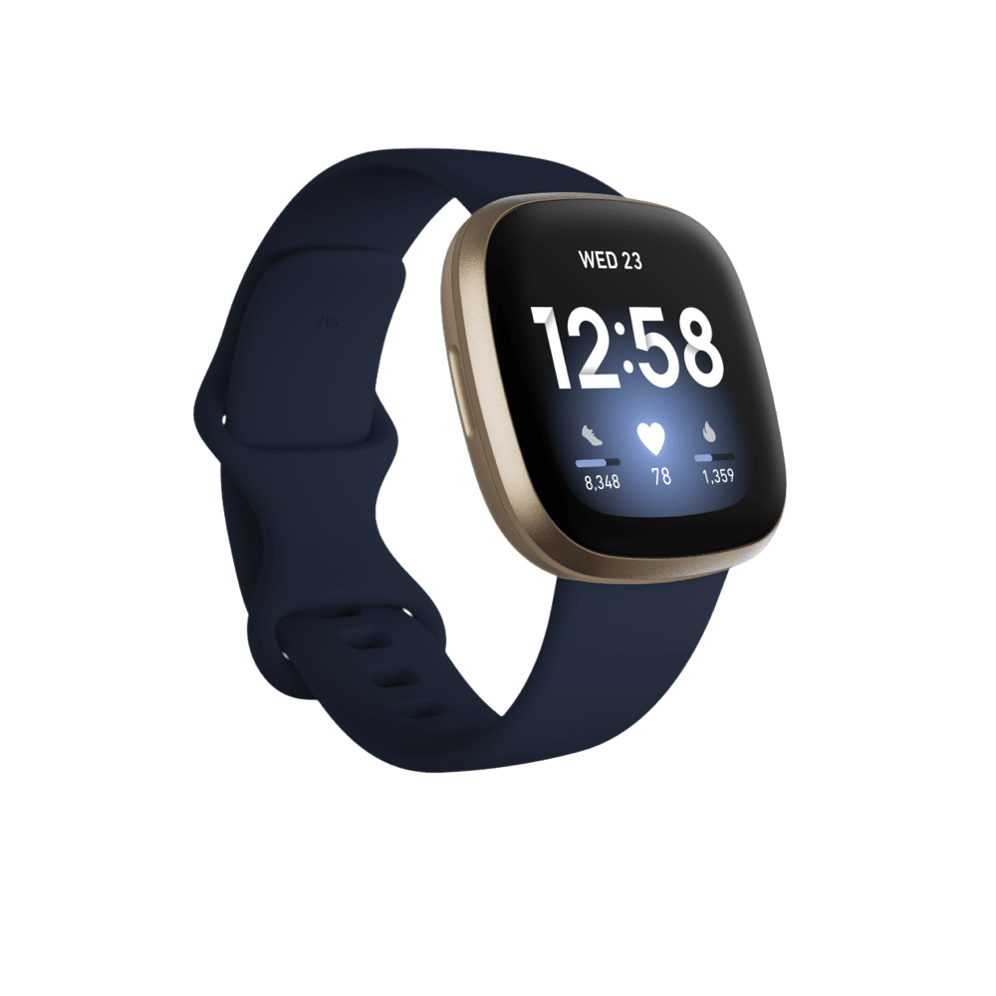

Fig 2.2 Fitbit Versa 3

**CHAPTER 3**

**Methodology**

**3.1 System Overview**

There are two major techniques to measure the pulse: Electro-cardiogram (ECG) and Photoplethysmography (PPG). ECG directly measures the electrical signal produced from the heart in each pulse. The devices using an ECG technique have to be attached on a patients’ chest, which may not be comfortable. Using a light technology to measure the change in blood volume due to the cardiac cycle is called the Photoplethysmography (PPG) technique. PPG detects the change of hemoglobin absorption by using reflection or transmission properties of light in the body’s tissues, which is a non-harmful technique resulting in being more comfortable for patients and ease of use for medical staff to monitor a cardiovascular system. Because of the mentioned advantages of the PPG technique, it is generally preferred for measuring the pulse for most patients. The PPG technique with light transmission property can be performed on any thin body parts such as fingertips. A light transmitter (light emitting diode or infrared diode) and a light receiver are gripped in opposite sides of a finger as shown in Figure. The wavelength can penetrate through hemoglobin and tissues in the finger to the receiver which can be photodiode, LDR, and phototransistor. The blood volume at the fingertip changes according to heart contraction and expansion which can be used to measure the pulse. At the time of heart contraction of a cardiac cycle, more blood circulates into vessels; thus, the transmitter sends less light to the receiver. Conversely, when there is a relaxation phase of the cardiac cycle, the concentration of the red blood cell decreases, resulting in more light being able to pass through a finger to the receiver. The intensity of light being received by the receiver is converted into the form of an electrical signal and then amplified for ease of observation.

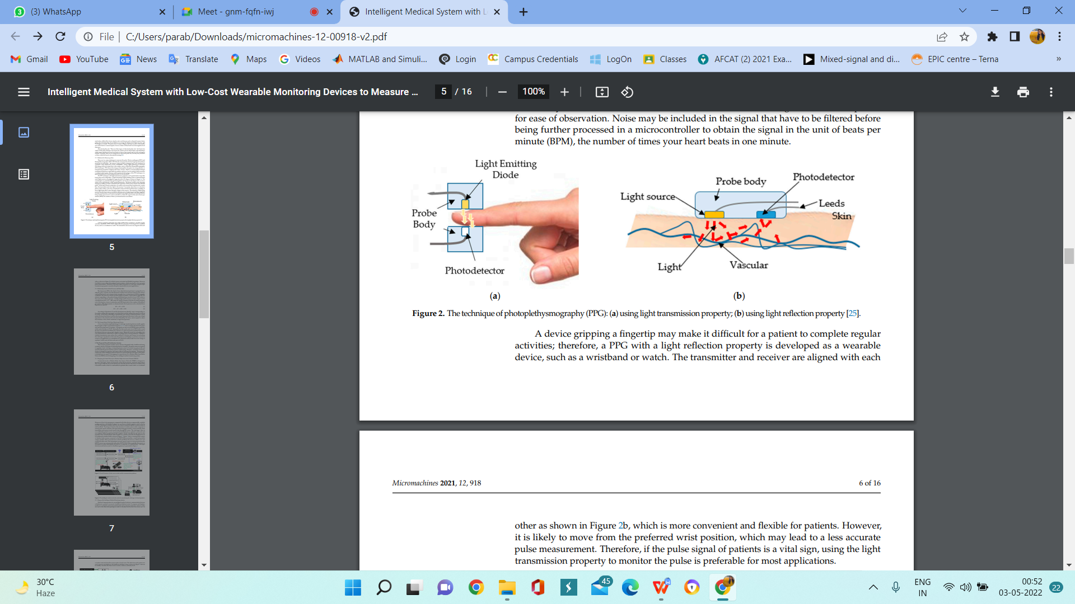

Fig.3.1 Photoplethysmography

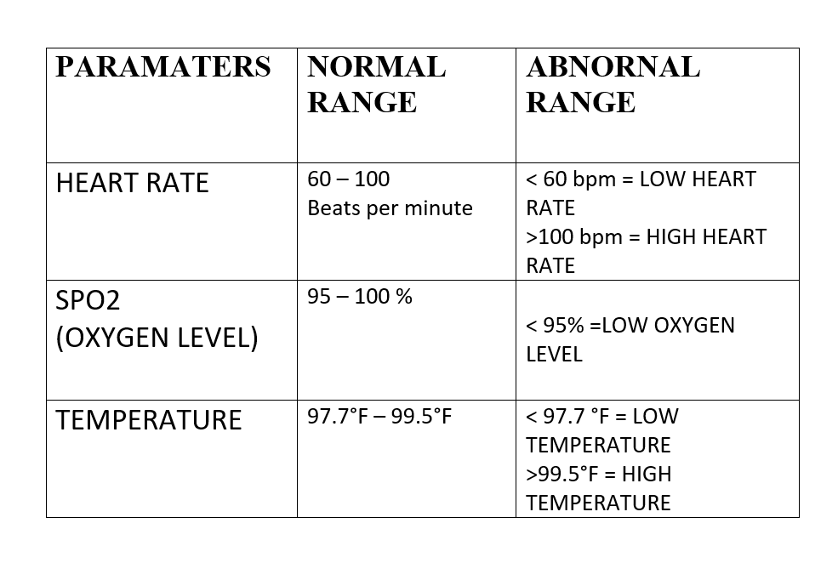

Table 3.1 Parameters

**3.2  Controller**

# Here, the controller used is Arduino microcontroller. Arduino Uno Microcontroller Board is based on the Microchip Technology ATmega328 8-bit Microcontroller (MCU). Arduino Uno features 14 digital input/output pins (six of which can be used as PWM outputs), six analog inputs, and a 16MHz quartz crystal. Uno also includes a USB connection, a power jack, an In-Circuit Serial Programming (ICSP) header, and a reset button. This Arduino MCU board contains everything the user needs to support the MCU. The user can get started by connecting the Uno to a computer with the USB cable or by powering it with an AC/DC adapter or battery. The Uno can be programmed with Arduino Software (Integrated Development Environment). The ATmega328 on the Uno comes preprogrammed with a bootloader that allows the user to upload new code to the MCU without the use of an external hardware programmer. Arduino Uno differs from preceding boards in that it does not use the FTDI USB-to-serial driver chip. This board instead features the Atmega16U2 programmed as a USB-to-serial converter.

**3.3 Block Diagram Of System**

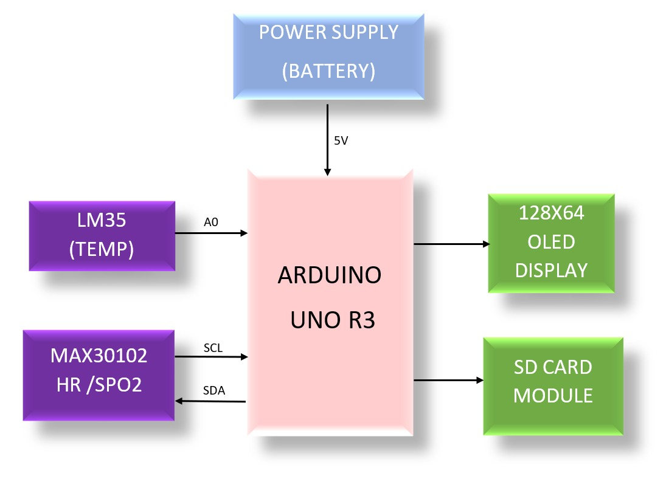

Fig.Block Diagram Of System

**3.4 Hardware Components**

* **MAX30102**

 The MAX30102 is a complete pulse oximetry and heart-rate sensor system solution module designed for the demanding requirements of wearable devices. The device maintains a very small solution size without sacrificing optical or electrical performance. Minimal external hardware components are required for integration into a wearable system. The MAX30102 is fully adjustable through software registers, and the digital output data can be stored in a 32-deep FIFO within the IC.

SpO2 Subsystem

The SpO2 subsystem of the MAX30102 contains ambient light cancellation (ALC), a continuous-time sigma-delta ADC, and a proprietary discrete time filter. The ALC has an internal Track/Hold circuit to cancel ambient light and increase the effective dynamic range. The SpO2 ADC has programmable full-scale ranges from 2µA to 16µA. The ALC can cancel up to 200µA of ambient current.

LED Driver

 The MAX30102 integrates Red and IR LED drivers to modulate LED pulses for SpO2 and HR measurements. The LED current can be programmed from 0 to 50mA with proper supply voltage. The LED pulse width can be programmed from 69µs to 411µs to allow the algorithm to optimize SpO2 and HR accuracy and power consumption based on use cases.

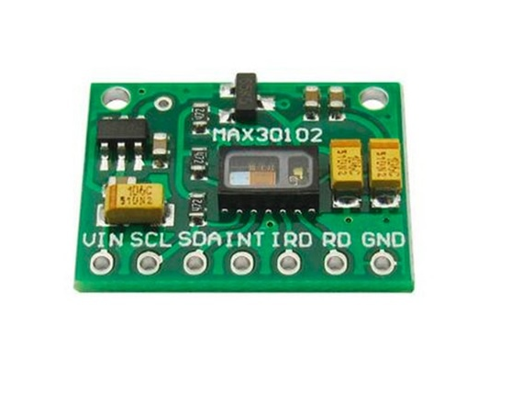 Fig 3.4.1. MAX30102

**ARDUINO UNO**

The Arduino UNO is categorised as a microcontroller that uses the ATmega328 as a controller in it.  It has 14 digital input/output pins (of which 6 can be used as PWM outputs), 6 analog inputs,16 MHz ceramic resonator (CSTCE16M0V53-R0), a USB connection, a power jack, an ICSP header and a reset button. It contains everything needed to support the microcontroller; simply connect it to a computer with a USB cable or power it with a AC-to-DC adapter or battery to get started.

The Arduino UNO board contains the following components and specifications:

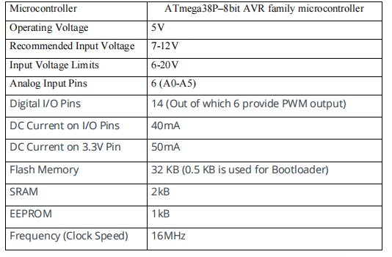

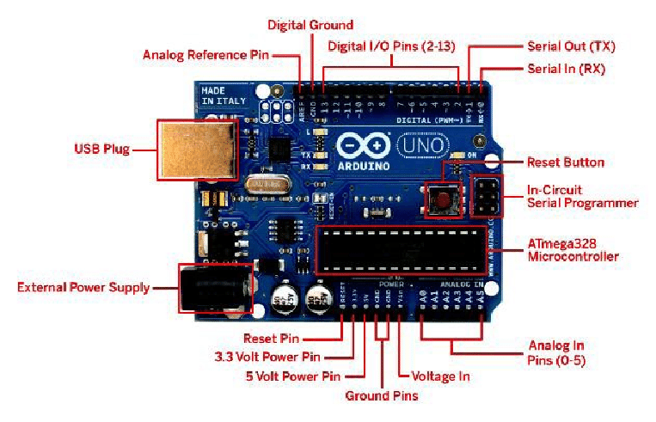

Fig. 3.4.2 Arduino Uno

**LM35 TEMPERATURE SENSOR**

In our system we are using LM35 temperature sensor. LM35 is a calibrated, readily available and low-priced sensor. Also it has accuracy of 0.50C. As the LM35 draws only 60 μA from the supply, it has very low self-heating of less than 0.1°C in still air. In order to increase the resolution of the system we have restricted the temperature range of the sensor only up to 300 C to 400C. LM 35 has resolution of 10mV/0C which increases linearly with the temperature. And at 00 C its output is 0 V. That means at 300 C output of sensor is 300mV and at 400 C its output is 400mV. But in order to use internal ADC of microcontroller (LPC 2148) this voltage range is not suitable. So we mapped these voltages to 0 V – 3.3 V (as internal ADC of LPC requires these levels). First of all sensor output is amplified to 1V and then 1V is subtracted from it and again amplified to suitable level (between 0-3.3V) . Purposefully 300mV offset voltage is not subtracted because the small offset error can cause large variation in the output when amplified. Following circuit gives the output of 0V-3.3v.

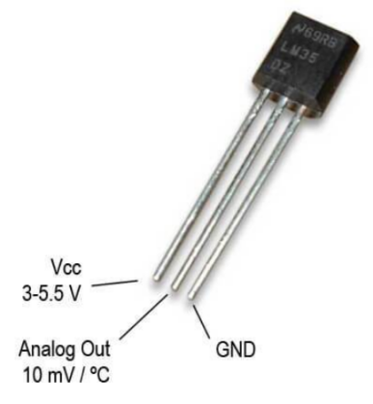

Fig 3.4.3 LM35 Temperature sensor

**SD CARD MODULE:-**

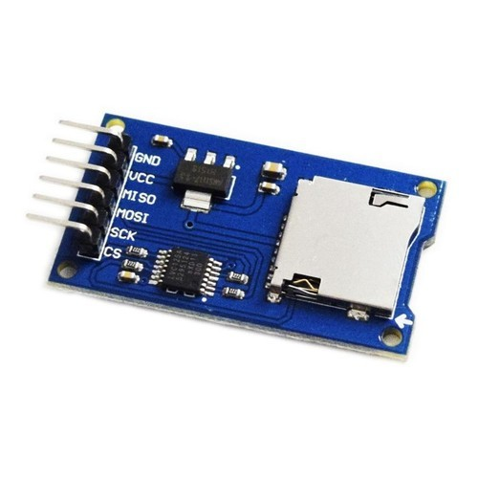The SD card module is specially useful for projects that require data logging. The Arduino can create a file in an SD card to write and save data using the SD library. There are different models from different suppliers, but they all work in a similar wa`y, using the SPI communication protocol.

Fig 3.4.4 SD card module

**OLED DISPLAY**

OLED is an Organic Light-Emitting Diode. OLED Display is a self light-emitting technology composed of a thin, multi-layered organic film placed between an anode and cathode. In contrast to LCD technology, OLED does not require a backlight. OLED possesses high application potential for virtually all types of displays and is regarded as the ultimate technology for the next generation of flat-panel displays.OLEDs are used to create digital displays in devices.

OLED features are as follows

* No need of the backlight
* The display is self-illuminating
* Power requirement is low
* They are offering the large viewing angle
* Full Compatible with Arduino
* Factory configured for SPI protocol (can easily change to IIC)
* Better performance characteristics than traditional LCD and LED displays.
* Only Need 2 I/O Port Control

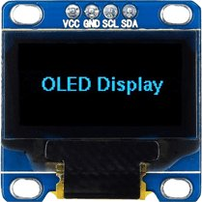

Fig 3.4.5 OLED Display

**CHAPTER 4**

**Design and Implementation**

4.1 Overview of Implementation:-

The project begins with studying various biological concepts and using that knowledge to start with the design calculations of our MEMS sensor. Keeping in mind the mission requirements of this project the various parameters (Heart Rate,Blood oxygenation,Temperature) are set and the components of this system are chosen.

After completion of the above process, the prototype model of this system is designed and then analyzed.

Later other skeleton of the MEMS system is developed, all the components are assembled and thereafter it is covered with its skin.

Now, the newly fabricated MEMS system is tested within its set limits and checked if the yield matches with the desired output.

4.2 Code:-

#include "ssd1306h.h"

#include "MAX30102.h"

#include "Pulse.h"

#include <avr/pgmspace.h>

#include <EEPROM.h>

#include <avr/sleep.h>

#include "LM35.h"

#ifndef cbi

#define cbi(sfr, bit) (_SFR_BYTE(sfr) &= ~_BV(bit))

#endif

#ifndef sbi

#define sbi(sfr, bit) (_SFR_BYTE(sfr) |= _BV(bit))

#endif

SSD1306 oled;

MAX30102 sensor;

Pulse pulseIR;

Pulse pulseRed;

MAFilter bpm;

// setting the sensor in the pin A0

// Command - LM35 name_of_variable(analog_pin);

LM35 temp(A0);

#define LED LED_BUILTIN

#define BUTTON 3

#define STARTBUTTON 2

#define OPTIONS 7

#define LED2 6

static const uint8_t heart_bits[] PROGMEM = { 0x00, 0x00, 0x38, 0x38, 0x7c, 0x7c, 0xfe, 0xfe, 0xfe, 0xff,

0xfe, 0xff, 0xfc, 0x7f, 0xf8, 0x3f, 0xf0, 0x1f, 0xe0, 0x0f,

0xc0, 0x07, 0x80, 0x03, 0x00, 0x01, 0x00, 0x00, 0x00, 0x00,

0x00, 0x00 };

//spo2_table is approximated as -45.060*ratioAverage* ratioAverage + 30.354 *ratioAverage + 94.845 ;

const uint8_t spo2_table[184] PROGMEM =

{ 95, 95, 95, 96, 96, 96, 97, 97, 97, 97, 97, 98, 98, 98, 98, 98, 99, 99, 99, 99,

99, 99, 99, 99, 100, 100, 100, 100, 100, 100, 100, 100, 100, 100, 100, 100, 100, 100, 100, 100,

100, 100, 100, 100, 99, 99, 99, 99, 99, 99, 99, 99, 98, 98, 98, 98, 98, 98, 97, 97,

97, 97, 96, 96, 96, 96, 95, 95, 95, 94, 94, 94, 93, 93, 93, 92, 92, 92, 91, 91,

90, 90, 89, 89, 89, 88, 88, 87, 87, 86, 86, 85, 85, 84, 84, 83, 82, 82, 81, 81,

80, 80, 79, 78, 78, 77, 76, 76, 75, 74, 74, 73, 72, 72, 71, 70, 69, 69, 68, 67,

66, 66, 65, 64, 63, 62, 62, 61, 60, 59, 58, 57, 56, 56, 55, 54, 53, 52, 51, 50,

49, 48, 47, 46, 45, 44, 43, 42, 41, 40, 39, 38, 37, 36, 35, 34, 33, 31, 30, 29,

28, 27, 26, 25, 23, 22, 21, 20, 19, 17, 16, 15, 14, 12, 11, 10, 9, 7, 6, 5,

3, 2, 1 } ;

int getVCC() {

//reads internal 1V1 reference against VCC

#if defined(AVR_ATmega1284P)

ADMUX = _BV(REFS0) | _BV(MUX4) | _BV(MUX3) | _BV(MUX2) | _BV(MUX1); // For ATmega1284

#else

ADMUX = _BV(REFS0) | _BV(MUX3) | _BV(MUX2) | _BV(MUX1); // For ATmega328

#endif

delay(2); // Wait for Vref to settle

ADCSRA |= _BV(ADSC); // Convert

while (bit_is_set(ADCSRA, ADSC));

uint8_t low = ADCL;

unsigned int val = (ADCH << 8) | low;

//discard previous result

ADCSRA |= _BV(ADSC); // Convert

while (bit_is_set(ADCSRA, ADSC));

low = ADCL;

val = (ADCH << 8) | low;

return (((long)1024 * 1100) / val)/100;

}

void print_digit(int x, int y, long val, char c=' ', uint8_t field = 3,const int BIG = 2)

{

uint8_t ff = field;

do {

char ch = (val!=0) ? val%10+'0': c;

oled.drawChar( x+BIG*(ff-1)*6, y, ch, BIG);

val = val/10;

--ff;

} while (ff>0);

oled.drawStr(5,0,F("."),1);

long a= (val-(long)val)*100;

print_digit(x+25,y,a,' ' ,2,1);

}

* Record, scale and display PPG Wavefoem

const uint8_t MAXWAVE = 72;

class Waveform {

public:

Waveform(void) {wavep = 0;}

void record(int waveval) {

waveval = waveval/8; // scale to fit in byte 缩放以适合字节

waveval += 128; //shift so entired waveform is +ve

waveval = waveval<0? 0 : waveval;

waveform[wavep] = (uint8_t) (waveval>255)?255:waveval;

wavep = (wavep+1) % MAXWAVE;

}

void scale() {

uint8_t maxw = 0;

uint8_t minw = 255;

for (int i=0; i<MAXWAVE; i++) {

maxw = waveform[i]>maxw?waveform[i]:maxw;

minw = waveform[i]<minw?waveform[i]:minw;

}

uint8_t scale8 = (maxw-minw)/4 + 1; //scale * 8 to preserve precision

uint8_t index = wavep;

for (int i=0; i<MAXWAVE; i++) {

disp_wave[i] = 31-((uint16_t)(waveform[index]-minw)*8)/scale8;

index = (index + 1) % MAXWAVE;

}

}

void draw(uint8_t X) {

for (int i=0; i<MAXWAVE; i++) {

uint8_t y = disp_wave[i];

oled.drawPixel(X+i, y);

if (i<MAXWAVE-1) {

uint8_t nexty = disp_wave[i+1];

if (nexty>y) {

for (uint8_t iy = y+1; iy<nexty; ++iy)

oled.drawPixel(X+i, iy);

}

else if (nexty<y) {

for (uint8_t iy = nexty+1; iy<y; ++iy)

oled.drawPixel(X+i, iy);

}

}

}

}

private:

uint8_t waveform[MAXWAVE];

uint8_t disp_wave[MAXWAVE];

uint8_t wavep = 0;

} wave;

int beatAvg;

int SPO2, SPO2f;

int current_temp;

int voltage;

bool filter_for_graph = false;

bool draw_Red = false;

uint8_t pcflag =0;

uint8_t istate = 0;

uint8_t sleep_counter = 0;

void button(void){

pcflag = 1;

}

void checkbutton(){

if (pcflag && !digitalRead(BUTTON)) {

istate = (istate +1) % 4;

filter_for_graph = istate & 0x01;

draw_Red = istate & 0x02;

EEPROM.write(OPTIONS, filter_for_graph);

EEPROM.write(OPTIONS+1, draw_Red);

}

pcflag = 0;

}

void Display_5(){

if(pcflag && !digitalRead(BUTTON)){

draw_oled(5);

delay(1100);

}

pcflag = 0;

}

void go_sleep() {

oled.fill(0);

oled.off();

delay(10);

sensor.off();

delay(10);

cbi(ADCSRA, ADEN); // disable adc

delay(10);

pinMode(0,INPUT);

pinMode(2,INPUT);

set_sleep_mode(SLEEP_MODE_PWR_DOWN);

sleep_mode(); // sleep until button press

// cause reset

setup();

}

void draw_oled(int msg) {

oled.firstPage();

do{

switch(msg){

case 0: oled.drawStr(10,0,F("Device error"),1);

break;

case 1: oled.drawStr(0,0,F("PLACE YOUR"),2);

oled.drawStr(25,18,F("FINGER"),2);

break;

case 2:

print_digit(86,0,beatAvg,' ',2,1);

oled.drawStr(5,0,F("bpm PR: "),1);

oled.drawStr(5,15,F("SpO2%: "),1);

oled.drawStr(5,30,F("temp: "),1);

print_digit(73,15,SPO2f,' ',2,1);

current_temp=temp.fah();

print_digit(73,30,current_temp,' ',2,1);

//temp.fah()

// print_digit(86,0,beatAvg);

// oled.drawStr(0,0,F("bpm PR"),2);

// oled.drawStr(0,16,F("SpO"),2);

// oled.drawStr(38,25,F("2"),1);

// print_digit(73,16,SPO2f,' ',3,2);

// oled.drawChar(116,16,'%',2);

break;

case 3: oled.drawStr(33,0,F("MTRX"),2);

oled.drawStr(17,15,F("A7"),2);

//oled.drawXBMP(6,8,16,16,heart_bits);

break;

case 4: oled.drawStr(10,12,F("OFF IN"),2);

oled.drawChar(90,12,10-sleep_counter/10+'0',2);

oled.drawChar(102,12,'s',2);

break;

case 5: oled.drawStr(0,0,F("Avg Pulse"),1);

print_digit(75,0,beatAvg);

oled.drawStr(0,15,F("AVG OXYGEN"),1);

oled.drawStr(0,22,F("saturation"),1);

print_digit(75,15,SPO2);

break;

}

} while (oled.nextPage());

}

long lastBeat = 0; //Time of the last beat

long displaytime = 0; //Time of the last display update

bool led_on = false;

void setup(void) {

pinMode(LED2, OUTPUT);

pinMode(LED, OUTPUT);

pinMode(BUTTON, INPUT_PULLUP);

// pinMode(STARTBUTTON, INPUT_PULLUP);

// attachInterrupt(digitalPinToInterrupt(STARTBUTTON),startAlgo, FALLING);

filter_for_graph = EEPROM.read(OPTIONS);

draw_Red = EEPROM.read(OPTIONS+1);

oled.init();

oled.fill(0x00);

draw_oled(3);

delay(3000);

if (!sensor.begin()) {

draw_oled(0);

while (1);

}

sensor.setup();

attachInterrupt(digitalPinToInterrupt(BUTTON),button, CHANGE);

}

void loop() {

sensor.check();

long now = millis(); //start time of this cycle

if (!sensor.available()) return;

uint32_t irValue = sensor.getIR();

uint32_t redValue = sensor.getRed();

sensor.nextSample();

if (irValue<5000) {

voltage = getVCC();

checkbutton();

draw_oled(sleep_counter<=50 ? 1 : 4); // finger not down message

:if(x>y)z=x;elsez=y

delay(200);

++sleep_counter;

if (sleep_counter>100) {

go_sleep();

sleep_counter = 0;

}

} else {

sleep_counter = 0;

// remove DC element

int16_t IR_signal, Red_signal;

bool beatRed, beatIR;

if (!filter_for_graph) {

IR_signal = pulseIR.dc_filter(irValue) ;

Red_signal = pulseRed.dc_filter(redValue);

beatRed = pulseRed.isBeat(pulseRed.ma_filter(Red_signal));

beatIR = pulseIR.isBeat(pulseIR.ma_filter(IR_signal));

} else {

IR_signal = pulseIR.ma_filter(pulseIR.dc_filter(irValue)) ;

Red_signal = pulseRed.ma_filter(pulseRed.dc_filter(redValue));

beatRed = pulseRed.isBeat(Red_signal);

beatIR = pulseIR.isBeat(IR_signal);

}

// invert waveform to get classical BP waveshape

wave.record(draw_Red ? -Red_signal : -IR_signal );

// check IR or Red for heartbeat

if (draw_Red ? beatRed : beatIR){

long btpm = 60000/(now - lastBeat);

if (btpm > 0 && btpm < 200) beatAvg = bpm.filter((int16_t)btpm);

lastBeat = now;

digitalWrite(LED, HIGH);

led_on = true;

// compute SpO2 ratio

long numerator = (pulseRed.avgAC() * pulseIR.avgDC())/256;

long denominator = (pulseRed.avgDC() * pulseIR.avgAC())/256;

int RX100 = (denominator>0) ? (numerator * 100)/denominator : 999;

// using formula

SPO2f = (10400 - RX100*17+50)/100;

// from table

if ((RX100>=0) && (RX100<184))

SPO2 = pgm_read_byte_near(&spo2_table[RX100]);

}

// update display every 50 ms if fingerdown

if (now-displaytime>50) {

displaytime = now;

wave.scale();

draw_oled(2);

}

Display_5();

if(SPO2f<94)

{

oled.drawStr(30,9,F("Low blood"),1);

oled.drawStr(30,20,F("oxygen"),1);

delay(1000);

blink_led();

}

if(beatAvg<60)

{

oled.drawStr(30,9,F("Low"),1);

oled.drawStr(30,20,F("Heart Rate"),1);

blink_led();

}

else if(beatAvg>100)

{

oled.drawStr(30,9,F("High"),1);

oled.drawStr(30,20,F("Heart Rate"),1);

blink_led();

}

if(current_temp>99.5)

{

oled.drawStr(30,9,F("High"),1);

oled.drawStr(30,20,F("body temp"),1);

blink_led();

}

}

// flash led for 25 ms

if (led_on && (now - lastBeat)>25){

digitalWrite(LED, LOW);

led_on = false;

}

}

void blink_led()

{

digitalWrite(6,HIGH);

delay(1000);

digitalWrite(6,LOW);

delay(1000);

4.3 Mathematical Calculations/ Analysis :-

Heart Rate Calculation

The threshold-crossing method for heart rate (like counting zero crossings) counts the number of times the signal crosses a threshold value. Since the PPG signal is asymmetric, we move the threshold slightly away from zero to avoid counting zero crossings from the secondary peaks near dicrotic notches.second data buffer of 100 sample per second data, we compute a centered moving average of 64 samples and subtract that from the data to obtain a high-pass-filtered result.y, this method avoids detecting oscillations in the PPG signal following the systole (dicrotic notches) as heartbeats. Note, the data is raw, not inverted as is typically done with PPG sensor displays, so the systole shows up as a valley in this data. The threshold is chosen as 1/3-1/2 (user adjustable) of the max PPG signal in the PPG data buffer. With the high pass filtered data, we measure the average distance of the data from zero. This is an efficient, RMS-like estimate of the signal’s AC amplitude, which is used in the calculation of SpO2.

Spo2 Calculation:-

The blood oxygen saturation level or SpO2 level is calculated from a calibrate curve plotting SpO2 versus ratio red and IR signals. This is done by calibrating against a known instrument or blood test reference in a hypoxia lab using breathe-down testing. This calibration plot, also known as the “R curve,” depends on the mechanical details of a PPG system.

The ratio of ratios “R” is given by:

R= (Rac/Rdc)/(IRac/IRdc)

SpO2 is calculated with positive coefficients (in a linear approximation) as:

SpO2 =(c0-c1R)*100

4.4 Simulation

LM35 simulation (at 30ºC)

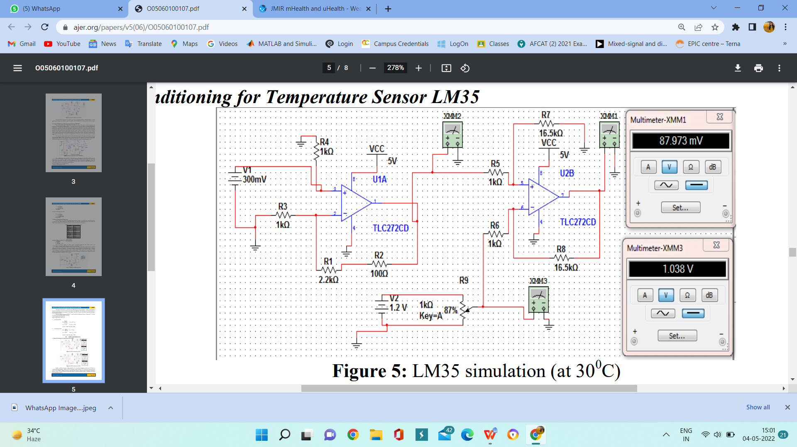

Fig 4.4.1 LM35 simulation (at 30ºC)

LM35 simulation (at 40ºC)

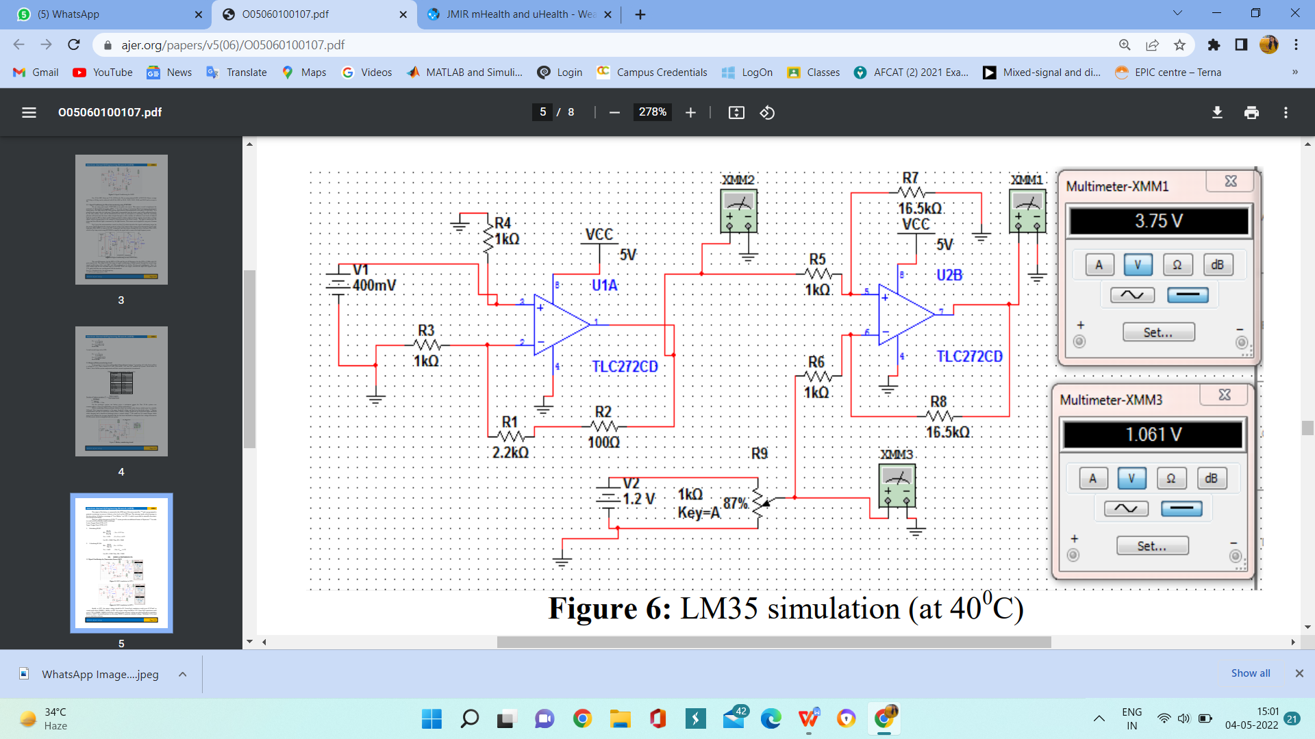

Fig 4.4.2 LM35 simulation (at 40ºC)

4.5 Implementation

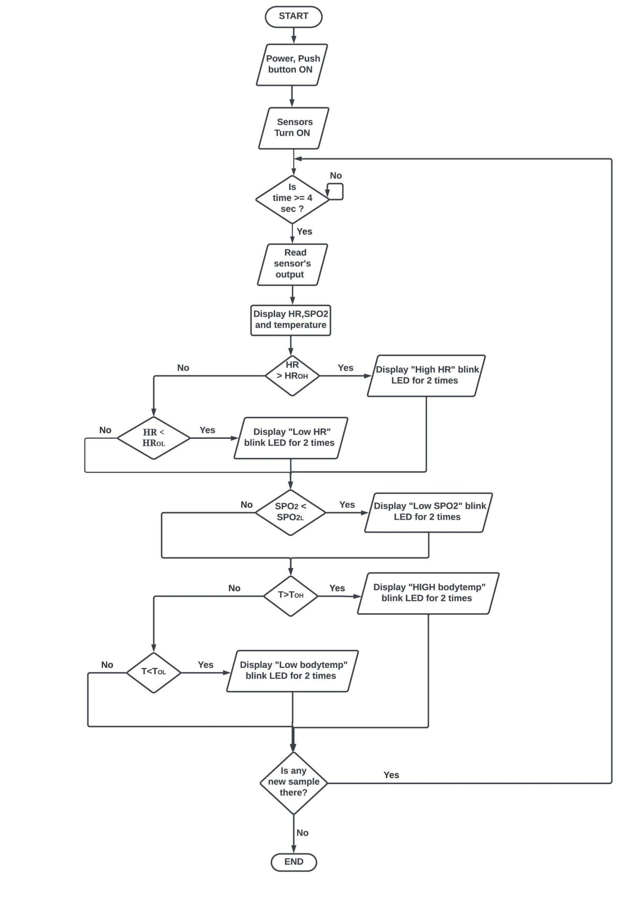

Fig 4.5.1 Flowchart of System

**CHAPTER 5**

**Results**

5.1 Snapshots

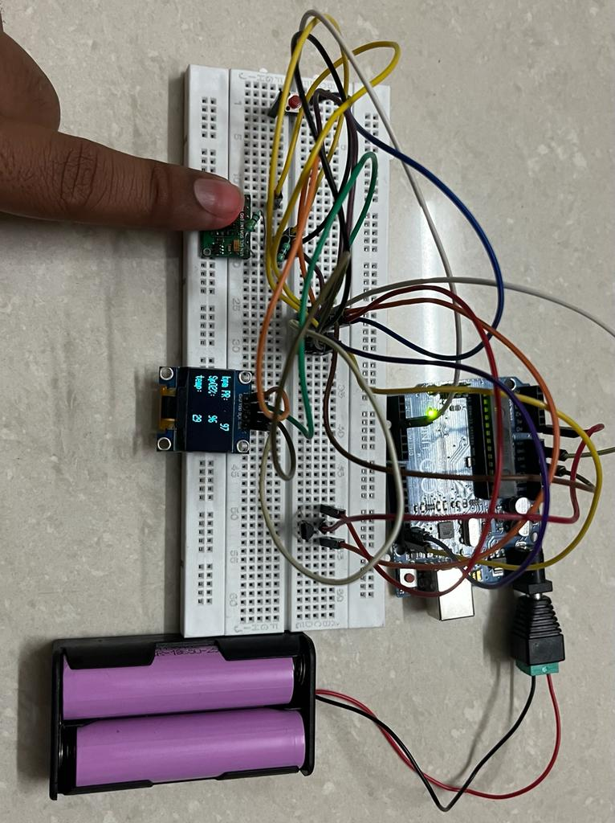

Fig 5.1.1 Working

5.2 Applications

1 Can be used as smart watch for sports enthusiast.

2 Diseases can be detected at early stages.

**CHAPTER 6**

**Conclusion**

A MEMS based vital sign monitoring system for human body has been successfully designed and tested, which measure skin temperature, heart beat and SPO2 level continuously with the displayed data on OLED display. The system can measure these three vital signs with the required speed, although discrepancies with other instruments were still found.Given that the average error for each measurands is within acceptable value (0.280 C for temperature, 1.5 bpm for heart rate and 1 bpm for respiratory rate), it is a good step towards the reliable and affordable vital sign instruments for bedside patient monitoring.

6.1 Summary

The idea is to sense vital body signs through MEMS sensors and interface with microcontroller. The output of the measured data will be displayed on a OLED screen. The data will be stored in SD card for recording purpose.

Following sensors are used in this project:

MAX30102-heart rate,spO2

LM35- Temperature sensor

6.2 Future scope of the project

1 Machine learning can be applied for gained data to calibrate other diagnosis

2 UV sensor can be detected to know whether rays are harmful or not

3 activity tracker can be used

4. Diet plan can be suggested on the values obtained

5. SOS can be implemented on emergency situations

6. Real time location can be tracked.

**References**

[1] The Measuring of Vital Signs Using Internet Of Things Technology

(Heart Rate And Respiration)

Demtania Gusti Kristiani, Triwiyanto Triwiyanto, Priyambada Cahya Nugraha,Bambang Guruh Irianto, Syaifudin, Dyah Titisari

[2] Adaptive threshold method for the peak detection of photoplethysmographic waveform Hang Sik Shin, Chungkeun Lee, Myoungho Lee

[3] FPGA-Based System for Countinous Monitoring of Three Vital Signs of Human Body

Aminuddin Rizal*, Munawar A Riyadi, Darjat

[4] Measuring and Transmitting Vital Body Signs Using MEMS Sensors

Murat GULER, M.Sc. Istanbul Technical University, Mechanical Engineering, System Dynamics and Control Lab, 34437, Gumussuyu, Istanbul, Turkey

1. Ru, L.; Zhang, B.; Duan, J.; Ru, G.; Sharma, A.; Dhiman, G.; Gaba, G.S.; Jaha, E.S.; Masud, M. A Detailed Research on Human Health Monitoring System Based on Internet of Things. Wirel. Commun. Mob. Comput. 2021, 2021, 5592454. [CrossRef]
2. Marathe, S.; Zeeshan, D.; Thomas, T.; Vidhya, S. A Wireless Patient Monitoring System using Integrated ECG module, Pulse Oximeter, Blood Pressure and Temperature Sensor. In Proceedings of the 2019 International Conference on Vision towards Emerging Trends in Communication and Networking (ViTECoN), Vellore, India, 30–31 March 2019.
3. Chowdary, K.C.; Krishna, L.; Prasad, K.L.; Thejesh, K. An Efficient Wireless Health Monitoring System. In Proceedings of the International Conference on I-SMAC (IoT in Social, Mobile, Analytics and Cloud), I-SMAC 2018, Palladam, India, 30–31 August 2018.
4. Kumar, V.D.A.; Subramanian, M.; Gopalakrishnan, G.; Vengatesan, K.; Elangovan, D.; Chitra, B. Implementation of the pulse rhythmic rate for the efficient diagnosing of the heartbeat. Healthc. Technol. Lett. 2019, 6, 48–52. [CrossRef] [PubMed]
5. Verma, D.; Bhasin, M. Real Time Optical Heart Rate Monitor. Int. J. Comput. Sci. Inf. Technol. 2014, 5, 7265–7269. 26. MAX30102 High-Sensitivity Pulse Oximeter and Heart-Rate Sensor for Wearable Health |https://www.maximintegrated.com/en/products/interface/sensor-interface/MAX30102.html (accessed on 21 July 2021)
6. Al Bassam, N.; Hussain, S.A.; Al Qaraghuli, A.; Khan, J.; Sumesh, E.; Lavanya, V. IoT based wearable device to monitor the signs of quarantined remote patients of COVID-19. Inform. Med. Unlocked 2021, 24, 100588. [CrossRef] [PubMed]