

**A**

**MINI-PROJECT REPORT**

**ON**

**“ Comprehensive Inspection and Analysis of Water Supply Distribution Lines ”**

By

**Sr. No Name Roll No.**

1 Pranita Annaldas 66

2 Ketaki Bidkar 67

3 Rumesha Khan 68

4 Samruddhi Chobharkar 69

5 Padmaja Alase 70

Under Guidance Of

**Mr. Samprit Patel**

**DEPARTMENT OF COMPUTER SCIENCE AND ENGINEERING**

**WALCHAND INSTITUTE OF TECHNOLOGY**

**SOLAPUR - 413006**

**(2023-2024)**

**CERTIFICATE**

This is to certify that the Mini-Project entitled

**“ Comprehensive Inspection and Analysis of Water Supply Distribution Lines ”**

Is

Submitted By

**Sr. No Name Roll No.**

1 Pranita Annaldas 66

2 Ketaki Bidkar 67

3 Rumesha Khan 68

4 Samruddhi Chobharkar 69

5 Padmaja Alase 70

|  |  |  |
| --- | --- | --- |
| **Mr. Samprit Patel**  **Project Guide** |  | **Dr. Mrs. A. M. Pujar**  **Head**  **Dept. of Computer Sci. & Engg.** |
|  | **Dr. V. A. Athavale**  **Principal** |  |

**DEPARTMENT OF COMPUTER SCIENCE AND ENGINEERING**

**WALCHAND INSTITUTE OF TECHNOLOGY**

**SOLAPUR (2023-2024)**

**INDEX**

|  |  |  |
| --- | --- | --- |
| **Sr No.** | **Topic** | **Page No.** |
| 1. | Abstract | 4 |
| 2. | Introduction | 5 |
| 3. | Problem Statement and Objectives | 6 |
| 4. | Background | 7 |
| 5. | Technologies Used | 8 |
| 6. | System Architecture and Working | 11 |
| 7. | Implementation | 13 |
| 8. | Testing Report | 15 |
| 9. | Results and Screenshots | 16 |
| 10. | Advantages and Disadvantages or Applications | 20 |
| 11. | Future scope | 22 |
| 12. | Conclusion | 23 |
| 13. | References | 24 |

**Abstract**

Water supply distribution lines form the backbone of modern urban infrastructure, ensuring the delivery of safe and clean drinking water to millions of households and industries worldwide. These intricate networks of pipes and conduits are essential for sustaining life, public health, and economic growth. However, the maintenance and preservation of these critical assets pose significant challenges in an era of expanding urbanization, aging infrastructure, and environmental uncertainties. This comprehensive introduction delves into the essential aspects of water supply distribution line inspection and analysis, highlighting the importance of proactive measures, the common issues encountered, the methods employed for inspection, and the overarching significance of this field in ensuring sustainable water access.

In 2009, the Jal Sansthan authorities identified 2,490 leakage points in the city’s water pipes in comparison to 2008, when 2,479 leakage points were reported. Even after the slight improvement, the city is still losing 25 percent of its supply due to leakage. With 4,100 million litres of water being supplied in a day after the water cut, a whooping quantity of 515 million litres is lost every day due to leakage. In order to avoid such problems smart solutions are required. Smart city infrastructure could be in terms of intelligent traffic automation, military, conveying logistics, and environment. Thus, Ultrasonic Water Flow Meter devices are excellent for measuring the flow rate of water in pipes. They work by sending ultrasonic sound waves through the water and measuring the time it takes for the waves to travel between two points. This method is non-intrusive and can provide accurate flow measurements. Ultrasonic flow meters are typically used for real-time monitoring of flow rates in pipes to detect anomalies, leaks, or blockages and surrounding monitoring.

1. **Introduction**
   1. **. Need**

Water supply distribution lines are the lifeline of modern urban infrastructure, ensuring the delivery of safe drinking water to millions worldwide. These networks of pipes are vital for sustaining life, public health, and economic growth. However, challenges arise with maintenance and preservation, especially with expanding urbanization and aging infrastructure. This introduction explores the essential aspects of water distribution line inspection, highlighting the need for proactive measures, common issues, inspection methods, and its significance for sustainable water access.

**1.2. Existing System**

The existing system for monitoring water distribution networks primarily relies on Supervisory Control and Data Acquisition (SCADA) systems. SCADA systems utilize remote terminal units (RTUs) or programmable logic controllers (PLCs) to collect real-time data from sensors installed along the pipeline network. These sensors measure parameters such as pressure, flow rate, and temperature, providing operators with essential information for monitoring and controlling the water distribution process. SCADA systems offer advantages such as remote access, real-time monitoring, and automated control capabilities, making them valuable tools in managing water infrastructure. However, despite their effectiveness, SCADA systems may have limitations when it comes to addressing specific challenges such as detecting leakages, pilferage, and optimizing service delivery processes.

**1.3. Proposed System**

The proposed system aims to detect leaks in a distributed pipeline system using a centralized approach. It consists of three main components: Prototype Functionality, Centralized Data Processing, and Database Management. Water flow sensors installed along distribution lines monitor flow in real-time, with data processed centrally for analysis. A Complaint Management System allows users to report leaks, an Admin Panel enables system monitoring, and a cloud-based dashboard offers intuitive visualization. GIS Mapping enhances the system with precise geographical locations of the pipeline network.

1. **Problem Statement and Objectives**

Water resources worldwide are depleting, and the looming prospect of a "ZERO water day" emphasizes the urgent need to safeguard these vital resources. One critical area within our control is mitigating water leakages and establishing a robust water distribution network to promote efficient water use. As a team, we recognize the challenge at hand: conducting thorough inspections of water supply distribution lines, which typically range from 100 to 200mm in diameter. These inspections are crucial for detecting leaks, pilferage, damage, and other issues that contribute to water loss.

To address this challenge, our team proposes implementing a solution that leverages a cloud-based dashboard for data analytics, visualization, and report generation. This innovative approach aims to enhance service delivery, improve repair work efficiency, reduce water leakage, and streamline the assessment of pipeline conditions. Our collaborative effort seeks to empower immediate response to contamination complaints, enable early detection of leaks, minimize labor-intensive breakdown management, and facilitate the GIS mapping of the pipelines.

Our team's collective expertise is crucial in overcoming deployment constraints related to live inspections, image analytics, and laser projections. We understand that accurate and efficient assessment of the water supply distribution lines is pivotal for the success of this solution. By implementing this comprehensive approach, we collectively take significant strides towards a sustainable water future, ensuring the efficient use and preservation of this invaluable resource.

**3.Background**

Supervisory Control and Data Acquisition (SCADA) systems are integral components of modern industrial infrastructure, facilitating the monitoring and control of various processes, including water pipeline management. These systems have been widely adopted due to their ability to provide real-time data, remote access, and automated control capabilities.The working principle of SCADA involves the deployment of sensors and control devices throughout the monitored environment, in this case, the water pipeline network. These sensors continuously collect data on parameters such as pressure, flow rate, and temperature. The data is then transmitted to a central control center where it is displayed on graphical user interfaces (GUIs) for operators to monitor.

SCADA systems utilize algorithms and logic to analyze the incoming data and detect abnormalities or deviations from expected values. In the context of leak detection in water pipelines, SCADA systems compare the current readings with historical data or predefined thresholds to identify potential leaks. Upon detecting a deviation indicative of a leak, the system generates alarms or alerts to notify operators, enabling them to investigate and address the issue promptly.

The depletion of global water resources highlights the urgent need for optimizing water management practices. One crucial aspect of water management is the efficient monitoring and maintenance of water distribution networks. The development of a new system is necessitated by challenges such as the need for thorough inspections of water supply distribution lines, ranging from 100 to 200mm in diameter. This new system requires access to a cloud-based dashboard for advanced data analytics, visualization, and report generation to enhance service delivery, improve repair work efficiency, reduce water leakage, and streamline pipeline condition assessment. Additionally, the new system aims to enable immediate action on contamination complaints, early detection of leaks, and facilitate GIS mapping of the pipelines. Overcoming deployment constraints involving live inspections, image analytics, and laser projections is crucial for accurate and efficient assessment of water supply distribution lines. While SCADA systems serve as foundational tools, the specific challenges and requirements outlined necessitate the development of a new system with enhanced capabilities to ensure the efficient and sustainable management of water resources.

**4. Technology Used**

**4.1. HTML, CSS, Javascript**

HTML, CSS and JavaScript are used for the frontend development of the our project. HTML provides the structure of web pages, CSS is utilized for styling and layout, while JavaScript enhances interactivity and dynamic behavior.

**4.2. PHP (Hypertext Preprocessor)**

PHP (Hypertext Preprocessor) is employed as the backend scripting language. It handles server-side logic, processing user requests, and generating dynamic content.

**4.3. MySQL:**

MySQL is utilized as the relational database management system (RDBMS) for storing and managing project data. It offers robust data storage, retrieval, and manipulation capabilities.

**4.4. Power Bi**

Power BI is a robust business analytics tool developed by Microsoft. It enables users to visualize and share insights from their data through interactive dashboards and reports.

**4.5. Colaboratory**

Colaboratory is a cloud-based platform provided by Google for writing, executing, and sharing Python code in a Jupyter notebook environment.

**4.6. Python**

Python is a high-level programming language known for its simplicity and readability. It is widely used for various applications, including data analysis, machine learning, web development, and more.

**4.7. Python Libraries**

**4.7.1. NumPy**

NumPy is a fundamental package for numerical computing in Python. It provides support for multidimensional arrays, mathematical functions, linear algebra, and random number generation.

**4.7.2. Pandas**

Pandas is a powerful library for data manipulation and analysis in Python. It offers data structures like DataFrame and Series, along with functions for cleaning, transforming, and analyzing tabular data.

**4.7.3. Scikit-learn (sklearn)**

Scikit-learn is a popular machine learning library in Python that provides simple and efficient tools for data mining and data analysis. It offers various algorithms for classification, regression, clustering, dimensionality reduction, and more.

**4.7.4. Seaborn**

Seaborn is a statistical data visualization library based on Matplotlib. It provides a high-level interface for drawing attractive and informative statistical graphics.

**4.8. Algorithms for Machine Learning:**

**4.8.1. Support Vector Machine (SVM)**

SVM is a supervised learning algorithm used for classification and regression tasks. It works by finding the hyperplane that best separates different classes in the feature space.

**4.8.2. Decision Tree**

Decision trees are tree-like structures that recursively partition the feature space based on the most informative features.

**4.8.3. Logistic Regression**

Logistic Regression is a statistical method used for binary classification tasks, estimating the probability that a given instance belongs to a particular class.

**4.8.4. Random Forest:**

Random Forest is an ensemble learning method that constructs multiple decision trees during training and outputs the mode of the classes (classification) or mean prediction (regression) of the individual trees.

1. **System Architecture and Working**

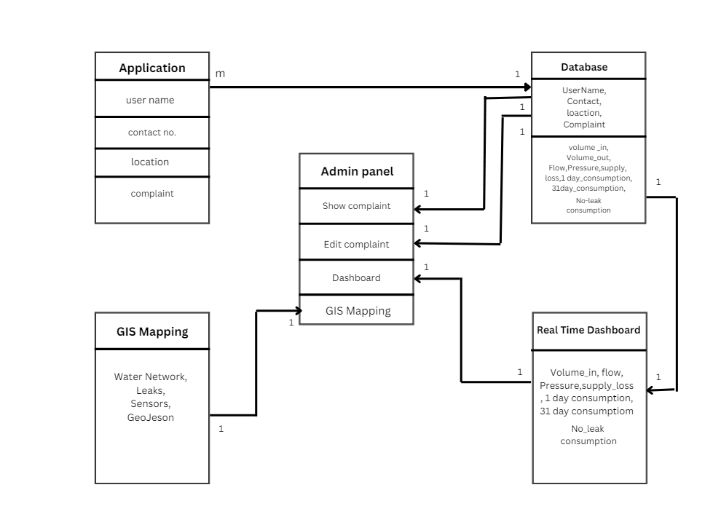Fig : Class Diagram

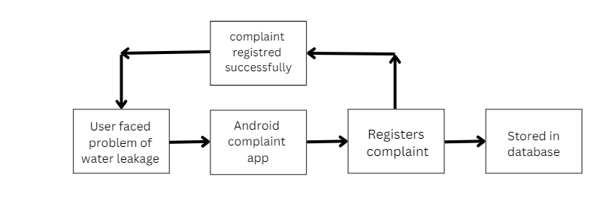Fig : Flow Diagram of Complaint Management

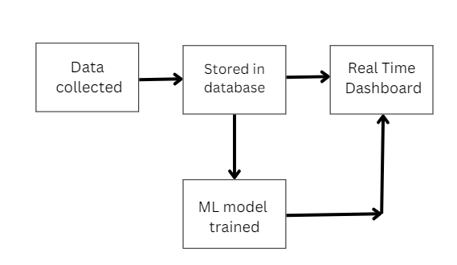

Fig : Flow Diagram of Real Time Dashboard

1. **Implementation**

The primary objective of this report is to outline a methodology for effectively detecting leaks in a distributed pipeline system using a centralized approach. The focus is on early detection to minimize water loss and prevent potential infrastructure damage. The proposed system comprises three main components: Prototype Functionality, Complaint Management System, and Admin Panel.

**6.1. Prototype Functionality**

To initiate the system, water flow measuring sensors are strategically installed along the distribution lines. These sensors continuously monitor the flow of water in real-time. Data collection is facilitated through the use of flow meters placed along the pipeline network.

**6.2. Centralised Data Processing**

Upon detection of any anomalies or potential leaks by the sensors, the system immediately transmits this data to a Central Aggregation Node. This node acts as the central hub for data processing. Here, the received data is analyzed and prepared for storage in the central database.

**6.3. Database Management**

All data collected by the sensors, including flow rates and anomaly alerts, is stored in the central database. This database serves as a comprehensive repository of historical and real-time information related to the water distribution system.

**6.4. Complaint Management System**

For user interaction and reporting, a Complaint Management System is provided. Users can access an application designed for reporting leaks or instances of contaminated water. Upon filing a complaint through the application, the data is stored in the central database for further action.

**6.5. Admin Panel**

An Admin Panel is made available for system administrators and the engineering team. Through this panel, they can monitor the system's status in real-time. The panel displays various metrics such as water flow rates, pressure levels, volume in and out, and current complaints. Administrators can take necessary actions based on the information provided.

**6.6. User-Friendly Dashboard**

To enhance user experience and data visualization, a cloud-based dashboard is created using Power BI. This dashboard provides a comprehensive overview of the system's performance and status. It includes visualizations such as gauage charts and Stacked bar charts depicting:

* Flow
* Pressure
* Volume_in
* 1 Day consumption
* 31 Day consumption
* Supply_Loss
* Consumption

**6.7. GIS Mapping**

To further augment the system, Geographic Information System (GIS) mapping is implemented. This feature provides precise geographical locations of the pipeline network. By integrating GIS mapping, the system enhances visualization capabilities and facilitates efficient management of the pipeline infrastructure.

**6.8. Acknowledgment**

We acknowledge the collaborative efforts of the engineering team and stakeholders in developing this methodology for a more sustainable and efficient water distribution system.

1. **Testing Report**

The testing report outlines the various testing phases conducted on the Water Supply Distribution Line Leak Detection System, a small-scale project. The project underwent Unit Testing, Performance Testing, System Testing to ensure its functionality and reliability.

**7.1. Unit Testing**

Unit Testing focused on verifying individual components of the Water Supply Distribution Line Leak Detection System. This phase ensured that each component, such as the water flow sensors, Complaint Management System, and Admin Panel, functioned correctly and met their specified requirements. The objective was to confirm the proper measurement of flow and volume by the sensors, the accurate storage and retrieval of complaints in the Complaint Management System, and the effective display and management of reported issues in the Admin Panel. Unit Testing results showed that all components performed as expected without errors, ensuring their reliability in the overall system.

**7.2. Performance Testing**

Performance Testing was conducted to assess the system's performance under various conditions. Scalability testing were performed to evaluate the system's response and resilience. The objective was to ensure that the system could handle expected scale with increased usage. Performance Testing results confirmed that the system met performance requirements and could effectively detect leaks and manage complaints in real-time.

**7.3. System Testing**

System Testing verified the overall functionality of the Water Supply Distribution Line Leak Detection System. This phase included testing sensor data transmission, complaint management, and admin panel functionality. The objective was to ensure that all system functionalities, from data transmission to complaint resolution, worked seamlessly together. System Testing results confirmed the system's effectiveness in detecting leaks, managing complaints, and providing stakeholders with a reliable solution for water supply distribution line management.

This concise testing report provides a brief overview of the testing phases conducted on the Water Supply Distribution Line Leak Detection System, emphasizing its small-scale nature. Each testing phase is summarized with its objective and role in ensuring the system's functionality and reliability.

1. **Results and Screenshots**

**Admin Panel**

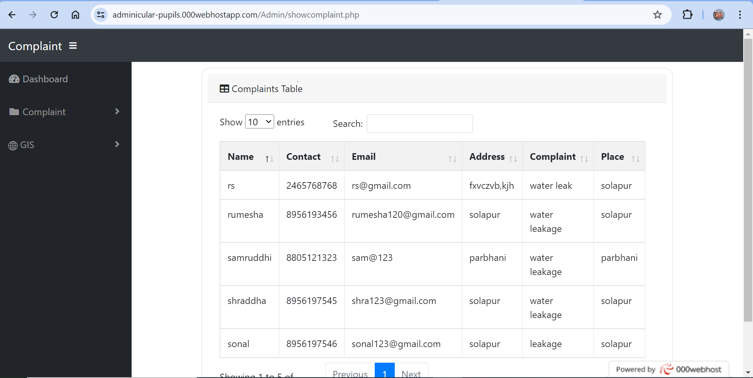

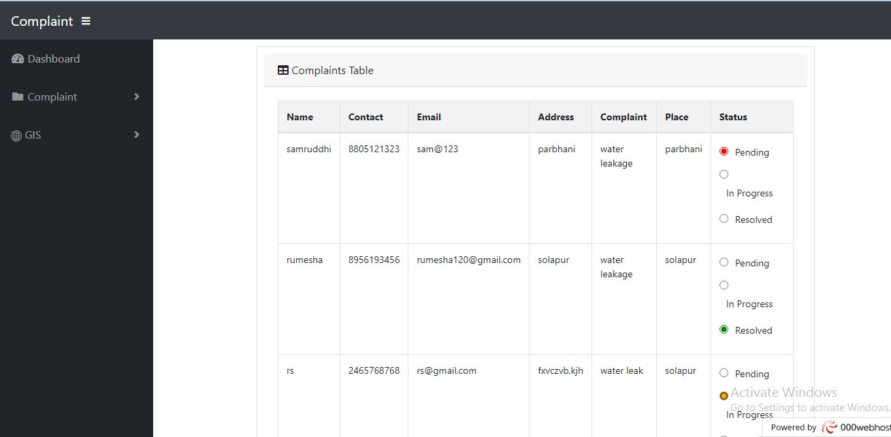

**Mobile Application** 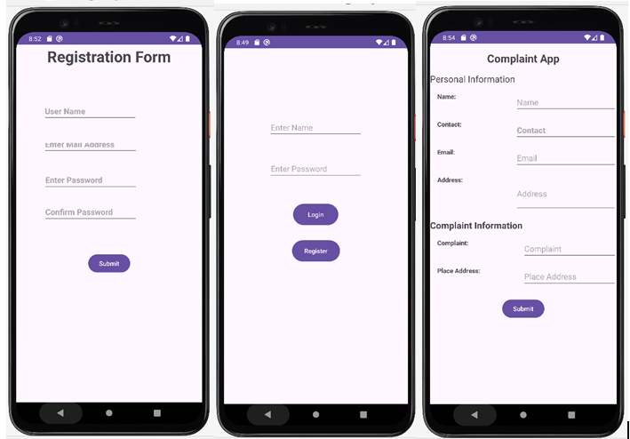

**Database**

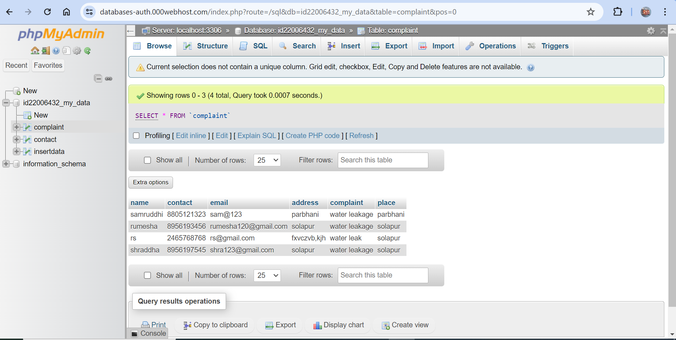

**ML Model**

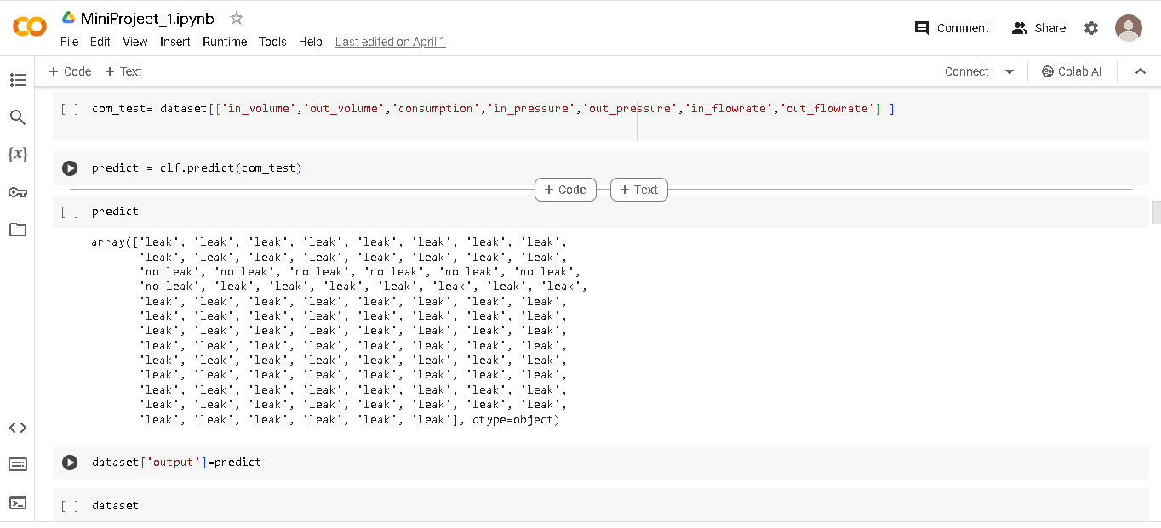

**SQL Server Management**

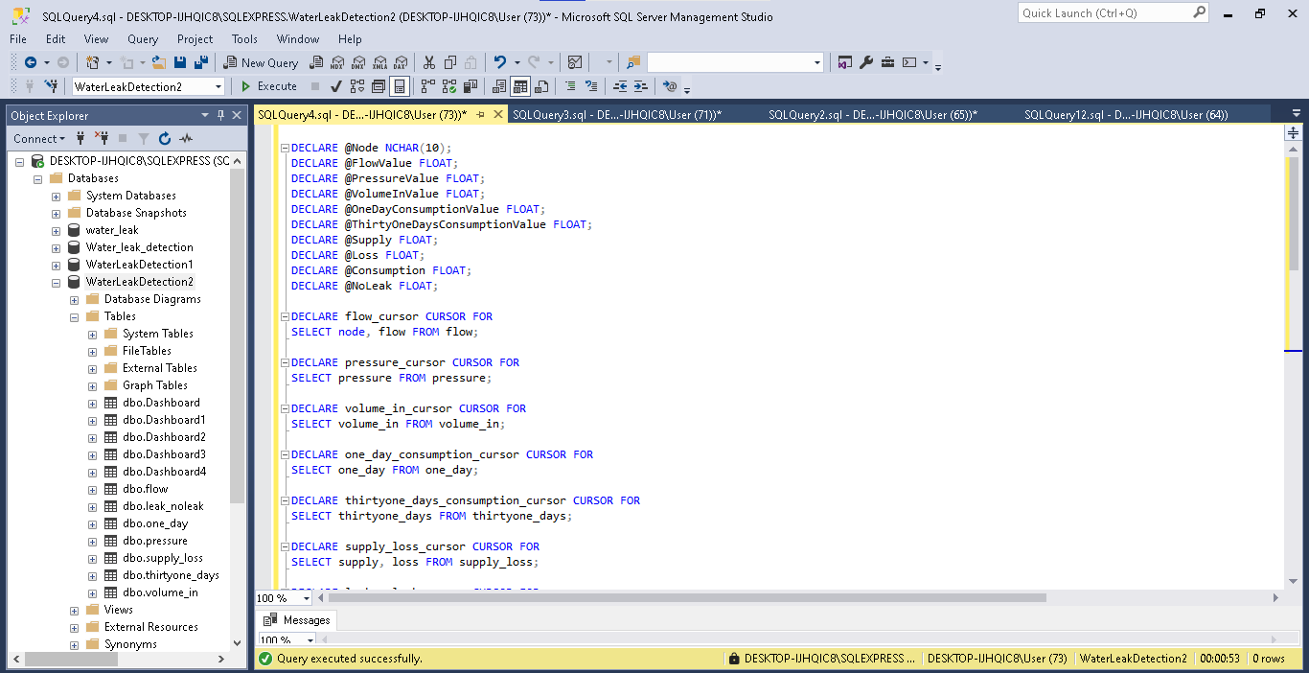

**Dashboard**

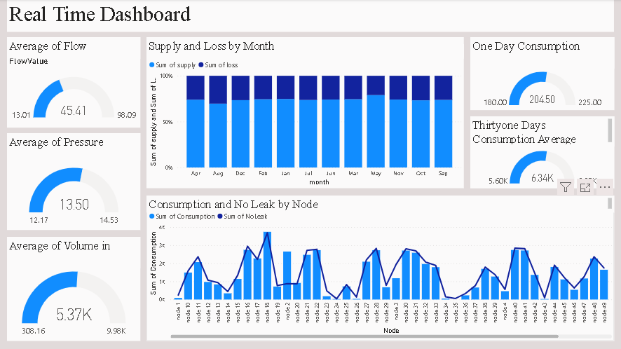

1. **Advantages and Disadvantages or Applications**

**9.1. Advantages**

The project offers several advantages, including:

Improved Leak Detection and Prevention: By implementing machine learning algorithms and real-time monitoring, the project significantly enhances the ability to detect and prevent leakages in water supply distribution lines, reducing water loss and conserving valuable resources.

Enhanced Service Delivery and Efficiency: The implementation of a cloud-based dashboard for data analytics and visualization improves service delivery by providing stakeholders with timely and actionable insights. This facilitates proactive maintenance and repair work, leading to enhanced operational efficiency and reduced downtime.

Streamlined Pipeline Condition Assessment: The project streamlines pipeline condition assessment by leveraging GIS mapping and image analytics technologies. This enables accurate and efficient assessment of pipeline health, facilitating targeted maintenance and optimization efforts.

Immediate Action on Contamination Complaints: The solution enables immediate action on contamination complaints through real-time monitoring and alerting mechanisms. This helps mitigate potential health risks and ensures the safety of the water supply for consumers.

Facilitated GIS Mapping: By implementing GIS mapping capabilities, the project facilitates better visualization and understanding of the pipeline network. This aids in decision-making, resource allocation, and infrastructure planning for future expansion and maintenance.

**9.2. Disadvantages**

Despite its advantages, the project may face certain challenges and limitations, including:

Cost of Implementation and Maintenance: The initial cost of implementing the project, including hardware, software, and training, may be significant. Additionally, ongoing maintenance and updates require financial resources and expertise.

Dependency on Data Quality: The accuracy and reliability of the machine learning models and analytics insights are dependent on the quality of the data collected. Inaccurate or incomplete data may lead to false alarms or incorrect predictions, impacting the effectiveness of the solution.

Cybersecurity Risks: As the project relies on cloud-based technologies and data transmission over networks, there is a risk of cybersecurity threats such as data breaches or system vulnerabilities. Robust cybersecurity measures and protocols must be implemented to safeguard sensitive information and infrastructure.

Integration Challenges: Integrating disparate systems and technologies, such as GIS mapping, image analytics, and machine learning models, may pose technical challenges and require careful coordination and compatibility testing.

Regulatory Compliance: Compliance with regulatory requirements and standards governing water management and infrastructure may pose challenges, particularly regarding data privacy, security, and environmental regulations. Ensuring compliance and obtaining necessary permits and approvals are essential aspects of the project implementation.

1. **Future scope**

As technology continues to advance, there are several avenues for future development and enhancement of the project:

**10.1. Integration of Advanced Sensor Technologies:** Incorporating advanced sensor technologies, such as acoustic sensors or fiber optic cables, could further improve the accuracy and efficiency of leak detection in water supply distribution lines.

**10.2. Enhanced Machine Learning Models:** Continuously refining and optimizing machine learning models can lead to better prediction accuracy and early detection of leaks, pilferage, and other issues. Exploring deep learning techniques and ensemble methods could potentially enhance the performance of the models.

**10.3. Expansion of GIS Mapping Capabilities:** Expanding GIS mapping capabilities to include predictive modeling and risk assessment can provide valuable insights into the condition and vulnerability of the pipeline network. Integration with geographic data sources and spatial analysis techniques could improve decision-making and resource allocation.

**10.4. Automation and Real-Time Decision Support:** Implementing automation features and real-time decision support systems can enable immediate response to detected anomalies, reducing manual intervention and minimizing downtime. Integration with predictive maintenance systems can optimize repair and maintenance schedules, further improving operational efficiency.

**10.5. Enhanced Data Analytics and Visualization:** Continuously improving data analytics and visualization capabilities can provide stakeholders with deeper insights into water distribution patterns, consumption trends, and infrastructure performance. Exploring advanced analytics techniques and interactive visualization tools can enhance understanding and decision-making.

1. **Conclusion/Summary**

The challenges faced in maintaining water supply distribution lines, such as leakage points and pilferage, highlight the urgency for effective solutions. The statistics from Jal Sansthan authorities emphasize the substantial water loss due to leaks, underscoring the necessity for proactive measures.

Our project aims to address these challenges by implementing a centralized approach to leak detection. Through Prototype Functionality, Complaint Management System, and the Admin Panel, we establish a robust system for early leak detection and efficient management.

The integration of water flow measuring sensors along distribution lines allows for real-time monitoring of water flow and volume. Any anomalies detected are swiftly transmitted to a Central Aggregation Node, where data is processed and stored in a central database.

The Complaint Management System provides a user-friendly platform for users to report leaks or contaminated water, ensuring prompt action and resolution. The Admin Panel allows for effective oversight and management of reported issues by the engineering team.

Additionally, the proposed cloud-based dashboard offers stakeholders a comprehensive view of the system's performance. With features such as flow rates, pressure levels, consumption trends, and GIS mapping, stakeholders can make informed decisions and take preventive measures.

By combining these components, our system aims to minimize water loss, prevent infrastructure damage, and enhance the efficiency of water distribution networks. It is a step towards creating a more sustainable and resilient water infrastructure, vital for conserving our precious water resources for future generations

**12. References**

1. Scikit-Learn. Machine Learning in Python. 2020. Available online: https://scikit-learn.org/stable/ (accessed on 5 November 2020).

2. Saravanan, R.; Sujatha, P. A State of Art Techniques on Machine Learning Algorithms: A Perspective of Supervised Learning Approaches in Data Classification. In Proceedings of the 2nd International Conference on Intelligent Computing and Control Systems (ICICCS), Secunderabad, India, 27–28 June 2019.

3. Ross, M.; Graves, C.A.; Campbell, J.W.; Kim, J.H. Using support vector machines to classify student attentiveness for the development of personalized learning systems. In Proceedings of the 2013 12th International Conference on Machine Learning and Applications (ICMLA), Miami, FL, USA, 4–7 December 2013.

4. <https://learn.microsoft.com/en-us/power-bi/create-reports/service-dashboard-create>

5. https://leetcode.com/explore/