**Spring 2018: CSCI 6990, ML-II Programming**

**Assignment #2**

**Pranita Deshpande (2549100)**

1. I have used five different artificial neural networks with 4 inputs layers, 3 output layers and 1,3,5,6 and 9 hidden layers as below

|  |  |
| --- | --- |
| ANN | Layer Model |
| 1 | [4 3 3] |
| 2 | [4 4 5 6 3] |
| 3 | [4 4 6 7 3 9 3] |
| 4 | [4 4 8 5 4 9 3 3] |
| 5 | [4 4 8 5 4 9 3 6 3] |

1. ANN input: Sepal length

Sepal width

Petal length

Petal width

1. ANN outputs: Iris-Sestos (1 0 0)

Iris Versicolor (0 1 0)

Iris Virginica (0 0 1)

1. Hidden layers should be with range 2 to 20
2. Each ANN should be trained using test and train data using 10 fold cross validation
3. Graph Representation: X-axis: Epoch (1-200)

Y-axis: MSE error rates

Red line: Train Data

Blue line: Test Data

**Artificial neural network: 1 with one hidden layer**

ANN= [4 3 3]

|  |  |
| --- | --- |
| k | Test Error |
| 1 | 0.3390 |
| 2 | 0.3472 |
| 3 | 0.3115 |
| 4 | 0.6532 |
| 5 | 0.2910 |
| 6 | 0.3229 |
| 7 | 0.4768 |
| 8 | 0.5096 |
| 9 | 0.3828 |
| 10 | 0.4321 |
| AVERAGE | 0.40661 |

Below are the graphs of first ANN with 10 cross fold validation

FCV: 1

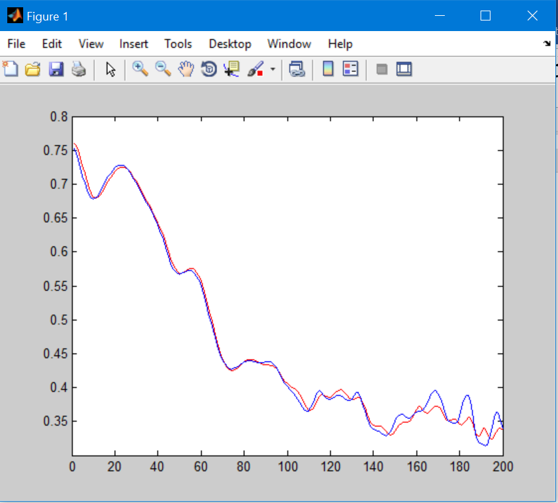

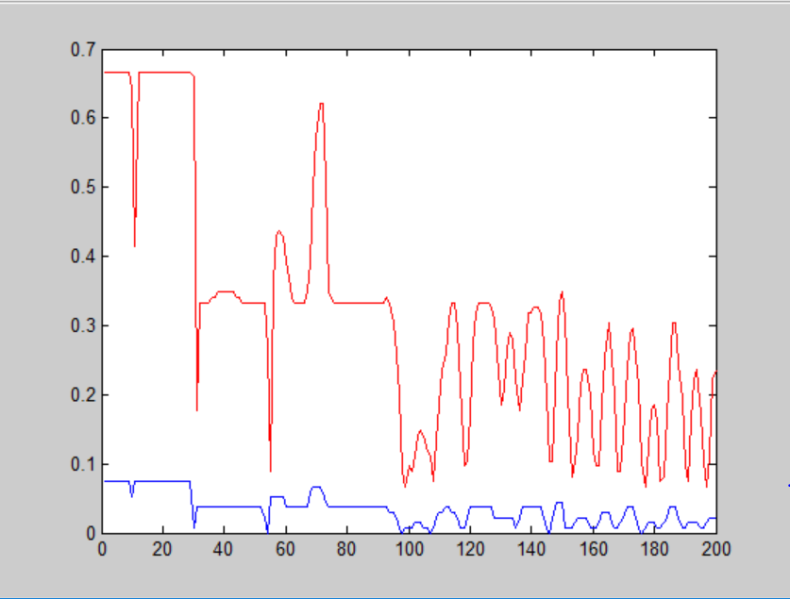

FCV: 2

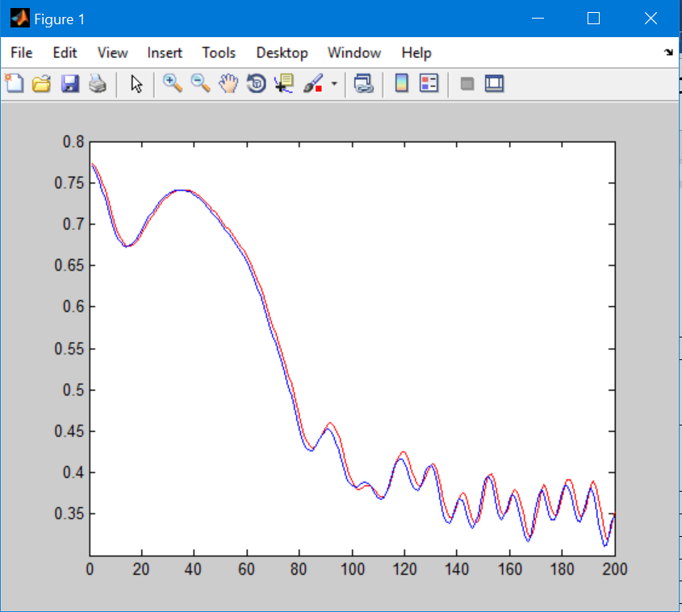

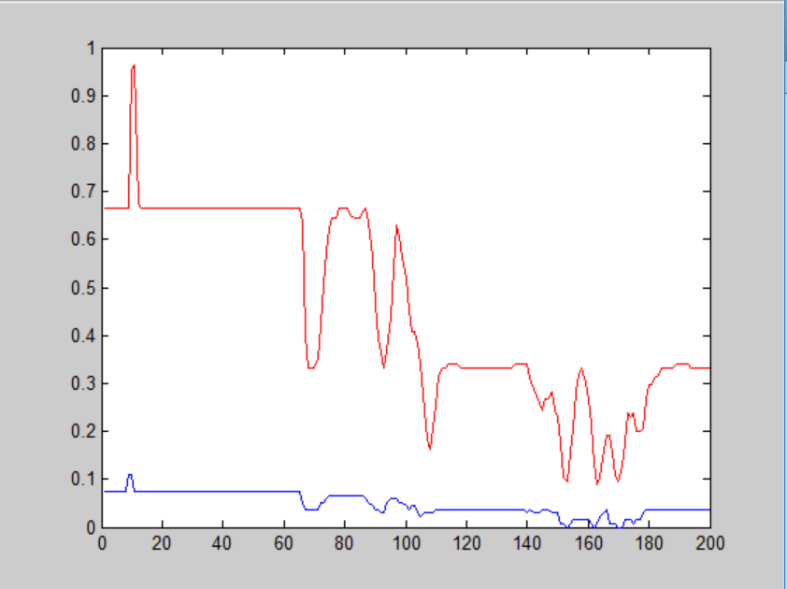

FCV: 3

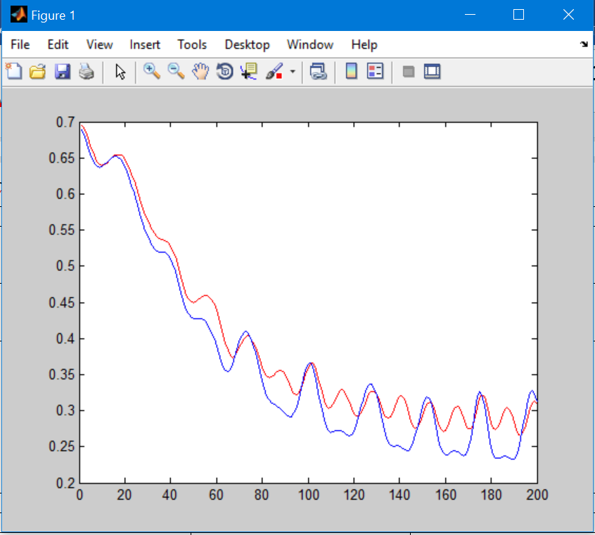  
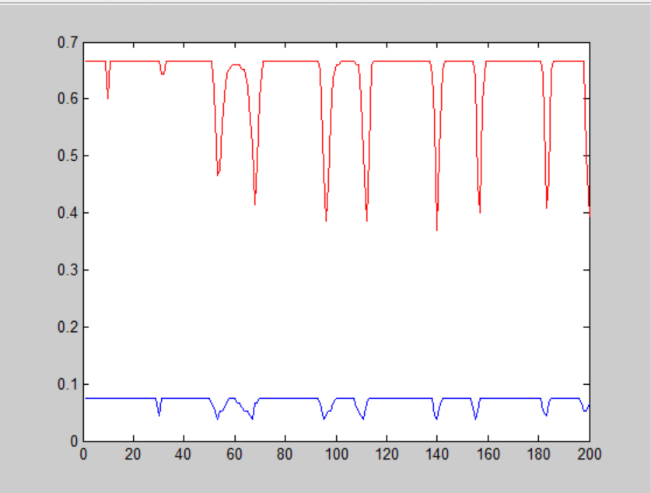

FCV:4

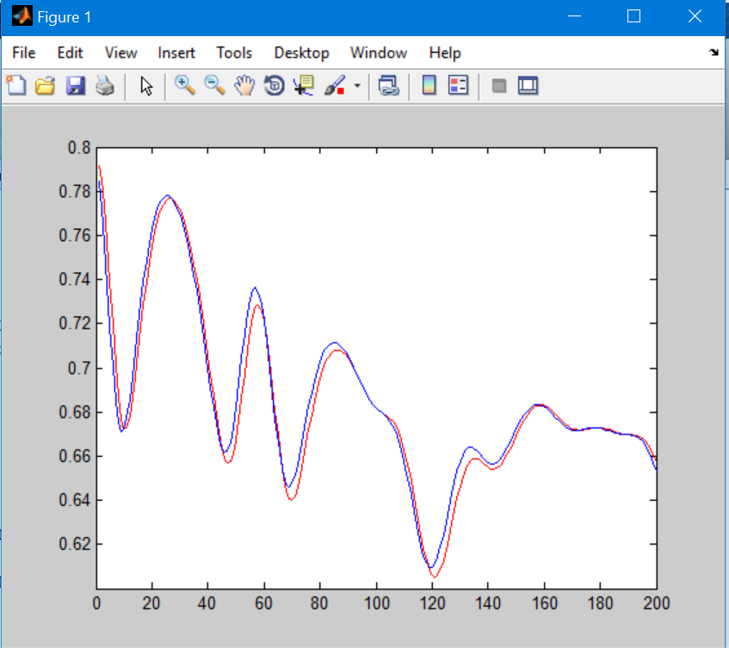

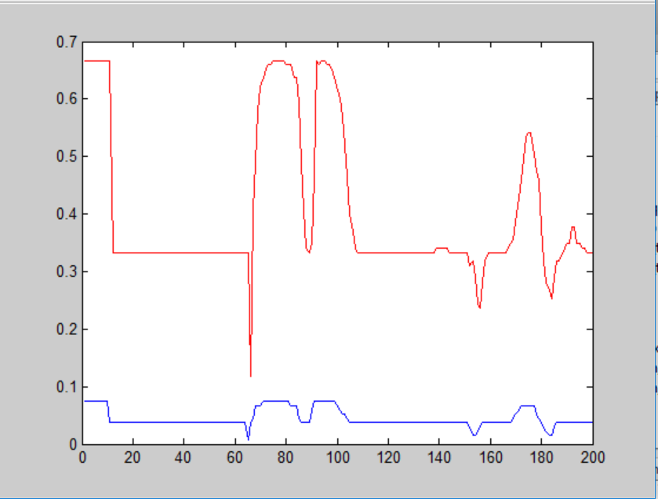

FCV:5

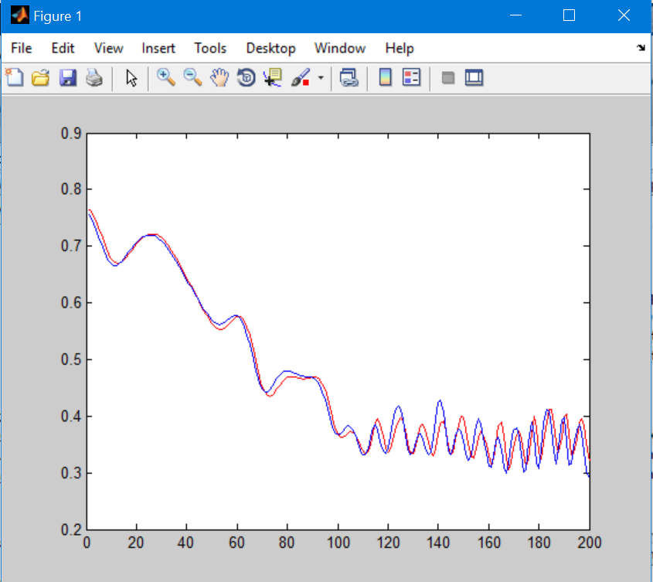

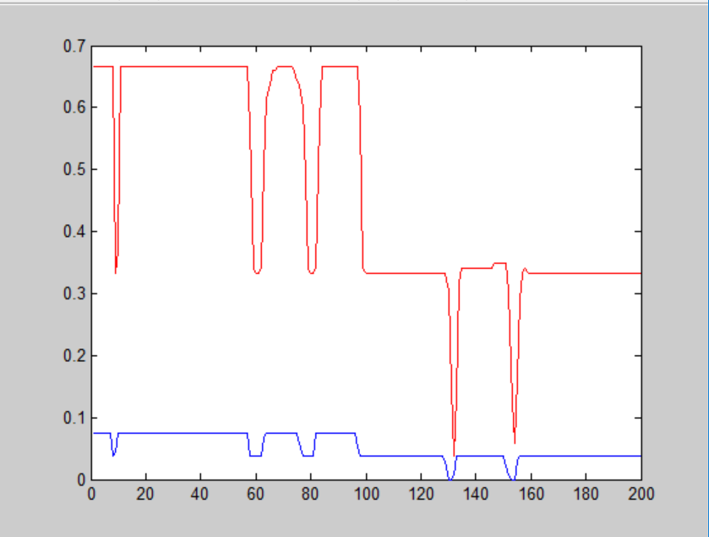

FCV:6

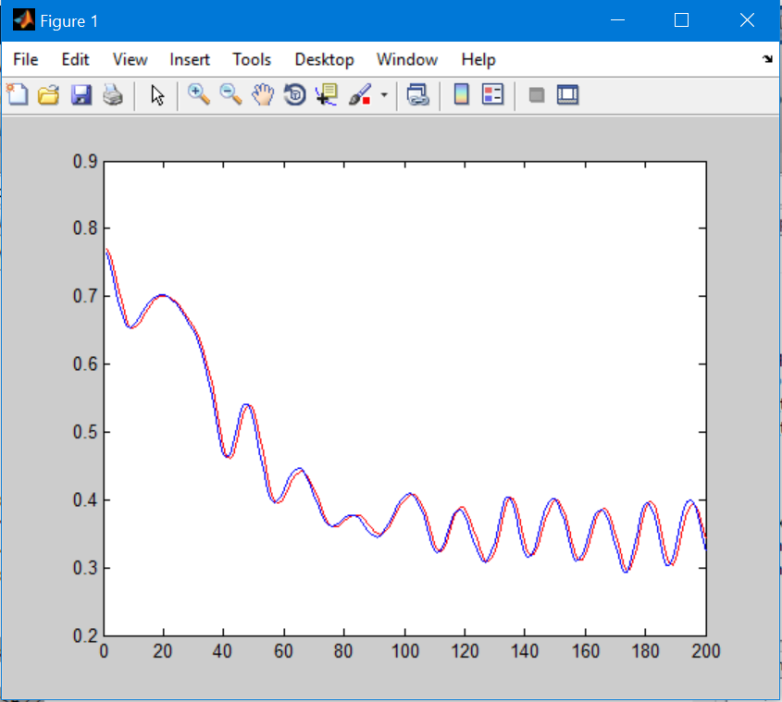

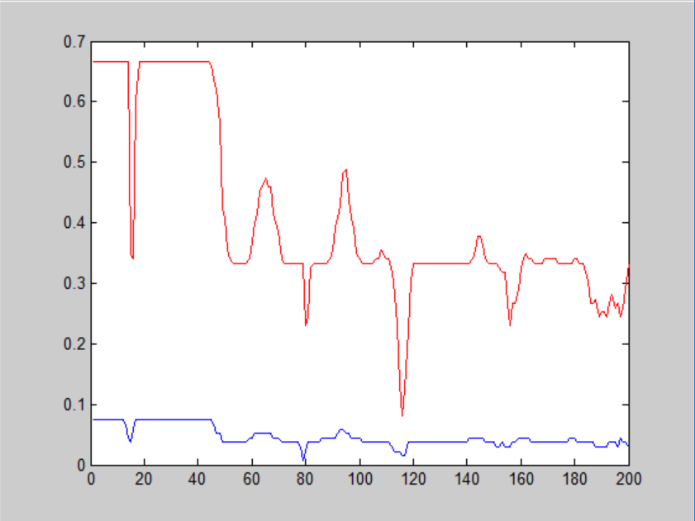

FCV:7

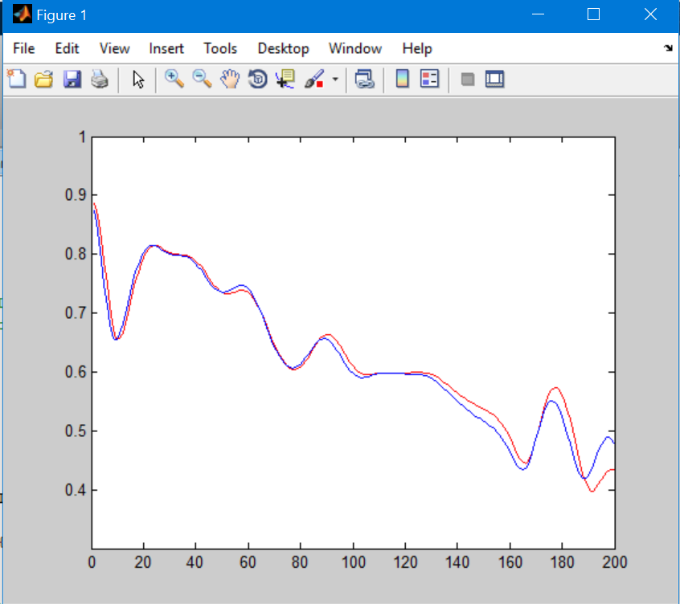

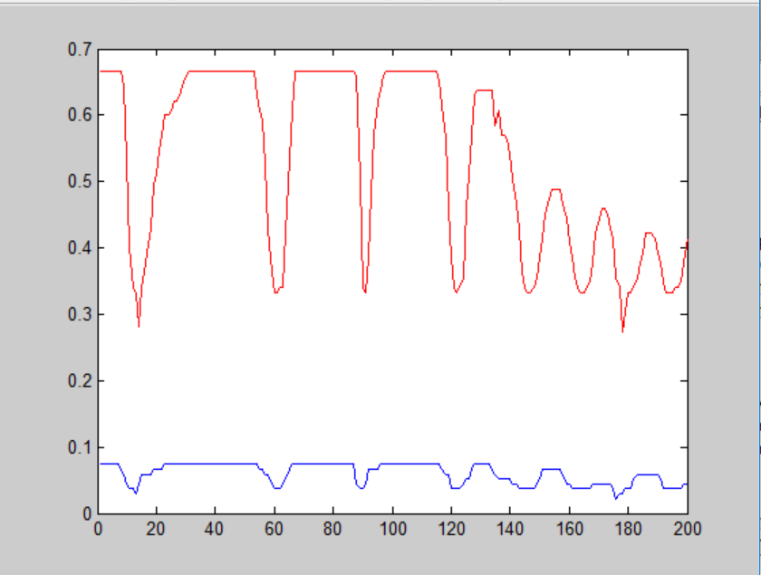

FCV:8

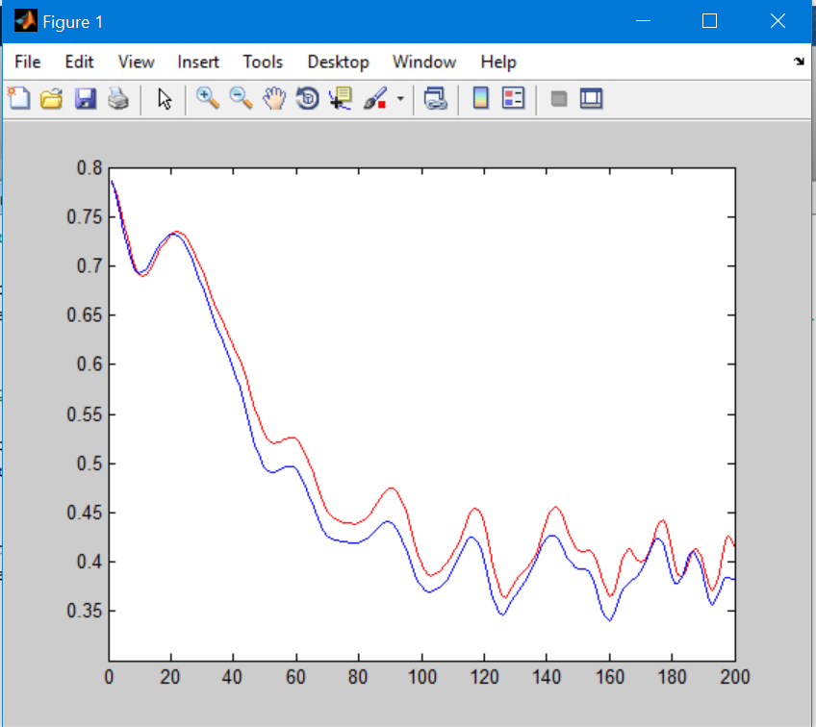

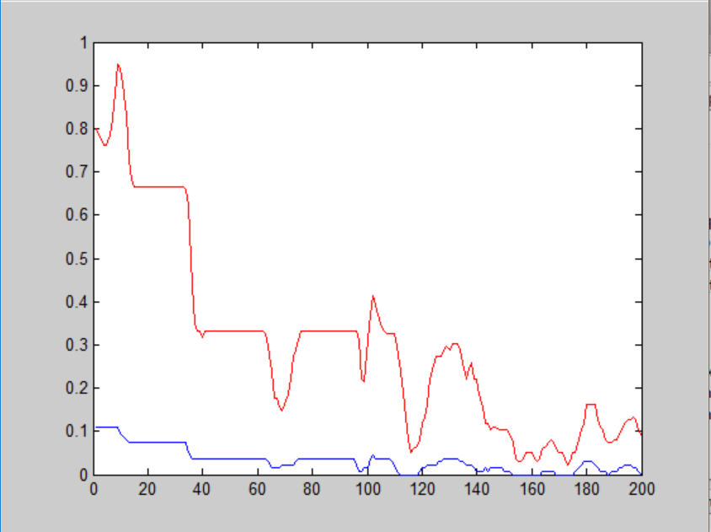

FCV:9

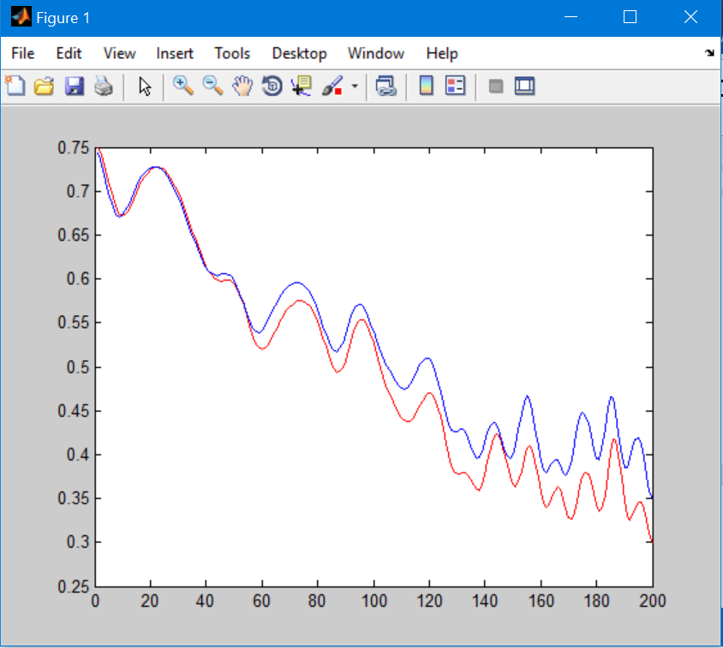

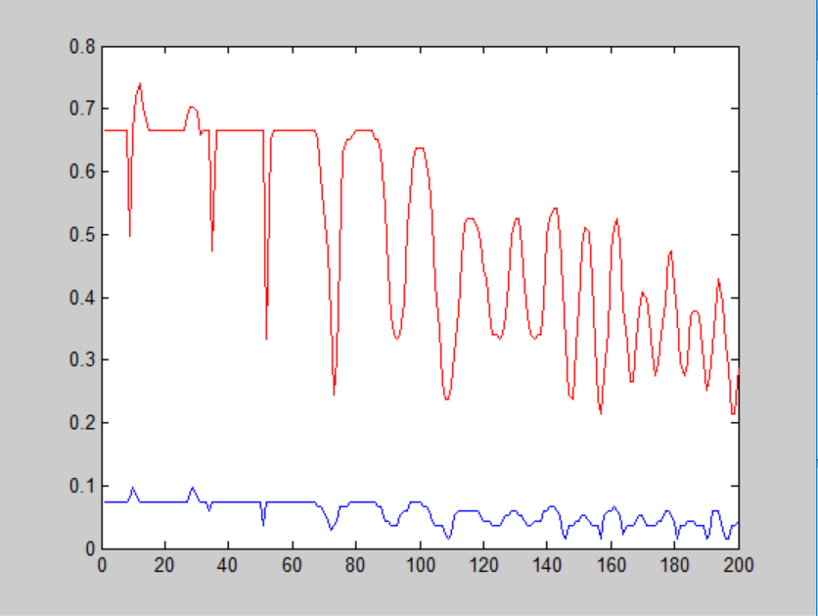

FCV: 10

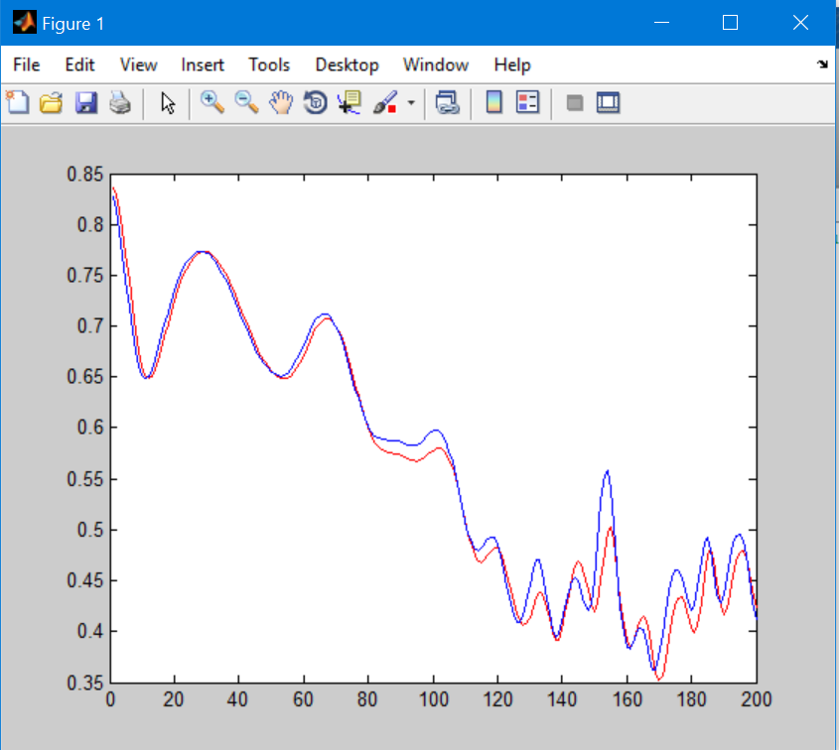

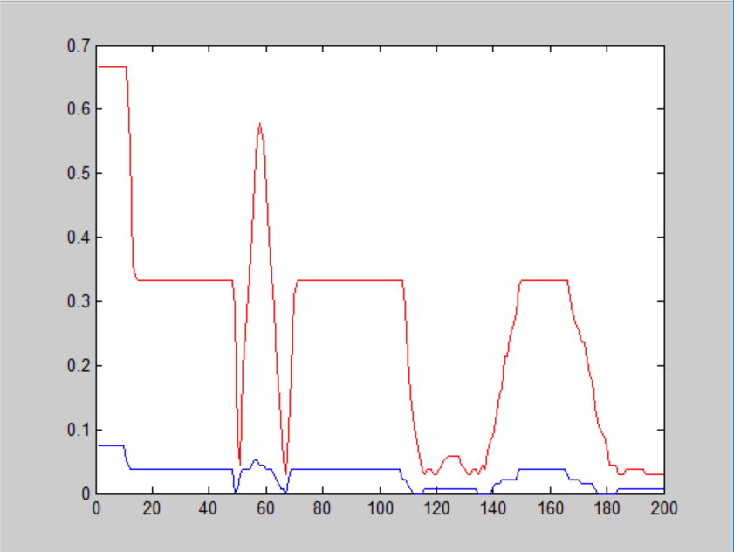

**Artificial neural network: 2 with three hidden layers**

ANN= [4 4 5 6 3]

|  |  |
| --- | --- |
| k | Test Error |
| 1 | 0.6864 |
| 2 | 0.6888 |
| 3 | 0.6722 |
| 4 | 0.7479 |
| 5 | 0.6814 |
| 6 | 0.6708 |
| 7 | 0.6751 |
| 8 | 0.7172 |
| 9 | 0.7068 |
| 10 | 0.6707 |
| Average | 0.69173 |

One of the graphs of 10 fold cross validation for ANN 2

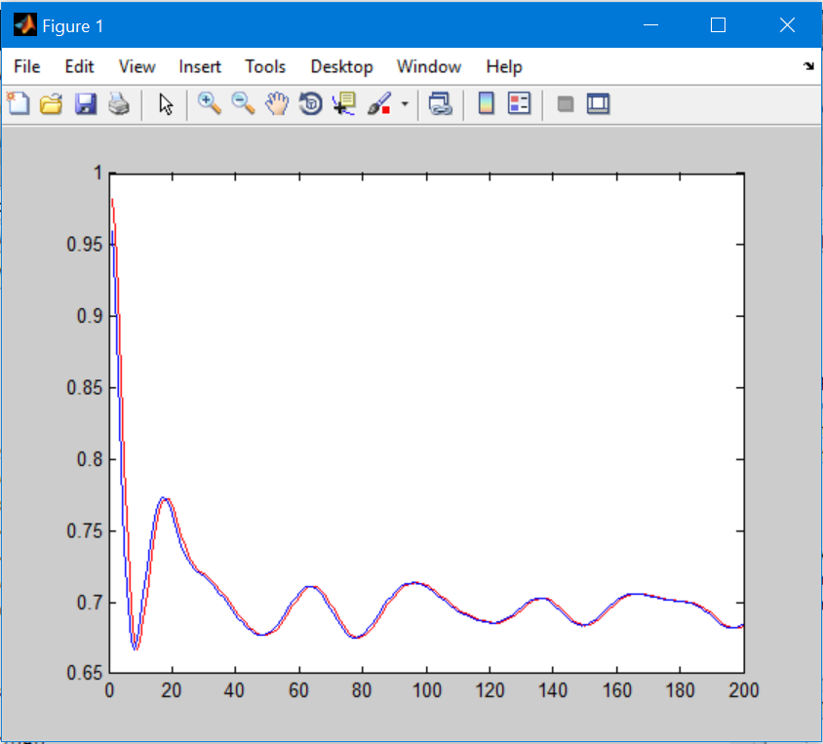

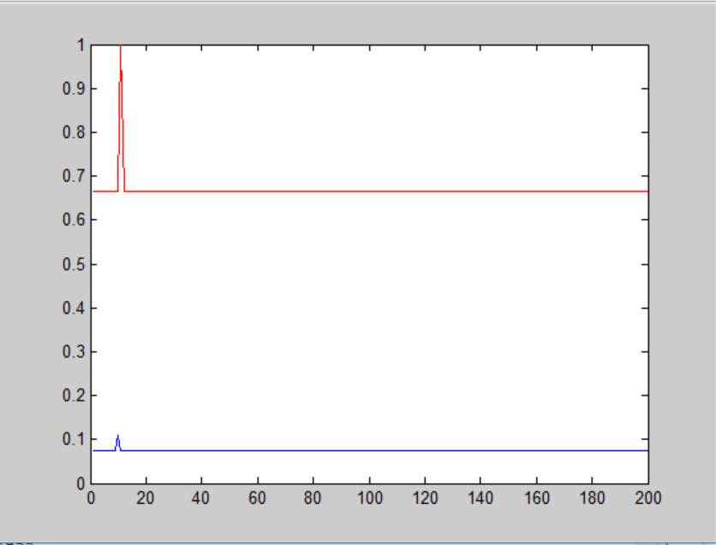

**Artificial neural network: 3 with five hidden layers**

ANN = [4 4 6 7 3 9 3]

|  |  |
| --- | --- |
| K | Test error |
| 1 | 0.6807 |
| 2 | 0.6842 |
| 3 | 0.6778 |
| 4 | 0.6690 |
| 5 | 0.6703 |
| 6 | 0.6692 |
| 7 | 0.6908 |
| 8 | 0.6776 |
| 9 | 0.7042 |
| 10 | 0.6807 |
| Average | 0.68045 |

One of the graphs of 10 fold cross validation for ANN 2

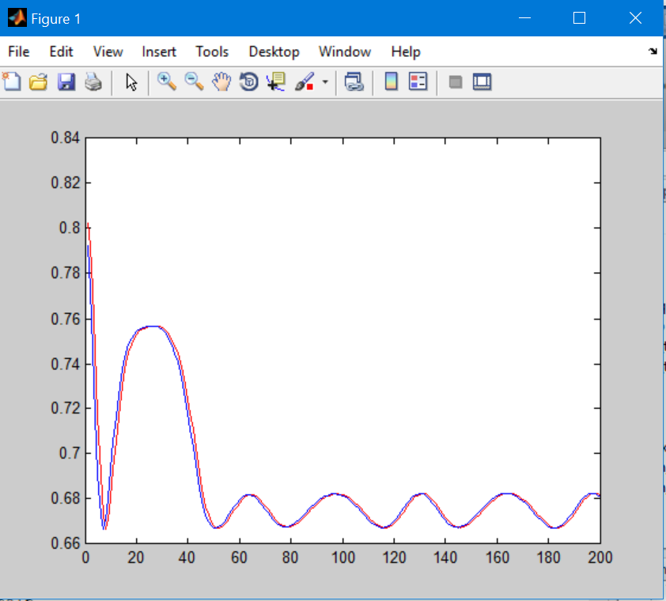

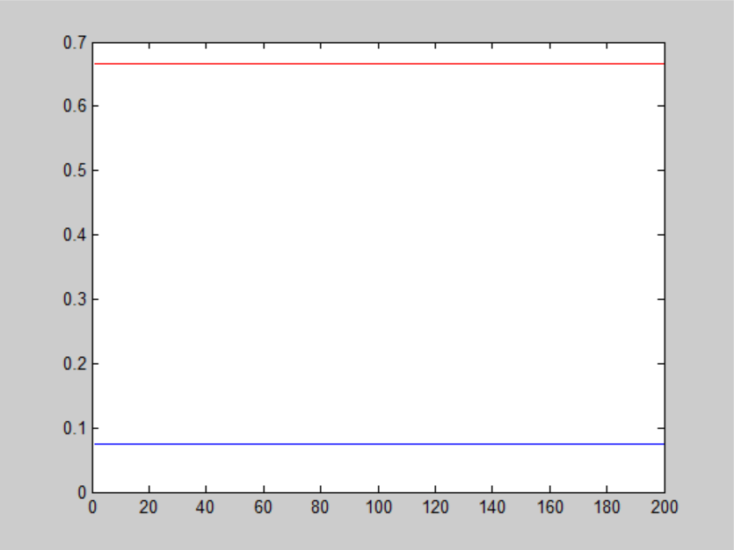

**Artificial neural network: 5 with six hidden layers**

ANN= [4 4 8 5 4 9 3 3]

|  |  |
| --- | --- |
| k | Test Error |
| 1 | 0.6865 |
| 2 | 0.7023 |
| 3 | 0.7247 |
| 4 | 0.6913 |
| 5 | 0.6733 |
| 6 | 0.6718 |
| 7 | 0.6677 |
| 8 | 0.6732 |
| 9 | 0.6762 |
| 10 | 0.6748 |
| Average | 0.68418 |

One of the graphs of 10 fold cross validation for ANN 2

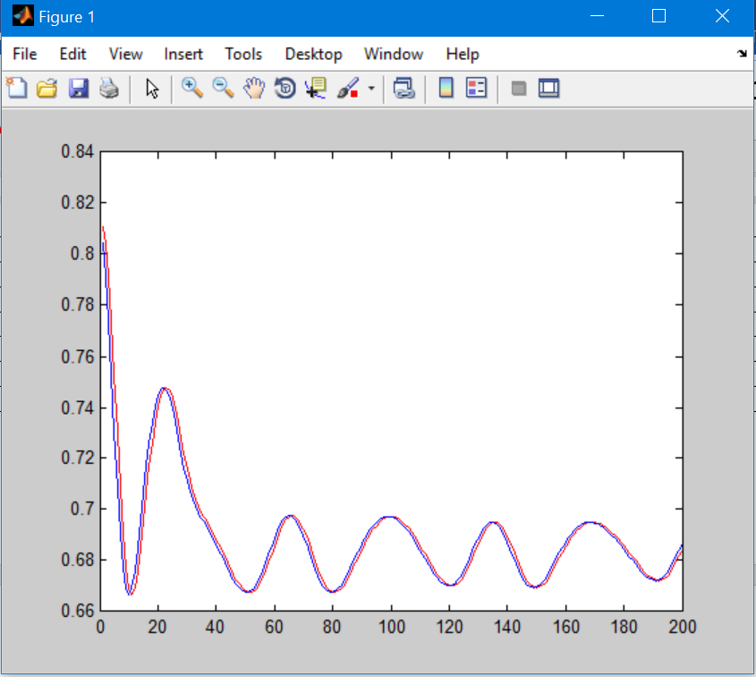



**Artificial neural network: 5 with seven hidden layers**

ANN= [4 4 8 5 4 9 3 6 3]

|  |  |
| --- | --- |
| k | Test Error |
| 1 | 0.6669 |
| 2 | 0.6762 |
| 3 | 0.6813 |
| 4 | 0.7653 |
| 5 | 0.6902 |
| 6 | 0.6765 |
| 7 | 0.6859 |
| 8 | 0.6690 |
| 9 | 0.6852 |
| 10 | 0.6939 |
| Average | 0.68904 |

One of the graphs of 10 fold cross validation for ANN 2

