**OSSEC**

1. **What is OSSEC and what are its key features/benefits?**

OSSEC is an open source host-based intrusion detection system that can be used to keep track of servers activity. It is used to monitor one server or multiple servers in server/agent mode and give you a real-time view into what’s happening on your server. It performs log analysis, integrity checking, Windows registry monitoring, rootkit detection, time-based alerting, and active response.

**Key Benefits**

1. **Compliance Requirements**

OSSEC helps customers meet specific compliance requirements such as PCI and HIPAA. It lets customers detect and alert on unauthorized file system modifications and malicious behavior embedded in the log files of commercial products as well as custom applications.

1. **Multi platform**

OSSEC has a cross-platform architecture that enables you to monitor multiple systems from a centralized location. It supports on most platforms such as Linux, Solaris, Windows, and Mac OS X.

1. **Real-time and Configurable Alerts**

OSSEC lets customers configure incidents they want to be alerted on, and lets them focus on raising the priority of critical incidents over the regular noise on any system. Integration with smtp, sms, and syslog allows customers to be on top of alerts by sending them to e-mail enabled devices. Active response options to block an attack immediately are also available.

1. **Integration with current infrastructure**

OSSEC will integrate with current investments from customers such as SIM/SEM (Security Incident Management/Security Events Management) products for centralized reporting and correlation of events.

1. **Centralized management**

OSSEC provides a simplified centralized management server to manage policies across multiple operating systems. Additionally, it also lets customers define server specific overrides for finer grained policies.

**Key Features**

1. **File Integrity checking**

The goal of file integrity checking is to detect system changes and alert you. It can be an attack, or a misuse by an employee or even a typo by an admin, any file, directory or registry change will be alerted to you.

1. **Log Monitoring**

Every operating system, application, and device on your network generate logs (events) to let you know what is happening. OSSEC collects, analyzes and correlates these logs to let you know if something suspicious is happening (attack, misuse, errors, etc).

1. **Rootkit detection**

Criminal hackers want to hide their actions, but using rootkit detection you can be notified when the system is modified in a way common to rootkits.

1. **Active response**

Active response allows OSSEC to take immediate action when specified alerts are triggered. This may prevent an incident from spreading before an administrator can take action.

1. **What is the architecture of OSSEC?**

OSSEC is composed of multiple pieces. It has a central manager for monitoring and receiving information from agents, syslog, databases, and from agentless devices.

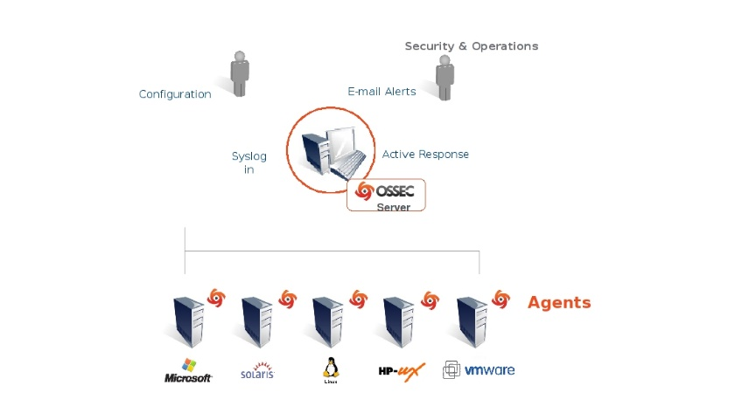This diagram shows the central manager receiving events from the agents and system logs from remote devices. When something is detected, active responses can be executed and the admin is notified.

## Manager (or Server)

## The manager is the central piece of the OSSEC deployment. It stores the file integrity checking databases, the logs, events, and system auditing entries. All the rules, decoders, and major configuration options are stored centrally in the manager; making it easy to administer even a large number of agents.

## Agents connect to the server on port 1514/udp. Communication to this port must be allowed for agents to communicate with the server.

## Agents

## The agent is a small program, or collection of programs, installed on the systems to be monitored. The agent will collect information and forward it to the manager for analysis and correlation. Some information is collected in real time, others periodically. It has a very small memory and CPU footprint by default, not affecting the system’s usage.

## Agentless

## For systems that an agent cannot be installed on, the agentless support may allow integrity checks to be performed. Agentless scans can be used to monitor firewalls, routers, and even Unix systems.

## Virtualization/VMware

## OSSEC allows you to install the agent on the guest operating systems. It may also be installed inside some versions of VMWare ESX, but this may cause support issues. With the agent installed inside VMware ESX you can get alerts about when a VM guest is being installed, removed, started, etc. It also monitors logins, logouts and errors inside the ESX server. In addition to that, OSSEC performs the Center for Internet Security (CIS) checks for VMware, alerting if there is any insecure configuration option enabled or any other issue.

## Firewalls, switches and routers

## OSSEC can receive and analyze syslog events from a large variety of firewalls, switches and routers. It supports all Cisco routers, Cisco PIX, Cisco FWSM, Cisco ASA, Juniper Routers, Netscreen firewall, Checkpoint and many others.

1. **Where is the configuration file how can you configure/customise OSSEC behavior?**

It is located at /var/ossec/etc/ossec.conf

After default and direct installation

It is in /var/ossec having sub directories like bin, etc, log, queue, rules, stats, tmp, var

Etc/ossec.conf has 6 sections

• global (global):- general information are set here : where to send notification and which SMTP server. Change it if you don’t receive alert, or want to white-list some host/ip.

• rules (rules):- has a list of files being monitored can add another you want to monitor, can write own rules <include> rules_config.xml</include>

• syscheck (syscheck/rootcheck):- <directories checkall=”yes”> with the path of directory</directories>

• alerts (alert):- alerts are sent to the mail. Each rule is configured with alert level.

• active-response (command/active-response);

• collector (localfile).

To configure

logcollector

to monitor one file:

<localfile>

<log_format>apache</log_format>

<location>/var/www/logs/error_log</location>

</localfile>

To configure

analysisd

to read a specific rules file:

<rules>

<include>myrules.xml</include>

</rules>

To configure

remoted

to accept remote syslog:

<remote>

<connection>syslog</connection>

<port>514</port>

<allowed-ips>192.168.2.0/24</allowed-ips>

</remote>

1. **Where is OSSEC output stored?**

The output from an event will be stored in an internal database

Internally stored in a tree structure.

1. **How do we control/fine tune events reported by OSSEC?**

1. **Where are rules stored? How are rules matched?**

Rules are stored in /var/ossec/rules/*.xml

First, the rules with 0 levels are tried, and then all the other rules in a decreasing order by their level.

If the level is the same, the order will be decided based on the rules list in /var/ossec/etc/ossec.conf file.

Note, for rules which have some requirement (for example if_sid), the requirement is tried first.

1. **What are the different rules groups?**

We can specify groups for specific rules. It’s used for active response reasons and for correlation.

We currently use the following groups:

* invalid_login
* authentication_success
* authentication_failed
* connection_attempt
* attacks
* adduser
* sshd
* ids
* firewall
* squid
* apache
* syslog

1. **What are different rules levels and what do they signify?**

The rules are classified in multiple levels. From the lowest (00) to the maximum level 16. Some levels are not used right now. Other levels can be added between them or after them.

**The rules will be read from the highest to the lowest level.**

00 - Ignored - No action taken. Used to avoid false positives. These rules are scanned before all the others. They include events with no security relevance.

01 - None -

02 - System low priority notification - System notification or status messages. They have no security relevance.

03 - Successful/Authorized events - They include successful login attempts, firewall allow events, etc.

04 - System low priority error - Errors related to bad configurations or unused devices/applications. They have no security relevance and are usually caused by default installations or software testing.

05 - User generated error - They include missed passwords, denied actions, etc. By itself they have no security relevance.

06 - Low relevance attack - They indicate a worm or a virus that have no affect to the system (like code red for apache servers, etc). They also include frequently IDS events and frequently errors.

07 - “Bad word” matching. They include words like “bad”, “error”, etc. These events are most of the time unclassified and may have some security relevance.

08 - First time seen - Include first time seen events. First time an IDS event is fired or the first time an user logged in. If you just started using OSSEC HIDS these messages will probably be frequently. After a while they should go away, It also includes security relevant actions (like the starting of a sniffer or something like that).

09 - Error from invalid source - Include attempts to login as an unknown user or from an invalid source. May have security relevance (specially if repeated). They also include errors regarding the “admin” (root) account.

10 - Multiple user generated errors - They include multiple bad passwords, multiple failed logins, etc. They may indicate an attack or may just be that a user just forgot his credentials.

11 - Integrity checking warning - They include messages regarding the modification of binaries or the presence of rootkits (by rootcheck). If you just modified your system configuration you should be fine regarding the “syscheck” messages. They may indicate a successful attack. Also included IDS events that will be ignored (high number of repetitions).

12 - High importancy event - They include error or warning messages from the system, kernel, etc. They may indicate an attack against a specific application.

13 - Unusual error (high importance) - Most of the times it matches a common attack pattern.

14 - High importance security event. Most of the times done with correlation and it indicates an attack.

15 - Severe attack - No chances of false positives. Immediate attention is necessary.